GMT (Generic Movie Tickets)

Software Requirements Specification

Version 3

10/22/2026

Group #3
Andres Akerlundh, Madison Stevens, Haoze Li

Prepared for
CS 250- Introduction to Software Systems
Instructor: Gus Hanna, Ph.D.
Fall 2026

Revision History

Date | Description | Author | Comments
9/14/26 | Version 1.0 | Group 3 | First Draft
10/8/26 | Version 2.0 | Group 3 | Software Design
10/22/26 | Version 3.0 | Group 3 | Test Plan

Document Approval

The following Software Requirements Specification has been accepted and approved by the following:
Signature | Printed Name | Title | Date
 | Dr. Gus Hanna | Software Eng. Instructor, CS 250

Table of Contents

Revision History.................................................................... ii
Document Approval............................................................. ii
1. Introduction......................................................................... 1
1.1 Purpose................................................................................... 1
1.2 Scope....................................................................................... 1
1.3 Definitions, Acronyms, and Abbreviations...................... 1
1.4 References............................................................................. 1
1.5 Overview................................................................................ 1
2. General Description......................................................... 2
2.1 Product Perspective............................................................. 2
2.2 Product Functions................................................................ 2
2.3 User Characteristics........................................................... 2
2.4 General Constraints........................................................... 2
2.5 Assumptions and Dependencies........................................... 2
3. Specific Requirements..................................................... 2
3.1 External Interface Requirements..................................... 3
3.1.1 User Interfaces................................................................. 3
3.1.2 Hardware Interfaces......................................................... 3
3.1.3 Software Interfaces........................................................... 3
3.1.4 Communications Interfaces............................................... 3
3.2 Functional Requirements.................................................... 3
3.2.1 Employee Operation.................................................................. 3
3.2.2 Purchase Tickets.......................................................................... 3
3.3 Use Cases................................................................................ 3
3.3.1 Use Case #1: Log In..................................................................... 3
3.3.2 Use Case #2: Purchase Movie Ticket............................................ 3
3.3.3 Use Case #3: Manage Movies and Screening Info........................ 3
3.4 Classes / Objects................................................................... 3
3.4.1 Class / Object #1 Movie............................................................... 3
3.4.2 Class / Object #2 Users............................................................... 3
3.5 Non-Functional Requirements........................................... 4
3.5.1 Performance..................................................................... 4
3.5.2 Reliability......................................................................... 4
3.5.3 Availability....................................................................... 4
3.5.4 Security............................................................................. 4
3.5.5 Maintainability................................................................. 4
3.5.6 Portability......................................................................... 4
3.6 Inverse Requirements.......................................................... 4
3.7 Design Constraints............................................................... 4
3.8 Logical Database Requirements........................................ 4
3.9 Other Requirements............................................................. 4
4. Analysis Models.................................................................. 4
4.1 Sequence Diagrams............................................................... 5
4.3 Data Flow Diagrams (DFD)................................................. 5
4.2 State-Transition Diagrams (STD)...................................... 5
5. Change Management Process..................................... 5
6. Software Design Specification
6.1 System Description
6.2 Software Architecture Overview
6.2.1 Software Architecture (SWA) Diagram
6.2.2 SWA Description
6.2.3 UML Class Diagram
6.2.4 Class Descriptions
6.2.4.1 Class: Movie
6.2.4.2 Class: Users
6.2.5 Data Structures
6.3 Development Plan and Timeline
6.3.1 Partitioning of Tasks
6.3.2 Timeline
6.3.3 Team Member Responsibilities
7. Test Plan
7.1 Test Objectives and Scope
7.1.1 Testing objective
7.1.2 Testing which function
7.1.3 Unit, Functional/Integration and System testing
7.1.4 Test data, erroneous input and failure scenarios
7.2 Test Cases and Coverage
7.2.1 Test Case Summary
7.2.2 Test Targets and Scope
7.2.3 Coverage of the Functions Listed in 7.1.2
7.3 GitHub Link
A. Appendices.............................................................................. 5
A.1 Appendix 1.............................................................................. 5
A.2 Appendix 2.............................................................................. 5

1. Introduction
This Software Requirements Specification describes the requirements for a cinema system. The system enables customers to view movie information, search for showtimes, select seats, and purchase movie tickets, while also allowing authorized cinema staff to manage movies, screenings, and bookings. This document provides an overview of the system and outlines its user requirements, functional requirements, and non-functional requirements, including usability, reliability, performance, and security.

1.1 Purpose
The purpose of this document is to define the requirements for the theater ticketing system, capturing the needs of customers and theater administrators. This SRS was developed through a client requirements interview, followed by a team brainstorming session to identify and refine additional functionality, evaluate feasibility, and document potential issues to guide future updates. This document provides a clear and detailed picture of the system's scope, goals, and expected behavior, including its target users, interface design, and the hardware and software needed to support it. The intended audience includes customers, the development and testing teams, and project stakeholders. They can rely on this document as a shared reference for a consistent understanding of the system's functionality throughout the software development lifecycle, from design through implementation.

1.2 Scope
This document defines the requirements for a movie ticketing website that enables users to browse movie listings, view showtimes, select seats, and book tickets online. It covers the needs of administrative users, customers, and the engineers who will be referring to this document, and describes the functionality required to support ticket booking, show scheduling, and related customer-facing features.
In scope for this system are movie listings and showtime browsing, seat selection and booking, payment processing, email confirmation of bookings, QR code generation for ticket check-in, and other related features supporting the end-to-end ticketing experience.
This SRS specifies the requirements for the software to be developed and can also serve as a reference for evaluating existing or third-party software components that may be used in building the system. It can be used directly to guide development, or adapted as a template for defining requirements on similar projects. It does not prescribe any particular method, notation, or tool to be used in preparing the specification itself.

1.3 Definitions, Acronyms, and Abbreviations

FAQ | Frequently Asked Questions
CRM | Customer Relationship
SRS | Software Requirements Specification
UI | User Interface
HTTPS | Hypertext Transfer Protocol Secure
API | Application Programming Interface
PCI | Payment Card Industry
SMTP | Simple Mail Transfer Protocol

1.4 References
- IEEE Std 830-1998, IEEE Recommended Practice for Software Requirements Specifications, Institute of Electrical and Electronics Engineers, 1998.
- Theater Ticketing System Client Requirements Interview, provided as part of course materials, 2026.
- Software Requirements Specification Template, provided by course instructor, 2026.

1.5 Overview

The remaining sections of this document provide a general description, including characteristics of the users of this project, the product's hardware, and the functional and data requirements of the product. General description of the project is discussed in section 2 of this document. Section 3 gives the functional requirements, data requirements and constraints and assumptions made while designing the Theater Ticketing System. It also gives the user a viewpoint of the product. Section 3 also gives the specific requirements of the product, and discusses the external interface requirements and gives detailed description of functional requirements. Section 4 is for supporting information.

2. General Description
This section provides a description of the movie ticketing system and its operating environment. It mainly summarizes the functions of our website, the user base that uses the website, the limitations of the website, and the assumptions and dependencies in the design of the website. This section provides information for the third section, but does not offer detailed design and implementation plans.

2.1 Product Perspective
The cinema ticketing system is an independent system that runs on the website. Users can access our website by searching through the browser or by entering the website address. No software installation is required. The system supports both online and in-person purchasing, with seat and showtime data updated live and shared between the website and in-person point of sale. The website can integrate external payment services such as Apple Pay and PayPal. Users can register as our users by using their Apple account or Google account.

2.2 Product Functions

For users of the website: Create an account and log in, view movie information, select the screening time, choose the viewing seat, purchase movie tickets with regular, deluxe, student, military, or senior pricing, purchase or use a membership card to reserve tickets, view movie tickets and viewing records, submit post-purchase feedback, and view movie ratings and critic reviews.

For cinema managers and customer needs: Add or update movie information, create or modify screening times, manage screening halls and seats, update movie ticket prices, view sales and reservations, and the function for canceling screenings due to special circumstances.
For the backend maintenance personnel: manage user accounts, control employee access rights, maintain website information, and monitor website operation status.

2.3 User Characteristics
Our website can be divided into three types of users: customers, cinema staff and back-end maintenance personnel.

Moviegoers are the main users of this system. They use the website to access their accounts, view movie and screening information, select seats and purchase movie tickets. Since most moviegoers only use the website when planning to watch a movie, they should be occasional users with varying levels of technical experience. They should be able to complete ordinary tasks with little or no formal training. For new users, brief instructions are sufficient. When introducing new features, simple guidance can be provided. Moviegoers can only use the customer-oriented functions.

Cinema management staff will frequently use this system in their daily operations to update movie information, manage seating arrangements, schedule showtimes, and allocate movies to screening halls. These users should possess basic computer skills and knowledge of theater operations. New staff may require initial training and guidance from experienced staff before independently using the management functions. Theater management has limited administrative privileges, allowing them to manage designated website content and operational information, but they do not have full system administrator privileges.

System administrators and maintenance personnel should possess high-level technical skills and have received specialized training. They are responsible for managing user and employee accounts, configuring system settings, monitoring system operation, diagnosing and resolving technical issues. They have the highest level of management authority over the website; therefore, this role must be restricted to authorized personnel.

2.4 General Constraints
There are the following points in regards to the limitations of this system. The limitations of the platform, as the system needs to run through a browser, may involve issues related to browser compatibility. External platform restrictions: Due to the need to comply with the third-party payment service interface and usage rules, if the third-party service is unavailable, then both payment and login functions will not be able to operate. At present, in terms of permissions, different restrictions are imposed on different user groups. Security and privacy restrictions mean that user data cannot be accessed by unauthorized individuals. The system must comply with applicable data privacy and payment security regulations. The project has a budget of $500,000 and a 4-month timeline to deliver a viable prototype, and covers 20 theaters in the San Diego area (Pacific time zone), supporting at least 1,000 concurrent users.

2.5 Assumptions and Dependencies
Assumptions
The system assumes that the user has a stable internet connection and accesses the website through a supported web browser. It also assumes that the user provides accurate and valid account information, and that the customer has at least one system-supported payment method. The system assumes regular theaters have 150 seats and deluxe theaters have 75 seats, and that ticket refunds are handled in person by theater staff rather than through the system.

Dependencies
The website relies on third-party payment services such as Apple Pay and PayPal, as well as servers and databases, Apple and Google's third-party login services, notification services via email or text messages, and information data provided by cinema staff regarding movie showtimes, seats, and prices.

3. Specific Requirements
This will be the largest and most important section of the SRS. The customer requirements will be embodied within Section 2, but this section will give the D-requirements that are used to guide the project’s software design, implementation, and testing.

3.1 External Interface Requirements

3.1.1 User Interfaces

The system shall provide a web-based graphical user interface accessible via standard web browsers (Chrome, Firefox, Safari, Edge). The interface shall include pages for browsing movies, viewing showtimes, selecting seats, checking out, and managing user accounts. The interface shall be responsive and support both desktop and mobile screen sizes. Admin users shall have access to a separate dashboard interface for managing movies, showtimes, and users.

3.1.2 Hardware Interfaces
The system shall not require specialized hardware. Users shall access the system through standard devices (desktop computers, laptops, tablets, smartphones) with internet connectivity. The system shall support standard input devices (keyboard, mouse, touchscreen).

3.1.3 Software Interfaces
The system shall interface with a payment processing service to handle credit card transactions. The system shall interface with a relational database to store movie, user, and transaction data. The system may interface with an email service to send booking confirmations and notifications. The system shall interface with a third-party movie data API, such as Rotten Tomatoes or IMDB, to retrieve movie information such as posters, descriptions, ratings, and critic reviews.

3.1.4 Communications Interfaces
The system shall communicate over HTTPS to ensure secure data transmission between the client and server. The system shall use standard internet protocols (TCP/IP) for all client-server communication. The system shall send email notifications over SMTP for booking confirmations, cancellations, and password resets.

3.2 Functional Requirements
This section describes specific features of the software project. If desired, some requirements may be specified in the use-case format and listed in the Use Cases Section.

3.2.1 Employee operation

3.2.1.1 Introduction:
The authorized cinema staff are required to update the information, prices and showtimes of the movies. The modified version can be seen by customers, but this function cannot be accessed by customers.

3.2.1.2 Inputs
The following inputs are required:
- Employee login credentials, including the employee account and password
- Movie title
- Movie synopsis
- Movie genre
- Movie rating
- Movie poster
- Showtime
- Auditorium or screening location
- Ticket price

3.2.1.3 Processing
After the system is received, it is necessary to check whether the employee account is correct. Based on the movie information, make the necessary modifications. Check whether the new information is complete and the format is correct. Save the modified information to the database, update the information so that customers can see it, and record the modification time and the personnel information.

3.2.1.4 Outputs
The system shall produce the following outputs:
- A confirmation message indicating that the movie information was successfully updated
- The updated movie information displayed on the employee management page
- The updated movie information displayed on the customer-facing page
- A modification record containing the changes, time of modification, and responsible employee, accessible only to authorized staff

3.2.1.5 Error Handling
Employee account error, movie information error, network or database connection failure. Inform the employees when an error occurs.

3.2.2 Purchase Tickets
3.2.2.1 Introduction
This feature allows a customer to browse movies, select a showtime, choose seats, and complete payment to purchase tickets online. Pricing varies by ticket type (regular, deluxe, student, military, senior), and seating is either assigned (deluxe theaters) or general admission (regular theaters). Tickets may be purchased between two weeks in advance and up to 10 minutes after the showtime starts, with a limit of 20 tickets per transaction. Unfinished purchases are abandoned and seats released after 5 minutes.
3.2.2.2 Inputs
- Movie, showtime, and seat selection
- Ticket type and quantity
- Payment information or membership card
- Customer account information (if logged in)
3.2.2.3 Processing
The system shall verify the showtime falls within the allowed booking window, check and reserve seat availability for 5 minutes during checkout, and calculate total cost based on ticket type and quantity. It shall process payment through the payment gateway or apply a valid membership card, then release the reservation if payment is not completed within the 5-minute window.
3.2.2.4 Outputs
- On-screen and emailed order confirmation (movie, showtime, seats, ticket type, total cost, order number)
- Updated seat availability
- Post-purchase feedback prompt
3.2.2.5 Error Handling
The system shall reject purchases outside the booking window, orders exceeding 20 tickets, and failed payments, prompting the customer to correct the issue. If selected seats become unavailable during checkout, or the 5-minute window expires, the system shall release the reservation and notify the customer.

3.3 Use Cases
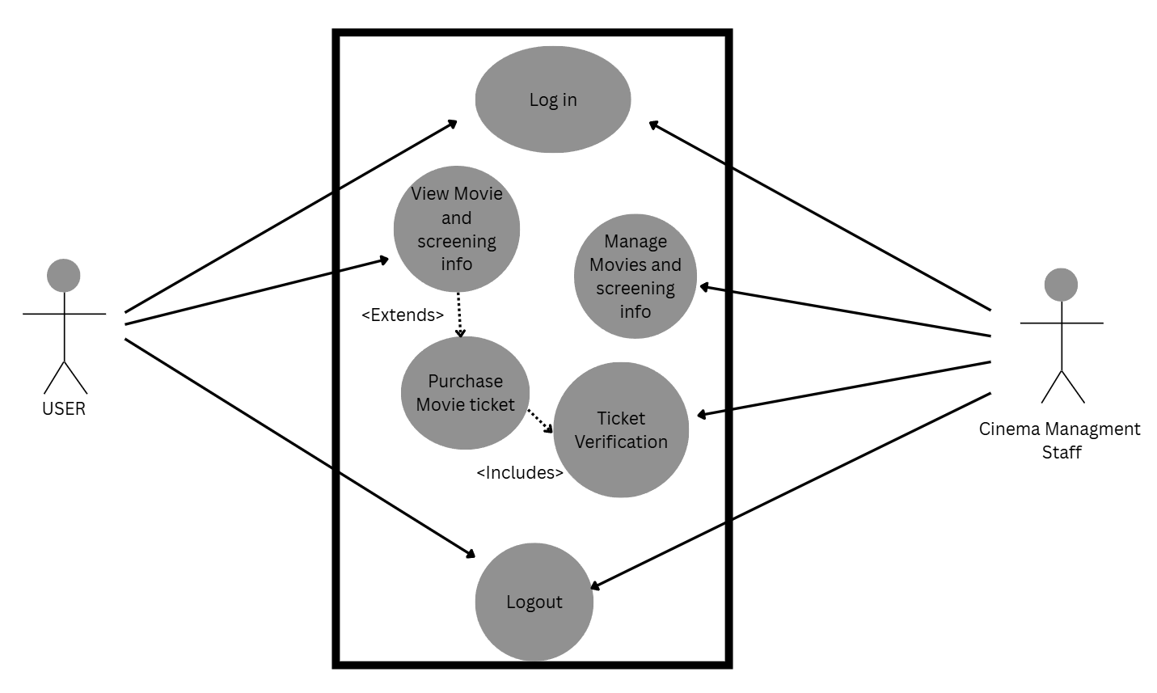

3.3.1 Use Case #1: Log In
Actor: User (Customer or Cinema Management Staff)
Description: A user logs into the system to access account-specific features.
Preconditions: The user has a registered account.
Main Flow:
- User navigates to the login page.
- User enters login credentials.
- System verifies the credentials.
- System grants access to the appropriate interface (customer-facing pages for a customer, employee management page for cinema staff).
Postconditions: The user is logged in and has access to role-appropriate features.

3.3.2 Use Case #2 Purchase Movie Ticket
Actor: User (Customer)
Description: A customer views movie and screening information, selects a showtime, chooses seats, and completes payment to purchase tickets, which are then verified at the theater.
Preconditions: The customer has viewed available movies and showtimes.
Main Flow:
- Customer selects a showtime and desired seats (assigned seating for deluxe theaters, general admission for regular theaters).
- Customer selects ticket type and quantity (regular, deluxe, student, military, senior).
- Customer enters payment information or applies a membership card.
- System verifies the booking window, reserves the selected seats, and processes payment.
- System confirms the purchase and displays/emails the order confirmation.
- At the theater, the customer's ticket is verified against their booking record before entry.
Postconditions: Tickets are purchased, seats are reserved, a confirmation is sent to the customer, and the ticket is verified for entry.
3.3.3 Use Case #3: Manage Movies and Screening Info
Actor: Cinema Management Staff
Description: Authorized cinema staff add, update, or remove movie and showtime information.
Preconditions: The staff member is logged into the employee management page.
Main Flow:
- Staff member selects a movie to add, update, or remove.
- Staff member enters or modifies movie details, showtimes, theater assignment, and ticket price.
- System validates the input and saves the changes.
- System updates the information on both the employee management page and the customer-facing page.
Postconditions: Movie and screening information is updated and visible to customers.

3.4 Classes / Objects

3.4.1 Class / Object #1 Movie

3.4.1.1 Attributes
- movieID (Integer): unique identifier for the movie
- title (String): name of the movie
- description (String): short synopsis
- genre (String): movie genre
- rating (String): MPAA rating (e.g., PG-13)
- duration (Integer): running time in minutes
- releaseDate (Date): date the movie is released
- posterURL (String): link to the poster image
- showtimes (List): scheduled screenings, each with theater, date, time, price, and seats available
3.4.1.2 Functions
- getMovieDetails(): returns the movie's information for display
- getShowtimes(): returns available showtimes for the movie
- checkSeatAvailability(showtime): returns the number of open seats for a showtime
- addMovie(), updateMovie(), removeMovie(): admin-only functions for managing the movie catalog

3.4.2 Class / Object #2 Users
3.4.2.1 Attributes
- userID (Integer): unique identifier for the user
- name (String): user's full name
- email (String): email address, used for login
- password (String): stored as a hashed value
- role (Enum: Customer, Admin): determines user permissions
- paymentInfo (Object): saved payment method (Customer only)
- purchaseHistory (List): past ticket purchases (Customer only)
- membershipStatus (Boolean): indicates whether the user holds a paid membership for ticket reservations
3.4.2.2 Functions
All users:
- register(), login(), logout()
- updateProfile()
Customer:
- searchMovies(): find movies by title, genre, or date
- selectSeats(showtime): choose seats for a screening
- purchaseTickets(): pay for and confirm a booking
- cancelBooking(): cancel a purchase where allowed
- viewPurchaseHistory(): view past and upcoming tickets
Admin:
- addMovie(), updateMovie(), removeMovie(): manage the movie catalog
- manageShowtimes(): add or change screenings and prices
- manageUsers(): view or deactivate customer accounts
- overridePurchase(): corrects or reverses a customer purchase error
- viewSalesReports(): view ticket sales data

3.5 Non-Functional Requirements
Non-functional requirements may exist for the following attributes. Often these requirements must be achieved at a system-wide level rather than at a unit level. State the requirements in the following sections in measurable terms (e.g., 95% of transaction shall be processed in less than a second, system downtime may not exceed 1 minute per day, > 30 day MTBF value, etc).

3.5.1 Performance
The system shall respond to user actions such as searching movies, selecting seats, and completing checkout within a time frame that does not disrupt the user experience. Specific target response times (e.g., page load time, transaction processing time) are to be determined based on team decision.

3.5.2 Reliability
The system shall prevent double booking of the same seat for the same showtime under concurrent access. A specific mean time between failures value is to be determined, as this project does not include a live deployment against which reliability could be measured.

3.5.3 Availability
As this system is not deployed to production, an uptime percentage is not applicable. If the system were deployed, an availability target (e.g., percentage uptime, maximum downtime per month) would need to be defined at that time.

3.5.4 Security
The system shall not store user passwords in plain text. The system shall not store complete payment card information directly; payment processing would rely on a third-party processor in a real implementation. Access to admin functions shall be restricted to authenticated users with the Admin role.

3.5.5 Maintainability
The system shall be organized into separate components for movie management, user accounts, and ticket purchasing, so that each part of the system could be modified independently. Coding standards and documentation practices are to be determined based on team decision.

3.5.6 Portability
The system's interface shall be designed to function on standard modern web browsers and to support both desktop and mobile screen sizes. Specific browser and version support and deployment environment are to be determined, as no deployment platform has been selected.

3.6 Inverse Requirements
State any *useful* inverse requirements.

3.7 Design Constraints
Specify design constrains imposed by other standards, company policies, hardware limitation, etc. that will impact this software project.

3.8 Logical Database Requirements
Will a database be used? If so, what logical requirements exist for data formats, storage capabilities, data retention, data integrity, etc.

3.9 Other Requirements
Catchall section for any additional requirements.

4. Analysis Models
List all analysis models used in developing specific requirements previously given in this SRS. Each model should include an introduction and a narrative description. Furthermore, each model should be traceable the SRS’s requirements.

4.1 Sequence Diagrams

4.3 Data Flow Diagrams (DFD)

4.2 State-Transition Diagrams (STD)

5. Change Management Process
Identify and describe the process that will be used to update the SRS, as needed, when project scope or requirements change. Who can submit changes and by what means, and how will these changes be approved.

6. Software Design Specification
This section is the Software Design Specification for GMT (Generic Movie Tickets). It continues the requirements in Sections 1–5 and is written for the developers who will implement and later maintain the system.

6.1 System Description
GMT (Generic Movie Tickets) is a web-based movie ticketing system designed to support ticket sales and theater management for 20 theaters in the San Diego area.

Customers can create and manage their accounts, browse movie descriptions and screening times, select cinemas and seats, purchase movie tickets through supported payment services, and receive electronic reservation confirmations.

The cinema staff log in to the management page using their employee accounts and passwords, add or modify movie information, manage the details of the movie details interface, set or modify the screening time, manage the screening venue and seats, modify the movie ticket prices, view the modification records of movie information, and ensure that all relevant information about the movies is accurate.

System maintenance personnel need to manage customer and employee accounts, set different account permissions, monitor the website, servers and databases, modify necessary system configurations, identify and fix system errors, handle technical issues, review logs and abnormal records, and back up and restore data.

External Services.
- Apple Pay and PayPal: Handling Online Payments;
- Apple and Google Login: Facilitates customer registration or login;
- Email/SMTP and SMS services: Sending ticket purchase confirmations, electronic tickets and password reset notifications;

6.2 Software Architecture Overview

6.2.1 Software Architecture (SWA) Diagram
[Insert the architectural diagram. Show all major components AND the connectors between them, and label each connector with its interaction type. Components suggested by Section 3.1: Web UI (customer and admin dashboard), application server, relational database, payment service (Apple Pay / PayPal), Apple/Google login, email service (SMTP), third-party movie data API.]
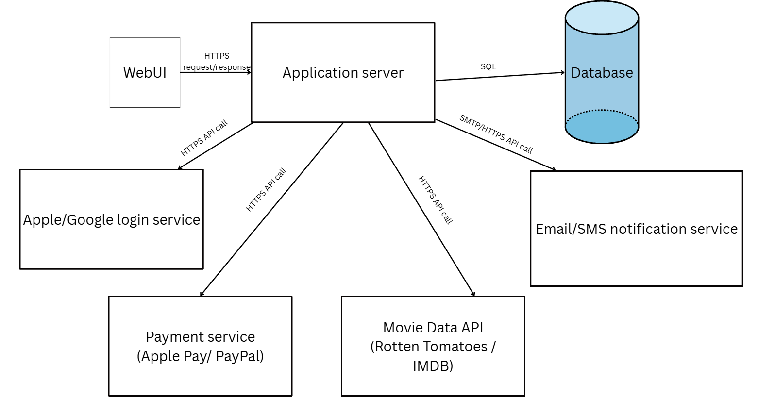

6.2.2 SWA Description
Components
Component | Responsibility | Interacts With
WebUI | Browser-based interface for customers (browsing, booking) and staff (movie/showtime management, admin dashboard) | Application server
Application server | Hosts business logic, including Movie and User classes; processes requests and enforces business rules | Web UI, Database, Payment service, Login service, Notification service, Movie data API
Database | Stores movie, user, showtime, and transaction data, partitioned by theater | Application server
Payment service (Apple Pay / PayPal) | External service that processes customer payment transactions | Application server
Apple/Google login service | External service used for account registration and authentication | Application server
Email/SMS notification service | External service used to send booking confirmations and notifications | Application server
Movie data API (Rotten Tomatoes / IMDB) | External service providing movie ratings, descriptions, and critic reviews | Application server

Connectors
Connector (From -> To) | Type / Protocol | Data Exchanged
Web UI -> Application server | HTTPS request/response | User actions (browse, select seats, purchase, login) and page data
Application server -> Database | SQL (transactions) | Movie, user, showtime, and booking records
Application server -> Payment service | HTTPS API call | Payment authorization and confirmation
Application server -> Login service | HTTPS API call(OAuth) | Authentication tokens, account verification
Application server -> Notification service | SMTP / HTTPS API call | Booking confirmations, cancellations, password resets
Application server -> Movie data API | HTTPS API call | Movie ratings, descriptions, critic reviews

6.2.3 UML Class Diagram
[Insert the complete UML class diagram: every class with name, attributes, operations, and the connections between classes (association, aggregation, composition, inheritance) with multiplicities. Section 3.4 defines Movie and Users; add the other classes your design needs (e.g., Showtime, Theater/Auditorium, Seat, Booking/Ticket, Payment, Membership).]
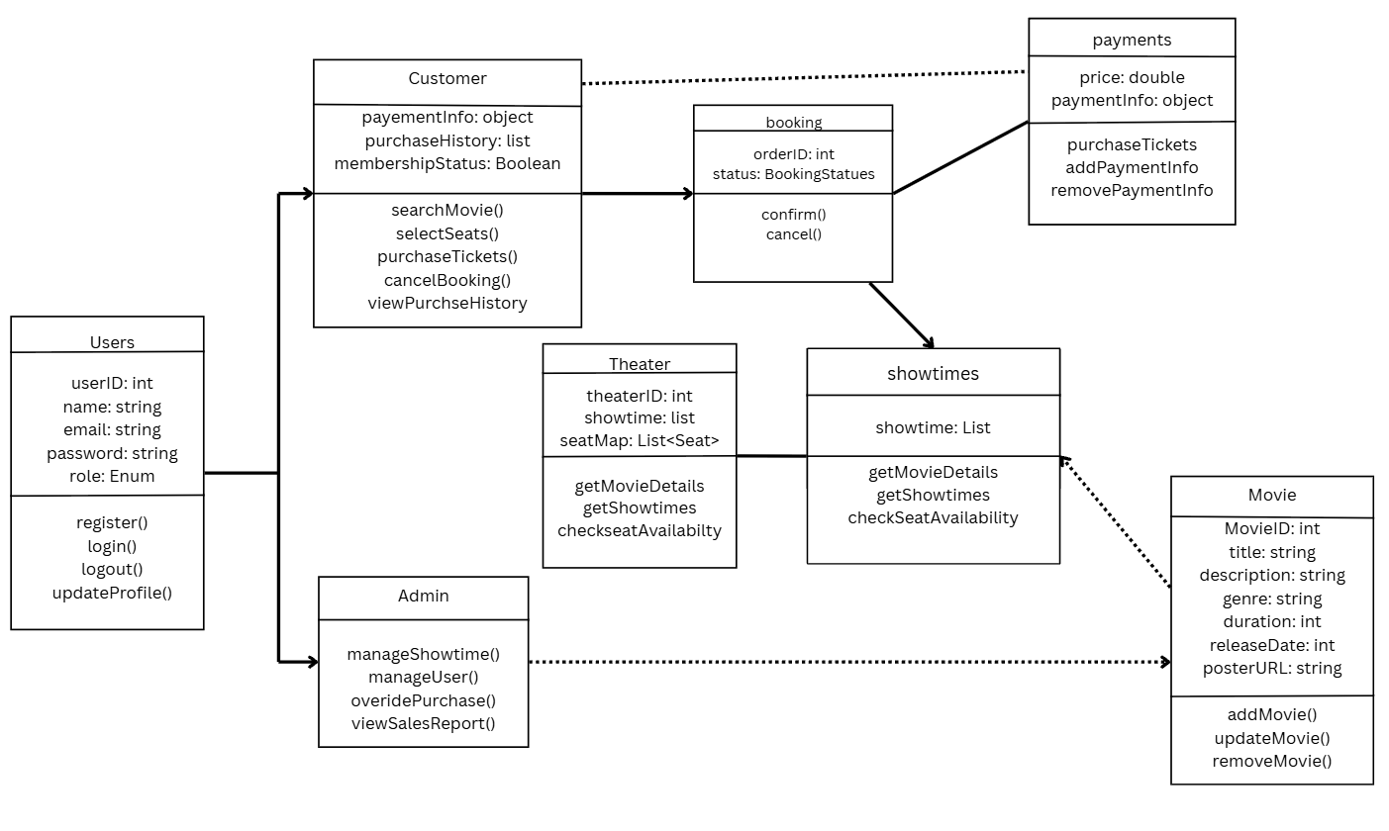

6.2.4 Class Descriptions

6.2.4.1 Class: Movie
Overview
Represents a movie in the catalog and the screenings scheduled for it. Admin-only operations manage the catalog.
Attributes
Attribute | Datatype | Description
movieID | Integer | unique identifier for the movie
title | String | name of the movie
description | String | short synopsis
genre | String | movie genre
rating | String | MPAA rating (e.g., PG-13)
duration | Integer | running time in minutes
releaseDate | Date | date the movie is released
posterURL | String | link to the poster image
showtimes | List | scheduled screenings, each with theater, date, time, price, and seats available

Operations
Operation | Parameters (name: type) | Returns | Description
getMovieDetails | none | Movie | returns the movie's information for display
getShowtimes | none | List | returns available showtimes for the movie
checkSeatAvailability | showtime: Showtime | Integer | returns the number of open seats for a showtime
addMovie / updateMovie / removeMovie | movie: Movie (add/update), movieID: Integer (remove) | Boolean | admin-only functions for managing the movie catalog

6.2.4.2 Class: Users
Overview
Represents any person with an account. The role attribute (Customer or Admin) determines which operations are permitted.
Attributes
Attribute | Datatype | Description
userID | Integer | unique identifier for the user
name | String | user's full name
email | String | email address, used for login
password | String | stored as a hashed value
role | Enum (Customer, Admin) | determines user permissions
paymentInfo | Object | saved payment method (Customer only)
purchaseHistory | List | past ticket purchases (Customer only)
membershipStatus | Boolean | whether the user holds a paid membership for ticket reservations

Operations
Operation | Parameters (name: type) | Returns | Description
register/login/logout | name: String, email: String, password: String (register); email: String, password: String (login) | Boolean | all users
updateProfile | userID: Integer, fields: Object | Boolean | all users
searchMovies | query: String | List | Customer: find movies
selectSeats | showtime: Showtime | List<Seat> | Customer: choose seats for a screening
purchaseTickets | showtimeID: Integer, seats: List<Seat>, ticketType: String | Boolean | Customer: pay for and confirm a booking
cancelBooking | orderID: Integer | Boolean | Customer: cancel a purchase where allowed
viewPurchaseHistory | none | List | Customer: view past and upcoming tickets
manageShowtimes | movieID: Integer, showtime: Showtime | Boolean | Admin: add or change screenings and prices
manageUsers | userID: Integer | Boolean | Admin: view or deactivate customer accounts
overridePurchase | orderID: Integer | Boolean | Admin: correct or reverse a customer purchase error
viewSalesReports | none | List<Report> | Admin: view ticket sales data

6.2.5 Data Structures
Data Structure | Type | Purpose | Used In
Showtime record | Struct (within Movie.showtimes) | Represents one scheduled screening: theaterID, date, time, price, seatsAvailable | Movie
Seat map | List<Seat> | Tracks individual assigned seats for deluxe theaters, or a simple available count for general admission | Movie, User
Ticket and purchases | Struct (within User.purchaseHistory) | Represents one booking: orderID, showtimeID, seats, ticketType, totalCost, purchaseTimestamp | User

6.3 Development Plan and Timeline

6.3.1 Partitioning of Tasks
# | Task | Description | Depends On
1 | Requirement analysis and framework design | Define database setup, finalize class design, confirm architecture. | NONE
2 | UI/UX Design | Design Wireframe and design customer-facing pages (movie browsing, seat selection, checkout) and admin dashboard, per 3.1.1 | Task 1
3 | Database design and setup | Design and implement the partitioned relational database schema for movies, users, showtimes, and tickets. | Task 1
4 | Frontend Development | Build customer and admin website pages and components from the UI/UX designs | Task 2
5 | User login authentication and account management | Connect to a third-party login system (Google/Apple) and encrypt the user passwords. | Task 3
6 | Movie catalog and showtime management | Implement Movie class operations and admin movie/showtime management interface | Task 3,Task 4
7 | Ticket purchasing flow | Implement seat selection, checkout, booking window/timeout logic, payment gateway integration | Task 4, Task 5, Task 6
8 | Testing and quality assurance | Unit and integration testing, including concurrent-access testing for seat booking | Task 7

6.3.2 Timeline
[Estimated schedule per task, with who is responsible. The project has a 4-month timeline (Section 2.4).]
Task # | Start Date | End Date | Milestone / Deliverable | Responsible
1 | 9/1/2026 | 9/24/2026 | Requirement Specification & Architecture Draft | All Members
2 | 9/25/2026 | 10/8/2026 | Software Design Specification (SDS) Completed | All Members
3 | 10/9/2026 | 10/25/2026 | Partitioned Relational Database Schema Setup | All Members
4 | 10/9/2026 | 10/30/2026 | Customer & Admin Web Layouts and Components | All Members
5 | 10/26/2026 | 11/13/2026 | Third-Party Auth & Password Encryption Module | All Members
6 | 10/31/2026 | 11/18/2026 | Movie Catalog & Admin Showtime Endpoints | All Members
7 | 11/19/2026 | 12/05/2026 | Integrated Ticket Purchasing & Seat Lock Flow | All Members
8 | 12/06/2026 | 12/16/2026 | Unit/Integration Testing & QA Test Report | All Members

6.3.3 Team Member Responsibilities
Team Member | Role | Responsibilities / Components Owned | GitHub Username
Andres Akerlundh | UI/UX Designer | responsible for the UI/UX design | AA6304
Madison Stevens | Programmer | responsible for html code and implementation of data structures | MadisonStevens98
Haoze Li | Project Manager | responsible for managing timeline, labor, and quality | hli1614

7. Test Plan

7.1 Test Objectives and Scope
This section covers the testing objectives, the functions to be tested, Unit, Functional/Integration and System tests, as well as test data, error inputs and failure scenarios.

7.1.1 Testing objective
This test plan is designed to verify whether the cinema ticketing system is operating in accordance with the requirements specified in the documentation, and whether it meets the needs of customers, staff, and system maintenance personnel. By testing individual components, the connections between components and the operation of the entire system, potential problems can be identified. The test will also verify whether the system can handle invalid inputs or unexpected malfunctions.

7.1.2 Testing which function
We will test the following functions:
- User registration, login, and account verification
- Browse movies, cinemas and available times
- Ticket price verification and display
- The availability of seats and the selection of seats
- Reserving movie tickets and payment processing
- Confirm the updated reservation information and the availability of seats on the website
- Authorization of staff login and information verification.
- Authorize the staff to manage the films, showtimes, screening halls, seats, and ticket prices.
- Account permission settings and tests to prevent unauthorized external access
- Error handling when inputting invalid information or encountering unavailable external services
- The accuracy of the system log information recorded by the staff and system maintenance personnel when operating the system
- ……

7.1.3 Unit, Functional/Integration and System testing
The test will be conducted at three levels: unit, functional/integrative, and system. Unit tests will evaluate the implementation of individual functions, such as login, payment, fare verification and logging, etc. The functional and integration tests will be a combination of unit tests. For instance, after logging in, the browsing of the target movie, booking seats, paying for the movie ticket, and confirming the reservation information - will this series of operations run smoothly? The system test will thoroughly examine the workflow from the perspectives of different users, such as the complete operation of an employee modifying movie information.

7.1.4 Test data, erroneous input and failure scenarios
This section of the test involves deliberately inputting some incorrect data to observe how the system responds to these data. It checks whether the system can correctly output these errors, such as negative movie ticket prices, or situations where images cannot be uploaded due to incorrect specifications, or cases where the system fails to save properly, etc.

7.2 Test Cases and Coverage
This section presents 10 test cases in Excel, (testCasesSample.xlsx), explaining which functions and testing levels these cases. The level of each, the test vectors used, and the parts of the design each one targets.

The three levels follow Section 7.1.3. A unit test checks one function in isolation, with its dependencies replaced by stubs. A functional (integration) test combines several units, such as the checkout page, purchaseTickets() and the payment service. A system test runs a complete workflow through the whole running system from the point of view of one type of user. The test case ID prefix (UNIT_, FUNC_, SYS_) shows the level in the Excel file.

7.2.1 Test Case Summary

Test ID | Level | Component under test | Test vectors (inputs) | What it covers (SRS trace)
UNIT_LOGIN | Unit | Users.login() | Valid credentials, authentication service stubbed to approve | Successful authentication (3.3.1)
UNIT_PAY | Unit | Customer.purchaseTickets() | Valid booking, payment service stubbed to approve | Booking confirmed after approved payment (3.2.2)
UNIT_SEAT | Unit | Movie.checkSeatAvailability() | Deluxe showtime of 75 seats: 5 reserved, then all reserved | Correct count and sold-out boundary of 0 (3.4.1, 2.5)
UNIT_PRICE | Unit | Admin.manageShowtimes() | Ticket price -5.00 (invalid), then 12.50 (valid) | Erroneous input rejected, valid input saved (3.2.1, 7.1.4)
FUNC_LOGIN | Functional | Web UI + Users.login() + Google login service | Valid Google account | Login through a third-party service (3.3.1, 2.1)
FUNC_PAY | Functional | Checkout page + purchaseTickets() + payment service | Valid test payment details, supported payment method | Payment, confirmed booking, seats unavailable, purchase history (3.2.2)
FUNC_ERR | Functional | Checkout page + purchaseTickets() + payment service | Declined payment details, then valid payment details | Payment failure message and successful retry (3.2.2.5)
SYS_BOOK | System | Whole system: customer purchase | Student ticket, 2 deluxe seats, payment sandbox, second session as in-person terminal | Full customer workflow, confirmation email, live seat data shared across channels (3.3.2, 2.1)
SYS_STAFF | System | Whole system: employee management | New showtime and price, then a customer account opening the management page | Staff workflow, customer view updated, modification record, access control (3.2.1, 3.3.3, 3.5.4)
SYS_CONC | System | Whole system: concurrent booking and timeout | Two customers pay for seat D5 at once; one customer idle for 5 minutes on seat E1 | No double booking and 5-minute abandonment (3.5.2, 3.2.2)

The test sets deliberately include valid input (approved payment, valid Google account, valid price), invalid input (negative price, declined payment, unauthorized access), boundary values (a sold-out showtime, the 5-minute checkout limit) and a concurrency scenario (two customers selecting the same seat).

7.2.2 Test Targets and Scope
Figure 7.1 (next page) marks which test cases target each part of the design. It uses the class diagram from Section 6.2.3, so the tests are traced to the same Users, Customer, Admin, Movie, Showtime, Seat, Booking and Payment classes that are described in Section 6.2.4. Unit tests (green) target single operations of one class, with the database, payment service and login service stubbed. Functional tests (yellow) target the interaction between classes and the external login and payment services. System tests (orange) cover the whole system boundary, including the database, the email notification service and the movie data service, which are exercised only through the system tests. Classes shown in grey (MembershipCard) are not covered by the 10 sample cases.
Figure 7.1 reuses the components and connectors of the Software Architecture in Section 6.2 and marks which tests target each part. Unit tests (blue) target single operations of the User and Movie classes. Functional tests (green) target the connectors between the Web UI, the application server and the external login and payment services. System tests (purple) cover the whole system boundary, including the database and the notification service, which are exercised only through the system tests.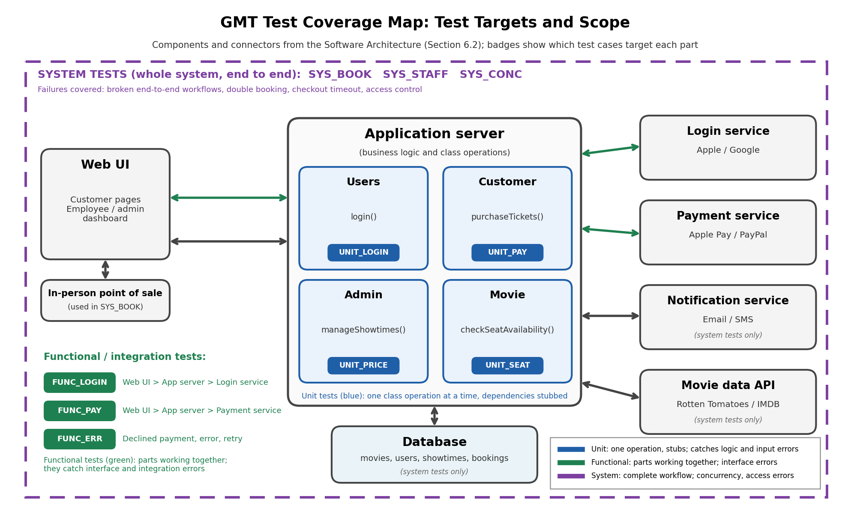

Figure 7.1: Test coverage map
7.2.3 Coverage of the Functions Listed in 7.1.2
Function listed in 7.1.2 | Test cases that cover it
User login and account verification | UNIT_LOGIN, FUNC_LOGIN
Browsing movies, theaters and showtimes | SYS_BOOK
Ticket price verification and display | UNIT_PRICE, SYS_BOOK, SYS_STAFF
Seat availability and seat selection | UNIT_SEAT, SYS_BOOK, SYS_CONC
Reserving tickets and payment processing | UNIT_PAY, FUNC_PAY, FUNC_ERR, SYS_BOOK
Updated reservation information and seat availability on the website | FUNC_PAY, SYS_BOOK, SYS_CONC
Staff login and management of movies, showtimes and prices | UNIT_PRICE, SYS_STAFF
Account permissions and blocking unauthorized access | SYS_STAFF
Error handling for invalid input and unavailable services | UNIT_PRICE, FUNC_ERR, SYS_CONC

The 10 sample test cases do not cover every item in 7.1.2 (user registration and the system logs kept for maintenance personnel are not covered). A full test suite would add cases for them at the unit and functional levels.

7.3 GitHub Link
https://github.com/MadisonStevens98/CS250-04-Fall2026/tree/8ce3fd59322fa7164c7ec2d3bea718dcc51bdf4d/SDSFolder

A. Appendices
Appendices may be used to provide additional (and hopefully helpful) information. If present, the SRS should explicitly state whether the information contained within an appendix is to be considered as a part of the SRS’s overall set of requirements.

Example Appendices could include (initial) conceptual documents for the software project, marketing materials, minutes of meetings with the customer(s), etc.

A.1 Appendix 1

A.2 Appendix 2

