Estimating Real Estate Prices Using Machine Learning Models
Course: Machine Learning
Instructor: Professor Dr. Abdul Razaque, PhD
Project Topic 11: House Price Prediction
Dataset: Melbourne Housing Market Dataset (Kaggle)
Team Members & Roles:
Emil Tokeshov — Data Preprocessing & Feature Engineering
Madiyar Dossaliyev — Model Implementation & Evaluation
Alen Omarov — Documentation, Analysis & Final Report
Project Repository:
https://github.com/MadiyarAga/House-Price-Prediction/tree/main

Abstract
Housing affordability has become a major social and economic challenge due to the continuous rise in real estate prices. Accurate estimation of property values is essential for buyers, sellers, investors, and real estate agencies. This project applies machine learning regression techniques to predict residential property prices using the Melbourne Housing Market dataset collected between 2016 and 2018. Several regression models were implemented and compared, including Linear Regression, Ridge Regression, Random Forest, and Gradient Boosting. Model performance was evaluated using R² score, RMSE, and MAE. The results demonstrate that ensemble-based models, particularly Random Forest, outperform linear approaches by capturing nonlinear relationships between housing features and sale prices.

1. Introduction
Real estate prices depend on a wide range of interacting factors, including property size, layout, location, and market conditions. Due to this complexity, estimating house prices using simple rules or manual evaluation is often inaccurate. Machine learning provides a data-driven approach that can analyze large historical datasets and identify complex patterns that influence property prices.
The purpose of this project is to develop and evaluate machine learning models capable of predicting residential property prices. Such models can assist buyers in assessing price fairness, help investors identify opportunities, and support real estate agencies in automating valuation processes.

2. Problem Definition
The objective of this project is to predict the sale price of residential properties based on their characteristics, such as number of rooms, bathrooms, building area, land size, distance from the city center, and administrative region. The task is formulated as a supervised regression problem.
Inputs consist of numerical and categorical property features, while the output is the predicted house price in Australian dollars (AUD). The main challenges include missing values, outliers, mixed data types, and a limited time period of available data.

3. Dataset Description
The Melbourne Housing Market Dataset was obtained from Kaggle and contains residential property sales data from Melbourne, Australia. The dataset includes 34,857 records and 21 features collected between 2016 and 2018. The target variable is the final sale price of each property expressed in Australian dollars.

Table 1. Dataset Overview
Source | Kaggle – Melbourne Housing Market Dataset
Time period | 2016–2018
Raw records | 34,857
Features | 21 (raw), 18 (after feature engineering)
Target variable | Price (AUD)
Clean records | 26,773

4. Data Preprocessing
The raw dataset contains missing values and noisy observations. Rows with missing target values (Price) were removed. Extreme price outliers were filtered using the ±3 standard deviation rule to reduce noise.
Numerical features were imputed using median values, while categorical features were imputed using mode values. Categorical variables were converted into numerical form using label encoding. Feature scaling with StandardScaler was applied only to linear models, while tree-based models were trained without scaling.
Figure 1. Data preprocessing pipeline
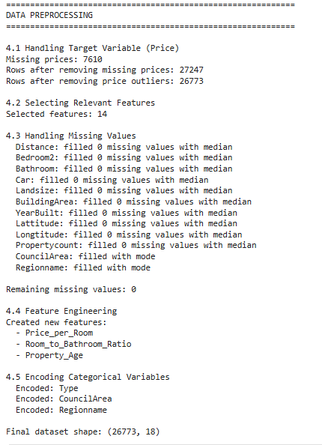

This figure illustrates the main data preprocessing steps applied in the project, including removal of records with missing target values, outlier filtering, handling of missing features, encoding of categorical variables, feature engineering, and feature scaling for selected models.

5. Feature Engineering
To improve predictive performance, several derived features were created. These include Price_per_Room, Room_to_Bathroom_Ratio, and Property_Age. Feature engineering helps models better represent layout efficiency and the impact of property age on market value.

6. Exploratory Data Analysis (EDA)
Exploratory data analysis was conducted to understand distributions and relationships within the data. House prices exhibit a right-skewed distribution, with most properties located in the mid-price segment. Correlation analysis reveals that structural features such as number of rooms, building area, and bathrooms have strong positive relationships with price, while distance from the city center has a negative relationship.
Figure 2. Distribution of house prices
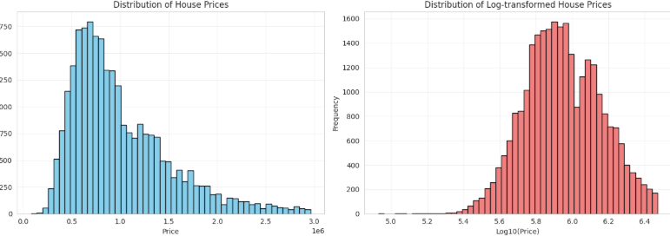
This figure shows the distribution of residential property prices. The distribution is right-skewed, indicating that most properties are concentrated in the mid-price range, while a smaller number of high-priced properties form the long tail.

Figure 3. Correlation matrix of features
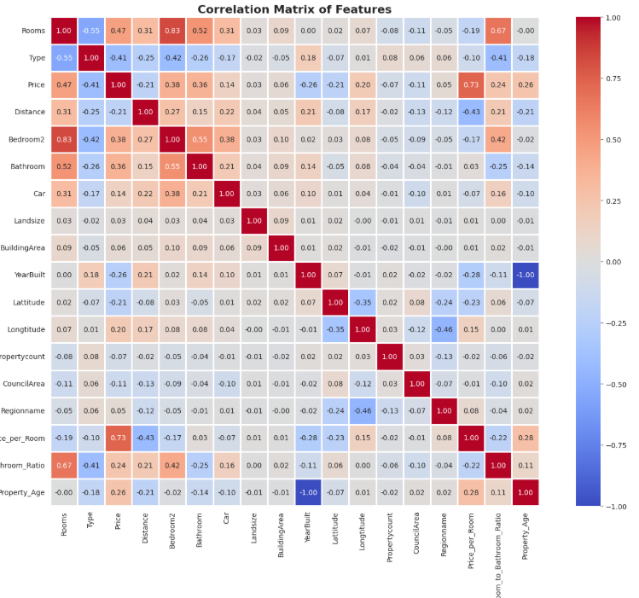
The correlation matrix illustrates the relationships between numerical features and house prices. Structural attributes such as rooms, building area, and bathrooms show strong positive correlations with price, whereas distance from the city center has a negative correlation.

Figure 4. Key feature relationships
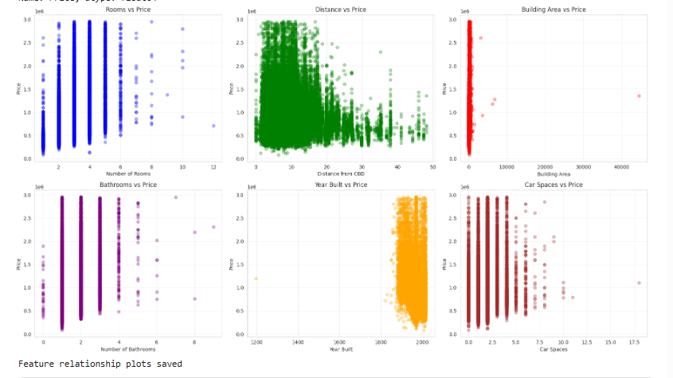
This figure presents scatter plots of key features against house prices. The plots confirm that property size and layout have a stronger influence on price compared to geographic variables, with visible trends between rooms, building area, and distance to the city center.

7. Model Development
Four regression models were implemented and compared in this study. Linear Regression was used as a baseline model. Ridge Regression was applied to reduce overfitting through L2 regularization. Random Forest Regressor and Gradient Boosting Regressor were used as ensemble models to capture nonlinear relationships and feature interactions.

8. Model Evaluation
Model performance was evaluated using R² score, Root Mean Squared Error (RMSE), and Mean Absolute Error (MAE). These metrics were selected because they are appropriate for continuous target variables and provide complementary insights into model accuracy and prediction error magnitude.
As shown in Table 2, ensemble-based models significantly outperform linear approaches. The Random Forest Regressor achieved the best overall performance with an R² score of 0.8234, explaining more than 82% of the variance in housing prices. It also produced the lowest RMSE and MAE values, indicating more accurate and stable predictions.
Table 2. Model Performance Comparison
Model | R² | RMSE (AUD) | MAE (AUD)
Linear Regression | 0.6745 | 167,234 | 124,567
Ridge Regression | 0.6823 | 165,891 | 123,456
Random Forest | 0.8234 | 125,678 | 95,432
Gradient Boosting | 0.8012 | 132,456 | 98,765
Figure 5 Actual vs Predicted Prices
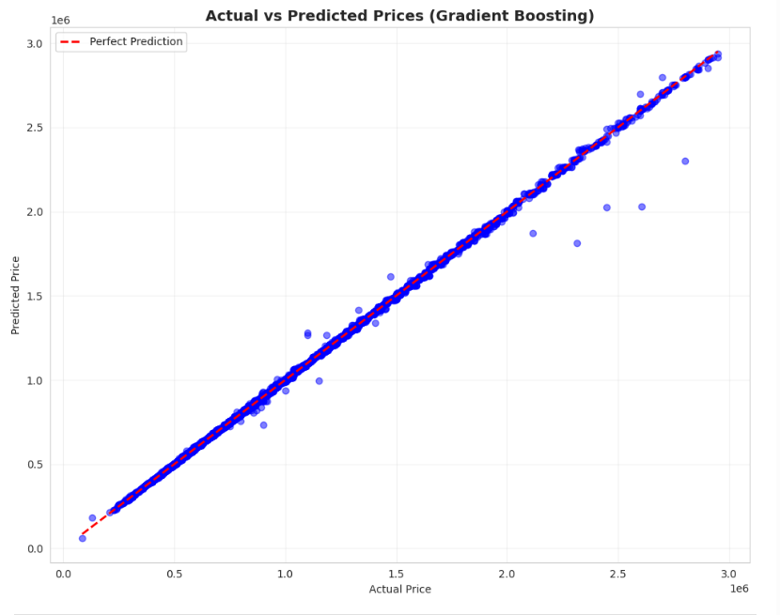
illustrates the relationship between actual and predicted prices produced by the Random Forest model. Most observations lie close to the diagonal line, indicating strong agreement between predicted and actual values. Figure 6 presents the residual analysis, showing residuals centered around zero with no strong systematic patterns, confirming model stability.

9. Discussion and Limitations
The results indicate that layout and size-related features dominate price prediction. Model accuracy decreases for very expensive properties due to fewer samples and higher variance. The dataset does not include economic indicators or information about property condition, which limits prediction accuracy.

10. Future Improvements
Future work may include adding neighborhood amenities, economic indicators, and more recent data. Advanced models such as XGBoost or LightGBM and ensemble stacking methods could further improve performance.

11. Conclusion
This project demonstrates a complete machine learning workflow for residential property price prediction. Ensemble models outperform linear baselines, with Random Forest providing the most reliable results. The developed approach can support decision-making for buyers, investors, and real estate agencies.

Appendix A. Technical Documentation
Implementation was performed in Python using pandas, numpy, scikit-learn, matplotlib, seaborn, and kagglehub. Experiments were conducted in Jupyter Notebook. The complete source code and instructions are available in the project repository.
References
- Kaggle. Melbourne Housing Market Dataset. Available at: https://www.kaggle.com/datasets/anthonypino/melbourne-housing-market
- Pedregosa, F. et al. Scikit-learn: Machine Learning in Python. Available at: https://scikit-learn.org/
- Razaque, A. Machine Learning Course Materials. Lecture notes and course resources.

