NIOS II On DE2-115 Set up Tutorial:

1. Download .zip file “name.zip”
2. Extract to desktop: 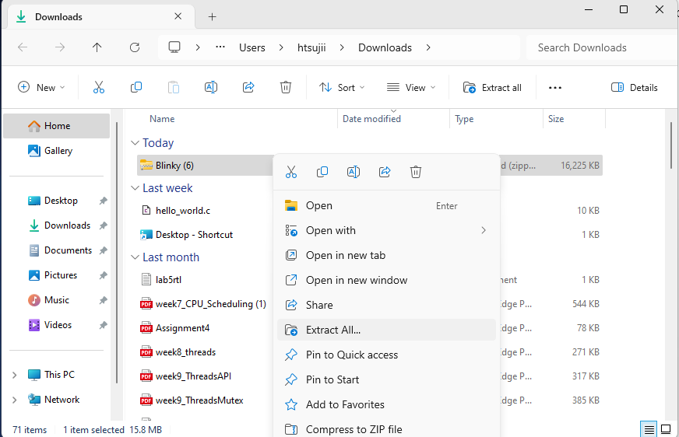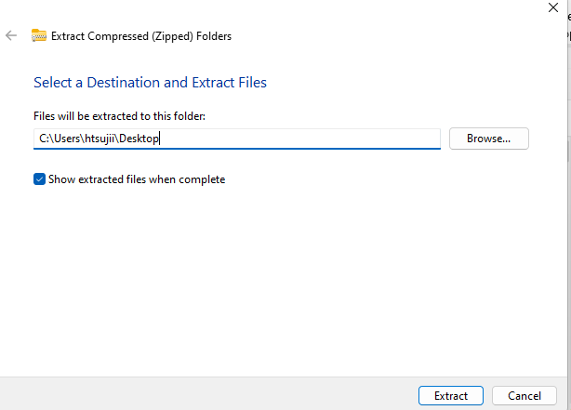
3. Open Quartus .QPF file: 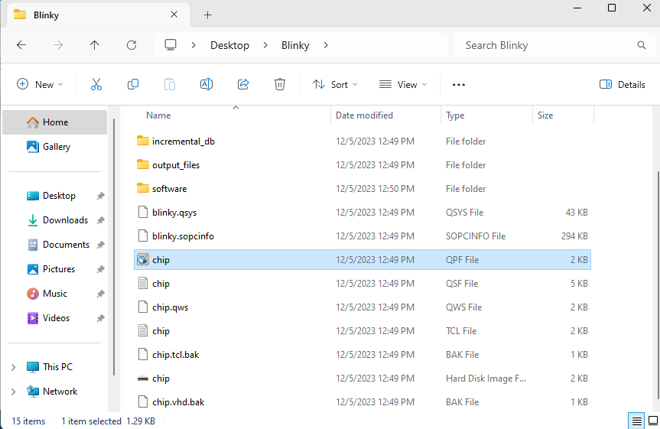
4. Use the included .SOF file to JTAG program the DE2-115 FPGA: 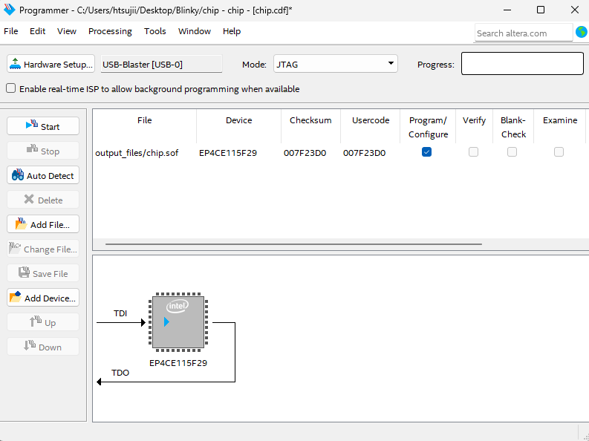
5. Open Eclipse:
6. In Eclipse click on file->Switch Workspace->Other…
7. Select Browse and navigate to the software folder in desktop and press ok: 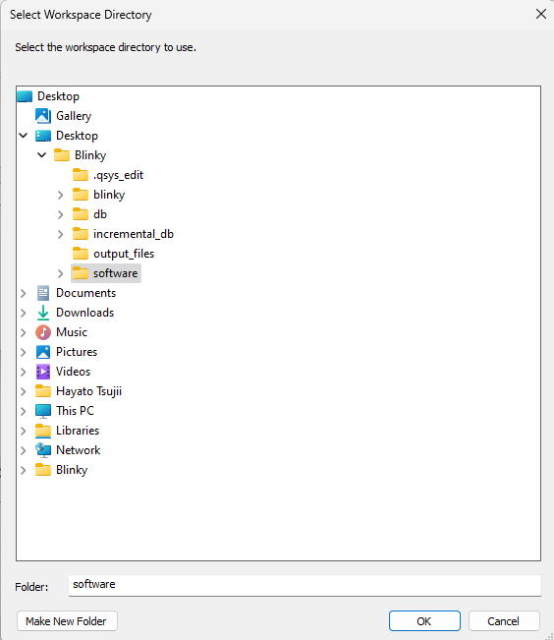
8. After Eclipse restarts, right click on the project explorer and select “import…”: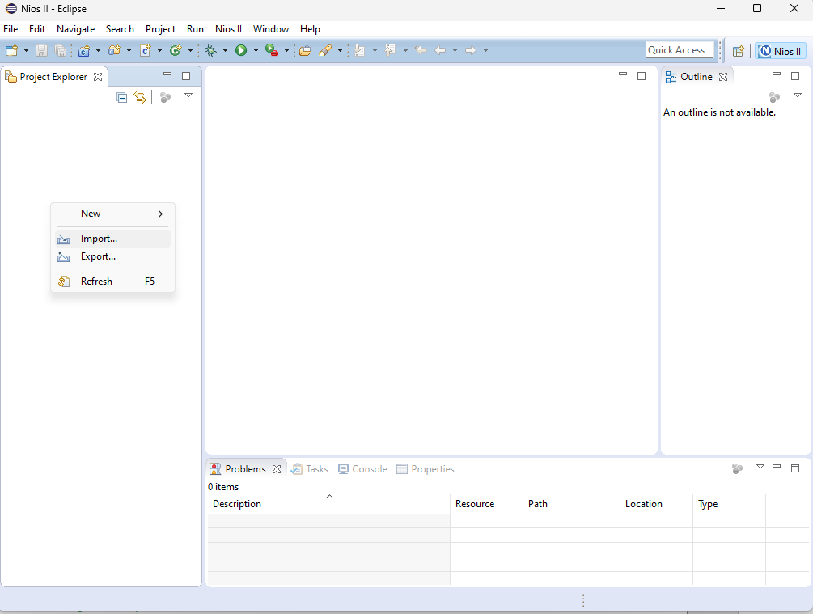
9. In General, select “Existing Projects into Workspace” then select next: 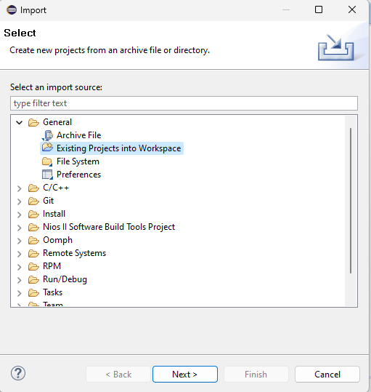
10. Select Browse and again select the software folder of the project that you unzipped: 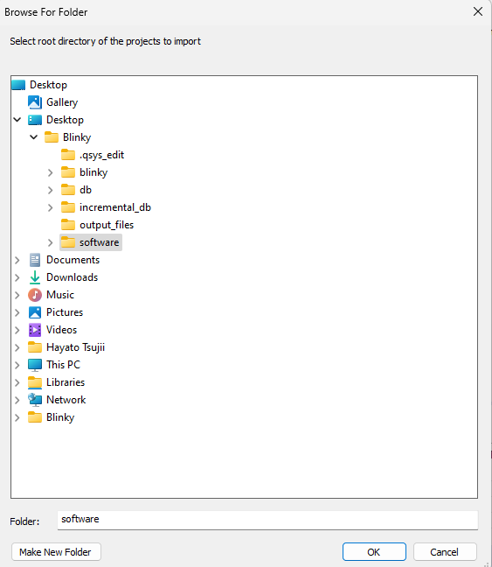
11. Press ok and then Finish.
12. Right click blinky-sw_bsp and select NIOS II-> generate BSP: 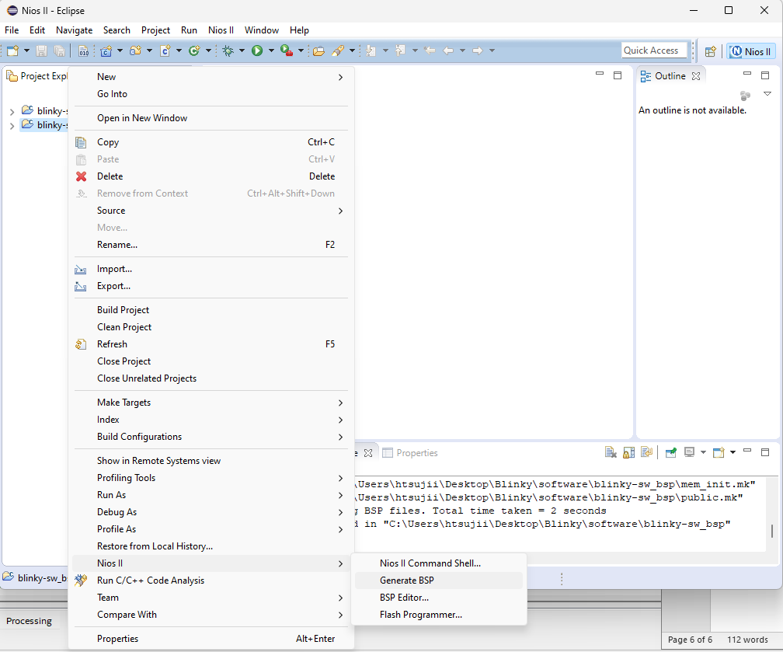
13. Right click blinky-sw_bsp and select build: 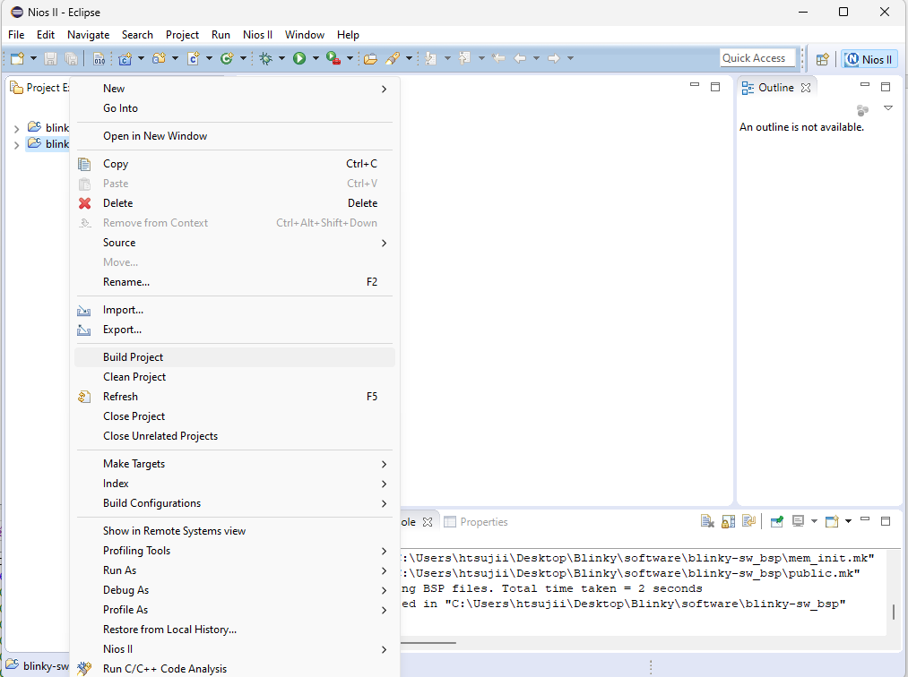
14. Wight clikc blinky-sw and select build: 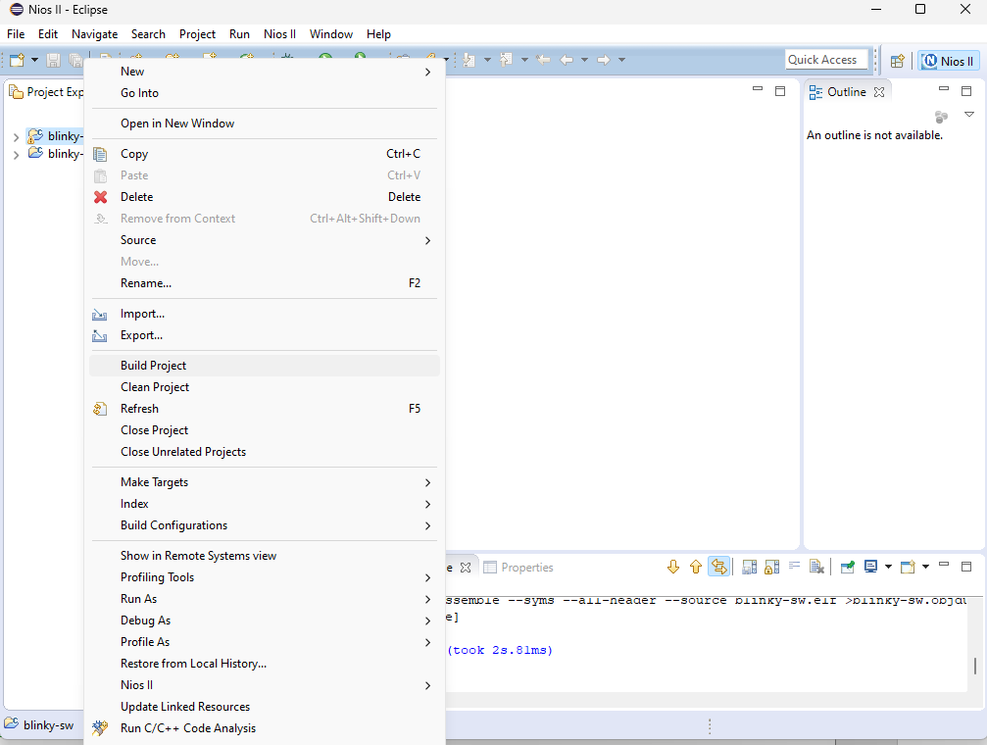
15. Right click blinky-sw and select Run As-> 3 NIOSII Hardware
16. Once you see “Initialization Done!” the project is ready to be used.

Notes For Issues:

* If error “no ELF found” please repeat steps 4-16.
* If any other error repeat steps 4-16.
* If the above fix does not work. Ensure that in the error menu that may pop up in “hardware configuration” tab check both boxes labelled “ignore mismatched base addresses” and “ignore mismatch time-stamps”