
Hosted Voice Solution
Simple cloud communications that grow with your business
A proposal prepared for Ship Cars Ltd

Prepared by Peter Hughes 17th September 2026
01325 647000 | blake-telecom.co.uk

One simple system for your whole team
Running a small business means doing a bit of everything. Your phone system should not add to the pile.
With a cloud platform, your calls, video meetings and team messages live together in one app. It works the same at your desk, at home or on the road.
That is what unified communications as a service, or UCaaS, gives you. There is nothing to install on site and no technical team to hire. We set it up, you plug in, and you are ready to talk.



What your team gets every day
 | Work from anywhere  Use one number on your desk phone, laptop or mobile, in the office or at home. |  | Video meetings  Meet colleagues and customers face to face, with screen sharing and room for up to 500 people.
 | Team chat  Message colleagues, share files and keep every conversation in one place. |  | Time saving AI  Automatic meeting summaries, live call transcription and clearer sound on every call.
 | Connects to your tools  Works with Microsoft 365, Microsoft Teams, Google Workspace, Salesforce, HubSpot and more. |  | Secure and dependable  Enterprise grade security, GDPR compliance and 99.999% uptime.

Built to grow with you
Small businesses rarely stay small. A cloud system grows at your pace, so you never pay for capacity you do not need and you never outgrow what you have.  Take on a new starter, open a second site or build a customer facing team, and your phones keep up. It is the same platform, the same app and the same friendly support throughout. | 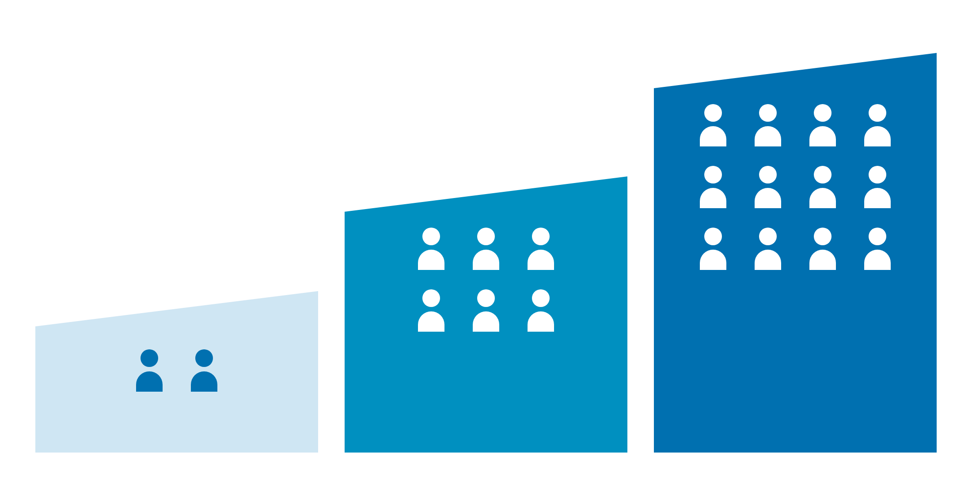

Start small. Begin with two users and a few handsets. We configure everything remotely, so you can be live in as little as 24 hours.
Add as you grow. Take on a new starter or open a new site, and add users and channels whenever you need them. There is no engineer visit and no new equipment.
Go further. When your customer facing team is ready, add a full contact centre to the same platform. Calls, email, web chat, SMS and social messages arrive in one workspace, with smart routing and live dashboards. There is no new supplier to find.

How we help you grow
- A free demonstration before you decide  - Remote setup and number transfer, handled by us  - A clear, itemised quote with nothing hidden | - A dedicated account manager, today and as you grow  - Phone service in over 50 countries  - Free apps for every user

Want to see it working?
We will show you the platform, the apps and the handsets, with no obligation. Call 01325 647000 and we will find a time that suits you.

Included with every licence
Every user gets the same full set of features. There is nothing to unlock and nothing to add later.

- Free desktop and mobile apps  - A professional welcome greeting  - Video meetings and team messaging  - A choice of AI voice or recording artist  - Call recording, free for 30 days  - Storage for up to 10 years, if you need it | - Voicemail sent to your inbox  - An auto attendant to route every call  - Music on hold  - Clear HD call quality  - Nuisance caller blocking  - Microsoft 365 and Google connections

On top of these, every licence includes more than 50 further features.

Room to grow: unified communications and contact centre
We supply one of the best known cloud communications platforms in the world, rated a leader by independent analysts for ten years in a row.  For every team member. HD voice, video meetings, team chat, file sharing, business SMS and voicemail to email in one app, on desk phones, computers, iPhone and Android.  For your customer facing team. Calls, email, web chat, SMS and social messages in one agent workspace, with smart routing, live dashboards, speech analytics and AI agent assist. Seats are priced per agent, based on the channels you need. | 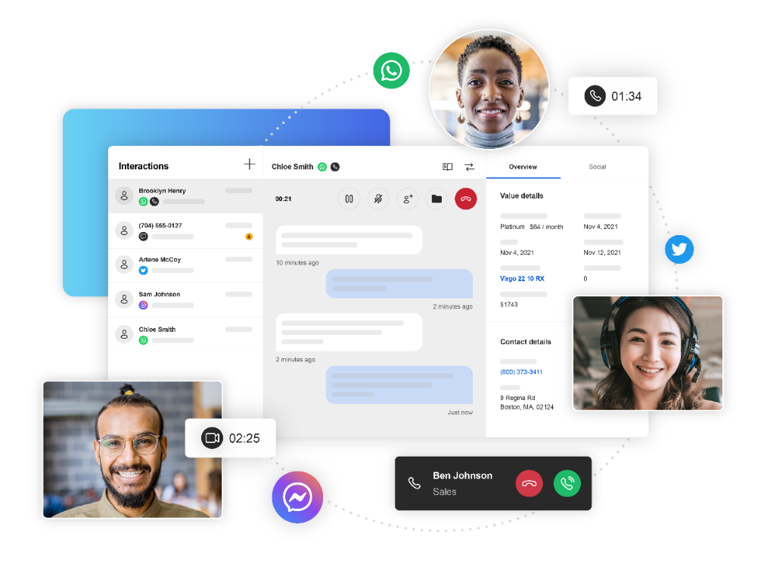

Choose your handsets
Every handset works with your cloud service from day one, and our team sets each one up before it is dispatched. Buy outright, or rent for a small monthly fee. Not sure which suits? Call 01325 647000 and we will recommend the right handset for each role.

Essential
Dependable phones for everyday use at every desk.
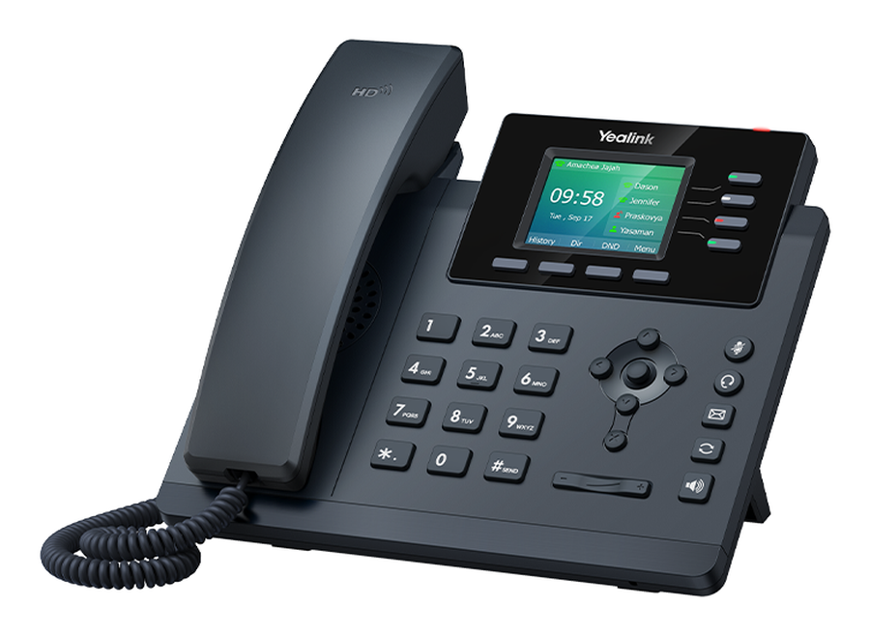 | Yealink SIP T34W  £90 to buy, or £3.95 a month to rent  A dependable colour screen phone for everyday use.  - Backlit 320 x 240 colour display  - Dual band WiFi, Gigabit Ethernet and Power over Ethernet  - USB port for a headset, with TLS 1.3 and WPA3 security  View the full specification
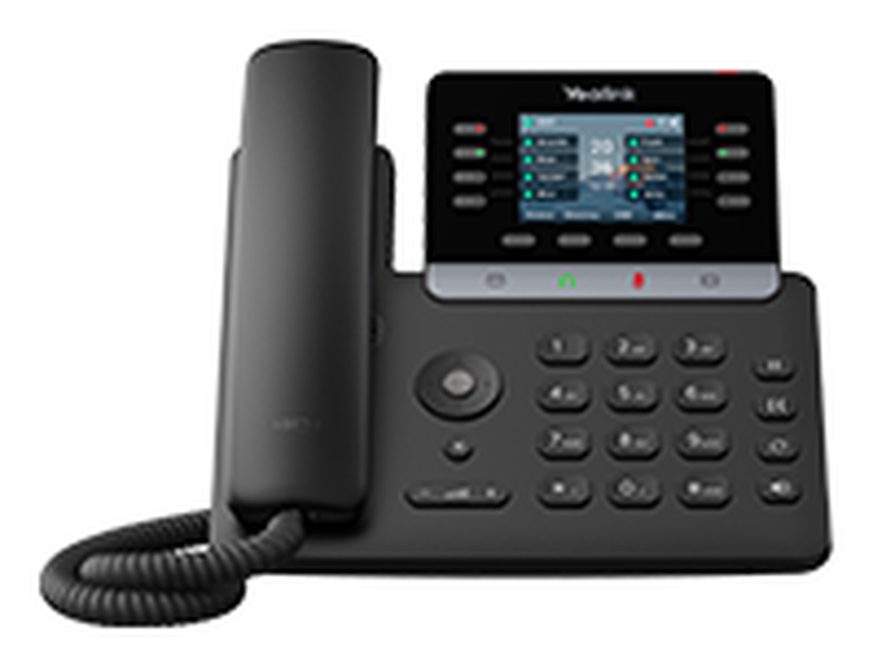 | Yealink SIP T73W  £99 to buy, or £4.00 a month to rent  A reliable, feature rich phone that suits every desk.  - 2.8 inch colour screen on an adjustable tilt stand  - Built in noise cancelling keeps every call crisp  - USB and EHS ports for headsets, plus WiFi and Bluetooth  View the full specification

Professional
Larger screens and extra connectivity for busier roles.
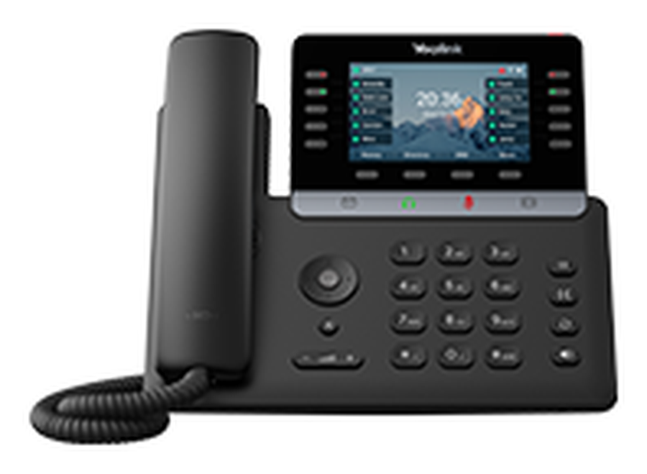 | Yealink SIP T74U  £127 to buy, or £4.60 a month to rent  A friendly, easy to read phone for busy desks.  - 4.3 inch colour screen with dark mode and several languages  - Call recording, intercom and a directory of up to 1,000 contacts  - Power over Ethernet. WiFi is available with our USB dongle  View the full specification
Yealink SIP T74W
£139.99 to buy, or £4.75 a month to rent
A smart, high end phone with a sharp high definition screen.
- Hall switch handset keeps the office quieter
- Wideband audio for natural sounding calls
- Bluetooth 5.0, dual band WiFi 6, and USB for headsets or recording
View the full specification
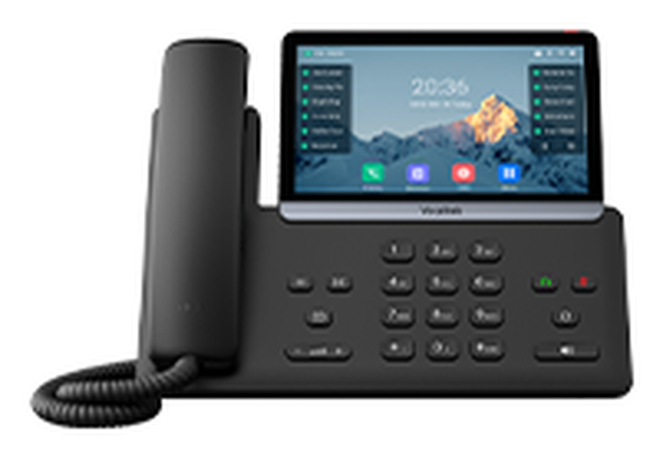 | Yealink SIP T77U  £181 to buy, or £6.20 a month to rent  A slimline phone that is effortless to use.  - 7 inch capacitive touch screen with backlight  - USB A and USB C ports to suit a modern desk  - Optima HD voice, WPA2 and TLS 1.3. WiFi is available with our USB dongle  View the full specification

Executive
Premium phones for people who live on the phone.
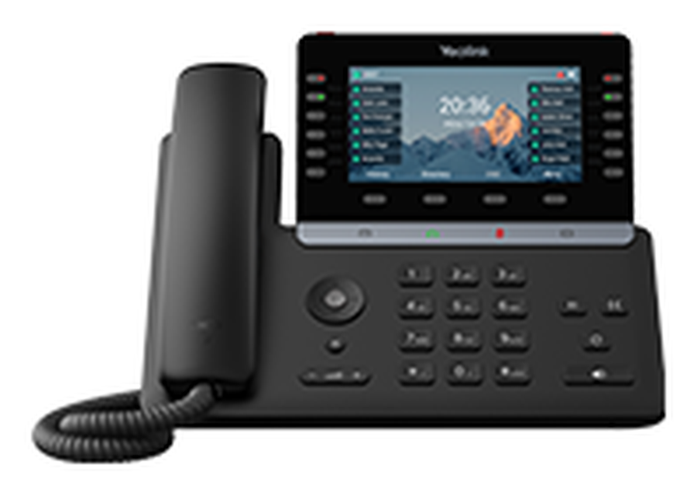 | Yealink SIP T85W  £145 to buy, or £6.50 a month to rent  Built for people who handle a lot of calls.  - 5.5 inch colour display (960 x 480) on a tilt stand  - 60 programmable buttons to shape the phone around your work  - Speakerphone, line status lights and Power over Ethernet  View the full specification
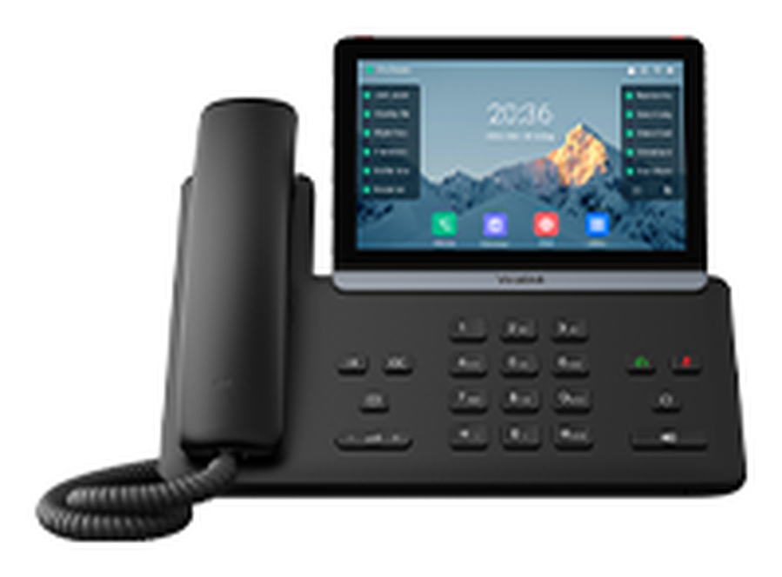 | Yealink SIP T87W  £199 to buy, or £7.50 a month to rent  The flagship of the range.  - 7 inch colour display (800 x 480) with HD Voice  - Desk or wall mounting, with up to 84 programmable functions  - Ethernet, WiFi or Bluetooth, and hearing aid compatible  View the full specification

Cordless handsets
Move around the building and never miss a call. Choose DECT or WiFi, whichever suits your site.
Cordless: DECT  Their own base station and wireless signal, separate from your WiFi. Ideal for warehouses, workshops, surgeries and shops. |  | Cordless: WiFi  They join the network you already have, with no base station and no extra cabling. Ideal for offices, hospitality and retail.
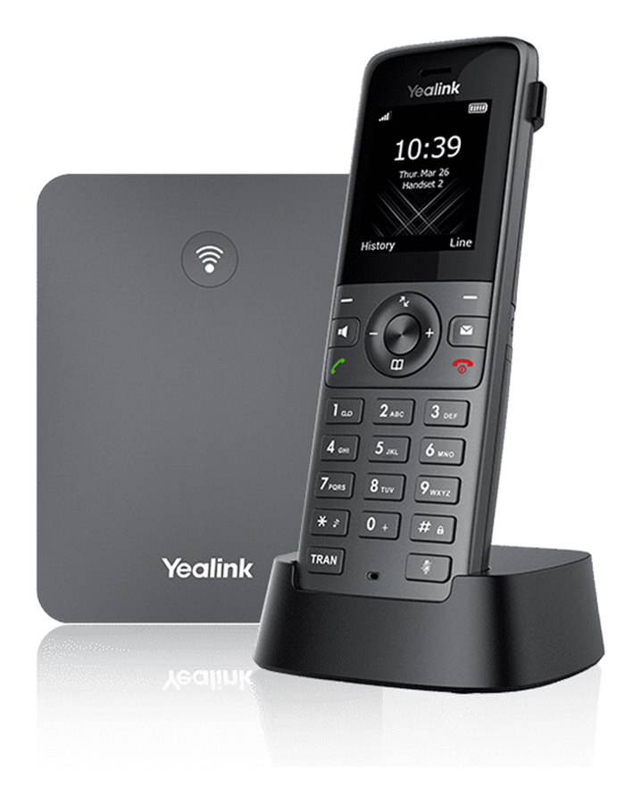  Yealink W73P DECT  £135 to buy, or £4.50 a month  A high performance cordless system for the whole building.  - Registers up to 10 W73H handsets from one base  - An ideal choice where there is no WiFi coverage  View the full specification |  | 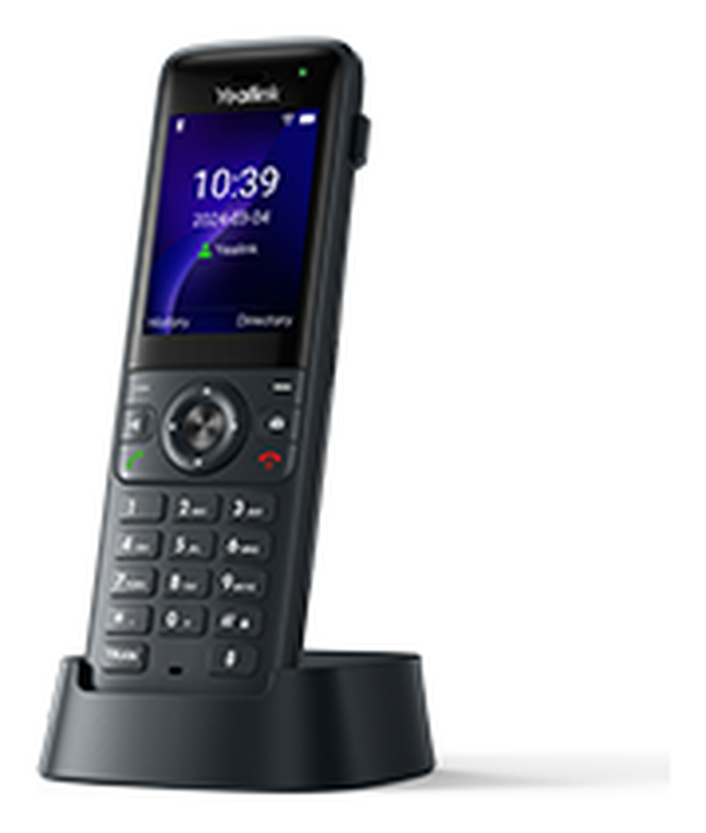  Yealink AX83H WiFi Handset  £99 to buy, or £4.00 a month  A WiFi handset that gives you freedom to move.  - Dual band WiFi 6, with up to 9 hours of talk time  - Up to 200 hours on standby from a 2000 mAh battery  View the full specification
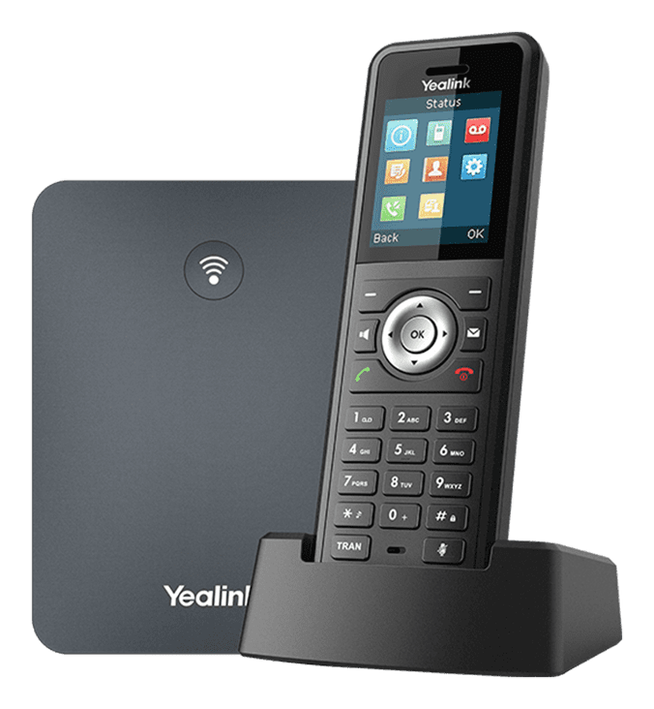  Yealink W79P DECT  £189 to buy, or £5.50 a month  A rugged cordless system for tough places.  - IP67 certified handset for dusty, humid and harsh conditions  - Registers up to 10 handsets, with Bluetooth and a vibration alarm  View the full specification |  | 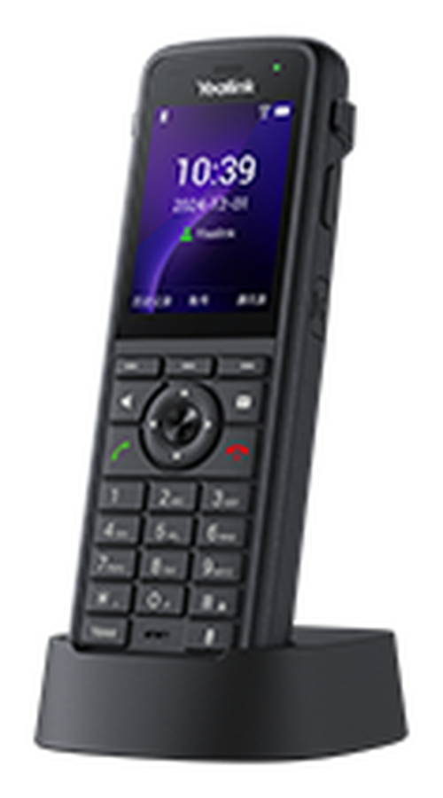  Yealink AX86R WiFi Cordless Phone  £155 to buy, or £5.00 a month  Made for demanding days.  - 780 minutes of talk time from a 3100 mAh battery  - Up to 300 hours on standby, with a 2.4 inch colour screen  View the full specification

Simple, clear pricing
One monthly licence for each person and one small setup charge. That is the core of your bill.

£12  per user, per month | One licence covers everything  - All 50+ business features  - Call recording for every user  - Unlimited UK calls to 01, 02, 03 and 07 numbers
£25  One off setup  Remote programming and engineering, done for you. | Free  Move your own handsets  Compatible handsets you already own can move to our platform at no charge.

Optional extras
Call queue service  An auto attendant with a queue, so important callers stay engaged while they wait. | £10  per month, per site
Professional recordings  A professional voice records your welcome message, on hold marketing, out of hours and voicemail messages. | £195  one off
AI voice recordings  Realistic AI voices record your welcome and night messages, and we show you how to change them any time. Demonstration on request. | £95  one off

Keeping your numbers
We apply to move your existing numbers to our platform, which takes around 14 days. While that happens we set up a temporary number, so you can divert your calls and never miss a customer.

Your own quote is itemised just as clearly. Prices are valid for 30 days and exclude VAT.

Fast business broadband
We have checked your local exchange, and your address can have a choice of FTTP speeds. Pick the one that suits your team. Every connection includes a static IP address and free installation.

Download | Upload | Installation | Monthly rental
80 Mbps | 20 Mbps | Free | £35.99
115 Mbps | 20 Mbps | Free | £38.99
220 Mbps | 30 Mbps | Free | £42.99
550 Mbps | 75 Mbps | Free | £49.99
1 Gbps | 115 Mbps | Free | £59.99

FTTP (Fibre to the Premises) brings pure fibre straight into your business, so your speed can grow with you, up to 1 Gbps download. Most companies now choose it for its flexibility. The monthly price includes the line, so there is no separate line rental.
Installation charges are subject to survey where required.

Business mobiles
We currently have unlimited business tariffs that beat the networks’ own prices. A fair usage policy applies abroad, and prices exclude VAT.
 | O2 SIM Only Small Biz Unlimited  £19.99 a month, then £23.99 after the first year | - Unlimited calls and texts  - Unlimited UK data  - EU roaming included
 | Vodafone SIM Only Unlimited  £19.99 a month, then £23.99 after the first year | - Unlimited calls and texts  - Unlimited UK data  - EU roaming included

About Blake Telecom
Blake Telecom is a local business communications company that supports customers across the UK. We have traded since 2004, and we offer SIP, VoIP, unified communications, hosted voice and data services, including Microsoft 365, along with many other products that keep your business talking. We are independent, so we recommend what fits your business, then agree a clear, itemised price with no hidden costs and no hard sell. | 

What our customers say
Darlington Farmers Auction Mart  “Blake Telecom has been paramount to the growth of our business by continuing to offer the very highest level of service. The equipment we have been supplied has been extremely flexible, allowing us to change with our needs. Blake Telecom’s knowledge and expertise have been very professional and we look forward to working together on our future projects.” |  | TD Jagger Property Consultants and Architects  “Blake Telecom have been supplying our business communications for well over 10 years. We have found both their systems and support to be fully robust and they have given excellent service throughout, with value for money for their products. Their approach to helping our business has always been excellent from every aspect and I would highly recommend their services.”

Ready to get started?
Call our team on 01325 647000 or visit blake-telecom.co.uk. We will arrange your demonstration and send a full, itemised quote.

Blake Telecom, 2 Peel Court, St Cuthbert’s Way, Darlington, Co Durham, DL1 1GB

