
Hosted Voice Solution
A proposal prepared for Echojet


Prepared by Peter Hughes
30th September 2026
01325 647000 | blake-telecom.co.uk

A phone system that works the way you do
Thank you for asking us to quote for your new telephone system. This proposal sets out a flexible cloud phone service, the handsets that go with it and exactly what each part costs.
Instead of a bulky box on the wall, your calls, messages and meetings run securely over the internet. There is no equipment to maintain and no engineer to book, and your team can work from the office, at home or on the move with the same number and the same features.

£12  per user, each month | £75  one off setup charge | 50+  features in every licence



Why businesses choose Blake Telecom
We have looked after UK businesses since 2004, and we stay independent so our advice always starts with what suits you. You get a dedicated account manager, clear pricing and a friendly team who answer the phone.

Everything included as standard
Every licence comes with a full set of business features. There is nothing to unlock and nothing extra to pay for.

✓ Desktop and mobile apps at no charge | ✓ A polished welcome greeting for callers
✓ Video meetings and team messaging | ✓ Your choice of AI voice or recording artist
✓ Call recording free for 30 days | ✓ Storage plans available for up to 10 years
✓ Voicemail sent straight to your email | ✓ Auto attendant to route every call
✓ Music on hold | ✓ Crisp HD call quality
✓ Nuisance caller blocking | ✓ Microsoft 365 and Google connections

On top of these, every licence includes more than 50 further features to explore.

See it in action
Would you like to try the platform, the apps and the handsets before you decide? Call 01325 647000 and we will arrange a demonstration at a time to suit you, with no obligation.

Getting started is simple
From choosing your phones to taking your first call, we handle the technical work for you.

1 | Choose your handsets  Browse the range on the next pages. You can buy each phone outright or rent it for a small monthly fee.
2 | Pick your licences  Pay one monthly licence for each person, and mix and match licence types to suit each role.
3 | We set everything up  We configure your system remotely, prepare your handsets in advance and move your existing numbers across.

Choose your handsets
Every handset below works with your cloud service from day one. Prices shown are to buy outright, or you can rent for the monthly fee listed.

Essential range
Dependable phones for everyday use at every desk.
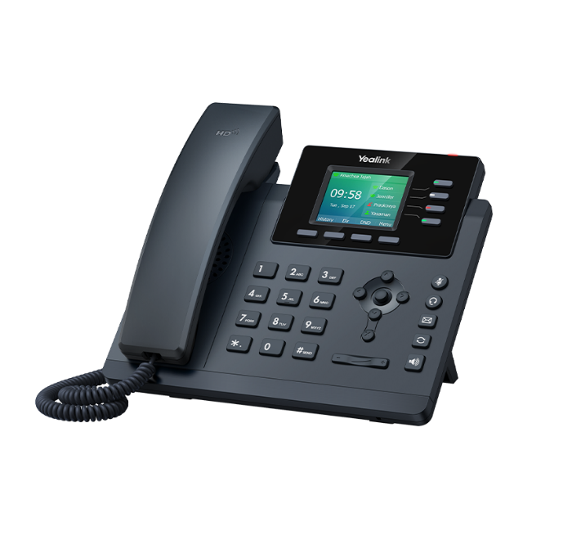 | Yealink SIP-T34W  £109 or £4.00 per month rental  The Yealink SIP-T34W is a high-performance, cost-effective colour screen Wi-Fi IP phone designed for enterprises. It features 320x240-pixel colour display with backlight, dual-band 2.4GHz & 5GHz Wi-Fi, dual-port Gigabit Ethernet with integrated Power over Ethernet (PoE) USB 2.0 port for headset connections. These capabilities combine to provide enterprises with an efficient and top-quality communication experience.  The T34W is shielded with the latest in security protocols, making your conversations more secure than ever. With TLS 1.3, you benefit from faster and more robust encryption, while WPA3 guards your network against emerging threats  Find out more: yealink.com/en/product-tech-specs/ip-phone-t34w
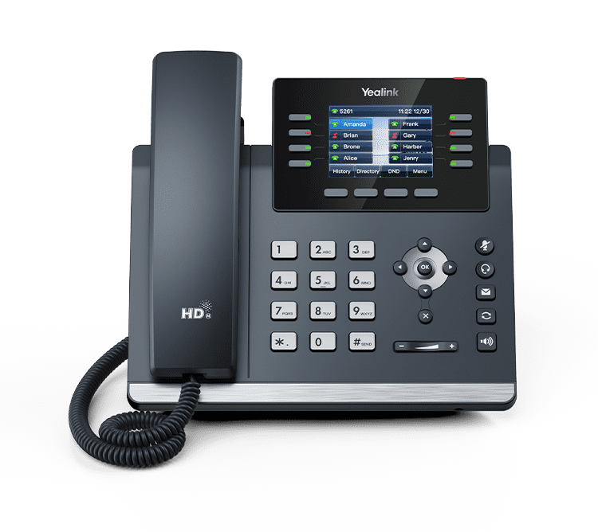 | Yealink SIP-T44W  £119 or £4.50 per month rental  With built-in Bluetooth 4.2 and dual-band 2.4G/5G WiFi, the SIP-T44W IP Phone ensures that you can keep up with modern wireless technology. Enjoy faster, hassle-free deployment with reduced cabling for a more attractive and efficient workspace.  Yealink Optima HD Voice technology combines cutting-edge hardware and software with wideband technology for maximum acoustic performance.  Features at a glance  - 2.8” colour LCD with backlight  - Optima HD voice with Acoustic Shield and Smart Noise Filtering  - Dual-port Gigabit Ethernet  - Built-in dual band 2.4G/5G Wi-Fi (802.11a/b/g/n/ac)  - Built-in Bluetooth 4.2  - Support USB recording  - Support expansion modules  - Headset, EHS support  - PoE support  - Stand with two adjustable angles, wall mountable  Find out more: yealink.com/en/product-detail/ip-phone-t44w

Professional range
Larger screens and extra connectivity for busier roles.
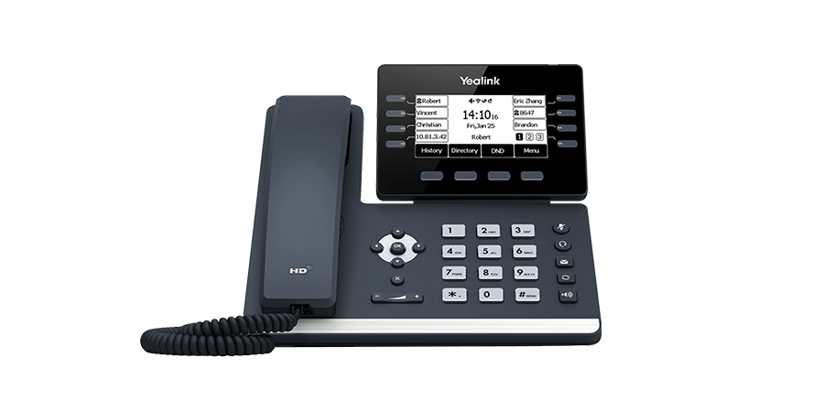 | Yealink SIP-T53W  £129 or £5.00 per month rental  Especially designed for busy executives and professionals, the Yealink SIP-T53W is an easy-to-use Prime Business Phone with an adjustable 3.7-inch graphical LCD that you can easily and flexibly find a comfortable viewing angle according to your personal and environmental needs. With built-in Bluetooth 4.2 and the built-in dual-band 2.4G/5G Wi-Fi, the SIP-T53W IP Phone ensures you to keep up with modern wireless technology and take the first chance in the future wireless age. The built-in USB 2.0 port allows for a direct wired/wireless USB headset or up to three Yealink EXP50 expansion modules connection. Benefitting from these features, the Yealink SIP-T53W is a powerful and expandable office phone that delivers optimum desktop efficiency and productivity.  Find out more: yealink.com/en/product-detail/ip-phone-t53w
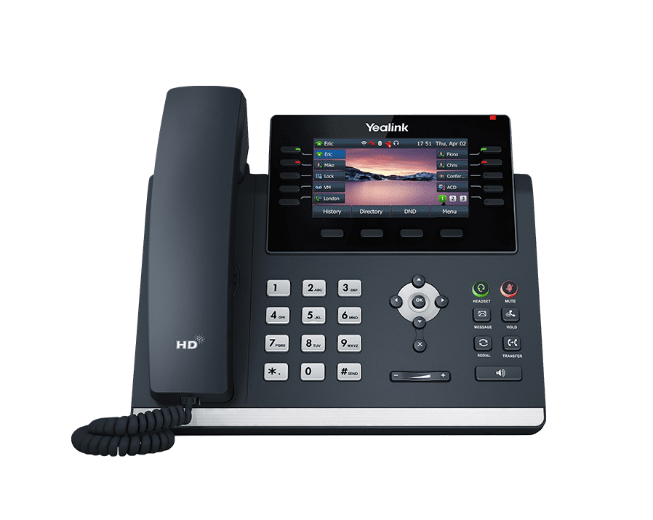 | Yealink SIP-T46U (no Wi-Fi)  £145 or £5.00 per month rental  The T4U series greatly improves the call experience and work efficiency with dual USB ports, Ultra HD sound quality, faster response speed, and even more advanced features. The T4U series will be a powerful assistant for modern business.  Yealink Optima HD Voice technology combines cutting-edge hardware and software with wideband technology for maximum acoustic performance.  Find out more: yealink.com/en/product-detail/ip-phone-t46u
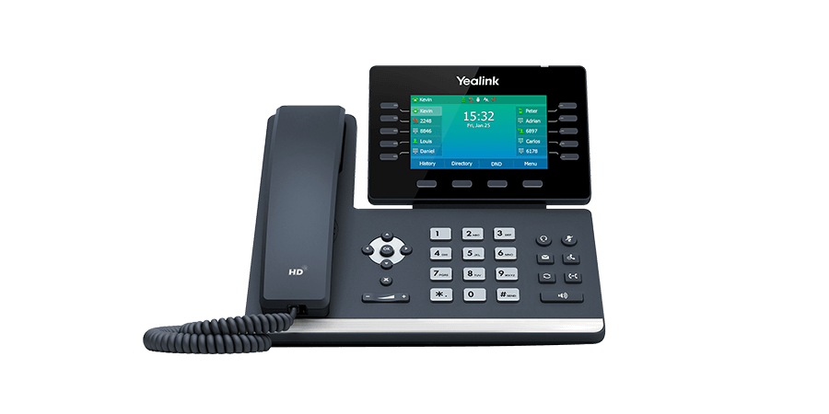 | Yealink SIP-T54W  £169 or £6.00 per month rental  Especially designed for busy executives and professionals, the Yealink SIP-T54W is an easy-to-use Prime Business Phone with an adjustable 4.3-inch colour LCD screen that you can easily and flexibly find a comfortable viewing angle according to your personal and environmental needs. With built-in Bluetooth 4.2 and the built-in dual-band 2.4G/5G Wi-Fi, the SIP-T54W IP Phone ensures you to keep up with modern wireless technology and take the first chance in the future wireless age. Its built-in USB 2.0 port allows for a direct wired/wireless USB headset. Benefitting from these features, the Yealink SIP-T54W is a powerful and expandable office phone that delivers optimum desktop efficiency and productivity.  Find out more: yealink.com/en/product-detail/ip-phone-t54w

Executive range
A premium look and feel for reception desks and senior teams.
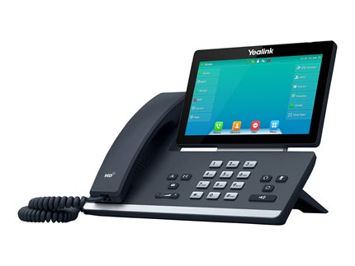 | Yealink SIP-T57W (Wi-Fi enabled)  £254 or £9 per month rental  Especially designed for busy executives and professionals, the Yealink SIP-T57W is an easy-to-use Prime Business Phone with an adjustable 7-inch multi-point touch screen that you can not only easily and flexibly find the comfortable viewing angle according to personal and environmental needs but also get a rich visual presentation and easy navigation with just one-touch. With built-in Bluetooth 4.2 and the built-in dual-band 2.4G/5G Wi-Fi, the SIP-T57W IP Phone ensures you to keep up with modern wireless technology and take the first chance in the future wireless age. Its built-in USB 2.0 port allows for a direct wired/wireless USB headset or up to three Yealink EXP50 expansion modules connection. Benefitting from these features, the Yealink SIP-T57W is a powerful and expandable office phone that delivers optimum desktop efficiency and productivity.  Find out more: yealink.com/en/product-detail/ip-phone-t57w
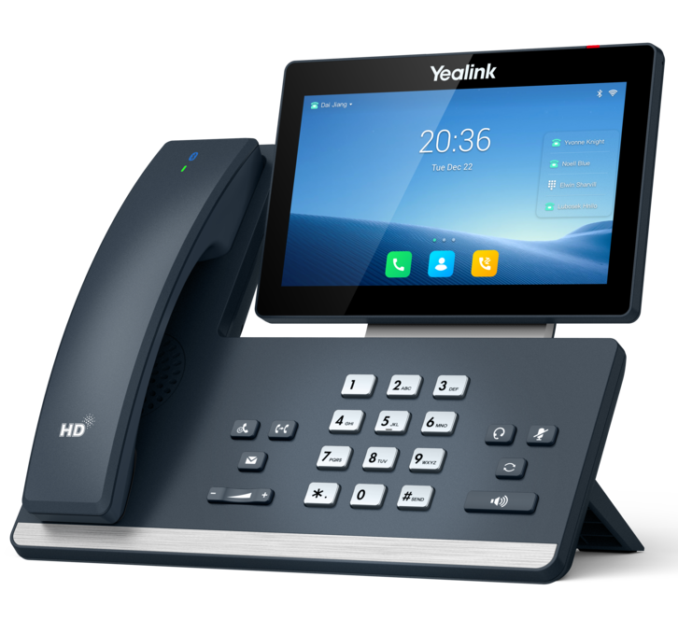 | Yealink SIP-T58W (Pro)  £289 or £12 per month rental  The Yealink SIP-T58W Pro is a simple-to-use smart business phone that provides an enriched HD audio and video calling experience for business professionals. This smart business phone enables productivity-enhancing visual communication with the ease of a standard phone. Pro means that this phone supports Yealink Bluetooth handset BTH58, with which users are free to move around when on a call - no more missed calls when they leave their desk. With a range of up to 10 meters (30 feet), the Yealink Bluetooth handset offers more office flexibility for users. Based on the Android 9.0 operating system, the SIP-T58W Pro adopts an innovative user interface, which is more concise and business, greatly improving user’s work efficiency. Furthermore, the SIP-T58W Pro integrates with IP video intercom systems from major vendors in the market, delivering true cost-efficiency to customers  Find out more: yealink.com/en/product-detail/ip-phone-t58w

Cordless range
The freedom to move around the building and never miss a call.
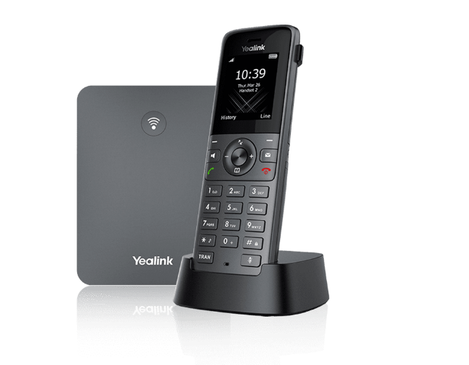 | Yealink W73P DECT  £145 or £4.50 per month rental  Combining the dedicated DECT handset W73H and the powerful base station W70B, Yealink W73P is a new cordless IP Phone system with high performance and optimised user experience for enhancing productivity in mobile working and wireless communication. Yealink’s new W73P embraces upgraded hardware, acoustic algorithm, as well as enhanced computing capacity and signal strength, providing faster response and HD audio with exceptional clarity and stability even in poor network conditions. Especially for workers of complex environments, the system also delivers noise-free conversations with a larger volume. In addition, the power efficiency and battery life are improved for amplifying flexibility and mobility by supporting up to 35 hours of talk time and 400 hours of standby.  Find out more: yealink.com/en/product-detail/dect-phone-w73p
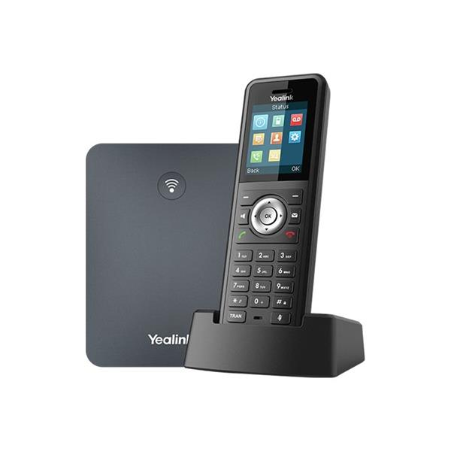 | Yealink W79P  £189 or £5.50 per month rental  For certain environments with special demands or challenges, a robust and ruggedized DECT phone system can be rather important and inevitable to enable flexible mobile communication throughout the spaces. With the reliable IP67 certified handset W59R and enhanced DECT station, the Yealink W79P works as an ideal solution to offer supreme cordless telephony experience for workers in challenging workplaces such as factories, warehouses, construction sites, etc.  Ruggedized and Reliable Audio Solution with Full Mobile Flexibility. Designed to be an ideal cordless phone system in complicated environments, Yealink W79P is equipped with professional hardware, sophisticated acoustic technology and enhanced computing capacity, to deliver interruption-free and flexible mobile communication experience.  Facing the challenges like potential noise and risks in spaces such as warehouses, factories and hospital, the W79P is reliable and effective with industry-leading network and signal performance, exceptional audio clarity and remarkable power efficiency.  Find out more: yealink.com/en/product-detail/dect-phone-w79p

Clear, simple pricing
Your service is built from a small number of monthly licences, plus a single setup charge. Choose what you need now and add more as your team grows.

Licences and setup
Item | Price | What it covers
User licence | £12 per month | Every standard feature for one person
X4 licence | £34 per month | Adds the ability to listen in on and monitor calls
Setup | £75 one off | Remote engineering, plus moving your existing numbers to us

You can mix and match licences to suit each person. Basic music on hold is included at no cost, and we recommend a professional recording if you would like callers to hear about your services while they wait.

Keeping your existing numbers
We apply to transfer your current numbers to our platform, which normally takes around 14 days. While that happens we set up a temporary number, so you can divert your calls and carry on taking enquiries without a break.

What might you pay?
A team of five, each with a T34W handset on rental:
5 user licences at £12: £60 per month
5 T34W handsets at £4.00: £20 per month
Total: £80 per month, plus a one off setup charge of £75 in the first month.

Optional extras
Extra | Price | What you get
Call queue service | £10 per month, per site | An auto attendant with a call queue, so valued callers stay engaged while they wait. Priced per site, not per user.
Free UK calls | £10 per month, per site | Free local, national and mobile calls to UK numbers, for each site rather than each person.
Professional recordings | £195 one off | A professional artist records your welcome, on hold marketing, out of hours and voicemail messages. You own the recording, and there is no monthly fee. Examples on request.
AI voice recordings | £95 one off | Realistic AI voices record your messages for you, and we show you how to change them whenever you like. Demonstration on request.

Prices are held for 30 days and exclude VAT.

Connectivity to match

Business broadband
Would faster internet help your new phone system and your team? We supply the latest business broadband, with speeds of up to 1Gbps. Just let us know and we will put a tailored quote together.

Business mobiles
We currently have unlimited SIM only deals that beat the networks’ own prices, so you can bring your mobiles under one roof.

 | O2 Small Biz Unlimited  £19.99 per month | ✓ Unlimited calls and texts  ✓ Unlimited UK data  ✓ EU roaming included*
 | Vodafone Unlimited  £21.99 per month | ✓ Unlimited calls and texts  ✓ Unlimited UK data  ✓ EU roaming included*
 | Three Unlimited (UK only)  £15.99 per month | ✓ Unlimited calls and texts  ✓ Unlimited UK data  ✗ No EU roaming
 | EE Unlimited  £27.99 per month | ✓ Unlimited calls and texts  ✓ Unlimited UK data  ✓ EU roaming included*

*Fair usage policy applies abroad. Prices exclude VAT.

About Blake Telecom
Blake Telecom is a Darlington based business communications company, supporting customers across the UK since 2004. We provide hosted voice, SIP, unified communications and data services, together with Microsoft 365 and a wide range of products designed to keep your business talking.
We take time to understand how you work, then recommend the right fit without hidden costs or a hard sell. Many of our customers have stayed with us for years, and we think that says it best.

What our customers say
Darlington Farmers Auction Mart
“Blake Telecom has been paramount to the growth of our business by continuing to offer our business the very highest level of service. The equipment we have been supplied has been extremely flexible allowing us to change needs. Blake Telecom’s knowledge and expertise have been very professional and we look forward to working together on our future projects.”

TD Jagger Property Consultants and Architects
“Blake Telecom have been supplying our business communications for well over 10 years. We have found both their systems and support to be fully robust and they have given excellent service throughout with value for money for their products. Their approach to helping our business has always been excellent from every aspect and I would highly recommend their services”

Ready to get started?
Call 01325 647000 or visit blake-telecom.co.uk and we will arrange your demonstration and a full, itemised quote.

Blake Telecom, 2 Peel Court, St Cuthbert’s Way, Darlington, Co Durham, DL1 1GB

