
Leased Line Solutions
A proposal prepared for [Client name]


Prepared by Peter Hughes
30th September 2026
01325 647000 | blake-telecom.co.uk

Connectivity your business can count on
Every email, video meeting, cloud file and customer call depends on one thing: your internet connection. When it slows down or drops, work slows down with it.
A leased line is a private fibre connection built for your business alone. Nobody shares it with you, so the speed you order is the speed you get, at every hour of the day, in both directions.
At Blake Telecom we have been connecting UK businesses since 2004. We are independent, so we compare the leading carriers for you and recommend the circuit that genuinely fits, rather than the one we happen to be tied to.

What a business leased line gives you
✓ Dedicated bandwidth that is never shared | ✓ Matching upload and download speeds
✓ Fast, stable connection for cloud and video | ✓ Scales from 10Mbps to 10Gbps and beyond
✓ Static IP addresses for remote access and hosting | ✓ Proactive monitoring and priority fault handling
✓ One UK account manager for everything | ✓ Optional backup line to keep you online

Did you know?
Most business broadband is shared with hundreds of neighbours and is slowest in the busiest hours of the working day. A leased line is uncontended, which means your bandwidth is reserved for you and stays steady, even at peak times.

Leased line or broadband?
Broadband is a sensible choice for smaller teams with light needs. Once you rely on cloud software, hosted telephony, video calls or large file transfers, the differences start to matter. Here is how the two compare.

 | Business broadband | Leased line
Bandwidth | Shared with other customers | Dedicated to your business alone
Upload speed | Usually a fraction of download | Matches your download speed
Consistency | Can slow at busy times | Steady speed around the clock
Connection type | Copper or part fibre | Pure fibre optic, end to end
Support | Standard fault handling | Priority fault handling and monitoring
IP addresses | Often changes | Fixed static addresses available
Best suited to | Small teams and light use | Growing teams, cloud and voice, multiple sites

If you already use, or are planning, a hosted voice system, a leased line is the natural partner. Voice calls need a steady flow of data, and a dedicated circuit keeps every conversation clear, even while colleagues are on video meetings and uploading files.

Our leased line services
We offer a full range of dedicated connectivity, designed around the way your business works.

Ethernet leased line  Our most popular service. A dedicated fibre internet connection with symmetrical speeds, ideal for offices that depend on the cloud, video and hosted telephony. |  | Point to point circuits  A private link between two or more of your sites. Share files, systems and phones across locations as if everyone were in the same building.

Resilient dual circuits  Two separate routes into your building, so if one is ever interrupted the other carries on. Built for businesses that cannot afford to stop. |  | Managed router and firewall  We supply, configure and look after your router and security, so your new circuit is protected from day one and you have one team to call.

Speeds to suit your team
Bandwidth is matched to the way you work today, with room to grow. We can upgrade your circuit as your business expands, often without changing the fibre.
Speed | Ideal for
50Mbps to 100Mbps | Small offices with cloud software, video calls and hosted voice
200Mbps to 500Mbps | Busy teams, large file sharing, backups and several video meetings at once
1Gbps | Growing businesses, multi site networks and heavy cloud use
10Gbps and above | Data intensive organisations, hosting and high volume workloads

Keep working, whatever happens
A fast connection is only half the story. The other half is staying connected. We build resilience into your service so that one problem never becomes a whole day of lost work.

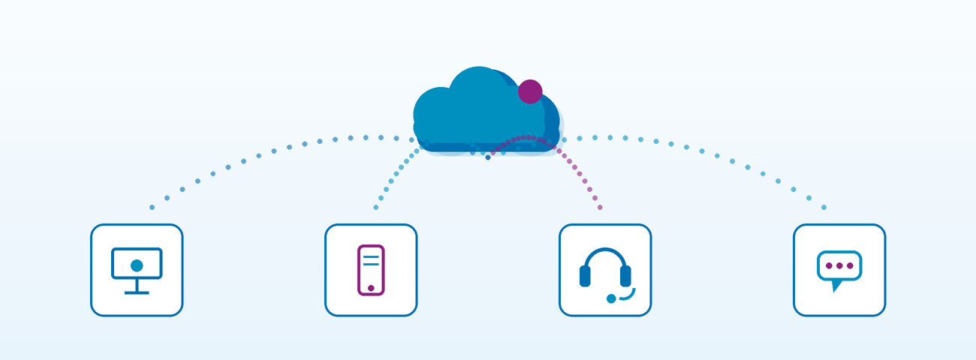

Protection at every level
✓ Mobile backup: automatic 4G and 5G failover keeps calls and email flowing | ✓ Dual circuits: two diverse fibre routes for the highest resilience
✓ Proactive monitoring: we spot issues, often before you do | ✓ Priority repairs: faults are escalated to the carrier straight away
✓ Managed security: firewall protection configured and maintained for you | ✓ UK based support: real people who know your setup

Preparing for the telephone network switch off
The UK is retiring its traditional analogue and ISDN phone lines. A leased line paired with a Blake Telecom hosted voice system moves you across smoothly, keeps your existing numbers and gives you a modern, future ready platform.

Who benefits most?
Leased lines make the biggest difference wherever people, data and customers depend on a fast, reliable connection. We regularly help:

Professional services  Solicitors, accountants, architects and consultants sending large documents and holding video meetings with clients all day. |  | Manufacturing and logistics  Sites that run cloud based stock, ordering and scheduling systems and cannot afford delays on the shop floor or the warehouse.

Healthcare and education  Surgeries, practices and schools that rely on secure access to online records, learning platforms and video. |  | Retail and hospitality  Businesses taking card payments, running tills and booking systems and offering guest connectivity across more than one site.

Growing and multi site teams  Companies adding staff, opening new premises or moving to hybrid working and needing one connected network. |  | Creative and digital businesses  Agencies and studios uploading and sharing large media files and working with clients and partners in the cloud.

From first call to go live
We manage the whole process, so you do not have to chase carriers or engineers. Here is what to expect.

1 | Free coverage check  Give us your postcode and we check which fibre routes and speeds are available at your address, across the leading UK carriers.
2 | Clear, itemised quote  You receive a straightforward quote setting out exactly what is included, with no hidden extras and no hard sell.
3 | Survey and order  Where needed, the carrier surveys your premises so the route into the building is confirmed before anything is built.
4 | Build and installation  The fibre is brought to your premises and we install and configure your router, firewall and any backup, then test everything.
5 | Go live and ongoing care  We switch you over at a time that suits you, then monitor the service and stay on hand through your dedicated account manager.

Build times depend on your location and the route required, and we keep you updated at every stage. Installation charges are subject to survey. All prices exclude VAT.

Your questions answered

What is a leased line?
A leased line is a dedicated fibre connection between your premises and the internet or another of your sites. The capacity is reserved for your business only, so it stays fast and consistent.

Is a leased line the same as fibre broadband?
No. Fibre broadband is shared with other customers and usually offers much slower uploads. A leased line is uncontended, offers matching upload and download speeds and includes stronger support.

How fast can a business leased line be?
Speeds typically range from 10Mbps to 10Gbps and beyond. We help you choose a sensible starting point and can increase it as you grow.

What happens if my connection fails?
We monitor your line and escalate faults to the carrier immediately. For extra protection, add a mobile backup or a second circuit so your business stays online while a fault is repaired.

Can I keep my existing phone numbers?
Yes. We port your numbers across to our hosted voice platform, and set up a temporary number while the move is completed so you never miss a call.

Will a leased line work with cloud software and video calls?
Absolutely. Dedicated bandwidth is exactly what Microsoft 365, Google Workspace, video meetings and cloud telephony need to run smoothly.

About Blake Telecom
Blake Telecom is an independent business communications provider based in Darlington, supplying customers throughout the UK since 2004. Our portfolio covers dedicated data connectivity, hosted voice, unified communications, business mobiles and audio visual equipment, all from one friendly team.
Because we are not tied to a single network, we can shop the market on your behalf and recommend the service that fits your needs and your budget. Many of our customers have stayed with us for well over a decade, which tells you a great deal about how we look after them.

Ready for a faster, steadier connection?
Call 01325 647000 for a free coverage check and a no obligation conversation, or visit blake-telecom.co.uk.
We will tell you straight away which speeds are available at your address.

Blake Telecom, 2 Peel Court, St Cuthbert’s Way, Darlington, Co Durham, DL1 1GB

