 | Get your business connected with reliability today.  01325 647000 | blake-telecom.co.uk

Business broadband  proposal  FTTP and SOGEA, checked for your address. | 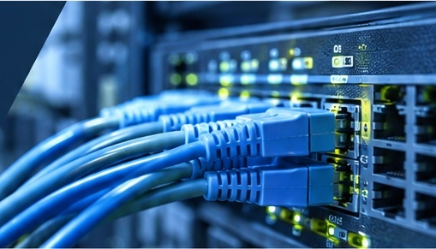
Prepared for Digital Devices by Peter Hughes | Postcode [ POSTCODE ]

Two ways to get connected
We have tested your local exchange. Two connection types are available to your business, and both give you dependable, business grade broadband.
FULL FIBRE  FTTP  Fibre to the Premises. Pure fibre brought directly into your business.  - Download speeds of up to 1Gbps  - Your speed can grow as you wish  - Better SLAs and more flexibility  - Chosen by most companies now installing |  | FIBRE AND COPPER  SOGEA  Delivered on a copper cable from the cabinet in your street.  - Joins the fibre network at the cabinet  - The line is included in the rental price  - No additional line rental charges  - A dependable option where full fibre is not yet available

  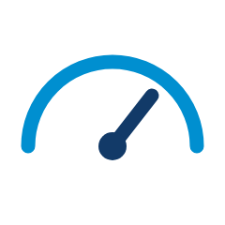 | A choice of speeds  From 80Mbps up to 1Gbps on FTTP.
   | Static IP address  Included with every connection.
   | Room to grow  Move up a speed as your business grows.
   | Checked for your address  We test your exchange before we quote.

From choice to connection
1  Choose your speed  Pick the connection that suits your team from the tables overleaf. |  | 2  We arrange installation  An engineer visit brings the connection into your premises, and we keep you updated. |  | 3  You are connected  We test the service and stay on hand through your account manager.

Get your business connected with reliability today.
01325 647000 | blake-telecom.co.uk

FTTP prices
Fibre to the Premises. Choose the speed that suits your team.
Download speed | Upload speed | Installation | Monthly rental
80 Mbps | 20 Mbps | Free | £35.99 a month
115 Mbps | 20 Mbps | Free | £38.99 a month
220 Mbps | 30 Mbps | Free | £42.99 a month
550 Mbps | 75 Mbps | Free | £49.99 a month
1 Gbps | 115 Mbps | Free | £59.99 a month

SOGEA prices
Delivered on copper from your street cabinet. The line is included in the rental.
Download speed | Upload speed | Installation | Monthly rental
[ speed ] | [ upload ] | [ price ] | [ price ]
[ speed ] | [ upload ] | [ price ] | [ price ]
[ speed ] | [ upload ] | [ price ] | [ price ]

Good to know
Static IP | Every connection comes with a static IP address.
Line rental | SOGEA rental includes the line, so there are no additional line rental charges.
Installation | Prices shown are for a brand new installation with an engineer visit. Installation is subject to survey where required.
Prices | All prices are monthly rentals and exclude VAT.

Ready to get connected?  Let our team arrange the right broadband connection for your business. | Arrange a no obligation consultation  01325 647000  blake-telecom.co.uk

