
Hosted Voice Solution
A proposal prepared for Highland House of Fraser

Prepared by Peter Hughes
1st October 2026
01325 647000 | blake-telecom.co.uk

Welcome to Blake Telecom
With more than 30 years of experience in communications, our portfolio has helped us become one of the UK’s leading independent providers of high speed data connectivity, hosted voice, audio visual equipment and business mobiles.
Because everything sits under one roof, our team is always on hand to look after your business requirements with solution based products in one place, leaving you free to concentrate on what matters most to you and your company.
We constantly monitor the technology market so that we stay one step ahead of our competitors, delivering innovative solutions that keep your business working one step ahead of the competition.
Our independence, together with a powerful network of preferential partnerships with leading UK suppliers, keeps the all important costs down. We strive to make sure you receive the right service, at the right price. Every time.

Executive Summary
Firstly, thank you for the opportunity to quote for your new telephone system. We trust you will find the details in this proposal in keeping with your requirements.
Here at Blake Telecom, we believe we can meet all of your needs, built on our reputation as an award winning business solutions provider that consistently delivers high levels of service through dedicated account managers.
Our communications solutions will help transform your business, equipping you with lower call costs, features you can easily control, and a business continuity solution that enables flexible working. Everything you need to work smarter and boost productivity.

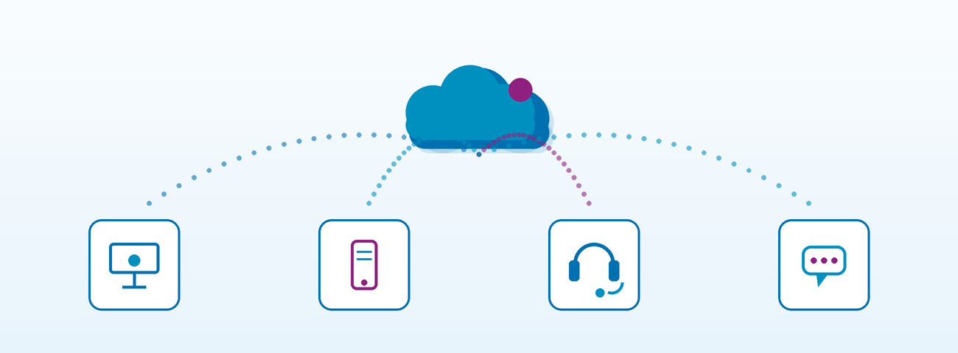
One cloud platform connecting every desk phone, mobile, computer and conversation.

Why Choose a Blake Telecom VoIP System?
A business VoIP telephone system from Blake Telecom can significantly reduce costs compared with a traditional PBX phone system. Give your business a professional welcome greeting and on hold music, or simply take advantage of our worldwide use. Here is just a taste of what comes as standard:

✓ Free desktop and mobile apps | ✓ Professional welcome greetings available
✓ Video meetings and messaging | ✓ AI voice or professional recording artists available
✓ Hot call recording available for 30 days and cold storage plans for up to 10 years | ✓ Worldwide calling packages to save you money
✓ Voicemail to email as standard | ✓ Call routing with auto attendant
✓ Music on hold | ✓ HD quality calls
✓ Block nuisance callers | ✓ Microsoft 365 and Google integration

…plus over 50 features as standard.

Want to see it in action?
Ask our team for a live demonstration of the platform, the apps and the handsets, with no obligation. Call 01325 647000 to arrange a time that suits you.

Choose your handsets
Our team sets up every handset before it leaves us, so you plug it in and start talking. Buy outright, or rent for the monthly price shown. Handsets with a W at the end of their model number can operate on WiFi wherever there is coverage, leaving you free to roam.

Essential
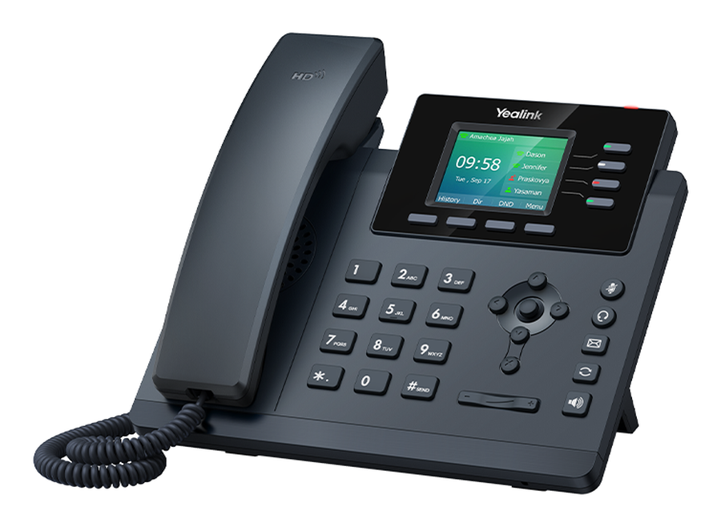  Yealink SIP T34W  £90 or £3.95 per month to rent  A dependable colour screen phone for everyday use. The backlit display, dual band WiFi and Gigabit Ethernet with Power over Ethernet make it easy to place, and a USB port takes a headset. Modern security protocols (TLS 1.3 and WPA3) keep your conversations private.  View the full specification |  | 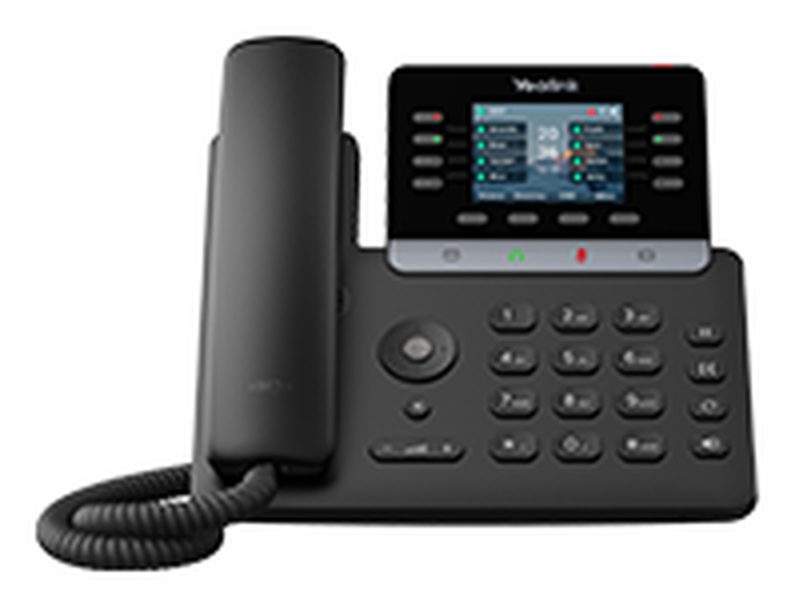  Yealink SIP T73W  £99 or £4.00 per month to rent  A reliable, feature rich phone that suits every desk. The 2.8 inch colour screen tilts for comfortable viewing, and built in noise cancelling keeps calls crisp. USB and EHS ports make a headset easy to add, and WiFi and Bluetooth come as standard, so there is no extra cabling.  View the full specification

Professional
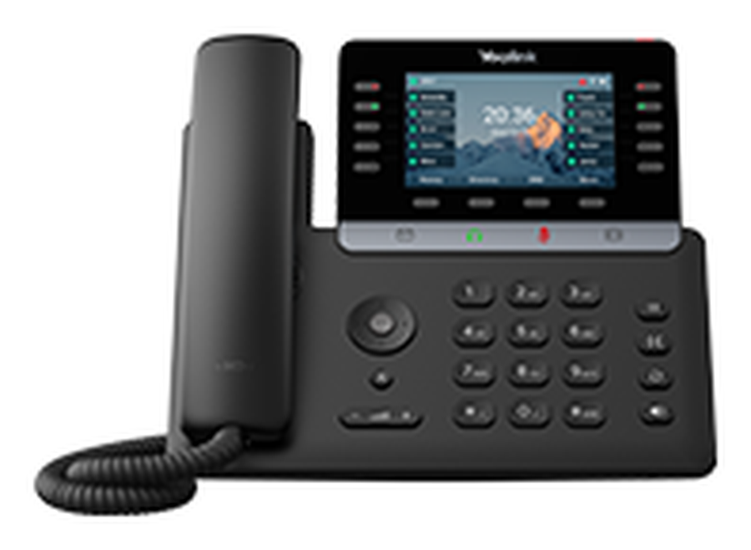  Yealink SIP T74U  £127 or £4.60 per month to rent  WiFi via our USB dongle  A 4.3 inch colour screen with a friendly layout, dark mode and support for several languages. The speakerphone is clear, and status lights make sure you never miss a call or message. It supports call recording, intercom and a directory of up to 1,000 contacts, with Power over Ethernet for a tidy setup.  View the full specification |  | Yealink SIP T74W  £139.99 or £4.75 per month to rent  A smart, high end phone with a sharp high definition screen. The Hall switch handset keeps the office quieter, and wideband audio makes calls sound natural. Bluetooth 5.0 and dual band WiFi 6 are built in, and the USB port takes a headset or recording.  View the full specification |  | 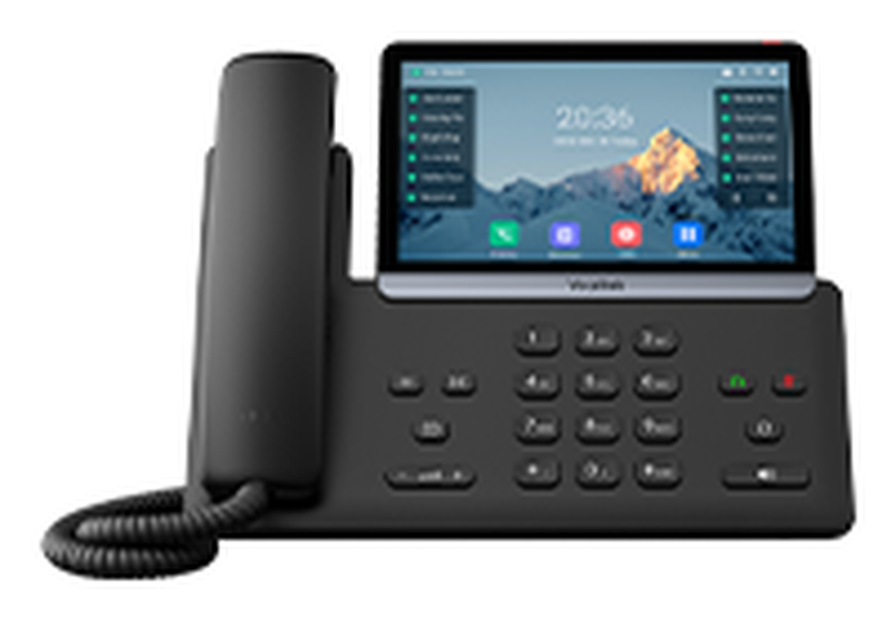  Yealink SIP T77U  £181 or £6.20 per month to rent  WiFi via our USB dongle  A slimline phone with a 7 inch touch screen that is effortless to navigate. USB A and USB C ports suit a modern desk. Optima HD voice and Smart Noise Filtering keep every call clear, while WPA2 and TLS 1.3 protect your communications.  View the full specification

Executive
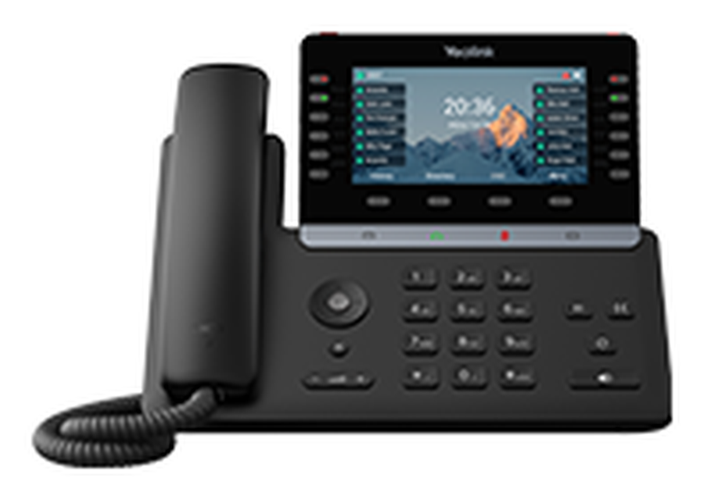  Yealink SIP T85W  £145 or £6.50 per month to rent  Built for people who handle a lot of calls. The 5.5 inch colour display tilts for all day comfort, and 60 programmable buttons let you shape the phone around your work. The speakerphone, volume control and line lights are simple to use, and Power over Ethernet means it fits into any office.  View the full specification |  | 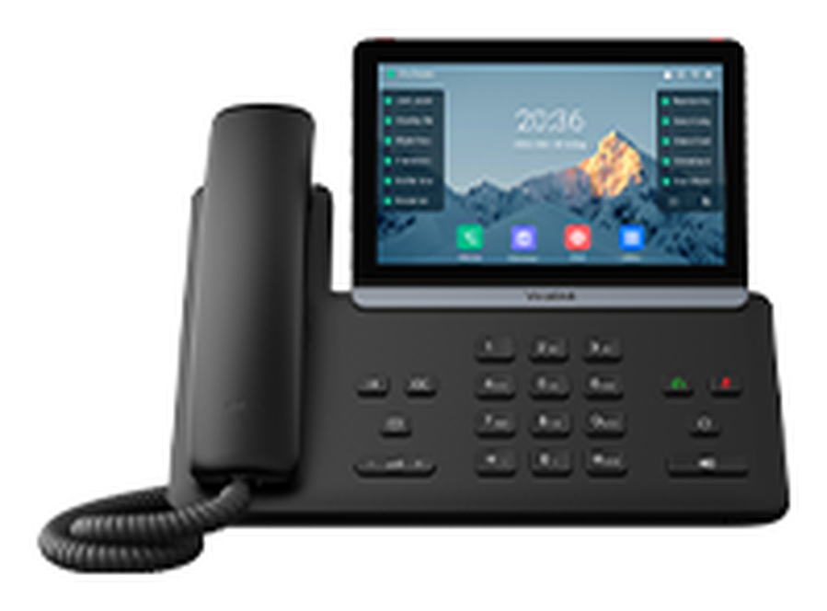  Yealink SIP T87W  £199 or £7.50 per month to rent  The flagship of the range. A 7 inch colour display puts key information at a glance, and HD Voice delivers excellent call quality. Use it on a desk or the wall, programme up to 84 functions and connect by Ethernet, WiFi or Bluetooth. It is hearing aid compatible, so everyone on the team can use it.  View the full specification

Cordless handsets
Move around the building and never miss a call. Choose DECT or WiFi, whichever suits your site.
DECT handsets  Their own base station and wireless signal, separate from your WiFi. Ideal where there is no WiFi to connect to. |  | WiFi handsets  Cordless freedom over the network you already have. No base station and no extra cabling.
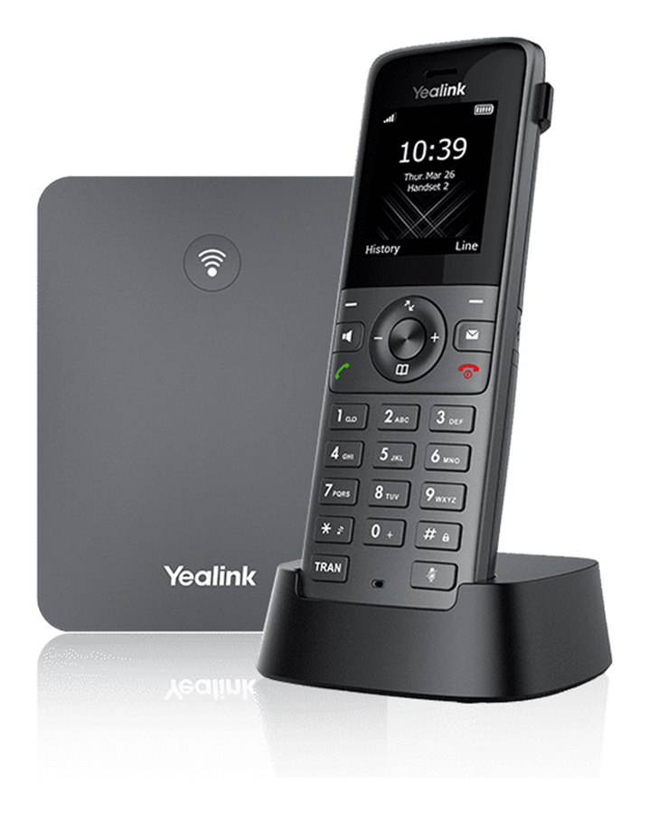  Yealink W73P DECT  £135 or £4.50 per month to rent  A high performance cordless system that registers up to 10 W73H handsets from a single base. Your team can move around the building and stay connected.  View the full specification |  | 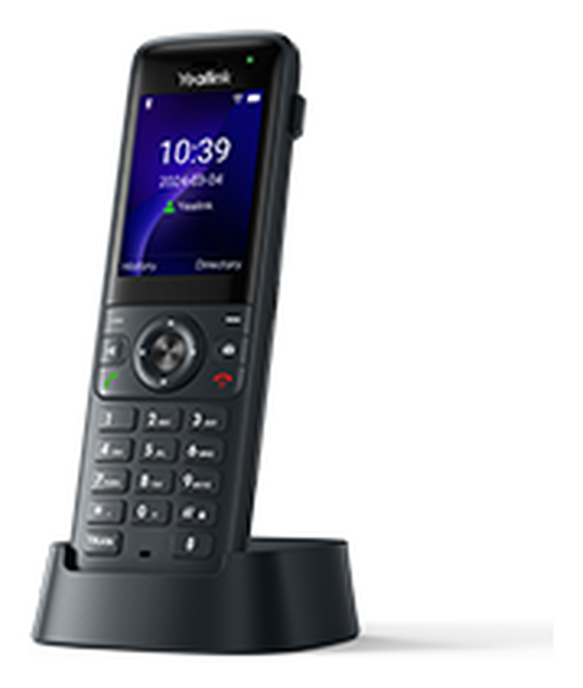  Yealink AX83H WiFi Handset  £99 or £4.00 per month to rent  WiFi gives you freedom to move around. Dual band WiFi 6 offers faster speeds and room for more devices, and the 2000 mAh battery lasts up to 9 hours of talk time or 200 hours on standby.  View the full specification
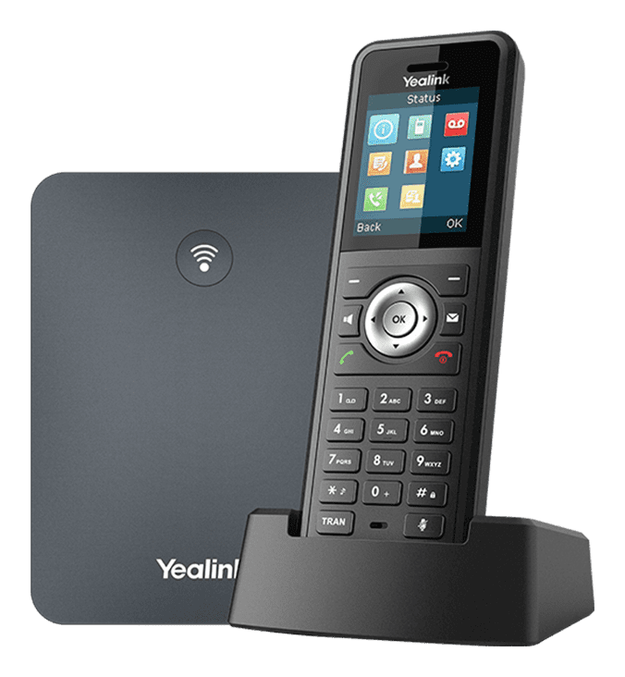  Yealink W79P DECT  £189 or £5.50 per month to rent  A rugged cordless system built around an IP67 handset, with Bluetooth and a vibration alarm. It copes with dust, damp and harsh conditions, and registers up to 10 handsets so the whole team stays reachable.  View the full specification |  | 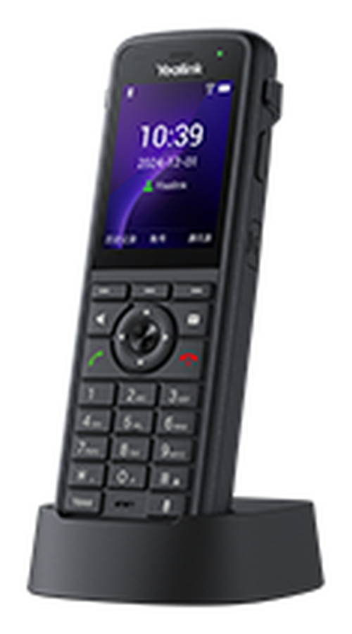  Yealink AX86R WiFi Cordless Phone  £155 or £5.00 per month to rent  Made for demanding days. The 3100 mAh battery gives 780 minutes of talk time or up to 300 hours on standby, and the 2.4 inch colour screen and comfortable shape make it easy to use.  View the full specification

Simple, clear pricing
Our cloud hosted voice platform eliminates the need for an expensive on site telephone system, reducing both upfront costs and ongoing maintenance expenses. With no PBX hardware to install or maintain, you benefit from a more flexible, feature rich communications solution while avoiding unnecessary equipment costs.
Unlike traditional telephone systems, all configuration and management are carried out remotely in the cloud. This means there are no engineer call out charges for system programming, changes, or routine updates, helping to keep your ongoing costs to a minimum.

Telephone setup
Getting started is simple. Choose the handsets you require and pay a straightforward monthly user licence fee. Every licence includes access to more than 50 standard business telephony features as part of the service. Simply choose the licence options below and whether you would like a licence with calls that are recorded or not.

Licences
Service for 2+ users | Price | Details
User licences (2+ users including call recording and free UK calls) | £12 each, per month | Includes 50+ standard features plus calls are recorded for every user. Plus unlimited calls to 01, 02, 03 and 07 numbers in the UK.
Programming and setup | £25 | Remote engineering and programming

To further reduce costs, compatible existing handsets can be transferred to our platform for free. We offer a lifetime warranty under the manufacturer’s terms and conditions if you buy your handsets from us only.

Keeping your numbers
We will apply to take over your existing telephone numbers and port them onto our platform. This takes around 14 days to complete, and during that time we set up a temporary number on the platform so your calls can be diverted and you never miss a customer.

Optional extras
Option | Price | What you get
Call queue service | £10 per month, per site | Auto attendant with a queue service that keeps important customers engaged while they wait.
Professional recordings | £195 single charge | A professional recording artist records your welcome message, on hold marketing, out of hours and voicemail messages.
AI voice recordings | £95 single charge | Realistic AI voices record your welcome and night messages, with basic training so you can change them at will. Demonstrations available on request.

Prices quoted are valid for 30 days and exclude VAT.

Taking your business further? Discover how Unified Communications as a Service (UCaaS) and Contact Centre as a Service (CCaaS) can transform your business communications. See the page headed Built to Scale.

Broadband Solutions Available for Your Address
We have completed our tests on your local exchange, and we are pleased to confirm that you are eligible for our business FTTP broadband service with a choice of speeds. Please see your options below for both sites.

Site one IV3 5PR

Download speed |  | Upload | New installation | Monthly rental
80 Mbps |  | 20 Mbps | Free | £35.99
115 Mbps |  | 20 Mbps | Free | £38.99
220 Mbps |  | 30 Mbps | Free | £42.99
550 Mbps |  | 75 Mbps | Free | £49.99
1 Gbps |  | 115 Mbps | Free | £59.99

Site two IV1 1HG

The exchange tests for this address have come back and show that standard FTTP is not available, however we have some further options available for great business internet.
SOGEA | SOGEA or fibre to the cabinet is available for only £35.99 per month, and tests show realistic speeds of up to 80Mbps for downloads.
Leased lines | Leased lines are available with speeds of up to 1Gb. This is a dedicated fibre line brought to you with a 1:1 contention rate and excellent SLAs. Please ask for details if you would like to discuss this.

Good to know about your connection
All of our connections come with a static IP address.
FTTP | FTTP (Fibre to the Premises) is a pure fibre service brought directly into your business, letting your internet speeds grow as you do, with downloads of up to 1 Gbps. Most companies now choose FTTP as it comes with better service level agreements and flexibility.
SOGEA | SOGEA is delivered to your premises on a copper cable, connected back to the cabinet in your street where it joins the fibre network to give you access to the internet. The rental price includes the line, so there are no additional line rental charges.
Installation | Installation charges are subject to survey where required.

Mobile Connectivity
We are currently offering business mobile users deals that even beat the networks’ own prices. Take a look at our unlimited business tariffs below.
 | O2 SIM Only Small Biz Unlimited  £19.99 per month (£23.99 after year one) | - Unlimited calls and texts  - Unlimited UK data  - EU roaming included*
 | Vodafone SIM Only Unlimited  £19.99 per month (£23.99 after year one) | - Unlimited calls and texts  - Unlimited UK data  - EU roaming included*

*Fair usage policy applies abroad. Prices exclude VAT.

Built to Scale: Unified Communications and Contact Centre
For businesses that want to go further, we supply one of the most recognised cloud communications platforms in the world, named a leader by independent analysts for ten consecutive years. It brings your phone system, video meetings, team messaging and customer contact together in one place, on one bill, with one login.

Unified communications (UCaaS)
Every user gets HD voice, video meetings for up to 500 participants, team chat, file sharing, business SMS and voicemail to email in a single app that works on desk phones, computers, iPhone and Android. AI is built in from day one, with automatic meeting summaries, live call transcription and smart noise suppression, and it integrates natively with Microsoft Teams, Salesforce, Dynamics 365, HubSpot, Zendesk and Google Workspace.

Contact centre (CCaaS)
When your customer facing team is ready, add a fully featured omnichannel contact centre on the same platform. Voice, email, web chat, SMS and social messages all arrive in one agent workspace, with intelligent routing so every enquiry reaches the right person first time. Supervisors get live dashboards, speech analytics and workforce management tools, while AI agent assist surfaces the right information during every conversation.

Scalability without limits  ✓ Start with two users, scale to hundreds  ✓ Add users and channels as you grow  ✓ 99.999% uptime service level agreement  ✓ Native phone service in over 50 countries  ✓ Live in as little as 24 hours  ✓ No engineer callouts, configured remotely  ✓ Enterprise grade security and GDPR compliance  ✓ Free apps for every user at no extra cost | 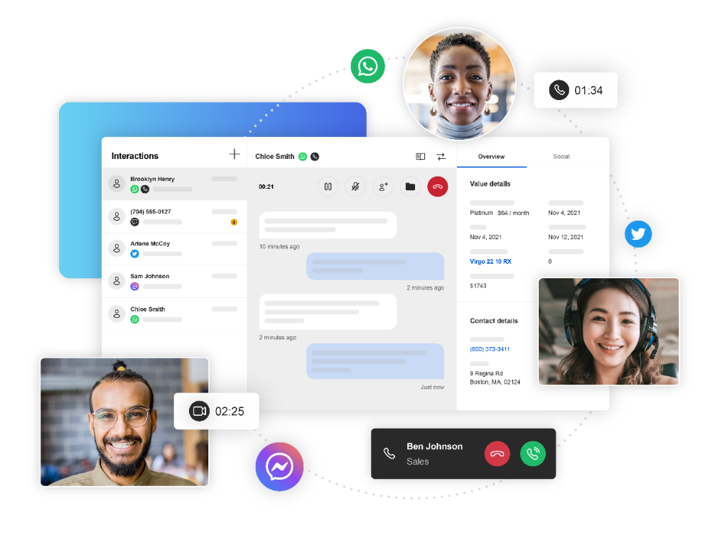

Simple pricing with no hidden fees
Contact centre seats are priced per agent based on the channels your team needs, and we always provide a clear, itemised quote before you commit to anything.

About Us
Blake Telecom is a local company providing solution based business communications throughout the UK. Trading since 2004 with customers across the country, we are strategically placed in the market to offer our clients next generation communications, including SIP, VoIP, unified communications, hosted voice and data solutions such as Microsoft 365, along with many other products designed to keep your business talking.  We work closely with our customers to find the perfect solution without additional costs or hard sell, and our clients have chosen to stay with our team for many years, proof of the service we deliver. | 

What Our Customers Say
“Blake Telecom has been paramount to the growth of our business by continuing to offer the very highest level of service. The equipment we have been supplied has been extremely flexible, allowing us to change with our needs. Blake Telecom’s knowledge and expertise have been very professional and we look forward to working together on our future projects.”  Darlington Farmers Auction Mart |  | “Blake Telecom have been supplying our business communications for well over 10 years. We have found both their systems and support to be fully robust and they have given excellent service throughout, with value for money for their products. Their approach to helping our business has always been excellent from every aspect and I would highly recommend their services.”  TD Jagger Property Consultants and Architects

Ready to get started?
Call our team on 01325 647000 or visit blake-telecom.co.uk

Blake Telecom, 2 Peel Court, St Cuthbert’s Way, Darlington, Co Durham, DL1 1GB

