
Hosted Voice Solution
Simple cloud communications that grow with your business
A proposal prepared for Ship Cars Ltd
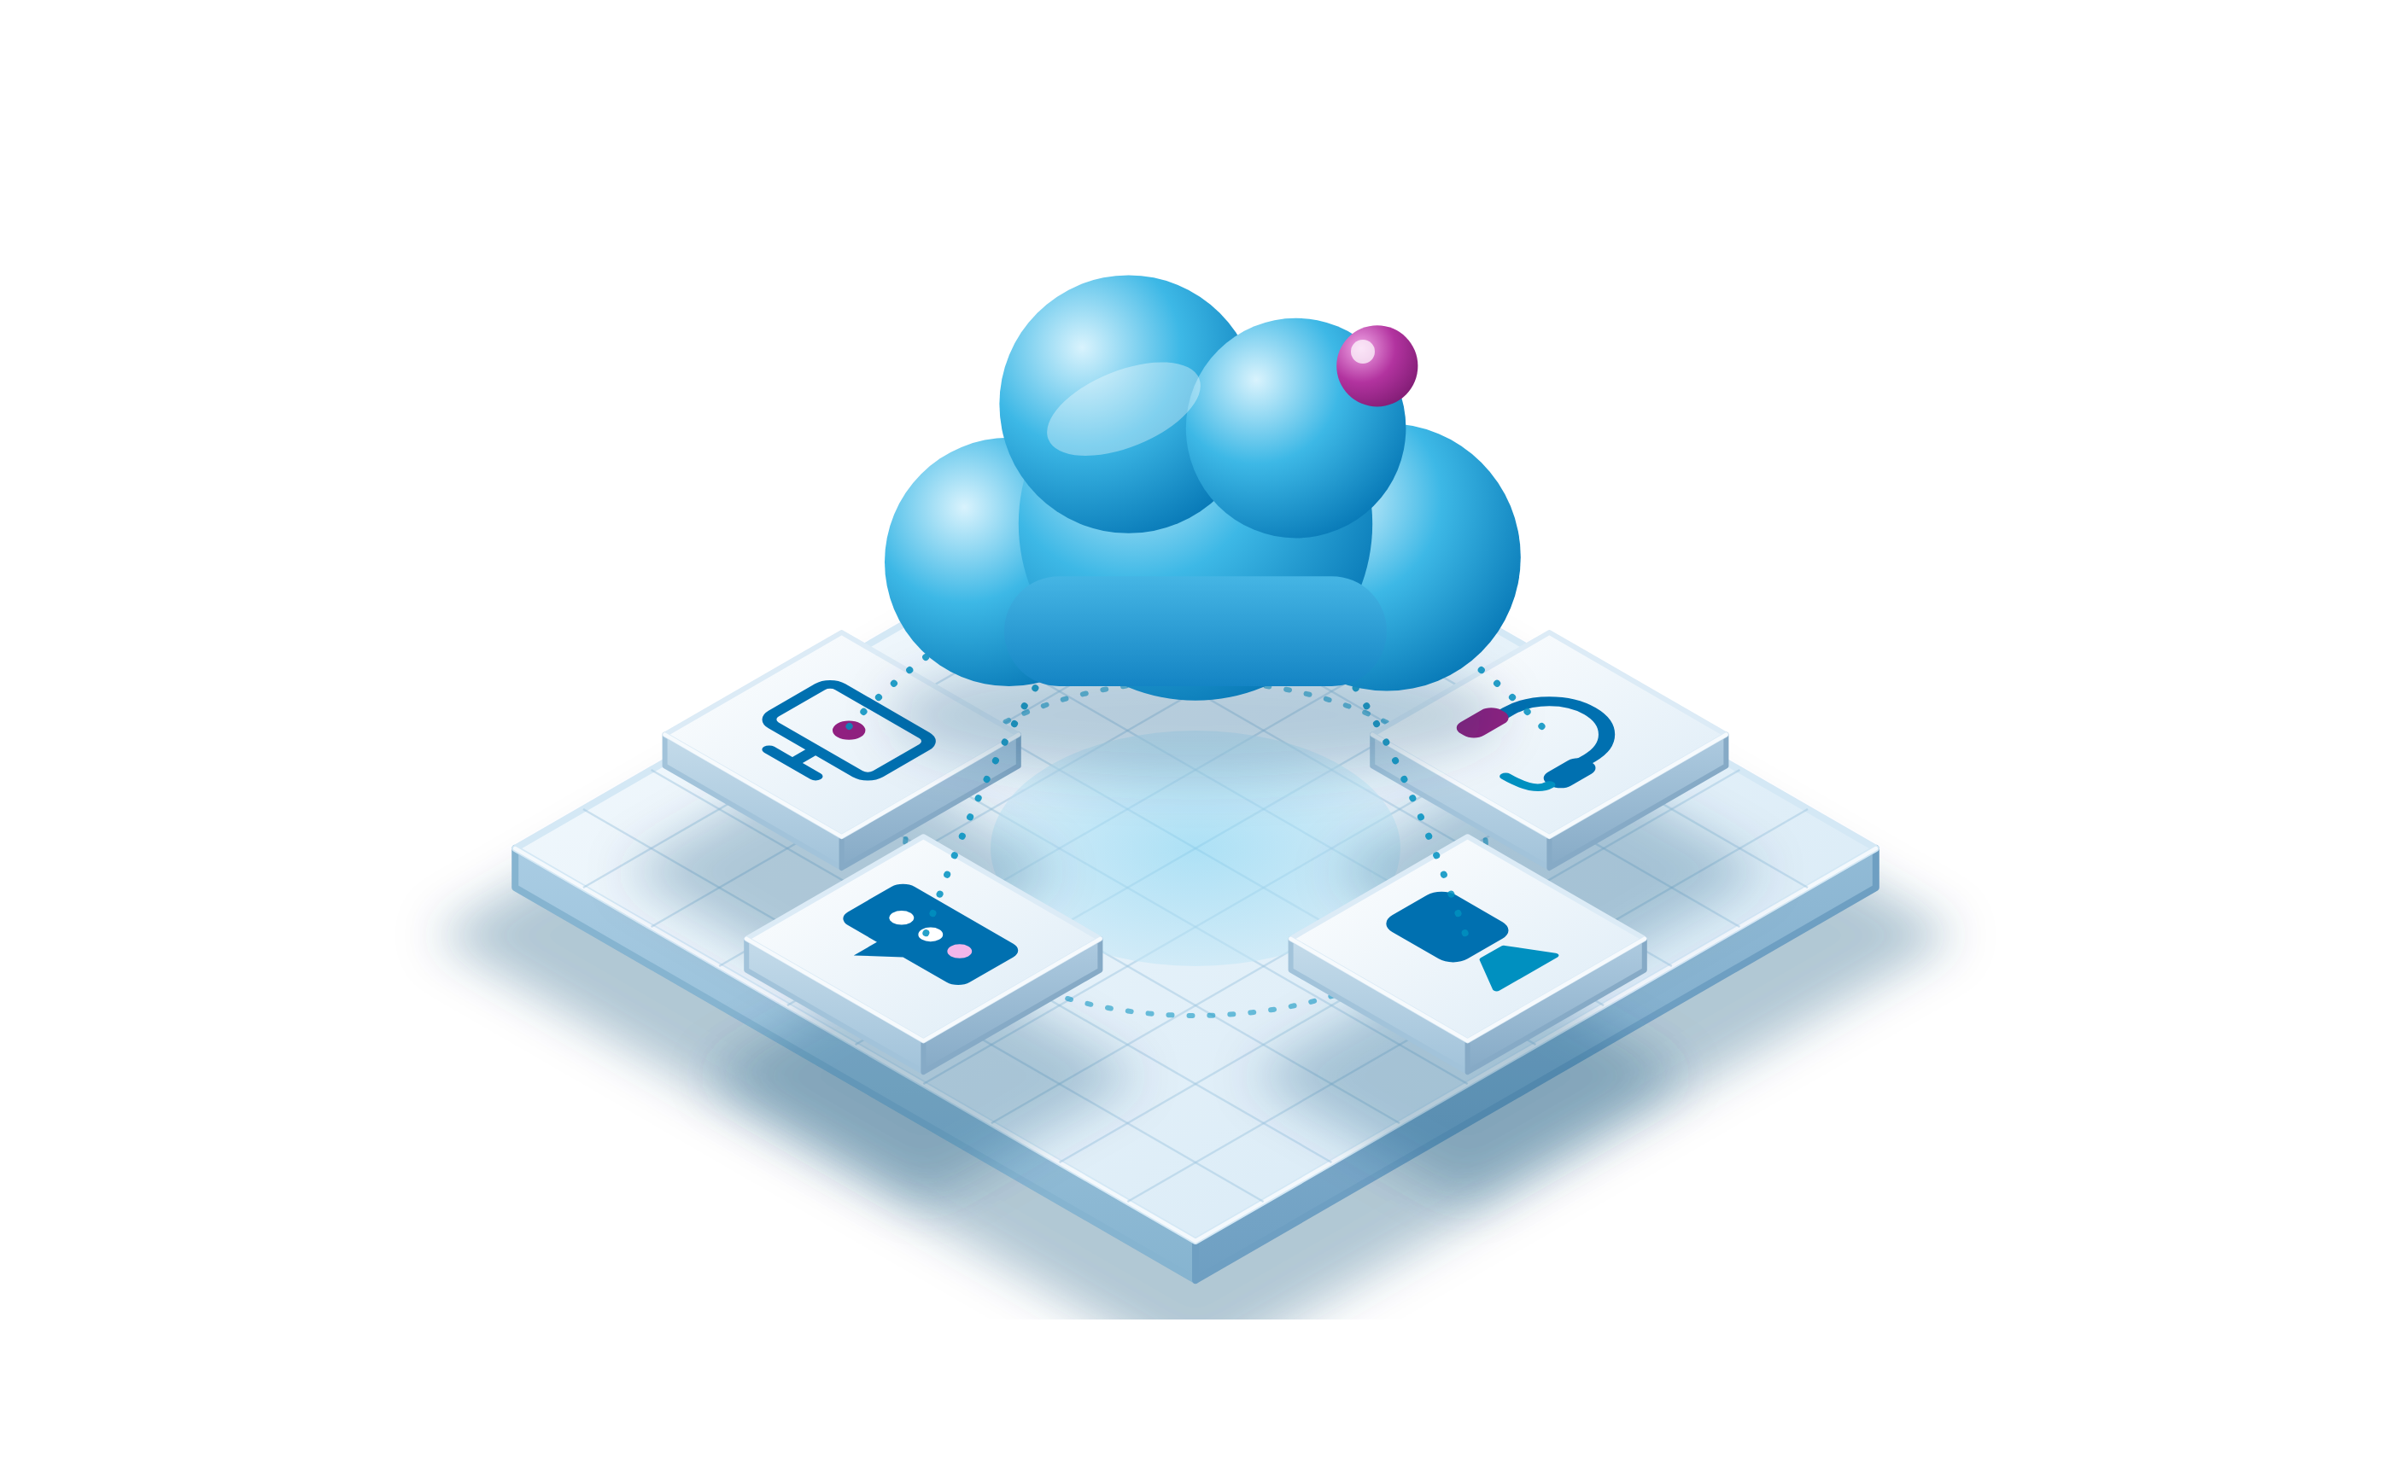
Prepared by Peter Hughes
17th September 2026
01325 647000 | blake-telecom.co.uk

Everything your team needs, in one simple system
Running a small business means wearing many hats. Your phone system should not be one more thing to worry about. With a cloud platform, your calls, video meetings and team messages live together in one app, and it works wherever you are: at your desk, at home or on the road.
That is what unified communications as a service, or UCaaS, gives you. There is no equipment to buy, no phone lines to install and no technical team to hire. We set it up, you plug in, and your business is ready to talk.

No hardware headaches  Nothing sits in a cupboard or on the wall. The platform lives in the cloud, and we keep it up to date for you. |  | One app, one login  Calls, video, chat and voicemail in a single app for your laptop, desk phone and mobile. |  | People you know  A dedicated account manager knows your business and answers when you call.

What your team gets every day
  Work from anywhere  Use one number on your desk phone, laptop or mobile, in the office or at home. |   Video meetings  Meet face to face with colleagues and customers, with screen sharing for up to 500 people. |   Team chat  Message colleagues, share files and keep every conversation in one place.
  AI that saves time  Automatic meeting summaries, live call transcription and clearer sound on every call. |   Fits your tools  Connects to Microsoft 365, Microsoft Teams, Google Workspace, Salesforce, HubSpot and more. |   Secure and dependable  Enterprise grade security, GDPR compliance and 99.999% uptime.

Built to grow with you
Small businesses rarely stay small. A cloud system grows at your pace, so you never pay for capacity you do not need and you never outgrow what you have.  Add a new starter, open a second site or take on a customer facing team, and your phone system keeps up. It is the same platform, the same app and the same friendly support from day one. | 

1 | Start small  Begin with two users and a few handsets. We configure everything remotely, so you can be live in as little as 24 hours.
2 | Add as you grow  Take on a new starter or open a new site, and add users and channels whenever you need them. There is no engineer visit and no new equipment.
3 | Go further  When your customer facing team is ready, add a full contact centre to the same platform. Calls, email, web chat, SMS and social messages arrive in one workspace, with smart routing and live dashboards. There is no new supplier to find.

How we help you grow
✓ A free demonstration before you decide | ✓ Remote setup and number transfer, handled by us
✓ A clear, itemised quote with nothing hidden | ✓ A dedicated account manager, today and as you grow
✓ Phone service in over 50 countries | ✓ Free apps for every user

Want to see it working?
We will show you the platform, the apps and the handsets, with no obligation. Call 01325 647000 and we will find a time that suits you.

Included with every licence
Every user gets the same full set of features. There is nothing to unlock and nothing to add later.

✓ Free desktop and mobile apps | ✓ A professional welcome greeting
✓ Video meetings and team messaging | ✓ A choice of AI voice or recording artist
✓ Call recording, free for 30 days | ✓ Storage for up to 10 years, if you need it
✓ Voicemail sent to your inbox | ✓ An auto attendant to route every call
✓ Music on hold | ✓ Clear HD call quality
✓ Nuisance caller blocking | ✓ Microsoft 365 and Google connections

On top of these, every licence includes more than 50 further features.

Unified communications and contact centre
We supply one of the best known cloud communications platforms in the world, rated a leader by independent analysts for ten years in a row. Your phones, video meetings, messaging and customer contact sit together, on one bill and one login.
For every team member. HD voice, video meetings, team chat, file sharing, business SMS and voicemail to email in a single app. It works on desk phones, computers, iPhone and Android, and AI is built in from day one.
For your customer facing team. Calls, email, web chat, SMS and social messages arrive in one agent workspace. Smart routing sends each enquiry to the right person first time, supervisors get live dashboards and speech analytics, and AI agent assist suggests the right answer during every conversation. Seats are priced per agent, based on the channels you need.

 | Why choose Blake Telecom?  We have supplied business communications since 2004. We are independent, so we recommend what fits your business rather than what suits a supplier. Every customer has a dedicated account manager, and you always see a clear, itemised price.

Choose your handsets
Every handset works with your cloud service from day one. Buy outright, or rent for the monthly price shown.

Essential
Dependable phones for everyday use at every desk.
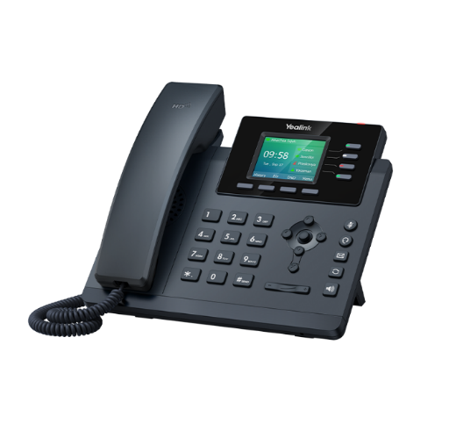  Yealink SIP T34W  A dependable colour screen phone for everyday use. The backlit display, dual band WiFi and Gigabit Ethernet with Power over Ethernet make it easy to place, and a USB port takes a headset. Modern security protocols (TLS 1.3 and WPA3) keep your conversations private.  View the full specification |  | 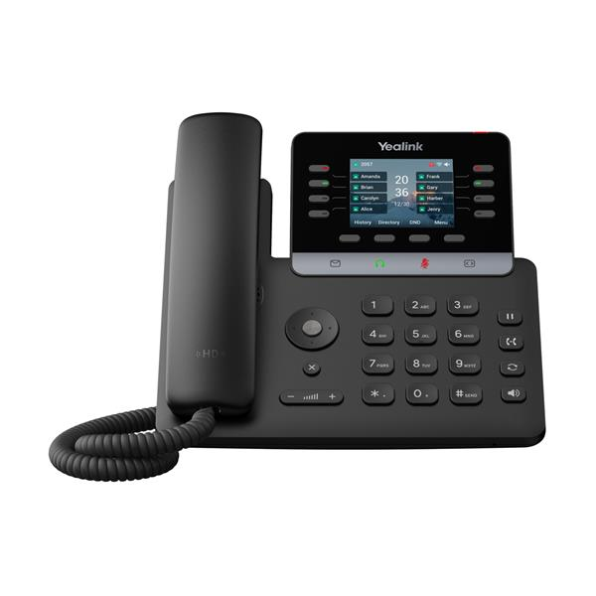  Yealink SIP T73W  A reliable, feature rich phone that suits every desk. The 2.8 inch colour screen tilts for comfortable viewing, and built in noise cancelling keeps calls crisp. USB and EHS ports make a headset easy to add, and WiFi and Bluetooth come as standard, so there is no extra cabling.  View the full specification
  Buy £90 | Rent £3.95 a month
  Buy £99 | Rent £4.00 a month

Every handset arrives ready to go
1 | We configure it  Our team sets up each handset for your account before it is dispatched.
2 | It arrives at your door  There is nothing technical to do when the parcel lands.
3 | Plug in and talk  Connect the handset to power and your network, and you are making calls.

Not sure which to pick?
Tell us how your team works and we will recommend the right handset for each role. You can mix and match across the range.
Call 01325 647000

Professional
Larger screens and extra connectivity for busier roles.
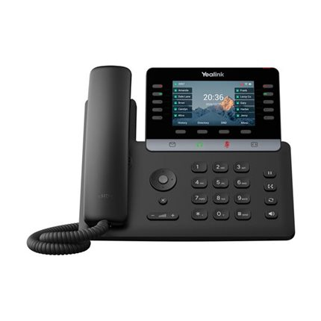  Yealink SIP T74U  A 4.3 inch colour screen with a friendly layout, dark mode and support for several languages. The speakerphone is clear, and status lights make sure you never miss a call or message. It supports call recording, intercom and a directory of up to 1,000 contacts, with Power over Ethernet for a tidy setup.  WiFi available with our USB dongle.  View the full specification |  | 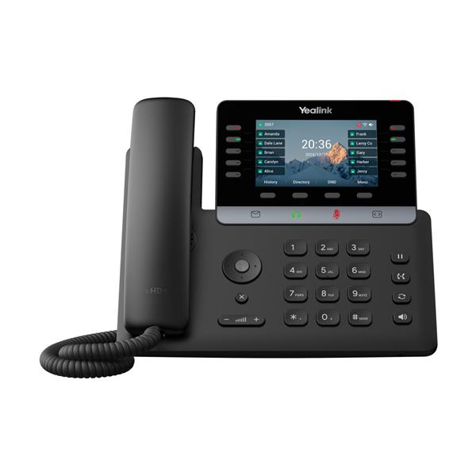  Yealink SIP T74W  A smart, high end phone with a sharp high definition screen. The Hall switch handset keeps the office quieter, and wideband audio makes calls sound natural. Bluetooth 5.0 and dual band WiFi 6 are built in, and the USB port takes a headset or recording.  View the full specification |  | 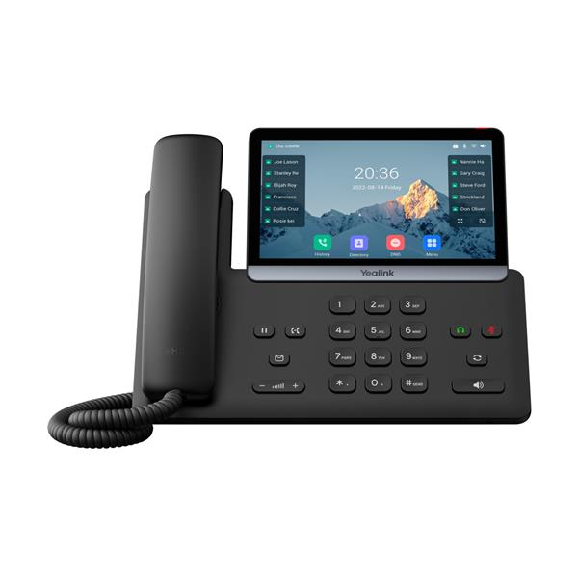  Yealink SIP T77U  A slimline phone with a 7 inch touch screen that is effortless to navigate. USB A and USB C ports suit a modern desk. Optima HD voice and Smart Noise Filtering keep every call clear, while WPA2 and TLS 1.3 protect your communications.  WiFi available with our USB dongle.  View the full specification
  Buy £127 | Rent £4.60 pm
  Buy £139.99 | Rent £4.75 pm
  Buy £181 | Rent £6.20 pm

Executive
Premium phones for people who live on the phone.
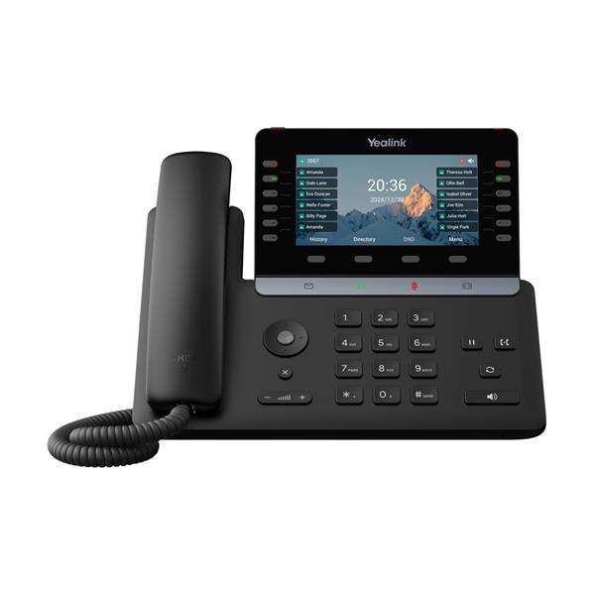  Yealink SIP T85W  Built for people who handle a lot of calls. The 5.5 inch colour display tilts for all day comfort, and 60 programmable buttons let you shape the phone around your work. The speakerphone, volume control and line lights are simple to use, and Power over Ethernet means it fits into any office.  View the full specification |  | 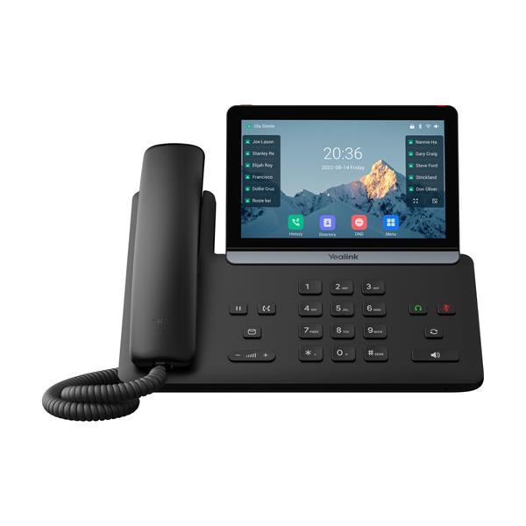  Yealink SIP T87W  The flagship of the range. A 7 inch colour display puts key information at a glance, and HD Voice delivers excellent call quality. Use it on a desk or the wall, programme up to 84 functions and connect by Ethernet, WiFi or Bluetooth. It is hearing aid compatible, so everyone on the team can use it.  View the full specification
  Buy £145 | Rent £6.50 a month
  Buy £199 | Rent £7.50 a month

Wireless DECT
The ideal choice for businesses without WiFi to connect to.
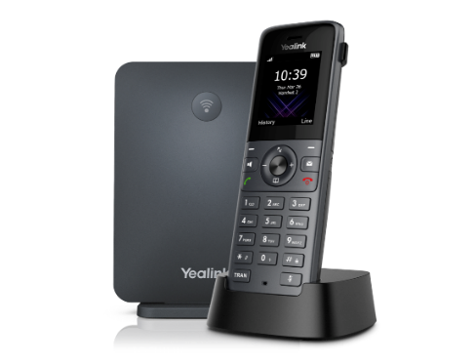  Yealink W73P DECT  A high performance cordless system that registers up to 10 W73H handsets from a single base. Your team can move around the building and stay connected.  View the full specification |  | 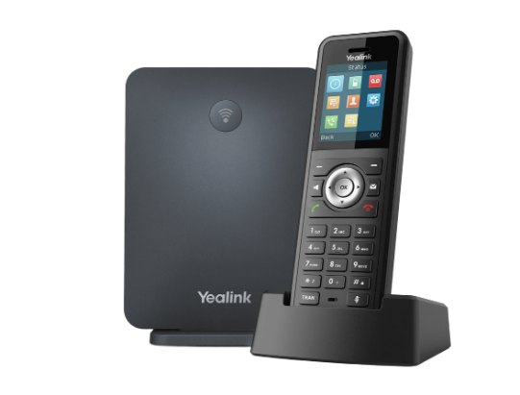  Yealink W79P DECT  A rugged cordless system built around an IP67 handset, with Bluetooth and a vibration alarm. It copes with dust, damp and harsh conditions, and registers up to 10 handsets so the whole team stays reachable.  View the full specification
  Buy £135 | Rent £4.50 a month
  Buy £189 | Rent £5.50 a month

WiFi handsets
Cordless freedom over the network you already have.
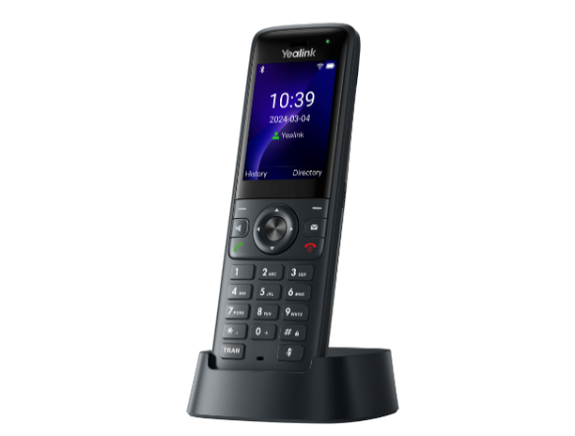  Yealink AX83H WiFi Handset  WiFi gives you freedom to move around. Dual band WiFi 6 offers faster speeds and room for more devices, and the 2000 mAh battery lasts up to 9 hours of talk time or 200 hours on standby.  View the full specification |  | 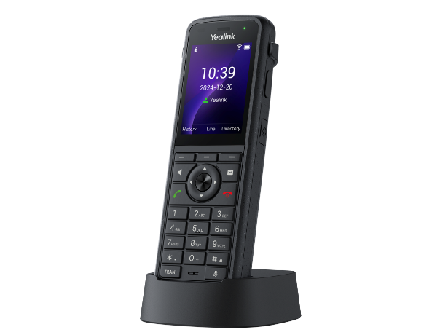  Yealink AX86R WiFi Cordless Phone  Made for demanding days. The 3100 mAh battery gives 780 minutes of talk time or up to 300 hours on standby, and the 2.4 inch colour screen and comfortable shape make it easy to use.  View the full specification
  Buy £99 | Rent £4.00 a month
  Buy £155 | Rent £5.00 a month

DECT or WiFi?
DECT handsets use their own base station and wireless signal, separate from your WiFi. One base supports up to 10 handsets, which suits warehouses, workshops, surgeries and shops.
WiFi handsets join the network you already have, with no base station and no extra cabling. They suit offices, hospitality and retail spaces with good coverage.

Simple, clear pricing
£12  per user, per month, with call recording and free UK calls included | £25  one off setup, all done remotely | 50+  business features in every licence

Your service
Item | Price | What you get
User licence | £12 per user, per month | All 50+ features, call recording for every user, and unlimited UK calls to 01, 02, 03 and 07 numbers
Setup | £25 one off | Remote programming and engineering

Compatible handsets you already own can move to our platform free of charge.

Keeping your numbers
We apply to move your existing numbers to our platform, which takes around 14 days. While that happens we set up a temporary number, so you can divert your calls and never miss a customer.

Optional extras
Extra | Price | What you get
Call queue service | £10 per month, per site | An auto attendant with a queue, so important callers stay engaged while they wait
Professional recordings | £195 one off | A professional voice records your welcome message, on hold marketing, out of hours and voicemail messages
AI voice recordings | £95 one off | Realistic AI voices record your welcome and night messages, and we show you how to change them any time. Demonstration on request

What might you pay?
A team of five, each with a T73W handset on rental:
5 user licences at £12 each: £60 per month
5 T73W handsets at £4.00 each: £20 per month
Total: £80 per month, plus a single £25 setup charge in the first month.

Your own quote is itemised just as clearly. Prices are valid for 30 days and exclude VAT.

Fast business broadband
We have checked your local exchange, and your address can have a choice of FTTP speeds. Pick the one that suits your team. Every connection includes a static IP address and free installation.

Download | Upload | Installation | Monthly rental
80 Mbps | 20 Mbps | Free | £35.99
115 Mbps | 20 Mbps | Free | £38.99
220 Mbps | 30 Mbps | Free | £42.99
550 Mbps | 75 Mbps | Free | £49.99
1 Gbps | 115 Mbps | Free | £59.99

FTTP (Fibre to the Premises) brings pure fibre straight into your business, so your speed can grow with you, up to 1 Gbps download. Most companies now choose it for its flexibility. The monthly price includes the line, so there is no separate line rental.
Installation charges are subject to survey where required.

Business mobiles
We currently have unlimited business tariffs that beat the networks’ own prices.
 | O2 SIM Only Small Biz Unlimited  £19.99 per month  then £23.99 after the first year | ✓ Unlimited calls and texts  ✓ Unlimited UK data  ✓ EU roaming included*
 | Vodafone SIM Only Unlimited  £19.99 per month  then £23.99 after the first year | ✓ Unlimited calls and texts  ✓ Unlimited UK data  ✓ EU roaming included*

*A fair usage policy applies abroad. Prices exclude VAT.

About Blake Telecom
Blake Telecom is a local business communications company that supports customers across the UK. We have traded since 2004, and we offer SIP, VoIP, unified communications, hosted voice and data services, including Microsoft 365, along with many other products that keep your business talking.
We take time to understand how you work, then recommend the right fit without hidden costs or a hard sell. Many of our customers have stayed with us for years, which says more than we could.

What our customers say
Darlington Farmers Auction Mart
“Blake Telecom has been paramount to the growth of our business by continuing to offer the very highest level of service. The equipment we have been supplied has been extremely flexible, allowing us to change with our needs. Blake Telecom’s knowledge and expertise have been very professional and we look forward to working together on our future projects.”

TD Jagger Property Consultants and Architects
“Blake Telecom have been supplying our business communications for well over 10 years. We have found both their systems and support to be fully robust and they have given excellent service throughout, with value for money for their products. Their approach to helping our business has always been excellent from every aspect and I would highly recommend their services.”

Ready to get started?
Call our team on 01325 647000 or visit blake-telecom.co.uk. We will arrange your demonstration and send a full, itemised quote.

Blake Telecom, 2 Peel Court, St Cuthbert’s Way, Darlington, Co Durham, DL1 1GB

