 | Get your business connected with reliability today.  01325 647000 | blake-telecom.co.uk

Leased line  solutions  Dedicated bandwidth for the way your business works. | 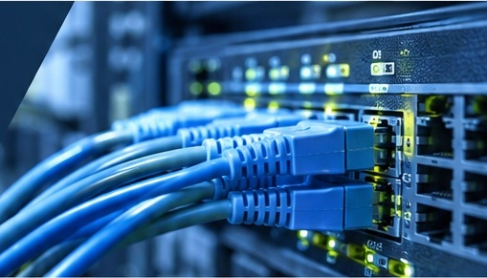

What is a leased line?  A leased line is a dedicated, high speed internet connection that provides a secure and reliable link between your business and the wider world.  Unlike standard broadband, it is not shared with other users, giving you consistent performance, lower latency and the bandwidth your business needs to operate at its best.
   | High speed and reliability  Dedicated bandwidth for consistent, high performance.
   | Enhanced security  A private connection, separated from the public internet.
   | Scalable  Easily increase your bandwidth as your business grows.
   | Nationwide coverage  Available across the UK, with multiple providers for the best solution.

Why choose a Blake Telecom leased line?
Our leased line solutions are designed to give your business the performance, security and flexibility it needs. Here are just a few of the key benefits.
- Dedicated, uncontended bandwidth  - Greater security and data protection  - Flexible packages to suit your needs |  | - Fast, reliable and always on  - Support for cloud and business critical applications  - Competitive pricing and transparent billing |  | - Improved voice and video quality  - Expert installation and ongoing support  - Peace of mind with a trusted UK based provider

Welcome to Blake Telecom
With more than 30 years of experience in communications, our portfolio has helped us become one of the UK’s leading independent providers of high speed data connectivity, hosted voice, audio visual equipment and business mobiles.  Because everything sits under one roof, our team is always on hand to look after your business requirements, leaving you free to concentrate on what matters most to you and your company. |  | We constantly monitor the technology market so that we stay one step ahead, delivering innovative solutions that keep your business ahead of the competition.  Our independence, together with a powerful network of preferential partnerships with leading UK suppliers, keeps costs down. We strive to make sure you receive the right service, at the right price. Every time.

Ready to get connected?  Let our team design the right leased line solution for your business. | Arrange a no obligation consultation  01325 647000  blake-telecom.co.uk

Get your business connected with reliability today.
01325 647000 | blake-telecom.co.uk

Your leased line  proposal  Prepared for Digital Devices | Prices checked for postcode  [ POSTCODE ]

What you can have at your address
We have completed our tests on your exchange and the products available in your area. You have a choice of four options, in three speeds. Choose the one that suits your team.
Your option  Type of service | 100Mbps  on a 1Gb bearer | 500Mbps  on a 1Gb bearer | 1Gbps  on a 1Gb bearer
FibreLight  Contended | 24 month term  FTTP (Fibre to the Premises). | £73.99  a month | £99  a month | £108  a month
FibreLight Plus  Contended | 24 month term  As FibreLight, with Service, Speed and Security. Enhanced Care and SecureEdge are built in. | £78.99  a month | £105  a month | £114  a month
FibreBright Secure  Uncontended | 36 month term  Smarter, more secure dedicated internet access with ITS SecureEdge. | £215  a month | £269  a month | £284  a month
Leased Line  Uncontended  Our standard leased line. | £252  a month | £286  a month | £286  a month

Good to know
Installation | £55 for every option, charged once. Installation is subject to survey.
Network | These services are not delivered on the BT Openreach network and are offered on various terms.
Choosing | Contended services share capacity with other customers. Uncontended services reserve it for you alone.
Prices | All prices are monthly rentals and exclude VAT.

Ready to get connected?  Let our team design the right leased line solution for your business. | Arrange a no obligation consultation  01325 647000  blake-telecom.co.uk

