Movie Theater Management and Online Ticket Booking System<Project Name>

Version 1.0

Revision History
Date | Version | Description | Author
22/10/2026 | 1.0 | Initial version of the document. | Huynh Thanh Tu

Use case Specification Document
1. UC-01 Reserve Seats 8
1.1 Use-Case Name 8
1.1.1 Brief Description 8
1.2 Flow of Events 8
1.2.1 Basic Flow 8
1.2.2 Alternative Flows 8
1.3 Special Requirements 10
1.3.1 Data Consistency and Idempotency 10
1.4 Preconditions 10
1.4.1 Reservation Preconditions 10
1.5 Postconditions 10
1.5.1 Successful Reservation 10
1.5.2 Unsuccessful Reservation 10
1.6 Extension Points 11
2. UC-02 Payment Webhook 13
2.1 Use-Case Name 13
2.1.1 Brief Description 13
2.2 Flow of Events 13
2.2.1 Basic Flow 13
2.2.2 Alternative Flows 13
2.3 Special Requirements 14
2.3.1 Payment Event Tracking and Consistency 14
2.4 Preconditions 14
2.5 Postconditions 14
2.5.1 Successfully Processed Payment Event 14
2.5.2 Failed Payment Event Processing 15
2.6 Extension Points 15
2.6.1 Payment Reconciliation 15
3. UC-03 Release Expired Bookings 17
3.1 Use-Case Name 17
3.1.1 Brief Description 17
3.2 Flow of Events 17
3.2.1 Basic Flow 17
3.2.2 Alternative Flows 18
3.3 Special Requirements 19
3.3.1 Booking and Seat-Allocation Consistency 19
3.3.2 Payment Safety 19
3.4 Preconditions 19
3.5 Postconditions 19
3.5.1 Successfully Released Booking 20
3.5.2 Booking Deferred for Payment Reconciliation 20
3.5.3 Booking Skipped 20
3.5.4 Processing Failed 20
3.6 Extension Points 20
3.6.1 Payment Reconciliation 20
3.6.2 Payment Processing 20
3.6.3 Refund Handling 20
4. UC-04 Payment Reconciliation 23
4.1 Use-Case Name 23
4.1.1 Brief Description 23
4.2 Flow of Events 23
4.2.1 Basic Flow 23
4.2.2 Alternative Flows 24
4.3 Special Requirements 25
4.3.1 Payment Verification and Reconciliation State 25
4.4 Preconditions 26
4.5 Postconditions 26
4.5.1 Payment Outcome Verified and Payment Applied 26
4.5.2 Payment Outcome Verified but Payment Not Applied 26
4.5.3 Payment Outcome Verified as Failed or Cancelled 27
4.5.4 Payment Outcome Remains Unresolved 27
4.5.5 Reconciliation Attempt Fails 27
4.6 Extension Points 27
4.6.1 Payment Reconciliation 27
5. UC-04A Refund 30
5.1 Use-Case Name 30
5.1.1 Brief Description 30
5.2 Flow of Events 30
5.2.1 Basic Flow 30
5.2.2 Alternative Flows 30
5.3 Special Requirements 31
5.3.1 Refund Request Identity and Idempotency 31
5.3.2 Refund Status and Verification 31
5.3.3 Reconciliation Resolution 32
5.4 Preconditions 32
5.5 Postconditions 32
5.5.1 Refund Successfully Verified 32
5.5.2 Refund Failure Verified 32
5.5.3 Refund Outcome Remains Unknown 32
5.5.4 Retry Required 32
5.6 Extension Points 33
5.6.1 Payment Reconciliation (UC-04) 33
6. UC-05 Validate Ticket 35
6.1 Use-Case Name 35
6.1.1 Brief Description 35
6.2 Flow of Events 35
6.2.1 Basic Flow 35
6.2.2 Alternative Flows 35
6.3 Special Requirements 36
6.4 Preconditions 37
6.5 Postconditions 37
6.5.1 Success: 37
6.5.2 Failure: 37
6.6 Extension Points 37
6.6.1 Browse Showtimes (UC-07) 37
6.6.2 Reserve Seats (UC-01) 38
6.6.3 Open Questions 38
7. UC-06 Browse Movies 40
7.1 Use-Case Name 40
7.1.1 Brief Description 40
7.2 Flow of Events 40
7.2.1 Basic Flow 40
7.2.2 Alternative Flows 40
7.3 Special Requirements 41
7.3.1 Catalogue and Display Data 41
7.3.2 Scope Boundary 41
7.4 Preconditions 41
7.5 Postconditions. 41
7.5.1 Successful Browse 42
7.5.2 No Result 42
7.5.3 Failed Browse 42
7.6 Extension Points 42
7.6.1 Browse Showtimes (UC-07) 42
7.6.2 Reserve Seats (UC-01) 42
7.6.3 Open Questions 42
8. UC-07 Browse Showtimes 44
8.1 Use-Case Name 44
8.1.1 Brief Description 44
8.2 Flow of Events 44
8.2.1 Basic Flow 44
8.2.2 Alternative Flows 44
8.3 Special Requirements 45
8.3.1 Showtime Eligibility 45
8.3.2 No Reservation Side Effects 45
8.4 Preconditions 45
8.5 Postconditions 46
8.5.1 Successful Browse 46
8.5.2 Successful Selection 46
8.5.3 No Result or Failure 46
8.6 Extension Points 46
8.6.1 Browse Movies (UC-06) 46
8.6.2 Reserve Seats (UC-01) 46
8.6.3 Open Questions 46
9. UC-08 Login and Role-Based Navigation 48
9.1 Use-Case Name 48
9.1.1 Brief Description 48
9.2 Flow of Events 48
9.2.1 Basic Flow 48
9.2.2 Alternative Flows 48
9.3 Special Requirements 49
9.3.1 Backend Is Authoritative 49
9.3.2 Role Scope 49
9.3.3 Scope Boundary 49
9.4 Preconditions 49
9.5 Postconditions 50
9.5.1 Login Succeeds 50
9.5.2 Login Fails or Authorization Is Denied 50
9.5.3 Logout 50
9.6 Extension Points 50
9.6.1 Protected Use Cases 50
9.6.2 Registration and Administration 50
9.6.3 Open Questions 50
10. UC-09 Checkout and Payment 52
10.1 Use-Case Name 52
10.1.1 Brief Description 52
10.2 Flow of Events 52
10.2.1 Basic Flow 52
10.2.2 Alternative Flows 52
10.3 Special Requirements 54
10.3.1 Authoritative Booking Data 54
10.3.2 Open Payment Attempt 54
10.3.3 Transaction and Gateway Boundary 54
10.3.4 Scope Boundary 54
10.4 Preconditions 54
10.5 Postconditions 54
10.5.1 Checkout Initiated 54
10.5.2 Client Redirect or Success Page 54
10.5.3 Payment Result 55
10.5.4 Rejected or Failed Checkout 55
10.6 Extension Points 55
10.6.1 Reserve Seats (UC-01) 55
10.6.2 Payment Webhook (UC-02) 55
10.6.3 Release Expired Bookings (UC-03) 55
10.6.4 Payment Reconciliation (UC-04) 55
10.6.5 Customer Booking Lifecycle (UC-10) 55
11. UC-10 Customer Booking Lifecycle 58
11.1 Use-Case Name 58
11.1.1 Brief Description 58
11.2 Flow of Events 58
11.2.1 Basic Flow 58
11.2.2 Alternative Flows 58
11.3 Special Requirements 60
11.3.1 Ownership and Authorization 60
11.3.2 State Authority 60
11.3.3 Cancellation Safety 60
11.3.4 Scope Boundary 60
11.4 Preconditions 60
11.5 Postconditions 60
11.5.1 Read-Only Viewing 61
11.5.2 Cancellation Succeeds Before Payment 61
11.5.3 Cancellation Is Rejected or Fails 61
11.5.4 Timeout or Stale Client State 61
11.6 Extension Points 61
11.6.1 Reserve Seats (UC-01) 61
11.6.2 Payment Webhook (UC-02) 61
11.6.3 Release Expired Bookings (UC-03) 61
11.6.4 Payment Reconciliation and Refund (UC-04/UC-04A) 61
11.6.5 Validate Ticket (UC-05) 61
11.6.6 Open Questions 61
12. UC-11 Chat with Promethe-Nous 64
12.1 Use-Case Name 64
12.1.1 Brief Description 64
12.2 Flow of Events 64
12.2.1 Basic Flow 64
12.2.2 Alternative Flows 65
12.3 Special Requirements 67
12.3.1 Ownership and Authorization 67
12.3.2 Data Reliability and Source Transparency 67
12.3.3 Revenue and Ranking Definitions 67
12.3.4 Authorization and Privacy 67
12.3.5 Operational and Lifecycle Boundaries 67
12.4 Preconditions 68
12.5 Postconditions 68
12.5.1 Successful Response 68
12.5.2 Partially Successful Response 68
12.5.3 Failed Request 68
12.5.4 Data Source or Service Unavailable 68
12.6 Extension Points 68
12.6.1 Reserve Seats (UC-01) 68
12.6.2 Browse Movies (UC-06) 69
12.6.3 Browse Showtimes (UC-07) 69
12.6.4 Reserve Seats (UC-01) 69
12.6.5 Checkout and Payment (UC-09) 69
12.6.6 Payment Webhook (UC-02) and Payment Reconciliation (UC-04) 69
12.6.7 Customer Booking Lifecycle (UC-10) 69
12.6.8 Validate Ticket (UC-05) 69
12.7 Business Rules and Related Requirements 69
12.8 Acceptance Criteria 69
12.9 Related Use Cases 70
12.10 Open Questions 70
13. Summary 73
13.1 Purpose and Scope 73
13.2 Use Cases Covered 73
13.3 Cross-Use-Case Relationships 73
13.4 Important Boundaries and Open Decisions 74
13.5 Overall Use-Case Diagram 74
13.5.1 Use Case List 74
13.5.2 Actor List 75
13.5.3 Overall Use-Case Diagram 75

UC-01 Reserve Seats

Use-Case Name

Brief Description
This use case allows a customer to reserve seats for a scheduled showtime. The system validates the request, checks seat availability, calculates ticket prices on the backend, and creates a pending booking with held seat allocations. The reservation is protected against duplicate requests and is subject to an expiration time.

Flow of Events

Basic Flow
- The customer submits a seat reservation request containing the showtime, selected seats, and a request_key.
- The system validates the customer and the reservation request.
- The system verifies that the showtime is in the scheduled state and satisfies the applicable reservation time conditions.
- The system checks the (user_id, request_key) pair to identify a previously submitted request.
- The system uses request_fingerprint to check the consistency of the request content.
- The system performs the required database operations using the locking order: Showtime → Booking → Payment attempts.
- The system checks whether the requested seats are already actively held or sold for the selected showtime.
- If an expired booking is eligible for inline cleanup, the system processes it only when there are no open payment attempts. No network calls are performed inside the transaction.
- The system calculates the ticket prices on the backend.
- The system creates a booking with the pending status and booking details with the held status in a database transaction.
- The system sets the booking expiration time through expires_at.
- The system returns the reservation result to the customer.

Alternative Flows

Duplicate Reservation Request
- The system identifies the request using (user_id, request_key).
- The system compares the incoming request content with the stored request_fingerprint
- If the request is a valid retry of the previously submitted request, the system handles it according to the established idempotency rules.
- If the same key is submitted with different request content, the system does not treat the request as an identical retry.
The exact error response for a reused key with a different fingerprint is not specified in the available source.

Invalid Showtime
- The system detects that the showtime is not in the scheduled state or does not satisfy the applicable reservation conditions.
- The system does not proceed with the normal reservation flow.
- The system does not create a successful reservation through this flow.
The exact response for each unsupported showtime state is not specified in the available source.

Reservation Time Conditions Not Satisfied
- The system determines that the reservation request does not satisfy the applicable reservation time conditions.
- The system does not proceed with the normal reservation flow.
- The system does not create a successful reservation through this flow.
The complete reservation time conditions and the corresponding response remain subject to the applicable requirements and unresolved questions.

Requested Seats Are Unavailable
- The system detects that one or more requested seats have active allocations for the selected showtime.
- The system does not complete the conflicting reservation as a successful request.
- The database constraints prevent the same seat from having multiple active allocations for the same showtime.
The exact error response for an unavailable seat is not specified in the available source.

Expired Booking Detected
- The system detects an expired booking during reservation processing.
- The system evaluates whether the booking is eligible for inline cleanup under the rules defined in UC-03.
- If inline cleanup is permitted, the system performs the required cleanup within the applicable database transaction and follows the required payment-safety conditions.
- If the booking is not eligible for inline cleanup, the system does not release its seat allocations through this alternative flow.
- The system does not perform network calls inside the database transaction.

Invalid Reservation Data
- The system detects that the reservation request fails the applicable validation rules.
- The system does not proceed with the normal reservation flow.
- The system does not create a successful reservation through this flow.
The exact validation errors and response format are not specified in the available source.

Concurrent Reservation Conflict
- The system detects a conflict while processing concurrent reservation requests.
- The system applies the database locking protocol and constraints to prevent multiple active allocations of the same seat for the same showtime.
- The system does not allow the conflicting request to create an invalid seat allocation.
- The system preserves the consistency of the booking and booking-detail records.
The exact error response for a conflicting request is not specified in the available source.

Special Requirements
The reservation process must preserve data consistency and support idempotent request processing. Booking records and their associated booking details must be created atomically. Ticket prices must be calculated on the backend, and database constraints must prevent multiple active allocations of the same seat for the same showtime. The process must follow the defined database locking protocol and must not perform network calls inside the reservation transaction.

Data Consistency and Idempotency
- Atomic creation: The booking and its associated booking details must be created within the same database transaction.
- Backend pricing: Ticket prices must be calculated on the backend rather than trusted from client-submitted prices.
- Idempotency: The system must use request_key and request_fingerprint according to the established idempotency rules.
- Seat-allocation consistency: A seat must not have multiple active allocations for the same showtime.
- Concurrency control: The system must follow the database locking protocol and applicable database constraints.
- Transaction boundaries: Network calls must not be performed inside the reservation transaction.
- Booking expiration: The booking expiration time must be represented by expires_at.
- Expired-booking cleanup: Any inline cleanup must follow UC-03 and must not bypass its payment-safety conditions.

Preconditions
The customer initiates a reservation request containing the information required for processing. The selected showtime and requested seats must satisfy the applicable reservation conditions.

Reservation Preconditions
- A customer initiates the reservation request.
- The request contains the required information, including the showtime, selected seats, and request_key.
- The showtime is in the scheduled state and satisfies the applicable reservation conditions.
- The requested seats are eligible for reservation under the applicable seat-allocation rules.
The exact reservation time limits and the response to each validation failure are governed by the applicable requirements and unresolved questions.

Postconditions
The result of this use case depends on whether the reservation succeeds.

Successful Reservation
- A booking is created with the pending status.
- The associated booking details are created with the held status.
- The booking has an expiration time represented by expires_at.
- The booking and its associated booking details are committed consistently within the same database transaction.

Unsuccessful Reservation
- The system does not create a successful reservation through the failed request.
- The system preserves the applicable database consistency and seat-allocation constraints.
- Any existing records remain subject to the established idempotency, transaction, and cleanup rules

Extension Points
No extension points are specified for this use case in the available requirements.
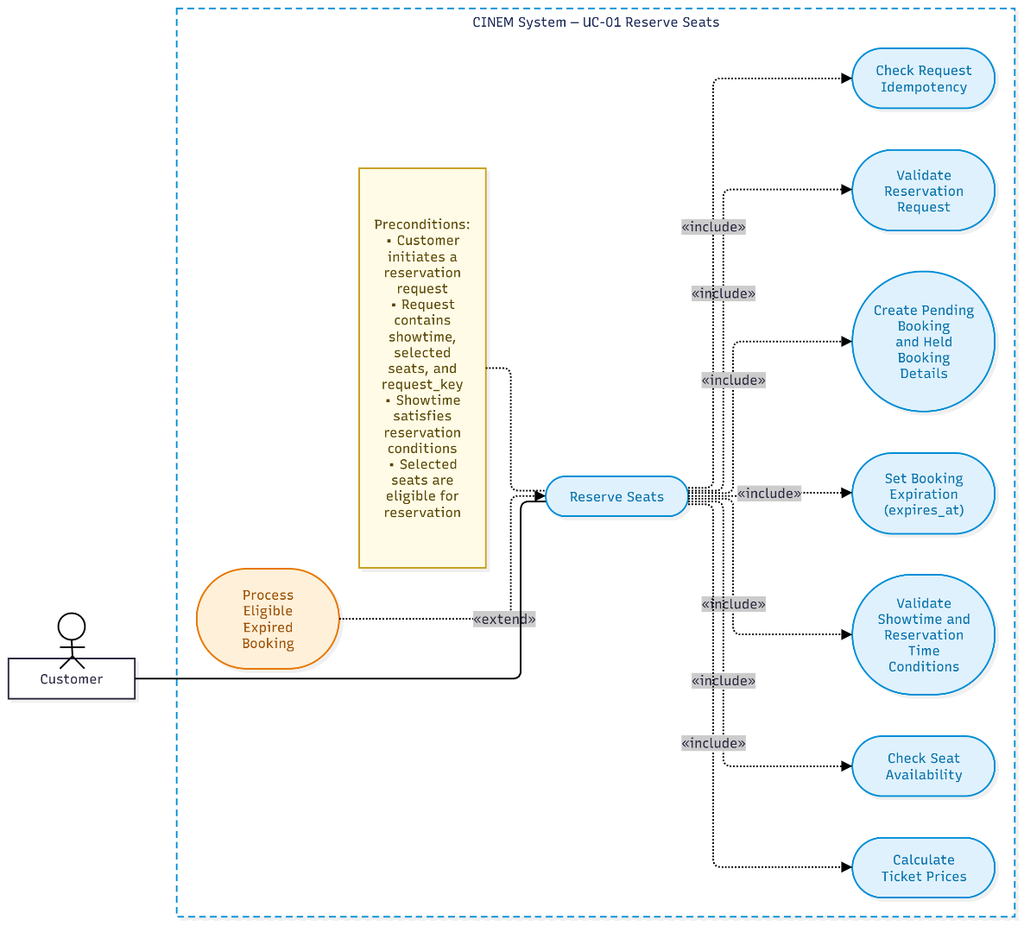
Figure 1: Use-Case Diagram UC-01 Reserve Seats
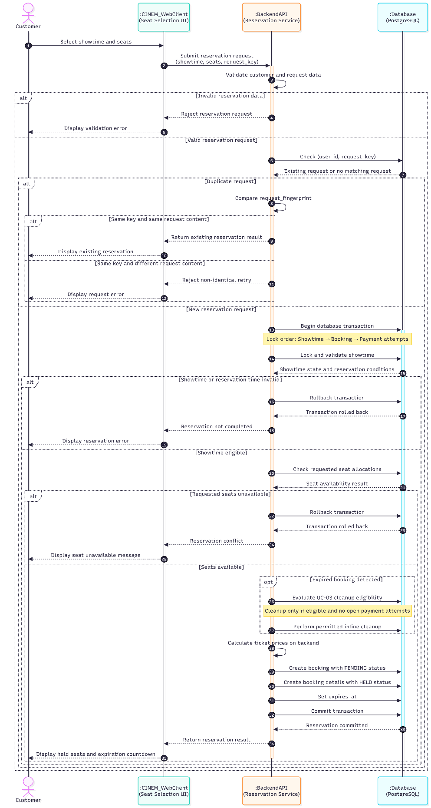
Figure 2: Sequence Diagram UC-01 Reserve Seats

UC-02 Payment Webhook

Use-Case Name

Brief Description
This use case describes how the system receives and processes payment notifications from the payment gateway. The system records payment events, processes payment outcomes, and applies a successful payment to the associated booking only when the booking remains eligible for confirmation. A successful payment that cannot be applied through the normal confirmation flow is routed to payment reconciliation.

Flow of Events

Basic Flow
- The payment gateway sends a payment notification to the system.
- The system receives the notification and records a payment event with the received status.
- The system processes the payment event and verifies the payment outcome according to the payment processing requirements.
- The system records the processing result by updating the payment event status to the applicable defined status.
- If the payment outcome is successful, the system checks whether the associated booking remains eligible for confirmation.
- If the booking is eligible for confirmation, the system applies the successful payment outcome according to the booking confirmation rules.
- If the payment succeeds but cannot be applied through the normal confirmation flow, the system routes the case to payment reconciliation.
- The system records the processing outcome.
The exact webhook payload, signature-verification procedure, response codes, and other gateway-specific details are not specified in the available source.

Alternative Flows

Payment Event Processing Fails
- The system cannot successfully process the received payment event.
- The system records the payment event with the failed status, where applicable.
- The resulting payment and booking states follow the applicable payment processing and recovery rules.
The specific failure conditions and recovery procedure are not fully specified in the available source.

Payment Succeeds but the Booking Is No Longer Eligible for Confirmation
- The system verifies that the payment succeeded.
- The system determines that the associated booking cannot be confirmed through the normal payment-application flow.
- The system preserves the verified financial outcome and does not set applied_at, confirm the booking, move details to sold, or issue tickets.
- The system routes the case to payment reconciliation and records refund_required or needs_review according to the available evidence.
Refund execution is handled separately by UC-04A and remains outside the current demonstration scope.

Payment Succeeds and the Booking Is Eligible for Confirmation
- The system verifies that the payment succeeded and that the associated booking remains eligible for confirmation.
- The system applies the successful payment outcome according to the booking-confirmation rules, including confirmation of the booking, conversion of held details to sold, and ticket issuance in the required transaction.
The system marks the payment event processed only after the applicable business changes have committed successfully.

Duplicate or Uncertain Payment Notification
- The system detects a duplicate notification or cannot establish a definitive payment outcome from the received notification.
- A duplicate notification does not apply the same successful payment outcome more than once; an uncertain outcome is not treated as successfully applied.
The system retains the event or unresolved payment state and routes it for the applicable retry or reconciliation handling without inventing gateway-specific behavior.

Special Requirements
The system must maintain payment event records and handle payment outcomes consistently with the booking confirmation and payment reconciliation rules. Gateway-specific technical requirements and additional nonfunctional requirements are not specified in the available source.

Payment Event Tracking and Consistency
- The system must maintain payment event records using the defined statuses: received, processed, and failed.
- Payment event status and payment status must be treated as distinct concepts.
- A successful payment must not be treated as an applied payment solely because the gateway reports success.
- A booking may be confirmed only after the successful payment outcome has been applied according to the booking confirmation rules.
- A successful payment that cannot be applied through the normal confirmation flow must be routed to payment reconciliation.
- Duplicate notifications must not cause the same successful payment outcome to be applied more than once.
- An uncertain payment outcome must not be treated as a successfully applied payment.
The exact implementation mechanisms and additional nonfunctional requirements are not specified in the available source.

Preconditions
- The system receives a payment notification from the payment gateway.
- The notification contains sufficient information for the system to associate the event with the relevant payment or booking.
The exact payload requirements and any additional preconditions are not specified in the available source.

Postconditions

Successfully Processed Payment Event
- The payment event is recorded and its processing outcome is reflected in the event status.
- If the payment succeeds and the booking remains eligible for confirmation, the successful payment outcome is applied according to the booking confirmation rules.
- If the payment succeeds but the booking cannot be confirmed through the normal flow, the case is routed to payment reconciliation.

Failed Payment Event Processing
- A failed payment event may be recorded with the failed status.
- An uncertain payment outcome is not treated as a successfully applied payment.
- The resulting payment and booking states depend on the applicable processing and recovery rules, which are not fully specified in the available source.

Extension Points
Payment reconciliation is a related process for handling a successful payment that cannot be applied through the normal booking confirmation flow. The available source does not specify a formal UML extension relationship or an exact extension point location.

Payment Reconciliation
When a successful payment cannot be applied through the normal confirmation flow, the system routes the case to payment reconciliation for further handling according to the reconciliation rules.
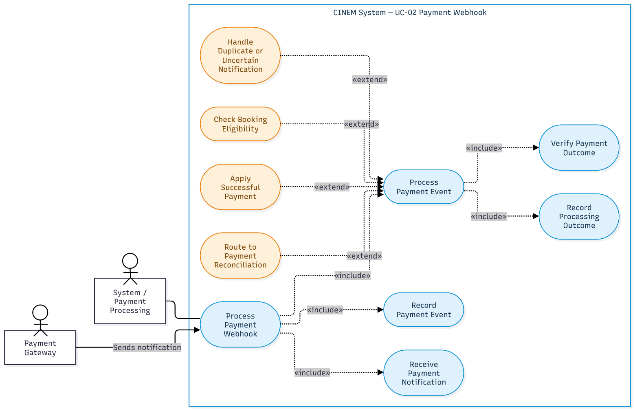
Figure 3: Use-Case Diagram UC-02 Payment Webhook
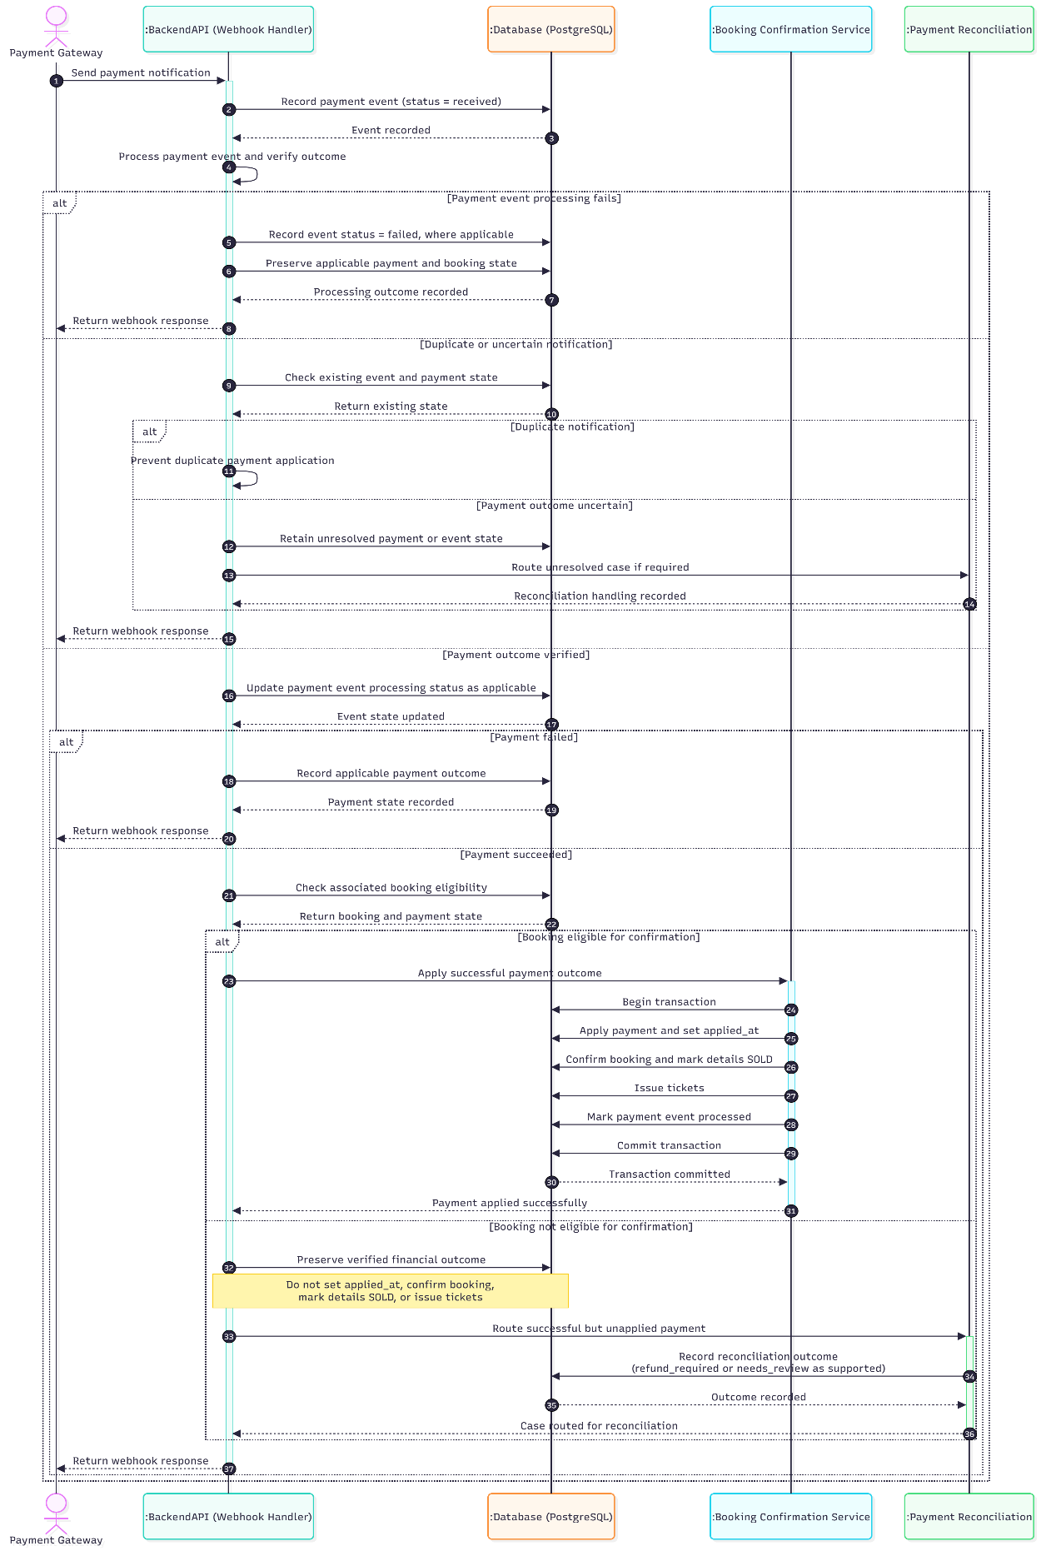
Figure 4: Sequence Diagram UC-02 Payment Webhook

UC-03 Release Expired Bookings

Use-Case Name

Brief Description
This use case describes how a system worker identifies and processes bookings whose seat-hold expiration time has passed. The system releases held seats only when the booking satisfies the applicable expiration and payment-safety conditions.
The process must preserve consistency between booking and booking-detail states, coordinate concurrent processing with payment webhooks, and avoid treating an expired seat hold as proof that a payment has failed. Payment attempts that may still be processed must be handled according to the configured grace period and payment reconciliation rules. When an external payment status query is required, it must be performed outside the database transaction that holds business locks.

Flow of Events

Basic Flow
- The system worker starts the expired-booking processing task. The task may also be triggered by inline cleanup during UC-01, subject to the conditions specified in that use case.
- The system scans for candidate bookings using the booking-expiration index. Eligible candidates are bookings whose status is pending and whose expires_at time has been reached or passed.
- The system begins processing each candidate according to the established database locking protocol: Showtime → Booking → Payment attempts. The initial scan must not hold booking locks for an unnecessarily long period or violate the required lock order.
- After acquiring the required locks, the system reads the current booking state, associated payment attempts, and database time using clock_timestamp().
- The system verifies that the booking is still pending and that its expires_at time has passed. If the booking has changed state or has not actually expired, the system skips it according to Alternative Flow A2.
- The system examines the associated payment attempts and determines whether any attempt requires further protection under the grace-period and reconciliation rules.
- If no payment attempt requires further protection, the system updates the booking and its associated booking details within the same database transaction:
  - Changes the booking status from pending to expired.
  - Changes all associated booking details with allocation_status = held to allocation_status = released.
  - Sets released_at according to the database schema.
- The system commits the transaction. The booking and booking-detail changes must either commit together or be rolled back together.
- After the release transaction commits successfully, the released seats may become available for new reservations, provided that no other effective seat allocation exists for the same showtime.

Alternative Flows

Booking Is No Longer Pending
- The system re-reads the booking after acquiring the required locks.
- The system finds that the booking is no longer pending or that its expires_at time has not passed according to the database clock.
- The system skips the booking because it is not eligible for expiration through this processing attempt.
- The system does not change the booking or its booking details through this processing attempt.

Payment Is Still Within the Grace Period
- The worker detects a payment attempt in created, pending, or unknown state.
- The attempt is still within the configured grace period.
- The worker leaves the booking and seat allocations unchanged.
- The booking is eligible for a later retry or reconciliation.

Payment Gateway Verification Is Required
- The worker determines that payment status requires verification.
- The worker ends the current transaction and releases database locks.
- The worker queries the Payment Gateway outside the transaction.
- The worker begins a new transaction and re-reads the booking and payment states.
- The worker proceeds only if the current state confirms that release is safe.

Payment Succeeded but Has Not Been Applied
- The worker detects a successful payment that has not yet been applied to the booking.
- The worker does not release the booking's seats.
- The case is coordinated with UC-02 to resolve the payment and booking state consistently.

Payment Succeeded After the Booking Was Released
- The worker or reconciliation process detects a successful payment after the booking has expired or its seats have been released.
- The system does not reclaim seats that may already have been allocated to another booking.
- The payment is handled according to the applicable state, such as refund_required or needs_review.
- Refund processing, if enabled, follows UC-04A.

Multiple Workers Process the Same Booking
- Multiple workers identify the same candidate booking.
- Database locking and state revalidation prevent conflicting releases.
- Only a valid state transition is committed. Repeated processing does not create additional releases.

Database Error
- An error occurs during the release transaction.
- The transaction is rolled back.
- The booking and its associated seat allocations are not left partially updated.
- The worker may retry according to the configured retry policy.

Worker Delayed or Unavailable
- The worker does not process the expired booking on time.
- The booking may remain pending and its seats may remain held until cleanup runs.
- Passing the expiration time alone does not mean that the booking has been released.

Special Requirements
This section describes the consistency, concurrency, and reliability requirements specific to automatic expiration of bookings and release of held seats. The worker must process eligible bookings safely, preserve consistency between booking and booking-detail states, and avoid releasing seats while a payment attempt may still be processed. The process must be idempotent so that repeated execution does not produce inconsistent state changes. Database row locking must prevent conflicting processing, and network calls must not be performed while database locks are held. Unresolved payment outcomes must be deferred to asynchronous reconciliation rather than treated as payment failures.

Booking and Seat-Allocation Consistency
- Only bookings in the pending state are eligible for expiration through this flow.
- A booking may be expired when its expires_at time has passed and it is safe to release its held seats.
- The booking status and associated booking-detail allocation statuses must be updated consistently.
- Released booking details must have released_at set to the release time.
- The worker must revalidate booking eligibility after acquiring the required locks.
- The worker must be idempotent and safe to run concurrently.

Payment Safety
- The system must not introduce a Payment.expired status; expiration applies to the booking.
- Payment attempts with created, pending, or unknown statuses must not automatically be treated as failed.
- Payment attempts that remain within the configured grace period must be protected from premature seat release.
- Unresolved payment outcomes must be handled through the applicable payment reconciliation process.
- If an external payment-status query is required, the system must not perform the network call while database locks are held.
- A successful payment must not be ignored solely because the booking's seat-hold expiration time has passed.

Preconditions
Before this use case begins, the system worker must be able to execute the expired-booking processing task. A candidate booking may be identified when its status is pending and its expires_at time has passed. The system must be able to access the relevant booking, booking-detail, and payment-attempt records to determine whether the booking can be safely expired. The booking's eligibility must be verified again after the required database locks have been acquired.

Postconditions
Immediately after this use case finishes, the system may be in one of the following states:

Successfully Released Booking
- The booking status is expired.
- The associated held booking details have been changed to released.
- The released booking details have released_at set.
- The booking and booking-detail changes have been committed in the same database transaction.
- The released seats may become available for reservation, provided that no other effective seat allocation exists for the same showtime.

Booking Deferred for Payment Reconciliation
- The booking is not silently expired and its seats are not silently released while a payment outcome remains unresolved and may still be processed.
- The unresolved payment outcome is left for the applicable payment reconciliation process.
- The exact resulting booking and allocation states for every unresolved-payment scenario depend on the applicable grace-period and reconciliation rules.

Booking Skipped
- A booking that is no longer pending is skipped by the expiration worker.
- No conflicting state changes are applied by that processing attempt.

Processing Failed
- The release transaction is rolled back if a database error prevents successful completion.
- The booking and booking details are not left partially updated by the failed transaction.
- The booking may be considered for subsequent processing according to the applicable retry policy.

Extension Points
This section identifies related processes that may be invoked when the normal expiration flow cannot safely complete.

Payment Reconciliation
When a payment attempt remains unresolved and may still be processed, the booking is not silently expired and its seats are not silently released. The unresolved payment outcome is deferred to the applicable payment reconciliation process. The exact formal relationship between this use case and the payment reconciliation use case is not fully specified in the available requirements.

Payment Processing

When a successful payment has not yet been applied to the booking, the system coordinates the case with UC-02 to resolve the booking and payment states consistently.

Refund Handling
When a successful payment is detected after the booking has expired or its seats have been released, the system must not reclaim seats that may already have been allocated to another booking. If the applicable payment state requires a refund and refund processing is enabled, the case may be handled through UC-04A.
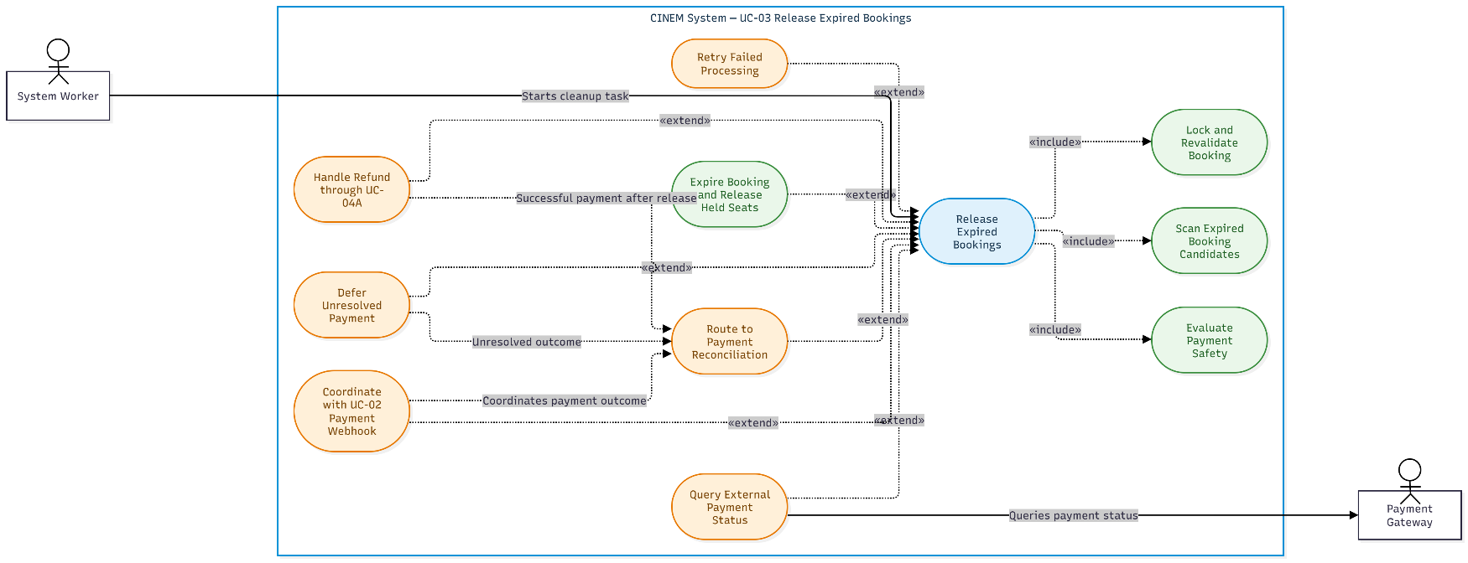
Figure 5: Use-Case Diagram UC-03 Release Expired Bookings
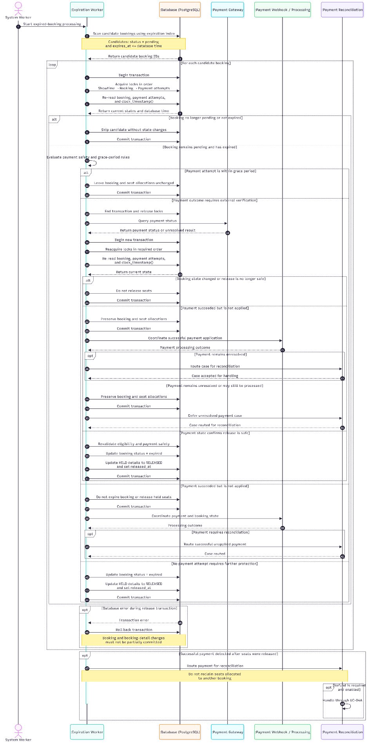
Figure 6: Sequence Diagram UC-03 Release Expired Bookings

UC-04 Payment Reconciliation

Use-Case Name

Brief Description
This use case describes how the System Worker reconciles payment records whose financial outcomes remain unverified or whose data requires further investigation. The system queries the payment gateway outside any database transaction holding business locks, verifies the gateway response, and re-reads the current payment and booking states before recording the verified outcome.
When a payment is verified as successful, the system preserves the actual financial result and evaluates whether the payment can be applied to the associated booking according to UC-02 — Process Payment Webhook. If the booking remains eligible for confirmation, the system delegates payment application to UC-02. If the payment cannot be applied, the system routes the case to needs_review or refund_required, as appropriate.
When a payment is verified as failed or cancelled, the system records the corresponding financial outcome. If the payment outcome remains unknown, the system retains an appropriate unresolved state and schedules further reconciliation according to the applicable retry policy.
Reconciliation determines the verified financial outcome and the appropriate subsequent handling. It does not itself execute a refund. Actual refund execution is outside the scope of the demonstration and is addressed separately by UC-04A — Refund.

Flow of Events

Basic Flow
- The System Worker identifies a payment requiring reconciliation, including a payment whose financial outcome remains unresolved or whose record requires further verification.
- The System Worker collects the payment information and transaction identifiers required to verify the financial outcome.
- The System Worker queries the payment gateway through the applicable Query/Check Status API outside any database transaction holding business locks.
- The system verifies the gateway response and opens a new database transaction.
- The system acquires the necessary database locks according to the established locking protocol and re-reads the current payment and associated booking states.
- The system evaluates the verified gateway response against the current database records. An older response must not overwrite a previously verified successful payment outcome.
- If the gateway confirms a successful payment and the financial information is consistent, the system records payment.status = succeeded and the available verified financial information, including the applicable payment timestamps, received amount, received currency, and provider transaction identifier.
- The system evaluates whether the payment can be applied to the associated booking according to the eligibility rules defined in UC-02 — Process Payment Webhook.
- If the booking remains eligible for confirmation, the system delegates payment application to UC-02. Booking confirmation, seat allocation updates, and ticket issuance must follow the transaction and consistency requirements defined in UC-02.
- If the payment succeeded but cannot be applied to the booking, the system preserves the verified financial outcome and determines whether the case requires refund_required or needs_review, according to the available evidence and applicable business rules.
- If the gateway confirms that the payment failed or was cancelled, the system records the corresponding verified payment outcome without treating an unverified response or timeout as proof of failure.
- If the payment outcome remains unknown, the system retains the appropriate unresolved payment state, updates next_reconcile_at according to the applicable retry policy, and records the information required for monitoring and subsequent reconciliation.
- The system commits the applicable database changes. Any event or reconciliation record associated with the operation must not be marked as successfully processed before the corresponding changes have been committed.
- The system completes the reconciliation attempt and leaves unresolved cases available for subsequent processing or authorized review, as applicable.

Alternative Flows

Payment Gateway Timeout or Error
- The System Worker attempts to query the payment gateway.
- The gateway times out, becomes unavailable, or returns an error that prevents the system from verifying the financial outcome.
- The system does not conclude that the payment failed solely because the query timed out or returned an inconclusive response.
- The system retains an appropriate unresolved payment state and records the error information needed for monitoring.
- The system schedules another reconciliation attempt according to the applicable retry policy.
- The system completes the current attempt without applying an unverified financial outcome.
The exact retry intervals, maximum retry duration, and escalation thresholds remain subject to the applicable open questions.

Conflicting or Out-of-Order Payment Results
- The system receives a gateway response that conflicts with a previously verified payment outcome or arrives out of order.
- The system compares the response with the current payment record and available transaction evidence.
- If the payment has already been verified as succeeded, the system does not downgrade its financial status solely because an older response reports failure.
- The system records the conflicting information as appropriate and routes the case to needs_review when further investigation is required.
- The system preserves the existing booking and ticket state unless a separate, authorized business process determines otherwise.

Payment Already Applied but Reconciliation Data Is Inconsistent
- The system identifies a payment that has already been applied to its booking but whose reconciliation data contains a discrepancy.
- The system records the discrepancy and sets payment.reconciliation_status = needs_review, as applicable.
- The system does not automatically reverse applied_at, cancel a confirmed booking, release sold seats, or invalidate issued tickets solely because the reconciliation data is inconsistent.
- The case remains subject to further investigation and an authorized resolution.

Successful Payment but Booking Is No Longer Eligible for Confirmation
- The system verifies that the payment succeeded.
- The system determines that the associated booking cannot be confirmed through the normal payment-application flow.
- The system preserves payment.status = succeeded and the verified financial information.
- The system does not apply the payment, confirm the booking, reclaim released seats, or issue tickets for a booking that is no longer eligible.
- The system sets payment.reconciliation_status = refund_required when the evidence establishes that a refund is required. Otherwise, it uses needs_review when further verification or a business decision is necessary.
- The system leaves refund execution to UC-04A — Refund, which is outside the scope of the demonstration.

Multiple Workers Reconcile the Same Payment
- Two or more workers identify the same payment for reconciliation.
- The system uses the applicable locking, claim, or conditional-update mechanism to prevent duplicate business effects.
- Each worker evaluates the current payment and booking states before applying changes.
- Only a worker that can validly process the current state performs the applicable updates.
- Subsequent workers recognize the updated state and avoid repeating completed business operations.
- The processing remains idempotent when retried.

Payment State Changes While the Gateway Is Being Queried
- The System Worker queries the gateway outside the database transaction.
- While the query is in progress, a webhook or another worker updates the payment or booking.
- After receiving the gateway response, the System Worker opens a new transaction, acquires the required locks, and re-reads the current records.
- The system evaluates whether the verified gateway response remains applicable to the latest state.
- If the response is outdated or conflicts with a newer verified result, the system does not blindly overwrite the current state. It preserves the newer result and routes the discrepancy for further reconciliation when necessary.

Payment Amount or Currency Does Not Match
- The system verifies that the gateway reports a successful payment.
- The system compares the received amount and currency with the expected payment amount and currency.
- If the received amount or currency does not match, the system preserves the verified financial outcome and records the actual received amount and currency when available.
- The system does not apply the payment to the booking while the applicable payment conditions remain unsatisfied.
- The system sets payment.reconciliation_status = needs_review and retains the discrepancy for further investigation.
- The system does not modify the booking total merely to match the amount received.
- The case remains subject to the applicable reconciliation and refund-handling rules.

Special Requirements
This section describes the consistency and verification requirements specific to payment reconciliation. The system must use verified payment outcomes when updating payment records and determining reconciliation states. Reconciliation must remain consistent with booking confirmation rules. A successful payment that cannot be applied to the associated booking through the normal confirmation flow must be classified for further review or refund handling. Actual refund execution is outside the scope of the demonstration.

Payment Verification and Reconciliation State
- The system must query the payment gateway outside any database transaction holding business locks.
- After obtaining the gateway response, the system must open a new transaction, acquire the necessary locks, and re-read the current payment and booking states before updating records.
- The system must not treat a timeout, unavailable gateway, or inconclusive response as proof that a payment failed.
- Verified financial outcomes must be recorded consistently with the payment schema.
- The system must preserve a previously verified successful payment outcome against an older or out-of-order response.
- The system must distinguish a successful payment from a payment that has been applied to a booking.
- A payment may be applied only when the associated booking satisfies the eligibility requirements defined in UC-02.
- A successful payment that cannot be applied must be routed to needs_review or refund_required, as appropriate.
- The reconciliation state must use the defined values: none, needs_review, refund_required, and resolved.
- refund_required indicates that a refund is required; it does not indicate that the refund has been completed.
- A reconciliation record must not be marked resolved until the applicable resolution conditions have been satisfied.
- The system must use appropriate locking, conditional updates, or equivalent safeguards to prevent duplicate business effects when workers run concurrently or retry an operation.
- Actual refund execution is outside the scope of the demonstration and is specified separately in UC-04A.
Additional retry intervals, maximum automatic reconciliation duration, escalation thresholds, and detailed manual-review permissions remain subject to the applicable open questions.

Preconditions
Before this use case begins, the system must have a payment record that requires reconciliation. The payment must be identifiable through the available payment and transaction information and associated with its booking when applicable. If gateway verification is required, the payment gateway must be available as the source of the transaction outcome, although an unsuccessful query does not prevent the system from retaining the unresolved payment for subsequent reconciliation.
The payment may be in an unresolved financial state, may contain information requiring verification, or may have a reconciliation status that requires further handling. A payment already resolved should not be selected for further reconciliation unless a new event or discrepancy requires additional processing.
Additional preconditions are not specified in the available source.

Postconditions
Immediately after this use case finishes, the system may be in one of the following states:

Payment Outcome Verified and Payment Applied
- The verified financial outcome is recorded in the payment record.
- The payment is applied only if the associated booking satisfies the eligibility requirements defined in UC-02.
- The booking, seat allocations, and issued tickets are updated according to UC-02.
- The related database changes are committed consistently within the transaction required by UC-02.
- Reconciliation processing does not create duplicate payment applications or ticket issuance.

Payment Outcome Verified but Payment Not Applied
- The verified financial outcome is preserved in the payment record.
- The payment is not applied to a booking that is no longer eligible for confirmation.
- The system does not reclaim released seats or issue tickets for an ineligible booking.
- The reconciliation status is set to refund_required or needs_review, as appropriate.
- Actual refund execution is not performed as part of this demonstration.

Payment Outcome Verified as Failed or Cancelled
- The corresponding verified financial outcome is recorded in the payment record.
- The system does not treat an inconclusive response as a verified failure or cancellation.
- Any further changes to the booking or payment records follow the applicable payment-processing rules.

Payment Outcome Remains Unresolved
- The payment retains an appropriate unresolved state.
- The next reconciliation attempt is scheduled according to the applicable retry policy when such scheduling is supported.
- The system records the information required for monitoring and subsequent processing.
- No financial or booking state is changed based solely on an unverified assumption.

Reconciliation Attempt Fails
- Database changes belonging to a failed transaction are rolled back.
- The system does not mark the corresponding operation as successfully processed before its required changes have been committed.
- A subsequent attempt can re-evaluate the current payment and booking states without duplicating completed business effects.

Extension Points
This section identifies the related payment-processing and refund-handling flows that may be invoked when reconciliation verifies a payment outcome.

Payment Reconciliation
When reconciliation verifies that a payment succeeded and the associated booking remains eligible for confirmation, the system delegates the payment-application process to UC-02 — Process Payment Webhook. UC-02 defines the applicable eligibility checks and the consistent update of the payment, booking, seat allocations, and tickets.
When a payment succeeded but cannot be applied to the associated booking, the system preserves the verified financial outcome and classifies the case as refund_required or needs_review, as appropriate. A case classified as refund_required may be handled by UC-04A — Refund when the relevant functionality and business authorization are available.
The exact formal UML relationship between these use cases is not specified in the available source.
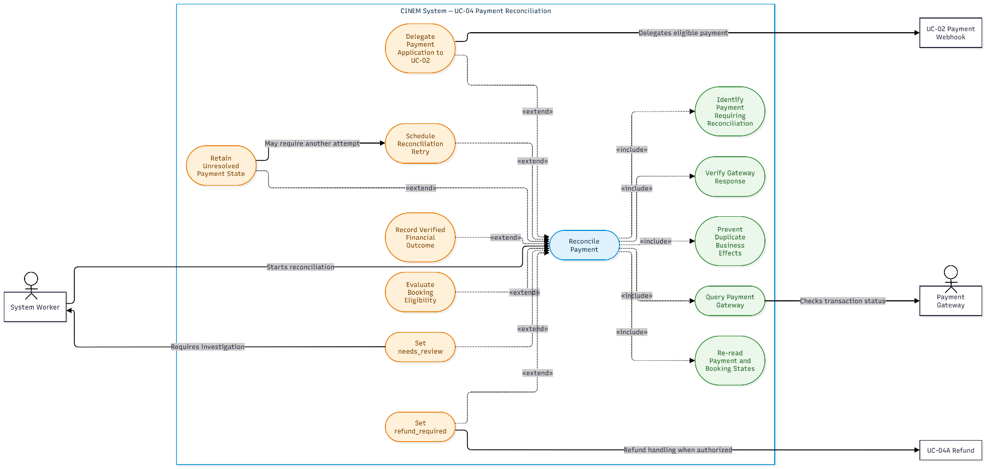
Figure 7: Use-Case Diagram UC-04 Payment Reconciliation
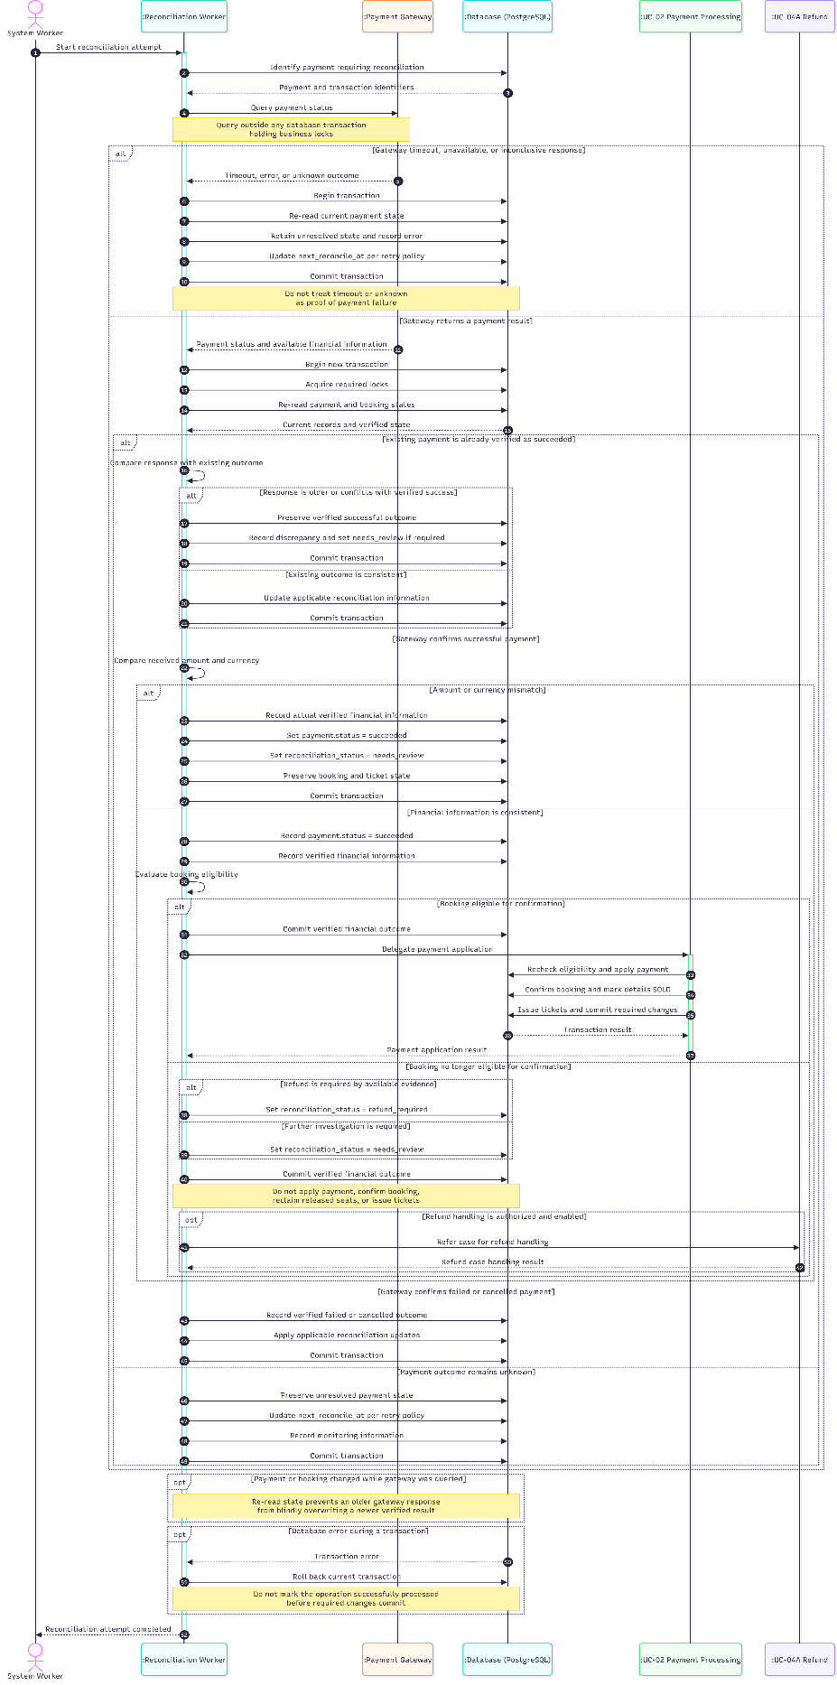
Figure 8: Sequence Diagram UC-04 Payment Reconciliation

UC-04A Refund

Use-Case Name

Brief Description
This use case describes the processing and tracking of a refund for a payment that has been determined to require a refund. The system records the refund request, submits it to the payment gateway, and tracks the result until the refund is verified as successful or the case requires further review. Refund processing is separate from payment reconciliation (UC-04). This use case defines the expected behavior and data contract; refund execution is outside the current demo scope.

Flow of Events

Basic Flow
- The system identifies a payment whose reconciliation outcome indicates that a refund is required.
- The system verifies that the associated payment has status succeeded and that no successful refund has already been recorded for the payment.
- The system creates or retrieves the refund record associated with the payment, subject to the applicable data constraints.
- The system generates and records a stable merchant_refund_id for the refund request.
- When refund execution is enabled, the system submits the refund request to the payment gateway using the recorded merchant_refund_id. The external gateway call is performed outside a database transaction that holds business locks.
- The system records the available response and updates the refund status according to the verified outcome.
- If the gateway confirms that the refund has succeeded and the result is verified, the system updates the refund status to succeeded and records completed_at.
- The system marks the associated reconciliation issue as resolved only after the successful refund has been verified and the corresponding database changes have been committed.
- The use case ends.

Alternative Flows

The Refund Result Is Unknown
- The payment gateway does not provide a verifiable final result, for example, because the request times out or the response is inconclusive.
- The system records or retains the refund status as unknown or pending, according to the available evidence.
- The system records relevant error or retry information and schedules or performs a subsequent status check when appropriate.
- The system reuses the same merchant_refund_id when checking or retrying the same refund request.
- The system does not treat the refund as successful and does not mark the reconciliation issue as resolved until success is verified.

The Refund Request Fails
- The payment gateway provides a verifiable result confirming that the refund has failed.
- The system updates the refund status to failed.
- The system records relevant response or error information.
- The system marks the associated reconciliation issue as needs_review so that the case can be reviewed or handled according to the applicable business process.
- The use case ends.

The Refund Request Must Be Retried
- The system determines that retrying the refund request is appropriate under the applicable retry policy.
- The system reuses the existing merchant_refund_id for the same refund request.
- The system checks the current refund status and any available gateway result before submitting or retrying the request.
- The system records the retry information, including next_retry_at and last_error where applicable.
- The system avoids creating a duplicate refund record or causing a duplicate refund operation for the same payment.
- The system continues processing according to the verified refund outcome.

The Refund Has Already Been Recorded or Processed
- The system finds an existing refund record for the payment or determines that the refund has already succeeded.
- The system checks the existing refund status and available processing evidence.
- The system does not create another refund record or repeat a completed refund operation.
- If the existing result is succeeded and the corresponding reconciliation issue has satisfied the resolution conditions, the system retains the resolved outcome.
- If the existing result is inconclusive or inconsistent, the system preserves the available evidence and routes the case for further review as appropriate.

Special Requirements
The following special requirements describe constraints and quality requirements that apply to the execution of this use case.

Refund Request Identity and Idempotency
- The system must use a stable merchant_refund_id to identify a refund request.
- The same merchant_refund_id must be reused when retrying or checking the outcome of the same refund request.
- Repeated processing, duplicate events, or worker retries must not cause duplicate refund records or duplicate business effects.
- The data model defines the uq_refund_payment uniqueness constraint to restrict refund records to the applicable rule of one refund record per payment.

Refund Status and Verification
- The system must distinguish a verified refund failure from a timeout, an inconclusive response, or an unknown outcome.
- The refund status must not be set to succeeded until the successful refund outcome has been verified.
- The refund status values defined for this use case are pending, unknown, succeeded, and failed.
- The system must retain relevant refund processing information, including retry scheduling and error details such as next_retry_at and last_error where applicable.

Reconciliation Resolution
- A refund being accepted by the payment gateway does not, by itself, mean that the refund has completed.
- The associated reconciliation issue may be marked resolved only when refund.status = succeeded has been verified and the corresponding changes have been committed.
- If the refund fails or remains unresolved, the system must not mark the reconciliation issue as resolved.
- Refund execution is outside the current demo scope. The behavior specified here defines the expected contract and does not imply that a complete refund integration is already implemented.

Preconditions
The preconditions describe the conditions that must be satisfied before this use case can begin.
- The associated payment has status succeeded.
- The payment has been determined to require a refund through the applicable reconciliation or business process.
- The system can identify the associated payment and its refund state.
- No successful refund has already been recorded for the payment.
- The system has sufficient information to identify the refund request and interact with the payment gateway, if refund execution is enabled.
- The applicable refund policy and processing authority must be established before operational refund execution is enabled.

Postconditions
The postconditions describe the state of the system after this use case completes or terminates through an alternative flow.

Refund Successfully Verified
- The refund status is succeeded.
- The system records completed_at.
- The associated reconciliation issue is marked resolved only after the successful refund has been verified and the corresponding changes have been committed.
- The refund record and relevant processing information are retained.

Refund Failure Verified
- The refund status is failed.
- Relevant response or error information is retained.
- The associated reconciliation issue is marked needs_review.
- The system does not treat the failed refund as resolved.

Refund Outcome Remains Unknown
- The refund status remains pending or unknown, according to the available evidence.
- Relevant retry scheduling and error information are retained where applicable.
- The associated reconciliation issue is not marked resolved solely because a refund request was submitted or accepted.
- The refund remains available for subsequent verification or review.

Retry Required
- The existing refund record and merchant_refund_id are reused for the same refund request.
- Relevant retry information is updated where applicable.
- No duplicate refund record or duplicate business effect is created.

Extension Points
The extension points describe where this use case may be invoked by or interact with other use cases.

Payment Reconciliation (UC-04)
UC-04 may identify a payment whose financial outcome has been verified but cannot be applied to the booking, and determine that a refund is required. That outcome may initiate UC-04A. UC-04 determines the reconciliation outcome; UC-04A handles the refund process and its result. The reconciliation issue is not considered resolved until the refund has been verified as successful or another valid, business-approved resolution has been recorded.
The exact formal UML extension relationship and extension-point location are not specified in the available source.
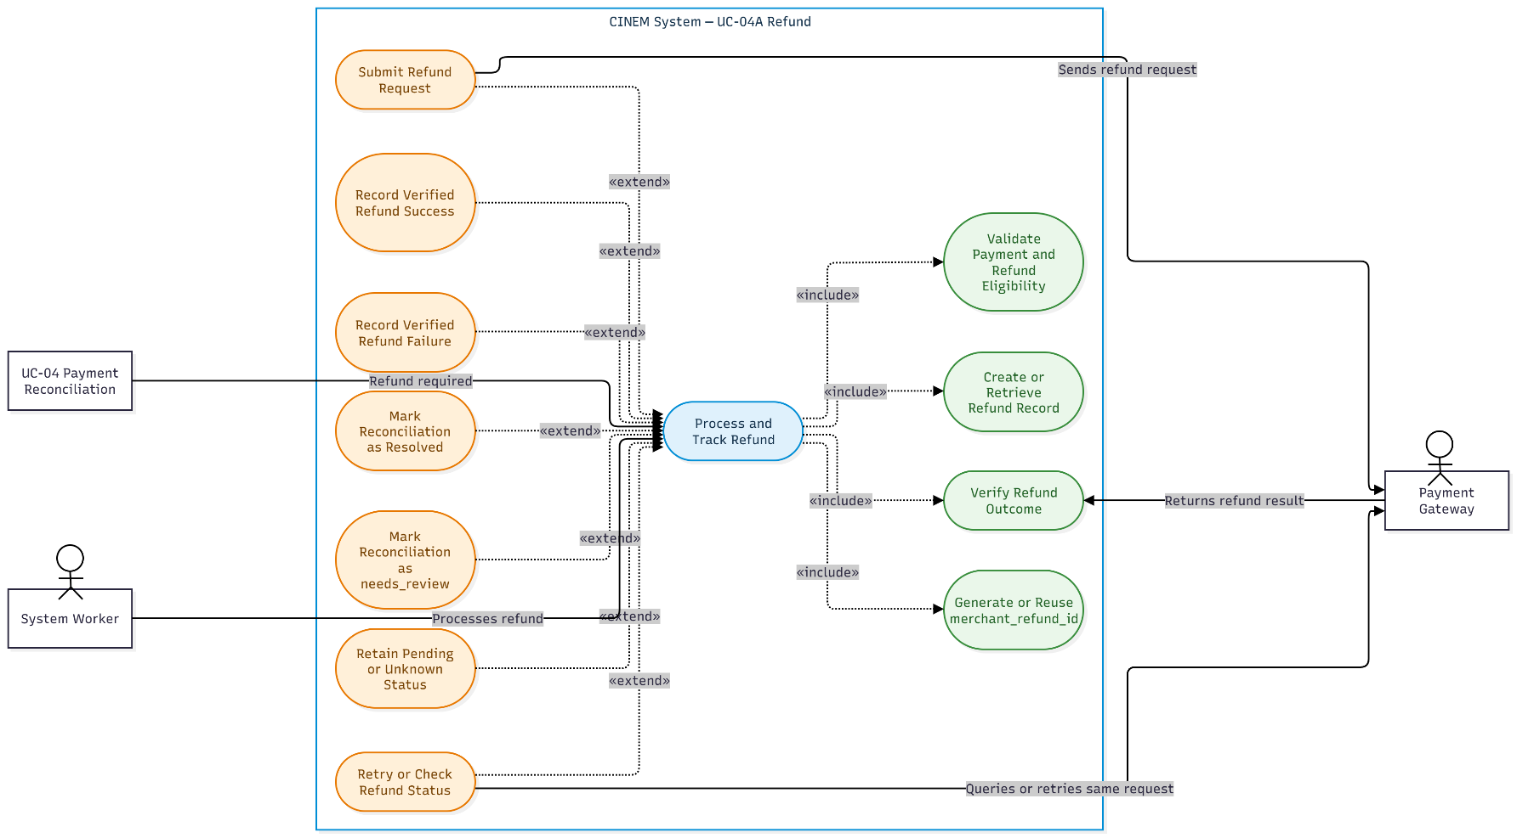
Figure 9: Use-Case Diagram UC-04A Refund
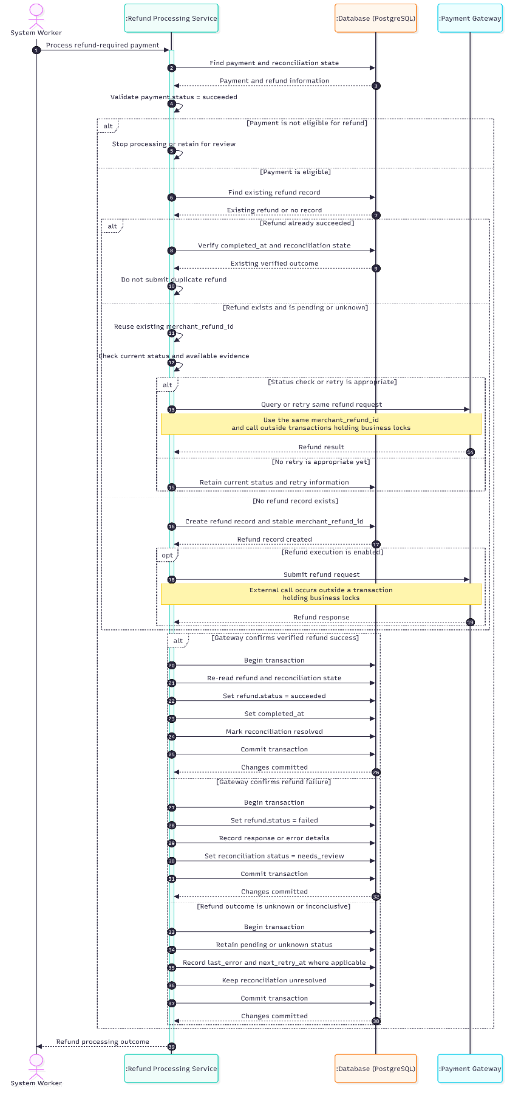
Figure 10: Sequence Diagram UC-04A Refund

UC-05 Validate Ticket

Use-Case Name

Brief Description
This use case allows Staff to validate a ticket identified by its QR code or ticket code, admit a valid ticket once, and prevent reuse or invalid admission. It validates the ticket in the context of the applicable showtime and admission window. A Couple booking produces separate tickets that are validated independently.

Flow of Events

Basic Flow
- The Staff user initiates ticket validation by scanning the ticket's QR code or entering its ticket code.
- The system receives the ticket code and verifies that it has the expected UUID format.
- The system retrieves the ticket and its associated booking, booking detail, showtime, and seat information.
- The system verifies that the ticket exists and that the associated booking is confirmed, the booking detail is sold, and the ticket is in the valid state.
- The system verifies the showtime context. If a showtime has been selected for the validation process, the system checks whether the ticket belongs to that showtime. If the showtime does not match, the system rejects the validation attempt as described in A3. If no showtime has been selected, the system displays the ticket's showtime and room information for verification.
- The system verifies that the current time falls within the configured admission window associated with the showtime. The admission-window rules remain subject to OQ-03 and must not be hard-coded in the use case.
- The system displays the ticket's relevant information, including the showtime, room, and seat. The seat label is obtained from seat_label_snapshot, and the room name is obtained from room_name_snapshot.
- The system performs a conditional state transition from valid to used within a transaction, recording used_at and validated_by_user_id. Only one concurrent validation attempt may successfully perform this transition.
- If the state transition succeeds, the system confirms that the ticket has been validated successfully and displays the result to the Staff user.
- The use case ends successfully.

Alternative Flows

Ticket Already Used
- The system determines that the ticket has already been used.
- The system rejects the validation attempt and informs the Staff user that the ticket has already been used. The system may display used_at for audit purposes.
- The system does not change the ticket state or overwrite the existing successful validation audit information.

Ticket Is Voided
- The system rejects the ticket and displays the stored void reason.
- The system rejects the validation attempt and displays the void reason, if available
- The system does not change the ticket state.
- The use case ends unsuccessfully.

Wrong Showtime, Room, or Admission Window
- The system determines that the ticket does not match the selected showtime, if one has been selected, or that the ticket is outside the configured admission window.
- The system rejects the validation attempt and displays an appropriate warning identifying the reason for rejection.
- The system does not change the ticket state or overwrite any existing successful validation audit information.
- The use case ends unsuccessfully.

Unknown or Malformed Ticket Code
- The system determines that the ticket code is malformed or that no corresponding ticket exists.
- The system rejects the validation attempt and displays a non-disclosing message, such as "Ticket not found".
- The use case ends unsuccessfully.

Booking or Detail Is Not Confirmed for Admission
- The system determines that the associated booking is not confirmed or that the booking detail is not sold.
- The system rejects the validation attempt because the ticket has not been validly issued.
- The system does not change the ticket state.
- The use case ends unsuccessfully.

Database Update Error
- The system encounters an error while updating the ticket state or committing the transaction.
- The system rolls back the transaction if the transaction has not committed successfully.
- The ticket remains valid if the transaction was rolled back, and the Staff user may retry validation.
- The system reports that validation could not be completed.
- The use case ends unsuccessfully.

Successful Commit but Response Lost
- The system successfully commits the transaction that changes the ticket state to used, but the response does not reach the Staff user.
- The ticket remains used, and the successful validation audit information is preserved.
- If the Staff user retries the validation, the system identifies the ticket as already used and follows A1 without overwriting the existing audit information.

Special Requirements
The following special requirements apply to this use case:
- Authorization: Only an authenticated, active Staff user authorized to validate tickets may perform this operation.
- Concurrency: The transition from valid to used must be conditional and transactional so that only one concurrent validation attempt succeeds.
- Auditability: Successful validation must record used_at and validated_by_user_id. Existing successful validation audit information must not be overwritten by subsequent attempts.
- Ticket information: The system uses room_name_snapshot and seat_label_snapshot to display the room and seat information associated with the ticket.
- Admission window: The admission-window rules must follow the configured business rules. The exact rules remain subject to OQ-03 and must not be assumed or hard-coded in this use case.
- Couple tickets: Each ticket associated with a Couple booking detail is validated independently. A booking detail with capacity_units_snapshot = 2 corresponds to two tickets; validating one ticket does not automatically validate the other.
- Showtime context: Whether Staff must select a showtime before scanning or whether the system determines it from the ticket remains subject to OQ-UC-07.

Preconditions
Staff is authenticated, the account is active, and Backend authorization permits ticket validation. The QR code decodes to a valid ticket_code, and the system can access the related ticket, booking detail, booking, showtime, and room data.
- Staff is authenticated and active.
- Staff has the approved ticket-validation permission.
- The Staff account is active and authorized to validate tickets.
- The QR code or entered ticket_code is syntactically valid.
- The system can retrieve the related booking, detail, showtime, and room records.
- The ticket validation process operates in the context of a showtime being checked. The showtime may be selected before scanning or determined from the scanned ticket. The default behavior for selecting or inferring the showtime remains subject to OQ-UC-07.

Postconditions
following postconditions describe the state of the system after the use case ends:

Success:
- The ticket status is changed from valid to used.
- The system records used_at and validated_by_user_id.
- Subsequent validation attempts cannot successfully validate the same ticket again.

Failure:
- If validation is rejected before a successful state transition, the ticket state remains unchanged.
- If a transaction fails before committing, its changes are rolled back and the ticket remains valid.
- If the transaction has already committed successfully but the response is lost, the ticket remains used and its successful validation audit information is preserved.
- The system does not overwrite existing successful validation audit information during subsequent attempts.

Extension Points
This section identifies related navigation points for browsing movies.

Browse Showtimes (UC-07)
The Customer may continue from a movie to UC-07 to view available showtimes. UC-07 must retrieve current showtime and status data; browsing a movie does not guarantee showtime availability or booking success.

Reserve Seats (UC-01)
UC-01 is reached only after the Customer proceeds through showtime selection and submits a reservation request. UC-06 does not create a booking or hold seats.

Open Questions
The following items remain unresolved in the source requirements:
- Which search, filter, and pagination functions are included in the first version?
- Can a movie with status ended still be opened in the customer-facing detail view?
These items must not be treated as confirmed requirements until the corresponding decisions are made.
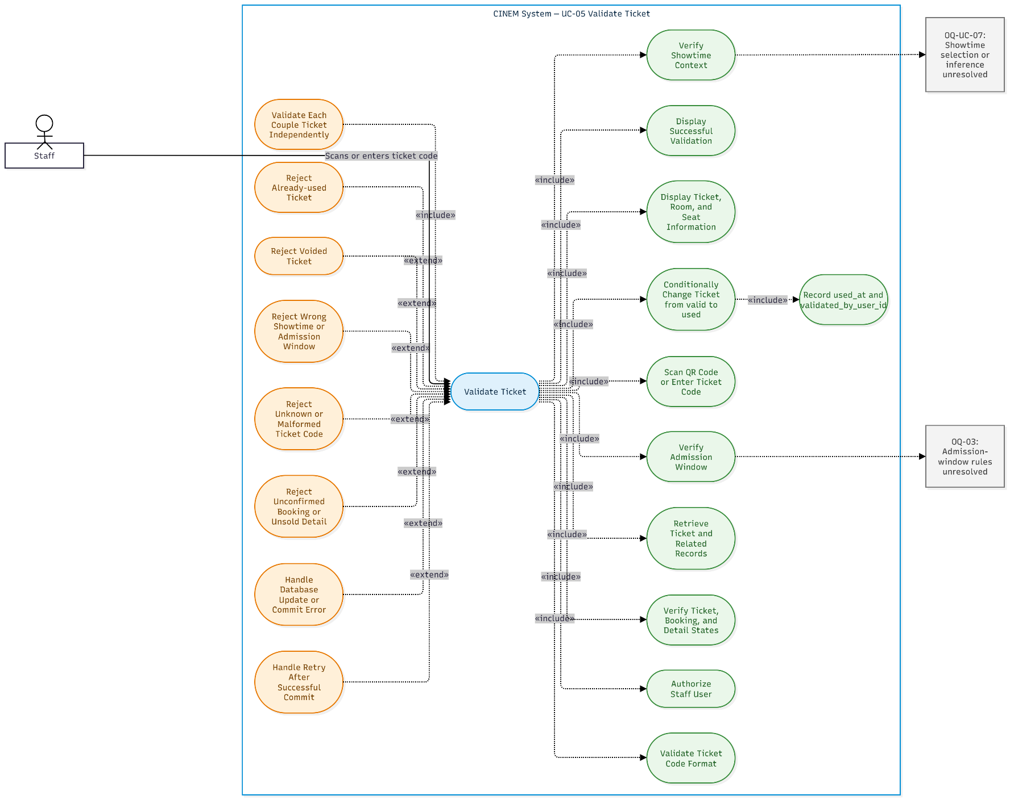
Figure 11: Use-Case Diagram UC-05 Validate Ticket
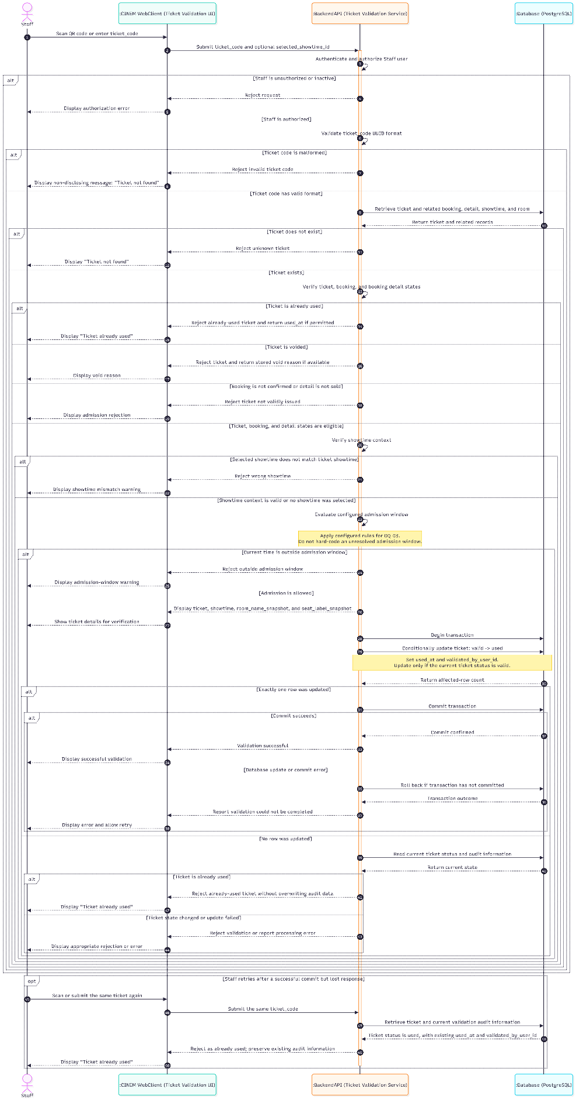
Figure 12: Sequence Diagram UC-05 Validate Ticket

UC-06 Browse Movies

Use-Case Name

Brief Description
This use case allows a Customer to browse the movie catalogue, search or filter available listings where supported, and view movie details. It provides information for choosing a movie and may transfer the Customer to UC-07. It does not create bookings, hold seats, create payment attempts, or process payment.

Flow of Events

Basic Flow
- [Customer] Opens the movie-list page.
- [System] Requests the movie catalogue from the Backend API.
- [System] Retrieves movies eligible for customer display according to the applicable business rules. Only movies with status now_showing or coming_soon are included in the customer-facing list; archived movies are excluded.
- [System] Returns the available movie display data, including title, description, duration, status, and genre information. Poster, age rating, and release date are displayed when the corresponding data is available.
- [Customer] May enter a search term or select a supported filter, if available.
- [System] Applies the supported search or filter conditions and returns the matching list. Pagination metadata is returned if pagination is supported.
- [Customer] Selects a movie.
- [System] Retrieves and displays the available details for the selected movie. Optional fields are displayed only when data exists.
- [Customer] May select the showtime function to continue to UC-07. The movie information previously loaded by UC-06 does not establish that a showtime is currently available or that booking is possible.

Alternative Flows

No Movies Match the Request
- The system returns an empty list and an appropriate message.
- The system treats the empty result as a valid response rather than a system failure.

No Search Results
- The system displays a message indicating that no movies match the supported search or filter conditions.
- The Customer may change the search term or filter, if those functions are supported.

Movie Does Not Exist or Is Not Permitted for Customer Viewing
- The system determines that the requested movie does not exist or is not permitted for customer viewing.
- The system returns an appropriate response without exposing internal data.
- The system does not display unauthorized movie details.

Optional Movie Data Is Missing
- The system displays fields for which data exists.
- The system does not invent missing descriptions, durations, poster images, age ratings, release dates, or other optional values.

API or Database Error
- The system returns the common error response according to the system's error-handling rules.
- The interface informs the Customer that the request may be retried.
- No booking, seat allocation, payment attempt, or ticket is created or changed.

Movie or Showtime Data Changes
- When the Customer continues to UC-07, the system retrieves current showtime and status data.
- Previously loaded movie information is not treated as authoritative evidence that a showtime is available or that booking is possible.
- The system follows the applicable UC-07 flow based on the current data.

Special Requirements
This section describes the information-display and boundary requirements for browsing movies.

Catalogue and Display Data
- The customer-facing movie list includes movies with status now_showing or coming_soon. Movies with status archived are excluded from the list.
- Movie details are retrieved from authoritative movie and genre data.
- The fields title, description, duration_minutes, release_date, poster_url, age_rating, and status correspond to the existing movie schema; genre information is obtained through movie_genre.
- The fields poster_url, age_rating, and release_date may be NULL. The system displays these fields only when data is available and does not fabricate missing values.
- Search, filtering, and pagination are applied only when supported by the approved first-version scope. Their exact scope remains open.

Scope Boundary
- UC-06 does not create bookings, hold seats, create payment attempts, issue tickets, or change payment state.
- Movie browsing does not require authentication under the current source requirements.
- Displaying movie information does not guarantee that a showtime is available or that a booking can succeed. Current showtime information must be checked through UC-07, and seat reservation is handled by UC-01.

Preconditions
The system can access the authoritative movie catalogue. Browsing is available without login under the source requirements; authentication is not required merely to view movies.
- The movie catalogue and the requested list or detail data can be retrieved from the system's authoritative data source.
- The Customer may browse movies without authentication.
- The system can determine whether a movie is eligible for customer display according to the applicable business rules.
- The frontend does not independently infer movie status or showtime availability.

Postconditions.
The postconditions describe what is visible after the browsing request completes.

Successful Browse
- The Customer receives a movie list or movie detail view based on authoritative data.
- Only information permitted for customer viewing is displayed.

No Result
- An empty list or an appropriate no-results message is displayed.
- An empty result does not constitute a system failure.

Failed Browse
- The system does not create or modify any booking, seat allocation, payment attempt, or ticket as a result of UC-06.
- The system does not treat previously loaded movie information as confirmation that booking is possible.

Extension Points
This section identifies related navigation points for browsing movies.

Browse Showtimes (UC-07)
The Customer may continue from a movie to UC-07 to view available showtimes. UC-07 must retrieve current showtime and status data; browsing a movie does not guarantee showtime availability or booking success.

Reserve Seats (UC-01)
UC-01 is reached only after the Customer proceeds through showtime selection and submits a reservation request. UC-06 does not create a booking or hold seats.

Open Questions
The following items remain unresolved in the source requirements:
- Which search, filter, and pagination functions are included in the first version?
- Can a movie with status ended still be opened in the customer-facing detail view?
These items must not be treated as confirmed requirements until the corresponding decisions are made.
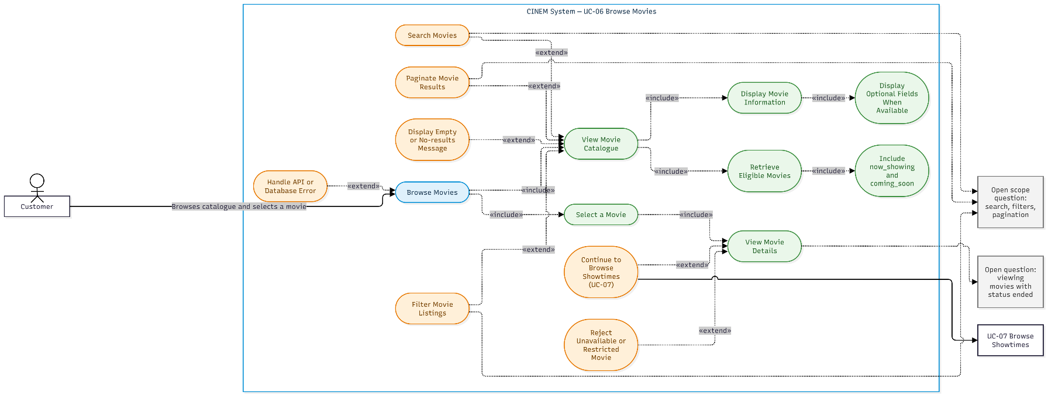
Figure 13: Use-Case Diagram UC-06 Browse Movies
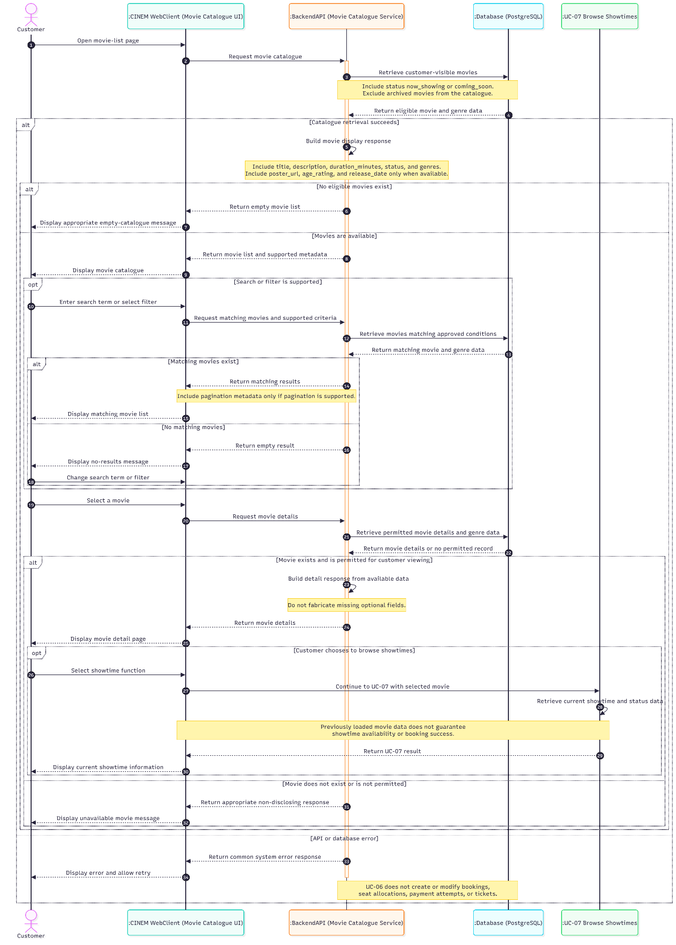
Figure 14: Sequence Diagram UC-06 Browse Movies

UC-07 Browse Showtimes

Use-Case Name

Brief Description
This use case allows a Customer to view showtimes for a movie and select a showtime to continue to seat selection and reservation. It displays showtime and venue information only; it does not create a booking, hold seats, create a payment attempt, or establish authoritative seat availability.

Flow of Events

Basic Flow
The Basic Flow describes how the Customer views showtimes and selects an eligible showtime to continue to seat reservation.
- The Customer opens showtime browsing from UC-06 or opens the showtime view directly for a requested movie.
- The System retrieves showtimes associated with the requested movie that are eligible for customer display.
- The System displays the eligible showtimes, including the start time, theatre, room, and supported price or label information when available. Only showtimes in the scheduled state that remain on sale under BR-ST-003 and FR-SHOW-001 are eligible for display and selection.
- The Customer optionally selects a supported date or theatre filter.
- If the selected filter is supported, the System returns and displays the matching eligible showtimes. If the filter is not supported, the System does not imply that the filter has been applied.
- The Customer selects a showtime to continue to seat selection and reservation.
- The System rechecks the selected showtime's current existence, status, and eligibility for sale.
- If the showtime remains eligible, the System transfers its identifier to UC-01.
- The Customer continues to UC-01, where the System performs the authoritative reservation and seat-availability checks.
The transfer of a showtime identifier does not create a booking, hold seats, or guarantee that the reservation will succeed.

Alternative Flows
The Alternative Flows describe how the System handles empty schedules, invalid selections, changed showtimes, missing venue data, and request failures.

No Showtimes
- If no eligible showtimes match the requested movie or supported filters, the System displays an empty schedule or an appropriate no-results message.
- The Customer may change the supported filters or return to movie browsing.

Showtime Does Not Exist
- If the requested showtime cannot be found, the System rejects the selection and informs the Customer that the showtime is unavailable.
- The System does not transfer the invalid showtime identifier to UC-01.

Showtime Is Not Bookable
- If the selected showtime is not in the scheduled state or is no longer on sale, the System rejects the selection.
- The System displays the current state when appropriate and allows the Customer to select another eligible showtime.

Showtime Is Cancelled or Changed
- If the selected showtime has been cancelled or its relevant information has changed, the System does not continue using stale interface data.
- The System displays the current information when available and asks the Customer to select another eligible showtime if necessary.

Stale Schedule Data
- The System retrieves or verifies the current showtime state when the Customer selects a showtime.
- Previously displayed schedule information is not treated as confirmation that the showtime remains eligible or that seats are available.

Venue or Room Data Is Unavailable
- If required theatre or room information cannot be retrieved, the System does not invent or fabricate the missing information.
- The System handles the failure using the applicable error-handling behavior or omits the affected showtime when it cannot be presented reliably.

API or Database Error
- If the request fails because of an API or database error, the System returns the common error response and displays an appropriate message.
- The failed request does not create a booking, hold seats, create a payment attempt, or issue a ticket.

Showtime Has No Available Seats
- UC-07 does not infer seat availability from the showtime schedule.
- If UC-01 determines that the requested seats cannot be reserved, UC-01 handles the result according to its own alternative flows.
- The Customer may return to UC-07 and select another showtime.

Special Requirements
This section describes the display, freshness, and scope-boundary requirements for showtime browsing.

Showtime Eligibility
- Only showtimes in the scheduled state that remain on sale under BR-ST-003 and FR-SHOW-001 are eligible for display and selection. The scope does not extend to showtimes in the in_progress state.
- The System must verify the current state of a selected showtime before transferring its identifier to UC-01.
- UC-01 remains responsible for the authoritative reservation checks, including seat availability and the successful reservation of seats.

No Reservation Side Effects
- UC-07 transfers the identifier of the selected showtime to UC-01; it does not create a booking or hold seats.
- UC-07 does not create a payment attempt, issue a ticket, or guarantee that a reservation will succeed.
- Displaying a showtime does not establish that any seat remains available.

Preconditions
The preconditions describe what must be true before the use case begins.
- The System can identify the requested movie.
- The System can access the current showtime data required to retrieve showtimes for the requested movie.
- Theatre and room information can be retrieved when required for displaying a showtime.
The selected showtime's current status and eligibility are verified during the flow before its identifier is transferred to UC-01.

Postconditions
The postconditions describe the result of browsing or selecting a showtime.

Successful Browse
- The Customer receives a showtime list based on the current showtime data available to the System.
- Only showtimes eligible for display under the applicable business rules are presented as selectable.

Successful Selection
- If the selected showtime remains eligible, its identifier is transferred to UC-01 for the reservation flow.
- No booking or seat hold is created by UC-07.

No Result or Failure
- An empty schedule, error, or rejected selection does not create or modify booking, seat-allocation, payment, or ticket state.
- The System does not treat previously displayed schedule information as proof that a reservation can succeed.

Extension Points
This section identifies the navigation relationship between browsing and reservation.

Browse Movies (UC-06)
UC-06 may initiate showtime browsing for a selected movie.

Reserve Seats (UC-01)
UC-01 performs authoritative seat and reservation checks after selection.

Open Questions
Supported filters, price display timing, real-time updates, and cancellation messaging remain open.
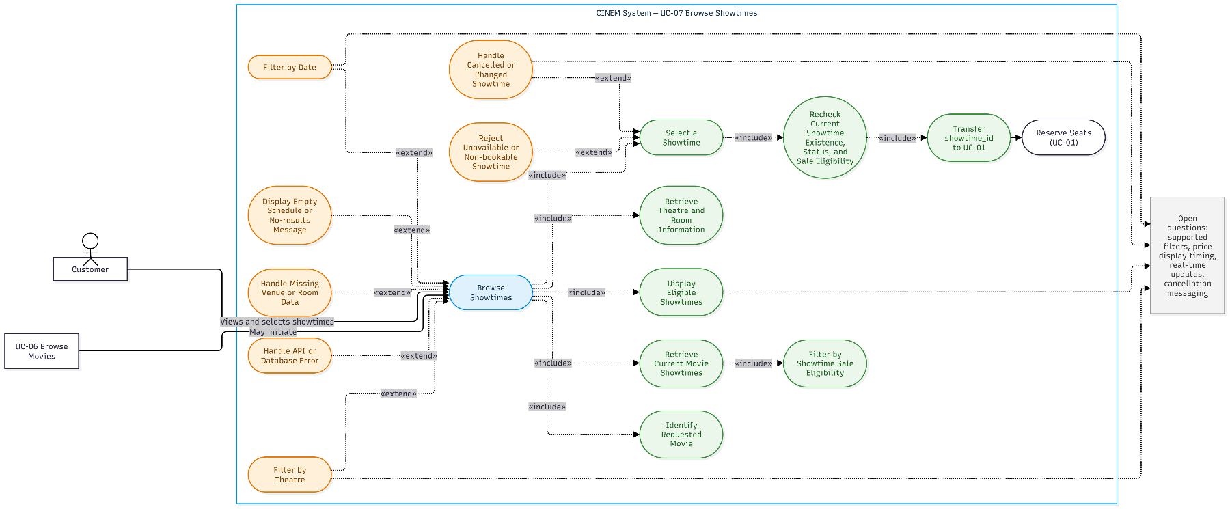
Figure 15: Use-Case Diagram UC-07 Browse Showtimes
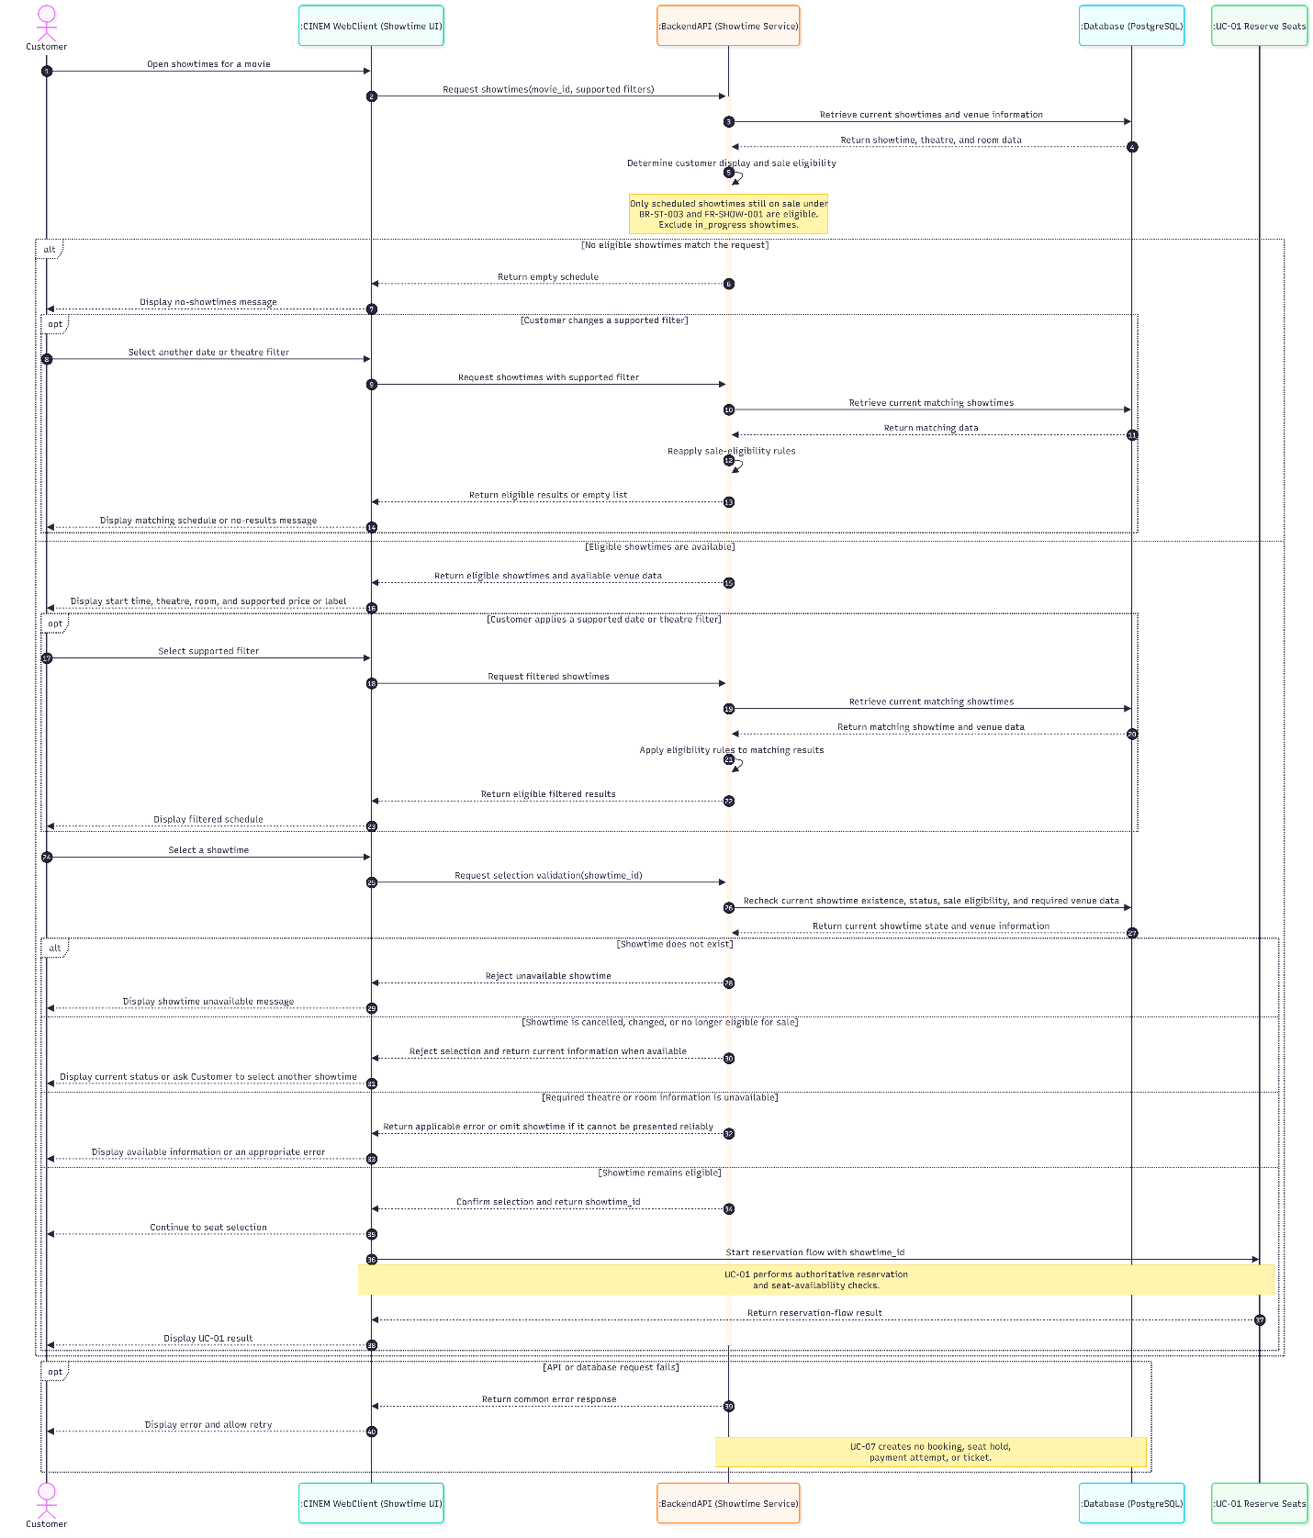
Figure 16: Sequence Diagram UC-07 Browse Showtimes

UC-08 Login and Role-Based Navigation

Use-Case Name

Brief Description
This use case describes login, logout, and backend-controlled access to protected functions. The system authenticates an active account and uses authoritative role and authorization policy to determine accessible areas. It does not specify registration or user/role administration, and it does not assume that Staff, Manager, and Admin permissions have been finalized.

Flow of Events

Basic Flow
The Basic Flow describes how a User logs in, accesses permitted functions, and logs out.
- The User submits login credentials to the Backend.
- The Backend authenticates the credentials and checks the account status.
- If the credentials are valid and the account is active, the Backend establishes a valid session according to the implemented session contract and determines the access result using the authoritative role and authorization policy.
- The Frontend uses the returned result to navigate to the corresponding area. Frontend navigation does not replace Backend authorization.
- When the User requests a protected function, the Backend validates the presented session or token and enforces the applicable role, authorization policy, and resource-ownership rules before processing the request.
- The User submits a logout request.
- The Backend handles the logout request according to the implemented session contract. The Frontend clears its local session state and returns the User to the public area.
Logout does not, by itself, establish that a previously issued token has been immediately revoked.

Alternative Flows
The Alternative Flows describe how the System handles failed authentication, invalid sessions, insufficient authorization, role changes, and logout errors.

Invalid Credentials
- The Backend rejects the login request and does not create a valid session.
- The response does not reveal whether an account exists or disclose sensitive authentication details.

Account Is Locked or Deactivated
- The Backend rejects the login request if the account status is locked or deactivated.
- No new valid session is issued.

Session or Token Is Invalid
- The Backend rejects the protected request when the presented session or token is invalid.
- The User must log in again when required by the authentication contract.
- The System does not infer or invent a specific session or token lifetime.

Insufficient Authorization
- The Backend rejects the operation when the User does not satisfy the applicable authorization policy, even if the Frontend displays the route.
- Customer resource-ownership checks remain enforced.
- The System does not grant unresolved Staff, Manager, or Admin permissions while the relevant policy remains open under OQ-04.

Role Changes After Token Issuance
- The System applies the current MVP limitation under BR-AUTH-004: a previously issued access token may remain valid until expiry when no immediate revocation or current-role revalidation mechanism is specified.
- The System does not assume immediate token revocation or a specific token lifetime.

Logout or Server Error
- If logout fails or the Backend cannot confirm the session outcome, the Frontend clearing its local state is not treated as proof that the Backend session or token has been revoked.
- Subsequent protected requests are handled according to the Backend's current session, token, and authorization checks.
- Logout does not modify booking, payment, ticket, role, or account data.

Special Requirements
This section describes authentication, authorization, and navigation constraints.

Backend Is Authoritative
- The Backend is authoritative for identity, role, authorization, and resource ownership.
- Frontend route visibility and navigation do not constitute authorization.
- Protected operations must be checked by the Backend before processing.

Role Scope
- The detailed Staff, Manager, and Admin permission boundaries remain open under OQ-04.
- UC-08 does not implicitly grant administration, payment, reconciliation, or other unresolved privileges.
- Customer ownership checks remain enforced for resources that belong to individual Customers.

Scope Boundary
- Registration remains under FR-AUTH-001, and user and role administration remains under FR-ADMIN-USER-001.
- Registration and user/role administration are referenced requirements, not subordinate flows of UC-08.
- The concrete session/token contract and any immediate revocation mechanism must not be inferred where they have not been specified.

Preconditions
The preconditions describe what must be available before the use case begins.
- The Backend can process the submitted credentials and retrieve the relevant account information for login.
- For successful login, the account must have the active status and the submitted credentials must be valid.
- For a protected request, the Backend must be able to evaluate the presented session or token and apply the relevant authorization policy.
A session or token is validated during the protected-request flow; its validity is not assumed solely because the Frontend displays an authenticated area.

Postconditions
The postconditions distinguish authentication, authorization, and logout outcomes.

Login Succeeds
- A valid session is established according to the implemented session contract.
- Access is determined by the Backend according to the applicable role and authorization policy.

Login Fails or Authorization Is Denied
- A failed login does not create a valid session.
- A protected operation that fails authorization is not performed, and the Backend does not return data beyond the User's permissions.

Logout
- The current session is handled according to the implemented session contract, and the Frontend clears its local session state.
- The System does not assume that logout immediately revokes a previously issued token unless the implemented contract specifies that behavior.
- Logout alone does not change booking, payment, ticket, role, or account data.

Extension Points
This section identifies the account and protected-use-case relationships.

Protected Use Cases
UC-01, UC-05, UC-09, and UC-10 rely on authentication and authorization where their preconditions require it.

Registration and Administration
Registration and user/role administration are referenced requirements, not extensions or included flows of UC-08.

Open Questions
The Staff/Manager/Admin permission boundary and concrete session/token contract remain unresolved.
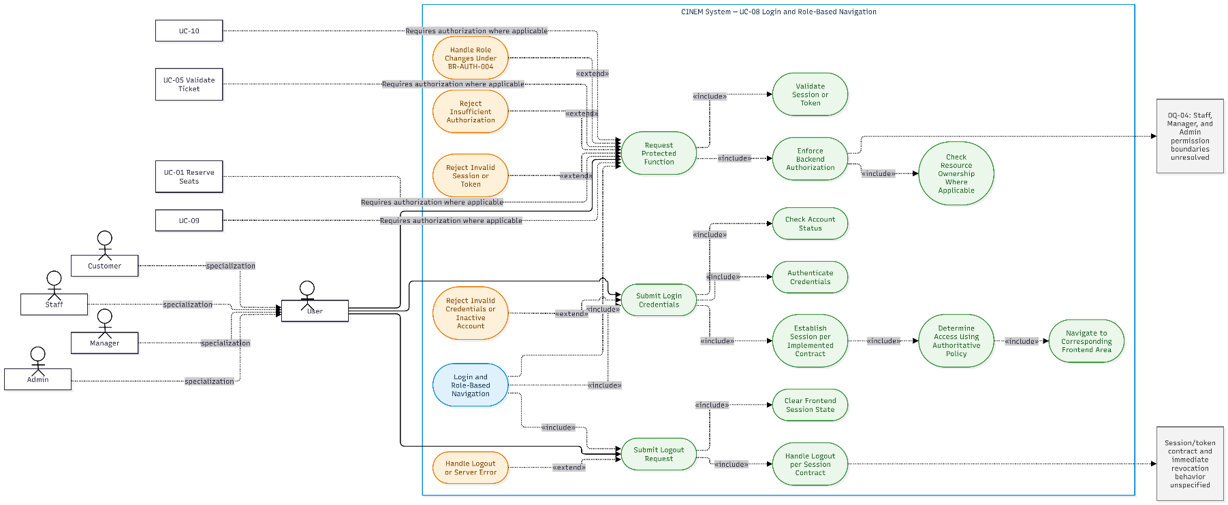
Figure 17: Use-Case Diagram UC-08 Login and Role-Based Navigation
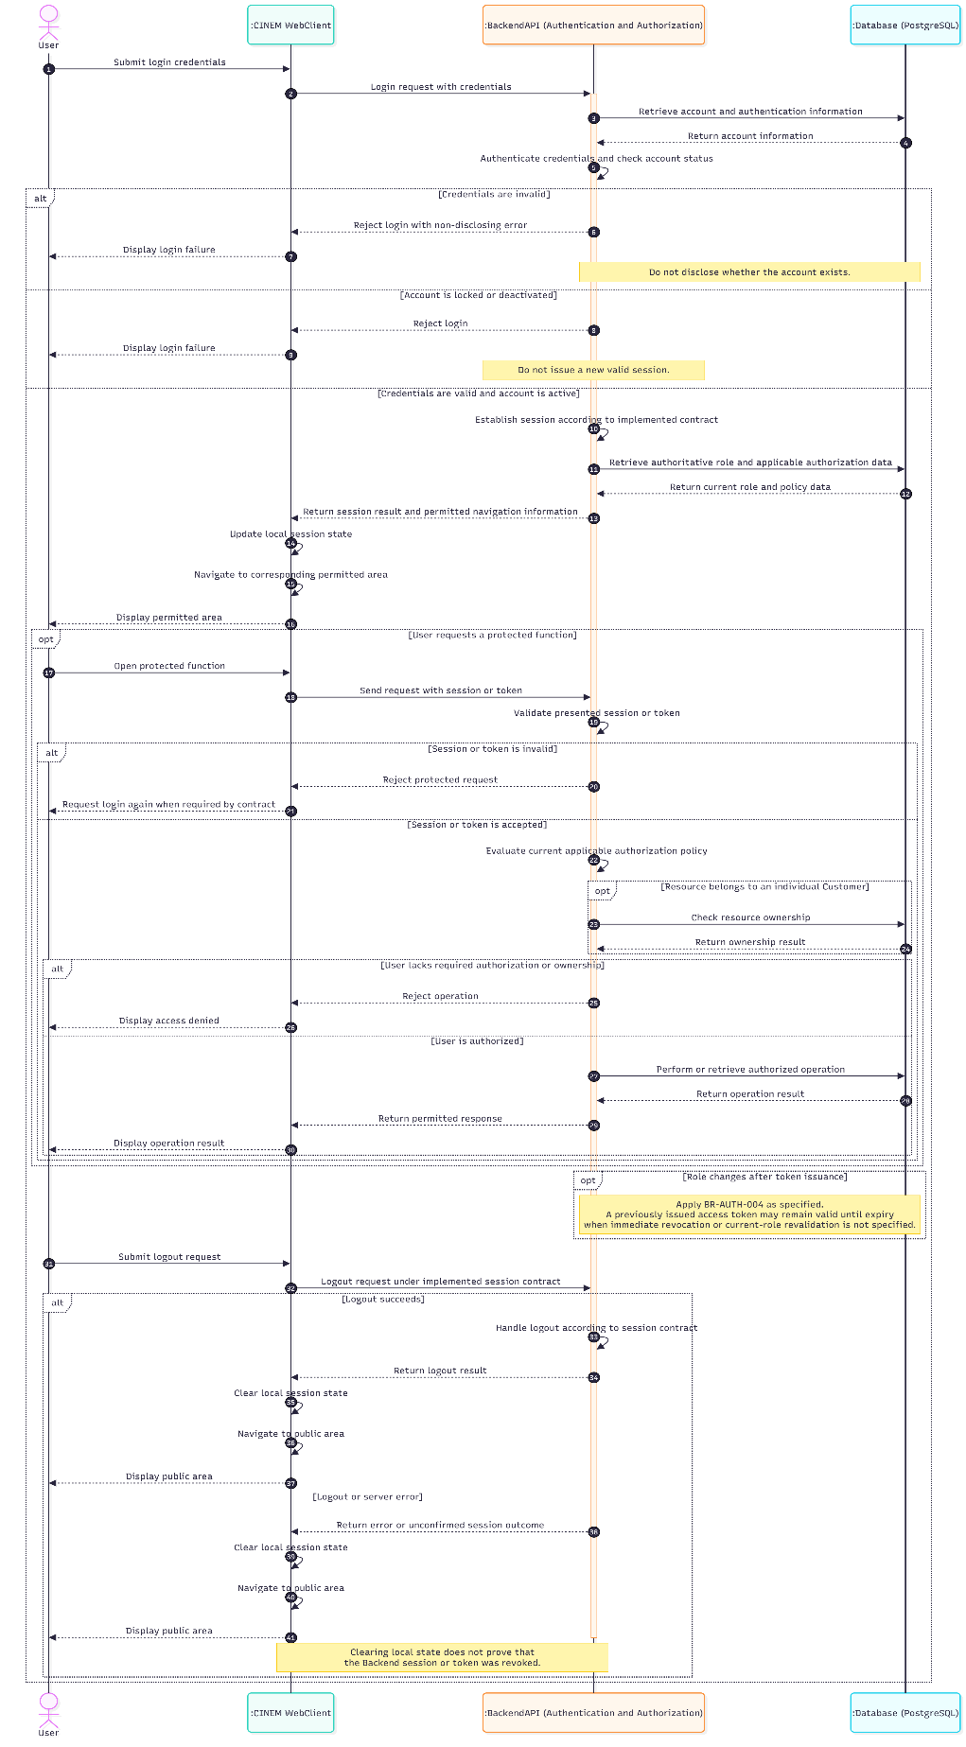
Figure 18: Sequence Diagram UC-08 Login and Role-Based Navigation

UC-09 Checkout and Payment

Use-Case Name

Brief Description
This use case lets a Customer start payment for a booking already created by UC-01. It validates ownership and current booking state, creates or reuses the correct open payment attempt, and transfers the Customer to the payment experience. It does not create a booking, confirm payment, apply payment, confirm the booking, issue tickets, or treat a redirect/success page as authoritative confirmation.

Flow of Events

Basic Flow
The Basic Flow describes how the Customer initiates payment for an existing booking and how the System prepares the corresponding payment attempt.
- The Customer selects payment for a booking previously created by UC-01 and submits the booking identifier.
- The Backend validates the Customer's session and ownership, then re-reads the booking, booking details, expiration time, applicable sale conditions, amount, and currency.
- The Backend rejects the request if the booking is not in the pending state, has expired, has no held booking details, does not belong to the Customer, or fails the applicable sale conditions.
- The Backend uses booking.total_amount and booking.currency as the authoritative payment amount and currency. Client-supplied price data is ignored.
- The Backend follows the prescribed lock order, Showtime → Booking → Payment attempts, and checks for an existing open payment attempt.
- If an open payment attempt with status created, pending, or unknown exists, the Backend reuses or returns that attempt according to the implemented integration contract. It does not create another open attempt.
- If no open attempt exists, the Backend creates a payment attempt with status created, the authoritative amount and currency, and a stable merchant_request_id. The Backend commits the short database transaction before making the external gateway call.
- After the attempt has committed, the Backend calls the Payment Gateway outside the database transaction through the provider-neutral adapter.
- The Backend returns the information required to continue the payment experience or display the current payment state according to the implemented contract.
- Payment-result receipt, verification, application, booking confirmation, and ticket issuance are handled by UC-02. UC-09 does not perform these operations.

Alternative Flows
The Alternative Flows describe how the System handles invalid bookings, concurrent checkout requests, uncertain gateway outcomes, and failed payment initiation.

Booking Is Invalid or Not Owned
- The Backend rejects the request if the booking does not exist, does not belong to the Customer, or cannot be accessed under the applicable authorization rules.
- The System does not create a payment attempt or disclose another Customer's booking information.

Booking Has Expired or Is Not Eligible
- The Backend rejects checkout if the booking has expired or no longer satisfies the applicable eligibility conditions.
- The System does not extend expires_at as a result of checkout.
- UC-03 handles booking expiration and release according to the booking lifecycle rules.

An Open Payment Attempt Already Exists
- The Backend reuses or returns the existing open attempt with status created, pending, or unknown, according to the implemented integration contract.
- The System does not create a second open attempt for the same booking.

Concurrent Checkout Requests
- The first request that successfully commits a new open payment attempt establishes the attempt to be used.
- A competing request resolves the uniqueness conflict or reads the already committed open attempt.
- A request must not call the gateway using an attempt that has not committed.
- The System ensures that concurrent requests do not create more than one open payment attempt for the same booking.

Gateway Timeout or Inconclusive Result
- If the gateway times out or the result cannot be determined, the System does not infer payment failure solely from the timeout.
- The System does not create a new attempt merely because the result is inconclusive.
- The payment remains subject to the applicable pending or unknown handling and is available for reconciliation by UC-04.

Client Displays Success Before Backend Application
- The Backend's authoritative payment and booking state remains unchanged solely because the Frontend displays a success page or receives a redirect.
- The System does not treat the client result as proof of payment.succeeded, payment application, booking confirmation, a held-to-sold transition, or ticket issuance.
- UC-02 handles payment-result verification and application.

Payment Fails or Is Cancelled
- When the payment result is verified and processed by UC-02, the payment may enter the failed or cancelled state, subject to the implemented contract.
- UC-09 does not independently determine or apply the payment result.
- The booking is not automatically changed by this checkout flow. A further attempt is permitted only if the booking remains eligible under the applicable business rules.

Transaction Error or Retry
- If the attempt-creation transaction fails before commit, the transaction is rolled back and the uncommitted attempt is not treated as an established attempt.
- A retry checks the current booking and payment-attempt state before creating or reusing an attempt.
- The retry must not violate the uniqueness constraints or create a second open payment attempt.
- The gateway is called only after the corresponding attempt has committed.

Special Requirements
This section describes checkout ownership, authoritative pricing, payment-attempt idempotency, and the boundary between initiating and applying payment.

Authoritative Booking Data
- The Backend obtains the payment amount and currency from the authoritative booking data.
- Client-supplied totals or price data are not used to determine the payment amount.
- Checkout operates on a booking already created by UC-01 and does not create a new booking.

Open Payment Attempt
- At most one open payment attempt with status created, pending, or unknown may exist for a booking, enforced by the applicable uniqueness constraint.
- merchant_request_id identifies the payment attempt for idempotent processing.
- Concurrent checkout requests must resolve to the same committed open attempt rather than create multiple open attempts.

Transaction and Gateway Boundary
- The payment-attempt creation transaction must commit before the Backend calls the Payment Gateway.
- The gateway call occurs outside a database transaction holding business locks.
- The concrete provider, endpoint, signature verification, retry behavior, and cancellation semantics remain subject to OQ-01 and the approved integration contract.

Scope Boundary
- UC-09 initiates checkout and prepares or reuses a payment attempt.
- UC-09 does not apply payment, confirm a booking, issue tickets, create a booking, or establish payment success from a redirect or client-side result.
- UC-02 handles payment-result verification and application; UC-04 handles reconciliation of unresolved outcomes.

Preconditions
The preconditions describe what must be true before checkout begins.
- The Customer is authenticated.
- A booking previously created by UC-01 is available for the Customer to identify.
- The Backend can access the booking and the associated booking details and payment-attempt records required for checkout.
The Backend verifies ownership, booking status, expiration, held details, sale conditions, and authoritative amount and currency during the flow. The booking is not assumed eligible solely because the Frontend displays it as payable.
The specific Payment Gateway and its integration contract remain subject to OQ-01.

Postconditions
The postconditions distinguish checkout initiation from payment confirmation and application.

Checkout Initiated
- Exactly one applicable open payment attempt is created or an existing open attempt is reused.
- A newly created attempt is committed before the Backend calls the Payment Gateway.
- Checkout initiation alone does not confirm or otherwise change the booking state.

Client Redirect or Success Page
- A redirect or success page does not establish payment.succeeded, payment application, booking confirmation, a held-to-sold transition, or ticket issuance.

Payment Result
- UC-02 receives, verifies, and processes payment results according to the applicable contract.
- UC-04 reconciles unresolved payment outcomes.
- UC-03 handles booking expiration and release.
- UC-04A describes refund behavior within its documented scope, which is outside the demo.

Rejected or Failed Checkout
- A rejected request does not create a new payment attempt.
- A failed attempt-creation transaction does not leave an uncommitted attempt treated as established.
- UC-09 does not create a duplicate booking, issue a ticket, apply payment, or transition booking details from held to sold.

Extension Points
This section identifies the payment and booking processes that continue after checkout.

Reserve Seats (UC-01)
UC-01 creates the booking and held allocation used by checkout.

Payment Webhook (UC-02)
UC-02 receives, verifies, applies, or rejects payment results and issues tickets when eligible.

Release Expired Bookings (UC-03)
UC-03 handles expiration and release.

Payment Reconciliation (UC-04)
UC-04 handles unknown or late payment outcomes.

Customer Booking Lifecycle (UC-10)
UC-10 displays authoritative state and handles approved cancellation conditions.
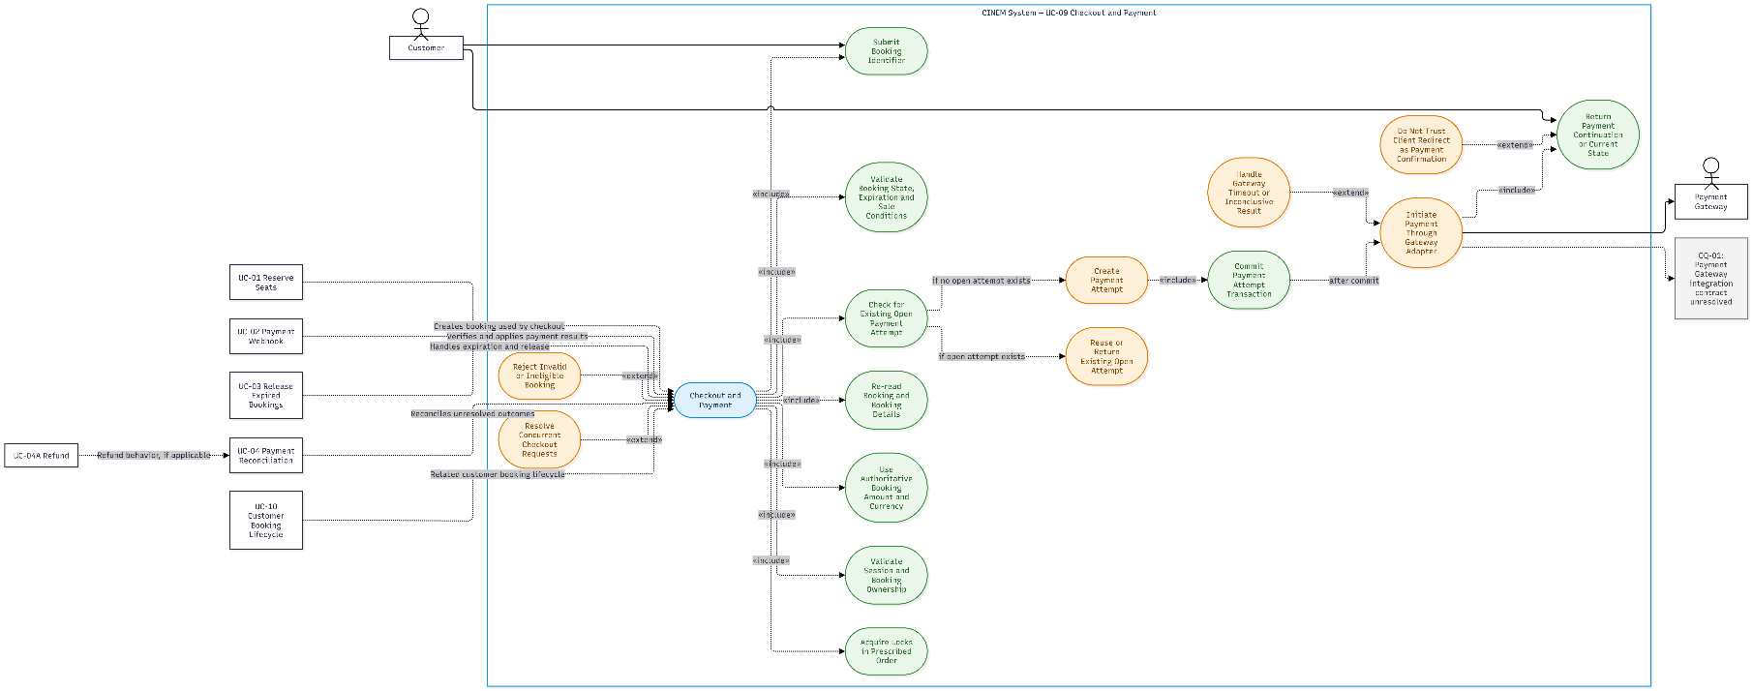
Figure 19: Use-Case Diagram UC-09 Checkout and Payment
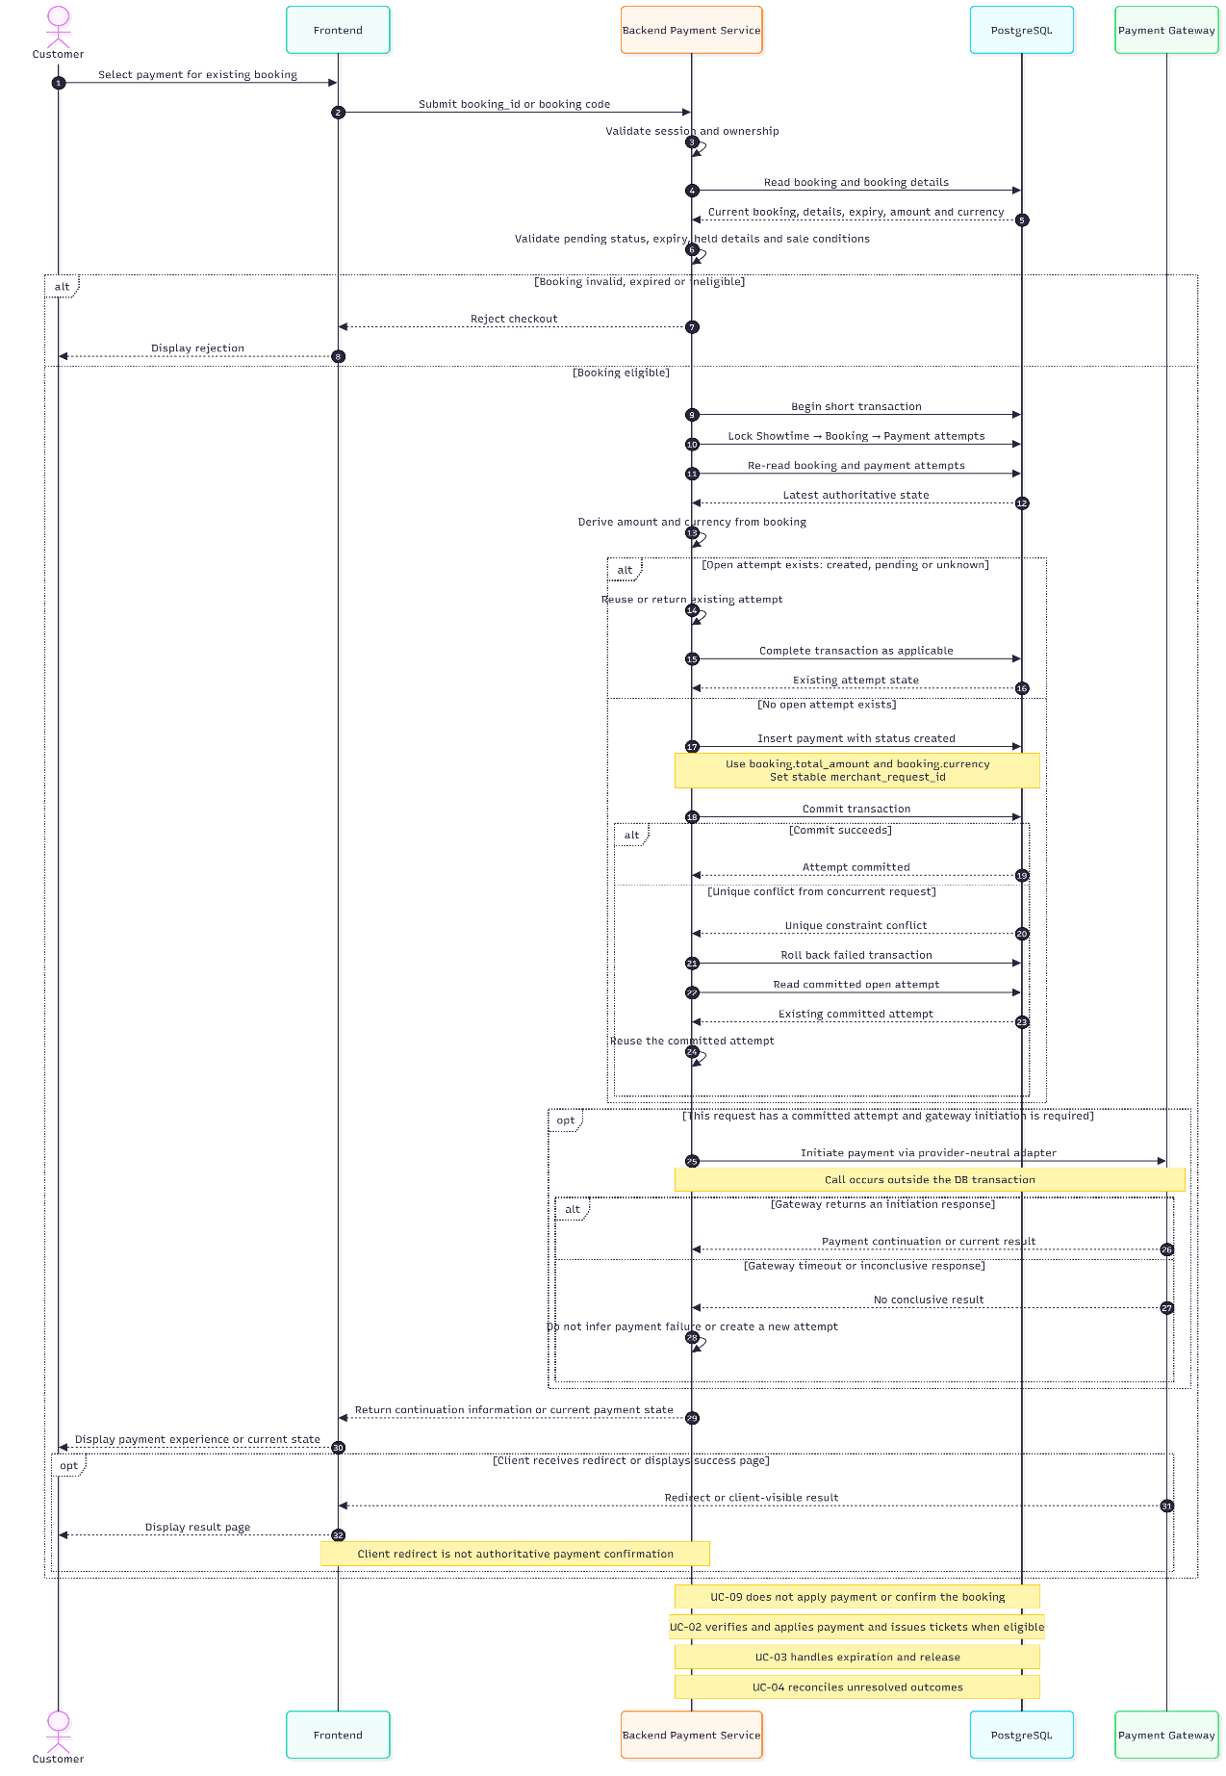
Figure 20: Sequence Diagram UC-09 Checkout and Payment

UC-10 Customer Booking Lifecycle

Use-Case Name

Brief Description
This use case lets a Customer view their bookings, payment attempts, booking details, and issued tickets, and request cancellation of a pending booking only when approved conditions are satisfied. Backend state is authoritative: elapsed time, redirect screens, and client status do not by themselves commit a lifecycle transition.

Flow of Events

Basic Flow
- [Customer] opens booking history, a booking detail view, or the ticket list.
- Backend identifies the current Customer and retrieves only the booking and ticket resources that the Customer is authorized to access.
- Backend returns the authoritative booking information, including status, relevant timestamps, expiration time, amount, currency, and associated showtime information.
- Backend returns the associated payment attempts and their recorded payment or reconciliation states. The system does not infer payment status from a redirect URL or client-side message.
- Backend returns booking details, including allocation status and the applicable seat and price snapshots. An allocation status does not represent the physical seat's status independently of the booking lifecycle.
- For a confirmed booking, Backend returns the issued tickets and their current statuses to the authorized booking owner.
- Frontend displays the returned state. Passing expires_at alone does not transition a booking to expired or release its allocations; UC-03 handles the expiration and release process.
- If the Customer requests cancellation, Backend revalidates ownership, booking status, detail allocation status, payment application state, and all associated payment attempts.
- If no open payment attempt and no succeeded-but-unapplied payment exist, Backend locks and rechecks the relevant state, then changes the eligible booking to cancelled and its held details to released within one transaction.
- If an open payment attempt exists, Backend performs the applicable Cancel/Query operation outside the locking transaction. Backend then starts a new transaction, locks and re-reads the relevant state, and commits cancellation only if the payment outcome and all cancellation conditions permit it.
- Backend returns the authoritative state after the operation. The Customer may start a new booking through UC-01; UC-10 does not create a replacement booking.

Alternative Flows

Booking Does Not Belong to Customer
- Backend rejects the viewing or cancellation request under BR-AUTH-002.
- The system does not disclose the requested booking's protected information.

Booking Has Passed expires_at
- Frontend does not change the booking or allocation state solely because the expiration timestamp has passed.
- UC-03 determines and commits expiration and release according to the applicable conditions.
- Backend returns the currently recorded authoritative state.

Booking Is Confirmed
- Backend rejects cancellation under the current demo policy.
- The system does not infer refund eligibility, void tickets, or change the booking state through UC-10.

Booking Is Expired or Cancelled
- Backend rejects a repeated cancellation request.
- The system does not modify the booking, details, payment attempts, or tickets as a result of the rejected request.

Open Payment Attempt Exists
- Backend performs the applicable Cancel/Query operation outside the locking transaction.
- If collection is confirmed or the result is inconclusive, Backend does not commit cancellation or release the held allocation.
- Backend returns the authoritative state available after the operation.

Payment Succeeded but Is Not Applied
- Backend does not treat the payment result as booking confirmation.
- Backend does not cancel the booking or release its allocation while the succeeded-but-unapplied payment remains unresolved.
- UC-02 and UC-04 handle payment application and reconciliation within their respective scopes.

Payment Succeeded and Is Applied
- Backend does not cancel the confirmed booking through UC-10.
- The system does not void issued tickets or create a refund through UC-10.

Payment Succeeds After Release
- Backend returns the recorded payment and reconciliation state.
- The system does not automatically restore the booking, reclaim released seats, or issue tickets solely because a late payment result is received.
- UC-02 and UC-04 handle the payment result according to their defined rules.

Concurrent Cancellation and Payment Confirmation
- After any gateway operation, Backend starts a new transaction and locks the relevant records in the required order: Showtime → Booking → Payment attempts.
- Backend re-reads the current booking, allocation, and payment states.
- Backend commits cancellation only if the latest state satisfies all applicable conditions. Stale client or pre-gateway state is not used to authorize the transition.

Refund Is Not Complete
- Booking cancellation and refund completion are treated as separate lifecycle events.
- UC-10 does not promise a refund or represent a refund as complete without authoritative evidence.
- Refund behavior remains within the scope defined for UC-04A and the approved payment integration contract.

Special Requirements
This section describes the ownership, authoritative state display, cancellation safety, and lifecycle boundaries that apply to this use case.

Ownership and Authorization
- Customers may view only their own authorized booking, payment, booking-detail, and ticket resources.
- Knowing a resource identifier does not grant access to that resource.
- UC-10 does not grant administrative lookup or management permissions.

State Authority
- Backend state is authoritative for booking, allocation, payment, reconciliation, and ticket status.
- The system preserves the state values and transition rules defined by the applicable source requirements.
- The frontend does not commit lifecycle transitions based only on elapsed time, a redirect, or client-side status.

Cancellation Safety
- Cancellation of a pending booking is permitted only when ownership, booking state, allocation state, and payment conditions satisfy the applicable rules.
- Gateway Cancel/Query operations occur outside the database transaction that holds the relevant business locks.
- After a gateway operation, Backend re-reads and validates the current state before committing cancellation.
- Booking cancellation and the release of held details must be committed atomically when cancellation is permitted.

Scope Boundary
- Booking, payment, ticket issuance, expiration, reconciliation, and refund are separate lifecycles handled by their respective use cases.
- UC-10 displays authoritative lifecycle state and requests eligible cancellation; it does not independently apply payments, issue tickets, process expiration, or complete refunds.
- Refund is not an assumed or guaranteed Customer benefit in the current demo.

Preconditions
This section describes the conditions required before the use case can execute. Conditions that depend on the requested operation are checked during the flow.
- Customer is authenticated and identified by Backend.
- Backend can retrieve the requested booking, payment, booking-detail, and ticket information and apply the required authorization checks.
- For cancellation, Backend can lock and re-read ownership, booking status, allocation status, and all associated payment attempts before changing state.
- A successful cancellation additionally requires the booking and payment state to satisfy the applicable cancellation conditions. These conditions are validated during the flow rather than assumed from frontend state.

Postconditions
This section describes the state after lifecycle information is viewed or a cancellation request is processed.

Read-Only Viewing
- Only authorized Customer data is returned.
- No booking, allocation, payment, or ticket state is changed by viewing the information.

Cancellation Succeeds Before Payment
- The booking is recorded as cancelled and its held details are recorded as released.
- Any applicable payment-attempt cancellation is handled only when the gateway outcome and current state permit it.
- Related database changes required for cancellation are committed atomically.

Cancellation Is Rejected or Fails
- The system does not commit the requested cancellation or release the allocation through that failed operation.
- The system does not create a refund or replacement booking.
- Backend returns or allows retrieval of the current authoritative state; a failed request does not establish that every related record is unchanged if an independent concurrent operation has legitimately changed it.

Timeout or Stale Client State
- The Customer can retrieve the current authoritative state after a timeout or stale response.
- The interface does not claim that cancellation, payment, or another lifecycle transition succeeded solely because a request was sent or a redirect was displayed.

Extension Points
This section identifies the lifecycle processes that provide or consume booking state.

Reserve Seats (UC-01)
UC-01 creates the booking and held allocations displayed by UC-10.

Payment Webhook (UC-02)
UC-02 applies verified payment and issues tickets when eligible.

Release Expired Bookings (UC-03)
UC-03 commits expiration and release; UC-10 does not infer it from elapsed time.

Payment Reconciliation and Refund (UC-04/UC-04A)
UC-04 and UC-04A handle late outcomes and refund behavior within their scope.

Validate Ticket (UC-05)
UC-05 consumes issued ticket state for admission validation.

Open Questions
Cancel/Query behavior, manual permissions, cancellation benefits, and grace-period configuration remain unresolved.
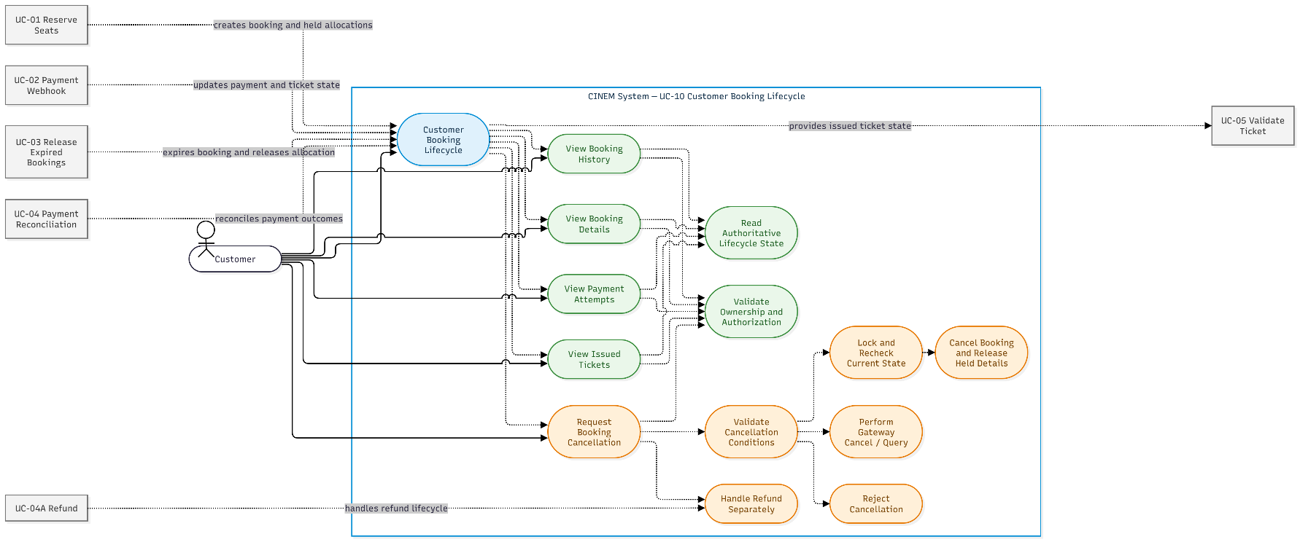
Figure 21: Use-Case Diagram UC-10 Customer Booking Lifecycle
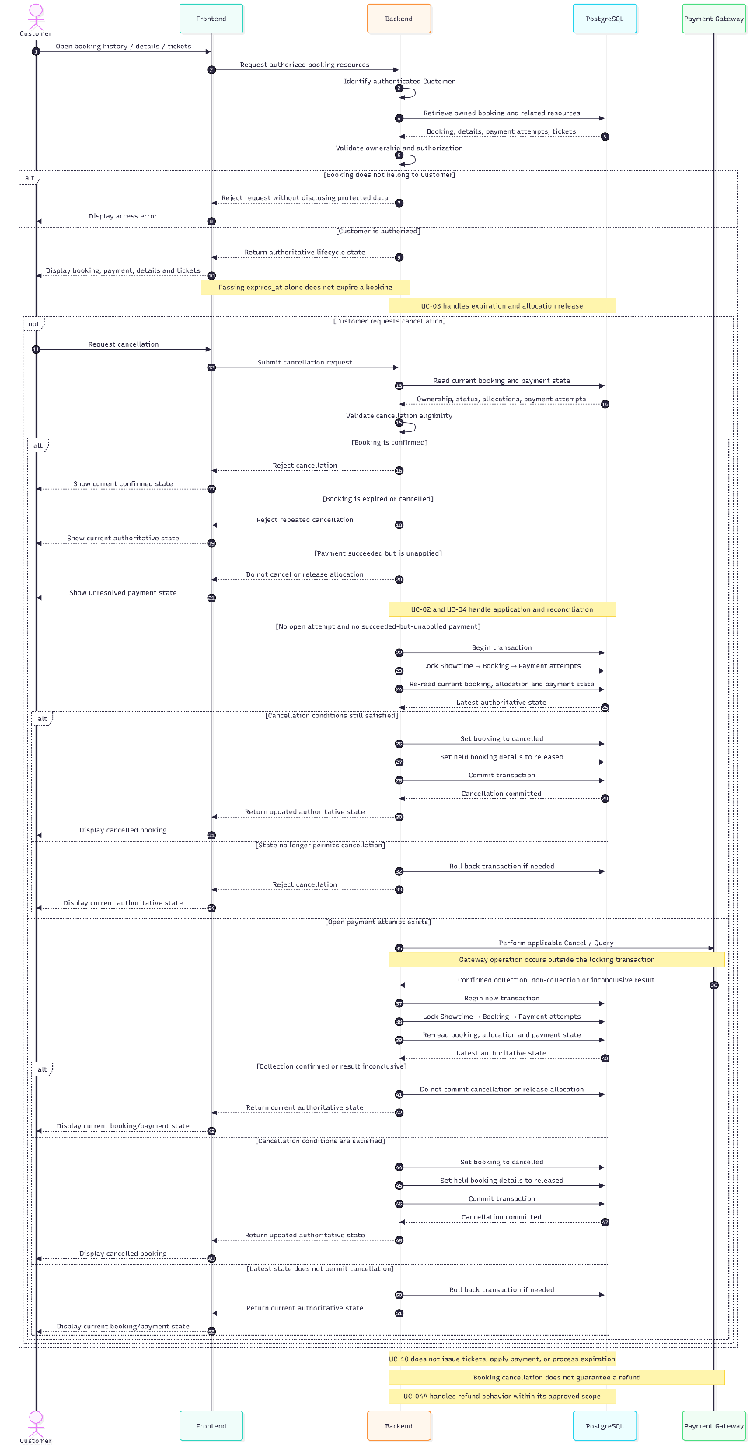
Figure 22: Sequence Diagram UC-10 Customer Booking Lifecycle

UC-11 Chat with Promethe-Nous

Use-Case Name

Brief Description
This use case allows a Customer to ask natural-language questions to Promethe-Nous about movie lookup and rankings, box-office revenue, movie recommendations, showtimes, ticket prices, and the booking process. The chatbot retrieves information from appropriate available sources and provides answers based on retrieved data. When relevant, it identifies the applicable market, reporting period, currency, data source, and data update time. If the required information is unavailable, inconsistent, or insufficient to support a conclusion, the chatbot communicates the limitation rather than presenting an unsupported answer.
Promethe-Nous provides information and guidance only. It does not independently confirm payments, create bookings, hold seats, cancel bookings, issue tickets, or change booking, payment, allocation, or ticket states.

Flow of Events

Basic Flow
- [Customer] opens booking history, a booking detail view, or the ticket list.
- [Customer] opens Promethe-Nous and submits a question or requests assistance.
- The system receives the question and identifies the user's intent, referenced movie or entity, relevant market, reporting period, and requested metric.
- The system classifies the request into one of the supported categories: movie lookup and rankings, box-office revenue analysis, movie recommendations, or showtime, ticket-price, and booking guidance.
- The system retrieves the relevant information from appropriate sources. Internal movie and showtime information is retrieved from the official Backend API or database. External box-office, ranking, or rating information is retrieved only from integrated and approved sources.
- The system processes the request according to its category:
  - Movie Lookup and Rankings: The system may identify the currently screening movie with the highest worldwide box-office revenue, provide a Top 10 ranking within a specified scope, identify the weekend box-office leader, or identify the movie with the highest audience rating when sufficient supporting data is available. A request for the most-watched movie in Vietnam is answered using view counts or ticket-sales data only if the source provides the relevant metric. Revenue must not be treated as a substitute for views or tickets sold.
  - Revenue Analysis: The system may retrieve current revenue, first-day revenue, opening-weekend revenue, first-seven-day revenue, domestic-versus-worldwide revenue, or growth over a specified period. The system identifies or clarifies the market, reporting period, currency, and metric definition. The first seven days, opening weekend, and calendar week are treated as distinct reporting periods.
  - Movie Recommendations: The system filters or ranks available movies using supported attributes, such as genre, duration, age rating, description, and review information. Example requests include horror movies currently screening, movies similar to Interstellar, family-suitable movies, and movies shorter than two hours.
  - Showtime and Booking Guidance: The system retrieves current showtimes, filters showtimes by requested times such as after 19:00, provides ticket prices from official sources, and explains the steps for selecting a showtime, choosing seats, and proceeding to checkout. Displaying a showtime or seat layout does not guarantee seat availability; Backend remains authoritative when the Customer performs UC-01.
- The system generates a natural-language response based on the retrieved information. When relevant, the response states the ranking criteria, market, reporting period, currency, data source, and data update time.
- [Customer] reviews the response and may submit a follow-up question in the same conversation.
- The system processes the follow-up using the necessary conversation context. Information that can change over time, such as showtimes, ticket prices, and booking status, is retrieved again from the appropriate authoritative source.
- [Customer] ends the conversation or leaves the chatbot interface.

Alternative Flows

Question Is Ambiguous
- If important criteria are missing, such as the market, reporting period, or whether the Customer means revenue, views, or tickets sold, the system asks a clarifying question or explicitly states the assumption used.
- The system does not silently select a definition that could make the answer misleading.
- The system continues processing after the request has been clarified or the applicable assumption has been communicated.

Requested Metric Has No Available Data Source
- The system informs the Customer that it cannot verify the requested metric using the available reliable sources.
- The system may provide a related metric if it clearly distinguishes that metric from the requested one.
- The system does not present a substitute metric as an exact answer to the original question.

Historical Data Is Unavailable
- If the available source contains only current data and no historical records, the system does not infer first-day revenue, first-week revenue, historical growth, or historical comparisons.
- The system explains that the required historical data is unavailable.
- The system may answer other parts of the question for which sufficient data exists.

Data Sources Conflict or Use Inconsistent Definitions
- The system identifies differences in market, currency, reporting period, or metric definition when the retrieved sources are not directly comparable.
- The system does not combine incompatible figures as if they represented the same measure.
- The system explains the discrepancy or states that a reliable conclusion cannot be established.

No Movie Matches the Requested Criteria
- The system informs the Customer that no available movie matches the specified criteria.
- The system may suggest relaxing one or more criteria.
- The system does not invent movie titles, durations, age ratings, or showtimes.

Showtime, Ticket Price, or Other Information May Be Outdated
- The system attempts to retrieve the latest information from the official source when available.
- If the latest information cannot be verified, the system communicates the known data time or its limitation.
- The system recommends checking the official booking interface before the Customer makes a booking.
- The system does not claim that outdated information represents the current state.

Customer Reports a Successful Payment but Has Not Received a Ticket
- The system guides the Customer to check the booking details or transaction history, or directs the Customer to an appropriate support channel.
- If booking lookup is integrated, the system retrieves the booking state from Backend only after verifying the Customer's authorization to access that booking.
- The system does not independently conclude that payment succeeded, change the booking to confirmed, or issue a ticket.
- Payment application, reconciliation, and ticket issuance remain governed by UC-02 and UC-04, as applicable.

Chatbot Service or Data Source Is Unavailable
- The system informs the Customer that the requested information cannot be verified at that time.
- The system does not fabricate an answer from stale or unavailable data.
- The system allows the Customer to retry or directs the Customer to an official information or support channel where appropriate.

Request Is Outside the Supported Scope or Requires Additional Authorization
- The system explains the applicable limitation and provides an appropriate alternative where possible.
- Requests for internal revenue reports, personal booking data, or administrative operations are not fulfilled for a Customer who lacks the required authentication and authorization.
- Access to restricted information is determined by Backend authorization, not by the chatbot's interpretation of the conversation

Question Uses Subjective Labels Such as “Famous Director” or “A-List Star”
- If no agreed classification criteria or reliable source is available, the system provides sourced biographical or career information where possible, or asks the Customer which criteria should be used.
- The system does not present subjective labels as objectively established facts without supporting criteria.

Question Is Outside the Movie and Cinema Domain
- The system politely explains the chatbot's supported scope.
- The system invites the Customer to ask a question related to movies, box-office information, recommendations, showtimes, ticket prices, or the booking process.

Special Requirements
This section describes the requirements for data reliability, response transparency, authorization, and the boundaries of chatbot operations.

Ownership and Authorization
- Customers may view only their own authorized booking, payment, booking-detail, and ticket resources.
- Knowing a resource identifier does not grant access to that resource.
- UC-10 does not grant administrative lookup or management permissions.
- Refund is not an assumed or guaranteed Customer benefit in the current demo.

Data Reliability and Source Transparency
- Responses must be based on information retrieved from appropriate available sources.
- Internal movie, showtime, ticket-price, and booking information must come from the applicable official system source.
- External box-office, ranking, view-count, ticket-sales, and rating information may be used only when the relevant source has been integrated and approved.
- Revenue, views, tickets sold, and audience ratings are distinct metrics and must not be treated as interchangeable.
- Where relevant, responses must identify the market, reporting period, currency, source, and data update time.
- When information is missing, inconsistent, or insufficient, the system must communicate the limitation rather than fabricate a result.

Revenue and Ranking Definitions
- First-day revenue, opening-weekend revenue, first-seven-day revenue, and calendar-week revenue must be distinguished.
- Comparisons across markets or periods must account for differences in reporting scope, metric definition, and currency.
- The system must not infer historical revenue or growth when the required historical data is unavailable.
- Subjective classifications, such as “famous director” or “A-list star,” require agreed criteria or must be presented with appropriate qualifications.

Authorization and Privacy
- Public movie information and general recommendations do not require Customer authentication.
- Personal booking information may be retrieved only after Customer authentication and Backend authorization.
- Internal revenue reports and administrative information are outside the Customer-facing scope unless a separately approved, authenticated, and authorized capability is defined.
- Knowing a booking identifier does not grant permission to access that booking.

Operational and Lifecycle Boundaries
- Promethe-Nous provides information and guidance; it does not independently create bookings, hold or release seats, cancel bookings, apply payments, confirm bookings, issue tickets, or complete refunds.
- UC-01 remains responsible for authoritative seat reservation and booking creation.
- UC-02 and UC-04 remain responsible for payment application and reconciliation within their respective scopes.
- UC-03 remains responsible for expiration and release of eligible bookings.
- UC-04A defines the separately scoped refund contract.
- UC-05 remains responsible for ticket validation.
- Displayed showtimes, seat layouts, prices, and booking information do not override the authoritative state returned by Backend.

Preconditions
This section describes the conditions required before the use case can execute. Conditions that depend on the request type are validated during the flow.
- The chatbot interface and conversation-processing service are accessible.
- At least one data source or knowledge base relevant to the requested information is available. External sources may be used only if integrated and approved.
- Internal information, including showtimes, ticket prices, and the Customer's booking state, must be retrieved from the applicable official source rather than inferred from conversation content or stale data.
- Authentication is not required for public movie information or general recommendations. Requests involving personal data or role-restricted functions require authentication and Backend authorization.
- Revenue, tickets sold, views, and audience ratings must be interpreted according to their respective definitions and sources. If a source does not provide a requested metric, the system must not replace it with another metric.

Postconditions
This section describes the state after the Customer receives a chatbot response or the system cannot fulfill the request.

Successful Response
- The Customer receives an answer or recommendation relevant to the question and supported by retrieved information.
- Where relevant, the response identifies the reporting scope and the data source or update time.
- No booking, booking_detail, payment, ticket, or seat-allocation state is changed solely as a result of the chatbot conversation.

Partially Successful Response
- The system answers the parts of the question supported by available data.
- The system explicitly identifies information that cannot be verified, is unavailable, or requires clarification.
- Unsupported assumptions are not presented as verified data.

Failed Request
- The system informs the Customer that it cannot provide or verify the requested information.
- No booking, payment, seat-allocation, or ticket state is created or changed by the failed chatbot request.
- Personal information and internal reports are not disclosed unless the required authentication and authorization conditions are satisfied.

Data Source or Service Unavailable
- The Customer is informed that the requested information cannot currently be verified.
- The system does not claim that stale information is current or that an unverified transaction has succeeded.
- The Customer may retry or use an appropriate official information or support channel.

Extension Points
This section identifies the use cases and services that provide information to, or remain responsible for operations discussed by, Promethe-Nous.

Reserve Seats (UC-01)
UC-01 creates the booking and held allocations displayed by UC-10.

Browse Movies (UC-06)
UC-06 provides movie discovery and movie information. Promethe-Nous may use the applicable movie information to answer movie lookup and recommendation questions.

Browse Showtimes (UC-07)
UC-07 provides showtime information. Promethe-Nous may retrieve and explain current showtimes but does not reserve seats or guarantee availability.

Reserve Seats (UC-01)
UC-01 creates a booking and holds eligible seat allocations. When the Customer decides to book, Promethe-Nous directs the Customer to the official booking flow; the chatbot does not create the booking itself.

Checkout and Payment (UC-09)
UC-09 starts payment for an existing eligible booking. Promethe-Nous may explain the checkout process but does not independently initiate or apply a payment.

Payment Webhook (UC-02) and Payment Reconciliation (UC-04)
UC-02 applies eligible verified payment outcomes, while UC-04 handles unresolved or late payment outcomes within its scope. Promethe-Nous does not independently confirm payment or issue tickets.

Customer Booking Lifecycle (UC-10)
UC-10 provides the Customer's authorized booking, payment, and ticket information and handles eligible cancellation requests. If booking lookup is supported by the chatbot integration, the information must be retrieved through the authorized Backend flow. Otherwise, Promethe-Nous guides the Customer to the official booking-history interface.

Validate Ticket (UC-05)
UC-05 validates issued tickets for admission. Promethe-Nous may explain ticket-related information but does not validate or consume a ticket.

Business Rules and Related Requirements
- Movie discovery and movie information: UC-06 and FR-MOVIE-001/002.
- Showtime information: UC-07 and FR-SHOW-001.
- Seat reservation and authoritative seat availability: UC-01.
- Checkout and payment handling: UC-09 and UC-02.
- Customer booking and ticket information: UC-10 and UC-05, where applicable.
- External data sources for box-office revenue, rankings, views, ticket sales, and ratings have not been finalized by this specification. Describing these capabilities does not mean that the relevant integrations already exist.
- Personal booking information and internal reports remain subject to the applicable authentication, authorization, and least-privilege requirements.

Acceptance Criteria
- AC-UC11-01 — Movie Lookup: The system answers movie-related questions when the required source data is available and explicitly identifies missing information when it is not.
- AC-UC11-02 — Revenue Ranking: Revenue rankings identify the relevant market, reporting period, currency, and data source where available. Revenue is not treated as equivalent to views or tickets sold.
- AC-UC11-03 — Top 10 Ranking: The list follows the requested criteria and scope and does not include entries unsupported by available data.
- AC-UC11-04 — Revenue by Period: The system distinguishes first-day revenue, opening-weekend revenue, first-seven-day revenue, and calendar-week revenue. It does not infer unavailable historical data.
- AC-UC11-05 — Market Comparison: The system compares only figures that are sufficiently compatible in scope, reporting period, and units. Otherwise, it explains the limitations.
- AC-UC11-06 — Movie Recommendations: Recommendations follow the Customer's criteria and use only movie attributes supported by available data.
- AC-UC11-07 — Showtimes and Ticket Prices: The system uses current official information when available and does not present outdated information as verified current information.
- AC-UC11-08 — Payment and Ticket Support: The system does not claim that payment succeeded or a ticket was issued without authoritative Backend confirmation.
- AC-UC11-09 — No Transaction Mutation: Ordinary chatbot interaction does not create bookings, hold seats, initiate or apply payments, cancel bookings, or issue tickets.
- AC-UC11-10 — Data Protection: Personal booking information and internal reports are accessed only when the required authentication and Backend authorization conditions are satisfied.
- AC-UC11-11 — Unavailable Sources: The system communicates source limitations and does not fabricate revenue figures, showtimes, or movie information.
- AC-UC11-12 — Ambiguous or Subjective Questions: The system asks for clarification or states the applied criteria for terms such as “most watched,” “famous,” and “A-list.”

Related Use Cases
- UC-06: Browse Movies.
- UC-07: Browse Showtimes.
- UC-01: Reserve Seats.
- UC-09: Checkout and Payment.
- UC-02: Payment Webhook.
- UC-04: Payment Reconciliation.
- UC-04A: Refund.
- UC-10: Customer Booking Lifecycle.
- UC-05: Validate Ticket.

Open Questions
- OQ-UC-11-01: Select and approve external data sources for worldwide box-office revenue, Vietnam box-office revenue, rankings, and audience ratings. Define access terms, usage limits, and update frequency.
- OQ-UC-11-02: Determine whether reliable view-count or ticket-sales data is available by market. If not, the system must not present “most-watched movie” as a verified statistical result.
- OQ-UC-11-03: Define “current revenue,” “first-day revenue,” “opening-weekend revenue,” “first-week revenue,” and “weekly growth.” Specify the applicable time zone, currency, market, and exchange-rate handling where necessary.
- OQ-UC-11-04: Define the criteria and sources for “famous director,” “A-list star,” and audience-rating rankings.
- OQ-UC-11-05: Select the official sources and update policy for ticket prices, showtimes, and customer-support information.
- OQ-UC-11-06: Decide whether Promethe-Nous may retrieve a Customer's booking information after authentication or should only guide the Customer to the booking-history interface.
- OQ-UC-11-07: Determine whether customer-support integration is required and, if so, define its supported operations and authorization boundaries.
- OQ-UC-11-08: Define the approved integration architecture and access controls for chatbot data retrieval, including how source availability and data freshness are handled.
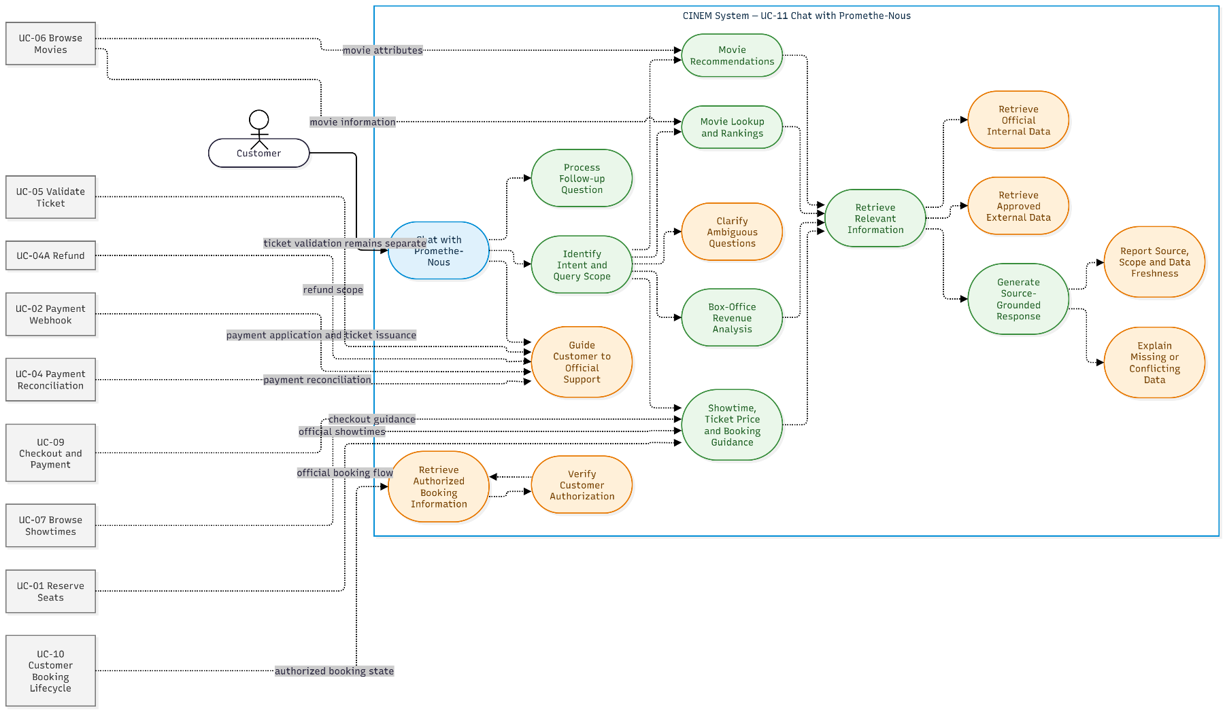
Figure 23: Use-Case Diagram UC-11 Chat with Promethe-Nous
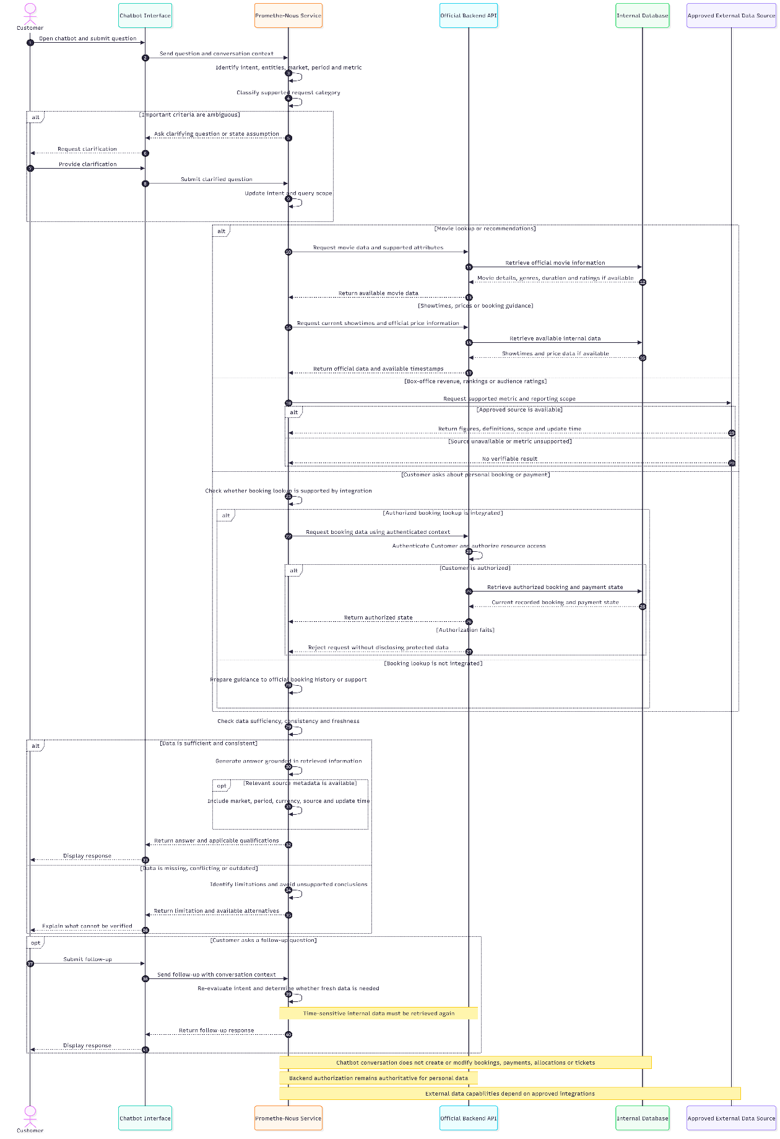
Figure 24: Sequence Diagram UC-11 Chat with Promethe-Nous

Summary

Purpose and Scope
This Use-Case Specification describes the observable behavior and cross-use-case boundaries of the Movie Theater Management and Online Ticket Booking System. It covers movie and showtime browsing, seat reservation, checkout, payment processing, booking lifecycle management, ticket validation, expiration handling, payment reconciliation, the separately specified refund contract, and chatbot-based movie information and customer guidance. It defines expected behavior and does not imply that every described integration or capability is implemented in the current demo.

Use Cases Covered
- UC-01 Reserve Seats: Atomically creates a pending booking and held seat allocations.
- UC-02 Payment Webhook: Receives, verifies, and applies eligible payment outcomes, or routes successful but unapplied payments for reconciliation.
- UC-03 Release Expired Bookings: Expires eligible pending bookings and releases held allocations without treating expiration as proof of payment failure.
- UC-04 Payment Reconciliation: Handles unresolved or late payment outcomes and preserves newer verified states according to the applicable reconciliation rules.
- UC-04A Refund: Defines the expected refund behavior and data contract; execution remains outside the current demo.
- UC-05 Validate Ticket: Validates and consumes an issued ticket once within the configured admission rules.
- UC-06 Browse Movies: Provides movie discovery without creating booking or payment state.
- UC-07 Browse Showtimes: Provides eligible showtime information without reserving seats or establishing seat availability.
- UC-08 Login and Role-Based Navigation: Authenticates users and supports role-based navigation while relying on backend authorization and leaving unresolved role boundaries open.
- UC-09 Checkout and Payment: Starts payment for an existing UC-01 booking by creating or reusing an eligible open payment attempt, without independently applying payment, confirming the booking, or issuing tickets.
- UC-10 Customer Booking Lifecycle: Displays authoritative customer-owned booking, payment, and ticket state and handles cancellation requests for eligible pending bookings.
- UC-11 Chat with Promethe-Nous: Answers Customer questions about movie lookup and rankings, box-office revenue when supported by available data, movie recommendations, showtimes, ticket prices, and the booking process. It communicates data limitations and does not independently create bookings, hold seats, confirm payments, cancel bookings, issue tickets, or change transaction states.

Cross-Use-Case Relationships
- The customer discovery flow proceeds from UC-06 to UC-07 and then to UC-01. Visibility of a showtime does not establish seat availability or guarantee that a reservation will succeed. UC-11 may provide movie information, recommendations, and showtime guidance using the applicable sources but does not replace these use cases.
- UC-01 creates the pending booking used by UC-09. UC-09 creates or reuses an eligible open payment attempt and transfers payment-result handling to UC-02.
- UC-02 applies verified successful payment when the applicable conditions are satisfied, confirms the booking, changes held details to sold, and issues tickets.
- UC-03 handles booking expiration and allocation release. UC-04 handles unresolved or late payment outcomes. UC-04A defines the separately scoped refund contract.
- UC-10 reads authoritative booking, payment, allocation, and ticket states and handles eligible cancellation requests. It does not infer lifecycle transitions from client-side time, redirects, or stale interface data.
- UC-05 validates tickets issued through the payment-application flow. UC-08 supports authentication and role-based navigation; backend authorization remains authoritative for protected operations.
- UC-11 may retrieve movie information from the sources used by UC-06 and showtime information from the sources used by UC-07. It may guide the Customer through the booking and checkout process covered by UC-01 and UC-09, but it does not perform those operations on the Customer's behalf.
- If booking lookup is supported by the chatbot integration, UC-11 may display a Customer's booking information only through an authorized Backend flow consistent with UC-10. Otherwise, it guides the Customer to the official booking-history interface.
- UC-11 does not independently apply payment outcomes, reconcile late payments, release expired bookings, validate tickets, or complete refunds. These responsibilities remain within UC-02, UC-03, UC-04, UC-05, and UC-04A, respectively.

Important Boundaries and Open Decisions
- Payment success is distinct from payment application. A refund-required state is distinct from refund completion. Reconciliation is considered resolved only when the applicable source-defined conditions are satisfied.
- Gateway operations requiring external verification occur outside database transactions holding business locks. The system then re-reads relevant state and applies conditional updates.
- The payment provider contract, retry intervals and limits, grace-period configuration, manual-review permissions, and Staff/Manager/Admin authorization boundaries remain unresolved where the source requirements leave them open.
- UC-07 does not hold seats. UC-09 does not independently apply payment or confirm a booking. UC-10 does not assume unapproved cancellation or refund benefits. UC-04A does not imply that a refund API is operational in the current demo.
- UC-11 provides information and guidance only. Its answers about revenue, rankings, views, ticket sales, and audience ratings depend on the availability, definitions, reliability, and approval of the relevant data sources. Revenue must not be treated as equivalent to views or tickets sold, and historical revenue or growth must not be inferred when historical data is unavailable.
- External data sources for box-office revenue, movie rankings, view counts, ticket sales, and audience ratings have not been finalized. The availability of these chatbot capabilities in the specification does not establish that their integrations have been implemented.
- Access to personal booking information and internal revenue reports through UC-11 requires separately defined authentication and authorization controls. Internal reporting is not part of the Customer-facing chatbot scope by default.
- Automatic field refresh and rendered page layout must be validated in Microsoft Word because DOCX rendering has not been verified.

Overall Use-Case Diagram

Use Case List
The document identifies 12 numbered Use Cases, from UC-01 to UC-11, with UC-04A defined as a separate Use Case.
ID | Use Case | Purpose
UC-01 | Reserve Seats | Hold seats and create a booking
UC-02 | Process Webhook | Process payment webhooks and apply payment results
UC-03 | Release Expired Bookings | Release expired bookings
UC-04 | Payment Reconciliation | Reconcile payments
UC-04A | Refund | Process refunds
UC-05 | Validate Ticket | Validate tickets at the cinema
UC-06 | Browse Movies | Browse movie listings and details
UC-07 | Browse Showtimes | View showtimes and select a screening
UC-08 | Login and Role-Based Navigation | Authenticate users and provide role-based navigation
UC-09 | Checkout and Payment | Complete checkout and initiate payment
UC-10 | Customer Booking Lifecycle | Retrieve bookings, view tickets, and request cancellations
UC-11 | Chat with Promethe-Nous | Provide chatbot assistance and information retrieval
In addition, the document references other business operations, such as viewing the seat map, registering an account, and managing data. These operations should not automatically be treated as independently specified Use Cases.

Actor List
- Customer: Browses movies, views showtimes, reserves seats, checks out, views bookings, and interacts with the chatbot.
- Staff: Validates tickets at the cinema.
- Manager: May participate in payment reconciliation activities, subject to approved permissions.
- Admin: Logs in and navigates to administrative functions according to assigned permissions.
- Payment Gateway: Sends webhooks and provides transaction results to the system.
- System / Background Worker: Automatically processes expired bookings and background payment-processing and reconciliation tasks.

Overall Use-Case Diagram
The following code groups Use Cases by business function and illustrates the actors, system boundary, and relationships between Use Cases. Dashed lines with labels describe business relationships and should not automatically be interpreted as «include» or «extend» relationships.
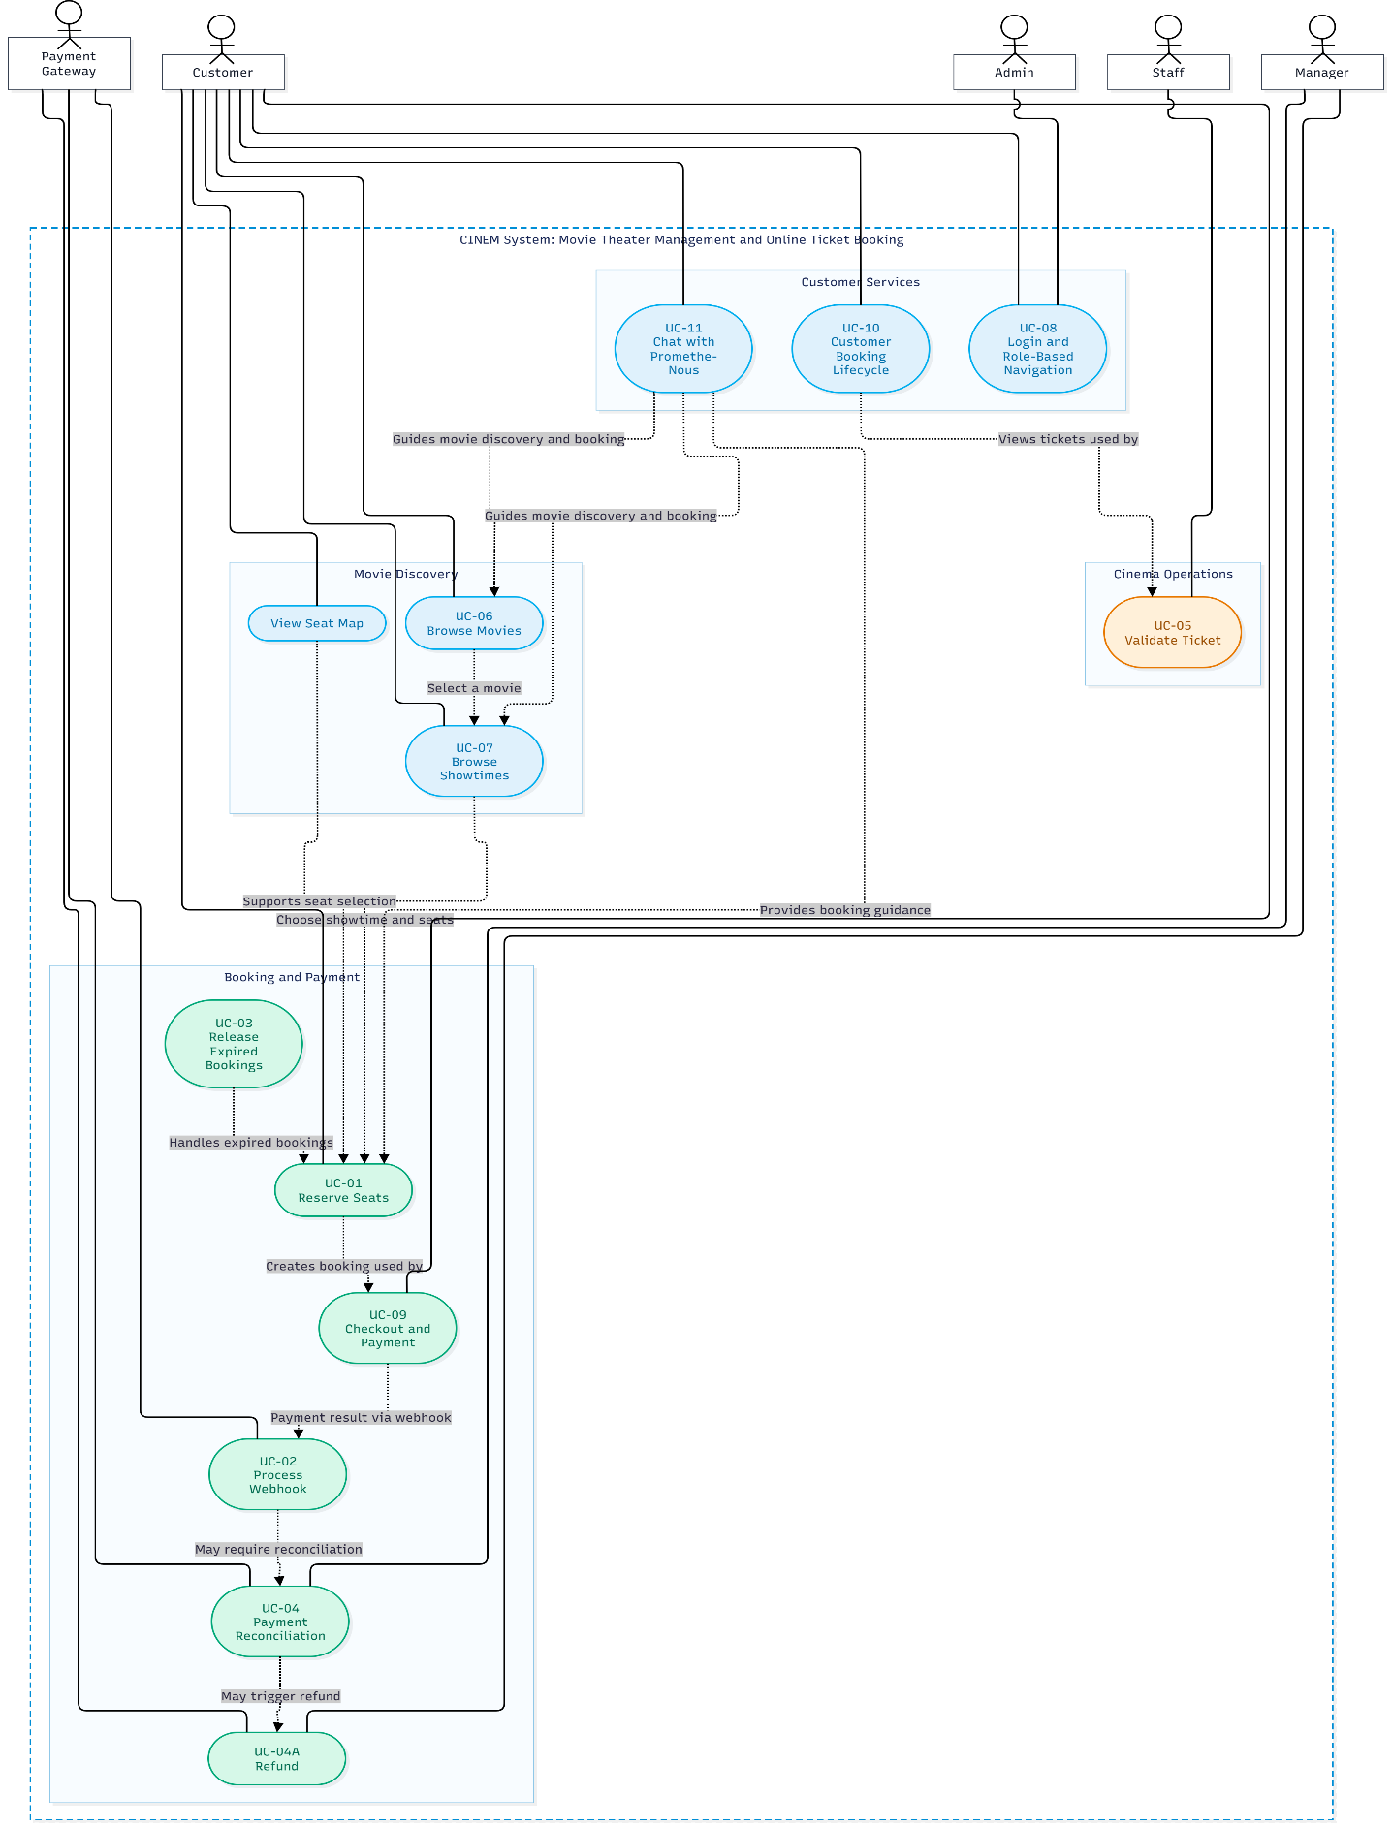
Figure 25: Overall Use-Case Diagram for the CINEM System

