Movie Theater Management and Online Ticket Booking System

Software Architecture Document

Version 3.15

Revision History
Date | Version | Description | Author
3/11/2026 | 1.0 | Created the initial Software Architecture Document and completed the Introduction section, including the introductory overview, Purpose, Scope, References, and Document Overview. Defined architectural coverage of the 28 use cases and documented the selected technology stack, layered modular monolith architecture, ASP.NET Core Identity, Brevo email integration, and external payment and AI integration boundaries. Identified Deployment and Implementation View as reserved for PA4. | Huynh Thanh Tu
3/11/2026 | 1.1 | Added Section 2, Architectural Goals and Constraints, with traceability to the Vision non-functional requirements and revised Use-Case Specifications. Defined goals for usability, performance, concurrency, transaction integrity, payment safety, security, authorisation, admission, auditability, persistence, email delivery, and informational AI assistance. Documented the selected technology stack, layered modular monolith architecture, communication mechanisms, reservation and payment timing, pricing rules, external integration boundaries, configuration management, and PA3 scope. Distinguished proposed quantitative verification targets from verified results. | Huynh Thanh Tu
3/11/2026 | 1.2 | Added the Use-Case Model introduction and catalogue of 28 use cases, including identifiers, names, descriptions, and mappings to functional domains D1–D9. Documented domain responsibilities and use-case counts, the functional decomposition overview, and descriptions accompanying the domain use-case diagrams. Clarified that functional domains do not map one-to-one to architectural components and that actor associations remain subject to detailed operation-level permissions. | Huynh Thanh Tu
3/11/2026 | 1.3 | Added eight cross-use-case business flows covering account access, discovery and booking, payment confirmation and ticket delivery, expiration and recovery, admission, cancellation and refunds, cinema configuration, and operational support. Clarified email-verification requirements, reservation timing, atomic payment confirmation and notification queueing, post-commit email delivery, and payment-safe seat release. Separated pending-booking cancellation from confirmed-booking cancellation and refund handling, including admission restrictions and refund-completion effects. | Huynh Thanh Tu
3/11/2026 | 1.4 | Added the Logical View overview and architectural organisation based on a layered architecture with a modular monolith backend. Defined components C01–C16, their responsibilities, provided services, main connections, and implementation technologies. Included the architectural overview diagram and established rules for frontend and internal communication, data ownership, coordinated transactions, external service calls, background execution, and backend authorisation. | Huynh Thanh Tu
3/11/2026 | 2.0 | Added the detailed design of C01 Web Application, including responsibilities, use-case traceability, implementation technologies, provided interfaces and services, dependencies, and communication mechanisms. Included the class diagram, key class attributes and operations, and class relationships. Documented data ownership, consistency rules, main processing flows, and failure handling. | Tran Thien An
3/11/2026 | 2.1 | Added the detailed design of C02 Backend API, including responsibilities, use-case traceability, implementation technologies, provided interfaces and services, dependencies, and communication mechanisms. Included the class diagram, key class attributes and operations, and class relationships. Documented data ownership, consistency rules, main processing flows, and failure handling. | Nguyen Quoc Nam
3/11/2026 | 2.2 | Added the detailed design of C03 Identity and Access, including responsibilities, use-case traceability, implementation technologies, provided interfaces and services, dependencies, and communication mechanisms. Included the class diagram, key class attributes and operations, and class relationships. Documented data ownership, consistency rules, main processing flows, and failure handling. | Nguyen Trung Chinh
3/11/2026 | 2.3 | Added the detailed design of C04 Movie Catalogue, including responsibilities, use-case traceability, implementation technologies, provided interfaces and services, dependencies, and communication mechanisms. Included the class diagram, key class attributes and operations, and class relationships. Documented data ownership, consistency rules, main processing flows, and failure handling. | Phan Van Viet
4/11/2026 | 2.4 | Added the detailed design of C05 Cinema and Seating, including responsibilities, use-case traceability, implementation technologies, provided interfaces and services, dependencies, and communication mechanisms. Included the class diagram, key class attributes and operations, and class relationships. Documented data ownership, consistency rules, main processing flows, and failure handling. | Tran Thien An
4/11/2026 | 2.5 | Added the detailed design of C06 Showtime Scheduling, including responsibilities, use-case traceability, implementation technologies, provided interfaces and services, dependencies, and communication mechanisms. Included the class diagram, key class attributes and operations, and class relationships. Documented data ownership, consistency rules, main processing flows, and failure handling. | Nguyen Quoc Nam
4/11/2026 | 2.6 | Added the detailed design of C07 Ticket Pricing, including responsibilities, use-case traceability, implementation technologies, provided interfaces and services, dependencies, and communication mechanisms. Included the class diagram, key class attributes and operations, and class relationships. Documented data ownership, consistency rules, main processing flows, and failure handling. | Nguyen Trung Chinh
4/11/2026 | 2.7 | Added the detailed design of C08 Booking and Checkout, including responsibilities, use-case traceability, implementation technologies, provided interfaces and services, dependencies, and communication mechanisms. Included the class diagram, key class attributes and operations, and class relationships. Documented data ownership, consistency rules, main processing flows, and failure handling. | Phan Van Viet
5/11/2026 | 2.8 | Added the detailed design of C09 Payment Processing, including responsibilities, use-case traceability, implementation technologies, provided interfaces and services, dependencies, and communication mechanisms. Included the class diagram, key class attributes and operations, and class relationships. Documented data ownership, consistency rules, main processing flows, and failure handling. | Tran Thien An
5/11/2026 | 2.9 | Added the detailed design of C10 Cancellation and Refund, including responsibilities, use-case traceability, implementation technologies, provided interfaces and services, dependencies, and communication mechanisms. Included the class diagram, key class attributes and operations, and class relationships. Documented data ownership, consistency rules, main processing flows, and failure handling. | Nguyen Quoc Nam
5/11/2026 | 2.10 | Added the detailed design of C11 Ticketing and Admission, including responsibilities, use-case traceability, implementation technologies, provided interfaces and services, dependencies, and communication mechanisms. Included the class diagram, key class attributes and operations, and class relationships. Documented data ownership, consistency rules, main processing flows, and failure handling. | Nguyen Trung Chinh
5/11/2026 | 2.11 | Added the detailed design of C12 Promethe-Nous, including responsibilities, use-case traceability, implementation technologies, provided interfaces and services, dependencies, and communication mechanisms. Included the class diagram, key class attributes and operations, and class relationships. Documented data ownership, consistency rules, main processing flows, and failure handling. | Phan Van Viet
6/11/2026 | 2.12 | Added the detailed design of C13 Persistence and Transactions, including responsibilities, use-case traceability, implementation technologies, provided interfaces and services, dependencies, and communication mechanisms. Included the class diagram, key class attributes and operations, and class relationships. Documented data ownership, consistency rules, main processing flows, and failure handling. | Tran Thien An
6/11/2026 | 2.13 | Added the detailed design of C14 Background Processing, including responsibilities, use-case traceability, implementation technologies, provided interfaces and services, dependencies, and communication mechanisms. Included the class diagram, key class attributes and operations, and class relationships. Documented data ownership, consistency rules, main processing flows, and failure handling. | Nguyen Quoc Nam
6/11/2026 | 2.14 | Added the detailed design of C15 Notification Delivery, including responsibilities, use-case traceability, implementation technologies, provided interfaces and services, dependencies, and communication mechanisms. Included the class diagram, key class attributes and operations, and class relationships. Documented data ownership, consistency rules, main processing flows, and failure handling. | Nguyen Trung Chinh
6/11/2026 | 2.15 | Added the detailed design of C16 Audit Logging, including responsibilities, use-case traceability, implementation technologies, provided interfaces and services, dependencies, and communication mechanisms. Included the class diagram, key class attributes and operations, and class relationships. Documented data ownership, consistency rules, main processing flows, and failure handling. | Phan Van Viet
6/11/2026 | 3.0 | Refined and finalised Figure 1: C01 Web Application Class Diagram, aligning classes, attributes, operations, and relationships with the component’s detailed design. | Tran Thien An
6/11/2026 | 3.1 | Refined and finalised Figure 2: C02 Backend API Class Diagram, aligning classes, attributes, operations, and relationships with the component’s detailed design. | Nguyen Quoc Nam
6/11/2026 | 3.2 | Refined and finalised Figure 3: C03 Identity and Access Class Diagram, aligning classes, attributes, operations, and relationships with the component’s detailed design. | Nguyen Trung Chinh
6/11/2026 | 3.3 | Refined and finalised Figure 4: C04 Movie Catalogue Class Diagram, aligning classes, attributes, operations, and relationships with the component’s detailed design. | Phan Van Viet
8/11/2026 | 3.4 | Refined and finalised Figure 5: C05 Cinema and Seating Class Diagram, aligning classes, attributes, operations, and relationships with the component’s detailed design. | Tran Thien An
8/11/2026 | 3.5 | Refined and finalised Figure 6: C06 Showtime Scheduling Class Diagram, aligning classes, attributes, operations, and relationships with the component’s detailed design. | Nguyen Quoc Nam
8/11/2026 | 3.6 | Refined and finalised Figure 7: C07 Ticket Pricing Class Diagram, aligning classes, attributes, operations, and relationships with the component’s detailed design. | Nguyen Trung Chinh
8/11/2026 | 3.7 | Refined and finalised Figure 8: C08 Booking and Checkout Class Diagram, aligning classes, attributes, operations, and relationships with the component’s detailed design. | Phan Van Viet
9/11/2026 | 3.8 | Refined and finalised Figure 9: C09 Payment Processing Class Diagram, aligning classes, attributes, operations, and relationships with the component’s detailed design. | Tran Thien An
9/11/2026 | 3.9 | Refined and finalised Figure 10: C10 Cancellation and Refund Class Diagram, aligning classes, attributes, operations, and relationships with the component’s detailed design. | Nguyen Quoc Nam
9/11/2026 | 3.10 | Refined and finalised Figure 11: C11 Ticketing and Admission Class Diagram, aligning classes, attributes, operations, and relationships with the component’s detailed design. | Nguyen Trung Chinh
9/11/2026 | 3.11 | Refined and finalised Figure 12: C12 Promethe-Nous Class Diagram, aligning classes, attributes, operations, and relationships with the component’s detailed design. | Phan Van Viet
10/11/2026 | 3.12 | Refined and finalised Figure 13: C13 Persistence and Transactions Class Diagram, aligning classes, attributes, operations, and relationships with the component’s detailed design. | Tran Thien An
10/11/2026 | 3.13 | Refined and finalised Figure 14: C14 Background Processing Class Diagram, aligning classes, attributes, operations, and relationships with the component’s detailed design. | Nguyen Quoc Nam
10/11/2026 | 3.14 | Refined and finalised Figure 15: C15 Notification Delivery Class Diagram, aligning classes, attributes, operations, and relationships with the component’s detailed design. | Nguyen Trung Chinh
10/11/2026 | 3.15 | Refined and finalised Figure 16: C16 Audit Logging Class Diagram, aligning classes, attributes, operations, and relationships with the component’s detailed design. | Phan Van Viet

Table of Contents
1. Introduction 16
1.1 Purpose 16
1.2 Scope 16
1.3 References 16
1.4 Document Overview 17
2. Architectural Goals and Constraints 17
2.1 Architectural Goals 17
2.2 Architectural Constraints 18
3. Use-Case Model 19
3.1 Use-Case Catalogue 19
3.2 Cross-Use-Case Business Flows 21
3.2.1 Account Registration and Access 21
3.2.2 Movie Discovery and Booking 21
3.2.3 Payment Confirmation and Ticket Delivery 21
3.2.4 Booking Expiration and Payment Recovery 22
3.2.5 Ticket Retrieval and Admission 22
3.2.6 Booking Cancellation and Refund Handling 22
3.2.6.1 Pending Booking Cancellation 22
3.2.6.2 Confirmed Booking Cancellation and Refund 22
3.2.7 Cinema Configuration and Showtime Preparation 22
3.2.8 Operational Access and Customer Support 23
3.3 Functional Domains 23
3.4 Functional Decomposition Overview. 24
3.5 Domain Use-Case Diagrams 24
3.5.1 D1 Customer Booking and Payment 24
3.5.2 D2 Customer Booking Management 24
3.5.3 D3 Ticket Validation and Admission 24
3.5.4 D4 Movie Catalog Management 24
3.5.5 D5 Cinema and Screening Room Setup 24
3.5.6 D6 Showtime and Schedule Management 24
3.5.7 D7 Ticket Types and Pricing Management 24
3.5.8 D8 User and Access Management 24
3.5.9 D9 Payment Exception and Recovery 24
4. Logical View 24
4.1 Architectural Organisation 25
4.1.1 Architectural Overview Diagram 26
4.2 Component Catalogue 27
4.3 Communication and Consistency Rules 28
4.4 Component C01 Web Application 29
4.4.1 Purpose and Responsibilities 29
4.4.2 Use-Case Traceability 29
4.4.3 Implementation Language and Technologies 30
4.4.4 Provided Interfaces and Services 30
4.4.5 Dependencies and Communication 30
4.4.6 Class Diagram 31
4.4.6.1 Key Class Descriptions 33
4.4.6.2 Class Relationships 34
4.4.7 Data Ownership and Consistency 34
4.4.8 Key Processing Flows and Failure Handling 35
4.4.8.1 Movie Discovery and Checkout 35
4.4.8.2 Account Access and Operational Navigation 35
4.4.8.3 Booking Access and Admission 35
4.4.8.4 Failure Handling and Recovery 35
4.5 Component C02 Backend API 36
4.5.1 Purpose and Responsibilities 36
4.5.2 Use-Case Traceability 36
4.5.3 Implementation Language and Technologies 37
4.5.4 Provided Interfaces and Services 37
4.5.5 Dependencies and Communication 38
4.5.6 Class Diagram 39
4.5.6.1 Key Class Descriptions 42
4.5.6.2 Class Relationships 43
4.5.7 Data Ownership and Consistency 44
4.5.8 Key Processing Flows and Failure Handling 44
4.5.8.1 Standard Customer or Operational Request 44
4.5.8.2 Payment Webhook Reception 45
4.5.8.3 Failure Handling 45
4.6 Component C03 Identity and Access 45
4.6.1 Purpose and Responsibilities 45
4.6.2 Use-Case Traceability 46
4.6.3 Implementation Language and Technologies 46
4.6.4 Provided Interfaces and Services 46
4.6.5 Dependencies and Communication 47
4.6.6 Class Diagram 48
4.6.6.1 Key Class Descriptions 50
4.6.6.2 Class Relationships 52
4.6.7 Data Ownership and Consistency 53
4.6.8 Key Processing Flows and Failure Handling 53
4.6.8.1 Customer Registration and Email Verification 53
4.6.8.2 Login Without an Active Session 54
4.6.8.3 Login When Another Session Is Active 54
4.6.8.4 Token Refresh and Logout 54
4.6.8.5 Account Administration and Protected Access 54
4.6.8.6 Failure Handling and Recovery 54
4.7 Component C04 Movie Catalogue 55
4.7.1 Purpose and Responsibilities 55
4.7.2 Use-Case Traceability 55
4.7.3 Implementation Language and Technologies 55
4.7.4 Provided Interfaces and Services 56
4.7.5 Dependencies and Communication 56
4.7.6 Class Diagram 57
4.7.6.1 Key Class Descriptions 59
4.7.6.2 Class Relationships 60
4.7.7 Data Ownership and Consistency 60
4.7.8 Key Processing Flows and Failure Handling 61
4.7.8.1 Public Movie Browsing 61
4.7.8.2 Public Movie Details 61
4.7.8.3 Movie Administration 61
4.7.8.4 Genre and Association Maintenance 61
4.7.8.5 Catalogue Information for Other Components 62
4.7.8.6 Failure Handling and Recovery 62
4.8 Component C05 Cinema and Seating 62
4.8.1 Purpose and Responsibilities 62
4.8.2 Use-Case Traceability 62
4.8.3 Implementation Language and Technologies 63
4.8.4 Provided Interfaces and Services 63
4.8.5 Dependencies and Communication 64
4.8.6 Class Diagram 65
4.8.6.1 Key Class Descriptions 67
4.8.6.2 Class Relationships 68
4.8.7 Data Ownership and Consistency 69
4.8.8 Key Processing Flows and Failure Handling 70
4.8.8.1 Cinema and Screening-Room Maintenance 70
4.8.8.2 Physical Seat-Layout Configuration 70
4.8.8.3 Seat Operational-Status Change 70
4.8.8.4 Seat-Type and Surcharge Maintenance 70
4.8.8.5 Configuration Queries for Scheduling and Booking 70
4.8.8.6 Failure Handling and Recovery 71
4.9 Component C06 Showtime Scheduling 71
4.9.1 Purpose and Responsibilities 71
4.9.2 Use-Case Traceability 71
4.9.3 Implementation Language and Technologies 72
4.9.4 Provided Interfaces and Services 72
4.9.5 Dependencies and Communication 73
4.9.6 Class Diagram 75
4.9.6.1 Key Class Descriptions 77
4.9.6.2 Class Relationships 79
4.9.7 Data Ownership and Consistency 79
4.9.8 Key Processing Flows and Failure Handling 80
4.9.8.1 Public Showtime Browsing 80
4.9.8.2 Showtime Creation 80
4.9.8.3 Controlled Rescheduling 80
4.9.8.4 Showtime Maintenance and State Changes 81
4.9.8.5 Screening Context for Booking and Admission 81
4.9.8.6 Failure Handling and Recovery 81
4.10 Component C07 Ticket Pricing 81
4.10.1 Purpose and Responsibilities 81
4.10.2 Use-Case Traceability 82
4.10.3 Implementation Language and Technologies 82
4.10.4 Provided Interfaces and Services 82
4.10.5 Dependencies and Communication 83
4.10.6 Class Diagram 84
4.10.6.1 Key Class Descriptions 86
4.10.6.2 Class Relationships 87
4.10.7 Data Ownership and Consistency 88
4.10.8 Key Processing Flows and Failure Handling 89
4.10.8.1 Ticket-Category Maintenance 89
4.10.8.2 Cinema Base-Price Configuration 89
4.10.8.3 Checkout Quotation 89
4.10.8.4 Reservation Price Revalidation 89
4.10.8.5 Failure Handling and Recovery 89
4.11 Component C08 Booking and Checkout 90
4.11.1 Purpose and Responsibilities 90
4.11.2 Use-Case Traceability 90
4.11.3 Implementation Language and Technologies 91
4.11.4 Provided Interfaces and Services 91
4.11.5 Dependencies and Communication 92
4.11.6 Class Diagram 95
4.11.6.1 Key Class Descriptions 98
4.11.6.2 Class Relationships 99
4.11.7 Data Ownership and Consistency 100
4.11.8 Key Processing Flows and Failure Handling 100
4.11.8.1 Selection and Checkout Restoration 100
4.11.8.2 Atomic Reservation Creation 101
4.11.8.3 Payment Initiation 101
4.11.8.4 Verified Booking Confirmation 101
4.11.8.5 Pending Cancellation and Safe Expiration 101
4.11.8.6 Booking Access and Schedule Changes 101
4.11.8.7 Failure Handling and Recovery 102
4.12 Component C09 Payment Processing 102
4.12.1 Purpose and Responsibilities 102
4.12.2 Use-Case Traceability 102
4.12.3 Implementation Language and Technologies 103
4.12.4 Provided Interfaces and Services 103
4.12.5 Dependencies and Communication 104
4.12.6 Class Diagram 106
4.12.6.1 Key Class Descriptions 109
4.12.6.2 Class Relationships 110
4.12.7 Data Ownership and Consistency 111
4.13 Component C09 Payment Processing 112
4.13.1 Purpose and Responsibilities 112
4.13.2 Use-Case Traceability 112
4.13.3 Implementation Language and Technologies 113
4.13.4 Provided Interfaces and Services 113
4.13.5 Dependencies and Communication 114
4.13.6 Class Diagram 116
4.13.6.1 Key Class Descriptions 119
4.13.6.2 Class Relationships 121
4.13.7 Data Ownership and Consistency 122
4.13.8 Key Processing Flows and Failure Handling 123
4.13.8.1 Payment Initiation 123
4.13.8.2 Payment Webhook Processing 123
4.13.8.3 Payment Reconciliation 123
4.13.8.4 Successful Payment That Cannot Be Applied 123
4.13.8.5 Payment Protection for Cancellation and Expiration 123
4.13.8.6 Failure Handling and Recovery 124
4.14 Component C10 Cancellation and Refund 124
4.14.1 Purpose and Responsibilities 124
4.14.2 Use-Case Traceability 124
4.14.3 Implementation Language and Technologies 125
4.14.4 Provided Interfaces and Services 125
4.14.5 Dependencies and Communication 127
4.14.6 Class Diagram 128
4.14.6.1 Key Class Descriptions 130
4.14.6.2 Class Relationships 132
4.14.7 Data Ownership and Consistency 133
4.14.8 Key Processing Flows and Failure Handling 133
4.14.8.1 Confirmed-Booking Cancellation Request 133
4.14.8.2 Cancellation Review 134
4.14.8.3 Admission While Review Is Pending 134
4.14.8.4 Unapplied Successful Payment 134
4.14.8.5 Recording External Refund Completion 134
4.14.9 Failure Handling and Recovery 134
4.15 Component C11 Ticketing and Admission 135
4.15.1 Purpose and Responsibilities 135
4.15.2 Use-Case Traceability 135
4.15.3 Implementation Language and Technologies 136
4.15.4 Provided Interfaces and Services 136
4.15.5 Dependencies and Communication 137
4.15.6 Class Diagram 139
4.15.6.1 Key Class Descriptions 142
4.15.6.2 Class Relationships 144
4.15.7 Data Ownership and Consistency 144
4.15.8 Key Processing Flows and Failure Handling 145
4.15.8.1 Ticket Issuance 145
4.15.8.2 Ticket Retrieval and Email Resend 145
4.15.8.3 QR Validation 145
4.15.8.4 Admission Confirmation 146
4.15.8.5 Ticket Invalidation After Refund Completion 146
4.15.8.6 Failure Handling and Recovery 146
4.16 Component C12 Promethe-Nous 147
4.16.1 Purpose and Responsibilities 147
4.16.2 Use-Case Traceability 147
4.16.3 Implementation Language and Technologies 147
4.16.4 Provided Interfaces and Services 148
4.16.5 Dependencies and Communication 148
4.16.6 Class Diagram 149
4.16.6.1 Key Class Descriptions 151
4.16.6.2 Class Relationships 153
4.16.7 Data Ownership and Consistency 153
4.16.8 Key Processing Flows and Failure Handling 154
4.16.8.1 Question Processing 154
4.16.8.2 Source Selection and Recommendations 154
4.16.8.3 External Service Failures 154
4.16.8.4 Information and Access Protection 154
4.17 Component C13 Persistence and Transactions 155
4.17.1 Purpose and Responsibilities 155
4.17.2 Use-Case Traceability 155
4.17.3 Implementation Language and Technologies 156
4.17.4 Provided Interfaces and Services 156
4.17.5 Dependencies and Communication 157
4.17.6 Class Diagram 157
4.17.6.1 Key Class Descriptions 160
4.17.6.2 Class Relationships 162
4.17.7 Data Ownership and Consistency 162
4.17.7.1 Logical Ownership and Persistence Scope 162
4.17.7.2 Atomic Business Changes 163
4.17.7.3 Constraints and Concurrency Protection 163
4.17.7.4 Notification Claims and Recovery 163
4.17.7.5 Data Representation and Retention 163
4.17.8 Key Processing Flows and Failure Handling 164
4.17.8.1 Read Operation 164
4.17.8.2 Coordinated Write Operation 164
4.17.8.3 External Calls and Result Application 164
4.17.8.4 Database Failures and Retry 164
4.17.8.5 Schema Changes 164
4.18 Component C14 Background Processing 165
4.18.1 Purpose and Responsibilities 165
4.18.2 Use-Case Traceability 165
4.18.3 Implementation Language and Technologies 165
4.18.4 Provided Interfaces and Services 166
4.18.5 Dependencies and Communication 166
4.18.6 Class Diagram 167
4.18.6.1 Key Class Descriptions 169
4.18.6.2 Class Relationships 170
4.18.7 Data Ownership and Consistency 171
4.18.7.1 Execution State and Durable Work 171
4.18.7.2 Transaction Boundaries 171
4.18.7.3 Concurrency and Repeated Execution 172
4.18.7.4 System Execution Context 172
4.18.8 Key Processing Flows and Failure Handling 172
4.18.8.1 Worker Startup and Scheduling 172
4.18.8.2 Booking Expiration 172
4.18.8.3 Payment Reconciliation 172
4.18.8.4 Notification Delivery 173
4.18.8.5 Execution Failures and Retry 173
4.18.8.6 Shutdown and Restart Recovery 173
4.19 Component C15 Notification Delivery 173
4.19.1 Purpose and Responsibilities 173
4.19.2 Use-Case Traceability 174
4.19.3 Implementation Language and Technologies 174
4.19.4 Provided Interfaces and Services 174
4.19.5 Dependencies and Communication 174
4.19.6 Class Diagram 175
4.19.6.1 Key Class Descriptions 176
4.19.6.2 Class Relationships 177
4.19.7 Data Ownership and Consistency 178
4.19.8 Key Processing Flows and Failure Handling 178
4.19.8.1 Initial Email Delivery 178
4.19.8.2 Retry and Recovery 178
4.20 Component C16 Audit Logging 179
4.20.1 Purpose and Responsibilities 179
4.20.2 Use-Case Traceability 179
4.20.3 Implementation Language and Technologies 179
4.20.4 Provided Interfaces and Services 180
4.20.5 Dependencies and Communication 180
4.20.6 Class Diagram 181
4.20.6.1 Key Class Descriptions 183
4.20.6.2 Class Relationships 184
4.20.7 Data Ownership and Consistency 184
4.20.7.1 Audit Record Ownership 184
4.20.7.2 Atomicity with Business Changes 184
4.20.7.3 Actor and Time Integrity 185
4.20.7.4 Recorded Changes and Sensitive Data 185
4.20.7.5 Immutability and Repeated Processing 185
4.20.8 Key Processing Flows and Failure Handling 185
4.20.8.1 Privileged Business Action 185
4.20.8.2 Refund Completion 186
4.20.8.3 Background Action 186
4.20.8.4 Validation and Persistence Failures 186
5. Deployment 186
6. Implementation View 186

Software Architecture Document

Introduction
This section introduces the Software Architecture Document for Promethe-Phos — Movie Theater Management and Online Ticket Booking System. It defines the document’s purpose and scope, identifies the supporting references, and outlines the architectural views presented in the following sections.

Purpose
This Software Architecture Document describes the architecture of Promethe-Phos — Movie Theater Management and Online Ticket Booking System. It establishes the architectural goals, major components, responsibilities, interfaces, and design constraints that guide implementation.
The document provides a common technical reference for team members responsible for frontend development, backend development, database integration, testing, and architectural review. It supports consistent implementation of the approved requirements and coordination between components developed by different team members.

Scope
The architecture covers the customer-facing web application, cinema-management interfaces, backend application services, persistent storage, background processing, and external service integrations.
The functional scope follows the 28 use cases defined in the revised Use-Case Specifications. It includes movie and showtime discovery, seat selection and reservation, guest and registered-customer checkout, payment processing, booking expiration, payment reconciliation, cancellation and refund management, electronic ticket issuance and admission, account and access management, cinema administration, and Promethe-Nous informational assistance.
The system uses React, Vite, and TypeScript for the frontend; ASP.NET Core Web API and C# for the backend; Entity Framework Core for data access; and PostgreSQL for persistent storage. ASP.NET Core Identity supports account authentication and email verification. Brevo provides transactional email delivery through an HTTPS API.
The architecture follows a layered design with a modular monolith backend. Backend modules have defined responsibilities and interfaces while operating within one backend application. Their logical separation does not imply independent deployment.
MoMo is the intended external payment gateway. Promethe-Nous integrates with an external AI service through a provider adapter. The AI provider and supporting external information sources remain subject to detailed design decisions. Automated external monetary refund execution is outside the current demonstration scope; the application manages refund obligations and records authorised evidence of externally completed refunds.
For PA3, this document focuses on architectural drivers, the use-case model, logical components, and component class designs. Deployment and Implementation View are reserved for PA4.

References
Reference | Document or Decision | Architectural Relevance
REF-01 | Promethe-Phos Vision Document | Product scope, stakeholder needs, quality objectives, and design and implementation constraints. References to non-functional requirements use the expanded NFR-01–NFR-25 set.
REF-02 | Revised Use-Case Specifications | Authoritative detailed functional requirements, business rules, authorisation boundaries, lifecycle behaviour, and the 28-use-case model.
REF-03 | Software Development Plan | Project organisation, development iterations, responsibilities, and delivery constraints.
REF-04 | PA3 assignment specification | Required architectural content, component class diagrams, and sections deferred to PA4.
REF-05 | Provided Software Architecture Document template | Required document structure and guidance for each architectural view.
REF-06 | Agreed project architecture and technology decisions | Selected frontend and backend stack, layered modular monolith architecture, ASP.NET Core Identity, and Brevo HTTPS API integration.
The detailed Use-Case Specifications govern functional behaviour where older Vision statements are inconsistent with the revised baseline. Changes to requirements or architectural decisions must be reflected in the affected documents and component contracts.

Document Overview
Architectural Goals and Constraints identifies the quality objectives, business invariants, technology choices, and external dependencies that influence the architecture.
Use-Case Model presents the functional decomposition and use-case diagrams reused from the Use-Case Specifications.
Logical View describes the architectural structure, component responsibilities, communication mechanisms, and dependencies. Each component subsection provides its use-case traceability, implementation technologies, interfaces, class diagram, key classes, data ownership, and relevant processing and failure-handling behaviour.
Deployment and Implementation View are reserved for PA4.

Architectural Goals and Constraints
The architecture of Promethe-Phos is guided by the quality requirements and implementation constraints defined in the Vision Document, together with the detailed business rules in the revised Use-Case Specifications. The following goals and constraints influence component responsibilities, communication, data management, and external integrations.
Quantitative performance and usability thresholds are proposed verification targets. Their achievement must be assessed in the agreed test environment before being reported as verified.

Architectural Goals
- Usability and responsive presentation: Provide consistent navigation for movie discovery, seat selection, checkout, ticket retrieval, and cinema operations. Interfaces shall reflect effective permissions and support the agreed desktop and mobile browsers. Proposed verification includes viewport widths of 375, 768, and 1280 CSS pixels and at least 80% unassisted completion of defined usability scenarios. [Vision NFR-01, NFR-02, NFR-21]
- Performance: Under the workloads and measurement conditions specified in the Vision, at least 95% of eligible movie/showtime retrieval requests should complete within 2 seconds, reservation requests within 3 seconds, and ticket-validation requests within 2 seconds. External payment processing, AI inference, media loading, and camera acquisition are measured separately. [Vision NFR-03–NFR-05]
- Concurrency and transaction integrity: Prevent conflicting active allocations for the same physical seat and showtime. Booking creation and allocation of all requested seats shall succeed or fail atomically. Concurrent reservation, expiration, payment, cancellation, and admission operations shall preserve the applicable business invariants. [Vision NFR-06–NFR-08]
- Verified and idempotent payment processing: Confirm bookings and issue valid tickets only after an eligible payment outcome has been verified. Repeated notifications, retries, and reconciliation shall not duplicate payment application, booking confirmation, or ticket issuance. Browser redirects shall not be treated as authoritative payment evidence. [Vision NFR-09, NFR-10, NFR-12]
- Safe expiration and recovery: Apply authoritative server deadlines and payment-protection rules consistently. Unresolved payment outcomes shall remain protected until the applicable verification and reconciliation rules permit further action. Expiration and reconciliation shall operate independently of the customer’s browser session. [Vision NFR-11, NFR-12; DIC-08]
- Authentication and authorisation: Enforce current account status, effective roles, and applicable cinema assignments on the backend. Protected state changes require the prescribed authorisation recheck before commit. Manager and Admin roles shall not automatically grant Staff-only admission permissions. [Vision NFR-13, NFR-14; UC-18]
- Security and privacy: Protect credentials, authentication tokens, verification links, booking-access information, and personal data. Validate incoming requests and prevent unauthorised access to booking and ticket records. Client responses and ordinary logs shall not expose secrets or detailed internal exceptions. [Vision NFR-15–NFR-17]
- Ticket admission integrity: Enforce booking-level QR eligibility, current screening context, admission time limits, remaining admission entitlements, and Staff–Cinema authorisation. Repeated or concurrent scans shall not produce excessive admissions or bypass cancellation and refund restrictions. [Vision NFR-18; UC-05]
- Auditability: Preserve the required actor, timestamp, action, and supporting evidence for refund processing and privileged operations. Mandatory audit records shall remain consistent with the business changes they document. [Vision NFR-19]
- Persistence and maintainability: Preserve committed records across normal backend restarts. Separate presentation, API handling, application coordination, domain rules, and infrastructure responsibilities. Define explicit module interfaces and repeatable tests for critical transitions and concurrency scenarios. [Vision NFR-20, NFR-22, NFR-23]
- Reliable email delivery: Support account-verification emails and booking-confirmation emails containing ticket information. Persist delivery requests with the related business changes, send outside business transactions, and support controlled retry and resend without duplicating bookings or tickets. [UC-02, UC-04, UC-08B, UC-09, UC-10, UC-19]
- Informational AI assistance: Restrict Promethe-Nous to permitted information retrieval and guidance. It shall not independently modify booking, payment, refund, ticket, or administrative states. Missing information and provider failures shall produce clear limitations or service-status feedback. The proposed response or meaningful feedback target is within 15 seconds for at least 90% of the agreed supported queries under controlled test conditions. [Vision NFR-24, NFR-25]

Architectural Constraints
- Application platform: Develop a browser-based application with customer-facing and authorised cinema-management interfaces using React, Vite, and TypeScript. [Vision DIC-01, DIC-02]
- Backend and persistence: Use C# and ASP.NET Core Web API for backend functionality, Entity Framework Core for designated data-access operations, and PostgreSQL for persistent storage. Database-specific constraints and locking may supplement EF Core where required for correctness. [Vision DIC-03–DIC-05, DIC-07]
- Architectural organisation: Use a layered design with a modular monolith backend. Components C01–C16 represent logical responsibilities; backend modules operate within one application and normally communicate through C# interfaces resolved through dependency injection. [Agreed architecture decision]
- Communication: Use HTTPS APIs with JSON for frontend–backend communication and HTTPS for supported external provider APIs. Client-side state shall not be the sole authority for seat availability, prices, deadlines, payment outcomes, ticket validity, or permissions. [Vision DIC-06]
- Identity management: Use ASP.NET Core Identity for account credentials and email-confirmation tokens. Application services shall enforce the additional role, account-state, guest-access, and cinema-assignment rules defined in the Use-Case Specifications. [Vision DIC-09; agreed technology decision]
- Reservation and payment timing: Preserve the distinction between selection and seat holding. The server-controlled five-minute selection session starts with the first seat selection. Booking creation at Checkout Step 1 to Step 2 inherits the original selection deadline. Successful external payment initiation establishes the ten-minute payment deadline, with the configured grace and reconciliation rules governing subsequent protection and release. [UC-01–UC-04, UC-09]
- Seat and pricing model: Treat each physical seat as one admission place. Maintain the two required booking-level ticket categories, Adult and Discounted, without assigning categories to individual seats. Separate cinema base prices from shared seat-type surcharges and preserve accepted booking price snapshots. [UC-01, UC-15C, UC-16A, UC-16B]
- Payment integration: Use MoMo as the intended payment gateway through a defined adapter. Execute external network calls outside database transactions holding business locks and revalidate relevant conditions before applying results. Any demonstration substitute shall be explicitly documented. [Vision DIC-10; UC-02, UC-04, UC-09]
- Refund execution boundary: Manage refund obligations, authorisation, evidence, and the resulting application-state transitions. Automatic execution of external monetary refunds is outside the current demonstration scope. [Vision DIC-11; UC-04A]
- Email integration: Use Brevo transactional email through its HTTPS API, encapsulated behind an email-sending interface. Keep sender configuration, credentials, provider quotas, and service endpoints outside business logic. [Agreed technology decision; Vision DIC-14]
- AI integration: Encapsulate the selected AI provider behind an adapter and expose only permitted query interfaces to the chatbot. Provider selection and external ranking or revenue sources remain detailed design decisions. [Vision DIC-12; UC-11]
- Time and configuration: Use authoritative server time and timezone-aware timestamps, with business-time presentation following Asia/Ho_Chi_Minh. Manage environment-specific configuration and secrets outside committed source code. [Vision DIC-13, DIC-14]
- Project delivery: Keep architectural complexity within the team’s resources and course schedule. PA3 covers the architectural drivers, use-case model, logical components, and class designs; Deployment and Implementation View remain reserved for PA4. [Vision DIC-15; PA3 assignment specification]

Use-Case Model
The use-case model defines the functional scope of Promethe-Phos through 28 use cases organised into nine functional domains, identified as D1–D9. These domains group related user goals and system responsibilities.
This section presents the use-case catalogue, cross-use-case business flows, functional domain grouping, and diagrams reproduced from the Use-Case Specifications. Detailed flows, preconditions, postconditions, business rules, and special requirements remain defined in the corresponding use-case specifications.
The functional domains describe requirements groupings. Their boundaries do not require a one-to-one correspondence with the architectural components presented in the Logical View.

Use-Case Catalogue
Use-Case ID | Use-Case Name | Description | Functional Domain
UC-01 | Reserve Seats | Validates the checkout selection and atomically creates a pending booking with held seat allocations, preserving the applicable selection deadline and accepted price snapshot. | D1
UC-02 | Payment Webhook | Receives and verifies payment notifications, applies eligible outcomes idempotently, and coordinates booking confirmation, ticket issuance, and email delivery requests. | D9
UC-03 | Release Expired Bookings | Processes eligible expired pending bookings and releases held seats while preserving payment protection, grace-period rules, and consistency with concurrent payment processing. | D9
UC-04 | Payment Reconciliation | Obtains authoritative payment status for unresolved attempts and safely applies verified outcomes or records cases requiring refund handling or review. | D9
UC-04A | Refund | Manages refund obligations arising from unapplied successful payments or approved qualifying cancellations, including authorised recording of externally completed refunds and their required business effects. | D9
UC-05 | Validate Ticket | Allows authorised Staff to validate a booking-level QR code and record eligible admissions within the admission window, enforcing remaining admission entitlements, age requirements, and discounted eligibility. | D3
UC-06A | Browse Movies | Allows Guests and Customers to browse, search, and filter publicly eligible movies according to catalogue visibility rules. | D1
UC-06B | View Movie Details | Presents permitted movie details, including descriptive information, classification, runtime, and available media, according to the movie’s visibility and status. | D1
UC-07 | Browse Showtimes | Allows Guests and Customers to browse eligible showtimes by applicable movie, cinema, and date and select a screening for booking. | D1
UC-08A | Register Customer Account | Creates a customer account after validating registration information, assigning the Customer role, and initiating email verification. | D8
UC-08B | Verify Email Address | Verifies ownership of a registered email address through a valid verification token and supports verification-link resend under the specified controls. | D8
UC-08C | Login | Authenticates an eligible account and establishes authenticated access with navigation reflecting effective roles, account status, and cinema assignments. | D8
UC-08D | Logout | Ends the current authenticated session and returns the application to unauthenticated access without changing existing booking or payment outcomes. | D8
UC-09 | Checkout and Payment | Supports guest and registered-customer checkout, validates contact information and required acknowledgements, coordinates reservation creation, and initiates an eligible external payment attempt. | D1
UC-10 | Customer Booking Lifecycle | Allows Customers and authorised Guests to retrieve bookings, access tickets, request email resend, cancel eligible pending bookings, and submit qualifying confirmed-booking cancellation requests. | D2
UC-11 | Chat with Promethe-Nous | Answers supported questions about movies, recommendations, showtimes, prices, booking procedures, and available external movie information using appropriate sources, without performing business-state changes. | D1
UC-12 | Manage Movie Catalog | Allows Admin to maintain movie records and movie–genre associations, with Manager read-only access and safeguards for visibility, historical information, and dependent showtimes. | D4
UC-13 | Manage Genres | Allows Admin to maintain genre definitions and status, with Manager read-only access and controls that preserve valid movie associations and historical references. | D4
UC-14A | Manage Cinemas | Provides authorised cinema information access and administration, enforcing role and assignment scope and protecting dependent rooms, showtimes, and bookings. | D5
UC-14B | Manage Screening Rooms | Provides authorised access to and maintenance of screening rooms, including operational configuration and safeguards for existing schedules and booking obligations. | D5
UC-15A | Configure Seat Layout | Allows authorised personnel to configure physical seating arrangements while preserving seat identity and protecting affected showtimes, allocations, and tickets. | D5
UC-15B | Change Seat Operational Status | Allows authorised personnel to change physical seat operational status while checking affected screening and booking obligations and preserving allocation consistency. | D5
UC-15C | Manage Seat Types | Allows Admin to maintain shared seat-type definitions and surcharges, with permitted read access for other roles and protection of accepted booking price snapshots. | D7
UC-16A | Manage Ticket Types | Allows Admin to maintain the required Adult and Discounted ticket-category definitions and eligibility information while preserving the two-category model. | D7
UC-16B | Configure Cinema Ticket Pricing | Allows Admin and appropriately assigned Managers to configure cinema-specific Adult and Discounted base prices, separately from shared seat-type surcharges and existing booking snapshots. | D7
UC-17 | Manage Showtimes and Schedules | Provides authorised showtime access and maintenance, enforcing room availability, scheduling conflicts, duration snapshots, and controlled changes affecting existing bookings. | D6
UC-18 | Manage User Accounts and Roles | Manages account access, roles, account states, and cinema assignments under the specified authorisation rules, with immediate effect on subsequent protected operations. | D8
UC-19 | Manage Bookings and Tickets | Allows authorised cinema personnel to retrieve scoped booking and ticket records, provide permitted customer assistance, and process cancellation-review or refund-related actions within their assigned responsibilities. | D2

Cross-Use-Case Business Flows
The following business flows describe how the 28 use cases cooperate across customer, operational, and system activities. A use case may participate in multiple flows. The sequences describe business coordination and do not introduce additional UML «include» or «extend» relationships.

Account Registration and Access
- A Guest registers a customer account through UC-08A Register Customer Account.
- The system sends an email-verification link. The user may complete UC-08B Verify Email Address before or after the first Customer login.
- The user signs in through UC-08C Login, subject to the applicable account rules. Customer login does not require prior email verification; access to internal-role operations requires a verified email address.
- The application presents navigation according to the account’s effective roles and cinema assignments.
- The user ends the authenticated session through UC-08D Logout.
Authorised account administration through UC-18 Manage User Accounts and Roles governs account states, role assignments, and cinema assignments. These changes affect subsequent protected operations.

Movie Discovery and Booking
- A Guest or Customer browses eligible movies through UC-06A Browse Movies.
- The user opens a selected movie through UC-06B View Movie Details.
- The user browses and selects an eligible screening through UC-07 Browse Showtimes.
- The user selects Adult and Discounted ticket quantities and the corresponding physical seats. The first seat selection starts the server-controlled selection session; no booking or seat hold exists at this stage.
- Through UC-09 Checkout and Payment, the user reviews the selection, provides the required contact information, and completes the required acknowledgements.
- When progressing from Checkout Step 1 to Step 2, the system executes UC-01 Reserve Seats to revalidate the selection and atomically create a pending booking with held allocations and accepted price snapshots.
- UC-09 initiates an eligible payment attempt and directs the user to the external payment gateway.
During discovery or checkout, the user may independently invoke UC-11 Chat with Promethe-Nous for supported information and guidance. Chatbot assistance does not create bookings, hold seats, or confirm payments.

Payment Confirmation and Ticket Delivery
- Following payment initiation through UC-09 Checkout and Payment, the payment gateway sends a notification.
- UC-02 Payment Webhook verifies the notification and checks whether the outcome can be applied to the booking.
- For an eligible successful payment, the system atomically records the applied payment outcome, confirms the booking, converts held allocations to sold allocations, issues the booking-level ticket and QR code, and persists the email-delivery request.
- After the transaction commits, the notification service sends the booking confirmation and ticket information. Failed delivery is retried without repeating booking confirmation or ticket issuance.
- The Customer or authorised Guest accesses the booking and ticket through UC-10 Customer Booking Lifecycle.
If a payment outcome is resolved through UC-04 Payment Reconciliation, the system uses the same protected confirmation and ticket-issuance rules. Email-delivery failure does not reverse a confirmed booking; delivery is retried according to the notification rules.

Booking Expiration and Payment Recovery
- UC-03 Release Expired Bookings identifies pending bookings whose applicable deadlines have passed.
- The system checks payment attempts and the required protection and grace-period conditions.
- If the booking is eligible for expiration, the system expires it and releases its held allocations.
- If a payment outcome remains unresolved, the system preserves the required protection and resolves the payment through UC-04 Payment Reconciliation.
- A verified successful outcome is applied only if the booking remains eligible for confirmation.
- If a verified successful payment cannot be applied, the system records the required refund obligation or review state for handling through UC-04A Refund.
UC-02 Payment Webhook may execute concurrently with expiration or reconciliation. These operations coordinate to prevent conflicting state changes, duplicate confirmation, or premature seat release.

Ticket Retrieval and Admission
- A Customer or authorised Guest retrieves the booking-level ticket through UC-10 Customer Booking Lifecycle or presents the delivered ticket.
- Staff with the required cinema assignment scan the QR code through UC-05 Validate Ticket.
- The system checks the booking and ticket state, screening context, admission window, and remaining admission entitlements.
- Staff perform the required age and discounted-eligibility checks and confirm the eligible number of admissions.
- The system records the admission counts and preserves the remaining entitlements for subsequent eligible admissions.
Authorised personnel may use UC-19 Manage Bookings and Tickets to provide permitted booking and ticket assistance. Access to operational support does not independently grant admission authority.

Booking Cancellation and Refund Handling

Pending Booking Cancellation
- The user requests cancellation of a pending booking.
- The system checks whether cancellation is permitted under the current payment state and payment-safety rules.
- If eligible, the system cancels the booking and releases its held allocations. This path does not initiate the confirmed-booking cancellation review or refund process.

Confirmed Booking Cancellation and Refund
- For a confirmed booking affected by qualifying rescheduling under UC-17 Manage Showtimes and Schedules, the user submits a cancellation request before the current showtime starts and while no admissions have been recorded.
- The system validates the cancellation conditions and records the request for review.
- Authorised personnel review the request through UC-19 Manage Bookings and Tickets.
- If approved, the request proceeds to UC-04A Refund. Admission is blocked while the approved cancellation awaits refund completion.
- Authorised personnel record the externally completed refund and the required supporting evidence.
- Successful refund completion cancels the booking, invalidates the ticket, and releases the sold allocations according to the specified rules.
A pending cancellation review does not itself block admission. The first successful admission automatically rejects the pending cancellation request. Refund obligations originating from payment reconciliation follow their own specified completion effects.

Cinema Configuration and Showtime Preparation
- Authorised personnel establish and maintain cinemas through UC-14A Manage Cinemas.
- Screening rooms are configured through UC-14B Manage Screening Rooms.
- Admin maintains shared seat-type definitions and surcharges through UC-15C Manage Seat Types.
- Authorised personnel configure physical seating arrangements through UC-15A Configure Seat Layout and maintain seat operational status through UC-15B Change Seat Operational Status.
- Admin maintains genre definitions through UC-13 Manage Genres and movie information and genre associations through UC-12 Manage Movie Catalog.
- Admin maintains the required ticket-category definitions through UC-16A Manage Ticket Types. Authorised Admins and assigned Managers configure cinema base prices through UC-16B Configure Cinema Ticket Pricing.
- Authorised personnel create and maintain showtimes through UC-17 Manage Showtimes and Schedules, using valid movie, room, seat, and scheduling information.
- Eligible movies and showtimes become available through UC-06A, UC-06B, and UC-07 for customer discovery and booking.
These configuration activities may be performed independently when their prerequisites are satisfied. Subsequent changes must protect existing schedules, allocations, tickets, and accepted booking price snapshots.

Operational Access and Customer Support
- An authorised administrator manages account roles and account states through UC-18 Manage User Accounts and Roles. Cinema assignments are maintained by the roles permitted by that specification.
- Operational users authenticate through UC-08C Login.
- The backend checks current permissions and cinema assignments for each protected operation.
- Authorised personnel use UC-19 Manage Bookings and Tickets to locate scoped records and perform the permitted assistance, ticket-delivery, cancellation-review, or refund-related actions.
- Admission operations proceed through UC-05 Validate Ticket, and refund processing proceeds through UC-04A Refund, with their respective authorisation and consistency checks.
- Operational users end their sessions through UC-08D Logout.

Functional Domains
Domain | Domain Name | Responsibility | Number of Use Cases
D1 | Customer Booking and Payment | Movie discovery, showtime browsing, seat reservation, checkout, payment initiation, and informational chatbot assistance. | 6
D2 | Customer Booking Management | Customer booking and ticket access, cancellation requests, and authorised operational support. | 2
D3 | Ticket Validation and Admission | Booking-level QR validation and controlled recording of admissions. | 1
D4 | Movie Catalog Management | Movie information, movie–genre associations, and genre definitions. | 2
D5 | Cinema and Screening Room Setup | Cinemas, screening rooms, physical seat layouts, and seat operational status. | 4
D6 | Showtime and Schedule Management | Showtime administration, scheduling conflicts, and controlled rescheduling. | 1
D7 | Ticket Types and Pricing Management | Shared seat types and surcharges, ticket categories, and cinema-specific base prices. | 3
D8 | User and Access Management | Registration, email verification, login, logout, account administration, roles, and cinema assignments. | 5
D9 | Payment Exception and Recovery | Payment webhooks, safe booking expiration, payment reconciliation, and refund handling. | 4
Total |  |  | 28

Functional Decomposition Overview.
The functional decomposition diagram presents the nine functional domains and the number of use cases assigned to each domain. The Use-Case Catalogue identifies the individual use cases within these groups. Actor associations and applicable UML relationships are presented in the domain use-case diagrams.

Domain Use-Case Diagrams
The diagrams D1–D9 present the actors and use cases associated with each functional domain. Actor associations shall be interpreted together with the operation-level permissions and cinema-assignment rules in the detailed specifications. An association does not grant unrestricted access to every operation within a use case.

D1 Customer Booking and Payment
This domain contains UC-06A, UC-06B, UC-07, UC-01, UC-09, and UC-11. It covers the customer journey from movie discovery to checkout and payment initiation. Promethe-Nous provides informational assistance without independently performing booking or payment operations.

D2 Customer Booking Management
This domain contains UC-10 and UC-19. It covers booking retrieval, ticket access, eligible customer cancellation requests, and operational assistance by authorised personnel.

D3 Ticket Validation and Admission
This domain contains UC-05. It covers validation of the booking-level QR code and recording of eligible admissions by Staff with the required cinema assignment.

D4 Movie Catalog Management
This domain contains UC-12 and UC-13. It covers movie information, movie–genre associations, and genre definitions. Admin performs authorised maintenance operations, while Manager access follows the specified read-only permissions.

D5 Cinema and Screening Room Setup
This domain contains UC-14A, UC-14B, UC-15A, and UC-15B. It covers cinema and room configuration, physical seat layouts, and operational seat status. Changes must respect applicable permissions and protect existing screening and booking obligations.

D6 Showtime and Schedule Management
This domain contains UC-17. It covers showtime creation and maintenance, schedule conflict prevention, and controlled rescheduling. Read and write access follows the actor permissions and cinema scope defined in the specification.

D7 Ticket Types and Pricing Management
This domain contains UC-15C, UC-16A, and UC-16B. It separates global seat-type and ticket-category administration from cinema-specific base-price configuration. Configuration changes preserve accepted booking price snapshots.

D8 User and Access Management
This domain contains UC-08A, UC-08B, UC-08C, UC-08D, and UC-18. It covers account registration, email verification, authentication, logout, and administration of account states, roles, and cinema assignments.

D9 Payment Exception and Recovery
This domain contains UC-02, UC-03, UC-04, and UC-04A. It covers verified payment notifications, payment-safe booking expiration, reconciliation of unresolved payment outcomes, and authorised refund processing.

Logical View
The logical view describes how Promethe-Phos is organised into components and how these components collaborate to realise the use cases. It defines component responsibilities, interfaces, communication mechanisms, implementation technologies, and internal class structures.
The system follows a layered architecture with a modular monolith backend. The frontend provides browser-based customer and operational interfaces. The backend separates API request handling, application coordination, domain rules, and infrastructure services.
The architecture contains sixteen logical components, identified as C01–C16. These identifiers are used consistently in component descriptions, diagrams, and interface references. Backend components communicate primarily through in-process C# interfaces and operate within one backend application.

Architectural Organisation
The architecture separates responsibilities as follows:
Architectural Area | Components | Responsibility
Web presentation | C01 Web Application | Presents customer and operational workflows, manages interface state, and communicates with the backend.
API boundary | C02 Backend API | Receives HTTP requests, establishes request context, validates transport data, invokes application services, and returns responses.
Business modules | C03–C12 | Coordinate use cases, enforce business rules, and manage the authoritative state associated with their responsibilities.
Shared infrastructure and execution | C13–C16 | Provide persistence, transaction support, background execution, email delivery, and audit recording.
Application coordination determines the sequence of operations required to execute a use case. Domain classes represent business concepts and enforce their associated rules. Infrastructure classes implement database access and external service communication.
A business module may contain both application and domain classes. Logical layers and business modules therefore describe complementary aspects of the architecture.

Architectural Overview Diagram
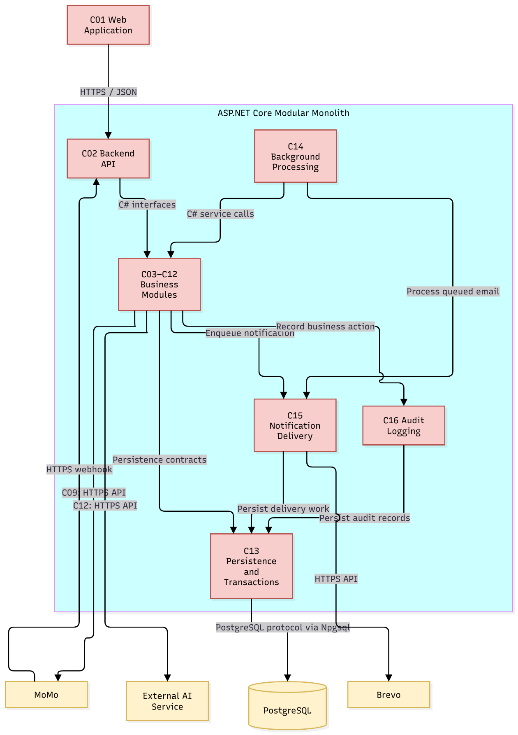
The diagram groups C03–C12 for readability. It does not imply unrestricted communication between all business modules. The component catalogue and individual component descriptions define the permitted responsibilities and dependencies.

Component Catalogue
ID | Component | Responsibilities and Provided Services | Main Connections | Implementation
C01 | Web Application | Provides public browsing, registration, checkout, booking and ticket views, chatbot interaction, and operational interfaces. Displays backend-authoritative results and deadlines. | Calls C02. | TypeScript, React, Vite, HTML, CSS
C02 | Backend API | Exposes application endpoints, handles request and response contracts, establishes authentication context, and routes requests to the appropriate application services. Receives payment webhooks. | C01, C03–C12, MoMo webhook sender. | C#, ASP.NET Core Web API
C03 | Identity and Access | Manages registration, email verification, login, logout, account states, roles, cinema assignments, and effective authorisation checks. | C02, C13, C15, C16; supplies authorisation services to protected modules. | C#, ASP.NET Core Identity
C04 | Movie Catalogue | Manages movies, genres, movie–genre associations, public visibility, and catalogue queries. | C02, C03, C06, C12, C13, C16. | C#
C05 | Cinema and Seating | Manages cinemas, screening rooms, physical seat layouts, seat operational status, shared seat types, and seat-type surcharges. | C02, C03, C06, C07, C08, C13, C16. | C#
C06 | Showtime Scheduling | Provides showtime queries, schedule maintenance, conflict checking, duration snapshots, and controlled rescheduling. | C02, C03, C04, C05, booking-impact services, C13, C15, C16. | C#
C07 | Ticket Pricing | Manages required ticket-category definitions and cinema base prices. Calculates prices using applicable base prices and physical seat-type surcharges. | C02, C03, C05, C08, C12, C13, C16. | C#
C08 | Booking and Checkout | Manages selection sessions, booking creation, held and sold allocations, accepted price snapshots, checkout coordination, eligible pending cancellation, and safe expiration. | C02–C03, C05–C07, C09–C11, C13–C16. | C#
C09 | Payment Processing | Initiates payment attempts, verifies notifications, reconciles unresolved outcomes, and coordinates idempotent application of verified payment results. | C02, C08, C10, C11, C13–C16, MoMo. | C#, HttpClient
C10 | Cancellation and Refund | Manages confirmed-booking cancellation requests, review outcomes, refund obligations, external-refund evidence, and refund-completion coordination. | C02, C03, C06, C08, C09, C11, C13, C15, C16. | C#
C11 | Ticketing and Admission | Issues booking-level tickets and QR identifiers, provides ticket information, and records eligible admissions with the required time, quota, and cancellation checks. | C02, C03, C06, C08–C10, C13, C15, C16. | C#
C12 | Promethe-Nous | Coordinates supported informational queries, retrieves permitted context, invokes external AI services, and returns answers with appropriate source information and limitations. | C02, C03, read-only information interfaces, external AI services. | C#, HttpClient
C13 | Persistence and Transactions | Implements database mappings, persistence contracts, transaction facilities, and database-level integrity mechanisms. | Business and infrastructure components; PostgreSQL. | C#, EF Core, Npgsql, PostgreSQL SQL
C14 | Background Processing | Schedules and executes booking expiration, payment reconciliation, and queued notification processing independently of customer sessions. | C08, C09, C15 and persistence facilities where required. | C#, ASP.NET Core hosted services
C15 | Notification Delivery | Prepares and queues transactional emails, sends through Brevo, records delivery attempts, and supports controlled retry and resend. | Requesting business modules, C13, C14, Brevo. | C#, HttpClient, Brevo HTTPS API
C16 | Audit Logging | Records required business actions, responsible actors, timestamps, affected records, and evidence references. | Protected application services, C03 actor context, C13. | C#
The connections listed above identify collaboration boundaries. Their direction and operation contracts are defined in the corresponding component subsections. They do not require mutually dependent service implementations.

Communication and Consistency Rules
- Frontend communication: C01 invokes C02 through HTTPS APIs using JSON request and response models. The frontend does not directly access PostgreSQL or hold external-service credentials.
- Internal communication: Backend components use explicit C# interfaces resolved through dependency injection. Interface contracts identify the provider, permitted operations, input and output types, and expected failure outcomes.
- Data ownership: Each business component owns the rules governing its data. Other components request changes through the owning component’s services. C13 supplies persistence mechanisms without taking ownership of business decisions.
- Shared transactions: Operations that must preserve one business invariant across several components use a coordinated database transaction. Verified payment application, booking confirmation, ticket issuance, and creation of the related notification request must remain consistent.
- External service calls: Calls to MoMo, Brevo, and AI providers occur outside database transactions holding business locks. Operations that subsequently change business state revalidate the required conditions before committing.
- Background execution: C14 invokes services supplied by the owning components. It does not duplicate reservation, payment, or notification rules.
- Authorisation: Protected operations use current account, role, and cinema-assignment information from C03. UI visibility alone does not establish permission.
- Dependency management: Cross-component workflows use a designated application coordinator and focused interfaces. Components do not create circular service dependencies by calling each other’s high-level coordinators.

Component C01 Web Application

Purpose and Responsibilities
The Web Application provides the browser-based interfaces of Promethe-Phos for Guests, Customers, Staff, Managers, and Admins. It presents customer and cinema-operation workflows, manages local interface state, collects user input, and communicates with C02 Backend API.
The component supports:
- Movie browsing, movie details, and showtime discovery.
- Ticket-quantity selection, physical seat selection, checkout, and payment redirection.
- Registration, email verification, login, and logout.
- Booking retrieval, ticket presentation, authorised email resend, and eligible cancellation requests.
- Staff ticket-validation and admission interfaces.
- Authorised cinema-management interfaces.
- Informational interaction with Promethe-Nous.
- Loading indicators, validation feedback, error messages, and recovery actions.
C01 reflects authoritative data returned by the backend. It does not independently determine seat availability, accepted prices, reservation deadlines, payment outcomes, ticket validity, or effective permissions.
Interface visibility follows the current access context supplied by the backend. Backend services remain responsible for authorising every protected operation.

Use-Case Traceability
Use Case | Contribution of C01
UC-06A Browse Movies; UC-06B View Movie Details; UC-07 Browse Showtimes | Presents eligible movies, permitted movie details, and available screening information. Collects browsing and filtering criteria.
UC-01 Reserve Seats; UC-09 Checkout and Payment | Presents ticket quantities, seat selection, checkout information, server deadlines, reservation results, and payment redirection.
UC-08A Register Customer Account; UC-08B Verify Email Address | Provides registration, verification-link processing, and permitted verification-email resend interfaces.
UC-08C Login; UC-08D Logout | Collects login information, presents authenticated navigation, and initiates logout.
UC-10 Customer Booking Lifecycle | Presents accessible bookings and tickets and submits authorised resend, pending-cancellation, and confirmed-cancellation requests.
UC-05 Validate Ticket | Provides the Staff QR-scanning interface, validation feedback, eligibility-check inputs, and admission confirmation.
UC-11 Chat with Promethe-Nous | Collects questions and displays answers, source information, limitations, and service-status feedback.
UC-12 Manage Movie Catalog; UC-13 Manage Genres | Provides authorised catalogue and genre viewing and maintenance interfaces.
UC-14A Manage Cinemas; UC-14B Manage Screening Rooms | Provides cinema and screening-room interfaces within the user’s permitted scope.
UC-15A Configure Seat Layout; UC-15B Change Seat Operational Status | Presents seating layouts and submits authorised layout or operational-status changes.
UC-15C Manage Seat Types; UC-16A Manage Ticket Types; UC-16B Configure Cinema Ticket Pricing | Presents shared seat types, ticket categories, and cinema pricing and submits permitted configuration changes.
UC-17 Manage Showtimes and Schedules | Provides showtime and schedule interfaces, including conflict feedback and controlled-rescheduling results.
UC-18 Manage User Accounts and Roles | Provides authorised account, role, account-state, and cinema-assignment interfaces.
UC-19 Manage Bookings and Tickets; UC-04A Refund | Supports scoped operational booking assistance, cancellation review, and authorised entry of externally completed refund evidence.
UC-02 Payment Webhook; UC-03 Release Expired Bookings; UC-04 Payment Reconciliation | Displays the resulting booking and payment states obtained from C02. Webhook handling, expiration, and reconciliation execute on the backend independently of C01.

Implementation Language and Technologies
The component is implemented using TypeScript and React, with Vite providing the development and build tooling. HTML and CSS define interface structure, layout, and responsive presentation.
It uses:
- React components and hooks for rendering and interaction.
- TypeScript models for interface state and API request and response data.
- The browser Fetch API for HTTPS communication with C02.
- Browser navigation for movement between application views and redirection to the payment gateway.
- Browser camera capabilities for the Staff QR-scanning interface, subject to user permission and device availability.
- Backend-provided access context for navigation and action visibility.
C01 does not contain database credentials, Brevo credentials, payment-provider secrets, or AI-provider credentials.
The class diagram represents logical frontend responsibilities. Boundary elements are realised as React components, while control elements are realised through hooks, state-management logic, or TypeScript services. The diagram does not require React class components.

Provided Interfaces and Services
Interface or Service | Responsibility
Customer browsing interface | Presents movie and showtime information and collects search, filter, and screening-selection inputs.
Account interface | Supports registration, verification, login, logout, and permitted verification-email resend.
Booking and checkout interface | Collects ticket quantities, selected seats, contact information, and acknowledgements; presents reservation and payment-initiation results.
Booking and ticket interface | Displays accessible bookings and the existing booking-level ticket or QR; supports permitted resend and cancellation actions.
Operational workspace | Presents authorised cinema-management functions and submits changes through C02.
Admission interface | Captures a booking QR, displays backend validation results, collects Staff eligibility checks, and submits admission confirmation.
Chat interface | Submits informational questions and displays answers and source information returned by the backend.
ApiClient | Supplies a shared frontend mechanism for HTTPS requests, response parsing, cancellation, and consistent API-error handling.
User-facing interfaces invoke backend services through C02. ApiClient is an internal service of C01 and does not provide a public server endpoint.

Dependencies and Communication
Calling Component | Receiving Component | Interface or Operation | Purpose | Communication
C01 Web Application | C02 Backend API | Account and access operations | Register, verify email, authenticate, log out, and obtain the current access context. | HTTPS with JSON request and response payloads.
C01 Web Application | C02 Backend API | Catalogue and showtime queries | Retrieve eligible movies, movie details, screening information, and seat availability. | HTTPS with JSON.
C01 Web Application | C02 Backend API | Selection, reservation, checkout, and payment-initiation operations | Maintain the server-controlled selection session, create a pending booking, and obtain an eligible payment-redirection result. | HTTPS with JSON.
C01 Web Application | C02 Backend API | Booking and ticket operations | Retrieve authorised records and request permitted resend or cancellation actions. | HTTPS with JSON.
C01 Web Application | C02 Backend API | Administration, admission, cancellation-review, and refund-recording operations | Perform protected operational activities within the current account’s permissions and cinema assignments. | HTTPS with JSON.
C01 Web Application | C02 Backend API | Promethe-Nous query operation | Submit questions and retrieve informational responses. | HTTPS with JSON.
C01 Web Application | MoMo hosted payment page | Payment URL returned by C02 | Navigate the user to the external payment interface. | Browser navigation over HTTPS.
C01 admission interface | Browser camera | Camera-access capability | Capture QR input after camera permission is granted. | Local browser API.
C01 does not directly invoke C03–C16 or access PostgreSQL. C02 routes frontend requests to the responsible backend services.
Payment-page navigation does not establish a successful payment. After returning to the application, C01 obtains the authoritative booking and payment status through C02.

Class Diagram
The diagram presents the principal frontend boundaries, shared access state, checkout coordination, and API communication. OperationsWorkspace represents the family of operational views; it does not represent one class containing all administrative logic.
Request and response types referenced in operation signatures represent the corresponding API contracts. Their detailed fields follow the operations they support.
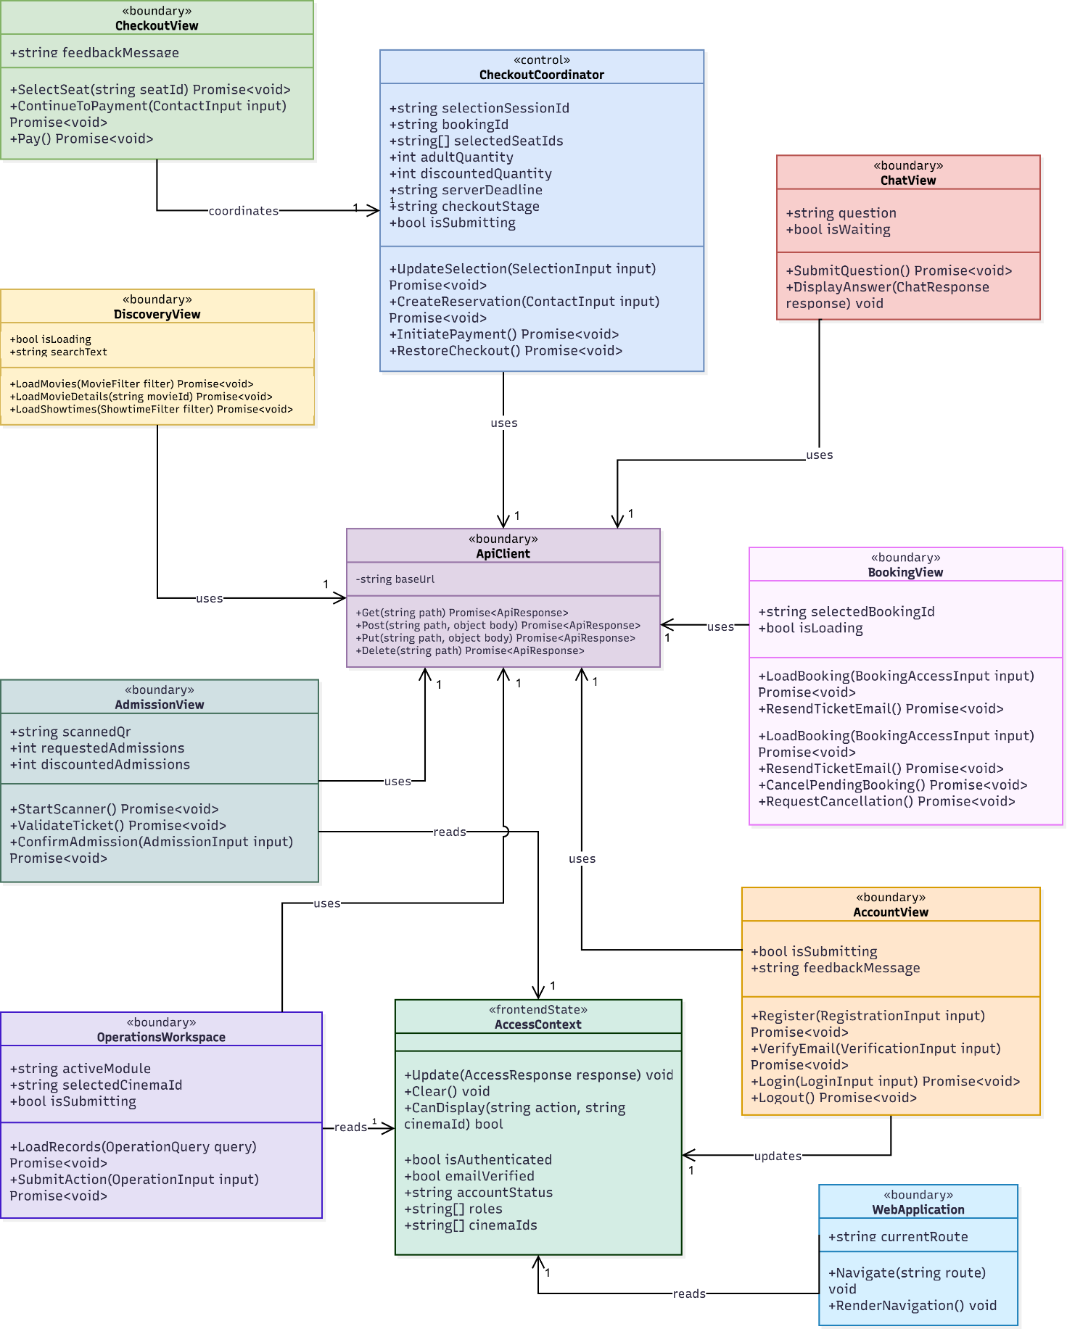
Figure 1: C01 Web Application Class Diagram.

Key Class Descriptions
Class or Logical Element | Responsibility | Key Attributes | Key Operations
WebApplication | Provides the application shell and navigation. | currentRoute identifies the current view. | Navigate(...) changes the active view; RenderNavigation() presents navigation appropriate to the access context.
AccessContext | Holds the frontend representation of the current account’s access information. | Authentication state, email-verification state, account status, roles, and cinema assignments. | Update(...) applies backend information; Clear() removes local authenticated context; CanDisplay(...) supports interface visibility only.
AccountView | Presents account-related forms and feedback. | isSubmitting prevents repeated interface submission; feedbackMessage presents the result. | Registration, email verification, login, and logout operations.
DiscoveryView | Presents movie and screening information. | Loading state and search text. | Loads eligible movies, movie details, and showtimes through C02.
CheckoutView | Presents ticket selection, contact information, acknowledgements, and payment actions. | Feedback for the active checkout interaction. | Delegates selection, reservation, and payment actions to CheckoutCoordinator.
CheckoutCoordinator | Coordinates frontend checkout state and server synchronisation. | Session and booking identifiers, selected seats, ticket quantities, server deadline, checkout stage, and submission state. | Updates selection, requests reservation creation, initiates payment, and restores eligible checkout state.
BookingView | Presents accessible booking and ticket records. | Selected booking identifier and loading state. | Retrieves bookings and submits permitted resend or cancellation requests.
OperationsWorkspace | Represents operational views for catalogue, cinema, seating, pricing, scheduling, account, booking, and refund administration. | Active module, selected cinema, and submission state. | Retrieves scoped records and delegates validated form submissions to the corresponding API operations.
AdmissionView | Supports Staff QR validation and admission confirmation. | Captured QR, requested admission counts, discounted counts, and submission state. | Starts scanning, obtains validation results, and submits admission confirmation.
ChatView | Provides informational chatbot interaction. | Current question and waiting state. | Submits a question and presents the returned answer and supporting information.
ApiClient | Centralises frontend HTTP communication and response handling. | baseUrl identifies C02. | Sends supported HTTP requests and returns parsed API responses or consistent failure information.
WebApplication and the view elements have boundary responsibilities. CheckoutCoordinator has a control responsibility. AccessContext represents local application state rather than an authoritative business entity. ApiClient forms the frontend boundary to C02.

Class Relationships
Source | Target | Relationship | Meaning
WebApplication | AccessContext | Association | The application shell reads the current access context when presenting navigation.
AccountView | AccessContext | Association | Account operations update or clear the frontend access context following backend results.
OperationsWorkspace; AdmissionView | AccessContext | Association | Protected views use access information to present available interface actions. Backend authorisation remains mandatory.
CheckoutView | CheckoutCoordinator | Association | The checkout interface retains access to the coordinator responsible for checkout state and API interactions.
AccountView; DiscoveryView; BookingView; OperationsWorkspace; AdmissionView; ChatView | ApiClient | Association | Each view or its supporting hook uses the shared API client for backend communication.
CheckoutCoordinator | ApiClient | Association | Checkout coordination uses the API client to synchronise selection, reservation, and payment state with C02.
The associations represent retained references to shared services or state within the frontend design. Navigation between pages does not imply inheritance or composition between the corresponding view elements.

Data Ownership and Consistency
C01 owns transient interface state, including active views, search filters, form inputs, loading indicators, validation messages, and currently displayed responses.
Authoritative account, booking, payment, ticket, cinema, pricing, and admission data remain owned by backend components. Local copies are used for presentation and must be refreshed when an operation changes the relevant state or when the backend reports a conflict.
The following rules apply:
- Seat selection does not itself establish a seat hold. C01 displays a held booking only after successful reservation creation.
- Countdown displays derive from server-provided deadlines and timing information. Local clock changes do not extend a selection or payment deadline.
- Booking creation preserves the applicable selection deadline; moving between checkout stages does not create a new selection period.
- Prices shown before reservation are subject to backend revalidation. Changed quotations require user acceptance according to the checkout rules.
- A successful browser redirect from the payment gateway is not authoritative payment evidence.
- Submission controls reduce accidental repeated actions but do not replace backend idempotency.
- Account-context changes and authorisation failures trigger appropriate interface refresh or access removal.
- Responses from superseded searches or selections must not overwrite newer interface state.
- Passwords, verification tokens, guest-access credentials, and sensitive ticket information are excluded from ordinary frontend logs.
- Sensitive data associated with the previous user is cleared when the authenticated session ends.

Key Processing Flows and Failure Handling

Movie Discovery and Checkout
- The user browses movies and showtimes through DiscoveryView.
- C01 retrieves eligible information through ApiClient and C02.
- The user selects ticket quantities and physical seats.
- CheckoutCoordinator synchronises selection with the backend. The first seat selection starts the server-controlled selection session; no booking or seat hold exists at this stage.
- The user enters checkout contact information and completes the required acknowledgements.
- When progressing from Checkout Step 1 to Step 2, C01 requests reservation creation.
- The backend revalidates the selection and atomically creates the pending booking and held allocations.
- C01 displays the accepted booking information and applicable server deadline.
- When the user initiates payment, C01 requests payment initiation and navigates to the payment URL returned by C02.
- After returning to the application, C01 retrieves the authoritative booking and payment state and presents the corresponding result.

Account Access and Operational Navigation
- The user registers, verifies an email address, or signs in through AccountView.
- C01 submits the request to C02 and displays the returned result.
- Following successful authentication, C01 updates AccessContext.
- WebApplication presents navigation consistent with the current roles and cinema assignments.
- Operational views request scoped records and submit protected actions through C02.
- If permissions or account status change, C01 responds to the backend result by refreshing the access context and removing unavailable actions.
- Logout ends the backend session and clears the associated frontend state.
Customer login does not require prior email verification. Access to internal-role operations follows the verified-email and authorisation rules enforced by the backend.

Booking Access and Admission
- A Customer or authorised Guest retrieves a booking through BookingView.
- C01 displays the booking status and existing ticket information returned by C02.
- Permitted resend and cancellation actions are submitted to the backend and reflected only after the returned outcome is processed.
- Authorised Staff capture a booking QR through AdmissionView.
- C01 requests ticket validation and displays the current screening context, remaining entitlements, and applicable restrictions.
- Staff perform the required age and discounted-eligibility checks and submit the admission counts.
- The backend revalidates eligibility and records the admission.
- C01 displays the committed result and updated remaining entitlements.

Failure Handling and Recovery
- Failed read requests display a clear error and an appropriate retry action.
- Validation failures retain relevant non-sensitive form inputs and identify the fields requiring correction.
- Seat conflicts, changed prices, expired sessions, and scheduling conflicts display backend-provided outcomes and guide the user to the affected step.
- A timeout after a state-changing request is treated as an uncertain outcome. C01 retrieves the current state or follows the operation’s idempotent retry contract before resubmitting.
- Unresolved payment outcomes remain displayed as pending or under verification until C02 reports an authoritative result.
- Reloading checkout restores only the state permitted by the server-side session and booking rules; it does not reset deadlines.
- Camera permission denial or unavailable camera hardware produces clear scanner feedback and does not record an admission.
- Chatbot failures display service-status feedback without affecting booking or payment state.
- Authorisation failures prevent further protected interaction and prompt access-context refresh or authentication as appropriate.
- Technical exceptions are converted into user-facing messages without exposing credentials, internal stack traces, or sensitive request data.

Component C02 Backend API

Purpose and Responsibilities
The Backend API provides the HTTP entry point to Promethe-Phos. It receives requests from C01 Web Application and payment notifications from MoMo, translates transport data into application inputs, invokes the responsible application services, and returns consistent responses.
The component is responsible for:
- Exposing endpoints for customer and operational workflows.
- Binding and validating request data at the transport boundary.
- Establishing request context, including the authenticated principal and request correlation identifier.
- Applying endpoint-level authentication and authorisation requirements.
- Invoking services supplied by C03–C12.
- Returning response models that expose only the information permitted for the caller.
- Translating application outcomes into consistent HTTP responses.
- Receiving payment webhook requests and forwarding the required notification data to C09 Payment Processing.
- Handling unexpected exceptions without exposing internal implementation details.
C02 validates request structure, required fields, and supported input formats. Business components validate business eligibility, current permissions, cinema assignments, state transitions, and concurrency conditions.
Controllers remain thin. They do not implement reservation rules, payment verification, refund eligibility, ticket issuance, or admission rules. Background expiration and reconciliation are initiated by C14 rather than depending on a frontend request to C02.

Use-Case Traceability
Use Case | Contribution of C02
UC-06A Browse Movies; UC-06B View Movie Details | Exposes public catalogue queries and returns permitted movie information from C04.
UC-07 Browse Showtimes | Exposes eligible showtime queries supplied by C06.
UC-01 Reserve Seats; UC-09 Checkout and Payment | Receives selection and checkout requests and invokes the responsible reservation and payment-initiation services.
UC-08A Register Customer Account; UC-08B Verify Email Address | Receives registration, email-verification, and permitted verification-resend requests for C03.
UC-08C Login; UC-08D Logout | Exposes authentication and logout operations supplied by C03.
UC-10 Customer Booking Lifecycle | Receives authorised booking-access, ticket-access, resend, and cancellation requests and routes them to the responsible services.
UC-02 Payment Webhook | Receives gateway notifications and forwards notification data to C09 for verification and idempotent processing.
UC-03 Release Expired Bookings; UC-04 Payment Reconciliation | Returns booking and payment states affected by background processing. These use cases do not require a public execution endpoint.
UC-04A Refund | Exposes authorised refund-recording operations supplied by C10.
UC-05 Validate Ticket | Receives QR-validation and admission-confirmation requests for C11.
UC-11 Chat with Promethe-Nous | Accepts supported informational queries and returns responses supplied by C12.
UC-12 Manage Movie Catalog; UC-13 Manage Genres | Exposes authorised movie and genre operations supplied by C04.
UC-14A Manage Cinemas; UC-14B Manage Screening Rooms; UC-15A Configure Seat Layout; UC-15B Change Seat Operational Status; UC-15C Manage Seat Types | Exposes cinema, room, seating, and seat-type operations supplied by C05.
UC-16A Manage Ticket Types; UC-16B Configure Cinema Ticket Pricing | Exposes ticket-category and cinema-pricing operations supplied by C07.
UC-17 Manage Showtimes and Schedules | Exposes authorised scheduling and rescheduling operations supplied by C06.
UC-18 Manage User Accounts and Roles | Exposes account, role, account-state, and cinema-assignment operations supplied by C03.
UC-19 Manage Bookings and Tickets | Exposes scoped booking and ticket assistance and routes cancellation-review and refund actions to their responsible services.

Implementation Language and Technologies
The component is implemented in C# using ASP.NET Core Web API.
It uses:
- ASP.NET Core controllers and routing for HTTP endpoints.
- Model binding and request-model validation.
- Authentication and authorisation middleware integrated with C03 Identity and Access.
- Dependency injection for application-service contracts.
- JSON request and response models.
- Centralised exception handling and consistent API error responses.
- Request correlation identifiers for diagnostic traceability.
- Browser-origin restrictions configured for the permitted frontend origins.
Authentication credential issuance and validation follow the mechanism supplied by C03. C02 does not introduce a separate authentication mechanism.
Controllers receive application services through dependency injection. They do not directly use EF Core or execute SQL; persistence access is performed through the responsible components and C13.

Provided Interfaces and Services
Endpoint Group | Responsibility
Account and access | Registration, email verification, verification resend, login, logout, account administration, roles, and cinema assignments.
Movie catalogue | Public movie queries and authorised movie and genre administration.
Cinema and seating | Cinema, room, physical seat, seat-layout, and shared seat-type operations.
Showtime scheduling | Public screening queries and authorised scheduling operations.
Ticket pricing | Ticket-category and cinema-pricing queries and administration.
Booking and checkout | Selection-session operations, reservation creation, checkout retrieval, booking retrieval, and eligible pending cancellation.
Payment initiation and status | Initiation of eligible payment attempts and retrieval of permitted payment-status information.
Payment webhook | Receipt of gateway notifications for verification and processing by C09.
Cancellation and refund | Confirmed-booking cancellation requests, authorised review, and recording of externally completed refunds.
Ticketing and admission | Authorised ticket retrieval, ticket-email resend, QR validation, and admission confirmation.
Promethe-Nous | Submission of supported informational questions and retrieval of answers and source information.
Each endpoint defines its request model, response model, access requirements, and expected failure outcomes. Application-service contracts identify the business component responsible for processing the request.
The payment webhook is an external integration endpoint. It does not require a customer login; notification authenticity is verified by C09 using the payment-provider verification rules.

Dependencies and Communication
Calling Component | Receiving Component | Interface or Operation | Purpose | Communication
C01 Web Application | C02 Backend API | Customer and operational endpoints | Submit requests and retrieve permitted application data. | HTTPS with JSON.
MoMo | C02 Backend API | Payment webhook endpoint | Deliver payment notifications. | HTTPS with the provider-defined payload and acknowledgement format.
C02 Backend API | C03 Identity and Access | IIdentityAccessService | Process account operations and obtain current access information. | In-process C# interface calls.
C02 Backend API | C04 Movie Catalogue | IMovieCatalogueService | Process public catalogue queries and authorised catalogue administration. | In-process C# interface calls.
C02 Backend API | C05 Cinema and Seating | ICinemaSeatingService | Process cinema, room, seating, and seat-type operations. | In-process C# interface calls.
C02 Backend API | C06 Showtime Scheduling | IShowtimeService | Query and maintain showtimes and schedules. | In-process C# interface calls.
C02 Backend API | C07 Ticket Pricing | ITicketPricingService | Query and maintain ticket categories and cinema pricing. | In-process C# interface calls.
C02 Backend API | C08 Booking and Checkout | IBookingCheckoutService | Coordinate selection, reservation, checkout, booking access, and eligible pending cancellation. | In-process C# interface calls.
C02 Backend API | C09 Payment Processing | IPaymentService | Initiate payment, obtain permitted status, and process gateway notifications. | In-process C# interface calls.
C02 Backend API | C10 Cancellation and Refund | ICancellationRefundService | Process cancellation requests, review decisions, and refund-completion evidence. | In-process C# interface calls.
C02 Backend API | C11 Ticketing and Admission | ITicketingService | Retrieve tickets, request authorised resend, validate QR input, and confirm admissions. | In-process C# interface calls.
C02 Backend API | C12 Promethe-Nous | IPrometheNousService | Process informational questions. | In-process C# interface calls.
The service interfaces listed above belong to their respective business components. Their definitions and implementations are detailed in those component sections.
For this design, C02 routes ticket-email resend requests to C11. C11 checks ticket-access eligibility and coordinates with C15 to queue delivery of the existing ticket. C02 does not directly send email.

Class Diagram
The class diagram presents the principal classes of C02 Backend API and their relationships in a single view. It includes API controllers, exception-handling classes, relevant ASP.NET Core framework types, and the application-service interfaces supplied by C03–C12.
All API controllers inherit from ASP.NET Core ControllerBase. Each controller holds a reference to the application-service interface responsible for its operations. Controllers handle HTTP requests and responses, while the corresponding business components perform application coordination and enforce business rules.
ApiExceptionMiddleware invokes the next request-pipeline delegate and handles unexpected exceptions through ApiErrorMapper. The mapper creates an ApiErrorResponse containing a safe error message and request trace identifier. HttpContext supplies the current HTTP request, response, authenticated principal, and cancellation information.
The diagram distinguishes three groups:
- C02 Backend API: controllers and API error-handling classes implemented within this component.
- ASP.NET Core: framework types used by the component.
- Business Service Contracts: interfaces owned by C03–C12 and consumed by C02. This group is not an additional component.
Generalization relationships identify controller inheritance. Associations identify retained service references. Dependencies identify types used during request processing and error-response creation. The application-service implementations belong to their owning business components and are therefore not shown.
The «boundary» and «control» stereotypes identify interaction and coordination responsibilities. The labels «framework», «delegate», and «response» identify framework types, the request-pipeline delegate, and response data respectively. Detailed transport models and complete endpoint contracts are specified in the API contract.
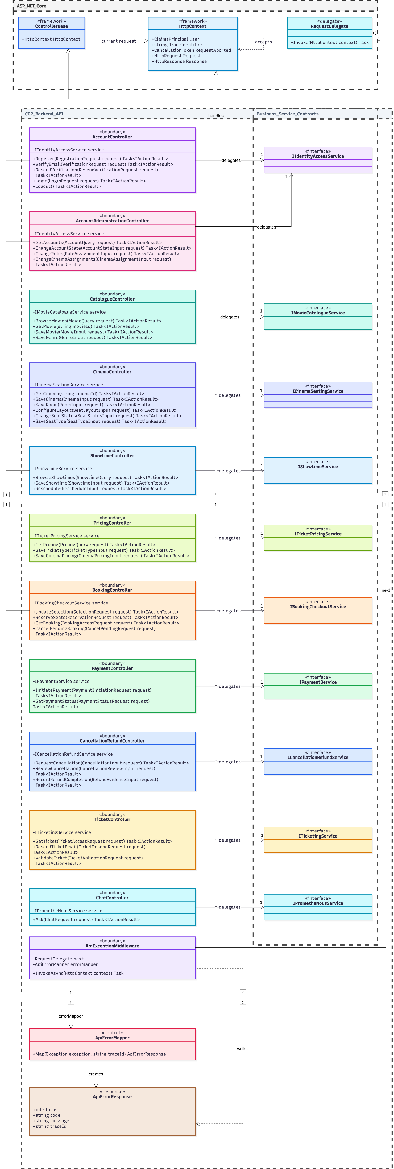
Figure 2: C02 Backend API Class Diagram.

Key Class Descriptions
Class or Interface | Responsibility | Key Attributes | Key Operations
AccountController | Receives customer account and authentication requests. | service: C03 application-service contract. | Registration, verification, verification resend, login, and logout.
BookingController | Receives selection, reservation, booking-access, and pending-cancellation requests. | service: C08 application-service contract. | Updates selection, requests reservation creation, retrieves authorised bookings, and requests pending cancellation.
PaymentController | Provides payment initiation and status endpoints and receives gateway notifications. | service: C09 application-service contract. | Initiates payment, retrieves permitted status, and forwards webhook data for verification and processing.
TicketController | Provides ticket-access, resend, validation, and admission endpoints. | service: C11 application-service contract. | Retrieves existing tickets, requests resend, validates QR input, and submits admission confirmation.
ChatController | Receives informational chatbot questions. | service: C12 application-service contract. | Ask(...) forwards the question and returns the resulting answer and source information.
CatalogueController | Provides public catalogue queries and protected catalogue administration. | service: C04 application-service contract. | Browses movies, retrieves details, and submits movie or genre changes.
CinemaController | Provides cinema, room, seating, and seat-type endpoints. | service: C05 application-service contract. | Retrieves cinema information and submits authorised configuration changes.
ShowtimeController | Provides public screening queries and protected scheduling operations. | service: C06 application-service contract. | Queries showtimes and submits schedule creation, maintenance, or rescheduling requests.
PricingController | Provides ticket-category and cinema-pricing endpoints. | service: C07 application-service contract. | Retrieves prices and submits authorised category or base-price changes.
AccountAdministrationController | Provides protected account, role, and cinema-assignment administration. | service: C03 application-service contract. | Queries accounts and submits account-state, role, and cinema-assignment changes.
CancellationRefundController | Provides confirmed-cancellation, review, and refund-recording endpoints. | service: C10 application-service contract. | Submits cancellation requests, review decisions, and externally completed refund evidence.
ApiExceptionMiddleware | Captures unhandled exceptions from the request pipeline. | next: the next pipeline delegate. | InvokeAsync(...) executes the remaining pipeline and returns a controlled error response when appropriate.
ApiErrorMapper | Maps recognised exceptions to safe API error responses. | No persistent state is required. | Map(...) determines the HTTP status, stable error code, safe message, and trace identifier.
ApiErrorResponse | Represents the common error-response structure. | status, code, message, and traceId. | No business operations; it carries response data.
RequestContext | Represents information associated with one HTTP request. | Correlation identifier, authenticated principal, and request cancellation token. | No business operations; it supplies request-scoped context.
Application-service interfaces | Define the business operations invoked by controllers. | No instance attributes are specified in these interfaces. | Operations are defined in the owning component sections and implemented outside C02.
The authenticated principal identifies the caller but is not sufficient evidence that stored roles or account conditions remain current. Protected application services obtain and recheck authoritative access information through C03 where required.

Class Relationships
Source | Target | Relationship | Meaning
AccountController; AccountAdministrationController | IIdentityAccessService | Association | Each controller retains a reference to the C03 contract for its permitted account operations.
BookingController | IBookingCheckoutService | Association | The controller delegates booking and checkout processing to C08.
PaymentController | IPaymentService | Association | The controller delegates payment initiation, status retrieval, and notification processing to C09.
+65+6  5280.8TicketController | ITicketingService | Association | The controller delegates ticket and admission operations to C11.
ChatController | IPrometheNousService | Association | The controller delegates informational questions to C12.
CatalogueController | IMovieCatalogueService | Association | The controller delegates catalogue queries and maintenance to C04.
CinemaController | ICinemaSeatingService | Association | The controller delegates cinema and seating operations to C05.
ShowtimeController | IShowtimeService | Association | The controller delegates showtime queries and maintenance to C06.
PricingController | ITicketPricingService | Association | The controller delegates category and pricing operations to C07.
CancellationRefundController | ICancellationRefundService | Association | The controller delegates cancellation and refund processing to C10.
ApiExceptionMiddleware | ApiErrorMapper | Association | The middleware uses the mapper to construct consistent error outcomes.
ApiExceptionMiddleware | RequestContext | Dependency | The middleware reads request-scoped information when handling an exception.
ApiErrorMapper | ApiErrorResponse | Dependency | The mapper creates the error-response object.
Controllers depend on request and response models through their operation signatures. These transport-model dependencies are omitted from the diagrams for readability.

Data Ownership and Consistency
C02 owns transport contracts and request-processing concerns. It does not own persistent business entities or make independent business-state decisions.
The following rules apply:
- Incoming identifiers and client-supplied values are treated as untrusted input.
- Transport validation does not replace business validation.
- Request models expose only fields that the corresponding operation permits the caller to supply.
- Response models exclude credentials, verification secrets, internal exception details, and information outside the caller’s access scope.
- Controllers preserve the operation identifiers or idempotency keys required by the relevant application contract.
- Controllers do not independently commit business transactions.
- Cross-component transactions are coordinated by application services, using C13.
- Payment notification data required for signature verification is preserved and passed to C09 without transformations that alter its verification meaning.
- A successful transport response reflects the application outcome; receipt of a webhook alone does not confirm a booking.
- Client disconnection or request cancellation does not prove that a business operation failed or rolled back.
- Required business audit records are produced by the responsible application services through C16. Request diagnostics do not replace those records.

Key Processing Flows and Failure Handling

Standard Customer or Operational Request
- C01 sends an HTTPS request to C02.
- The request pipeline establishes a correlation identifier and authentication context.
- Routing selects the appropriate controller operation.
- Model binding and transport validation check the request structure.
- Endpoint-level access requirements are applied.
- The controller invokes the responsible application service.
- The application service validates current access, business conditions, and concurrency requirements and executes the operation.
- The controller maps the outcome to the permitted response model and HTTP status.
- C02 returns the response to C01.
Protected state changes remain subject to the application service’s required authorisation recheck before commit.

Payment Webhook Reception
- MoMo sends a notification to the payment webhook endpoint.
- C02 captures the notification data required by the provider contract.
- PaymentController forwards the notification to C09.
- C09 verifies authenticity, identifies the payment attempt, and determines whether the outcome is eligible for application.
- C09 coordinates idempotent processing and any required booking, ticket, and notification changes.
- C02 returns the acknowledgement required by the payment integration contract.
Duplicate notifications are handled by C09. C02 does not issue tickets or mark a payment successful merely because the notification was received.

Failure Handling
- Invalid request structure or field formats produce a validation response identifying the relevant input errors.
- Unauthenticated requests to protected endpoints are rejected.
- Authenticated callers without the required permission or cinema scope are denied access.
- Missing or inaccessible resources are reported without exposing protected information.
- Business conflicts, such as unavailable seats, changed prices, or invalid state transitions, are returned as explicit application outcomes.
- Unexpected exceptions are handled centrally and returned as safe error responses with a correlation identifier.
- Provider failures are translated from the responsible component’s outcome; controllers do not retry state-changing business operations automatically.
- Request timeouts and client disconnections are treated as transport outcomes. Subsequent status retrieval or idempotent retry determines the business result.
- Cancellation signals are propagated where safe. Critical transaction completion follows the owning application service’s consistency rules.
- Diagnostic logs exclude credentials, verification tokens, full sensitive payloads, and payment-provider secrets.

Component C03 Identity and Access

Purpose and Responsibilities
Identity and Access manages customer registration, email verification, authentication, authenticated sessions, account states, roles, cinema assignments, and access decisions.
The component supports:
- Customer registration with the Customer role.
- Verification of registered email addresses and controlled verification-link resend.
- Credential validation and JWT access-token issuance.
- Refresh-token rotation and authenticated-session renewal.
- A single active authenticated session per account.
- Explicit replacement of an existing session when the user chooses to continue signing in elsewhere.
- Logout and session revocation.
- Authorised account, role, account-state, and cinema-assignment administration.
- Current permission checks for protected operations.
ASP.NET Core Identity manages credentials and email-confirmation tokens. C03 manages the additional session policy and application-specific access rules.
Customer login is permitted before email verification. Internal-role operations require a verified email address and the applicable role and cinema assignment. Manager and Admin roles do not automatically provide Staff admission permissions.
An authenticated session represents one login context rather than a hardware identity. Multiple tabs may share the same session. A separate browser or private-browsing context requires a separate login and is subject to the single-active-session rule.

Use-Case Traceability
Use Case | Contribution of C03
UC-08A Register Customer Account | Validates registration information, creates the account, assigns the Customer role, and initiates verification-email delivery.
UC-08B Verify Email Address | Generates and validates email-confirmation tokens, updates verification state, and controls verification-link resend.
UC-08C Login | Validates credentials and account eligibility, handles existing-session conflicts, and issues credentials for the accepted session.
UC-08D Logout | Revokes the current session and prevents further use of its access and refresh tokens.
UC-18 Manage User Accounts and Roles | Enforces the permitted administration of account states, roles, and cinema assignments.
UC-10 Customer Booking Lifecycle | Supplies the authenticated account context used to enforce customer ownership. Guest booking-access rules remain the responsibility of the booking services.
UC-05 Validate Ticket | Verifies current Staff permission, verified-email status, and the required cinema assignment.
UC-12–UC-17 administrative operations | Supplies current role and cinema-scope checks for the corresponding management operations.
UC-19 Manage Bookings and Tickets; UC-04A Refund | Supplies current access decisions for operational assistance, cancellation review, and refund recording.
Other protected operations | Validates session activity and account eligibility and supplies current authorisation information.
Refresh and session replacement support the login lifecycle. They do not introduce additional numbered use cases.

Implementation Language and Technologies
The component is implemented in C# within the ASP.NET Core backend.
It uses:
- ASP.NET Core Identity for accounts, password hashing, credential verification, roles, and email-confirmation tokens.
- JWT access tokens containing account and session identifiers and token-validation metadata.
- ASP.NET Core JWT Bearer authentication at the C02 boundary.
- Cryptographically random refresh tokens, with only their hashes stored persistently.
- C13 persistence and transaction services backed by EF Core and PostgreSQL.
- C15 Notification Delivery for verification emails.
- C16 Audit Logging for required account and access-management records.
JWT signing keys, issuer and audience settings, token lifetimes, and verification settings are managed through protected backend configuration.
A valid JWT signature is necessary but not sufficient for access. Protected requests also require an active server-side session and an eligible account.

Provided Interfaces and Services
Interface or Operation | Responsibility
IIdentityAccessService.RegisterAsync(...) | Creates an eligible customer account and initiates email verification.
IIdentityAccessService.VerifyEmailAsync(...) | Validates an email-confirmation token and updates the account’s verification state.
IIdentityAccessService.ResendVerificationAsync(...) | Generates and queues a replacement verification email under the applicable controls.
IIdentityAccessService.LoginAsync(...) | Validates credentials and establishes a session or returns an existing-session conflict.
IIdentityAccessService.ReplaceSessionAsync(...) | Completes an explicitly confirmed session replacement after validating a short-lived replacement challenge.
IIdentityAccessService.RefreshAsync(...) | Validates and rotates a refresh token for the current active session and issues a replacement access token.
IIdentityAccessService.LogoutAsync(...) | Revokes the caller’s current session.
IIdentityAccessService.GetAccessContextAsync(...) | Returns current account, role, and cinema-assignment information permitted for the caller.
IIdentityAccessService.GetAccountsAsync(...) | Returns account records within the administrator’s permitted scope.
IIdentityAccessService.ChangeAccountStateAsync(...) | Applies an authorised account-state change and the required session effects.
IIdentityAccessService.ChangeRolesAsync(...) | Applies authorised role changes.
IIdentityAccessService.ChangeCinemaAssignmentsAsync(...) | Applies authorised cinema-assignment changes.
IAccessAuthorizationService.AuthorizeAsync(...) | Checks current session, account state, verified-email requirements, roles, and applicable cinema scope.
When another active session exists, successful credential validation does not immediately issue a second session. C03 returns a conflict and a short-lived replacement challenge.
The user may cancel the new login or explicitly confirm replacement. The challenge is bound to the account and the session observed during the conflict. It cannot be used as an access token.

Dependencies and Communication
Calling Component | Receiving Component | Interface or Operation | Purpose | Communication
C02 Backend API | C03 Identity and Access | IIdentityAccessService | Process registration, verification, login, replacement, refresh, logout, and account administration. | In-process C# interface calls.
C02 Backend API | C03 Identity and Access | IAccessAuthorizationService | Validate current access for protected requests after JWT validation. | In-process C# interface calls.
Protected application services | C03 Identity and Access | IAccessAuthorizationService | Check operation-level permissions and perform required authorisation rechecks before commit. | In-process C# interface calls within the applicable consistency protocol.
C03 Identity and Access | ASP.NET Core Identity | Identity account, password, role, and confirmation-token operations | Perform credential and identity-management functions. | In-process framework calls.
C03 Identity and Access | C13 Persistence and Transactions | Identity stores and IIdentityAccessStore | Persist accounts, assignments, sessions, refresh-token records, and replacement challenges. | In-process persistence contracts and coordinated transactions.
C03 Identity and Access | C15 Notification Delivery | NotificationService.QueueVerificationEmail(...) | Queue a verification email containing the generated confirmation link. | In-process C# method call.
C03 Identity and Access | C16 Audit Logging | Audit-recording service | Record required privileged account and access changes. | In-process C# calls within the associated transaction where required.
C03 does not call Brevo directly. Verification-email submission is performed by C15 after the relevant transaction commits.

Class Diagram
The class diagram presents account management, session control, token issuance, and authorisation in one view. IdentityAccessService implements the application contract consumed by C02. It delegates session lifecycle operations to SessionService and permission decisions to AccessAuthorizationService.
AppUser extends the ASP.NET Core Identity user type. Identity role and user-role structures are supplied by the framework; CinemaAssignment represents the additional cinema scope required by the application.
«framework» identifies a framework-supplied type, and «dataType» identifies a returned data structure. Service interfaces owned by C13 and classes supplied by C15 are shown to explain dependencies.
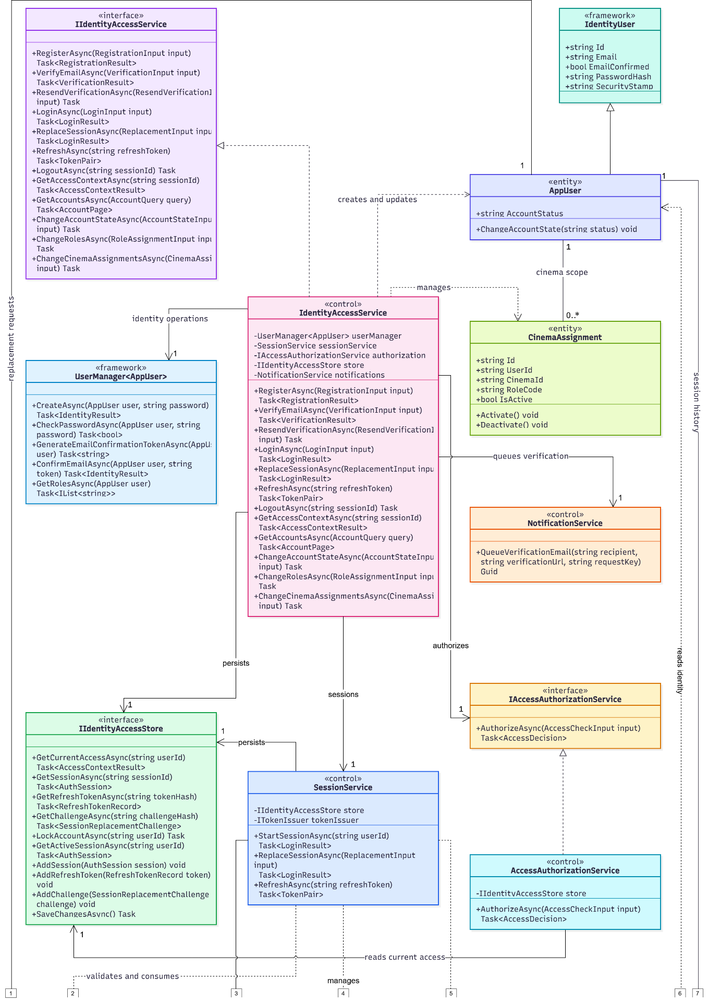
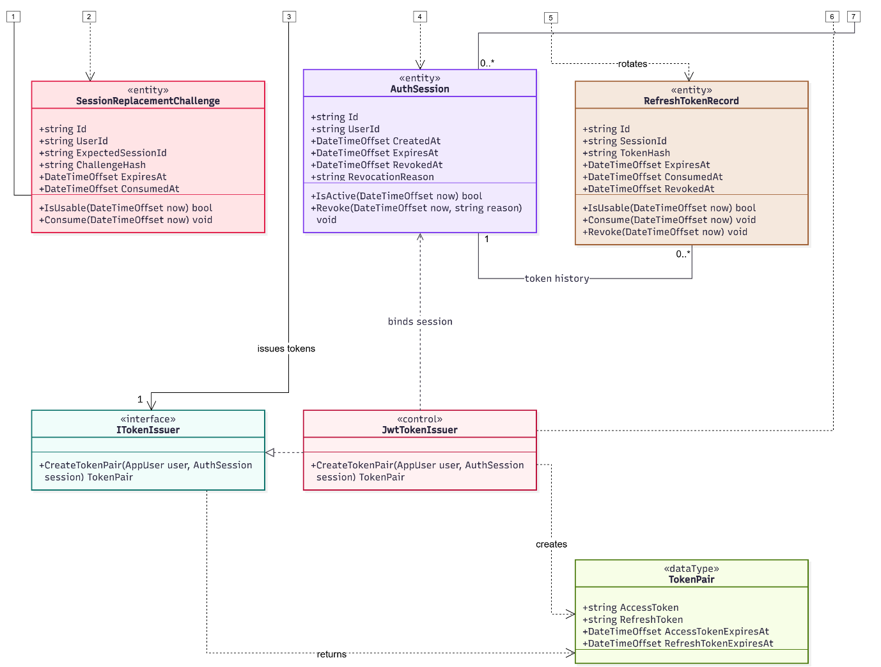
Figure 3: C03 Identity and Access Class Diagram.
Historical session records may be retained, but an account has at most one active session. RevokedAt and ConsumedAt are optional until the corresponding event occurs. Persistence operations that acquire locks execute within the caller’s transaction; SaveChangesAsync() does not independently commit that transaction.

Key Class Descriptions
Class or Interface | Responsibility | Key Attributes | Key Operations
IIdentityAccessService | Defines account and session operations exposed to C02. | No instance attributes. | Registration, verification, login, replacement, refresh, logout, access-context retrieval, and administration.
IdentityAccessService | Coordinates account workflows and authorised administration. | References to Identity, session management, authorisation, persistence, and notification services. | Implements the operations defined by IIdentityAccessService.
AppUser | Represents an application account and its business account state. | Inherited Identity identifier, email, verification state, and credential fields; AccountStatus. | ChangeAccountState(...) applies the domain state change after authorisation and validation.
IdentityUser | Provides the framework account structure. | Account identifier, email, email-confirmation state, password hash, and security stamp. | Managed through ASP.NET Core Identity services.
UserManager<AppUser> | Provides framework account, password, role, and confirmation-token operations. | Framework-managed dependencies. | Creates users, checks passwords, generates and validates email-confirmation tokens, and retrieves roles.
CinemaAssignment | Represents an account’s role-specific operational scope at a cinema. | User identifier, cinema identifier, role code, and active state. | Activates or deactivates an assignment.
SessionService | Enforces the single-active-session policy and manages token renewal and revocation. | Persistence and token-issuer references. | Starts or replaces sessions, rotates refresh tokens, and revokes sessions.
AuthSession | Records one authenticated login context. | Account identifier, creation and expiry times, optional revocation time and reason. | Checks activity and records revocation.
RefreshTokenRecord | Records the hash and lifecycle of a refresh token. | Session identifier, token hash, expiry, consumption, and revocation timestamps. | Checks usability and records consumption or revocation.
SessionReplacementChallenge | Records a limited opportunity to replace a specific existing session after credential validation. | Account identifier, expected old session, challenge hash, expiry, and consumption time. | Checks usability and records one-time consumption.
ITokenIssuer; JwtTokenIssuer | Define and implement access-token and refresh-token generation. | Signing configuration is supplied through protected configuration. | CreateTokenPair(...) issues tokens bound to the account and session.
TokenPair | Carries newly issued credentials to the authentication response. | Access token, refresh token, and expiry times. | No business operations.
IAccessAuthorizationService; AccessAuthorizationService | Define and implement current access checks. | Persistence reference. | AuthorizeAsync(...) evaluates current account, session, role, verification, and cinema-scope conditions.
IIdentityAccessStore | Defines application-specific persistence and locking operations implemented by C13. | No instance attributes. | Retrieves current access and session data, acquires account-level locks, and persists lifecycle records.
NotificationService | Queues verification emails through C15. | Detailed in C15. | QueueVerificationEmail(...) creates the delivery request.

Class Relationships
Source | Target | Relationship | Meaning
IdentityAccessService | IIdentityAccessService | Realization | Implements the account and session application contract.
AccessAuthorizationService | IAccessAuthorizationService | Realization | Implements current access evaluation.
JwtTokenIssuer | ITokenIssuer | Realization | Implements token generation.
AppUser | IdentityUser | Generalization | Extends the Identity account model with application account state.
IdentityAccessService | UserManager<AppUser>; SessionService; IAccessAuthorizationService; IIdentityAccessStore; NotificationService | Association | Retains references to the services used to coordinate account workflows.
SessionService | IIdentityAccessStore; ITokenIssuer | Association | Uses persistence and token generation during session operations.
AccessAuthorizationService | IIdentityAccessStore | Association | Retrieves authoritative access information.
AppUser | AuthSession | Association | One account may have historical sessions, with at most one active session.
AppUser | CinemaAssignment | Association | One account may have multiple cinema assignments under the permitted role rules.
AppUser | SessionReplacementChallenge | Association | Replacement challenges belong to the account whose credentials were verified.
AuthSession | RefreshTokenRecord | Association | A session has a history of refresh-token records created through rotation.
IdentityAccessService | AppUser; CinemaAssignment | Dependency | Creates or updates accounts and assignments through the relevant operations.
SessionService | AuthSession; RefreshTokenRecord; SessionReplacementChallenge | Dependency | Processes session creation, replacement, refresh, and revocation.
JwtTokenIssuer | AppUser; AuthSession; TokenPair | Dependency | Reads account and session identity and creates the token result.
ITokenIssuer | TokenPair | Dependency | Returns the token result defined by its contract.

Data Ownership and Consistency
C03 owns account access state, role membership, cinema assignments, authenticated sessions, refresh-token records, and session-replacement challenges. Password and confirmation-token handling uses ASP.NET Core Identity.
Booking ownership, guest booking access, payment state, and ticket validity remain governed by their respective business components.
The following rules apply:
- Each account has at most one active authenticated session.
- Session creation and replacement are serialised using an account-level lock and a coordinated transaction.
- Concurrent logins cannot create two active sessions.
- Replacing a session atomically revokes the old session and activates the new session.
- A replacement challenge is short-lived, single-use, and bound to the expected existing session.
- If the active session changes before replacement completes, the old challenge cannot revoke the newly established session.
- Access tokens identify both the account and the authenticated session.
- Protected requests validate the JWT and check the referenced session and current account state.
- Logout revokes the current session. Its access and refresh tokens are rejected on subsequent protected requests.
- Administrative account blocking revokes active sessions. Unblocking an account does not reactivate revoked sessions.
- Refresh tokens are rotated atomically. A consumed or revoked refresh token cannot create another token pair.
- Raw refresh tokens and replacement challenges are not stored persistently; their hashes are stored for validation.
- Current roles and cinema assignments govern authorisation. Role claims embedded in a JWT do not override newer backend information.
- Internal-role access requires verified email. Customer login may occur before verification.
- Mandatory audit records are committed consistently with the privileged changes they describe.
- Verification-email requests participate in the associated transaction where atomic coordination is required. External email submission occurs after commit.
Session revocation blocks subsequent requests. Operations already in progress follow their required pre-commit access recheck and transaction rules.

Key Processing Flows and Failure Handling

Customer Registration and Email Verification
- C02 submits validated registration input to C03.
- C03 validates the applicable registration requirements and creates the account through ASP.NET Core Identity.
- The account receives the Customer role.
- C03 generates an email-confirmation token and constructs the verification link.
- C03 queues the verification email through C15.
- The account changes and delivery request are committed consistently.
- C15 submits the email after commit.
- When the user follows the link, C03 validates the account and token and updates email-confirmation state.
- C02 returns the verification result.
Verification-email resend applies the prescribed controls and does not create another account.

Login Without an Active Session
- C02 submits the login credentials to C03.
- C03 validates the credentials and current account eligibility.
- C03 starts a transaction and acquires the account-level lock.
- It rechecks account eligibility and the absence of another active session.
- SessionService creates a session.
- JwtTokenIssuer generates an access token and refresh token bound to that session.
- C03 persists the session and refresh-token hash and commits the transaction.
- The token pair and permitted access context are returned through C02.
Tokens are returned only after the session transaction succeeds.

Login When Another Session Is Active
- C03 validates the submitted credentials and account eligibility.
- It identifies the existing active session.
- C03 returns an existing-session conflict and a short-lived replacement challenge without issuing a second active session.
- C01 offers the user the choice to cancel or replace the existing session.
- If the user cancels, the existing session remains active.
- If the user confirms replacement, C02 submits the challenge to C03.
- C03 locks the account and revalidates the challenge, account state, and expected existing session.
- C03 atomically consumes the challenge, revokes the old session, and creates the new session and refresh-token record.
- After commit, C03 returns the new token pair.
The old device’s subsequent protected requests are rejected because its session has been revoked.

Token Refresh and Logout
- For refresh, C03 locates the refresh-token record using the submitted token’s hash.
- It validates token expiry, consumption state, session activity, and account eligibility.
- Within a coordinated transaction, C03 consumes the old refresh token and records its replacement.
- C03 returns the replacement token pair after commit.
- For logout, C03 identifies and revokes the authenticated session.
- C01 clears its locally held authentication state.
Refresh does not create an additional active session. Reuse of a consumed refresh token is rejected.

Account Administration and Protected Access
- The caller submits an account, role, or assignment operation through C02.
- C03 checks the caller’s current account, session, roles, and permitted cinema scope.
- C03 validates the requested change against the operation-specific administration rules.
- It applies the change and records the required audit information within the coordinated transaction.
- Account blocking revokes the active session.
- Subsequent protected operations use the updated access information.
Admin and Manager permissions remain distinct from Staff admission authority. A cinema assignment does not independently grant a role that the account does not possess.

Failure Handling and Recovery
- Invalid credentials produce a controlled authentication failure without revealing unnecessary account information.
- Ineligible account states prevent session creation and refresh.
- An existing active session produces a user decision rather than automatic displacement.
- Expired, consumed, or mismatched replacement challenges are rejected without revoking another session.
- Concurrent login, replacement, refresh, and logout operations are resolved through locking and transaction checks.
- Invalid or expired verification tokens do not change email-confirmation state.
- Email-delivery failure does not delete the account or mark its email as verified. C15 handles delivery retry.
- Expired or revoked sessions require authentication again.
- Loss of a login or refresh response does not justify bypassing session or token-consumption checks. The user may need to authenticate again.
- Privileged changes are not reported as successful unless their required persistent changes and audit records commit successfully.
- Passwords, access tokens, raw refresh tokens, replacement challenges, and verification tokens are excluded from ordinary logs.

Component C04 Movie Catalogue

Purpose and Responsibilities
Movie Catalogue manages movie information, genre definitions, movie–genre associations, and catalogue visibility. It supplies public browsing and detail queries and supports authorised catalogue administration.
The component is responsible for:
- Browsing, searching, and filtering publicly eligible movies.
- Retrieving movie details according to visibility and lifecycle rules.
- Maintaining movie descriptions, classifications, runtime, release information, and media references.
- Maintaining genre definitions and their operational status.
- Managing movie–genre associations.
- Providing read-only movie information to Showtime Scheduling and Promethe-Nous.
- Protecting historical references and existing showtime information when catalogue records change.
Admin performs authorised movie and genre maintenance. Manager access is read-only according to the Use-Case Specifications. Public queries expose only information permitted for Guests and Customers.
Movies that have ended are excluded from public listings but may remain accessible through a permitted read-only detail view. Archived movies are not publicly accessible.
C04 owns catalogue information and visibility decisions. C06 owns showtime eligibility, schedule maintenance, and showtime runtime snapshots. Updating a movie’s runtime does not retroactively change the duration of an existing showtime.

Use-Case Traceability
Use Case | Contribution of C04
UC-06A Browse Movies | Retrieves publicly eligible movies and applies supported search, filter, and pagination criteria.
UC-06B View Movie Details | Returns permitted descriptive information, classification, runtime, genre information, and media references.
UC-12 Manage Movie Catalog | Maintains movie records and movie–genre associations, enforces administrative permissions, and protects dependent records.
UC-13 Manage Genres | Maintains genre definitions and status while preserving valid associations and historical references.
UC-07 Browse Showtimes | Supplies movie information used alongside screening information owned by C06.
UC-17 Manage Showtimes and Schedules | Supplies movie runtime, classification, and catalogue state for showtime validation and snapshot creation.
UC-11 Chat with Promethe-Nous | Supplies permitted read-only catalogue information for supported movie queries and recommendations.

Implementation Language and Technologies
The component is implemented in C# within the ASP.NET Core backend.
It uses:
- Application services for catalogue queries and administrative coordination.
- Domain classes for movie, genre, and association behaviour.
- C03 access checks for protected catalogue operations.
- Persistence contracts implemented by C13 using EF Core and PostgreSQL.
- C16 Audit Logging for required privileged changes.
- Dependency injection for service and persistence contracts.
Poster and trailer locations are represented as media references. C04 does not implement a media-streaming service.
Public responses are produced from query models rather than exposing tracked persistence entities directly.

Provided Interfaces and Services
Interface or Operation | Responsibility
IMovieCatalogueService.BrowseMoviesAsync(...) | Returns a paginated collection of publicly eligible movies matching the supported criteria.
IMovieCatalogueService.GetMovieDetailsAsync(...) | Returns public movie details after applying detail-view visibility rules.
IMovieCatalogueService.GetGenresAsync(...) | Returns genre information permitted for the requested public or administrative context.
IMovieCatalogueService.GetManagedMoviesAsync(...) | Returns catalogue records within the caller’s administrative read permissions.
IMovieCatalogueService.GetManagedMovieAsync(...) | Returns a movie’s administrative detail view after authorisation.
IMovieCatalogueService.SaveMovieAsync(...) | Creates or updates movie information following authorisation and validation.
IMovieCatalogueService.ChangeMovieStatusAsync(...) | Applies an allowed movie-state transition after checking its effects on existing references.
IMovieCatalogueService.SetMovieGenresAsync(...) | Updates a movie’s genre associations atomically.
IMovieCatalogueService.SaveGenreAsync(...) | Creates or updates a genre definition.
IMovieCatalogueService.ChangeGenreStatusAsync(...) | Changes genre status while preserving association and historical-reference rules.
IMovieCatalogueReader.GetSchedulingInfoAsync(...) | Supplies movie information required by C06 to validate and prepare a showtime.
IMovieCatalogueReader.SearchPermittedMoviesAsync(...) | Supplies catalogue information permitted for informational assistance by C12.
Public and administrative queries have distinct access and visibility rules. A movie identifier alone does not grant access to an archived or otherwise restricted record.

Dependencies and Communication
Calling Component | Receiving Component | Interface or Operation | Purpose | Communication
C02 Backend API | C04 Movie Catalogue | IMovieCatalogueService | Process public catalogue queries and authorised movie and genre administration. | In-process C# interface calls.
C06 Showtime Scheduling | C04 Movie Catalogue | IMovieCatalogueReader.GetSchedulingInfoAsync(...) | Obtain current movie information for showtime validation and duration snapshot creation. | In-process C# interface calls.
C12 Promethe-Nous | C04 Movie Catalogue | IMovieCatalogueReader.SearchPermittedMoviesAsync(...) | Retrieve permitted catalogue context for informational answers. | In-process C# interface calls.
C04 Movie Catalogue | C03 Identity and Access | IAccessAuthorizationService.AuthorizeAsync(...) | Check current permissions for administrative reads and changes. | In-process C# interface calls.
C04 Movie Catalogue | C13 Persistence and Transactions | IMovieCatalogueStore | Query and persist movies, genres, associations, and dependency information required for validation. | In-process persistence contracts.
C04 Movie Catalogue | C16 Audit Logging | Audit-recording service | Record required privileged catalogue changes. | In-process C# calls coordinated with the business transaction.
C04 does not modify C06 showtime records directly. Dependency checks use persisted references through C13; they do not transfer ownership of scheduling decisions to C04.

Class Diagram
The class diagram presents catalogue coordination, visibility decisions, movie and genre entities, and the contracts used for access checks, persistence, and audit recording.
MovieCatalogueService implements both the application-facing catalogue contract and the read-only contract used by other components. CatalogueVisibilityPolicy distinguishes public-list eligibility from public-detail eligibility.
MovieGenre represents an explicit association between a movie and a genre. Association relationships preserve the distinction between catalogue records and their links; deleting or changing a link does not imply deletion of either referenced record.
The «dataType» stereotype identifies query input. External service interfaces are shown without their complete operations because their detailed definitions belong to the owning components.
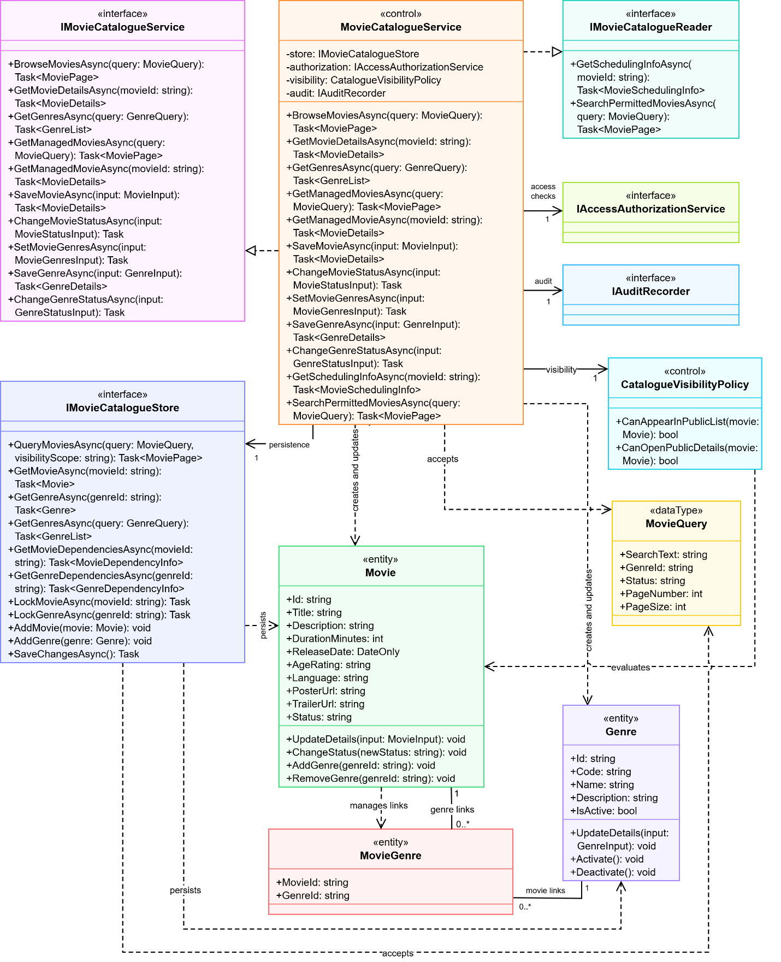
Figure 4: C04 Movie Catalogue Class Diagram.
The association multiplicities describe structural relationships. Any minimum genre-assignment requirement is enforced by the relevant use-case rules when saving or publishing a movie.
MovieQuery.Status is a filtering criterion, not permission to retrieve restricted movies. The application service supplies the permitted visibility scope.

Key Class Descriptions
Class or Interface | Responsibility | Key Attributes | Key Operations
IMovieCatalogueService | Defines public catalogue and protected administration operations consumed by C02. | No instance attributes. | Public browsing, detail retrieval, administrative queries, movie maintenance, genre maintenance, and association updates.
IMovieCatalogueReader | Defines read-only catalogue access for C06 and C12. | No instance attributes. | Supplies scheduling information and permitted movie-search results.
MovieCatalogueService | Coordinates catalogue operations, access checks, dependency validation, persistence, and audit recording. | References to persistence, authorisation, visibility policy, and audit services. | Implements the catalogue and read-only service contracts.
CatalogueVisibilityPolicy | Evaluates whether a movie may appear in public listings or be opened through public details. | No persistent state. | CanAppearInPublicList(...) and CanOpenPublicDetails(...).
Movie | Represents maintained movie information and catalogue lifecycle state. | Identifier, title, description, runtime, release date, age rating, language, media references, and status. | Updates descriptive information, changes status, and manages genre links.
Genre | Represents a reusable genre definition. | Identifier, code, name, description, and active state. | Updates details and activates or deactivates the definition.
MovieGenre | Represents the relationship between one movie and one genre. | MovieId and GenreId. | No independent business operations; association changes are coordinated through the movie and application service.
MovieQuery | Carries supported search, filter, and pagination criteria. | Search text, genre filter, status filter, page number, and page size. | No business operations.
IMovieCatalogueStore | Defines catalogue persistence and dependency-query operations implemented by C13. | No instance attributes. | Queries records, retrieves dependency information, obtains locks, registers new entities, and saves changes.
IAccessAuthorizationService | Supplies current operation-level access checks from C03. | Defined in C03. | Validates the caller’s current eligibility for the requested catalogue operation.
IAuditRecorder | Represents the audit-recording contract supplied by C16. | Defined in C16. | Records required privileged changes and their actor and affected-record information.
Input and result types referenced by operation signatures define the corresponding service contracts. They are omitted from the diagram where their individual fields do not affect the component’s principal class relationships.

Class Relationships
Source | Target | Relationship | Meaning
MovieCatalogueService | IMovieCatalogueService | Realization | Implements public queries and catalogue administration.
MovieCatalogueService | IMovieCatalogueReader | Realization | Implements the read-only contract used by other components.
MovieCatalogueService | IMovieCatalogueStore | Association | Retains a persistence reference for catalogue queries and changes.
MovieCatalogueService | IAccessAuthorizationService | Association | Retains access to current authorisation checks.
MovieCatalogueService | CatalogueVisibilityPolicy | Association | Uses the shared public-visibility rules.
MovieCatalogueService | IAuditRecorder | Association | Records required privileged catalogue actions.
MovieCatalogueService | Movie; Genre | Dependency | Creates or updates catalogue entities during application operations.
MovieCatalogueService | MovieQuery | Dependency | Receives query criteria for supported catalogue searches.
CatalogueVisibilityPolicy | Movie | Dependency | Evaluates movie information without taking ownership of the entity.
Movie | MovieGenre | Association | One movie may have multiple genre links; each link belongs to one movie.
Genre | MovieGenre | Association | One genre may be referenced by multiple movie links; each link identifies one genre.
Movie | MovieGenre | Dependency | Movie operations create or remove links within the maintained association collection.
IMovieCatalogueStore | Movie; Genre; MovieQuery | Dependency | Persistence operations accept or return catalogue entities and query criteria.

Data Ownership and Consistency
C04 owns movie records, genre definitions, movie–genre associations, and catalogue visibility rules.
C06 owns showtimes and their duration snapshots. C08 owns accepted booking information and price snapshots. Catalogue updates must not overwrite historical values owned by those components.
The following rules apply:
- Public listing eligibility and public detail eligibility are evaluated separately.
- Ended movies are excluded from public listings while permitted read-only details may remain accessible.
- Archived movies are excluded from public catalogue responses.
- Administrative access does not bypass role restrictions. Manager access remains read-only.
- Movie runtime must satisfy the specification’s validation rules.
- Changes to movie runtime do not automatically recalculate existing showtime end times or duration snapshots.
- Movie–genre links reference existing records and do not contain duplicate movie–genre pairs.
- A requested set of genre associations is validated and updated atomically.
- Genre status changes preserve existing references according to the specified association rules.
- Changes affecting dependent showtimes or historical records require dependency validation before commit.
- Catalogue operations do not cascade-delete showtimes, bookings, payments, or tickets.
- Concurrency checks and locking prevent a dependency check from being invalidated by a conflicting operation before commit.
- C04 and C06 follow a consistent lock order for operations involving shared movie references.
- Required audit records remain consistent with the catalogue changes they document.
- Saving persistence changes does not independently commit a transaction owned by the coordinating application service.
Visibility filtering is applied before pagination and result counting so that public page sizes and totals describe only the permitted result set.

Key Processing Flows and Failure Handling

Public Movie Browsing
- C02 submits the supported browsing criteria to C04.
- MovieCatalogueService validates the query and establishes the public visibility scope.
- The persistence query applies visibility conditions, search criteria, filters, and pagination.
- C04 returns the permitted movie summaries and pagination information.
- C02 returns the response to C01.
User-supplied status filters cannot expand the public visibility scope.

Public Movie Details
- C02 submits the selected movie identifier.
- C04 retrieves the movie and evaluates public-detail eligibility.
- If access is permitted, C04 returns the descriptive information, classification, runtime, genres, and permitted media references.
- If access is not permitted, C04 returns an outcome that does not expose restricted catalogue information.
Showtime availability is obtained through C06. Access to movie details does not itself establish that a screening is bookable.

Movie Administration
- C02 submits an administrative read or maintenance request.
- C04 checks the caller’s current permissions through C03.
- For a change, C04 validates the submitted movie information and requested operation.
- The application service starts the required transaction and obtains the relevant concurrency protection.
- C04 retrieves and validates dependent-record information.
- It applies the permitted movie changes without modifying existing showtime snapshots.
- The service performs the required pre-commit authorisation recheck and records the required audit information.
- The transaction commits and C04 returns the result.
An operation that would violate dependency or historical-reference rules is rejected without partially changing the movie.

Genre and Association Maintenance
- C04 verifies that the caller is authorised to maintain genres or movie–genre associations.
- It validates the genre definition, requested status change, or complete set of requested associations.
- It checks referenced records and applicable status restrictions.
- C04 applies the change within the required transaction.
- Duplicate links and invalid references are rejected.
- Required audit information is recorded consistently with the change.
- The transaction commits and the updated result is returned.

Catalogue Information for Other Components
- C06 or C12 invokes the read-only catalogue contract.
- C04 applies the access and visibility rules appropriate to the caller’s operation.
- For scheduling, C04 supplies current movie information needed by C06.
- C06 validates scheduling eligibility and preserves the required movie-duration snapshot when creating or updating a showtime.
- For Promethe-Nous, C04 supplies only catalogue information permitted for the informational query.
C12 does not receive unrestricted administrative access through the read-only contract.

Failure Handling and Recovery
- Invalid search or maintenance inputs return validation feedback without changing stored records.
- Missing or restricted movies return controlled outcomes without exposing protected details.
- Unauthorised maintenance requests are rejected before applying changes.
- Invalid genre references or duplicate associations cause the association update to fail atomically.
- Conflicting catalogue updates return a conflict outcome requiring the caller to reload current information.
- Dependency conflicts prevent changes that would violate scheduling or historical-reference rules.
- Transaction failures roll back the associated catalogue changes and mandatory audit records.
- Missing optional media is represented without fabricating a poster or trailer reference.
- A failed catalogue query does not trigger changes to movie, showtime, booking, or ticket state.
- Diagnostic messages exclude sensitive account context and internal database exception details.

Component C05 Cinema and Seating

Purpose and Responsibilities
Cinema and Seating manages cinemas, screening rooms, physical seating layouts, seat operational status, and shared seat-type definitions and surcharges.
The component is responsible for:
- Maintaining cinema information and operational state.
- Maintaining screening-room information and configuration.
- Defining physical seat positions and labels within each room.
- Preserving physical seat identity when layouts change.
- Managing whether a physical seat is operational.
- Maintaining shared seat types and their surcharges.
- Supplying cinema, room, seat, and seat-type information to scheduling, pricing, and booking services.
- Validating configuration changes against existing schedules and booking obligations.
C05 distinguishes physical configuration from showtime-specific allocation. A physical seat’s operational status belongs to C05. Whether that seat is available, held, or sold for a particular showtime is determined by C08 Booking and Checkout.
Each physical seat represents one admission place. Couple seats and multi-person seat capacity are outside the current model.
Shared seat-type definitions and surcharges are maintained by Admin. Other cinema and seating operations follow the role and cinema-assignment permissions defined in their corresponding use-case specifications.
C05 does not create bookings, release allocations, invalidate tickets, or execute refunds. A configuration change that conflicts with existing obligations is rejected unless the required resolution has already been completed through the responsible business components.

Use-Case Traceability
Use Case | Contribution of C05
UC-14A Manage Cinemas | Provides authorised cinema queries and maintenance, including dependency checks for operational changes.
UC-14B Manage Screening Rooms | Maintains screening-room information and configuration while protecting existing schedules and bookings.
UC-15A Configure Seat Layout | Creates and updates physical seating arrangements, preserves seat identity, and validates affected dependencies.
UC-15B Change Seat Operational Status | Changes physical seat operational status after checking relevant screening and booking obligations.
UC-15C Manage Seat Types | Maintains shared seat-type definitions and surcharges under Admin authority.
UC-07 Browse Showtimes | Supplies cinema and room information used when presenting eligible screenings.
UC-01 Reserve Seats; UC-09 Checkout and Payment | Supplies physical-seat and operational information used during seat selection and reservation validation.
UC-16B Configure Cinema Ticket Pricing | Supplies valid cinema references used by C07 when maintaining cinema-specific base prices.
UC-17 Manage Showtimes and Schedules | Supplies room and seating configuration used by C06 for scheduling eligibility checks.
UC-05 Validate Ticket | Supplies cinema and room reference information where required by the admission workflow.

Implementation Language and Technologies
The component is implemented in C# within the ASP.NET Core backend.
It uses:
- Application services for configuration workflows and dependency validation.
- Domain classes for cinemas, screening rooms, physical seats, and seat types.
- C03 authorisation services for current roles and cinema assignments.
- Persistence contracts implemented by C13 using EF Core and PostgreSQL.
- Coordinated transactions and concurrency controls for configuration changes.
- C16 Audit Logging for required privileged operations.
C05 exposes in-process service contracts to other backend components. Browser requests reach C05 through C02 Backend API.
Seat-layout data describes physical placement and identity. The visual rendering of a seat map belongs to C01 Web Application.

Provided Interfaces and Services
Interface or Operation | Responsibility
ICinemaSeatingService.GetCinemasAsync(...) | Returns cinema information permitted for the requested access context.
ICinemaSeatingService.GetCinemaAsync(...) | Returns an accessible cinema record.
ICinemaSeatingService.SaveCinemaAsync(...) | Creates or updates authorised cinema information.
ICinemaSeatingService.ChangeCinemaStatusAsync(...) | Applies a permitted cinema-state change after dependency validation.
ICinemaSeatingService.GetRoomsAsync(...) | Returns accessible screening rooms for a cinema.
ICinemaSeatingService.SaveRoomAsync(...) | Creates or updates screening-room information.
ICinemaSeatingService.ChangeRoomStatusAsync(...) | Applies a permitted room-state change while protecting screening and booking obligations.
ICinemaSeatingService.GetSeatLayoutAsync(...) | Returns physical seat positions, labels, types, and operational states for a room.
ICinemaSeatingService.ConfigureSeatLayoutAsync(...) | Validates and atomically applies a permitted physical-layout change.
ICinemaSeatingService.ChangeSeatStatusAsync(...) | Changes a physical seat’s operational status after checking affected obligations.
ICinemaSeatingService.GetSeatTypesAsync(...) | Returns seat-type definitions within the permitted read scope.
ICinemaSeatingService.SaveSeatTypeAsync(...) | Creates or updates shared seat-type information and surcharge values under Admin authority.
ICinemaSeatingService.ChangeSeatTypeStatusAsync(...) | Changes seat-type status while preserving valid physical-seat references.
ICinemaSeatingReader.GetRoomConfigurationAsync(...) | Supplies cinema, room, and physical-layout information to scheduling services.
ICinemaSeatingReader.GetSeatConfigurationAsync(...) | Supplies configuration for selected seats to reservation services.
ICinemaSeatingReader.GetSeatTypeSurchargesAsync(...) | Supplies current shared seat-type surcharges to pricing services.
Read-only contracts do not grant permission to alter physical configuration. Show-specific availability is obtained from the booking and allocation services rather than inferred from GetSeatLayoutAsync(...).

Dependencies and Communication
Calling Component | Receiving Component | Interface or Operation | Purpose | Communication
C02 Backend API | C05 Cinema and Seating | ICinemaSeatingService | Process permitted cinema, room, seating, and seat-type queries and maintenance. | In-process C# interface calls.
C06 Showtime Scheduling | C05 Cinema and Seating | ICinemaSeatingReader.GetRoomConfigurationAsync(...) | Validate cinema, room, and seating configuration for scheduling. | In-process C# interface calls.
C07 Ticket Pricing | C05 Cinema and Seating | ICinemaSeatingReader.GetSeatTypeSurchargesAsync(...) | Retrieve shared seat-type surcharges for price calculation. | In-process C# interface calls.
C08 Booking and Checkout | C05 Cinema and Seating | ICinemaSeatingReader.GetSeatConfigurationAsync(...) | Validate selected physical seats, room membership, seat types, and operational eligibility. | In-process C# interface calls coordinated with reservation consistency checks.
C05 Cinema and Seating | C03 Identity and Access | IAccessAuthorizationService.AuthorizeAsync(...) | Check current operation permissions and cinema scope. | In-process C# interface calls.
C05 Cinema and Seating | C13 Persistence and Transactions | ICinemaSeatingStore | Retrieve and persist configuration and inspect dependent records. | In-process persistence contracts and coordinated transactions.
C05 Cinema and Seating | C16 Audit Logging | IAuditRecorder | Record required configuration changes and their responsible actors. | In-process C# interface calls within the associated transaction where required.
Dependency information obtained through C13 supports validation only. C05 does not use persistence access to change showtime, booking, payment, or ticket states owned by other components.

Class Diagram
The class diagram presents configuration services, dependency validation, physical cinema entities, and supporting contracts in one view.
CinemaSeatingService implements both the application-facing management contract and the read-only contract used by other components. ConfigurationChangePolicy evaluates proposed changes against the affected configuration and dependency information.
A cinema has screening rooms, a room has physical seats, and each seat references one shared seat type. These relationships are represented as associations because configuration changes must preserve referenced records and do not imply cascading deletion of historical information.
The «dataType» stereotype identifies input and dependency-summary structures. Interfaces supplied by C03 and C16 are shown without repeating their complete definitions.
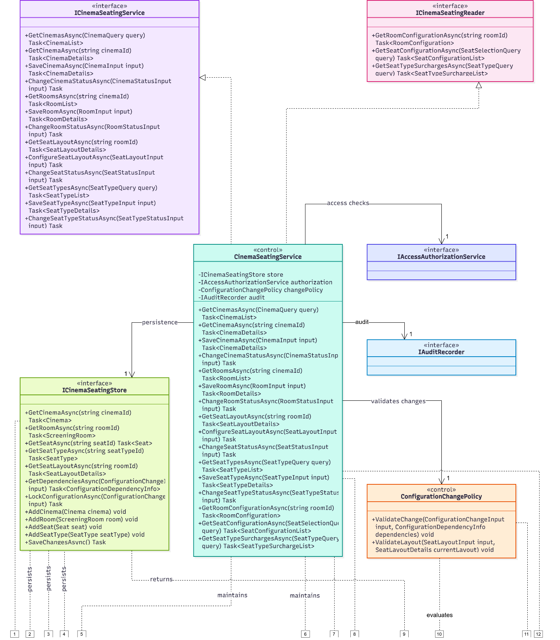
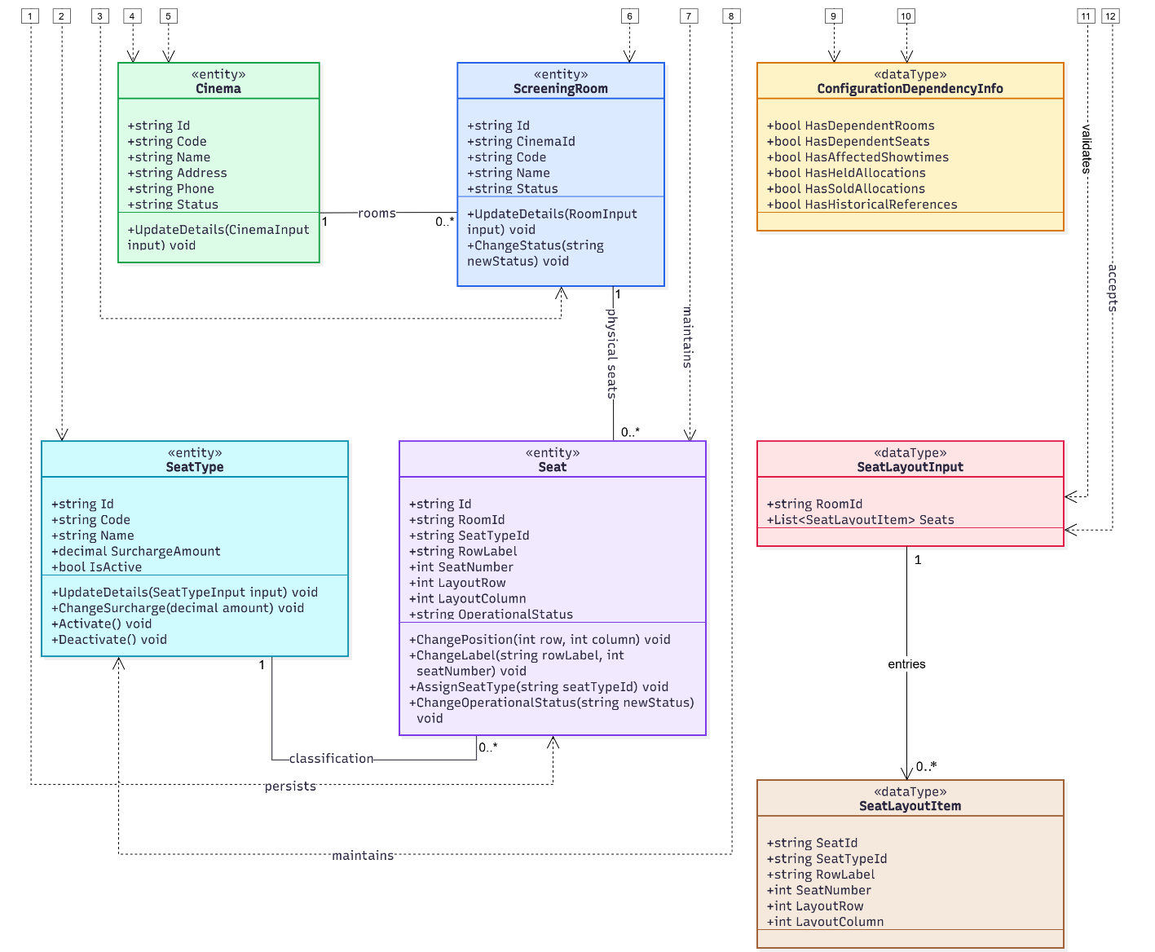
Figure 5: C05 Cinema and Seating Class Diagram.
SeatLayoutItem.SeatId identifies an existing seat when modifying a layout and is absent for a newly proposed seat. LayoutRow and LayoutColumn describe display placement; they do not represent additional admission capacity.
The diagram shows principal persistence operations. Read-model queries and full request and response fields are detailed in the corresponding contracts.

Key Class Descriptions
Class or Interface | Responsibility | Key Attributes | Key Operations
ICinemaSeatingService | Defines queries and configuration operations consumed by C02. | No instance attributes. | Cinema, room, layout, seat-status, and seat-type queries and maintenance.
ICinemaSeatingReader | Defines read-only configuration access for scheduling, pricing, and booking. | No instance attributes. | Retrieves room configuration, selected-seat information, and seat-type surcharges.
CinemaSeatingService | Coordinates authorisation, configuration validation, dependency checks, persistence, and audit recording. | References to persistence, authorisation, change policy, and audit services. | Implements management and read-only service contracts.
ConfigurationChangePolicy | Evaluates whether a proposed configuration change is compatible with the current layout and dependent obligations. | No persistent state. | Validates configuration changes and physical-layout structure.
Cinema | Represents a cinema and its maintained operational information. | Identifier, code, name, address, phone, and status. | Updates details and applies an authorised state change.
ScreeningRoom | Represents a screening room belonging to one cinema. | Identifier, cinema identifier, code, name, and status. | Updates room information and operational state.
Seat | Represents one identifiable physical admission place in a room. | Identifier, room, seat type, row label, seat number, layout coordinates, and operational status. | Changes position, label, seat type, or operational status after application-level validation.
SeatType | Represents a shared classification and surcharge used by physical seats. | Identifier, code, name, surcharge, and active state. | Maintains descriptive information, changes the surcharge, and activates or deactivates the definition.
SeatLayoutInput | Carries a proposed room layout. | Room identifier and proposed seat entries. | No business operations.
SeatLayoutItem | Describes one existing or new seat in the proposed layout. | Optional existing seat identifier, seat type, label, and position. | No business operations.
ConfigurationDependencyInfo | Summarises dependencies relevant to the proposed change. | Indicators for dependent configuration, affected showtimes, allocations, and historical references. | No business operations; the policy interprets the information according to the operation.
ICinemaSeatingStore | Defines persistence, dependency queries, and configuration-locking operations supplied by C13. | No instance attributes. | Retrieves records, inspects dependencies, acquires concurrency protection, and persists changes.
IAccessAuthorizationService | Supplies current role and cinema-scope checks from C03. | Defined in C03. | Authorises the requested read or maintenance operation.
IAuditRecorder | Supplies required audit recording from C16. | Defined in C16. | Records the responsible actor, action, affected configuration, and required supporting information.

Class Relationships
Source | Target | Relationship | Meaning
CinemaSeatingService | ICinemaSeatingService | Realization | Implements configuration queries and maintenance.
CinemaSeatingService | ICinemaSeatingReader | Realization | Implements read-only configuration services.
CinemaSeatingService | ICinemaSeatingStore | Association | Retains the persistence contract used for queries and changes.
CinemaSeatingService | IAccessAuthorizationService | Association | Uses current access checks for protected operations.
CinemaSeatingService | ConfigurationChangePolicy | Association | Uses the policy to validate proposed configuration changes.
CinemaSeatingService | IAuditRecorder | Association | Records required privileged configuration actions.
Cinema | ScreeningRoom | Association | One cinema may contain multiple rooms; each room belongs to one cinema.
ScreeningRoom | Seat | Association | One room may contain multiple physical seats; each seat belongs to one room.
SeatType | Seat | Association | A shared seat type may classify multiple seats; each seat has one assigned seat type.
SeatLayoutInput | SeatLayoutItem | Association | A layout request contains a collection of proposed seat entries.
CinemaSeatingService | Cinema; ScreeningRoom; Seat; SeatType | Dependency | Creates or changes configuration entities during authorised operations.
CinemaSeatingService | SeatLayoutInput | Dependency | Accepts the proposed physical layout.
ConfigurationChangePolicy | SeatLayoutInput; ConfigurationDependencyInfo | Dependency | Evaluates proposed layout data and affected dependencies.
ICinemaSeatingStore | Configuration entities; ConfigurationDependencyInfo | Dependency | Persistence operations retrieve or store entities and return dependency information.

Data Ownership and Consistency
C05 owns physical cinema configuration: cinemas, screening rooms, physical seats, seat types, and shared seat-type surcharges.
C06 owns showtime schedules. C08 owns showtime-specific seat allocations and accepted booking snapshots. C07 owns ticket-category definitions and cinema-specific base prices.
The following rules apply:
- Each room belongs to one cinema.
- Each physical seat belongs to one room and represents one admission place.
- Each physical seat references one valid seat type.
- Seat labels and occupied layout positions are unique within the applicable room.
- Layout gaps represent physical spacing or aisles rather than reservable seats.
- Existing seat identifiers are preserved when editing permitted labels, positions, or configuration.
- Referenced seats are not deleted and recreated merely to redraw a layout.
- Layout changes are validated as a complete proposed configuration and applied atomically.
- Removing a seat from a proposed layout does not automatically authorise deletion of its persistent record.
- A seat’s operational state does not independently determine its availability for a showtime.
- Disabling a cinema, room, seat, or seat type does not automatically cancel bookings or release allocations.
- Changes affecting schedules or booking obligations require the applicable dependency checks.
- Shared seat-type surcharge changes do not rewrite accepted booking price snapshots.
- Seat-type changes do not redefine the Adult and Discounted ticket categories.
- Configuration changes and reservation or scheduling operations use a compatible concurrency protocol so that eligibility cannot change unnoticed between validation and commit.
- Current authorisation is rechecked before committing protected changes where required.
- Mandatory audit records commit consistently with the configuration changes they describe.
LockConfigurationAsync(...) represents concurrency protection for the affected operation. Its implementation in C13 follows the shared lock order used by scheduling and booking workflows. Saving changes does not independently commit the coordinating transaction.

Key Processing Flows and Failure Handling

Cinema and Screening-Room Maintenance
- C02 submits the requested cinema or room operation.
- C05 checks the caller’s current permissions and applicable cinema assignment through C03.
- The service validates the proposed information and referenced parent records.
- For a change affecting operational eligibility, C05 acquires the required concurrency protection and retrieves dependency information.
- ConfigurationChangePolicy evaluates the proposed change.
- C05 updates the permitted configuration and records the required audit information.
- The service performs the required pre-commit authorisation recheck.
- The transaction commits and C05 returns the updated result.
A rejected change leaves the previous configuration intact.

Physical Seat-Layout Configuration
- C05 receives the target room and the complete proposed seat layout.
- It validates access to the room and its cinema.
- The service retrieves the current layout and relevant dependencies.
- It checks seat identifiers, room membership, labels, positions, and seat-type references.
- Existing entries retain their physical seat identifiers. New entries receive new identifiers when persisted.
- Proposed removals or changes are checked against affected showtimes, allocations, and historical references.
- C05 applies the accepted layout changes atomically and records the required audit information.
- The updated physical layout is returned after commit.
An invalid seat entry causes the layout update to fail as a whole rather than partially changing the room.

Seat Operational-Status Change
- An authorised caller requests a physical seat-status change.
- C05 retrieves the seat, its room, and the associated cinema.
- The service checks the caller’s current cinema scope.
- It obtains the required concurrency protection and inspects affected screening and booking obligations.
- If the change is permitted, C05 updates the physical seat’s operational status.
- The change and required audit record are committed together.
- Subsequent scheduling and reservation validation use the updated configuration.
The operation does not directly release held seats, cancel confirmed bookings, or invalidate tickets.

Seat-Type and Surcharge Maintenance
- C05 verifies the caller’s Admin authority.
- It validates the seat-type information and surcharge according to the specification.
- For status changes, the service checks physical seats and other references affected by the change.
- C05 applies the permitted update and records the required audit information.
- After commit, C07 uses the current surcharge for subsequent price calculations.
- Existing accepted booking snapshots remain unchanged.

Configuration Queries for Scheduling and Booking
- C06, C07, or C08 requests the configuration required for its operation.
- C05 returns the relevant cinema, room, seat, or seat-type information.
- The calling component applies its own business rules.
- Where the caller will commit a protected business change, it coordinates configuration validation with the shared concurrency protocol.
- C08 determines showtime-specific availability from its allocation state in addition to C05 physical-seat eligibility.

Failure Handling and Recovery
- Invalid cinema, room, seat, or seat-type references return controlled validation outcomes.
- Duplicate seat labels or occupied layout positions reject the proposed layout.
- A seat identifier belonging to another room cannot be used to modify the target room.
- Unauthorised configuration changes are rejected without applying partial updates.
- Conflicts with active schedules or booking obligations return an explicit dependency-conflict result.
- Concurrent configuration changes require reloading current data before retrying where the previous proposal is no longer valid.
- Transaction failures roll back configuration changes and their mandatory audit records.
- Physical configuration errors do not trigger automatic booking cancellation, refund execution, or ticket invalidation.
- Read failures return service errors without modifying stored configuration.
- Diagnostic responses do not expose database exceptions or sensitive account information.

Component C06 Showtime Scheduling

Purpose and Responsibilities
Showtime Scheduling manages screening schedules and provides authoritative showtime information for discovery, booking, admission, and cancellation eligibility.
The component is responsible for:
- Retrieving publicly eligible showtimes by movie, cinema, and date.
- Providing authorised operational access to screening schedules.
- Creating and maintaining showtimes.
- Validating movie, cinema, and screening-room eligibility.
- Preventing conflicting schedules within a screening room.
- Preserving the movie-duration snapshot associated with each showtime.
- Applying the required turnaround interval when checking room occupancy.
- Coordinating controlled rescheduling with existing booking obligations.
- Supplying the current official screening time to booking, ticketing, and cancellation services.
- Recording required schedule changes and supporting audit information.
C06 owns the official showtime schedule. C04 owns movie information, while C05 owns cinema, room, and physical-seat configuration. C08 owns bookings and allocations; C10 owns cancellation requests and refund obligations; C11 owns tickets and admissions.
Changing a showtime does not independently authorise booking cancellation, ticket invalidation, seat release, or refund completion. These effects are handled through the responsible components according to the Use-Case Specifications.

Use-Case Traceability
Use Case | Contribution of C06
UC-07 Browse Showtimes | Returns eligible screenings filtered by the applicable movie, cinema, and business date.
UC-17 Manage Showtimes and Schedules | Provides authorised schedule queries, showtime creation and maintenance, conflict detection, and controlled rescheduling.
UC-06B View Movie Details | Supplies eligible screenings displayed alongside permitted movie details.
UC-01 Reserve Seats; UC-09 Checkout and Payment | Supplies current screening information and eligibility for reservation and checkout validation.
UC-03 Release Expired Bookings; UC-04 Payment Reconciliation | Supplies screening context where required by booking-state and payment-outcome processing.
UC-05 Validate Ticket | Supplies the current official start time, cinema, and room used to validate admission context and time limits.
UC-10 Customer Booking Lifecycle | Supplies the current screening time used alongside the purchased-time snapshot to evaluate qualifying rescheduling.
UC-19 Manage Bookings and Tickets; UC-04A Refund | Supplies schedule-change context for cancellation review and the associated refund workflow.
UC-11 Chat with Promethe-Nous | Supplies permitted read-only screening information for informational responses.

Implementation Language and Technologies
The component is implemented in C# within the ASP.NET Core backend.
It uses:
- Application services for scheduling workflows and cross-component coordination.
- Domain classes and policies for showtime timing, eligibility, and conflict checks.
- C03 authorisation services for current roles and cinema assignments.
- Read-only contracts supplied by C04 and C05.
- Persistence and transaction services supplied by C13 using EF Core and PostgreSQL.
- Database constraints and coordinated locking to prevent concurrent scheduling conflicts.
- C16 Audit Logging for required privileged schedule changes.
- C15 Notification Delivery when the specified schedule-change workflow requires customer notification.
Timestamps use DateTimeOffset. Date-based browsing interprets the requested business date in Asia/Ho_Chi_Minh and converts it into an unambiguous timestamp interval for querying.
External email submission is performed by C15 after the associated transaction commits.

Provided Interfaces and Services
Interface or Operation | Responsibility
IShowtimeService.BrowseShowtimesAsync(...) | Returns publicly eligible screenings matching supported movie, cinema, and date filters.
IShowtimeService.GetShowtimeAsync(...) | Returns permitted public screening details.
IShowtimeService.GetManagedScheduleAsync(...) | Returns schedule information within the caller’s operational access scope.
IShowtimeService.SaveShowtimeAsync(...) | Creates or updates a showtime through the applicable validation and dependency rules.
IShowtimeService.RescheduleAsync(...) | Applies a permitted time change after conflict and booking-impact validation.
IShowtimeService.ChangeShowtimeStatusAsync(...) | Applies a permitted lifecycle-state change without bypassing existing obligations.
IShowtimeReader.GetBookingContextAsync(...) | Supplies screening information required for reservation and checkout.
IShowtimeReader.GetAdmissionContextAsync(...) | Supplies the current official screening time, cinema, and room for admission validation.
IShowtimeReader.GetCurrentScheduleAsync(...) | Supplies current schedule information for booking retrieval and cancellation evaluation.
IShowtimeReader.SearchPublicShowtimesAsync(...) | Supplies permitted screening information to Promethe-Nous.
SaveShowtimeAsync(...) does not provide a shortcut around controlled rescheduling. Changes to timing or other protected scheduling fields follow the same validation and coordination rules as the dedicated operations.
Application services return screening information rather than granting unconditional permission to reserve or admit. The calling business component performs its own required checks.

Dependencies and Communication
Calling Component | Receiving Component | Interface or Operation | Purpose | Communication
C02 Backend API | C06 Showtime Scheduling | IShowtimeService | Process public showtime queries and authorised scheduling operations. | In-process C# interface calls.
C08 Booking and Checkout | C06 Showtime Scheduling | IShowtimeReader.GetBookingContextAsync(...) | Obtain current screening eligibility and timing for reservation and checkout. | In-process C# interface calls coordinated with the booking transaction.
C10 Cancellation and Refund | C06 Showtime Scheduling | IShowtimeReader.GetCurrentScheduleAsync(...) | Obtain current screening time for cancellation eligibility and review. | In-process C# interface calls.
C11 Ticketing and Admission | C06 Showtime Scheduling | IShowtimeReader.GetAdmissionContextAsync(...) | Obtain current cinema, room, and screening time for admission checks. | In-process C# interface calls coordinated with admission processing.
C12 Promethe-Nous | C06 Showtime Scheduling | IShowtimeReader.SearchPublicShowtimesAsync(...) | Retrieve permitted screening information. | In-process C# interface calls.
C06 Showtime Scheduling | C03 Identity and Access | IAccessAuthorizationService | Check current operation permissions and cinema scope. | In-process C# interface calls.
C06 Showtime Scheduling | C04 Movie Catalogue | IMovieCatalogueReader.GetSchedulingInfoAsync(...) | Validate the movie and obtain information required for the duration snapshot. | In-process C# interface calls.
C06 Showtime Scheduling | C05 Cinema and Seating | ICinemaSeatingReader.GetRoomConfigurationAsync(...) | Validate cinema, room, and seating configuration. | In-process C# interface calls.
C06 Showtime Scheduling | C08 Booking and Checkout | IBookingScheduleImpactService | Assess affected booking obligations and coordinate required booking-owned effects of an approved schedule change. | In-process C# interface calls within the coordinated transaction.
C06 Showtime Scheduling | C13 Persistence and Transactions | IShowtimeStore | Query schedules, protect room occupancy, and persist showtime changes. | In-process persistence contracts and coordinated transactions.
C06 Showtime Scheduling | C15 Notification Delivery | Schedule-change notification service | Queue notifications required by an accepted schedule change. | In-process C# calls within the coordinated transaction.
C06 Showtime Scheduling | C16 Audit Logging | IAuditRecorder | Record required schedule changes and their responsible actors. | In-process C# interface calls.
IBookingScheduleImpactService is a focused contract owned by C08. Its implementation operates on the supplied change context and does not call back into C06 while the same change is being coordinated.
Schedule-change notifications reuse the existing booking and ticket identity. They do not create another booking or issue an additional admission entitlement.

Class Diagram
The class diagram presents scheduling coordination, showtime data, timing policies, and the external contracts required for validation and persistence.
ShowtimeService implements management and read-only scheduling interfaces. SchedulingPolicy validates timing and room occupancy, while ShowtimeVisibilityPolicy determines eligibility for public discovery.
Showtime preserves the duration snapshot used to calculate the screening end time. ShowtimeChange records the before-and-after timing of an accepted rescheduling operation. This history does not replace the purchased screening-time snapshot owned by C08.
External interfaces are shown without their complete operations where their detailed definitions belong to another component. The «dataType» stereotype identifies query and proposed-change data.
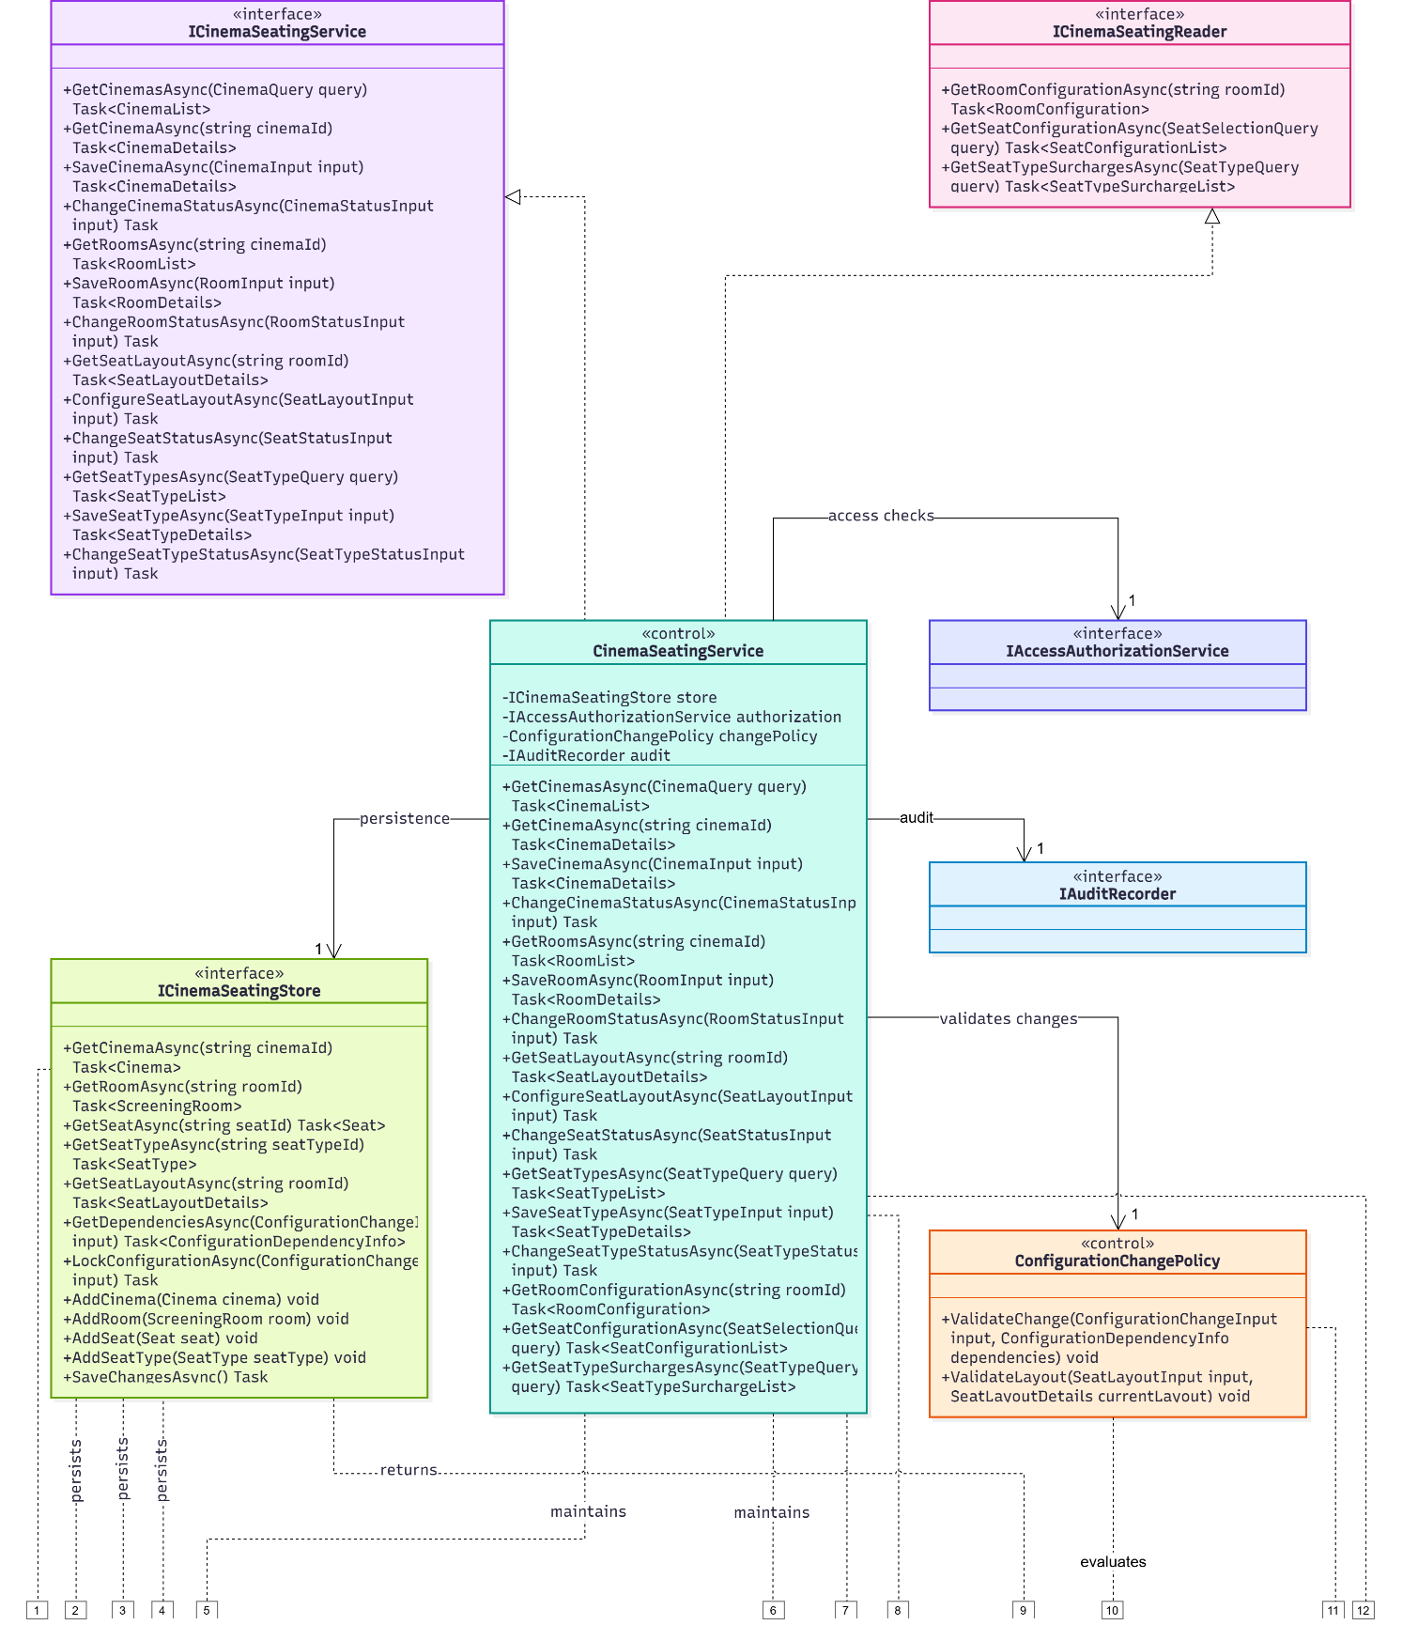
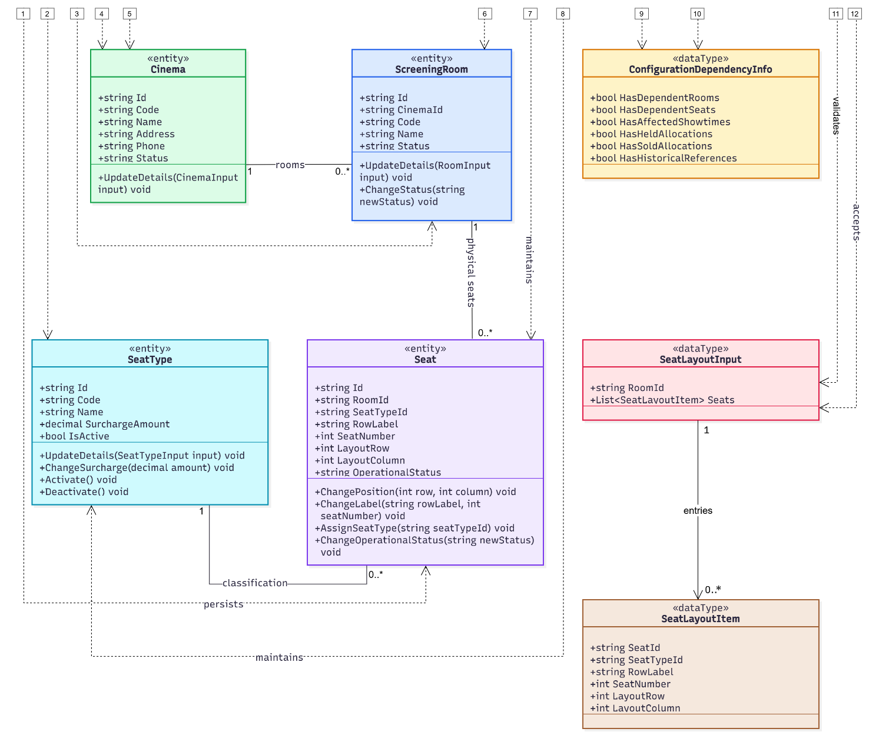
Figure 6: C06 Showtime Scheduling Class Diagram.
IScheduleChangeNotifier is the C15 contract for schedule-change messages. Its implementation queues delivery requests and does not call the external email provider within the scheduling transaction.
The public query implementation applies the same eligibility rules described by ShowtimeVisibilityPolicy before counting and paginating results.

Key Class Descriptions
Class or Interface | Responsibility | Key Attributes | Key Operations
IShowtimeService | Defines public queries and protected schedule-management operations consumed by C02. | No instance attributes. | Browsing, detail retrieval, schedule maintenance, rescheduling, and status changes.
IShowtimeReader | Defines read-only screening information supplied to other components. | No instance attributes. | Retrieves booking, admission, current-schedule, and public-query context.
ShowtimeService | Coordinates access checks, configuration validation, conflict detection, booking-impact processing, persistence, notification queueing, and audit recording. | References to policies and collaborating service contracts. | Implements management and read-only scheduling contracts.
SchedulingPolicy | Applies timing and room-occupancy rules. | No persistent state. | Validates timing, calculates screening end and occupied-until times, and detects interval overlap.
ShowtimeVisibilityPolicy | Determines whether a screening is eligible for public discovery. | No persistent state. | Evaluates current screening, movie, cinema, room, and timing context.
Showtime | Represents an official screening and its scheduling state. | Movie and room identifiers, start and end times, duration snapshot, turnaround interval, and status. | Reschedules using the preserved duration snapshot, changes status, and calculates room occupancy end.
ShowtimeChange | Preserves the timing history of an accepted rescheduling operation. | Old and new start and end times, actor, timestamp, and reason. | No independent mutation operation; recorded by the application service when the change commits.
ShowtimeQuery | Carries supported public search criteria. | Movie, cinema, business date, and pagination fields. | No business operations.
RescheduleInput | Represents a requested start-time change. | Showtime identifier, proposed start time, and reason. | No business operations.
ScheduleInterval | Represents a room-occupancy interval used for conflict checks. | Start time and occupied-until time. | No independent business operations.
IShowtimeStore | Defines scheduling persistence and concurrency operations implemented by C13. | No instance attributes. | Retrieves schedules and room intervals, obtains locks, and persists showtimes and change history.
IBookingScheduleImpactService | Supplies booking-impact assessment and booking-owned processing from C08. | Defined in C08. | Assesses a proposed change and applies the permitted booking effects of an accepted change.
IScheduleChangeNotifier | Supplies transactional queueing of required schedule-change messages through C15. | Defined in C15. | Queues messages using the accepted change and affected recipient information.
External access, catalogue, seating, and audit interfaces | Supply current permissions, referenced configuration, and required audit recording. | Defined in their owning components. | Used by the scheduling service for the corresponding operation.

Class Relationships
Source | Target | Relationship | Meaning
ShowtimeService | IShowtimeService | Realization | Implements public queries and schedule-management operations.
ShowtimeService | IShowtimeReader | Realization | Implements read-only screening contracts.
ShowtimeService | IShowtimeStore | Association | Retains access to scheduling persistence and locking operations.
ShowtimeService | SchedulingPolicy; ShowtimeVisibilityPolicy | Association | Uses timing, conflict, and public-eligibility rules.
ShowtimeService | IAccessAuthorizationService | Association | Checks current operation-level access and cinema scope.
ShowtimeService | IMovieCatalogueReader; ICinemaSeatingReader | Association | Retrieves current movie and physical-room configuration.
ShowtimeService | IBookingScheduleImpactService | Association | Coordinates booking-related assessment and effects through C08.
ShowtimeService | IScheduleChangeNotifier; IAuditRecorder | Association | Queues required notifications and records required audit information.
ShowtimeService | Showtime; ShowtimeChange | Dependency | Creates or updates showtimes and records accepted timing changes.
ShowtimeService | ShowtimeQuery; RescheduleInput | Dependency | Accepts query criteria and proposed rescheduling input.
Showtime | ShowtimeChange | Association | One showtime may have multiple historical timing changes; each change references one showtime.
Showtime | ScheduleInterval | Dependency | Represents its occupied room interval using scheduling data.
SchedulingPolicy | ScheduleInterval | Dependency | Compares intervals when checking conflicts.
IShowtimeStore | Showtime; ShowtimeChange; ShowtimeQuery; ScheduleInterval | Dependency | Persistence operations accept or return scheduling records and query data.

Data Ownership and Consistency
C06 owns showtime records, official start and end times, duration snapshots, scheduling state, and schedule-change history.
The following rules apply:
- Each showtime references one movie and one screening room.
- Referenced movie, cinema, room, and seating configuration must satisfy the applicable scheduling requirements.
- The screening end time is calculated from the official start time and the accepted duration snapshot.
- A later movie-runtime edit in C04 does not automatically change an existing showtime.
- Rescheduling preserves the showtime’s duration snapshot unless a separately permitted operation explicitly changes it under the relevant safeguards.
- Room-conflict checks include the required turnaround interval.
- Occupancy intervals use a consistent half-open representation: the start is included and the occupied-until boundary is excluded.
- Two applicable occupancy intervals in the same room must not overlap.
- Application validation is supported by database integrity controls so that concurrent requests cannot both create conflicting schedules.
- Booking-impact validation and the accepted schedule change execute within a coordinated consistency protocol.
- The purchased screening-time snapshot owned by C08 is preserved when the official schedule changes.
- Cancellation eligibility compares the current official screening time with the applicable purchased-time snapshot, rather than merely checking whether any change-history record exists.
- Admission checks use the current official screening time and revalidate it within the protected admission operation.
- A schedule change does not itself complete a cancellation or refund.
- Required change history, audit records, and notification requests commit consistently with the schedule change.
- External notification delivery occurs after commit.
- Locks involving scheduling and bookings follow the shared order, preserving the required Showtime → Booking → Payment Attempt ordering where those records are involved.
Room-level schedule protection is acquired consistently for competing schedule changes. Other workflows must not introduce a reversed lock acquisition that would undermine the shared protocol.

Key Processing Flows and Failure Handling

Public Showtime Browsing
- C02 or C12 submits supported movie, cinema, and date criteria.
- C06 validates the query and converts the requested business date into the appropriate timestamp range.
- The query applies public eligibility rules using the current screening and referenced configuration.
- Filtering occurs before pagination and result counting.
- C06 returns permitted screening summaries.
A returned screening is a discovery result, not a guarantee that the requested seats remain available. Reservation services revalidate current conditions.

Showtime Creation
- C02 submits the proposed movie, room, and screening time.
- C06 checks the caller’s current authority and cinema scope.
- It retrieves movie information from C04 and room configuration from C05.
- The service validates the proposed screening and establishes the duration snapshot.
- It calculates the screening end and room-occupancy end.
- Within the required transaction, C06 protects the room schedule and checks for conflicting occupancy intervals.
- The service revalidates configuration and authorisation as required before commit.
- C06 creates the showtime and records the required audit information.
- The transaction commits and the created screening is returned.

Controlled Rescheduling
- An authorised caller submits the showtime identifier, proposed start time, and reason.
- C06 retrieves the current showtime and checks access to its cinema.
- The service acquires the required room and showtime concurrency protection.
- It recalculates end and occupancy times using the preserved duration snapshot.
- C06 checks conflicts and obtains booking-impact information from C08.
- If the proposed change violates the applicable timing or booking rules, the operation is rejected.
- For an accepted change, C06 updates the official schedule and records the previous and new times.
- C08 applies any required booking-owned effects without overwriting purchased-time snapshots.
- C06 records required audit information and queues required schedule-change notifications.
- The coordinated transaction commits.
- C15 sends queued messages after commit.
Qualifying cancellation requests are subsequently handled by C10 and the relevant customer or operational workflows. Rescheduling does not automatically execute a monetary refund.

Showtime Maintenance and State Changes
- C06 checks current operation permissions and retrieves the showtime.
- It identifies whether the requested change affects timing, room occupancy, public eligibility, or existing obligations.
- Timing changes follow the controlled-rescheduling protocol.
- Other protected changes undergo their required dependency and concurrency checks.
- C06 commits the accepted update and required audit information together.
A generic maintenance endpoint cannot bypass the safeguards of a dedicated scheduling operation.

Screening Context for Booking and Admission
- C08, C10, or C11 requests the current screening context.
- C06 supplies the official screening time, location, and relevant lifecycle information.
- The caller applies its own reservation, cancellation, or admission rules.
- Before a protected state change commits, the caller coordinates the required schedule revalidation and locking.
- If the schedule changed concurrently, the operation is re-evaluated or rejected rather than committed using stale timing.

Failure Handling and Recovery
- Invalid movie or room references produce controlled validation failures.
- Unauthorised requests are rejected without changing the schedule.
- Invalid timing or overlapping room occupancy produces a scheduling-conflict response.
- Concurrent changes are resolved through locking, revalidation, and database constraints.
- Booking-impact conflicts reject the proposed change without partially updating the schedule.
- Failed transactions roll back the schedule change, associated history, required audit records, and queued notification requests.
- Notification failure does not reverse a committed official schedule change. C15 handles delivery retry.
- Repeated requests that do not change the current schedule do not create duplicate rescheduling history or initial notifications.
- Historical showtimes are not destructively removed while referenced records require their preservation.
- Error responses do not expose internal database details or restricted booking information.

Component C07 Ticket Pricing

Purpose and Responsibilities
Ticket Pricing manages ticket-category definitions and cinema-specific base prices and calculates booking prices using the selected physical seats.
The component is responsible for:
- Maintaining the two required ticket categories: Adult and Discounted.
- Maintaining the descriptive and eligibility information associated with those categories.
- Maintaining cinema-specific base prices for Adult and Discounted tickets.
- Retrieving shared seat-type surcharges from C05.
- Calculating price quotations for the selected ticket quantities and physical seats.
- Supplying an itemised price breakdown for checkout and booking snapshot creation.
- Enforcing current permissions for ticket-category and pricing administration.
Ticket categories apply to booking-level quantities. They are not assigned to individual physical seats. Each selected physical seat contributes its seat-type surcharge once.
C07 owns ticket-category definitions and cinema base-price configuration. C05 owns seat types and shared surcharges. C08 owns the accepted price snapshot stored with a booking.
Changing a base price, category description, or seat-type surcharge does not recalculate an existing booking’s accepted price.

Use-Case Traceability
Use Case | Contribution of C07
UC-16A Manage Ticket Types | Maintains the required Adult and Discounted definitions and eligibility information while preserving the two-category model.
UC-16B Configure Cinema Ticket Pricing | Maintains cinema-specific base prices under Admin or appropriately assigned Manager authority.
UC-15C Manage Seat Types | Consumes the shared surcharges maintained by C05 without taking ownership of seat-type administration.
UC-01 Reserve Seats | Supplies the validated price breakdown used when C08 creates the booking and its accepted price snapshot.
UC-09 Checkout and Payment | Supplies checkout quotations and supports detection of price changes before reservation creation.
UC-11 Chat with Promethe-Nous | Supplies permitted ticket-category and pricing information for informational responses.
UC-05 Validate Ticket | Supplies category eligibility information where required; C11 enforces admission counts and discounted entitlements.

Implementation Language and Technologies
The component is implemented in C# within the ASP.NET Core backend.
It uses:
- Application services for pricing queries and administration.
- Domain entities for ticket categories and cinema base prices.
- A pricing calculator for deterministic arithmetic.
- C03 authorisation services for current role and cinema-scope checks.
- C05 read-only services for physical-seat information and seat-type surcharges.
- Persistence contracts implemented by C13 using EF Core and PostgreSQL.
- C16 Audit Logging for required pricing changes.
Monetary values use C# decimal and compatible PostgreSQL numeric storage. Binary floating-point types are not used for monetary calculations.
C07 performs no external payment-provider calls. C09 Payment Processing uses the accepted booking amount supplied through the booking workflow.

Provided Interfaces and Services
Interface or Operation | Responsibility
ITicketPricingService.GetTicketTypesAsync(...) | Returns the two ticket-category definitions within the permitted read scope.
ITicketPricingService.SaveTicketTypeAsync(...) | Updates permitted category descriptions and eligibility information under Admin authority.
ITicketPricingService.GetCinemaPricingAsync(...) | Returns cinema-specific Adult and Discounted base prices.
ITicketPricingService.SaveCinemaPricingAsync(...) | Validates and updates cinema base prices under the applicable authority.
ITicketPricingService.CalculateQuoteAsync(...) | Validates pricing inputs and returns the current itemised quotation.
ITicketPricingReader.GetPricingInformationAsync(...) | Supplies permitted category and base-price information to other components.
ITicketPricingReader.GetValidatedQuoteAsync(...) | Supplies a current quotation to C08 for comparison with the user’s accepted selection and creation of the booking snapshot.
SaveTicketTypeAsync(...) does not create arbitrary additional ticket categories or change the meaning of the two required category identifiers.
A quotation does not create a booking, hold seats, or guarantee availability. Its values become an accepted booking snapshot only when C08 successfully completes reservation creation.

Dependencies and Communication
Calling Component | Receiving Component | Interface or Operation | Purpose | Communication
C02 Backend API | C07 Ticket Pricing | ITicketPricingService | Retrieve pricing information and process authorised category or base-price changes. | In-process C# interface calls.
C08 Booking and Checkout | C07 Ticket Pricing | ITicketPricingReader.GetValidatedQuoteAsync(...) | Obtain the current price breakdown for checkout validation and booking snapshot creation. | In-process C# interface calls within the reservation consistency protocol.
C12 Promethe-Nous | C07 Ticket Pricing | ITicketPricingReader.GetPricingInformationAsync(...) | Retrieve permitted pricing and category information. | In-process C# interface calls.
C11 Ticketing and Admission | C07 Ticket Pricing | ITicketPricingReader.GetPricingInformationAsync(...) | Retrieve applicable category definitions and eligibility information when required. | In-process C# interface calls.
C07 Ticket Pricing | C03 Identity and Access | IAccessAuthorizationService | Check current category-administration and cinema-pricing permissions. | In-process C# interface calls.
C07 Ticket Pricing | C05 Cinema and Seating | ICinemaSeatingReader | Retrieve the selected seats’ configuration and associated seat-type surcharges. | In-process C# interface calls.
C07 Ticket Pricing | C13 Persistence and Transactions | ITicketPricingStore | Retrieve and persist category definitions and cinema base prices. | In-process persistence contracts and coordinated transactions.
C07 Ticket Pricing | C16 Audit Logging | IAuditRecorder | Record required category and pricing changes. | In-process C# interface calls coordinated with the change transaction.
For reservation pricing, C08 supplies the cinema and room context obtained from authoritative screening information. C07 does not trust an arbitrary client-supplied cinema identifier as the pricing context for a selected showtime.

Class Diagram
The class diagram presents pricing administration, quotation coordination, monetary calculation, and the category and base-price entities.
TicketPricingService implements both the application-facing service contract and the read-only contract consumed by other components. It retrieves authoritative configuration and passes validated values to PricingCalculator.
PriceQuote records the calculated category quantities, base-price amounts, seat surcharges, and total. Its seat-charge entries identify physical seats and their surcharge contributions; they do not assign Adult or Discounted categories to individual seats.
The «dataType» stereotype identifies pricing inputs and calculated results. These structures are not authoritative booking records.
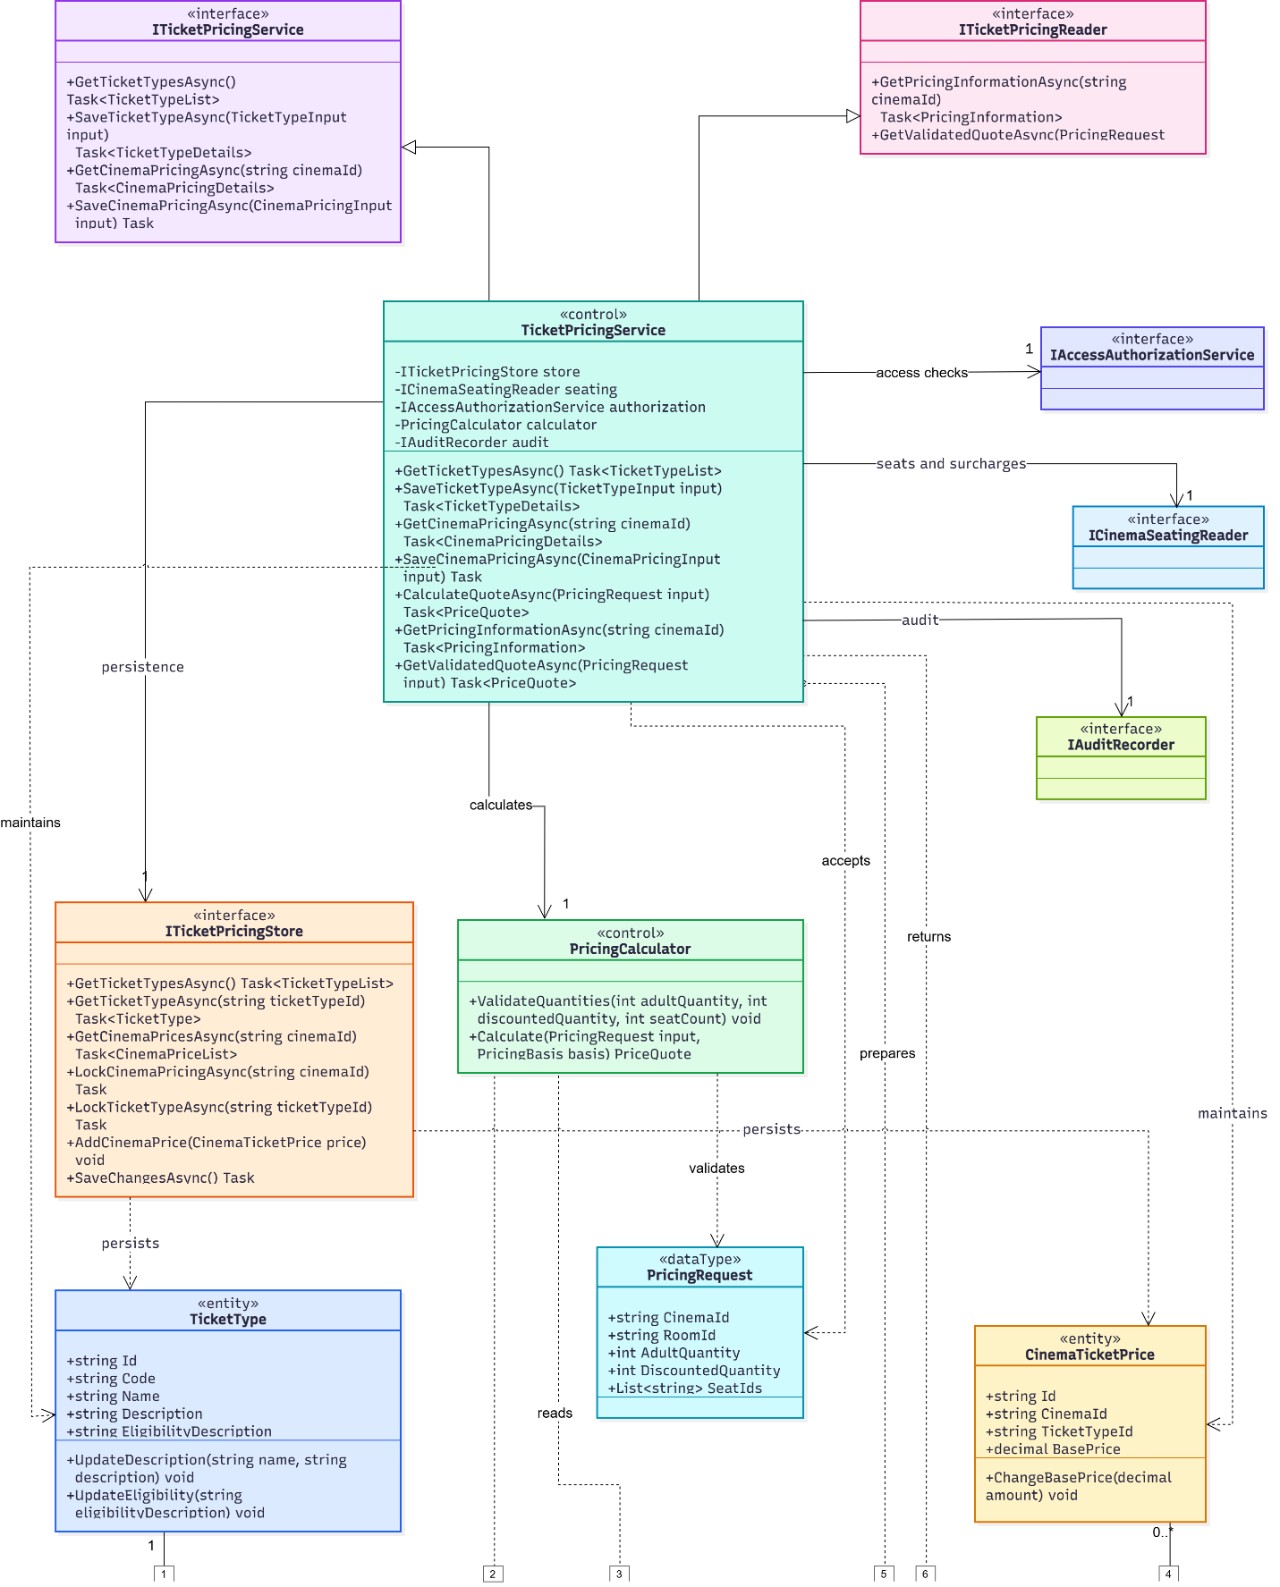
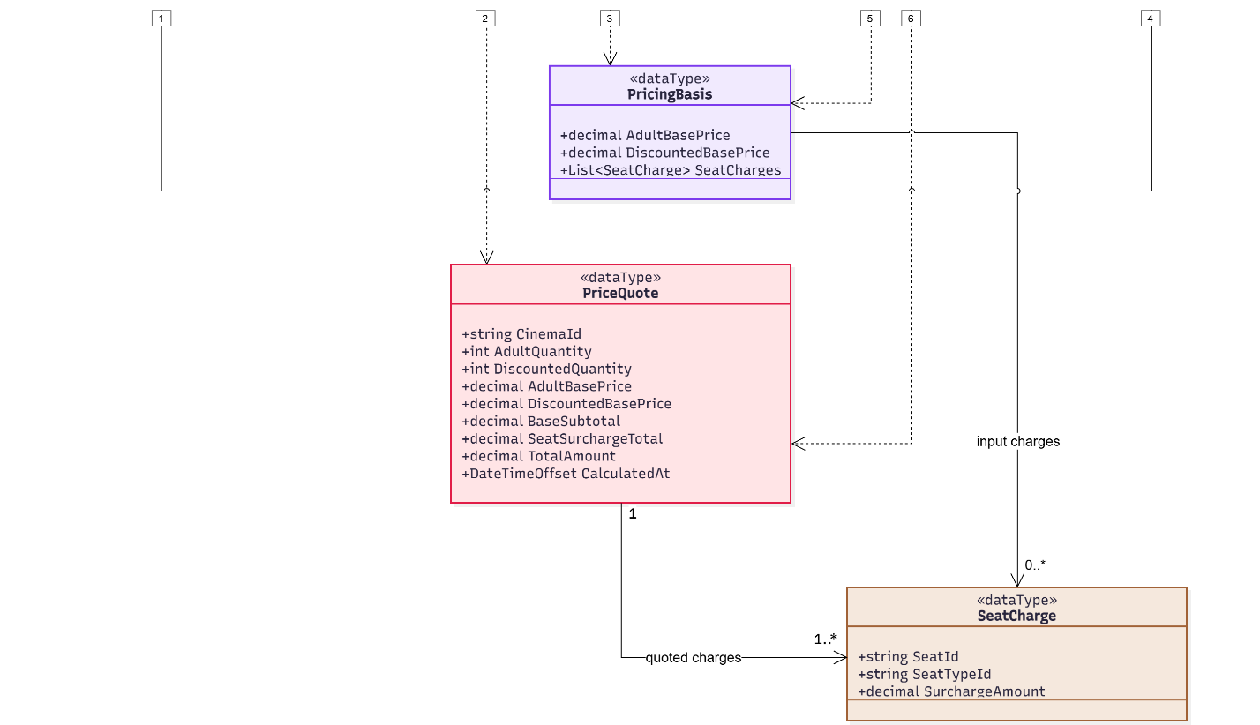
Figure 7: C07 Ticket Pricing Class Diagram.
TicketType.Code identifies Adult or Discounted and is not freely editable. PriceQuote represents a successful quotation for a non-empty seat selection. An incomplete selection is not returned as a validated reservation quotation.
The quoted charges association represents the seat-charge collection belonging to the quotation’s data structure. Request and response types not expanded in the diagram are defined by their corresponding service contracts.

Key Class Descriptions
Class or Interface | Responsibility | Key Attributes | Key Operations
ITicketPricingService | Defines category queries, cinema-price administration, and quotation operations consumed by C02. | No instance attributes. | Retrieves and maintains category and price information and calculates quotations.
ITicketPricingReader | Defines read-only pricing operations for other components. | No instance attributes. | Returns permitted pricing information and validated quotations.
TicketPricingService | Coordinates authorisation, configuration retrieval, quotation validation, persistence, and audit recording. | References to persistence, seating, authorisation, calculation, and audit services. | Implements management and read-only pricing contracts.
PricingCalculator | Performs deterministic quantity validation and monetary calculation. | No persistent state. | Validates ticket quantities against seat count and calculates the itemised quotation.
TicketType | Represents one of the two required booking-level ticket categories. | Identifier, stable code, name, description, and eligibility information. | Updates permitted descriptive and eligibility information without creating another category.
CinemaTicketPrice | Represents the base price for one ticket category at one cinema. | Cinema identifier, category identifier, and base price. | Changes the base price after the applicable validation and authorisation.
PricingRequest | Carries the selection to be priced. | Cinema and room context, Adult and Discounted quantities, and selected seat identifiers. | No business operations.
PricingBasis | Carries authoritative monetary inputs retrieved for one calculation. | Adult and Discounted base prices and per-seat surcharge entries. | No business operations.
PriceQuote | Carries the complete calculated price breakdown. | Quantities, base-price values, base subtotal, surcharge total, total amount, calculation time, and associated seat charges. | No state-changing business operations.
SeatCharge | Represents one physical seat’s surcharge contribution. | Seat identifier, seat-type identifier, and surcharge amount. | No business operations; it does not assign a ticket category to the seat.
ITicketPricingStore | Defines pricing persistence and locking operations supplied by C13. | No instance attributes. | Retrieves categories and prices, protects configuration changes, and saves updates.
ICinemaSeatingReader | Supplies physical-seat configuration and shared surcharges from C05. | Defined in C05. | Returns the information required to construct the pricing basis.
IAccessAuthorizationService | Supplies current role and cinema-scope checks from C03. | Defined in C03. | Authorises category or cinema-price operations.
IAuditRecorder | Supplies required audit recording from C16. | Defined in C16. | Records privileged pricing changes and the responsible actor.

Class Relationships
Source | Target | Relationship | Meaning
TicketPricingService | ITicketPricingService | Realization | Implements pricing queries and administration.
TicketPricingService | ITicketPricingReader | Realization | Implements the read-only pricing contract.
TicketPricingService | ITicketPricingStore | Association | Retains the persistence contract for categories and cinema prices.
TicketPricingService | ICinemaSeatingReader | Association | Retrieves physical-seat configuration and shared surcharges.
TicketPricingService | IAccessAuthorizationService | Association | Uses current access checks.
TicketPricingService | PricingCalculator | Association | Delegates validated monetary calculation to the calculator.
TicketPricingService | IAuditRecorder | Association | Records required privileged changes.
TicketType | CinemaTicketPrice | Association | A category may have base-price records for multiple cinemas; each price record references one category.
PricingBasis | SeatCharge | Association | Supplies the per-seat surcharge inputs used for calculation.
PriceQuote | SeatCharge | Association | Includes the per-seat surcharge breakdown for the validated selection.
TicketPricingService | TicketType; CinemaTicketPrice | Dependency | Creates or updates the permitted pricing configuration.
TicketPricingService | PricingRequest; PricingBasis; PriceQuote | Dependency | Accepts the selection, constructs the calculation basis, and returns a quotation.
PricingCalculator | PricingRequest; PricingBasis; PriceQuote | Dependency | Validates calculation inputs and creates the resulting quotation.
ITicketPricingStore | TicketType; CinemaTicketPrice | Dependency | Retrieves and persists pricing entities.

Data Ownership and Consistency
C07 owns ticket-category definitions and cinema-specific base prices. C05 owns seat-type definitions and surcharges. C08 owns accepted booking snapshots.
For Adult quantity \(q_A\), Discounted quantity \(q_D\), cinema base prices \(p_A\) and \(p_D\), and selected-seat surcharges \(s_1,\ldots,s_n\), the quotation is calculated as:
\[ \text{TotalAmount} = q_Ap_A + q_Dp_D + \sum_{i=1}^{n}s_i \]
The selected-seat count must satisfy:
\[ n=q_A+q_D \]
The following rules apply:
- The model contains exactly two required category codes: Adult and Discounted.
- Ticket quantities are non-negative integers, and a validated reservation quotation requires at least one ticket.
- The total quantity must satisfy the configured booking limit.
- Selected seat identifiers must be distinct and belong to the authorised room context.
- Each physical seat contributes one surcharge, regardless of the booking-level ticket-category quantities.
- No Adult or Discounted category is assigned to an individual seat.
- Each cinema has at most one base-price record for each required category.
- Required base prices and applicable surcharge information must be available before a validated quotation is returned.
- Missing pricing configuration is not treated as a zero price.
- Monetary inputs satisfy the amount and precision rules defined by the pricing specifications.
- Admin maintains shared category definitions. Admin and appropriately assigned Managers maintain cinema base prices.
- C07 cannot modify shared seat-type surcharges through a cinema-price operation.
- Pricing inputs used for reservation are read and validated under a consistency protocol coordinated with C05, C08, and C13.
- If current prices differ from the quotation accepted by the user, checkout requests renewed acceptance according to its rules.
- Price reacceptance does not reset the original selection deadline.
- C08 persists accepted quantities, base prices, surcharge contributions, and totals with the booking.
- Subsequent configuration changes do not modify that accepted snapshot.
- Payment initiation uses the accepted booking amount rather than recalculating the booking from current prices.
- Required pricing updates and audit records commit consistently.
Current category descriptions do not retroactively alter purchased ticket quantities or recorded admission entitlements.

Key Processing Flows and Failure Handling

Ticket-Category Maintenance
- C02 submits the requested category update.
- C07 checks the caller’s current Admin authority through C03.
- The service retrieves the existing Adult or Discounted definition.
- It validates the permitted descriptive and eligibility changes.
- Attempts to introduce an additional category or change a required category identifier are rejected.
- C07 applies the accepted update and records the required audit information.
- The transaction commits and the updated definition is returned.

Cinema Base-Price Configuration
- C02 submits the target cinema and proposed category prices.
- C07 checks Admin authority or the applicable Manager–Cinema assignment.
- The service validates the cinema reference, required categories, and monetary values.
- It acquires the required pricing concurrency protection.
- C07 creates or updates the cinema’s category-price records.
- The service performs the required authorisation recheck and records the pricing change.
- The transaction commits.
- Subsequent quotations use the updated prices; existing booking snapshots remain unchanged.

Checkout Quotation
- C08 or C02 submits the selection through the applicable pricing operation.
- C07 validates ticket quantities, distinct seat identifiers, and the supplied authoritative screening context.
- The service retrieves the cinema’s Adult and Discounted base prices.
- It retrieves physical-seat configuration and the corresponding seat-type surcharges from C05.
- C07 checks room membership and the presence of all required pricing inputs.
- PricingCalculator verifies that total ticket quantity equals selected-seat count.
- The calculator computes category subtotals, the sum of seat surcharges, and the total.
- C07 returns the itemised quotation.
The quotation does not hold the selected seats. C08 remains responsible for allocation eligibility and atomic reservation creation.

Reservation Price Revalidation
- When checkout progresses to reservation creation, C08 requests a validated quotation.
- C07 obtains current pricing inputs under the coordinated reservation consistency protocol.
- C08 compares the returned breakdown with the price information accepted by the user.
- If a price change requires renewed acceptance, the reservation is not silently completed at the changed amount.
- If the price is accepted and all reservation conditions pass, C08 stores the quotation values as the booking’s accepted snapshot.
- Booking creation, seat holding, and snapshot persistence commit atomically.
- Later payment processing uses the stored booking total.

Failure Handling and Recovery
- Invalid quantities or a mismatch between ticket count and seat count return validation failures.
- Duplicate seats or seats outside the selected room are rejected.
- Missing category prices or surcharge configuration prevent a validated quotation.
- Unauthorised category or cinema-price changes are rejected without partial updates.
- Concurrent price changes are handled through transaction checks and revalidation.
- A changed quotation is returned for user acceptance according to checkout rules; it does not extend the selection deadline.
- Transaction failures roll back pricing changes and their mandatory audit records.
- A failed quotation does not create a booking or allocate seats.
- Retrieval of an existing booking uses its stored price snapshot rather than requiring current pricing configuration.
- Diagnostic responses do not expose internal database exceptions or sensitive account context.

Component C08 Booking and Checkout

Purpose and Responsibilities
Booking and Checkout manages selection sessions, booking creation, checkout coordination, booking access, and the lifecycle of showtime-specific seat allocations.
The component is responsible for:
- Maintaining server-controlled selection sessions.
- Supporting guest and registered-customer checkout.
- Validating ticket quantities, selected seats, contact information, and required acknowledgements.
- Creating pending bookings and holding all requested seats atomically.
- Preserving accepted price and screening-time snapshots.
- Coordinating eligible payment initiation with C09.
- Providing authorised customer and operational booking queries.
- Cancelling eligible pending bookings.
- Expiring eligible pending bookings without violating payment-protection rules.
- Applying booking and allocation transitions within coordinated payment and refund workflows.
- Assessing the effects of schedule changes on existing bookings.
The first seat selection starts a five-minute selection session. Selection alone does not create a booking or hold a seat. Booking creation occurs when checkout progresses from Step 1 to Step 2 and inherits the original selection deadline.
Successful external payment initiation establishes the ten-minute payment deadline. Expiration and release subsequently follow the applicable payment-protection, grace-period, and reconciliation rules.
C08 owns bookings, selection sessions, accepted booking snapshots, and showtime-specific allocations. C09 owns payment attempts and verification. C10 owns confirmed-booking cancellation requests and refund obligations. C11 owns tickets and admissions.

Use-Case Traceability
Use Case | Contribution of C08
UC-01 Reserve Seats | Revalidates the selection and atomically creates the pending booking, accepted snapshots, and held seat allocations.
UC-09 Checkout and Payment | Coordinates guest and customer checkout, preserves selection deadlines, and requests eligible payment initiation through C09.
UC-10 Customer Booking Lifecycle | Provides authorised booking retrieval and eligible pending-booking cancellation. Supplies booking context for ticket access and confirmed-cancellation requests.
UC-03 Release Expired Bookings | Identifies and expires eligible pending bookings and releases their held allocations under payment-safety rules.
UC-02 Payment Webhook | Participates in verified payment application by confirming the booking and converting held allocations to sold allocations.
UC-04 Payment Reconciliation | Applies eligible booking transitions when payment outcomes are resolved and preserves unresolved-payment protection.
UC-04A Refund | Applies the required booking and allocation effects when C10 completes a qualifying cancellation refund.
UC-05 Validate Ticket | Supplies booking state and entitlements for coordinated admission validation.
UC-17 Manage Showtimes and Schedules | Assesses affected booking obligations and preserves purchased screening-time snapshots during controlled rescheduling.
UC-19 Manage Bookings and Tickets | Supplies scoped operational booking queries and booking context for permitted customer assistance.

Implementation Language and Technologies
The component is implemented in C# within the ASP.NET Core backend.
It uses:
- Application services for checkout and booking lifecycle coordination.
- Domain entities for selection sessions, bookings, allocation records, and accepted snapshots.
- C03 access checks for authenticated customer and operational requests.
- A guest-access policy for guest selection sessions and booking retrieval.
- Read-only contracts supplied by C05, C06, and C07.
- C09 payment-initiation and payment-protection contracts.
- Persistence contracts implemented by C13 using EF Core and PostgreSQL.
- Database transactions, uniqueness constraints, and coordinated locking.
- C14 background execution for expiration processing.
- C16 Audit Logging for required booking operations.
Authoritative deadlines use server time and timezone-aware timestamps. Monetary snapshots use decimal and compatible database numeric storage.
External payment calls are performed through C09 outside database transactions holding business locks.

Provided Interfaces and Services
Interface or Operation | Responsibility
IBookingCheckoutService.UpdateSelectionAsync(...) | Starts or updates an authorised selection session without holding seats or resetting its original deadline.
IBookingCheckoutService.GetCheckoutAsync(...) | Restores the permitted selection or booking context for the current checkout stage.
IBookingCheckoutService.ReserveSeatsAsync(...) | Atomically creates a pending booking, accepted snapshots, and held allocations.
IBookingCheckoutService.InitiatePaymentAsync(...) | Checks checkout context and delegates eligible payment initiation to C09.
IBookingCheckoutService.GetBookingAsync(...) | Returns a booking after customer ownership or guest-access validation.
IBookingCheckoutService.GetCustomerBookingsAsync(...) | Returns bookings belonging to the authenticated Customer.
IBookingCheckoutService.GetManagedBookingsAsync(...) | Returns operational booking records within the caller’s permitted cinema scope.
IBookingCheckoutService.CancelPendingAsync(...) | Cancels an eligible pending booking and releases held allocations when payment-safety rules permit.
IBookingExpirationService.ProcessExpiredAsync(...) | Processes candidate bookings and expires only those eligible for safe release.
IBookingLifecycleService.ConfirmVerifiedPaymentAsync(...) | Applies the booking and allocation portion of an eligible verified-payment outcome within the caller’s coordinated transaction.
IBookingLifecycleService.CompleteCancellationAsync(...) | Applies booking cancellation and allocation release for a qualifying completed cancellation refund.
IBookingScheduleImpactService.AssessChangeAsync(...) | Evaluates booking obligations affected by a proposed schedule change.
IBookingScheduleImpactService.ApplyAcceptedChangeAsync(...) | Applies required booking-owned effects of an accepted schedule change while preserving purchased snapshots.
Lifecycle operations are internal application contracts. They are not public endpoints that allow a client to declare a payment successful or a refund complete.
Ticket retrieval and resend are routed through C11. Confirmed-booking cancellation requests are routed through C10; C08 does not duplicate those workflows.

Dependencies and Communication
Calling Component | Receiving Component | Interface or Operation | Purpose | Communication
C02 Backend API | C08 Booking and Checkout | IBookingCheckoutService | Process checkout, reservation, booking retrieval, and eligible pending cancellation. | In-process C# interface calls.
C14 Background Processing | C08 Booking and Checkout | IBookingExpirationService | Trigger payment-safe expiration processing. | In-process C# interface calls.
C09 Payment Processing | C08 Booking and Checkout | IBookingLifecycleService.ConfirmVerifiedPaymentAsync(...) | Apply booking confirmation and allocation conversion as part of verified payment processing. | In-process C# calls within a coordinated transaction.
C10 Cancellation and Refund | C08 Booking and Checkout | IBookingLifecycleService.CompleteCancellationAsync(...) | Apply the booking and allocation effects of a qualifying completed cancellation refund. | In-process C# calls within a coordinated transaction.
C06 Showtime Scheduling | C08 Booking and Checkout | IBookingScheduleImpactService | Assess and apply permitted booking-owned schedule-change effects. | In-process C# calls within the scheduling consistency protocol.
C11 Ticketing and Admission | C08 Booking and Checkout | Booking-context query contract | Obtain authorised booking state and entitlements for ticket and admission operations. | In-process C# calls with the required transaction and locking context.
C08 Booking and Checkout | C03 Identity and Access | IAccessAuthorizationService | Check current account eligibility, permissions, and cinema assignments. | In-process C# interface calls.
C08 Booking and Checkout | C05 Cinema and Seating | ICinemaSeatingReader | Validate selected physical seats, room membership, and operational configuration. | In-process C# interface calls.
C08 Booking and Checkout | C06 Showtime Scheduling | IShowtimeReader | Obtain current screening eligibility and timing. | In-process C# interface calls.
C08 Booking and Checkout | C07 Ticket Pricing | ITicketPricingReader | Revalidate prices and obtain the accepted snapshot values. | In-process C# interface calls.
C08 Booking and Checkout | C09 Payment Processing | Payment initiation and protection contracts | Initiate eligible payment and determine whether a pending booking may be cancelled or expired. | In-process C# calls; external provider communication remains inside C09.
C08 Booking and Checkout | C13 Persistence and Transactions | IBookingStore | Persist sessions, bookings, snapshots, and allocations and enforce concurrency controls. | In-process persistence contracts and coordinated transactions.
C08 Booking and Checkout | C16 Audit Logging | IAuditRecorder | Record required booking-state changes and operational actions. | In-process C# interface calls.
The payment-protection contract returns current payment-state information without initiating a recursive booking transition. External reconciliation is performed by C09 outside the transaction holding booking locks.

Class Diagram
The class diagram presents checkout coordination, booking lifecycle services, selection sessions, booking snapshots, and allocation records in one view.
BookingCheckoutService handles customer and operational entry points. BookingLifecycleService applies internal booking transitions requested by payment and refund workflows. BookingExpirationService coordinates safe expiration, while BookingScheduleImpactService supplies the contract required by C06.
A booking owns its accepted price snapshot. Allocation records associate the booking with physical seats for a specific showtime. They are retained as lifecycle records rather than deleted when their allocations are released.
The «dataType» stereotype identifies an accepted snapshot value structure. Supporting input and response types are referenced through operation signatures without expanding every transport field.
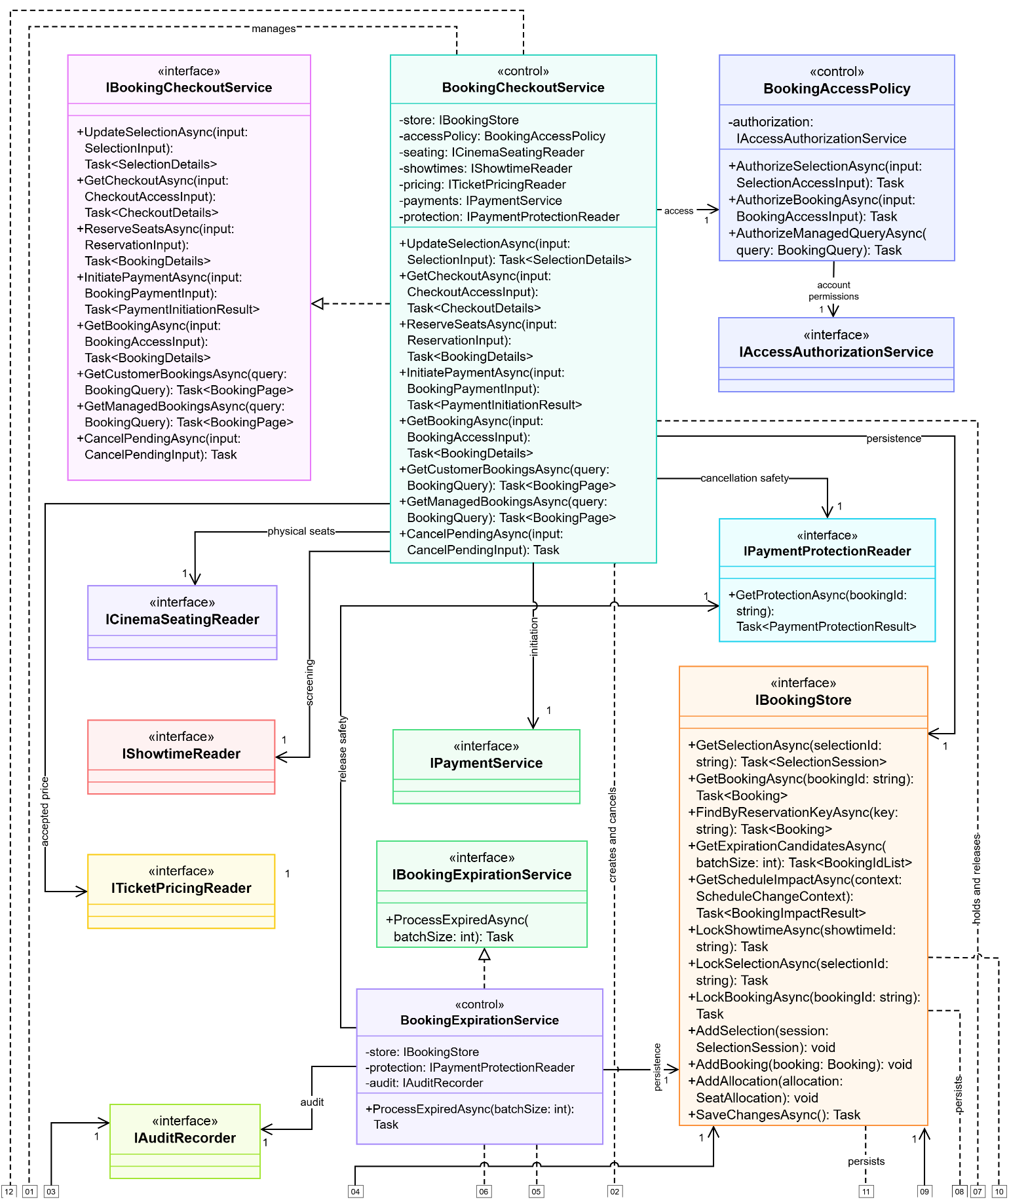
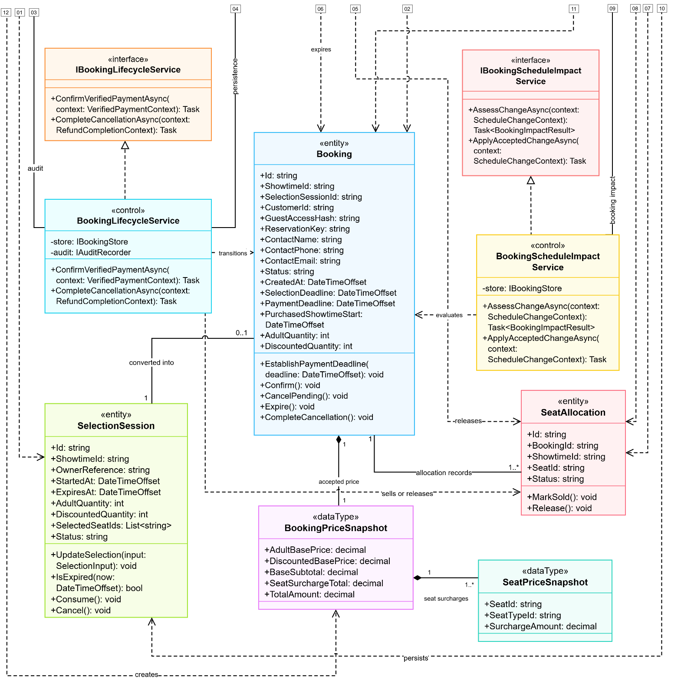
Figure 8: C08 Booking and Checkout Class Diagram.
CustomerId is absent for a guest booking. GuestAccessHash applies where guest-access credentials are used. PaymentDeadline is absent until successful payment initiation establishes it. These optional fields are represented by nullable types in the implementation.
The relationship between a selection session and a booking permits at most one booking to be created from that session. Repeated reservation requests return the existing compatible result rather than creating another booking.

Key Class Descriptions
Class or Interface | Responsibility | Key Attributes | Key Operations
IBookingCheckoutService | Defines checkout, reservation, booking-query, and pending-cancellation operations. | No instance attributes. | Selection updates, checkout restoration, reservation, payment initiation, retrieval, and cancellation.
BookingCheckoutService | Coordinates user-facing booking workflows and authoritative validation. | Persistence, access, seating, showtime, pricing, payment, and protection references. | Implements the checkout contract.
IBookingLifecycleService; BookingLifecycleService | Define and implement booking transitions used by verified payment and completed cancellation-refund workflows. | Persistence and audit references. | Confirms bookings and applies qualifying completed cancellations.
IBookingExpirationService; BookingExpirationService | Define and implement payment-safe expiration. | Persistence, payment-protection, and audit references. | Retrieves candidates, revalidates eligibility, and expires eligible bookings.
IBookingScheduleImpactService; BookingScheduleImpactService | Define and implement booking-impact support for C06. | Persistence reference. | Assesses proposed changes and applies permitted booking-owned effects.
BookingAccessPolicy | Validates selection ownership, customer ownership, guest access, and operational scope. | Current authorisation service reference. | Authorises selection, booking access, and scoped operational queries.
SelectionSession | Represents a time-limited selection without seat ownership. | Owner reference, screening, original start and expiry times, quantities, selected seats, and state. | Updates the selection without resetting the deadline, checks expiry, and records consumption or cancellation.
Booking | Represents the booking lifecycle and accepted customer information. | Screening, owner or guest-access information, reservation key, contact data, deadlines, purchased screening time, quantities, and state. | Establishes the payment deadline and applies permitted lifecycle transitions.
SeatAllocation | Represents a booking’s claim on one physical seat for one showtime. | Booking, showtime, physical seat, and allocation state. | Converts a held allocation to sold or releases it.
BookingPriceSnapshot | Preserves the booking’s accepted monetary breakdown. | Accepted category prices, subtotals, surcharge total, and total amount. | No recalculation operation after acceptance.
SeatPriceSnapshot | Preserves one selected seat’s accepted surcharge contribution. | Physical seat, seat type, and surcharge amount. | No independent business operations.
IBookingStore | Defines booking persistence and concurrency operations supplied by C13. | No instance attributes. | Retrieves and protects sessions and bookings, finds idempotent results, and persists records.
IPaymentProtectionReader | Supplies current payment protection information from C09. | No instance attributes. | Reports whether payment state permits cancellation or expiration or requires continued protection.
External service interfaces | Supply authoritative physical configuration, screening, pricing, access, payment initiation, and audit recording. | Defined in their owning components. | Invoked for the corresponding booking operation.

Class Relationships
Source | Target | Relationship | Meaning
BookingCheckoutService | IBookingCheckoutService | Realization | Implements checkout and booking-access operations.
BookingLifecycleService | IBookingLifecycleService | Realization | Implements internal booking transitions.
BookingExpirationService | IBookingExpirationService | Realization | Implements safe expiration processing.
BookingScheduleImpactService | IBookingScheduleImpactService | Realization | Implements booking-impact coordination for scheduling.
BookingCheckoutService | Persistence, access, configuration, pricing, and payment contracts | Association | Retains the services required to coordinate checkout.
BookingAccessPolicy | IAccessAuthorizationService | Association | Uses current account and operational permissions.
BookingLifecycleService | IBookingStore; IAuditRecorder | Association | Persists coordinated transitions and required audit information.
BookingExpirationService | IBookingStore; IPaymentProtectionReader; IAuditRecorder | Association | Combines persistence, payment safety, and required audit recording.
BookingScheduleImpactService | IBookingStore | Association | Queries and updates booking-owned information during schedule coordination.
SelectionSession | Booking | Association | A selection session produces at most one booking.
Booking | SeatAllocation | Association | A booking has allocation records for its selected seats.
Booking | BookingPriceSnapshot | Composition | The accepted price snapshot belongs exclusively to its booking.
BookingPriceSnapshot | SeatPriceSnapshot | Composition | The snapshot owns its accepted per-seat surcharge entries.
Application services | SelectionSession; Booking; SeatAllocation; BookingPriceSnapshot | Dependency | Create, inspect, or transition the corresponding records during their workflows.
IBookingStore | SelectionSession; Booking; SeatAllocation | Dependency | Persistence operations accept or return booking entities.

Data Ownership and Consistency
C08 owns selection sessions, bookings, contact information captured at checkout, purchased screening-time snapshots, accepted price snapshots, and showtime-specific seat allocations.
The following rules apply:
- The first seat selection starts the server-controlled five-minute session.
- Updating quantities, changing selected seats, or reaccepting a changed quotation does not reset the selection deadline.
- Selection-session data does not prevent another user from reserving the same seat.
- Booking creation at Checkout Step 1 to Step 2 inherits the original selection deadline.
- All requested seats are held together or none are held.
- Each physical seat represents one admission place.
- Adult and Discounted quantities are stored at booking level and total the number of selected seats.
- Ticket categories are not assigned to individual allocation records.
- A database constraint prevents conflicting active allocations for the same physical seat and showtime.
- Released allocation records do not block a later eligible booking.
- Accepted base prices, seat surcharges, quantities, and total amount are persisted with the booking.
- Client-supplied totals are not authoritative.
- A stable reservation key and selection-session relationship prevent duplicate booking creation on retry.
- Reusing a reservation key with incompatible input is rejected.
- Successful payment initiation establishes the ten-minute payment deadline; repeated requests do not arbitrarily extend it.
- Expiration does not infer payment failure from a passed deadline alone.
- Unresolved payment outcomes remain protected until the applicable verification and reconciliation rules permit release.
- Verified payment application coordinates payment state, booking confirmation, sold allocations, ticket issuance, and the initial email request in one transaction.
- Confirmed-booking cancellation effects occur only through the applicable C10 completion workflow.
- Guest access requires a valid access mechanism; knowledge of a booking identifier alone is insufficient.
- Operational queries enforce current role and cinema scope.
- Purchased screening-time snapshots remain unchanged when C06 reschedules the showtime.
- Transactions involving shared records preserve the required Showtime → Booking → Payment Attempt lock order.
- External provider calls occur outside transactions holding business locks.
Expiration candidates are only candidates. Each booking is reloaded and revalidated under the required locks before any state change.

Key Processing Flows and Failure Handling

Selection and Checkout Restoration
- The user selects the first physical seat through C01 and C02.
- C08 establishes an authorised selection session with a server-controlled five-minute deadline.
- Subsequent changes update quantities and selected seats without holding them or restarting the timer.
- The user proceeds to Checkout Step 1 with the original session and deadline.
- A permitted Step 1 reload restores the existing selection and remaining time.
- After reservation creation, a permitted Step 2 reload restores the existing booking rather than creating another booking.
Reloading the seat-selection page follows the specified cancellation and clearing rules for that selection session.

Atomic Reservation Creation
- C02 submits the reservation request, selection-session reference, contact information, acknowledgements, and reservation key.
- C08 validates access to the selection session and checks for an existing compatible reservation result.
- The service acquires the required concurrency protection.
- It revalidates the unexpired session, current screening, physical seats, ticket quantities, and applicable booking limit.
- C07 supplies the current validated quotation.
- If the quotation requires renewed acceptance, C08 returns the price-change outcome without silently reserving at the new price.
- C08 checks that every requested seat can be allocated.
- The service creates the pending booking, accepted snapshots, and all held allocations.
- The selection session is marked as consumed.
- The transaction commits and the existing selection deadline is returned with the booking.
If any required seat or condition fails, the reservation transaction does not partially allocate seats.

Payment Initiation
- The user requests payment for an accessible pending booking.
- C08 validates the checkout context and delegates payment initiation to C09.
- C09 protects and records the eligible payment attempt according to its initiation protocol.
- The external gateway call occurs outside the transaction holding business locks.
- C09 revalidates the relevant state before applying the initiation result.
- Successful initiation establishes the payment deadline and returns the permitted payment-navigation information.
- C01 directs the user to the gateway.
Closing the browser does not cancel the payment attempt or immediately release its protected seats.

Verified Booking Confirmation
- C09 verifies a payment outcome from a webhook or reconciliation.
- The coordinating workflow acquires the required locks and checks idempotency and confirmation eligibility.
- BookingLifecycleService confirms the booking and converts held allocations to sold allocations.
- C11 issues the booking-level ticket and QR.
- C15 queues the initial confirmation email.
- The payment result and all required business changes commit together.
- Email submission occurs after commit.
C08 does not confirm bookings from browser-return parameters or an unverified client declaration.

Pending Cancellation and Safe Expiration
- An authorised user requests pending cancellation, or C14 starts expiration processing.
- C08 locks and reloads the affected booking in the required order.
- It obtains current payment-protection information from C09.
- If cancellation or expiration is permitted, C08 applies the corresponding booking transition and releases all held allocations atomically.
- If an outcome remains unresolved or protected, C08 retains the required allocation protection.
- C09 resolves the payment through its verification and reconciliation workflow outside the lock-holding transaction where external communication is necessary.
A passed grace period alone is not sufficient evidence to release an unresolved payment’s seats.

Booking Access and Schedule Changes
- C08 validates customer ownership, guest access, or operational cinema scope.
- It returns the permitted booking information and accepted snapshots.
- Ticket access and resend proceed through C11, while confirmed-cancellation requests proceed through C10.
- When C06 proposes a schedule change, C08 assesses the affected booking obligations.
- If the change is accepted, C08 applies only the required booking-owned effects.
- The original purchased screening time and accepted price remain preserved.

Failure Handling and Recovery
- Expired selection sessions reject reservation creation without starting another five-minute period.
- Seat conflicts reject the complete reservation rather than producing a partially reserved booking.
- Duplicate reservation requests return the existing compatible result.
- Incompatible reuse of an idempotency key returns a conflict.
- Missing or changed pricing information prevents silent confirmation at an unaccepted amount.
- Transaction failures roll back the booking, snapshots, allocation changes, and selection consumption together.
- A timeout after submission is treated as an uncertain result; retrieval by the authorised session or reservation key determines whether creation committed.
- Protected or unresolved payments prevent unsafe pending cancellation or expiration.
- Duplicate verified payment processing does not duplicate booking confirmation, sold allocations, tickets, or initial notification requests.
- A successful payment that cannot be applied is handled through C09 and C10 rather than forcing the booking into an invalid confirmed state.
- Expiration workers may retry safely because eligibility is rechecked for every booking.
- Unauthorised booking retrieval does not disclose contact information, ticket data, or guest-access credentials.
- Logs exclude raw guest-access credentials and unnecessary personal checkout information.

Component C09 Payment Processing

Purpose and Responsibilities
Payment Processing manages payment attempts, integration with MoMo, verification of payment notifications, reconciliation of unresolved outcomes, and idempotent application of verified payment results.
The component is responsible for:
- Initiating eligible payment attempts using the accepted booking amount.
- Recording payment-attempt identifiers, deadlines, and processing outcomes.
- Verifying gateway notifications before accepting them as payment evidence.
- Querying the gateway when payment outcomes require reconciliation.
- Applying the same confirmation rules to webhook and reconciliation results.
- Coordinating booking confirmation, allocation conversion, ticket issuance, and notification queueing.
- Supplying payment-protection information to pending-booking cancellation and expiration workflows.
- Recording successful payments that cannot be applied and coordinating the required refund obligation or review.
- Preserving payment-event evidence for idempotency and operational investigation.
C09 owns payment attempts, payment events, provider references, and verification outcomes. C08 owns booking and allocation states. C10 owns refund obligations and refund completion. C11 owns ticket issuance, while C15 owns email delivery.
A browser return from MoMo is not authoritative evidence of payment success. Booking confirmation requires a verified eligible outcome processed by the backend.

Use-Case Traceability
Use Case | Contribution of C09
UC-09 Checkout and Payment | Initiates eligible payment attempts using the accepted booking amount and returns payment-navigation information.
UC-02 Payment Webhook | Verifies notifications, identifies the corresponding attempt, and applies eligible outcomes idempotently.
UC-04 Payment Reconciliation | Queries authoritative provider status for unresolved attempts and applies the verified outcome through the shared processing protocol.
UC-03 Release Expired Bookings | Supplies payment-protection information and prevents premature release when an outcome remains unresolved.
UC-01 Reserve Seats | Supplies payment context where required by payment-safe inline expiration of existing bookings.
UC-10 Customer Booking Lifecycle | Supplies permitted payment-status information and payment-safety decisions for pending cancellation.
UC-04A Refund | Identifies verified successful payments that cannot be applied and supplies evidence for the required refund obligation.
UC-19 Manage Bookings and Tickets | Supplies scoped payment and reconciliation information for authorised operational assistance.

Implementation Language and Technologies
The component is implemented in C# within the ASP.NET Core backend.
It uses:
- Application services for payment initiation, status retrieval, and reconciliation.
- A shared outcome processor for webhook and reconciliation results.
- A provider interface implemented by a MoMo adapter.
- HttpClient for supported gateway HTTPS APIs.
- Provider-specific signature generation and verification encapsulated within the adapter.
- C13 persistence and transaction services using EF Core and PostgreSQL.
- C14 background execution for reconciliation.
- C03 authorisation services for protected customer and operational requests.
- C16 Audit Logging for required payment-related actions.
Provider credentials, signing secrets, endpoints, timeouts, grace periods, and reconciliation settings are supplied through protected backend configuration.
The selected MoMo integration contract defines request formats, signature construction, response interpretation, and acknowledgement requirements. These provider details remain outside booking and ticket domain classes.

Provided Interfaces and Services
Interface or Operation | Responsibility
IPaymentService.InitiatePaymentAsync(...) | Validates payment eligibility, coordinates initiation, and returns the permitted provider-navigation result.
IPaymentService.GetPaymentStatusAsync(...) | Returns payment information after validating access to the associated booking.
IPaymentService.ProcessWebhookAsync(...) | Verifies and processes a provider notification through the shared outcome processor.
IPaymentReconciliationService.ProcessUnresolvedAsync(...) | Selects due unresolved attempts and performs controlled reconciliation.
IPaymentReconciliationService.ReconcileAsync(...) | Queries and resolves one payment attempt under the applicable processing rules.
IPaymentProtectionReader.GetProtectionAsync(...) | Returns current payment-protection information without making an external gateway call or changing booking state.
IPaymentGateway.CreatePaymentAsync(...) | Submits a provider-specific payment-initiation request.
IPaymentGateway.VerifyNotification(...) | Verifies notification authenticity and converts valid data into a normalised outcome.
IPaymentGateway.QueryPaymentAsync(...) | Retrieves and verifies the provider status for a known attempt.
PaymentOutcomeProcessor.ApplyAsync(...) | Applies a verified outcome through the common idempotency, eligibility, and transaction protocol.
Gateway operations are internal integration services. They are not exposed as endpoints that allow a client to submit an arbitrary amount or declare a booking paid.
Payment-status responses distinguish provider payment state from whether that payment has been applied to a booking.

Dependencies and Communication
Calling Component | Receiving Component | Interface or Operation | Purpose | Communication
C02 Backend API | C09 Payment Processing | IPaymentService | Initiate payment, retrieve permitted status, and forward gateway notifications. | In-process C# interface calls.
C08 Booking and Checkout | C09 Payment Processing | IPaymentService.InitiatePaymentAsync(...) | Initiate payment for an eligible accessible booking. | In-process C# interface calls.
C08 Booking and Checkout | C09 Payment Processing | IPaymentProtectionReader.GetProtectionAsync(...) | Determine whether cancellation or expiration may safely proceed. | In-process calls within the shared consistency protocol; no external network call.
C14 Background Processing | C09 Payment Processing | IPaymentReconciliationService | Trigger reconciliation of due unresolved attempts. | In-process C# interface calls.
C09 Payment Processing | MoMo | IPaymentGateway implemented by MoMoPaymentGateway | Create a payment and query payment status. | HTTPS using provider-defined request and response formats.
MoMo | C02 Backend API, then C09 | Payment webhook endpoint | Deliver notifications for verification and processing. | HTTPS to C02 followed by an in-process call to C09.
C09 Payment Processing | C03 Identity and Access | IAccessAuthorizationService | Check current account and operational permissions where authentication is required. | In-process C# interface calls.
C09 Payment Processing | C08 Booking and Checkout | Booking-context contract and IBookingLifecycleService | Validate booking eligibility, establish the payment deadline, and apply booking confirmation and allocation effects. | In-process calls within the relevant coordinated transaction.
C09 Payment Processing | C10 Cancellation and Refund | IRefundObligationService | Record the required obligation or review for a verified successful payment that cannot be applied. | In-process C# calls within the coordinated transaction.
C09 Payment Processing | C11 Ticketing and Admission | ITicketIssuanceService | Issue the existing booking’s ticket entitlement once after eligible confirmation. | In-process C# calls within the confirmation transaction.
C09 Payment Processing | C15 Notification Delivery | NotificationService.QueueBookingEmail(...) | Queue the initial confirmation email after ticket information has been prepared. | In-process C# call within the confirmation transaction.
C09 Payment Processing | C13 Persistence and Transactions | IPaymentStore | Persist attempts, events, processing outcomes, and reconciliation information. | In-process persistence contracts and coordinated transactions.
C09 Payment Processing | C16 Audit Logging | IAuditRecorder | Record required payment-processing actions and exceptions. | In-process C# interface calls.
C09 coordinates the initial booking-confirmation email request. C11 remains responsible for authorised ticket-email resend, as defined in C02.
External provider calls occur outside transactions holding showtime, booking, or payment-attempt locks.

Class Diagram
The class diagram presents initiation, reconciliation, payment-protection queries, provider integration, and shared outcome application in one view.
PaymentService coordinates public-facing payment operations. PaymentReconciliationService resolves uncertain results. Both use PaymentOutcomeProcessor, ensuring that verified webhook and reconciliation outcomes follow the same rules.
MoMoPaymentGateway implements the provider contract and converts provider-specific messages into application-level results. PaymentAttempt distinguishes the provider outcome from the application of that outcome to the booking.
The «dataType» stereotype identifies normalised integration results. External component contracts are shown without repeating their complete definitions.
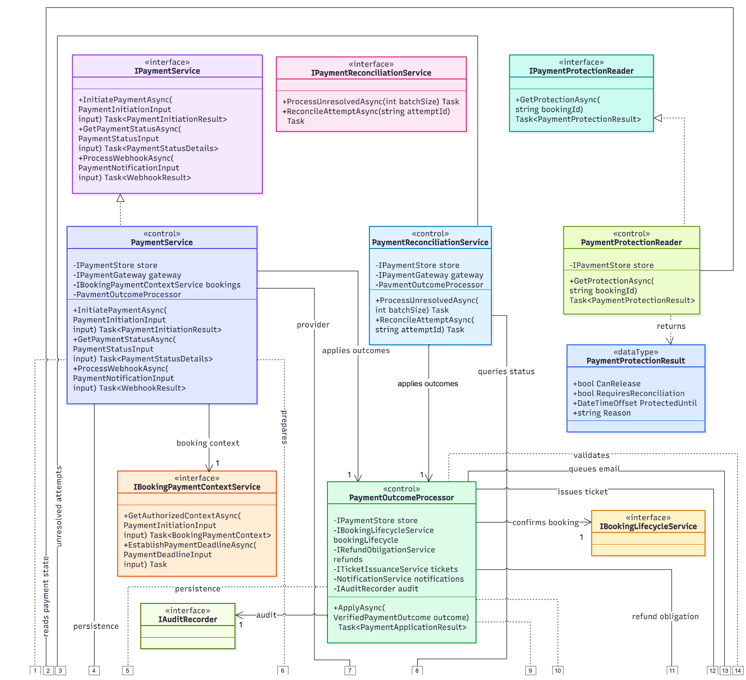
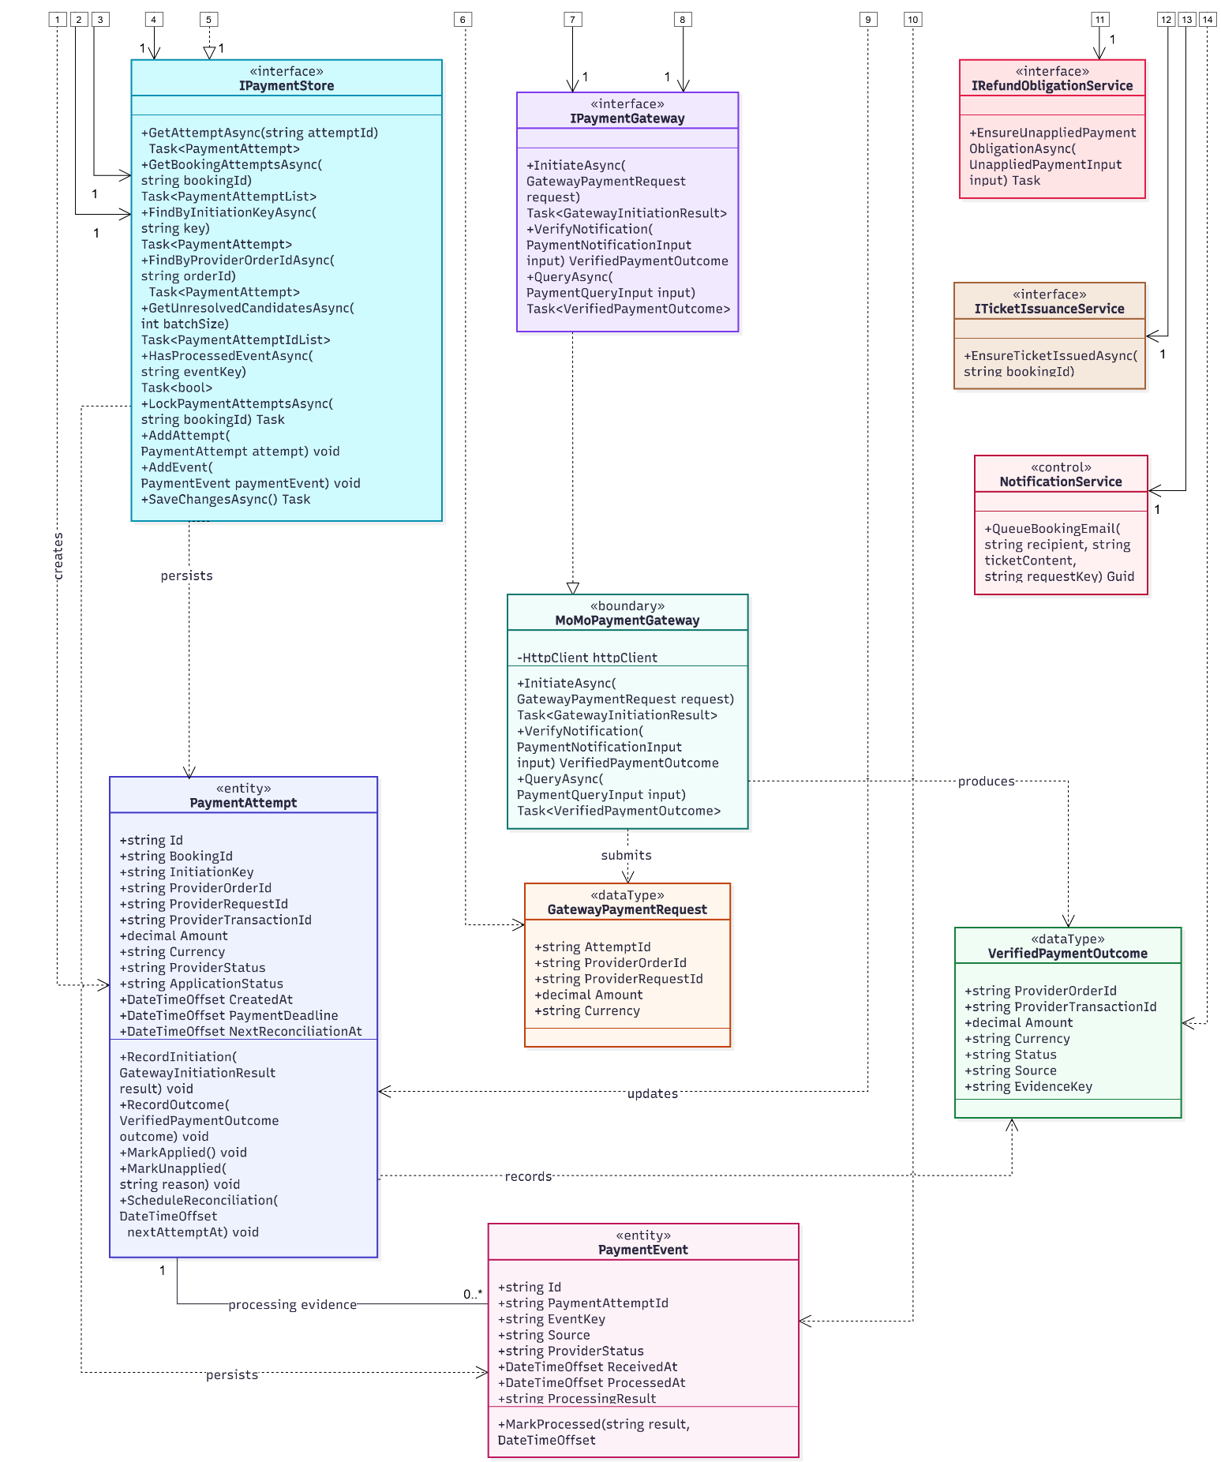
Figure 9: C09 Payment Processing Class Diagram.
Provider transaction identifiers, payment deadlines, reconciliation times, and event processing timestamps are optional until the corresponding information exists.
ProtectedUntil is not unconditional permission to release seats after that timestamp. CanRelease remains false when unresolved payment conditions require continued protection.
LockPaymentContextAsync(...) follows the shared Showtime → Booking → Payment Attempt order. It does not authorise acquiring those locks in a different sequence.

Key Class Descriptions
Class or Interface | Responsibility | Key Attributes | Key Operations
IPaymentService; PaymentService | Define and coordinate initiation, status retrieval, and webhook processing. | Persistence, gateway, outcome processor, booking context, and authorisation references. | Initiates payment, retrieves permitted status, and processes notifications.
IPaymentReconciliationService; PaymentReconciliationService | Define and execute reconciliation of unresolved attempts. | Persistence, gateway, and shared outcome-processor references. | Selects due attempts, queries the provider, and submits verified results for application.
IPaymentProtectionReader; PaymentProtectionReader | Supply current release-safety information without external calls or booking transitions. | Persistence reference. | Evaluates relevant attempts and returns a protection decision.
PaymentOutcomeProcessor | Applies verified outcomes consistently across webhook and reconciliation paths. | Persistence, booking, ticketing, refund, notification, and audit references. | ApplyAsync(...) coordinates idempotent outcome application.
IPaymentGateway | Defines provider-independent initiation, notification verification, and status-query operations. | No instance attributes. | Creates payments, verifies notifications, and queries outcomes.
MoMoPaymentGateway | Implements the MoMo integration boundary. | HTTP client and protected provider configuration. | Builds provider requests, verifies responses and notifications, and returns normalised results.
PaymentAttempt | Represents one initiated or attempted external payment associated with a booking. | Internal and provider identifiers, accepted amount, currency, initiation state, provider state, application state, deadlines, and reconciliation timing. | Records initiation, verified outcomes, application, unapplied success, and reconciliation scheduling.
PaymentEvent | Records identifiable provider observations and their processing results. | Attempt reference, deduplication key, source, result code, processing outcome, and timestamps. | Records the completed processing outcome.
VerifiedPaymentOutcome | Carries provider evidence after verification by the adapter. | Correlation references, amount, currency, provider status, result code, source, and verification time. | No business operations.
PaymentProtectionResult | Describes whether booking release is currently safe. | Release decision, reconciliation requirement, applicable protection time, and reason. | No business operations.
IPaymentStore | Defines payment persistence and concurrency operations supplied by C13. | No instance attributes. | Retrieves attempts and events, finds idempotent results, obtains locks, and persists changes.
IBookingPaymentContextService | Supplies current booking access, accepted amount, initiation eligibility, and deadline coordination from C08. | Defined in C08. | Provides the booking-owned operations needed during initiation.
IBookingLifecycleService | Applies the booking and allocation portion of an eligible verified outcome. | Defined in C08. | Confirms the booking within the shared transaction.
ITicketIssuanceService | Supplies idempotent ticket issuance from C11. | Defined in C11. | Creates or returns the booking-level ticket and QR.
IRefundObligationService | Supplies refund-obligation recording from C10. | Defined in C10. | Records the appropriate obligation or review for unapplied successful payments.
NotificationService; IAuditRecorder | Supply transactional notification queueing and required audit recording. | Defined in C15 and C16. | Queue the initial confirmation email and record relevant actions.

Class Relationships
Source | Target | Relationship | Meaning
PaymentService | IPaymentService | Realization | Implements initiation, status retrieval, and webhook processing.
PaymentReconciliationService | IPaymentReconciliationService | Realization | Implements unresolved-payment recovery.
PaymentProtectionReader | IPaymentProtectionReader | Realization | Implements the payment-protection query contract.
MoMoPaymentGateway | IPaymentGateway | Realization | Implements the external payment-provider adapter.
PaymentService | Persistence, gateway, outcome-processing, booking-context, and authorisation services | Association | Retains collaborators used for payment operations.
PaymentReconciliationService | IPaymentStore; IPaymentGateway; PaymentOutcomeProcessor | Association | Combines stored attempt information, provider queries, and shared outcome application.
PaymentProtectionReader | IPaymentStore | Association | Reads current attempt information for release decisions.
PaymentOutcomeProcessor | Persistence, booking, ticketing, refund, notification, and audit contracts | Association | Coordinates the required business effects of verified outcomes.
PaymentAttempt | PaymentEvent | Association | One payment attempt may have multiple recorded observations; each event references one identified attempt.
PaymentService | PaymentAttempt | Dependency | Creates or retrieves the attempt used for initiation.
PaymentReconciliationService | PaymentAttempt | Dependency | Processes unresolved attempts and schedules further reconciliation.
PaymentOutcomeProcessor | PaymentAttempt; PaymentEvent; VerifiedPaymentOutcome | Dependency | Validates evidence, records its processing, and updates the attempt.
MoMoPaymentGateway | VerifiedPaymentOutcome | Dependency | Creates normalised evidence after verification.
PaymentProtectionReader | PaymentProtectionResult | Dependency | Produces the payment-safety decision.
IPaymentStore | PaymentAttempt; PaymentEvent | Dependency | Retrieves and persists payment entities.

Data Ownership and Consistency
C09 owns payment attempts, provider correlation identifiers, verified payment observations, and their application outcomes.
The following rules apply:
- Payment amounts originate from the accepted booking snapshot rather than frontend input or current ticket prices.
- Initiation keys and provider request references identify attempts consistently across retries.
- A repeated compatible initiation request does not create another external payment attempt.
- Incompatible reuse of an initiation key is rejected.
- The system does not create another attempt while an earlier attempt remains protected or unresolved unless the applicable payment rules explicitly permit it.
- An initiation timeout is an uncertain outcome, not proof that the provider rejected the request.
- Successful initiation establishes the ten-minute payment deadline under the agreed timing rules.
- The configured grace period supports verification and reconciliation; it does not automatically make unresolved seats releasable.
- Notification authenticity, provider references, amount, currency, and transaction identity are validated before applying an outcome.
- Webhook and reconciliation paths use the same outcome processor.
- Provider success and successful application to a booking are recorded separately.
- Duplicate observations do not duplicate payment application, booking confirmation, ticket issuance, or initial notification requests.
- An older or repeated non-success observation does not silently reverse an already applied successful payment.
- Conflicting verified observations require controlled reconciliation or review.
- Eligible success is applied atomically with booking confirmation, allocation conversion, ticket issuance, and initial email queueing.
- A verified successful payment that cannot be applied is preserved and routed to the applicable refund or review workflow.
- Multiple successful payments for the same booking do not create additional ticket entitlements.
- Unresolved outcomes retain the protection required by the payment-safety rules.
- Reconciliation calls

Component C09 Payment Processing

Purpose and Responsibilities
Payment Processing manages payment attempts, integration with MoMo, verification of payment notifications, reconciliation of unresolved outcomes, and coordinated application of verified payment results.
The component is responsible for:
- Initiating eligible payment attempts using the accepted booking amount.
- Communicating with MoMo through a provider adapter.
- Verifying notification authenticity and matching provider results to the corresponding payment attempt.
- Recording payment events and processing outcomes.
- Applying verified outcomes idempotently.
- Coordinating successful payment application with booking confirmation, ticket issuance, and notification queueing.
- Reconciling unresolved payment attempts through authoritative provider queries.
- Supplying payment-protection information for pending cancellation and booking expiration.
- Recording unapplied successful payments and requesting the appropriate refund obligation or review through C10.
C09 owns payment attempts, provider references, payment events, and payment-verification outcomes. C08 owns bookings and seat allocations. C10 owns refund obligations and refund completion. C11 owns tickets and admission entitlements.
A browser return from the payment gateway is not authoritative evidence of payment success. Booking confirmation requires a verified and eligible outcome obtained through payment notification or reconciliation.

Use-Case Traceability
Use Case | Contribution of C09
UC-09 Checkout and Payment | Initiates an eligible payment attempt using the accepted booking amount and returns permitted gateway-navigation information.
UC-02 Payment Webhook | Verifies incoming notifications, records processing evidence, and applies eligible outcomes idempotently.
UC-04 Payment Reconciliation | Queries authoritative provider status for unresolved attempts and applies verified outcomes through the shared processing protocol.
UC-03 Release Expired Bookings | Supplies payment protection, deadline, and unresolved-outcome information used to determine whether seat release is safe.
UC-10 Customer Booking Lifecycle | Supplies permitted payment status and prevents pending cancellation when payment-safety conditions prohibit it.
UC-04A Refund | Supplies verified payment evidence and requests refund handling when a successful payment cannot be applied.
UC-01 Reserve Seats | Uses the accepted booking and price snapshot created by reservation; it does not recalculate the payable amount.
UC-19 Manage Bookings and Tickets | Supplies scoped payment information and processing outcomes for permitted operational assistance.

Implementation Language and Technologies
The component is implemented in C# within the ASP.NET Core backend.
It uses:
- Application services for payment initiation, reconciliation, and outcome application.
- A provider adapter implemented with HttpClient.
- HTTPS and provider-defined request, response, and signature formats.
- Cryptographic verification according to the configured MoMo integration contract.
- Persistence contracts implemented by C13 using EF Core and PostgreSQL.
- Coordinated transactions, record locking, and uniqueness constraints.
- C14 background execution for reconciliation.
- C16 Audit Logging for required payment-processing records.
Payment-provider credentials, signature secrets, endpoints, request timeouts, and retry settings are supplied through protected backend configuration.
External initiation and status-query calls occur outside database transactions holding business locks. Their results are revalidated before application.

Provided Interfaces and Services
Interface or Operation | Responsibility
IPaymentService.InitiatePaymentAsync(...) | Initiates an eligible payment attempt or returns the existing compatible initiation result according to the retry rules.
IPaymentService.GetPaymentStatusAsync(...) | Returns payment information permitted for the requesting customer, authorised guest, or operational user.
IPaymentService.ProcessWebhookAsync(...) | Verifies a provider notification and submits its outcome to the shared application protocol.
IPaymentReconciliationService.ProcessUnresolvedAsync(...) | Processes a bounded batch of unresolved payment attempts.
IPaymentReconciliationService.ReconcileAttemptAsync(...) | Queries and resolves one eligible payment attempt.
IPaymentProtectionReader.GetProtectionAsync(...) | Reports current payment protection for booking cancellation or expiration.
PaymentOutcomeProcessor.ApplyAsync(...) | Applies a verified outcome under transaction, eligibility, and idempotency controls.
IPaymentGateway.InitiateAsync(...) | Submits a payment-initiation request to the configured provider.
IPaymentGateway.VerifyNotification(...) | Validates notification authenticity and extracts provider outcome information.
IPaymentGateway.QueryAsync(...) | Retrieves authoritative provider status for a known payment attempt.
IPaymentGateway is an internal provider-integration contract. Its implementation does not directly confirm bookings or issue tickets.
IPaymentProtectionReader reads current payment information without making external network calls or recursively initiating booking transitions.

Dependencies and Communication
Calling Component | Receiving Component | Interface or Operation | Purpose | Communication
C02 Backend API | C09 Payment Processing | IPaymentService | Receive payment initiation, permitted status queries, and gateway notifications. | In-process C# interface calls.
C08 Booking and Checkout | C09 Payment Processing | IPaymentService.InitiatePaymentAsync(...) | Initiate payment after checkout-context validation. | In-process C# interface call.
C08 Booking and Checkout | C09 Payment Processing | IPaymentProtectionReader | Determine whether pending cancellation or expiration is safe. | In-process C# interface call within the applicable consistency protocol.
C14 Background Processing | C09 Payment Processing | IPaymentReconciliationService | Trigger reconciliation independently of browser activity. | In-process C# interface calls.
C09 Payment Processing | C03 Identity and Access | IAccessAuthorizationService | Check current account and operational permissions where required. | In-process C# interface calls.
C09 Payment Processing | C08 Booking and Checkout | Booking-access and payment-context contracts | Validate access and obtain authoritative booking amount, deadlines, and eligibility. | In-process C# calls.
C09 Payment Processing | C08 Booking and Checkout | IBookingLifecycleService.ConfirmVerifiedPaymentAsync(...) | Confirm the booking and convert held allocations to sold allocations. | In-process C# call within the coordinated payment-application transaction.
C09 Payment Processing | C10 Cancellation and Refund | IRefundObligationService | Record an obligation arising from a verified successful payment that cannot be applied. | In-process C# call within the coordinated transaction.
C09 Payment Processing | C11 Ticketing and Admission | ITicketIssuanceService | Issue the existing booking’s ticket and QR idempotently after eligible payment verification. | In-process C# call within the coordinated transaction.
C09 Payment Processing | C15 Notification Delivery | NotificationService.QueueBookingEmail(...) | Queue the initial booking-confirmation email using the issued ticket information. | In-process C# method call within the coordinated transaction.
C09 Payment Processing | C13 Persistence and Transactions | IPaymentStore | Persist attempts and events and provide payment-processing concurrency protection. | In-process persistence contracts.
C09 Payment Processing | C16 Audit Logging | IAuditRecorder | Record required payment-processing actions and evidence references. | In-process C# interface calls.
C09 Payment Processing | MoMo | MoMoPaymentGateway | Initiate payment and query provider status. | HTTPS using the provider-defined API contract.
MoMo | C02 Backend API | Payment webhook endpoint | Deliver notifications subsequently forwarded to C09. | HTTPS using the provider-defined notification contract.
Payment initiation may enter through C02 or the checkout coordinator, but both paths invoke the same C09 operation and eligibility checks.

Class Diagram
The class diagram presents payment initiation, provider integration, reconciliation, payment-protection queries, and the shared outcome processor in one view.
PaymentService coordinates initiation and webhook reception. PaymentReconciliationService obtains authoritative status for unresolved attempts. Both submit verified outcomes to PaymentOutcomeProcessor, ensuring that webhook processing and reconciliation use the same business-transition rules.
PaymentAttempt records the lifecycle of one payment attempt. PaymentEvent records received or queried outcome evidence and its application result. A successful provider outcome is distinguished from whether that payment was applied to a booking.
The «dataType» stereotype identifies provider request or result data. Interfaces owned by other components are shown without repeating their complete definitions.
#chatgpt-mermaid-_r_fr6_{font-family:-apple-system-body,ui-sans-serif,-apple-system,system-ui,"Segoe UI",Helvetica,"Apple Color Emoji",Arial,sans-serif,"Segoe UI Emoji","Segoe UI Symbol";font-size:16px;fill:rgb(13, 13, 13);}@keyframes edge-animation-frame{from{stroke-dashoffset:0;}}@keyframes dash{to{stroke-dashoffset:0;}}#chatgpt-mermaid-_r_fr6_ .edge-animation-slow{stroke-dasharray:9,5!important;stroke-dashoffset:900;animation:dash 50s linear infinite;stroke-linecap:round;}#chatgpt-mermaid-_r_fr6_ .edge-animation-fast{stroke-dasharray:9,5!important;stroke-dashoffset:900;animation:dash 20s linear infinite;stroke-linecap:round;}#chatgpt-mermaid-_r_fr6_ .error-icon{fill:rgb(243, 243, 243);}#chatgpt-mermaid-_r_fr6_ .error-text{fill:rgb(13, 13, 13);stroke:rgb(13, 13, 13);}#chatgpt-mermaid-_r_fr6_ .edge-thickness-normal{stroke-width:1px;}#chatgpt-mermaid-_r_fr6_ .edge-thickness-thick{stroke-width:3.5px;}#chatgpt-mermaid-_r_fr6_ .edge-pattern-solid{stroke-dasharray:0;}#chatgpt-mermaid-_r_fr6_ .edge-thickness-invisible{stroke-width:0;fill:none;}#chatgpt-mermaid-_r_fr6_ .edge-pattern-dashed{stroke-dasharray:3;}#chatgpt-mermaid-_r_fr6_ .edge-pattern-dotted{stroke-dasharray:2;}#chatgpt-mermaid-_r_fr6_ .marker{fill:rgb(143, 143, 143);stroke:rgb(143, 143, 143);}#chatgpt-mermaid-_r_fr6_ .marker.cross{stroke:rgb(143, 143, 143);}#chatgpt-mermaid-_r_fr6_ svg{font-family:-apple-system-body,ui-sans-serif,-apple-system,system-ui,"Segoe UI",Helvetica,"Apple Color Emoji",Arial,sans-serif,"Segoe UI Emoji","Segoe UI Symbol";font-size:16px;}#chatgpt-mermaid-_r_fr6_ p{margin:0;}#chatgpt-mermaid-_r_fr6_ g.classGroup text{fill:rgb(83, 154, 248);stroke:none;font-family:-apple-system-body,ui-sans-serif,-apple-system,system-ui,"Segoe UI",Helvetica,"Apple Color Emoji",Arial,sans-serif,"Segoe UI Emoji","Segoe UI Symbol";font-size:10px;}#chatgpt-mermaid-_r_fr6_ g.classGroup text .title{font-weight:bolder;}#chatgpt-mermaid-_r_fr6_ .cluster-label text{fill:rgb(13, 13, 13);}#chatgpt-mermaid-_r_fr6_ .cluster-label span{color:rgb(13, 13, 13);}#chatgpt-mermaid-_r_fr6_ .cluster-label span p{background-color:transparent;}#chatgpt-mermaid-_r_fr6_ .cluster rect{fill:rgb(243, 243, 243);stroke:rgba(0, 0, 0, 0.1);stroke-width:1px;}#chatgpt-mermaid-_r_fr6_ .cluster text{fill:rgb(13, 13, 13);}#chatgpt-mermaid-_r_fr6_ .cluster span{color:rgb(13, 13, 13);}#chatgpt-mermaid-_r_fr6_ .nodeLabel,#chatgpt-mermaid-_r_fr6_ .edgeLabel{color:rgb(13, 13, 13);}#chatgpt-mermaid-_r_fr6_ .noteLabel .nodeLabel,#chatgpt-mermaid-_r_fr6_ .noteLabel .edgeLabel{color:rgb(13, 13, 13);}#chatgpt-mermaid-_r_fr6_ .edgeLabel .label rect{fill:rgb(222, 234, 251);}#chatgpt-mermaid-_r_fr6_ .label text{fill:rgb(13, 13, 13);}#chatgpt-mermaid-_r_fr6_ .labelBkg{background:rgb(222, 234, 251);}#chatgpt-mermaid-_r_fr6_ .edgeLabel .label span{background:rgb(222, 234, 251);}#chatgpt-mermaid-_r_fr6_ .classTitle{font-weight:bolder;}#chatgpt-mermaid-_r_fr6_ .node rect,#chatgpt-mermaid-_r_fr6_ .node circle,#chatgpt-mermaid-_r_fr6_ .node ellipse,#chatgpt-mermaid-_r_fr6_ .node polygon,#chatgpt-mermaid-_r_fr6_ .node path{fill:rgb(222, 234, 251);stroke:rgb(83, 154, 248);stroke-width:1;}#chatgpt-mermaid-_r_fr6_ .divider{stroke:rgb(83, 154, 248);stroke-width:1;}#chatgpt-mermaid-_r_fr6_ g.clickable{cursor:pointer;}#chatgpt-mermaid-_r_fr6_ g.classGroup rect{fill:rgb(222, 234, 251);stroke:rgb(83, 154, 248);}#chatgpt-mermaid-_r_fr6_ g.classGroup line{stroke:rgb(83, 154, 248);stroke-width:1;}#chatgpt-mermaid-_r_fr6_ .classLabel .box{stroke:none;stroke-width:0;fill:rgb(222, 234, 251);opacity:0.5;}#chatgpt-mermaid-_r_fr6_ .classLabel .label{fill:rgb(83, 154, 248);font-size:10px;}#chatgpt-mermaid-_r_fr6_ .relation{stroke:rgb(143, 143, 143);stroke-width:1;fill:none;}#chatgpt-mermaid-_r_fr6_ .dashed-line{stroke-dasharray:3;}#chatgpt-mermaid-_r_fr6_ .dotted-line{stroke-dasharray:1 2;}#chatgpt-mermaid-_r_fr6_ [id$="-compositionStart"],#chatgpt-mermaid-_r_fr6_ .composition{fill:rgb(143, 143, 143)!important;stroke:rgb(143, 143, 143)!important;stroke-width:1;}#chatgpt-mermaid-_r_fr6_ [id$="-compositionEnd"],#chatgpt-mermaid-_r_fr6_ .composition{fill:rgb(143, 143, 143)!important;stroke:rgb(143, 143, 143)!important;stroke-width:1;}#chatgpt-mermaid-_r_fr6_ [id$="-dependencyStart"],#chatgpt-mermaid-_r_fr6_ .dependency{fill:rgb(143, 143, 143)!important;stroke:rgb(143, 143, 143)!important;stroke-width:1;}#chatgpt-mermaid-_r_fr6_ [id$="-dependencyEnd"],#chatgpt-mermaid-_r_fr6_ .dependency{fill:rgb(143, 143, 143)!important;stroke:rgb(143, 143, 143)!important;stroke-width:1;}#chatgpt-mermaid-_r_fr6_ [id$="-extensionStart"],#chatgpt-mermaid-_r_fr6_ .extension{fill:transparent!important;stroke:rgb(143, 143, 143)!important;stroke-width:1;}#chatgpt-mermaid-_r_fr6_ [id$="-extensionEnd"],#chatgpt-mermaid-_r_fr6_ .extension{fill:transparent!important;stroke:rgb(143, 143, 143)!important;stroke-width:1;}#chatgpt-mermaid-_r_fr6_ [id$="-aggregationStart"],#chatgpt-mermaid-_r_fr6_ .aggregation{fill:transparent!important;stroke:rgb(143, 143, 143)!important;stroke-width:1;}#chatgpt-mermaid-_r_fr6_ [id$="-aggregationEnd"],#chatgpt-mermaid-_r_fr6_ .aggregation{fill:transparent!important;stroke:rgb(143, 143, 143)!important;stroke-width:1;}#chatgpt-mermaid-_r_fr6_ [id$="-lollipopStart"],#chatgpt-mermaid-_r_fr6_ .lollipop{fill:rgb(222, 234, 251)!important;stroke:rgb(143, 143, 143)!important;stroke-width:1;}#chatgpt-mermaid-_r_fr6_ [id$="-lollipopEnd"],#chatgpt-mermaid-_r_fr6_ .lollipop{fill:rgb(222, 234, 251)!important;stroke:rgb(143, 143, 143)!important;stroke-width:1;}#chatgpt-mermaid-_r_fr6_ .edgeTerminals{font-size:11px;line-height:initial;}#chatgpt-mermaid-_r_fr6_ .classTitleText{text-anchor:middle;font-size:18px;fill:rgb(13, 13, 13);}#chatgpt-mermaid-_r_fr6_ .edgeLabel[data-look="neo"]{background-color:rgb(252, 252, 252);text-align:center;}#chatgpt-mermaid-_r_fr6_ .edgeLabel[data-look="neo"] p{background-color:rgb(252, 252, 252);}#chatgpt-mermaid-_r_fr6_ .edgeLabel[data-look="neo"] rect{opacity:0.5;background-color:rgb(252, 252, 252);fill:rgb(252, 252, 252);}#chatgpt-mermaid-_r_fr6_ .label-icon{display:inline-block;height:1em;overflow:visible;vertical-align:-0.125em;}#chatgpt-mermaid-_r_fr6_ .node .label-icon path{fill:currentColor;stroke:revert;stroke-width:revert;}#chatgpt-mermaid-_r_fr6_ .node .neo-node{stroke:rgb(83, 154, 248);}#chatgpt-mermaid-_r_fr6_ [data-look="neo"].node rect,#chatgpt-mermaid-_r_fr6_ [data-look="neo"].cluster rect,#chatgpt-mermaid-_r_fr6_ [data-look="neo"].node polygon{stroke:url(#chatgpt-mermaid-_r_fr6_-gradient);filter:drop-shadow( 1px 2px 2px rgba(185,185,185,1));}#chatgpt-mermaid-_r_fr6_ [data-look="neo"].swimlane.cluster rect{filter:none;}#chatgpt-mermaid-_r_fr6_ [data-look="neo"].node path{stroke:url(#chatgpt-mermaid-_r_fr6_-gradient);stroke-width:1px;}#chatgpt-mermaid-_r_fr6_ [data-look="neo"].node .outer-path{filter:drop-shadow( 1px 2px 2px rgba(185,185,185,1));}#chatgpt-mermaid-_r_fr6_ [data-look="neo"].node .neo-line path{stroke:rgb(83, 154, 248);filter:none;}#chatgpt-mermaid-_r_fr6_ [data-look="neo"].node circle{stroke:url(#chatgpt-mermaid-_r_fr6_-gradient);filter:drop-shadow( 1px 2px 2px rgba(185,185,185,1));}#chatgpt-mermaid-_r_fr6_ [data-look="neo"].node circle .state-start{fill:#000000;}#chatgpt-mermaid-_r_fr6_ [data-look="neo"].icon-shape .icon{fill:url(#chatgpt-mermaid-_r_fr6_-gradient);filter:drop-shadow( 1px 2px 2px rgba(185,185,185,1));}#chatgpt-mermaid-_r_fr6_ [data-look="neo"].icon-shape .icon-neo path{stroke:url(#chatgpt-mermaid-_r_fr6_-gradient);filter:drop-shadow( 1px 2px 2px rgba(185,185,185,1));}#chatgpt-mermaid-_r_fr6_ :root{--mermaid-font-family:-apple-system-body,ui-sans-serif,-apple-system,system-ui,"Segoe UI",Helvetica,"Apple Color Emoji",Arial,sans-serif,"Segoe UI Emoji","Segoe UI Symbol";}«interface»IPaymentService+InitiatePaymentAsync(PaymentInitiationInput input) : Task<PaymentInitiationResult>+GetPaymentStatusAsync(PaymentStatusInput input) : Task<PaymentStatusDetails>+ProcessWebhookAsync(PaymentNotificationInput input) : Task<WebhookResult>«control»PaymentService-IPaymentStore store-IPaymentGateway gateway-IBookingPaymentContextService bookings-PaymentOutcomeProcessor outcomeProcessor+InitiatePaymentAsync(PaymentInitiationInput input) : Task<PaymentInitiationResult>+GetPaymentStatusAsync(PaymentStatusInput input) : Task<PaymentStatusDetails>+ProcessWebhookAsync(PaymentNotificationInput input) : Task<WebhookResult>«interface»IPaymentReconciliationService+ProcessUnresolvedAsync(int batchSize) : Task+ReconcileAttemptAsync(string attemptId) : Task«control»PaymentReconciliationService-IPaymentStore store-IPaymentGateway gateway-PaymentOutcomeProcessor outcomeProcessor+ProcessUnresolvedAsync(int batchSize) : Task+ReconcileAttemptAsync(string attemptId) : Task«interface»IPaymentProtectionReader+GetProtectionAsync(string bookingId) : Task<PaymentProtectionResult>«control»PaymentProtectionReader-IPaymentStore store+GetProtectionAsync(string bookingId) : Task<PaymentProtectionResult>«control»PaymentOutcomeProcessor-IPaymentStore store-IBookingLifecycleService bookingLifecycle-IRefundObligationService refunds-ITicketIssuanceService tickets-NotificationService notifications-IAuditRecorder audit+ApplyAsync(VerifiedPaymentOutcome outcome) : Task<PaymentApplicationResult>«interface»IPaymentGateway+InitiateAsync(GatewayPaymentRequest request) : Task<GatewayInitiationResult>+VerifyNotification(PaymentNotificationInput input) : VerifiedPaymentOutcome+QueryAsync(PaymentQueryInput input) : Task<VerifiedPaymentOutcome>«boundary»MoMoPaymentGateway-HttpClient httpClient+InitiateAsync(GatewayPaymentRequest request) : Task<GatewayInitiationResult>+VerifyNotification(PaymentNotificationInput input) : VerifiedPaymentOutcome+QueryAsync(PaymentQueryInput input) : Task<VerifiedPaymentOutcome>«entity»PaymentAttempt+string Id+string BookingId+string InitiationKey+string ProviderOrderId+string ProviderRequestId+string ProviderTransactionId+decimal Amount+string Currency+string ProviderStatus+string ApplicationStatus+DateTimeOffset CreatedAt+DateTimeOffset PaymentDeadline+DateTimeOffset NextReconciliationAt+RecordInitiation(GatewayInitiationResult result) : void+RecordOutcome(VerifiedPaymentOutcome outcome) : void+MarkApplied() : void+MarkUnapplied(string reason) : void+ScheduleReconciliation(DateTimeOffset nextAttemptAt) : void«entity»PaymentEvent+string Id+string PaymentAttemptId+string EventKey+string Source+string ProviderStatus+DateTimeOffset ReceivedAt+DateTimeOffset ProcessedAt+string ProcessingResult+MarkProcessed(string result, DateTimeOffset processedAt) : void«dataType»GatewayPaymentRequest+string AttemptId+string ProviderOrderId+string ProviderRequestId+decimal Amount+string Currency«dataType»VerifiedPaymentOutcome+string ProviderOrderId+string ProviderTransactionId+decimal Amount+string Currency+string Status+string Source+string EvidenceKey«dataType»PaymentProtectionResult+bool CanRelease+bool RequiresReconciliation+DateTimeOffset ProtectedUntil+string Reason«interface»IPaymentStore+GetAttemptAsync(string attemptId) : Task<PaymentAttempt>+GetBookingAttemptsAsync(string bookingId) : Task<PaymentAttemptList>+FindByInitiationKeyAsync(string key) : Task<PaymentAttempt>+FindByProviderOrderIdAsync(string orderId) : Task<PaymentAttempt>+GetUnresolvedCandidatesAsync(int batchSize) : Task<PaymentAttemptIdList>+HasProcessedEventAsync(string eventKey) : Task<bool>+LockPaymentAttemptsAsync(string bookingId) : Task+AddAttempt(PaymentAttempt attempt) : void+AddEvent(PaymentEvent paymentEvent) : void+SaveChangesAsync() : Task«interface»IBookingPaymentContextService+GetAuthorizedContextAsync(PaymentInitiationInput input) : Task<BookingPaymentContext>+EstablishPaymentDeadlineAsync(PaymentDeadlineInput input) : Task«interface»IBookingLifecycleService«interface»IRefundObligationService+EnsureUnappliedPaymentObligationAsync(UnappliedPaymentInput input) : Task«interface»ITicketIssuanceService+EnsureTicketIssuedAsync(string bookingId) : Task<TicketDeliveryInfo>«control»NotificationService+QueueBookingEmail(string recipient, string ticketContent, string requestKey) : Guid«interface»IAuditRecorderpersistenceproviderbooking contextapplies outcomesunresolved attemptsqueries statusapplies outcomesreads payment statepersistenceconfirms bookingrefund obligationissues ticketqueues emailauditprocessing evidencecreatespreparesupdatesrecordsvalidatessubmitsproducesreturnsrecordspersistspersists1111111111111110..*
Figure: C09 Payment Processing Class Diagram.
Provider transaction identifiers, payment deadlines, reconciliation times, and processing timestamps are optional until the corresponding lifecycle event occurs.
VerifiedPaymentOutcome indicates that provider-level verification has completed. The outcome processor still validates its relationship to the stored attempt, including amount, currency, identifiers, and application eligibility.
ProtectedUntil does not authorise release by itself. An unresolved outcome may require protection beyond a previously calculated deadline.

Key Class Descriptions
Class or Interface | Responsibility | Key Attributes | Key Operations
IPaymentService | Defines payment initiation, permitted status retrieval, and webhook processing. | No instance attributes. | Initiates payment, retrieves status, and processes notifications.
PaymentService | Coordinates initiation and notification reception. | Persistence, provider, booking-context, and outcome-processor references. | Implements the payment application contract.
IPaymentReconciliationService; PaymentReconciliationService | Define and implement recovery of unresolved attempts. | Persistence, provider, and outcome-processor references. | Select due attempts, query provider status, and apply verified results.
IPaymentProtectionReader; PaymentProtectionReader | Define and implement payment-protection queries for C08. | Persistence reference. | Returns release eligibility, reconciliation requirements, and protection reasons.
PaymentOutcomeProcessor | Applies verified outcomes through one consistent transaction protocol. | References to payment persistence, booking lifecycle, refunds, ticket issuance, notification queueing, and audit recording. | Validates and applies an outcome idempotently.
IPaymentGateway | Defines provider-independent initiation, notification verification, and status queries. | No instance attributes. | Initiates provider payment, verifies notifications, and queries status.
MoMoPaymentGateway | Implements the MoMo integration boundary. | HTTP client and externally supplied provider configuration. | Converts requests, verifies signatures, communicates with MoMo, and maps provider outcomes.
PaymentAttempt | Represents one payment attempt and distinguishes provider outcome from business application. | Booking, idempotency key, provider identifiers, amount, currency, provider status, application status, and relevant timestamps. | Records initiation and outcomes, marks application, and schedules reconciliation.
PaymentEvent | Records verified notification or reconciliation evidence and its processing result. | Attempt identifier, event key, source, provider status, receipt time, processing time, and result. | Marks processing completion.
GatewayPaymentRequest | Carries the provider-initiation data derived from the accepted booking. | Attempt and provider identifiers, amount, and currency. | No business operations.
VerifiedPaymentOutcome | Carries a provider-verified outcome for business validation. | Provider identifiers, amount, currency, status, source, and evidence key. | No independent state-changing operations.
PaymentProtectionResult | Reports whether payment conditions permit release or require continued protection. | Release eligibility, reconciliation requirement, protection time, and reason. | No business operations.
IPaymentStore | Defines payment persistence and concurrency operations supplied by C13. | No instance attributes. | Retrieves attempts and events, protects concurrent processing, and persists changes.
IBookingPaymentContextService | Supplies authorised booking information and coordinated deadline updates from C08. | Defined in C08. | Retrieves the accepted payable context and establishes the payment deadline.
IRefundObligationService | Supplies idempotent recording of unapplied-payment obligations through C10. | Defined in C10. | Ensures the required obligation exists without duplication.
ITicketIssuanceService | Supplies idempotent booking-level ticket issuance through C11. | Defined in C11. | Returns the existing or newly issued ticket information.
NotificationService; IAuditRecorder | Supply email queueing and required audit recording. | Defined in C15 and C16. | Participate in the coordinated business transaction without external email submission.

Class Relationships
Source | Target | Relationship | Meaning
PaymentService | IPaymentService | Realization | Implements payment application operations.
PaymentReconciliationService | IPaymentReconciliationService | Realization | Implements unresolved-payment recovery.
PaymentProtectionReader | IPaymentProtectionReader | Realization | Implements payment-protection queries.
MoMoPaymentGateway | IPaymentGateway | Realization | Implements provider communication and verification.
PaymentService | IPaymentStore; IPaymentGateway; IBookingPaymentContextService; PaymentOutcomeProcessor | Association | Retains collaborators for initiation, access validation, and outcome application.
PaymentReconciliationService | IPaymentStore; IPaymentGateway; PaymentOutcomeProcessor | Association | Retrieves unresolved attempts and applies authoritative query results.
PaymentProtectionReader | IPaymentStore | Association | Reads current payment state without external network activity.
PaymentOutcomeProcessor | Booking, refund, ticket, notification, persistence, and audit contracts | Association | Coordinates the required business effects of a verified outcome.
PaymentAttempt | PaymentEvent | Association | One attempt may have multiple evidence records from notifications and reconciliation.
PaymentService | PaymentAttempt; GatewayPaymentRequest | Dependency | Creates the local attempt and provider request.
PaymentOutcomeProcessor | PaymentAttempt; PaymentEvent; VerifiedPaymentOutcome | Dependency | Validates evidence and records application results.
MoMoPaymentGateway | GatewayPaymentRequest; VerifiedPaymentOutcome | Dependency | Submits provider input and produces verified outcome data.
PaymentProtectionReader | PaymentProtectionResult | Dependency | Creates the protection decision returned to C08.
PaymentAttempt | VerifiedPaymentOutcome | Dependency | Records verified provider information.
IPaymentStore | PaymentAttempt; PaymentEvent | Dependency | Retrieves and persists payment records.

Data Ownership and Consistency
C09 owns payment attempts, provider identifiers, verified payment events, reconciliation scheduling information, and payment-application outcomes.
The following rules apply:
- The payment amount comes from the accepted booking snapshot.
- Client-supplied amounts, payment statuses, and browser-return parameters are not authoritative.
- Initiation requests use stable identifiers to detect compatible retries.
- Reuse of an initiation key with incompatible input is rejected.
- A new attempt is not created while an existing attempt remains protected in a way that prohibits another attempt.
- Provider identifiers and applicable event keys are protected by uniqueness constraints.
- Notification authenticity is checked before its contents are used to change business state.
- Verified outcomes must match the stored attempt’s expected provider identifiers, amount, and currency.
- Webhook and reconciliation processing use the same outcome-application protocol.
- Event deduplication is supplemented by business-state checks; different events reporting the same success cannot apply payment twice.
- Provider success and booking application are recorded separately.
- Successful payment initiation establishes the ten-minute payment deadline according to the agreed timing rules.
- Retry, notification receipt, and status polling do not arbitrarily extend that deadline.
- Expiration considers the configured grace period and authoritative payment resolution.
- An unresolved outcome remains protected even after the nominal deadline and grace period have passed.
- External calls occur outside transactions holding business locks.
- After an external call, relevant records are reloaded and revalidated before applying its result.
- Shared processing preserves the required Showtime → Booking → Payment Attempt lock order.
- Eligible payment application, booking confirmation, allocation conversion, ticket issuance, and initial notification queueing commit atomically.
- Verified successful payments that cannot be applied create the required refund obligation or review outcome without issuing an invalid ticket.
- A later failure notification cannot silently reverse an already verified and applied success.
- Required audit records commit consistently with the payment changes they describe.
An initiation timeout represents an uncertain external outcome. It does not establish that the provider failed to create the payment or that the corresponding seats can safely be released.

Key Processing Flows and Failure Handling

Payment Initiation
- C02 or C08 submits a payment-initiation request.
- C09 validates booking access and obtains the accepted amount and current booking context from C08.
- The coordinating transaction acquires the required locks and checks booking eligibility, deadlines, and existing attempts.
- C09 returns an existing compatible result where permitted or records a new initiation attempt.
- The preparation transaction commits.
- MoMoPaymentGateway submits the request outside the lock-holding transaction.
- C09 starts a new transaction and reloads the booking and attempt in the required lock order.
- It revalidates the result against current state.
- Successful initiation records the provider references and establishes the payment deadline consistently with C08.
- The transaction commits and permitted payment-navigation information is returned.
An ambiguous initiation result is retained for recovery rather than treated as a definitive failure.

Payment Webhook Processing
- C02 forwards the provider notification and required verification data to C09.
- MoMoPaymentGateway verifies the notification.
- C09 identifies the corresponding local payment attempt.
- The outcome processor validates identifiers, amount, currency, and evidence consistency.
- It acquires the required locks and checks whether the outcome has already been processed or applied.
- For an eligible successful payment, C08 confirms the booking and converts allocations to sold.
- C11 ensures that the booking-level ticket exists.
- C15 queues the initial booking-confirmation email using a stable request key.
- C09 records the payment event, application result, and required audit information.
- The coordinated transaction commits.
- C02 returns the provider-required acknowledgement.
Email delivery occurs after commit and does not determine whether payment confirmation succeeded.

Payment Reconciliation
- C14 invokes the reconciliation service.
- C09 selects attempts requiring authoritative status resolution.
- It reads the provider identifiers needed for the query.
- MoMoPaymentGateway queries MoMo outside the business-lock transaction.
- The returned outcome is passed to PaymentOutcomeProcessor.
- The processor reloads current state and applies the same validation and idempotency rules used for webhooks.
- A resolved outcome updates the attempt and the applicable business records.
- An unresolved or temporarily unavailable result retains the necessary protection and schedules a controlled retry.
Concurrent webhook processing may resolve the attempt before the query result is applied. Reconciliation rechecks current state and does not repeat completed effects.

Successful Payment That Cannot Be Applied
- C09 verifies that the provider reports a successful payment.
- The coordinated application check determines that booking confirmation is no longer eligible.
- C09 records the success as unapplied rather than marking the payment as failed.
- C10 records the required refund obligation or review state using the verified payment evidence.
- The evidence and obligation are committed consistently.
- The system does not issue a valid ticket or reclaim seats already allocated elsewhere.
An additional successful payment for an already confirmed booking does not create another ticket or admission entitlement.

Payment Protection for Cancellation and Expiration
- C08 requests payment-protection information while processing a pending cancellation or expiration.
- C09 examines the current attempts under the applicable consistency protocol.
- It considers initiation state, payment deadlines, grace-period conditions, verified outcomes, and unresolved processing.
- The reader returns whether release is permitted or further reconciliation is required.
- C08 applies its own booking transition only when the combined business conditions permit it.
The reader does not contact MoMo while C08 holds business locks.

Failure Handling and Recovery
- Invalid signatures and inconsistent provider identifiers are rejected without confirming a booking.
- Amount or currency mismatches are not silently accepted.
- Duplicate notifications return the appropriate result without repeating business effects.
- Out-of-order events are evaluated against current verified state.
- Network failures and provider timeouts preserve uncertainty where a payment may still exist.
- Unresolved attempts are retried through controlled reconciliation.
- A browser closure does not cancel an active payment attempt.
- A failed local commit after provider success is recovered through notification retry or reconciliation.
- Refund-obligation creation is idempotent and does not duplicate the same monetary obligation.
- Notification-delivery failures do not reverse committed payment application.
- Payment status is disclosed only within the caller’s authorised booking or operational scope.
- Ordinary logs exclude provider secrets, signature keys, and unnecessary sensitive payment payloads.

Component C10 Cancellation and Refund

Purpose and Responsibilities
Cancellation and Refund manages confirmed-booking cancellation requests, authorised cancellation review, refund obligations, and the recording of externally completed refunds.
The component is responsible for:
- Accepting cancellation requests for confirmed bookings affected by qualifying rescheduling.
- Checking request timing, purchased and current screening times, and admission history.
- Providing scoped cancellation-review operations.
- Recording approval, rejection, and automatic rejection following admission.
- Maintaining refund obligations arising from approved cancellations or unapplied successful payments.
- Recording authorised evidence of externally completed monetary refunds.
- Coordinating the required booking, allocation, and ticket effects after refund completion.
- Preserving consistent audit records for cancellation and refund processing.
C10 does not execute monetary refunds through MoMo. External monetary refund execution remains outside the current demonstration scope. An authorised operator records the completed refund and its supporting evidence.
C08 remains responsible for eligible pending-booking cancellation. C10 handles the separate confirmed-booking cancellation workflow and payment-related refund obligations.
A cancellation request pending review does not block admission. The first successful admission automatically rejects the pending request. Once cancellation is approved and awaiting refund completion, admission is blocked, while the booking remains confirmed and its sold allocations remain retained.

Use-Case Traceability
Use Case | Contribution of C10
UC-04A Refund | Maintains refund obligations, validates authorised completion evidence, and coordinates origin-specific completion effects.
UC-10 Customer Booking Lifecycle | Accepts eligible confirmed-booking cancellation requests from Customers and authorised Guests and returns their status.
UC-19 Manage Bookings and Tickets | Supports scoped cancellation review and permitted refund-related operational actions.
UC-17 Manage Showtimes and Schedules | Uses the current official screening time and the purchased-time snapshot to evaluate qualifying rescheduling.
UC-05 Validate Ticket | Supplies cancellation restrictions and automatically rejects a pending cancellation request when the first admission commits.
UC-04 Payment Reconciliation | Receives verified evidence of successful payments that cannot be applied to a booking.
UC-02 Payment Webhook | Supports refund-obligation creation when verified notification processing identifies an unapplied successful payment.

Implementation Language and Technologies
The component is implemented in C# within the ASP.NET Core backend.
It uses:
- Application services for cancellation review and refund-completion coordination.
- Domain entities for cancellation requests, refund obligations, and completion evidence.
- A cancellation policy for eligibility evaluation.
- C03 authorisation services for current account, role, and cinema-scope checks.
- Booking, scheduling, payment, and admission context supplied by the owning components.
- Persistence contracts implemented by C13 using EF Core and PostgreSQL.
- Coordinated transactions and record locking.
- C16 Audit Logging for mandatory cancellation and refund records.
Monetary amounts use decimal. Request, review, and completion timestamps use DateTimeOffset.
C10 does not contain payment-provider credentials or directly call MoMo to transfer money.

Provided Interfaces and Services
Interface or Operation | Responsibility
ICancellationRefundService.RequestCancellationAsync(...) | Validates and records a qualifying confirmed-booking cancellation request.
ICancellationRefundService.GetCancellationAsync(...) | Returns cancellation information after customer ownership, guest-access, or operational-scope validation.
ICancellationRefundService.GetReviewQueueAsync(...) | Returns cancellation requests within the caller’s permitted review scope.
ICancellationRefundService.ReviewCancellationAsync(...) | Approves or rejects a pending request after current eligibility and authority checks.
ICancellationRefundService.GetRefundAsync(...) | Returns permitted refund-obligation and processing information.
ICancellationRefundService.RecordRefundCompletionAsync(...) | Records authorised evidence of an externally completed refund and applies the required completion effects.
IRefundObligationService.EnsureUnappliedPaymentObligationAsync(...) | Ensures that the appropriate refund obligation exists for a verified successful payment that was not applied.
ICancellationAdmissionService.GetAdmissionRestrictionAsync(...) | Returns cancellation-related restrictions relevant to admission.
ICancellationAdmissionService.RejectPendingOnFirstAdmissionAsync(...) | Rejects a pending cancellation request within the transaction recording the booking’s first successful admission.
Request approval is not refund completion. Approval establishes the cancellation-related admission restriction and refund obligation; completion requires the prescribed evidence and authorised recording operation.
Internal obligation and admission operations are not exposed as unrestricted customer endpoints.

Dependencies and Communication
Calling Component | Receiving Component | Interface or Operation | Purpose | Communication
C02 Backend API | C10 Cancellation and Refund | ICancellationRefundService | Submit cancellation requests, retrieve permitted records, review requests, and record refund completion. | In-process C# interface calls.
C09 Payment Processing | C10 Cancellation and Refund | IRefundObligationService | Record an obligation for a verified unapplied successful payment. | In-process C# call within the coordinated payment-processing transaction.
C11 Ticketing and Admission | C10 Cancellation and Refund | ICancellationAdmissionService | Check admission restrictions and reject a pending request upon first admission. | In-process C# calls within the admission transaction.
C10 Cancellation and Refund | C03 Identity and Access | IAccessAuthorizationService | Check current review, refund-recording, and cinema-scope permissions. | In-process C# interface calls.
C10 Cancellation and Refund | C08 Booking and Checkout | Booking-access and context contracts | Validate customer or guest access and obtain booking state, purchased screening time, and accepted monetary information. | In-process C# calls.
C10 Cancellation and Refund | C06 Showtime Scheduling | IShowtimeReader.GetCurrentScheduleAsync(...) | Obtain the current official screening time for cancellation eligibility. | In-process C# interface call.
C10 Cancellation and Refund | C09 Payment Processing | Payment-evidence query contract | Validate the verified payment and refundable monetary basis associated with an obligation. | In-process read-only C# calls.
C10 Cancellation and Refund | C11 Ticketing and Admission | Admission-context and ticket-invalidation contracts | Obtain committed admission information and invalidate the ticket after qualifying cancellation-refund completion. | In-process C# calls within the applicable consistency protocol.
C10 Cancellation and Refund | C08 Booking and Checkout | IBookingLifecycleService.CompleteCancellationAsync(...) | Cancel the booking and release sold allocations after qualifying refund completion. | In-process C# call within the coordinated completion transaction.
C10 Cancellation and Refund | C13 Persistence and Transactions | ICancellationRefundStore | Persist requests, obligations, evidence, and concurrency-protected transitions. | In-process persistence contracts.
C10 Cancellation and Refund | C16 Audit Logging | IAuditRecorder | Record mandatory review and refund-completion actions and evidence references. | In-process C# calls within the associated transaction.
Cross-component context queries do not recursively initiate cancellation, payment, or admission transitions. Each coordinating operation uses a defined transaction boundary and shared lock order.

Class Diagram
The class diagram presents cancellation coordination, eligibility evaluation, refund-obligation creation, admission interaction, and refund-completion processing in one view.
CancellationRefundService implements customer and operational cancellation workflows. RefundObligationService supplies the contract consumed by C09. CancellationAdmissionService supports C11 without independently recording admissions.
RefundCompletionProcessor applies completion effects according to the obligation’s origin. Cancellation-related refunds require booking cancellation and ticket invalidation. Refunds for unapplied successful payments do not automatically cancel an otherwise valid booking or invalidate its ticket.
The «dataType» stereotype identifies the consolidated context evaluated by the cancellation policy. External contracts are shown without repeating their full definitions.
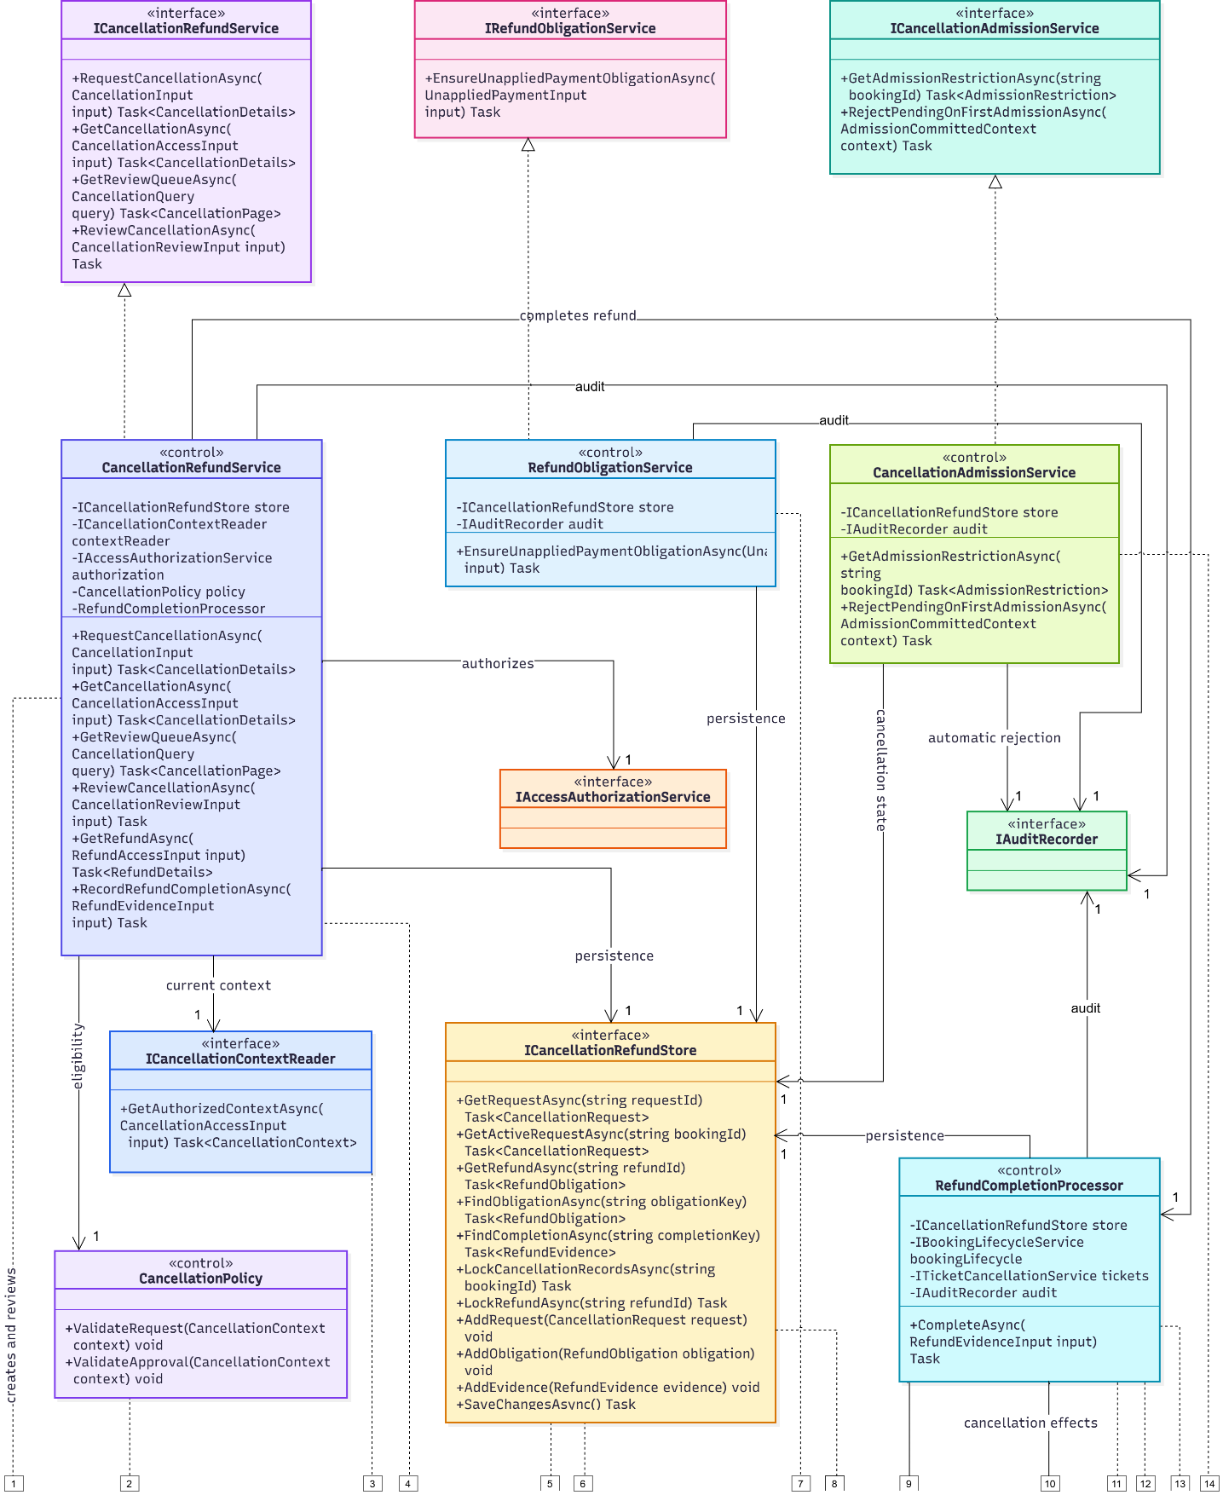
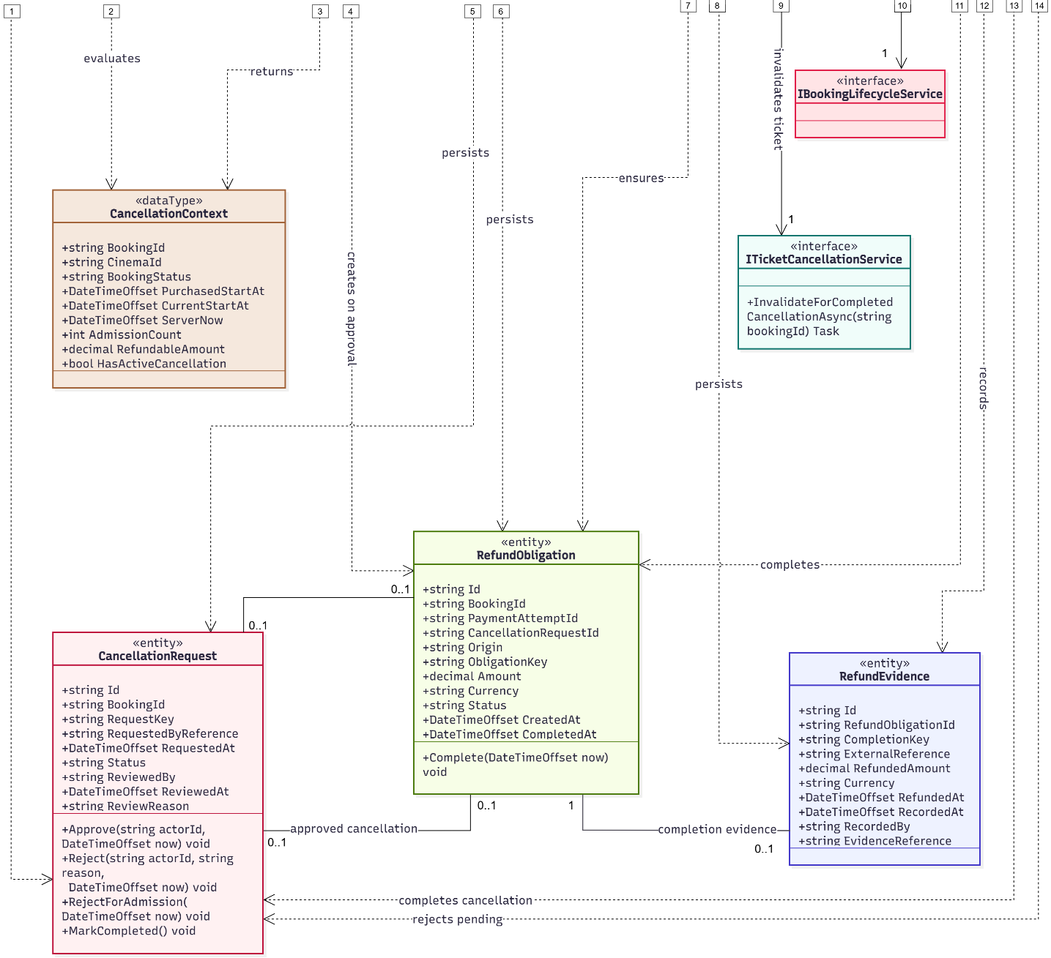
Figure 10: C10 Cancellation and Refund Class Diagram.
ReviewedBy, ReviewedAt, and CompletedAt are absent until the corresponding transition occurs. CancellationRequestId is absent for obligations originating from unapplied payments.
An approved cancellation produces one associated refund obligation. An unapplied-payment obligation does not require a cancellation request. RefundEvidence represents the accepted completion record and may reference the supporting evidence required by the specification.
ICancellationContextReader is a read-only coordination contract that assembles authorised information from the owning components. It does not independently change booking, payment, schedule, or admission state.

Key Class Descriptions
Class or Interface | Responsibility | Key Attributes | Key Operations
ICancellationRefundService | Defines cancellation requests, review, refund queries, and completion recording. | No instance attributes. | Receives requests, returns scoped records, reviews cancellation, and records completion.
CancellationRefundService | Coordinates access checks, eligibility validation, cancellation review, and completion entry points. | Persistence, context, authorisation, policy, completion, and audit references. | Implements the application contract.
CancellationPolicy | Applies request and approval eligibility rules. | No persistent state. | Validates qualifying rescheduling, timing, booking state, admission conditions, and conflicting requests.
CancellationContext | Carries authoritative information required for eligibility evaluation. | Booking state, cinema, purchased and current start times, server time, admission count, refundable amount, and active-request indicator. | No independent business operations.
CancellationRequest | Records one confirmed-booking cancellation request and its review lifecycle. | Booking, request key, requester reference, request time, status, reviewer, review time, and reason. | Approves, rejects, automatically rejects for admission, and records completion.
IRefundObligationService; RefundObligationService | Define and implement idempotent creation of unapplied-payment obligations. | Persistence and audit references. | Ensures that the required obligation exists.
RefundObligation | Records the monetary obligation and its origin. | Booking, payment attempt, optional cancellation request, obligation key, amount, currency, status, and timestamps. | Records completion after validated evidence and required effects succeed.
RefundEvidence | Records the accepted evidence of external refund completion. | Obligation, completion key, external reference, amount, currency, completion time, recording actor, and evidence reference. | No independent business-state transition.
RefundCompletionProcessor | Coordinates origin-specific completion effects. | Persistence, booking lifecycle, ticket invalidation, and audit references. | Records evidence and commits the required completion transitions.
ICancellationAdmissionService; CancellationAdmissionService | Define and implement cancellation checks used during admission. | Persistence and audit references. | Returns restrictions and rejects a pending request when first admission commits.
ICancellationContextReader | Defines authorised retrieval of current cancellation context. | No instance attributes. | Assembles booking, schedule, payment, and admission information.
ICancellationRefundStore | Defines persistence and locking operations supplied by C13. | No instance attributes. | Retrieves requests and obligations, checks idempotency, locks records, and persists changes.
ITicketCancellationService | Supplies C11 ticket invalidation for completed qualifying cancellation. | Defined in C11. | Invalidates the existing booking-level ticket.
External booking, authorisation, and audit interfaces | Supply booking completion effects, current permissions, and mandatory audit recording. | Defined in their owning components. | Participate in the coordinated workflow.

Class Relationships
Source | Target | Relationship | Meaning
CancellationRefundService | ICancellationRefundService | Realization | Implements customer and operational cancellation workflows.
RefundObligationService | IRefundObligationService | Realization | Implements unapplied-payment obligation creation.
CancellationAdmissionService | ICancellationAdmissionService | Realization | Implements cancellation-related admission operations.
CancellationRefundService | Persistence, context, authorisation, policy, completion, and audit services | Association | Retains collaborators required for request and review coordination.
RefundObligationService | ICancellationRefundStore; IAuditRecorder | Association | Persists idempotent obligations and required audit information.
RefundCompletionProcessor | Persistence, booking lifecycle, ticket cancellation, and audit contracts | Association | Coordinates completion effects across components.
CancellationAdmissionService | ICancellationRefundStore; IAuditRecorder | Association | Reads cancellation state and records automatic rejection.
CancellationRequest | RefundObligation | Association | A request has at most one cancellation-related obligation; an obligation may instead originate from an unapplied payment.
RefundObligation | RefundEvidence | Association | An obligation has at most one accepted completion record.
CancellationRefundService | CancellationRequest; RefundObligation | Dependency | Creates or reviews requests and establishes obligations on approval.
CancellationPolicy; ICancellationContextReader | CancellationContext | Dependency | Evaluate or return the authoritative eligibility context.
RefundObligationService | RefundObligation | Dependency | Creates or returns the existing compatible obligation.
RefundCompletionProcessor | RefundObligation; RefundEvidence; CancellationRequest | Dependency | Records evidence and applies the appropriate completion transitions.
CancellationAdmissionService | CancellationRequest | Dependency | Rejects a pending request as part of first-admission processing.
ICancellationRefundStore | CancellationRequest; RefundObligation; RefundEvidence | Dependency | Retrieves and persists cancellation and refund records.

Data Ownership and Consistency
C10 owns cancellation requests, review decisions, refund obligations, and recorded refund-completion evidence.
The following rules apply:
- Confirmed-booking cancellation requires qualifying rescheduling under the applicable specification.
- Eligibility compares the current official screening time with the purchased-time snapshot. The existence of a historical schedule-change record alone is insufficient.
- A request must be submitted strictly before the current screening start and while no admissions have been recorded.
- Customer ownership or authorised guest access is checked before accepting a request.
- Duplicate submissions do not create duplicate active cancellation requests.
- Review operations validate current eligibility and current operational authority.
- Pending review does not block admission.
- The first successful admission and rejection of the pending cancellation request commit atomically.
- Approval and admission are serialised so that both cannot succeed based on contradictory booking state.
- Approved cancellation awaiting refund blocks admission.
- Approval does not immediately cancel the booking or release sold allocations.
- Refund amount and currency are derived from verified payment and booking information rather than accepted from an arbitrary client declaration.
- An obligation’s origin determines its completion effects.
- Repeated reports of the same unapplied successful payment do not create duplicate obligations.
- Refund completion requires the prescribed external evidence and current authorisation.
- Completion recording does not itself transfer money.
- A compatible repeated completion request returns the existing result without duplicating business effects.
- Conflicting reuse of a completion key or external evidence is rejected or referred for review.
- For qualifying cancellation refunds, evidence recording, obligation completion, cancellation-request completion, booking cancellation, ticket invalidation, allocation release, and mandatory audit recording commit together.
- For unapplied-payment refunds, completion does not automatically invalidate a separately valid booking or ticket.
- Shared workflows preserve the required Showtime → Booking → Payment Attempt lock order, followed by cancellation and refund records in a consistent order.
- Required authorisation is rechecked before committing protected review and refund operations.
External monetary execution and local completion recording are separate events. If local recording fails after money has been returned externally, recovery records the existing external refund; it does not instruct the operator to transfer the money again.

Key Processing Flows and Failure Handling

Confirmed-Booking Cancellation Request
- A Customer or authorised Guest submits a cancellation request through C02.
- C10 validates access to the booking.
- The service obtains current booking, schedule, payment, and admission context.
- Under the required concurrency protection, it verifies qualifying rescheduling, the current request deadline, zero admissions, and the absence of a conflicting active request.
- C10 creates the pending cancellation request using a stable request key.
- Required audit information is recorded.
- The transaction commits and the pending-review result is returned.
The booking remains confirmed, and admission remains possible while the request is pending review.

Cancellation Review
- An authorised operator retrieves a request within the permitted cinema scope.
- C10 validates current review authority.
- It acquires the required locks and reloads request, booking, screening, payment, and admission state.
- The service checks that the request remains eligible for the proposed decision.
- Rejection records the decision, actor, time, and reason.
- Approval records the decision and creates the corresponding refund obligation.
- The decision, obligation where applicable, and mandatory audit information commit together.
- An approved request blocks subsequent admission while awaiting refund completion.
Approval retains the booking’s confirmed state and sold allocations until the required completion effects are applied.

Admission While Review Is Pending
- C11 begins a protected admission-confirmation operation.
- C11 checks the cancellation restriction through C10 using the shared transaction and locking protocol.
- An approved cancellation awaiting refund causes admission to be rejected.
- A pending review does not independently prevent an otherwise eligible admission.
- When the first admission is recorded, C10 rejects the pending request.
- The admission and automatic rejection commit together.
If approval committed first, admission cannot proceed using an earlier pending-review result.

Unapplied Successful Payment
- C09 verifies a successful payment that cannot be applied to a booking.
- It invokes EnsureUnappliedPaymentObligationAsync(...) with the verified payment evidence.
- C10 checks for an existing obligation using the stable origin key.
- It returns the existing compatible obligation or records the required new obligation.
- The payment-application outcome, obligation, and required audit information commit consistently.
This workflow does not require a customer cancellation request.

Recording External Refund Completion
- An authorised operator submits the obligation identifier and required evidence of the externally completed refund.
- C10 validates current permissions and access to the affected cinema and records.
- The service locks and reloads the obligation and relevant business state.
- It validates the external reference, amount, currency, evidence, and completion idempotency.
- RefundCompletionProcessor records the accepted completion evidence.
- For a qualifying cancellation obligation, C08 cancels the booking and releases sold allocations, while C11 invalidates the ticket.
- For an unapplied-payment obligation, only the applicable obligation-completion effects are performed.
- C10 marks the obligation and, where applicable, cancellation request as completed.
- The required business changes and audit records commit atomically.

Failure Handling and Recovery
- Requests without qualifying rescheduling are rejected.
- Requests submitted at or after the current screening start are rejected.
- Existing admissions prevent acceptance or approval where the cancellation rules require zero admissions.
- Duplicate requests and repeated payment notifications do not create duplicate obligations.
- Concurrent review and admission operations revalidate state under the same locking protocol.
- Invalid or insufficient refund evidence does not mark an obligation complete.
- Amount or currency mismatches require correction or review rather than silent acceptance.
- Repeated completion submissions do not repeat booking cancellation, ticket invalidation, or seat release.
- Local transaction failure rolls back the recorded completion and associated business transitions.
- Recovery after an already executed external refund reuses its evidence and does not execute another transfer.
- Revoked permissions or changed cinema assignments prevent unauthorised completion at the required pre-commit check.
- Error responses and logs exclude unnecessary personal information and sensitive financial evidence.

Component C11 Ticketing and Admission

Purpose and Responsibilities
Ticketing and Admission manages booking-level electronic tickets, ticket access, authorised ticket-email resend, QR validation, and the recording of admissions.
The component is responsible for:
- Issuing one booking-level ticket and QR following eligible verified payment application.
- Returning existing ticket information without creating duplicate tickets.
- Providing authorised customer, guest, and operational ticket access.
- Queuing permitted ticket-email resend requests through C15.
- Resolving scanned QR information to the corresponding ticket and booking.
- Validating the current booking, ticket, screening, cancellation, and admission context.
- Enforcing Staff authority and the required cinema assignment.
- Recording individual or batch admissions.
- Preserving total and discounted admission entitlements.
- Invalidating tickets when a qualifying cancellation refund completes.
One QR represents the entire booking. Admissions are recorded as counts rather than assigned to individual seats. A booking may be admitted in multiple batches while remaining within its purchased entitlements.
The admission window extends from five minutes before the current official screening start until twenty minutes after that start. No operational override permits admission outside the specified window.
C11 owns tickets and admission records. C08 owns bookings and allocations, C06 owns the current official screening time, and C10 owns cancellation and refund state.

Use-Case Traceability
Use Case | Contribution of C11
UC-05 Validate Ticket | Validates booking-level QR information and records eligible admissions under current timing, authorisation, age, and discounted-entitlement rules.
UC-02 Payment Webhook | Issues the booking-level ticket idempotently within eligible verified-payment processing.
UC-04 Payment Reconciliation | Uses the same issuance operation when reconciliation resolves an eligible successful payment.
UC-09 Checkout and Payment | Supplies the ticket information displayed after the booking is confirmed.
UC-10 Customer Booking Lifecycle | Provides authorised ticket retrieval and ticket-email resend.
UC-19 Manage Bookings and Tickets | Supports permitted operational ticket retrieval and delivery assistance.
UC-04A Refund | Invalidates the ticket when a qualifying cancellation refund completes.
UC-17 Manage Showtimes and Schedules | Uses the current official screening time for admission while preserving the existing booking-level ticket identity.
UC-16A Manage Ticket Types | Uses applicable category eligibility information while preserving the booking’s purchased entitlement counts.

Implementation Language and Technologies
The component is implemented in C# within the ASP.NET Core backend.
It uses:
- Application services for ticket access, issuance, resend, and admission coordination.
- Domain entities for tickets and admission records.
- An admission policy for time-window and entitlement validation.
- QR encoding behind a dedicated interface.
- C03 current authorisation and cinema-assignment checks.
- Booking and screening context supplied by C08 and C06.
- C10 cancellation-admission and refund-completion contracts.
- Persistence contracts implemented by C13 using EF Core and PostgreSQL.
- Coordinated transactions, locking, and idempotency controls.
- C15 transactional email queueing.
- C16 Audit Logging for required operational actions.
QR payloads use an opaque ticket-access value rather than embedding personal information or treating the booking identifier alone as an access credential.
Browser camera acquisition belongs to C01. C11 receives decoded QR input through C02 and performs authoritative validation.

Provided Interfaces and Services
Interface or Operation | Responsibility
ITicketingService.GetTicketAsync(...) | Returns an existing ticket after customer ownership, guest-access, or operational-scope validation.
ITicketingService.ResendTicketEmailAsync(...) | Queues an authorised resend containing the existing booking-level ticket and QR.
ITicketingService.ValidateTicketAsync(...) | Validates QR input and returns the current admission context without consuming entitlements.
ITicketingService.ConfirmAdmissionAsync(...) | Revalidates eligibility and records an individual or batch admission atomically.
ITicketIssuanceService.EnsureTicketIssuedAsync(...) | Returns the existing ticket or issues it once within eligible verified-payment processing.
ITicketCancellationService.InvalidateForCompletedCancellationAsync(...) | Invalidates the ticket within qualifying cancellation-refund completion.
IAdmissionReader.GetAdmissionSummaryAsync(...) | Supplies committed admission totals to authorised cancellation and booking workflows.
IQrCodeEncoder.Encode(...) | Produces a QR representation of the ticket payload.
Ticket validation and admission confirmation are separate operations. A successful validation response does not reserve admission entitlements or guarantee that a later confirmation will succeed.
Ticket issuance and cancellation interfaces are internal contracts. They do not allow a browser client to issue or invalidate tickets independently.

Dependencies and Communication
Calling Component | Receiving Component | Interface or Operation | Purpose | Communication
C02 Backend API | C11 Ticketing and Admission | ITicketingService | Retrieve tickets, request resend, validate QR input, and confirm admissions. | In-process C# interface calls.
C09 Payment Processing | C11 Ticketing and Admission | ITicketIssuanceService | Issue the booking-level ticket during eligible payment application. | In-process C# call within the coordinated transaction.
C10 Cancellation and Refund | C11 Ticketing and Admission | IAdmissionReader | Obtain committed admission totals for cancellation eligibility and review. | In-process read-only C# calls under the applicable locking protocol.
C10 Cancellation and Refund | C11 Ticketing and Admission | ITicketCancellationService | Invalidate the ticket after qualifying cancellation-refund completion. | In-process C# call within the coordinated transaction.
C11 Ticketing and Admission | C03 Identity and Access | IAccessAuthorizationService | Check current Staff authority, verified-email requirements, cinema assignment, and other ticket-access permissions. | In-process C# interface calls.
C11 Ticketing and Admission | C08 Booking and Checkout | Booking-access and context contracts | Validate ticket access and retrieve booking state and purchased entitlements. | In-process C# calls.
C11 Ticketing and Admission | C06 Showtime Scheduling | IShowtimeReader.GetAdmissionContextAsync(...) | Retrieve the current official screening time, cinema, and room. | In-process C# interface call.
C11 Ticketing and Admission | C07 Ticket Pricing | Category-information contract | Retrieve applicable ticket-category descriptions and eligibility information. | In-process read-only C# calls.
C11 Ticketing and Admission | C10 Cancellation and Refund | ICancellationAdmissionService | Check restrictions and reject a pending cancellation request when first admission commits. | In-process C# calls within the admission transaction.
C11 Ticketing and Admission | C13 Persistence and Transactions | ITicketStore | Persist tickets, admission counts, and admission records and enforce concurrency controls. | In-process persistence contracts.
C11 Ticketing and Admission | C15 Notification Delivery | NotificationService.QueueBookingEmail(...) | Queue authorised resend of the existing ticket. | In-process C# method call.
C11 Ticketing and Admission | C16 Audit Logging | IAuditRecorder | Record required ticket and admission actions. | In-process C# calls coordinated with the business transaction.
Read-only admission and cancellation-context queries do not recursively initiate changes in the calling component. The coordinating workflow determines the transaction boundary.

Class Diagram
The class diagram presents ticket issuance, authorised access, QR encoding, admission validation, and ticket invalidation in one view.
TicketingService handles user-facing operations. TicketIssuanceService creates the booking-level ticket idempotently. AdmissionService revalidates and records admission batches. TicketCancellationService applies ticket invalidation requested by C10.
Ticket preserves purchased total and discounted entitlements and their consumed counts. AdmissionRecord records each successful batch and its idempotency key. The QR payload identifies the ticket but does not independently authorise Staff operations.
The «dataType» stereotype identifies operational input and consolidated validation context.
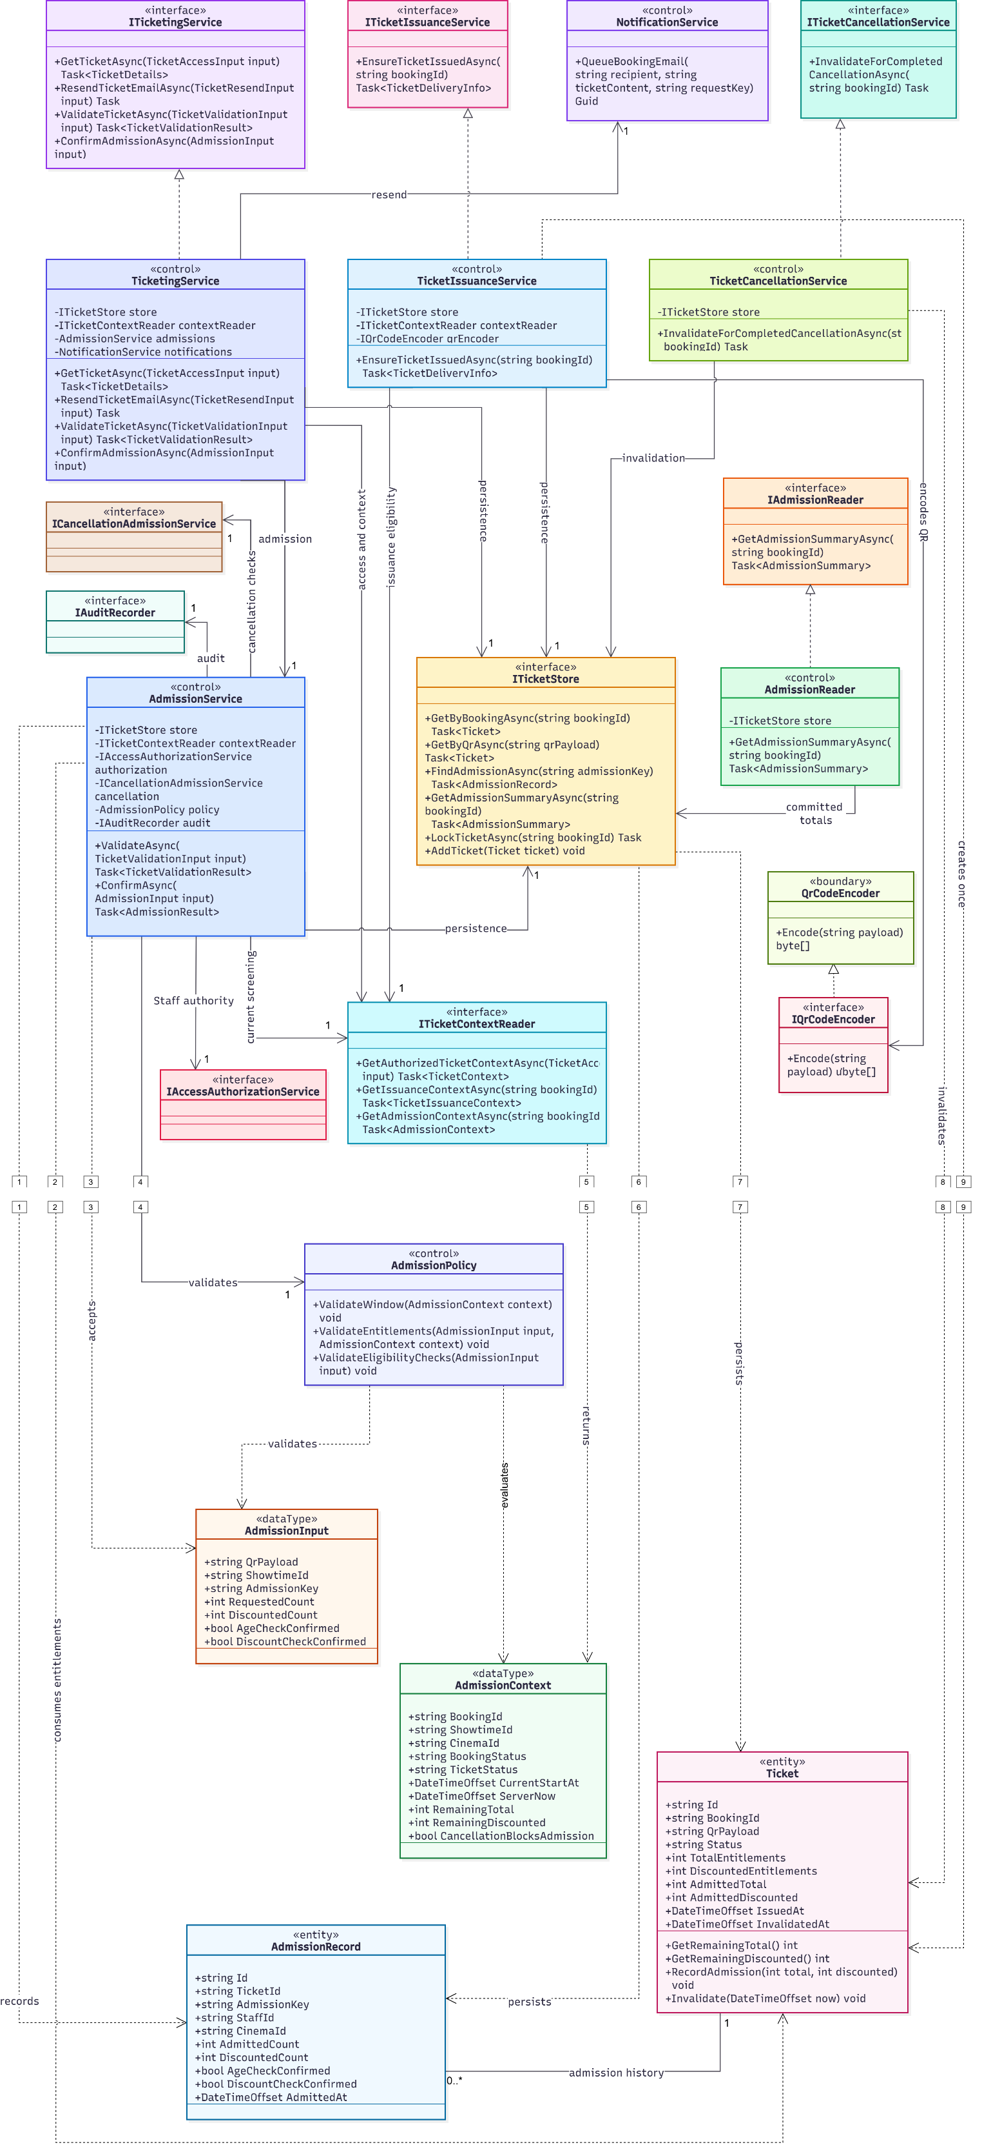
Figure 11: C11 Ticketing and Admission Class Diagram.
InvalidatedAt is absent until ticket invalidation occurs. DiscountCheckConfirmed is required when the submitted batch consumes discounted entitlements.
ITicketContextReader assembles information from the owning components without independently changing their state. The QR encoder is a boundary to the encoding library, not an external ticket-authorisation service.

Key Class Descriptions
Class or Interface | Responsibility | Key Attributes | Key Operations
ITicketingService; TicketingService | Define and implement ticket retrieval, resend, validation, and admission entry points. | Persistence, context, admission, and notification references. | Retrieves existing tickets, queues resend, and delegates admission processing.
ITicketIssuanceService; TicketIssuanceService | Define and implement idempotent ticket issuance. | Persistence, issuance context, and QR encoder references. | Ensures that one booking-level ticket exists for an eligible confirmed booking.
AdmissionService | Coordinates current access, screening, cancellation, entitlement checks, and admission persistence. | Persistence, context, authorisation, cancellation, policy, and audit references. | Validates QR input and confirms a revalidated admission batch.
AdmissionPolicy | Applies admission-window, quantity, and eligibility-check rules. | No persistent state. | Validates timing, remaining entitlements, and Staff confirmations.
ITicketCancellationService; TicketCancellationService | Define and implement ticket invalidation requested by C10. | Persistence reference. | Invalidates the ticket as part of completed qualifying cancellation.
IAdmissionReader; AdmissionReader | Define and implement read-only access to committed admission totals. | Persistence reference. | Returns admission summaries for authorised internal workflows.
Ticket | Represents the booking-level ticket and admission entitlements. | Booking identifier, opaque QR payload, status, purchased and consumed counts, and lifecycle timestamps. | Calculates remaining counts, records admitted quantities, and invalidates the ticket.
AdmissionRecord | Preserves one committed admission batch. | Ticket, idempotency key, Staff actor, cinema, counts, eligibility confirmations, and timestamp. | No independent editing operation; created by the admission transaction.
AdmissionInput | Carries the requested admission batch and screening context. | QR payload, showtime, request key, counts, and Staff confirmations. | No business operations.
AdmissionContext | Carries current authoritative eligibility information. | Booking and ticket states, cinema, screening time, server time, remaining counts, and cancellation restriction. | No business operations.
IQrCodeEncoder; QrCodeEncoder | Define and implement QR representation generation. | Encoding-library configuration where required. | Encodes the existing opaque ticket payload.
ITicketStore | Defines ticket and admission persistence supplied by C13. | No instance attributes. | Retrieves and locks tickets, checks admission idempotency, and persists changes.
ITicketContextReader | Supplies authorised ticket and admission context. | No instance attributes. | Assembles current booking, screening, and issuance information.
External authorisation, cancellation, notification, and audit contracts | Supply current access checks, cancellation coordination, email queueing, and required audit recording. | Defined in their owning components. | Participate in the corresponding ticket workflow.

Class Relationships
Source | Target | Relationship | Meaning
TicketingService | ITicketingService | Realization | Implements the application-facing ticket contract.
TicketIssuanceService | ITicketIssuanceService | Realization | Implements idempotent issuance.
TicketCancellationService | ITicketCancellationService | Realization | Implements cancellation-related invalidation.
AdmissionReader | IAdmissionReader | Realization | Implements committed admission queries.
QrCodeEncoder | IQrCodeEncoder | Realization | Implements QR encoding.
TicketingService | Persistence, context, admission, and notification services | Association | Retains collaborators for ticket access and assistance.
TicketIssuanceService | ITicketStore; ITicketContextReader; IQrCodeEncoder | Association | Retrieves eligibility context, creates the ticket, and encodes its QR.
AdmissionService | Persistence, context, authorisation, cancellation, policy, and audit services | Association | Coordinates admission validation and recording.
TicketCancellationService; AdmissionReader | ITicketStore | Association | Update ticket validity or retrieve committed admission information.
Ticket | AdmissionRecord | Association | One ticket may have multiple successful admission batches.
TicketIssuanceService | Ticket | Dependency | Creates or returns the existing booking-level ticket.
AdmissionService | Ticket; AdmissionRecord; AdmissionInput | Dependency | Processes the request, updates entitlements, and creates the admission record.
AdmissionPolicy | AdmissionInput; AdmissionContext | Dependency | Evaluates the requested batch against current eligibility.
ITicketContextReader | AdmissionContext | Dependency | Returns the current context.
TicketCancellationService | Ticket | Dependency | Applies invalidation within cancellation completion.
ITicketStore | Ticket; AdmissionRecord | Dependency | Retrieves and persists ticket and admission records.

Data Ownership and Consistency
C11 owns ticket records, opaque QR identities, admission counters, and successful admission records.
The following rules apply:
- One booking has at most one issued booking-level ticket.
- Initial issuance requires eligible verified payment application.
- Duplicate payment processing returns the existing ticket rather than creating another QR identity.
- Ticket retrieval and email resend preserve the existing ticket and QR.
- QR possession does not grant operational authority to confirm admission.
- Admission requires current Staff permission, verified-email eligibility, and the required cinema assignment.
- Admin or Manager authority alone does not grant Staff admission permission.
- The scanned ticket must match the active screening context.
- Admission uses the current official start time, including an accepted rescheduling.
- Server time determines whether the operation falls within the permitted admission window.
- Staff confirm the required age and discounted-eligibility checks.
- Rejected individuals do not consume admission entitlements.
- Admissions are recorded by count, not by physical seat.
- Each successful batch preserves both total and discounted entitlements.
- Validation alone does not increment counters.
- Concurrent confirmations are serialised so that their combined counts cannot exceed purchased entitlements.
- A stable admission key prevents a repeated submission from consuming entitlements twice.
- A pending cancellation request remains compatible with admission, but first admission rejects that request in the same transaction.
- Approved cancellation awaiting refund blocks admission.
- Completed qualifying cancellation invalidates the ticket consistently with booking cancellation and allocation release.
- Historical admission records are preserved.
- Shared operations follow the required showtime and booking lock order before ticket and related cancellation records are updated.
Let \(R_T\) be the remaining total entitlements, \(R_D\) the remaining discounted entitlements, \(a\) the requested admission count, and \(d\) the discounted count in that batch. A successful batch must satisfy:
\[ 1 \le a \le R_T \]\[ 0 \le d \le \min(a,R_D) \]\[ a-d \le R_T-R_D \]
The final condition prevents non-discounted admissions from consuming places reserved for remaining discounted entitlements.

Key Processing Flows and Failure Handling

Ticket Issuance
- C09 begins eligible verified-payment application within the coordinated transaction.
- C08 confirms the booking and converts its held allocations to sold allocations.
- C09 invokes EnsureTicketIssuedAsync(...).
- C11 checks for an existing ticket and returns it when already issued.
- Otherwise, C11 creates the booking-level ticket with the purchased total and discounted quantities.
- It generates an opaque QR payload and its QR representation.
- The ticket is persisted within the same coordinated transaction.
- C11 returns ticket-delivery information for initial email queueing.
- Payment, booking, ticket, and notification-request changes commit together.

Ticket Retrieval and Email Resend
- C02 submits a ticket-access or resend request.
- C11 validates customer ownership, guest access, or the operator’s permitted cinema scope.
- It retrieves the existing ticket and current booking context.
- Retrieval returns the permitted ticket information.
- Resend creates a separate authorised notification request through C15 using the existing ticket and QR.
- The delivery request commits before C15 sends the email.
A resend does not reset admission counters, restore an invalid ticket, or create additional entitlements.

QR Validation
- Authorised Staff submit the decoded QR and screening context through C02.
- C11 resolves the QR to a ticket.
- It checks current Staff authority and cinema assignment.
- The service retrieves booking state, current screening time, remaining entitlements, and cancellation restrictions.
- AdmissionPolicy evaluates current eligibility.
- C11 returns permitted screening information, remaining counts, and any rejection reason.
This response is advisory for the upcoming confirmation. The confirmation operation repeats the relevant checks.

Admission Confirmation
- Staff perform the required age and discounted-eligibility checks.
- C02 submits the eligible batch counts and a stable admission key.
- C11 checks for an already committed compatible result.
- The coordinating transaction obtains the required showtime, booking, ticket, and cancellation protection.
- C11 reloads current state and rechecks authority, screening context, server time, cancellation restrictions, and remaining entitlements.
- The policy validates the requested total and discounted counts.
- C11 updates counters and creates the admission record.
- If this is the first admission and a cancellation request is pending, C10 rejects that request within the same transaction.
- Required audit information is recorded.
- The transaction commits and updated remaining counts are returned.
Individuals who fail the required checks are excluded from the submitted eligible batch and do not consume entitlements.

Ticket Invalidation After Refund Completion
- C10 validates evidence for a qualifying completed cancellation refund.
- The coordinated transaction protects the relevant booking and ticket.
- C08 applies booking cancellation and allocation release.
- C11 invalidates the existing ticket.
- C10 records completion and the required audit information.
- All required effects commit together.
Refund completion for an unapplied additional payment does not independently invalidate a valid ticket associated with another applied payment.

Failure Handling and Recovery
- Unknown or malformed QR input returns a controlled rejection without exposing unrelated booking information.
- Wrong cinema or screening context prevents admission.
- Missing Staff permission or a revoked cinema assignment prevents confirmation.
- Requests outside the admission window are rejected without an override.
- Invalidated tickets, ineligible booking states, and approved cancellations awaiting refund prevent admission.
- Failed age or discounted-eligibility checks do not consume entitlements.
- Excessive batch counts or discounted-quota violations are rejected atomically.
- Concurrent scans revalidate counters and cannot produce excessive admissions.
- Repeated admission keys return the existing compatible result; incompatible reuse is rejected.
- Transaction failure rolls back counters, admission records, automatic cancellation rejection, and mandatory audit changes.
- A timeout after confirmation requires retrieval or idempotent retry rather than a new uncontrolled admission request.
- Email-delivery failures are handled by C15 without changing ticket validity or admission counts.
- QR payloads and sensitive ticket-access information are excluded from ordinary diagnostic logs.

Component C12 Promethe-Nous

Purpose and Responsibilities
Promethe-Nous provides informational assistance for movie discovery and the customer booking journey. It coordinates permitted information retrieval, prepares contextual requests for the configured language model, and returns answers with supporting source references and relevant limitations.
The component supports:
- Questions about publicly available movies, showtimes, ticket categories, and cinema pricing.
- Movie recommendations based on expressed preferences and available movie information.
- Guidance on booking, payment, ticket retrieval, and cancellation procedures.
- External movie information retrieved from TMDB.
- Follow-up questions using conversation history retained only for the current session.
- Clear feedback when information is missing or an external service is unavailable.
Internal application services remain authoritative for cinema operations, showtimes, ticket prices, and applicable booking rules. TMDB supplies supplementary movie information.
Promethe-Nous does not create bookings, hold seats, initiate payments, approve cancellations, execute refunds, issue tickets, or modify administrative records. It does not retrieve private booking or account records in the current scope.

Use-Case Traceability
Use Case | Contribution of C12
UC-11 Chat with Promethe-Nous | Receives questions, retrieves permitted information, invokes the language model, and returns contextual answers.
UC-06A Browse Movies | Supports movie discovery and recommendations using publicly eligible catalogue information.
UC-06B View Movie Details | Explains available movie information and supplements it with identified TMDB information.
UC-07 Browse Showtimes | Answers showtime enquiries using public showtime queries supplied by C06.
UC-09 Checkout and Payment | Explains checkout and payment procedures without executing checkout or payment operations.
UC-10 Customer Booking Lifecycle | Explains ticket retrieval and cancellation procedures without accessing or changing individual bookings.
The supporting contributions do not transfer ownership of these use cases to C12 or introduce additional UML «include» or «extend» relationships.

Implementation Language and Technologies
The component is implemented in C# within the ASP.NET Core backend.
It uses:
- Explicit C# interfaces for permitted information queries to other backend components.
- HttpClient for external HTTPS communication.
- JSON request and response models for AI inference and TMDB integration.
- Ollama running in the group’s Kaggle notebook environment for demonstration inference.
- An ngrok HTTPS endpoint exposing the configured inference service.
- Backend-managed credentials for the configured inference endpoint and TMDB API.
- Bounded in-memory storage for session conversation history.
- Backend configuration for the model identifier, endpoint addresses, timeouts, context limits, and session expiration.
OllamaAiGateway encapsulates the inference request format and endpoint configuration. TmdbMovieSource encapsulates TMDB-specific requests and response mapping.
The ngrok tunnel configuration and application request authentication are separate concerns. The backend uses the authentication mechanism configured for the exposed inference endpoint.
Kaggle and ngrok form part of the demonstration infrastructure. Their availability determines whether AI inference can be performed.

Provided Interfaces and Services
Interface or Operation | Responsibility
IPrometheNousService.AskAsync(...) | Processes a supported question using permitted context and the current conversation session.
IPrometheNousService.ClearConversationAsync(...) | Clears conversation history belonging to the current caller’s session.
ChatContextBuilder.BuildAsync(...) | Collects relevant internal information, procedural guidance, and external movie information.
IExternalMovieSource.SearchAsync(...) | Searches external movie information to resolve a requested title.
IExternalMovieSource.GetDetailsAsync(...) | Retrieves supplementary information for an identified external movie.
IExternalMovieSource.GetTopRatedAsync(...) | Retrieves a source-labelled list of highly rated movies.
IAiGateway.GenerateAsync(...) | Submits a bounded contextual request to the configured inference endpoint.
IConversationSessionStore | Retrieves, updates, and clears temporary conversation history.
Conversation identifiers are scoped to a validated caller context. A client-supplied conversation identifier alone does not authorise access to conversation history.
The model receives only the information required to answer the question. Authentication credentials, private operational records, and unrestricted database access are not exposed to it.

Dependencies and Communication
Calling Component | Receiving Component | Interface or Operation | Purpose | Communication
C02 Backend API | C12 Promethe-Nous | IPrometheNousService | Submit questions and clear the current conversation. | In-process C# interface calls
C12 Promethe-Nous | C03 Identity and Access | Validated access context | Scope authenticated conversations and respect current session validity. | In-process C# contracts
C12 Promethe-Nous | C04 Movie Catalogue | IMovieCatalogueReader | Retrieve publicly eligible movie information. | In-process C# read-only interface calls
C12 Promethe-Nous | C06 Showtime Scheduling | IShowtimeReader | Retrieve publicly available showtimes. | In-process C# read-only interface calls
C12 Promethe-Nous | C07 Ticket Pricing | ITicketPricingReader | Retrieve applicable ticket-category and cinema-pricing information. | In-process C# read-only interface calls
C12 Promethe-Nous | TMDB | IExternalMovieSource, implemented by TmdbMovieSource | Retrieve supplementary movie information. | HTTPS API with JSON
C12 Promethe-Nous | Kaggle-hosted inference service through ngrok | IAiGateway, implemented by OllamaAiGateway | Generate an answer from the supplied question and context. | HTTPS API with JSON
C01 communicates with C12 through C02. It does not directly call the inference endpoint or receive provider credentials.
Procedural guidance is maintained as versioned application content aligned with the approved Use-Case Specifications. It is not inferred from model knowledge alone.

Class Diagram
The diagram shows question coordination, contextual retrieval, temporary conversation storage, and external adapters. Interfaces representing C04, C06, and C07 are included to show collaboration boundaries; their implementations belong to their respective components.
«dataType» identifies structured request and response data. «boundary» identifies external service adapters, while «control» identifies application coordination classes.
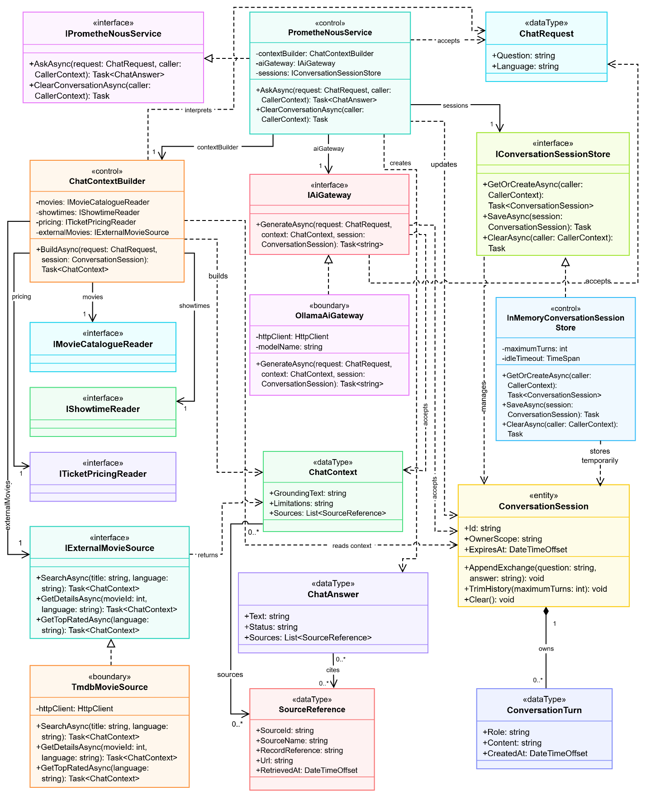
Figure 12: C12 Promethe-Nous Class Diagram.
CallerContext is the shared request context established by the API and identity infrastructure. It is not a client-controlled ownership declaration. Cancellation tokens and configuration classes are omitted from the diagram for readability.

Key Class Descriptions
Class or Interface | Responsibility | Key Attributes | Key Operations
IPrometheNousService | Defines the application-facing chatbot contract. | None. | AskAsync(...); ClearConversationAsync(...).
PrometheNousService | Coordinates input validation, session access, context retrieval, inference, and answer construction. | contextBuilder, aiGateway, sessions. | Processes questions and clears the current conversation.
ChatContextBuilder | Collects permitted information and identifies source limitations. | Read-only movie, showtime, pricing, and external-source references. | BuildAsync(...).
ChatRequest | Carries the submitted question and preferred language. | Question, Language. | No business operations.
ChatContext | Carries retrieved facts and their provenance. | GroundingText, Limitations, Sources. | No business operations.
ChatAnswer | Represents the response returned to the client. | Text, Status, Sources. | No business operations.
SourceReference | Identifies information used to support an answer. | Source identifier, name, record reference, optional URL, and retrieval time. | No business operations.
ConversationSession | Maintains bounded conversation context for one caller scope. | Id, OwnerScope, ExpiresAt. | Appends exchanges, trims history, and clears content.
ConversationTurn | Represents one user or assistant message. | Role, Content, CreatedAt. | No business operations.
IConversationSessionStore | Defines temporary session-storage operations. | None. | Retrieves, saves, and clears sessions.
InMemoryConversationSessionStore | Implements temporary storage with expiration and history limits. | maximumTurns, idleTimeout. | Implements the session-storage contract.
IAiGateway | Defines provider-independent answer generation. | None. | GenerateAsync(...).
OllamaAiGateway | Calls the configured inference endpoint through ngrok. | httpClient, modelName. | Converts contextual input into an inference request and extracts the generated answer.
IExternalMovieSource | Defines supplementary movie-information retrieval. | None. | Searches movies and retrieves details or top-rated information.
TmdbMovieSource | Implements external retrieval using TMDB. | httpClient. | Maps TMDB responses into contextual facts and source references.
Internal reader interfaces | Expose permitted information from C04, C06, and C07. | None. | Operations are defined in the owning components.

Class Relationships
Source | Target | Relationship | Meaning
PrometheNousService | IPrometheNousService | Realization | Implements the chatbot application contract.
PrometheNousService | Context builder, AI gateway, and session store | Association | Retains references to its collaborators.
ChatContextBuilder | Internal readers and external movie source | Association | Uses retained references to retrieve permitted information.
OllamaAiGateway | IAiGateway | Realization | Implements inference communication.
TmdbMovieSource | IExternalMovieSource | Realization | Implements TMDB retrieval.
InMemoryConversationSessionStore | IConversationSessionStore | Realization | Implements temporary session storage.
ConversationSession | ConversationTurn | Composition | Owns its conversation turns; clearing or expiring the session removes its retained history.
ChatContext; ChatAnswer | SourceReference | Association | Retain references to supporting sources. Source references may be reused between context and answer.
Services and contracts | Request, context, answer, and session types | Dependency | Accept, return, construct, or process these objects.

Data Ownership and Consistency
C12 owns temporary conversation context and generated answers. It does not own movie catalogue records, showtimes, ticket prices, bookings, payments, refunds, or tickets.
Conversation history is stored in backend memory for the current session and is not persisted in PostgreSQL. It is removed when explicitly cleared or expired and is lost when the backend restarts. Logout or session replacement prevents further access under the previous authenticated session.
Session updates are serialised per conversation to preserve message order. History length and input size are bounded to control memory use and inference context size.
Information precedence follows these rules:
- C04 determines which internal movies may be presented.
- C06 supplies authoritative public showtimes.
- C07 supplies applicable cinema-pricing information.
- Approved procedural guidance determines explanations of application workflows.
- TMDB supplies supplementary external movie information.
- Generated model text does not override these sources.
Source references are assembled from retrieved information. Model-generated URLs or unsupported source identifiers are not accepted as verified citations.
TMDB ratings, popularity indicators, and revenue information are presented with their corresponding meaning. Missing or unusable revenue values are reported as unavailable. The application does not infer a market, reporting period, or box-office ranking that the retrieved data does not establish.

Key Processing Flows and Failure Handling

Question Processing
- C02 establishes the caller context and passes the question to C12.
- PrometheNousService validates question length and retrieves the caller’s conversation session.
- The service checks whether the request falls within the supported informational scope.
- ChatContextBuilder retrieves relevant public application information, procedural guidance, and TMDB information where needed.
- If the movie identity is ambiguous, the service requests clarification rather than combining information from different movies.
- The service prepares bounded conversation history and source-labelled context.
- OllamaAiGateway submits the request to the configured inference endpoint.
- The service checks the response format and source identifiers, constructs ChatAnswer, and records the completed exchange in temporary session history.
- C02 returns the answer and its supporting references to C01.

Source Selection and Recommendations
- Questions about cinema showtimes and prices use internal application readers.
- Questions about supplementary movie information may use TMDB.
- Recommendations distinguish movies available in the local catalogue from external suggestions.
- External ratings or ranked lists identify their source and ranking basis.
- Earlier conversation messages provide conversational context; time-sensitive operational facts are retrieved again when required.
- Requests to perform transactions are answered with guidance to the relevant application workflow.

External Service Failures
- TMDB failure does not prevent answers supported entirely by internal information.
- Missing external facts produce an explicit limitation rather than invented information.
- An unavailable Kaggle notebook or ngrok endpoint produces service-unavailable feedback.
- Timeouts, authentication failures, invalid responses, and provider rate limits are handled without exposing credentials or internal exception details.
- Retries are bounded by the overall request deadline.
- Conversation history is not appended with a fabricated successful answer after inference failure.
- The proposed performance target remains an answer or meaningful status feedback within 15 seconds for at least 90% of agreed supported queries under controlled test conditions.

Information and Access Protection
- External text and user messages are treated as untrusted content.
- Retrieval is restricted to explicitly permitted read-only interfaces.
- The model receives no database credentials, provider secrets, or business-state mutation interfaces.
- Authenticated conversation access follows the current session state supplied by C03.
- Ordinary diagnostic logs exclude credentials and full conversation content.
- Clearing a conversation removes its retained application history; subsequent questions begin without that history.

Component C13 Persistence and Transactions

Purpose and Responsibilities
Persistence and Transactions provides database access, object–relational mapping, transaction management, and database-level integrity mechanisms for the backend.
The component supports:
- Persistence implementations for contracts defined by the owning business components.
- Mapping application entities to PostgreSQL tables, relationships, indexes, and constraints.
- Coordinated transactions spanning multiple component operations.
- Concurrency protection through database constraints, conditional updates, and explicit locking where required.
- Durable storage of notification requests and mandatory audit records.
- Atomic claiming and recovery of background-processing work.
- Version-controlled database schema migrations.
- Translation of database failures into defined persistence outcomes.
Business components determine whether an operation is permitted and which state transitions must occur. C13 executes the corresponding persistence operations without taking ownership of booking, payment, refund, admission, pricing, or authorisation decisions.
C13 does not expose database access directly to the frontend and does not call external payment, email, or AI providers.

Use-Case Traceability
Use Cases | Contribution of C13
UC-01 Reserve Seats | Atomically persists the booking, accepted price snapshot, and requested seat allocations while preventing conflicting active allocations.
UC-02 Payment Webhook; UC-04 Payment Reconciliation | Stores payment attempts and notification evidence and supports atomic application of eligible payment outcomes.
UC-03 Release Expired Bookings | Supports candidate retrieval, locking, deadline rechecks, and atomic booking expiration and allocation release.
UC-04A Refund | Persists refund obligations, completion evidence, and coordinated business-state changes.
UC-05 Validate Ticket | Supports concurrency-safe admission recording, admission-request deduplication, and related cancellation-request updates.
UC-06A Browse Movies; UC-06B View Movie Details; UC-07 Browse Showtimes | Executes queries supporting public movie and showtime retrieval.
UC-08A–UC-08D; UC-18 Manage User Accounts and Roles | Stores identity records, account states, roles, cinema assignments, and application session records.
UC-09 Checkout and Payment; UC-10 Customer Booking Lifecycle; UC-19 Manage Bookings and Tickets | Supports booking retrieval, checkout persistence, authorised lifecycle updates, and durable email-resend requests.
UC-12; UC-13 | Persists movies, genres, and their associations while protecting historical references.
UC-14A; UC-14B; UC-15A–UC-15C | Persists cinema, room, seating, and seat-type configuration with dependency and integrity checks.
UC-16A; UC-16B | Persists ticket categories and cinema-specific prices.
UC-17 Manage Showtimes and Schedules | Persists showtimes and scheduling snapshots and supports conflict prevention and coordinated schedule changes.
UC-11 Chat with Promethe-Nous | Indirectly supports internal information retrieval through C04, C06, and C07. Conversation history is not persisted by C13.

Implementation Language and Technologies
The component is implemented in C# using:
- Entity Framework Core for entity mapping, change tracking, and designated queries and updates.
- The Npgsql EF Core provider for PostgreSQL integration.
- PostgreSQL for persistent storage and database-level integrity enforcement.
- Parameterised SQL for operations requiring PostgreSQL-specific locking, constraints, or atomic work claiming.
- ASP.NET Core dependency injection for scoped persistence services.
- EF Core migrations and reviewed SQL migration statements for schema changes.
A scoped ApplicationDbContext is shared by stores participating in the same application operation. Concurrent requests and independently executed background tasks use separate scopes and context instances.
For operations spanning multiple saves or stores, an explicit transaction defines the complete atomic boundary. EF Core supports explicit transactions around multiple database operations; an individual SaveChanges call alone does not define the full boundary of a multi-step workflow. Microsoft Learn

Provided Interfaces and Services
Interface or Service | Responsibility
Component-specific persistence contracts | Retrieve and persist records required by the owning component.
IUnitOfWork.SaveChangesAsync(...) | Flush tracked changes to the database within the current transaction, where one exists.
ITransactionManager.BeginAsync(...) | Starts an explicit database transaction for a coordinated operation.
IApplicationTransaction.CommitAsync(...) | Commits the transaction after all required changes have been flushed successfully.
IApplicationTransaction.RollbackAsync(...) | Rolls back the transaction when the operation cannot complete.
PostgresConcurrencyGuard | Executes the defined database locking operations through the current context and transaction.
EfEmailDeliveryStore | Adds notification requests, atomically claims due work, and records processing outcomes.
DatabaseErrorTranslator | Maps recognised database failures to persistence error categories without exposing internal database details.
Database migrations | Apply versioned changes to tables, mappings, indexes, and constraints.
Persistence contracts belong to the components that require them. C13 supplies their database implementations.
Transaction ownership belongs to the application service coordinating the operation. Participating stores and nested services must not independently commit that transaction.
Where an existing store contract includes SaveChangesAsync(...), the method flushes changes through the shared context. It does not commit an enclosing explicit transaction.

Dependencies and Communication
Calling Component | Receiving Component | Interface or Operation | Purpose | Communication
C03 Identity and Access | C13 | Identity persistence and application-specific access stores | Persist accounts, roles, assignments, and session state. | In-process C# contracts
C04 Movie Catalogue | C13 | Movie catalogue persistence contract | Query and maintain catalogue records. | In-process C# contracts
C05 Cinema and Seating | C13 | ICinemaSeatingStore | Persist cinema, room, seat, and seat-type configuration. | In-process C# contracts
C06 Showtime Scheduling | C13 | Showtime persistence contract | Query and update schedules and scheduling snapshots. | In-process C# contracts
C07 Ticket Pricing | C13 | Pricing persistence contract | Store ticket categories and cinema prices. | In-process C# contracts
C08 Booking and Checkout | C13 | Booking persistence contract | Persist bookings, allocations, and price snapshots. | In-process C# contracts
C09 Payment Processing | C13 | Payment persistence contract | Persist payment attempts, received events, and processing outcomes. | In-process C# contracts
C10 Cancellation and Refund | C13 | Cancellation and refund persistence contract | Persist requests, obligations, and refund evidence. | In-process C# contracts
C11 Ticketing and Admission | C13 | Ticketing and admission persistence contract | Persist tickets and admission records. | In-process C# contracts
C15 Notification Delivery | C13 | IEmailDeliveryStore | Persist, claim, and update delivery requests. | In-process C# contracts
C16 Audit Logging | C13 | Audit persistence contract | Persist mandatory audit records. | In-process C# contracts
Coordinating application services | C13 | ITransactionManager; IUnitOfWork | Coordinate changes within one database transaction. | In-process C# interface calls
C13 | PostgreSQL | EF Core/Npgsql and parameterised SQL | Execute queries, updates, locks, and transaction commands. | PostgreSQL wire protocol over TCP/IP; TLS for remote database connections
C14 creates execution scopes for background tasks and invokes the owning component’s services. Those services use C13 through their persistence contracts.
C12 accesses internal information through business-component readers rather than directly querying C13.

Class Diagram
The diagram presents the shared persistence infrastructure and the notification-store implementation as a concrete example of the store pattern. Other component-specific stores follow the same structure and retain the contracts described in their respective component sections.
«boundary» identifies database adapters. «control» identifies transaction and persistence coordination. «framework» identifies framework-provided types.
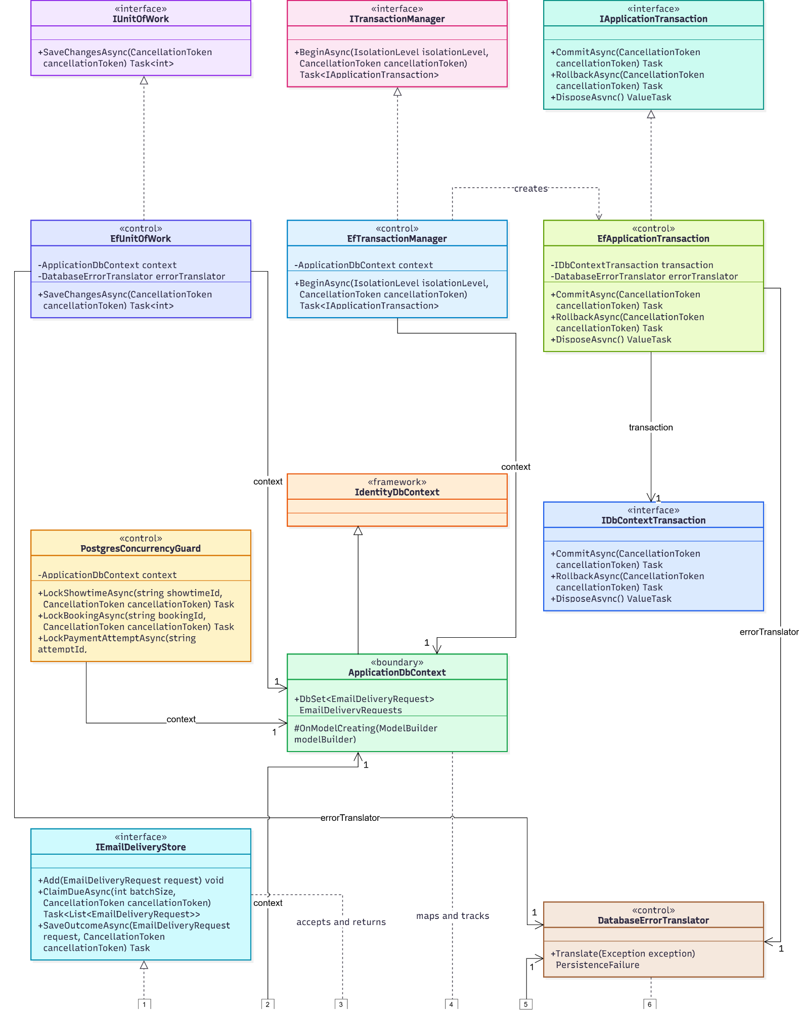
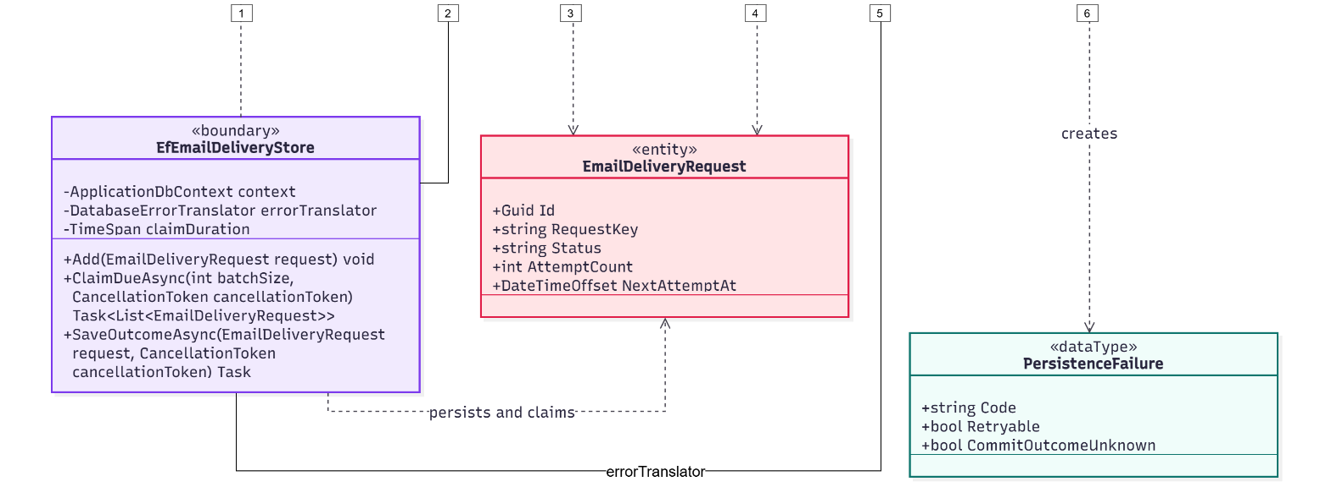
Figure 13: C13 Persistence and Transactions Class Diagram.
IdentityDbContext represents the configured ASP.NET Core Identity context base; its generic arguments are omitted for readability. The diagram shows the notification entity set as an example, rather than repeating every entity defined in the business-component diagrams.
EmailDeliveryRequest belongs to C15. Its abbreviated appearance here explains the persistence relationship and does not transfer ownership to C13.

Key Class Descriptions
Class or Interface | Responsibility | Key Attributes | Key Operations
ApplicationDbContext | Configures mappings and tracks changes for the current persistence scope. | Entity sets, including EmailDeliveryRequests; other sets correspond to the owning components’ entities. | OnModelCreating(...) configures mappings and constraints; inherited EF Core operations perform persistence.
IUnitOfWork | Defines the shared change-flush contract. | None. | SaveChangesAsync(...).
EfUnitOfWork | Flushes tracked changes and translates recognised persistence failures. | context, errorTranslator. | SaveChangesAsync(...).
ITransactionManager | Defines explicit transaction creation. | None. | BeginAsync(...).
EfTransactionManager | Starts a transaction on the shared context and returns its application-facing wrapper. | context. | BeginAsync(...).
IApplicationTransaction | Defines transaction completion and cleanup. | None. | CommitAsync(...), RollbackAsync(...), DisposeAsync().
EfApplicationTransaction | Wraps the database transaction and handles completion errors. | transaction, errorTranslator. | Commits, rolls back, and disposes the underlying transaction.
PostgresConcurrencyGuard | Centralises the principal locking operations used by relevant persistence stores. | context. | Locks showtime, booking, and payment-attempt records within the current transaction.
IEmailDeliveryStore | Defines C15’s required persistence operations. | None. | Adds requests, claims due work, and saves outcomes.
EfEmailDeliveryStore | Implements durable notification storage and processing claims. | context, errorTranslator, claimDuration. | Implements IEmailDeliveryStore.
DatabaseErrorTranslator | Converts recognised provider errors into application-safe persistence categories. | No domain state. | Translate(...).
PersistenceFailure | Describes a persistence failure without exposing database internals. | Code, Retryable, CommitOutcomeUnknown. | No business operations.
EmailDeliveryRequest | Represents notification work owned by C15. | Abbreviated identifier, deduplication key, status, and scheduling fields. | Full operations are defined in C15.
Other store implementations include identity/access, movie catalogue, cinema/seating, showtime, pricing, booking, payment, cancellation/refund, ticketing/admission, and audit stores. Each uses the shared context and implements the owning component’s persistence contract.

Class Relationships
Source | Target | Relationship | Meaning
ApplicationDbContext | IdentityDbContext | Generalization | Extends the Identity-compatible context with application mappings.
EfUnitOfWork | IUnitOfWork | Realization | Implements the change-flush contract.
EfTransactionManager | ITransactionManager | Realization | Implements transaction creation.
EfApplicationTransaction | IApplicationTransaction | Realization | Implements transaction completion and cleanup.
EfEmailDeliveryStore | IEmailDeliveryStore | Realization | Implements C15’s persistence contract.
Unit of work, transaction manager, concurrency guard, and store | ApplicationDbContext | Association | Retain the scoped context used for their database operations.
EfTransactionManager | EfApplicationTransaction | Dependency | Creates the transaction wrapper.
EfApplicationTransaction | IDbContextTransaction | Association | Retains the underlying framework transaction reference.
Persistence implementations | DatabaseErrorTranslator | Association | Retain a translator for recognised database failures.
Context and notification-store types | EmailDeliveryRequest | Dependency | Map, accept, return, or persist C15’s entity.
DatabaseErrorTranslator | PersistenceFailure | Dependency | Creates a structured failure description.
The context does not have composition ownership over business entities. Disposing a context does not delete the corresponding database records.

Data Ownership and Consistency

Logical Ownership and Persistence Scope
Business components own the meaning and permitted transitions of their records. C13 owns their persistence mappings, database access implementations, and technical integrity mechanisms.
Stores participating in one coordinated operation share the same context and explicit transaction. They must not create independent contexts that would break the required atomic boundary.
A context is not used concurrently by parallel tasks. Background tasks create separate scopes, and parallel reads use separate contexts where needed.

Atomic Business Changes
The following operations require coordinated persistence:
Operation | Changes That Must Remain Consistent
Reservation creation | Booking, all requested allocations, accepted price snapshot, and reservation deduplication information.
Eligible payment confirmation | Applied payment outcome, confirmed booking, sold allocations, issued ticket, notification request, and required audit records.
Booking expiration or eligible pending cancellation | Booking state and release of the associated held allocations.
Ticket admission | Recorded admission counts, request deduplication, and automatic rejection of a pending cancellation request where required.
Confirmed-booking refund completion | Refund evidence and completion state, booking cancellation, ticket invalidation, allocation release, and required audit records.
Account session replacement | Revocation of the previous active session and creation of the replacement session.
The application service defines the required business changes. C13 ensures that their persistence succeeds or fails within the specified transaction.

Constraints and Concurrency Protection
- Primary and foreign keys preserve identity and valid references.
- Database uniqueness prevents conflicting active allocations for the same physical seat and showtime.
- Scheduling constraints and coordinated locking protect against overlapping room schedules.
- Unique business identifiers and request keys support idempotent reservation, payment, admission, and notification processing.
- Check constraints enforce suitable record-level limits, including non-negative values and valid count relationships.
- Cross-record rules use coordinated transactions and locking; they are not assumed to be enforced by simple row-level checks.
- Related showtime, booking, and payment-attempt locks follow the agreed order: showtime, booking, then payment attempt.
- Multiple records of the same category are locked in a deterministic order.
- Operations re-read relevant state after acquiring protection and before applying changes.
Isolation level, locking, and database constraints are selected together for each operation. A preliminary availability query alone does not establish exclusive ownership of a seat or schedule slot.

Notification Claims and Recovery
Notification requests created during a business operation participate in that operation’s transaction.
Background claiming uses a separate short transaction. A successful claim records a lease expiry and a claim token identifying the processing attempt. Outcome updates must match the current claim token so that a stale worker cannot overwrite a newer attempt.
Lease metadata may be mapped as persistence-only fields. It does not need to become part of the business-facing email content model.
A claim reduces concurrent processing but does not guarantee exactly-once delivery to an external provider. C15 handles uncertain submission outcomes and possible duplicate emails.

Data Representation and Retention
- Monetary values use decimal application types and appropriate PostgreSQL numeric mappings.
- Timestamps representing instants use UTC-compatible mappings; business-time presentation follows the system’s timezone rules.
- Accepted booking prices and required scheduling snapshots remain preserved after later configuration changes.
- Historical bookings, payments, refunds, and audit records are protected from unintended cascading deletion.
- Credentials and provider secrets are not stored in ordinary business records or diagnostic messages.
- C12 conversation history remains outside PostgreSQL under the agreed session-only design.

Key Processing Flows and Failure Handling

Read Operation
- The owning application service validates access and determines the permitted query scope.
- Its persistence store executes a parameterised query through the scoped context.
- The query applies the required filters and pagination.
- The store returns entities or projected result models.
- The owning component prepares the application response.
Read-only queries avoid unnecessary entity tracking. Persistence results do not independently grant permission to perform a later state change.

Coordinated Write Operation
- The coordinating application service begins a transaction through ITransactionManager.
- Participating stores acquire the required locks in the agreed order.
- The owning services revalidate current permissions, deadlines, and business conditions.
- The services apply the required entity changes and register related notification and audit records.
- IUnitOfWork.SaveChangesAsync(...) flushes the changes.
- Database constraints provide the final integrity checks.
- The coordinator commits the transaction.
- Follow-up external processing occurs after commit.
If the operation fails before successful completion, the coordinator rolls back the transaction and disposes its persistence scope.

External Calls and Result Application
- The owning component records any required initiation information in a short transaction.
- The transaction completes before the external network call.
- The component calls the external provider.
- A new transaction reloads and protects the relevant records.
- The component revalidates eligibility and applies the result idempotently.
- C13 persists the resulting changes atomically.
A database transaction does not include or roll back an external payment or email submission.

Database Failures and Retry
- Constraint violations become defined conflict outcomes rather than raw database error messages.
- Deadlocks and serialization failures may trigger bounded retries of the complete database operation using a fresh persistence scope.
- A retry re-reads current state and repeats required business validation.
- External network calls are not automatically replayed as part of a database retry.
- Connection loss during commit is treated as an uncertain outcome. The system checks durable business identifiers before attempting the operation again.
- Transaction cancellation and disposal release resources; request cancellation does not prove that a commit failed.
- Recognised errors are translated into application-safe categories. Unexpected errors are logged with a correlation identifier and returned through the standard error-handling path.

Schema Changes
- Schema changes are represented by version-controlled migrations.
- Migrations include required constraints, indexes, and PostgreSQL-specific statements.
- Database schema updates are executed as a controlled deployment activity, not during ordinary user requests.
- Changes affecting historical records or existing constraints are reviewed for data compatibility before application.

Component C14 Background Processing

Purpose and Responsibilities
Background Processing executes recurring system tasks independently of customer browser sessions. It schedules processing cycles, creates execution scopes, invokes the responsible application services, and handles execution-level failures.
The component supports three background activities:
- Booking expiration through C08 Booking and Checkout.
- Payment reconciliation through C09 Payment Processing.
- Queued email delivery through C15 Notification Delivery.
C14 controls when processing is attempted. The owning components determine which records are eligible and what business changes are permitted.
The component is responsible for:
- Starting and stopping workers with the backend application.
- Applying configured processing intervals and batch sizes.
- Preventing overlapping cycles within each worker instance.
- Creating a separate dependency-injection scope for each processing cycle.
- Propagating cancellation requests during application shutdown.
- Recording execution diagnostics and applying bounded delays after failures.
- Resuming processing from durable application state after a restart.
Background execution does not depend on an open browser tab or an active customer session. It requires the backend application to remain running.

Use-Case Traceability
Use Case | Contribution of C14
UC-03 Release Expired Bookings | Periodically invokes C08 to identify and process bookings eligible for expiration.
UC-04 Payment Reconciliation | Periodically invokes C09 to reconcile payment attempts whose outcomes require verification.
UC-02 Payment Webhook | Supports recovery through reconciliation when notifications are delayed, missing, or leave an unresolved outcome. Webhook handling itself belongs to C09.
UC-08A Register Customer Account; UC-08B Verify Email Address | Triggers processing of queued verification-email requests through C15.
UC-09 Checkout and Payment | Supports subsequent payment recovery and delivery of queued booking-confirmation emails.
UC-10 Customer Booking Lifecycle; UC-19 Manage Bookings and Tickets | Triggers processing of authorised ticket-email resend requests queued by the responsible services.
UC-04A Refund | Indirectly supports discovery of refund obligations when C09 reconciles an unapplied successful payment. C14 does not execute refunds.

Implementation Language and Technologies
The component is implemented in C# using ASP.NET Core hosted services.
It uses:
- BackgroundService for long-running worker lifecycle management.
- Asynchronous operations and cancellation tokens.
- IServiceScopeFactory to create a fresh scope for each processing cycle.
- Dependency injection to resolve scoped application services.
- Configuration-bound options for processing intervals, failure delays, and batch sizes.
- Structured application logging for execution diagnostics.
Hosted services do not automatically receive a dependency-injection scope. Each worker therefore creates a scope before resolving services that depend on scoped persistence resources. Microsoft Learn
The workers run within the modular monolith backend. The current design does not require a separate scheduler server or message broker.

Provided Interfaces and Services
Service or Operation | Responsibility
RecurringWorker.ExecuteAsync(...) | Runs the recurring execution loop until application shutdown is requested.
RecurringWorker.RunCycleAsync(...) | Defines the processing cycle implemented by each concrete worker.
BookingExpirationWorker | Creates an execution scope and invokes C08 booking-expiration processing.
PaymentReconciliationWorker | Creates an execution scope and invokes C09 payment-reconciliation processing.
NotificationDeliveryWorker | Creates an execution scope and invokes C15 queued-email processing.
WorkerScheduleOptions | Supplies the enabled state, processing interval, failure delay, and batch size for a worker.
Each worker awaits the completion of its current cycle before scheduling the next cycle. Processing intervals are measured between completed cycles, preventing a slow cycle from creating overlapping executions within the same worker instance.
C14 exposes no customer-facing API. Its entry points are invoked by the application host.

Dependencies and Communication
Calling Component | Receiving Component | Interface or Operation | Purpose | Communication
ASP.NET Core application host | C14 Background Processing | Hosted-service lifecycle | Start workers and request graceful shutdown. | In-process framework calls
C14 Background Processing | C08 Booking and Checkout | IBookingExpirationService.ProcessDueAsync(...) | Process bookings that may be eligible for expiration. | In-process C# interface calls
C14 Background Processing | C09 Payment Processing | IPaymentReconciliationService.ProcessDueAsync(...) | Reconcile payment attempts requiring authoritative verification. | In-process C# interface calls
C14 Background Processing | C15 Notification Delivery | NotificationDispatcher.ProcessDueAsync(...) | Process queued email-delivery requests. | In-process C# service calls
C08, C09, and C15 | C13 Persistence and Transactions | Owning component’s persistence contracts | Retrieve due work and persist processing outcomes. | In-process C# contracts
The expiration and reconciliation interfaces define the worker-facing contracts supplied by C08 and C09. Their implementations remain in those components.
C14 does not call MoMo or Brevo directly. C09 and C15 perform those integrations and apply their corresponding result-handling rules.
C14 also does not directly update booking, payment, or notification tables.

Class Diagram
The class diagram shows a shared recurring-worker base class and three specialised workers. Each concrete worker resolves its application service within a newly created scope.
«control» identifies execution coordination classes. «dataType» identifies configuration data. «framework» identifies a framework-provided class.
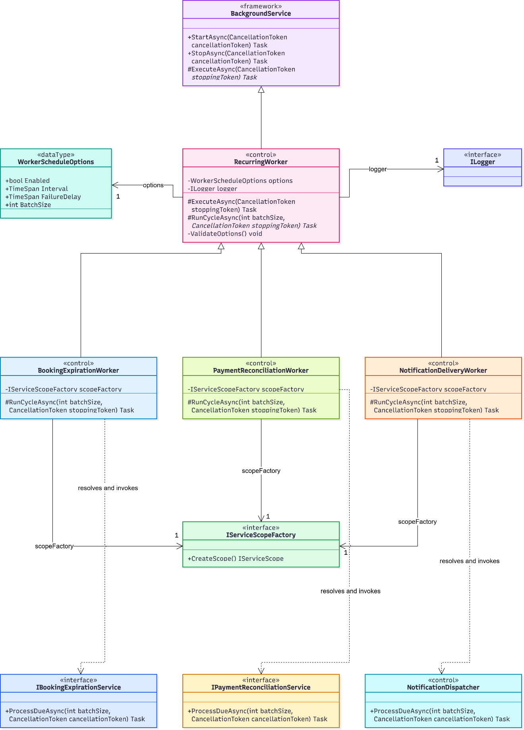
Figure 14: C14 Background Processing Class Diagram.
RecurringWorker is abstract. Each concrete worker implements RunCycleAsync(...).
IServiceScopeFactory and ILogger are framework interfaces. The implementation uses an asynchronous scope where required for asynchronous disposal; scope creation extension methods are omitted from the diagram.
IBookingExpirationService, IPaymentReconciliationService, and NotificationDispatcher represent collaborators owned by C08, C09, and C15 respectively. Their internal classes are described in those components.

Key Class Descriptions
Class or Interface | Responsibility | Key Attributes | Key Operations
RecurringWorker | Implements recurring execution, configuration validation, cancellation handling, logging, and delay after a failed cycle. | options: worker-specific configuration; logger: execution diagnostics. | ExecuteAsync(...) controls the loop; RunCycleAsync(...) defines the specialised processing step; ValidateOptions() checks configuration.
BookingExpirationWorker | Delegates each expiration cycle to C08. | scopeFactory: creates a fresh execution scope. | RunCycleAsync(...) resolves and invokes IBookingExpirationService.
PaymentReconciliationWorker | Delegates each reconciliation cycle to C09. | scopeFactory: creates a fresh execution scope. | RunCycleAsync(...) resolves and invokes IPaymentReconciliationService.
NotificationDeliveryWorker | Delegates each notification cycle to C15. | scopeFactory: creates a fresh execution scope. | RunCycleAsync(...) resolves and invokes NotificationDispatcher.
WorkerScheduleOptions | Defines one worker’s execution configuration. | Enabled, Interval, FailureDelay, and BatchSize. | No business operations.
BackgroundService | Supplies the application-host lifecycle for asynchronous workers. | Framework-managed lifecycle state. | StartAsync(...), StopAsync(...), and ExecuteAsync(...).
IServiceScopeFactory | Creates scopes used to resolve scoped application services. | None specified. | CreateScope(); asynchronous scope creation is available through framework extensions.
ILogger | Supplies structured execution logging. | None specified. | Framework logging operations; individual overloads are omitted.
IBookingExpirationService | Exposes C08’s background-expiration entry point. | None. | ProcessDueAsync(...).
IPaymentReconciliationService | Exposes C09’s background-reconciliation entry point. | None. | ProcessDueAsync(...).
NotificationDispatcher | Processes due notification requests under C15’s delivery and retry rules. | Internal dependencies are defined in C15. | ProcessDueAsync(...).
Each worker receives its own WorkerScheduleOptions configuration. Expiration, reconciliation, and notification processing can therefore use different intervals and batch sizes.

Class Relationships
Source | Target | Relationship | Meaning
RecurringWorker | BackgroundService | Generalization | Extends the framework worker lifecycle with shared recurring-execution behaviour.
BookingExpirationWorker | RecurringWorker | Generalization | Implements the booking-expiration processing cycle.
PaymentReconciliationWorker | RecurringWorker | Generalization | Implements the payment-reconciliation processing cycle.
NotificationDeliveryWorker | RecurringWorker | Generalization | Implements the notification-delivery processing cycle.
RecurringWorker | WorkerScheduleOptions | Association | Retains the configuration for its execution loop.
RecurringWorker | ILogger | Association | Retains a logging reference.
Each concrete worker | IServiceScopeFactory | Association | Retains a scope factory used for individual cycles.
BookingExpirationWorker | IBookingExpirationService | Dependency | Resolves and invokes the service inside a temporary scope.
PaymentReconciliationWorker | IPaymentReconciliationService | Dependency | Resolves and invokes the service inside a temporary scope.
NotificationDeliveryWorker | NotificationDispatcher | Dependency | Resolves and invokes the dispatcher inside a temporary scope.
The application-service relationships are dependencies because the worker does not retain those scoped services between cycles.
C14 does not introduce a persistent business entity. Its durable work items remain represented by records owned by C08, C09, and C15.

Data Ownership and Consistency

Execution State and Durable Work
C14 owns worker configuration and temporary execution state, such as whether a cycle is running and the delay before its next attempt.
The owning components retain durable processing state:
Owning Component | Durable State Used by Background Processing
C08 Booking and Checkout | Booking deadlines, booking states, seat allocations, and information needed to evaluate expiration eligibility.
C09 Payment Processing | Payment attempts, reconciliation eligibility, provider evidence, and processing outcomes.
C15 Notification Delivery | Queued email requests, delivery attempts, retry times, and processing claims.
Worker timers are scheduling mechanisms. They are not the authoritative source of booking or payment deadlines.
After a backend restart, workers query durable due work again. The application does not need to reconstruct every missed timer tick.

Transaction Boundaries
C14 does not open a transaction around an entire worker loop or processing batch.
C08, C09, and C15 define their own transaction boundaries through C13. A batch may contain multiple independently committed work items.
Successfully committed items remain committed if a later item fails. A subsequent cycle re-evaluates outstanding work using current persisted state.
External provider calls occur under the owning component’s rules and outside database transactions holding business locks.

Concurrency and Repeated Execution
Within one worker instance, processing cycles do not overlap. Different workers may execute concurrently using separate scopes and persistence contexts.
Worker-local execution control does not provide a distributed lock. If multiple backend instances run, correctness remains dependent on the owning components’ database locking, conditional updates, claims, and idempotency mechanisms.
Repeated execution must preserve the following properties:
- Expiration does not release payment-protected allocations.
- Reconciliation does not apply the same payment outcome more than once.
- Notification retries do not repeat booking confirmation or ticket issuance.
- Stale processing attempts cannot overwrite a newer claimed outcome.
- A timer firing does not establish that a record is eligible for modification.
Protected records remain subject to authoritative state checks even if processing is delayed.

System Execution Context
Background operations execute under a defined system context. They do not impersonate an arbitrary Customer, Staff member, Manager, or Admin.
Where an operation requires an audit record, the owning component records the system actor and relevant correlation information through C16.
C14 execution logs describe worker activity. They do not replace mandatory business audit records.

Key Processing Flows and Failure Handling

Worker Startup and Scheduling
- The application host starts the registered workers.
- Each worker validates its configuration, including positive intervals and a valid batch size.
- A disabled worker exits without starting its processing loop.
- An enabled worker begins its first processing cycle.
- The worker awaits completion of the cycle.
- It waits for the configured interval before beginning the next cycle.
- The loop continues until application shutdown is requested.
Separate worker loops prevent a slow notification cycle from directly blocking expiration or reconciliation scheduling.

Booking Expiration
- BookingExpirationWorker creates a fresh execution scope.
- It resolves IBookingExpirationService from C08.
- C08 retrieves a bounded set of candidate bookings.
- C08 rechecks deadlines, current booking state, payment protection, and applicable grace-period conditions.
- Eligible bookings are expired and their held allocations released atomically.
- Bookings with unresolved protected payment outcomes remain protected and are handled according to the reconciliation rules.
- The worker records the cycle outcome and disposes the scope.
The worker does not independently calculate a new booking deadline or release seats because a polling interval has elapsed.

Payment Reconciliation
- PaymentReconciliationWorker creates a fresh execution scope.
- It resolves IPaymentReconciliationService from C09.
- C09 selects payment attempts due for reconciliation.
- C09 obtains authoritative provider information outside transactions holding business locks.
- C09 reloads and protects the affected records before applying an eligible result.
- The component applies the result idempotently or records the required unresolved, review, or refund-obligation state.
- The worker records the cycle outcome and disposes the scope.
Reconciliation may execute concurrently with webhook processing. C09 and C13 preserve consistency between those execution paths.

Notification Delivery
- NotificationDeliveryWorker creates a fresh execution scope.
- It resolves NotificationDispatcher from C15.
- The dispatcher atomically claims a bounded set of due requests through C13.
- C15 submits messages to Brevo outside the claiming transaction.
- C15 records acceptance, retry scheduling, or terminal failure using the current processing claim.
- The worker records the cycle outcome and disposes the scope.
Authorised resend requests and initial notifications use the same delivery-processing mechanism.

Execution Failures and Retry
- Expected record-level failures are handled by the owning component according to its business rules.
- A cycle-level exception is logged, and the worker disposes the current scope before waiting for the configured failure delay.
- The next cycle creates a fresh scope and queries current durable state.
- C14 does not immediately replay individual payment or email submissions after an uncertain external outcome.
- Retry eligibility and next-attempt timestamps for individual records remain owned by C09 and C15.
- Cancellation caused by normal application shutdown is treated as lifecycle completion rather than a processing fault.
- Persistent failures remain visible through structured error logs and repeated cycle-failure diagnostics.
- Logs exclude provider credentials, verification tokens, and full sensitive message content.

Shutdown and Restart Recovery
- The application host requests worker cancellation.
- Workers stop scheduling new cycles and pass cancellation to active operations.
- Owning services complete or roll back their current database operations where possible.
- Execution scopes are disposed.
- After restart, workers retrieve outstanding due work from persistent storage.
- Expired processing claims become recoverable under the owning component’s rules.
Abrupt termination may prevent graceful cleanup. Recovery therefore relies on durable state, expiring claims where applicable, and idempotent processing rather than on shutdown code alone.
A failed or interrupted background cycle does not reverse an already committed booking, payment, ticket, or email-processing outcome.

Component C15 Notification Delivery

Purpose and Responsibilities
Notification Delivery provides transactional email services for account verification and booking-confirmation workflows. It prepares email content, persists delivery requests, submits messages to Brevo, and records processing outcomes.
The component supports:
- Account-verification emails containing links generated by Identity and Access.
- Booking-confirmation emails containing booking details and the existing booking-level ticket or QR.
- Controlled retries after temporary delivery failures.
- Authorised ticket-email resend requests.
Identity and Access validates verification tokens and updates account verification state. Booking, payment, and ticketing components determine booking confirmation and ticket validity. Notification Delivery prepares and queues messages using information supplied by the responsible application services. Where atomic coordination is required, the delivery request is persisted within the transaction that records the associated business change. Email submission occurs only after that transaction commits.

Use-Case Traceability
Use Case | Contribution of C15
UC-08A Register Customer Account | Supports delivery of the verification email initiated after account creation.
UC-08B Verify Email Address | Delivers verification links and permitted replacement verification emails.
UC-02 Payment Webhook | Processes notification requests created following eligible payment confirmation and ticket issuance.
UC-04 Payment Reconciliation | Processes notification requests created when reconciliation successfully confirms a booking.
UC-09 Checkout and Payment | Supports delivery of the confirmed booking and ticket resulting from checkout.
UC-10 Customer Booking Lifecycle | Supports authorised ticket-email resend requests.
UC-19 Manage Bookings and Tickets | Supports permitted operational requests to resend ticket information.

Implementation Language and Technologies
The component is implemented in C# within the ASP.NET Core backend.
It uses:
- HttpClient to call the Brevo transactional email API over HTTPS.
- JSON for provider request and response payloads.
- Persistence services implemented by C13 through EF Core and PostgreSQL.
- Background execution supplied by C14.
- Backend configuration for the API key, sender identity, endpoint, timeout, and retry settings.
The provider integration is encapsulated behind IEmailSender, allowing notification coordination to remain independent of Brevo-specific request formats.

Provided Interfaces and Services
Service or Operation | Responsibility
NotificationService.QueueVerificationEmail(...) | Prepares a verification email using the recipient and verification link supplied by C03 and adds a durable delivery request.
NotificationService.QueueBookingEmail(...) | Prepares a booking email using authorised booking and ticket information and adds a durable delivery request.
NotificationDispatcher.ProcessDueAsync(...) | Claims due delivery requests, sends messages, and records processing outcomes.
IEmailSender.SendAsync(...) | Submits an email to the configured provider and returns its acceptance or failure result.
Queueing operations participate in the caller’s transaction where the notification request must be committed with the associated business change. They do not independently commit that transaction.
A stable request key prevents duplicate processing of the same business event from creating duplicate initial notification requests. An explicitly authorised resend creates a separate delivery request while retaining the existing booking and ticket.

Dependencies and Communication
Calling Component | Receiving Component | Interface or Operation | Purpose | Communication
C03 Identity and Access | C15 Notification Delivery | NotificationService.QueueVerificationEmail(...) | Prepare and queue an account-verification email using the verification link supplied by C03. | In-process C# method call.
Booking and payment application services | C15 Notification Delivery | NotificationService.QueueBookingEmail(...) | Queue the initial booking-confirmation email within the transaction that confirms the booking and issues the ticket. | In-process C# method call within the coordinated database transaction.
Services implementing UC-10 and UC-19 | C15 Notification Delivery | NotificationService.QueueBookingEmail(...) | Queue an authorised resend using the existing booking and ticket, with a separate delivery-request key. | In-process C# method call.
C14 Background Processing | C15 Notification Delivery | NotificationDispatcher.ProcessDueAsync(...) | Trigger processing of due email-delivery requests. | In-process asynchronous C# method call.
C15 Notification Delivery | C13 Persistence and Transactions | IEmailDeliveryStore.Add(...), ClaimDueAsync(...), SaveOutcomeAsync(...) | Register delivery requests, atomically claim due work, and persist processing outcomes. | In-process C# interface calls to the persistence implementation supplied by C13.
C15 Notification Delivery | Brevo | Brevo transactional email API, invoked by BrevoEmailSender.SendAsync(...) | Submit an email and obtain the provider’s acceptance or failure response. | HTTPS REST API with JSON, after the associated business transaction commits.
IEmailDeliveryStore defines the persistence contract used by C15. Its database implementation belongs to C13. Provider message identifiers and error fields are optional until the corresponding processing result exists.

Class Diagram
The class diagram shows the internal structure of Notification Delivery, including notification coordination, persistent delivery requests, email content, and the provider integration. NotificationService and NotificationDispatcher use IEmailDeliveryStore for persistence, while BrevoEmailSender implements IEmailSender for email submission. The database implementation of IEmailDeliveryStore belongs to C13 and is described in that component’s class design.
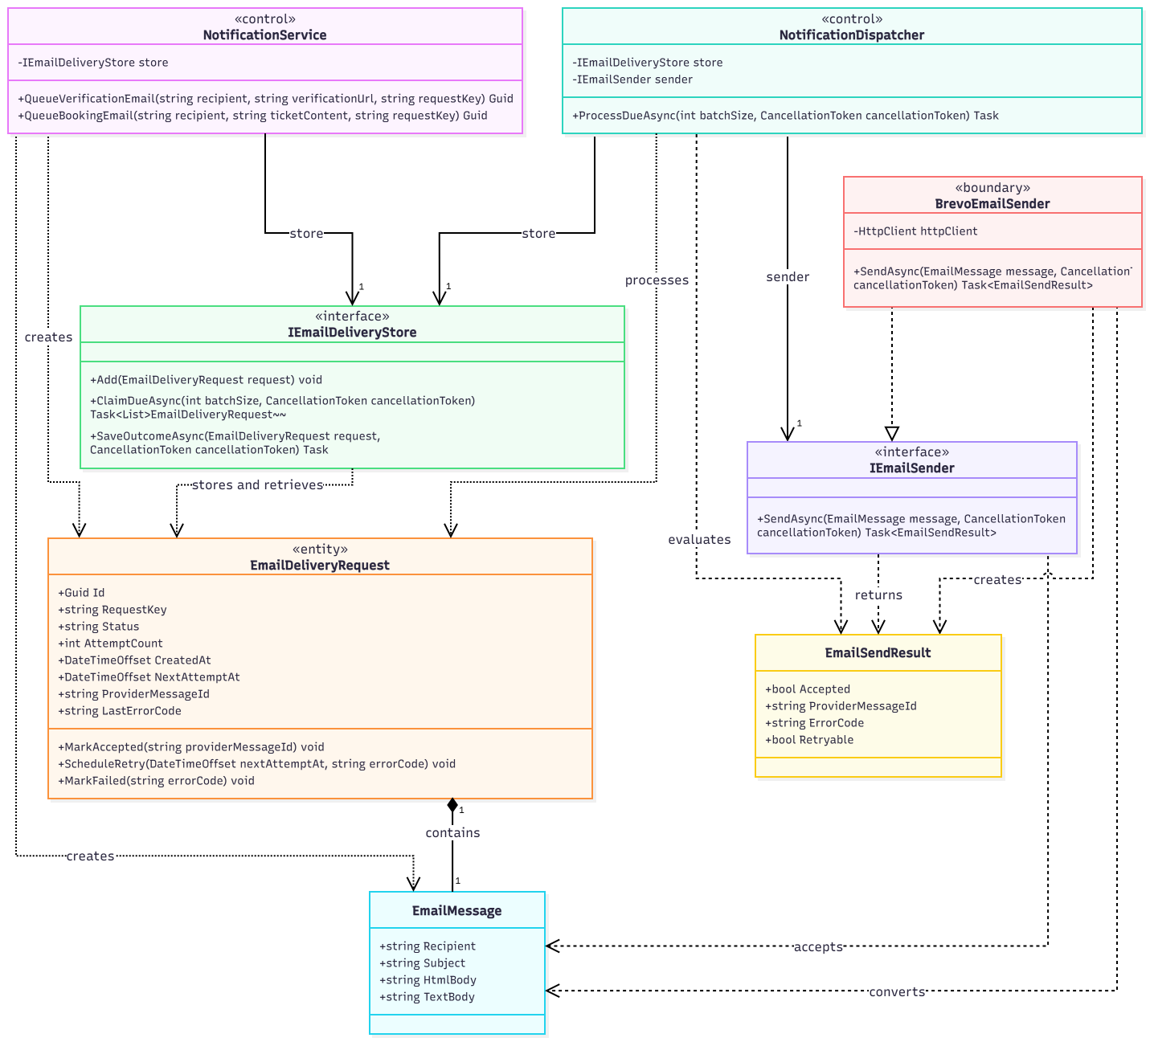
Figure 15: C15 Notification Delivery Class Diagram.

Key Class Descriptions
Class or Interface | Responsibility | Key Attributes | Key Operations
NotificationService | Prepares verification and booking emails and creates delivery requests. | store: persistence contract used to add delivery requests. | QueueVerificationEmail(...) prepares a verification email; QueueBookingEmail(...) prepares a booking-confirmation or authorised resend email. Both return the delivery-request identifier.
NotificationDispatcher | Coordinates processing of due requests and applies retry rules. | store: persistence access; sender: provider-independent email sender. | ProcessDueAsync(...) claims due requests, submits messages, evaluates results, and records outcomes.
EmailDeliveryRequest | Represents a persistent email-delivery request and its processing state. | Id: request identifier; RequestKey: deduplication key; Status: processing state; AttemptCount: number of sending attempts; CreatedAt: creation time; NextAttemptAt: scheduled processing time; ProviderMessageId and LastErrorCode: available provider or failure information. | MarkAccepted(...) records provider acceptance; ScheduleRetry(...) records a temporary failure and the next attempt time; MarkFailed(...) records a terminal failure.
EmailMessage | Holds the email content owned by a delivery request. | Recipient, Subject, HtmlBody, and TextBody describe the destination and rendered content. | No business operations are defined; this class carries email data.
IEmailDeliveryStore | Defines the persistence contract used by notification services. | No instance attributes are specified in the interface. | Add(...) registers a new request for persistence; ClaimDueAsync(...) atomically claims eligible requests; SaveOutcomeAsync(...) persists processing outcomes.
IEmailSender | Defines provider-independent email submission. | No instance attributes are specified in the interface. | SendAsync(...) accepts an EmailMessage and asynchronously returns an EmailSendResult.
BrevoEmailSender | Implements email submission through the Brevo HTTPS API. | httpClient: HTTP client used for provider communication. | SendAsync(...) converts email content into the provider request, submits it, and maps the response into an EmailSendResult.
EmailSendResult | Carries the outcome of a provider submission attempt. | Accepted: whether the provider accepted the request; ProviderMessageId: provider identifier where available; ErrorCode: failure information; Retryable: whether a failure is eligible for retry. | No business operations are defined; the dispatcher evaluates the returned data.

Class Relationships
Source | Target | Relationship | Meaning
NotificationService | IEmailDeliveryStore | Association | The service retains one store reference to register delivery requests.
NotificationDispatcher | IEmailDeliveryStore | Association | The dispatcher retains one store reference to claim requests and persist outcomes.
NotificationDispatcher | IEmailSender | Association | The dispatcher retains one sender reference to submit email messages.
BrevoEmailSender | IEmailSender | Realization | BrevoEmailSender implements the email-submission contract defined by IEmailSender.
EmailDeliveryRequest | EmailMessage | Composition | Each delivery request owns exactly one email-content object. That object is not shared between delivery requests.
NotificationService | EmailDeliveryRequest; EmailMessage | Dependency | The service creates the delivery request and its email content.
NotificationDispatcher | EmailDeliveryRequest; EmailSendResult | Dependency | The dispatcher processes requests and evaluates submission results.
IEmailDeliveryStore | EmailDeliveryRequest | Dependency | The persistence operations accept or return delivery-request objects.
IEmailSender | EmailMessage; EmailSendResult | Dependency | The submission operation accepts email content and returns a submission result.
BrevoEmailSender | EmailMessage; EmailSendResult | Dependency | The provider adapter converts email content into a Brevo request and creates the corresponding result object.

Data Ownership and Consistency
C15 owns email-delivery requests and their processing outcomes. Account verification state, booking state, payment outcomes, ticket validity, and admission records remain owned by their respective business components.
The persistence design enforces uniqueness of the notification request key. Concurrent background executions use an atomic claim mechanism so that the same request is not intentionally processed by multiple workers at the same time.
Requests created as part of booking confirmation are committed with the associated business transaction. Brevo submission occurs after that transaction commits.
The recorded acceptance status indicates that the provider accepted the submission request. It does not establish successful delivery to the recipient’s mail server or that the recipient has read the email.A successful API response does not establish that the recipient has read the email.

Key Processing Flows and Failure Handling

Initial Email Delivery
- The responsible application service validates the business action and prepares the required verification or booking information.
- NotificationService creates an email-delivery request with a stable request key.
- The request is committed with the associated business change where atomic coordination is required.
- C14 invokes NotificationDispatcher.
- The dispatcher claims due requests through IEmailDeliveryStore.
- BrevoEmailSender submits each email over HTTPS outside the business transaction.
- The dispatcher records provider acceptance or the failure outcome.

Retry and Recovery
- Temporary provider failures are retried according to the configured retry policy.
- Invalid sender configuration, invalid request data, and other non-retryable failures are recorded for correction.
- Interrupted work becomes eligible for recovery after its processing claim expires.
- A timeout may leave provider acceptance uncertain. Retry handling must account for possible duplicate email delivery; notification retries must never repeat booking confirmation or ticket issuance.
- Authorised resend requests reuse the existing booking-level ticket and QR.
- API keys, verification tokens, and full sensitive email content are excluded from ordinary diagnostic logs.

Component C16 Audit Logging

Purpose and Responsibilities
Audit Logging records significant business actions and privileged operations so that their origin, purpose, and effects can be traced.
The component supports:
- Recording the responsible actor, action, affected record, and occurrence time.
- Capturing the relevant cinema scope and request correlation identifier.
- Recording selected state changes and supporting evidence references.
- Distinguishing authenticated-user actions from system-initiated operations.
- Persisting mandatory audit records within the transaction containing the associated business changes.
- Preventing modification or deletion of committed audit records through normal application operations.
The component receives audit information from the application service performing the action. It validates and prepares the audit record, then registers it for persistence through C13.
C16 does not determine whether a booking, refund, account update, or administrative operation is permitted. The owning component authorises and executes the action.
Business audit records are separate from diagnostic logs. Diagnostic logs support troubleshooting; audit records preserve the required evidence of business actions.

Use-Case Traceability
Use Case | Contribution of C16
UC-04A Refund | Records required refund actions, responsible personnel, affected obligations, and references to externally completed refund evidence.
UC-18 Manage User Accounts and Roles | Records privileged changes to account states, roles, and cinema assignments.
UC-19 Manage Bookings and Tickets | Records cancellation-review decisions and other operational actions requiring traceability.
UC-17 Manage Showtimes and Schedules | Records controlled schedule changes, responsible actors, and relevant before-and-after values.
UC-12 Manage Movie Catalog; UC-13 Manage Genres | Records catalogue administration actions where required by the operation specification.
UC-14A; UC-14B; UC-15A–UC-15C | Records required cinema, room, seating, operational-status, and seat-type configuration changes.
UC-16A; UC-16B | Records required ticket-category and cinema-pricing changes.
UC-02; UC-03; UC-04 | Records system-initiated payment or expiration actions where the corresponding specification requires an audit entry.
UC-05 Validate Ticket | Supports additional audit entries required by the admission specification. Admission records themselves remain owned by C11.
The owning use-case specification determines which actions require audit records. Routine reads and every technical processing step are not automatically treated as auditable business actions.

Implementation Language and Technologies
The component is implemented in C# within the ASP.NET Core backend.
It uses:
- In-process C# interfaces for audit-recording requests.
- Validated actor context supplied by C03 and the application execution scope.
- An authoritative server clock for occurrence timestamps.
- Explicitly selected structured fields for recorded changes.
- Persistence services implemented by C13 using EF Core and PostgreSQL.
- The caller’s database transaction when the audit record must remain atomic with the associated business change.
C16 does not require an external logging platform or a separate background worker. Mandatory audit records are registered synchronously within the business operation.

Provided Interfaces and Services
Interface or Operation | Responsibility
IAuditRecorder.Record(...) | Validates an audit request, captures actor and time information, and registers the record for persistence. Returns the audit-record identifier.
IAuditActorContext.GetCurrentActor() | Supplies the validated user or system actor associated with the current execution scope.
AuditDataPolicy.Validate(...) | Checks required action, target, reason, and evidence information against the supported audit-action rules.
AuditDataPolicy.SelectAllowedChanges(...) | Produces the permitted field-change representation and excludes sensitive or irrelevant values.
IAuditStore.Add(...) | Registers an audit record in the shared persistence context without independently saving or committing the transaction.
Record(...) returns an identifier for the registered record. The record becomes durable only when the coordinating operation successfully commits.
The current component provides audit recording. It does not introduce a new audit-search screen, export use case, or unrestricted audit-reading API.

Dependencies and Communication
Calling Component | Receiving Component | Interface or Operation | Purpose | Communication
C03 Identity and Access | C16 Audit Logging | IAuditRecorder.Record(...) | Record required account, role, assignment, and access-state changes. | In-process C# interface calls
C04 Movie Catalogue | C16 Audit Logging | IAuditRecorder.Record(...) | Record required catalogue administration actions. | In-process C# interface calls
C05 Cinema and Seating | C16 Audit Logging | IAuditRecorder.Record(...) | Record required cinema and seating configuration changes. | In-process C# interface calls
C06 Showtime Scheduling | C16 Audit Logging | IAuditRecorder.Record(...) | Record controlled schedule changes. | In-process C# interface calls
C07 Ticket Pricing | C16 Audit Logging | IAuditRecorder.Record(...) | Record required ticket-category and pricing changes. | In-process C# interface calls
C08 Booking and Checkout | C16 Audit Logging | IAuditRecorder.Record(...) | Record booking lifecycle actions requiring audit evidence. | In-process C# interface calls
C09 Payment Processing | C16 Audit Logging | IAuditRecorder.Record(...) | Record payment-result application or recovery actions where required. | In-process C# interface calls
C10 Cancellation and Refund | C16 Audit Logging | IAuditRecorder.Record(...) | Record cancellation decisions, refund completion, and evidence references. | In-process C# interface calls
C11 Ticketing and Admission | C16 Audit Logging | IAuditRecorder.Record(...) | Record additional ticketing or admission actions where required. | In-process C# interface calls
C16 Audit Logging | C03 and the validated execution context | IAuditActorContext | Obtain the current user or system actor. | In-process C# context access
C16 Audit Logging | C13 Persistence and Transactions | IAuditStore | Persist audit records with the associated business changes. | In-process C# persistence contract
C14 supplies the execution scope for background work. The owning application service records any required audit action using the system actor established for that scope.
C16 does not accept a browser-supplied actor identifier as authoritative.

Class Diagram
The diagram shows audit coordination, actor-context access, field-selection rules, and the audit record registered for persistence.
«dataType» identifies structured input and context values. «entity» identifies a durable audit record. «control» identifies coordination and validation classes.
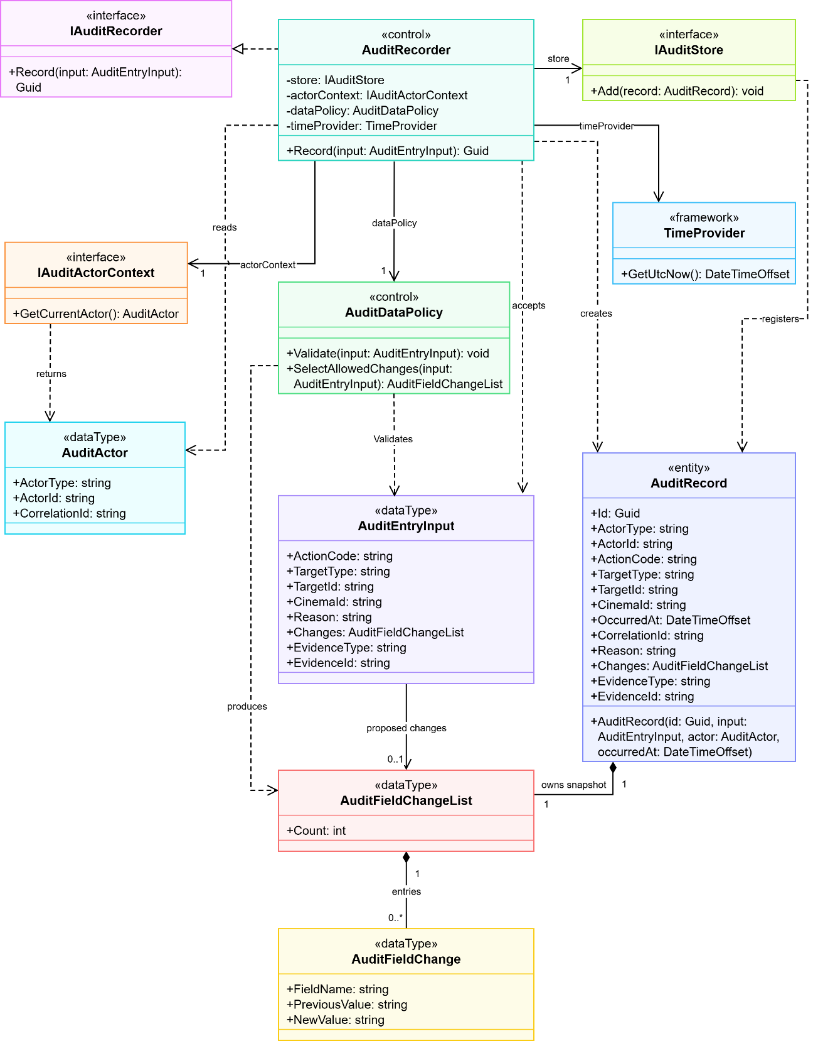
Figure 16: C16 Audit Logging Class Diagram.
Public attributes shown on AuditRecord represent readable properties. They are initialised during construction and have no public setters.
The recorder creates a defensive copy of the permitted field changes. Later changes to the input object cannot alter the audit record.
AuditFieldChangeList is a named collection type. An audit record may contain an empty collection when field-level changes are not applicable.
The implementation of IAuditStore belongs to C13. IAuditActorContext is supplied by the validated request or background execution scope.

Key Class Descriptions
Class or Interface | Responsibility | Key Attributes | Key Operations
IAuditRecorder | Defines the audit-recording contract used by application services. | None. | Record(...) registers an audit entry and returns its identifier.
AuditRecorder | Coordinates input validation, actor capture, timestamp assignment, field selection, and persistence registration. | store, actorContext, dataPolicy, timeProvider. | Record(...).
IAuditActorContext | Supplies the actor associated with the validated execution scope. | None. | GetCurrentActor().
AuditActor | Identifies the acting user or system process. | ActorType, ActorId, CorrelationId. | No business operations.
AuditDataPolicy | Applies supported action rules and determines which values may enter the audit record. | No persistent state. | Validate(...); SelectAllowedChanges(...).
AuditEntryInput | Carries business-action information supplied by the owning service. | Action, target, optional cinema scope, reason, proposed changes, and evidence reference. | No business operations.
AuditFieldChangeList | Groups field changes belonging to one audit entry. | Count; contained field changes. | Collection behaviour; individual collection methods are omitted.
AuditFieldChange | Represents one selected before-and-after value pair. | FieldName, PreviousValue, NewValue. | No business operations.
AuditRecord | Preserves the completed audit entry. | Identifier, actor, action, target, timestamp, correlation identifier, selected changes, reason, and evidence reference. | Constructor establishes the record. No update or delete operation is provided.
IAuditStore | Defines persistence registration for audit records. | None. | Add(...).
TimeProvider | Supplies authoritative server time through an injectable clock. | Framework-managed state. | GetUtcNow().
CinemaId, Reason, previous/new values, and evidence references are optional where the action does not require them. Their requiredness is determined by the action-specific policy.

Class Relationships
Source | Target | Relationship | Meaning
AuditRecorder | IAuditRecorder | Realization | Implements the application-facing audit contract.
AuditRecorder | IAuditStore | Association | Retains a persistence contract for registering records.
AuditRecorder | IAuditActorContext | Association | Retains access to the validated execution actor.
AuditRecorder | AuditDataPolicy | Association | Retains the policy used to validate and filter audit data.
AuditRecorder | TimeProvider | Association | Retains the clock used to assign occurrence time.
AuditRecorder | AuditEntryInput; AuditActor; AuditRecord | Dependency | Accepts action information, reads actor context, and creates an audit record.
IAuditActorContext | AuditActor | Dependency | Returns the actor representation.
AuditDataPolicy | AuditEntryInput; AuditFieldChangeList | Dependency | Validates the input and produces permitted changes.
AuditEntryInput | AuditFieldChangeList | Association | References proposed changes supplied by the calling service.
AuditRecord | AuditFieldChangeList | Composition | Owns its immutable change snapshot.
AuditFieldChangeList | AuditFieldChange | Composition | Owns the field-change entries within that snapshot.
IAuditStore | AuditRecord | Dependency | Accepts an audit record for persistence.

Data Ownership and Consistency

Audit Record Ownership
C16 owns audit records and the rules governing their structure. The business components retain ownership of the underlying records and decisions.
For example:
- C10 owns refund obligations and refund-completion evidence.
- C11 owns tickets and admission records.
- C03 owns account states, roles, and cinema assignments.
- C06 owns showtimes and schedule changes.
An audit record references these business records. It does not replace them or become the authoritative source of their current state.

Atomicity with Business Changes
A mandatory audit record is registered within the same persistence scope and transaction as the business change it documents.
The coordinating application service commits both together. If the audit record cannot be prepared or persisted, the associated operation must not be reported as successfully completed.
C16 does not independently call SaveChangesAsync(...) or commit the transaction.
A rolled-back operation does not leave a committed success audit record. Diagnostic reporting of a failed attempt follows the separate application-logging path.
An external monetary refund cannot be reversed by a database rollback. If recording its completion fails, the refund remains to be reconciled and recorded using the existing external evidence; the application must not instruct personnel to execute the monetary refund again merely because persistence failed.

Actor and Time Integrity
- Actor identity comes from the validated execution scope.
- User actions record the authenticated account identifier.
- Background actions record a defined system actor identifier.
- Privileged actions retain the actor who performed the action even if that account’s roles later change.
- OccurredAt records the server time when the application records the action.
- An external event’s actual occurrence time remains part of the owning business evidence where required.
- A correlation identifier connects related processing records but does not replace authorisation or business identifiers.
Historical audit records are not deleted when an account is disabled or a referenced business record is archived.

Recorded Changes and Sensitive Data
Only selected fields relevant to the action are recorded. The system does not serialise complete request objects or tracked entities into audit records.
Audit data excludes:
- Passwords and password hashes.
- Access tokens, refresh tokens, and verification tokens.
- Provider API keys and other credentials.
- Full payment-provider payloads containing sensitive information.
- Full email bodies and private conversation history.
- Unnecessary personal information.
Evidence references identify records owned by the relevant component. They do not embed provider secrets or unrestricted access links.

Immutability and Repeated Processing
The normal application path permits inserting audit records but provides no update or delete service for committed entries. C13 enforces the corresponding persistence restrictions.
If a correction is required, a new authorised entry records the correction and references the affected record; the original entry remains intact.
Business-operation idempotency governs repeated processing. A retry that discovers an already completed action returns its existing outcome rather than recording another successful transition.
Multiple audit entries may legitimately refer to the same target when they describe distinct actions, such as cancellation approval followed by refund completion. A correlation identifier is therefore not treated as a globally unique audit-event key.

Key Processing Flows and Failure Handling

Privileged Business Action
- The owning application service authenticates and authorises the requested operation.
- It begins the required transaction and obtains the applicable concurrency protection.
- It revalidates the business conditions and applies the intended changes.
- It constructs AuditEntryInput with the action code, affected record, relevant changes, and required reason or evidence reference.
- AuditRecorder obtains the actor from IAuditActorContext.
- AuditDataPolicy validates the entry and selects permitted field values.
- The recorder obtains the server timestamp and constructs an immutable AuditRecord.
- IAuditStore.Add(...) registers the record in the shared persistence context.
- The coordinating service saves and commits the business changes and audit record together.

Refund Completion
- Authorised personnel provide the required evidence of an externally completed refund through C10.
- C10 validates the obligation, evidence, permissions, and applicable completion conditions.
- C10 applies the required refund and related business-state changes.
- C10 requests an audit entry containing the actor, refund-obligation identifier, completion action, and evidence reference.
- C16 registers the audit record.
- The coordinator commits the refund changes, required booking and ticket effects, and audit record atomically.
The audit entry documents the application’s recording of refund completion. The monetary refund itself remains an external action.

Background Action
- C14 creates a background execution scope.
- The owning component processes the eligible record under its system-operation rules.
- Where audit recording is required, the component supplies the action and target information to C16.
- C16 obtains the system actor and records the relevant context.
- The owning component commits the audit entry with the corresponding state transition.
Worker start, stop, and polling messages remain execution diagnostics rather than business audit entries.

Validation and Persistence Failures
- Missing mandatory actor, target, reason, or evidence information causes audit validation to fail.
- An unsupported action code is rejected rather than stored as an ambiguous action.
- Sensitive fields are excluded according to the audit-data policy.
- Failure to persist a mandatory audit record causes the associated database operation to fail or roll back.
- Database retry handling is coordinated through the owning operation and C13.
- An uncertain commit outcome is resolved by checking the durable business result before retrying.
- Errors returned to clients exclude internal audit contents, database details, and secrets.
- Diagnostic logs include sufficient correlation information to investigate the failure without exposing the protected audit data.

Deployment
[Leave this section blank for PA4.
In this section, describe how the system is deployed by mapping the components in Section 4 to machines running them. For example, your mobile app is running on a mobile device (Android, iOS, etc), your server runs all components on the server side including the database]

Implementation View
[Leave this section blank for PA4.
In this section, provide folder structures for your code for all components described in Section 4.]

Deployment

Deployment Overview

Online Deployment

UML Deployment Diagram

Node and Artifact Descriptions

Local Development Deployment

UML Deployment Diagram

Node and Artifact Descriptions

Component Deployment Mapping

Communication Links and Protocols

Runtime Configuration and Startup

Environment Configuration

Database Initialization

Background Processing

Deployment Status and Limitations

Implementation View

Source Code Organisation

Overall Repository Structure

Repository Directory Tree

Main Directory Responsibilities

Backend Implementation Structure

Backend Directory Tree

Existing Backend Structure

Planned Backend Organisation

Frontend Implementation Structure

Frontend Directory Tree

Existing Frontend Structure

Planned Frontend Organisation

Component-to-Code Mapping

Supporting Files and Configuration

Dependency and Organisation Rules

