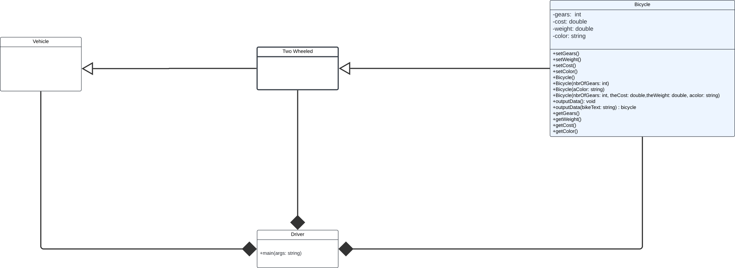

**Brief overview**

The Vehicle is the parent class, TwoWheeled is the child class, and Bicycle is the sub-Child class. Since bicycle extends TwoWheeled and TwoWheeled extends Vehicle, They are inherited. The Driver Class is connected to the other classes, because it contains the main argument that is needed run the program.