|  |  |  |
| --- | --- | --- |
| **Situation** | **Strategy** | **Tactics** |
| * **Idea:**   An online presence that allows customers to purchase fitness advice from trained professionals and join <<Gym name here>> remotely.   * **Target Customers:**   People who are interested in health and fitness along with current members of the gym interested in online fitness and nutritional support.   * **Market Size:**   According to Deloitte’s Health and Fitness report (2016) the revenue on the health and fitness market is 230 Million Euro with 12.2% of the population over the age of 15 involved in some sort of gym or fitness club.   * **Competitive Landscape:**   While the gym landscape is one with many competitors few have taken advantage of using an online platform for nutrition, fitness and health. | * **Value Proposition:**   The nature of this concept allows users to use an online website as a resource for nutrition, exercise and support.   * **Revenue Model:**   The gym will generate revenue through membership this will be facilitated and enhance by the website with exercise and nutritional information and by allowing the booking of classes and memberships online.   * **Market Strategy:**   Using SEO (search engine optimisation) and email marketing will keep current customers interested while attracting new ones by ensuring the website remains high on relevant search engines such as Google and Bing.   * **The Numbers:**   The following milestones are listed for the next four years.   |  |  |  |  |  | | --- | --- | --- | --- | --- | |  | 2017 | 2018 | 2019 | 2020 | | Units | 10K | 50k | 100k | 200k | | Rev | 50k | 250k | 500k | 1M | | Exp. | 20k | 100k | 200k | 250k | | Ol | 30K | 150k | 300k | 750k | | * **Solution summary:**   The website will be designed using ASP.NET. ASP.NET is a Web development model that provides the necessary material needed to build enterprise-class web applications. ASP.NET is programmed using the C# programming language, a powerful language that is excellent for web design.   * **Customer Validation**   Customer validation is gathered via a series of focus groups where random unbiased customers can test out the product before release. This shows a roadmap of how the product can be improved and provides insights that may have been missed by developers. |
|  |  |  |

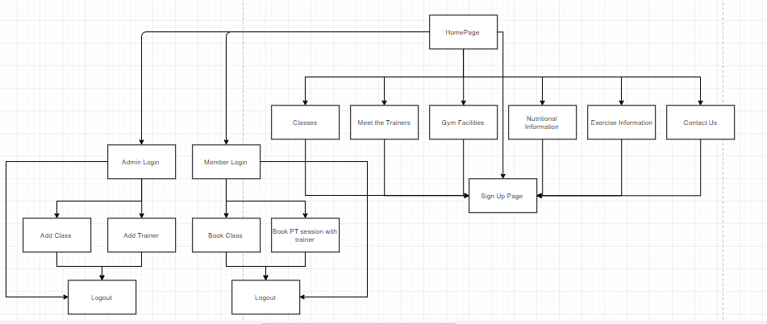

Development plan:

The plan is to develop a front end with a number of pages showcasing the gym and its facilities, nutritional information, exercise advice, a meet the trainers section and classes section. There will be login section where a user can login as a member and book classes and book a session with a specific trainer. The user can also login as an admin and create new classes and add trainers.