Jim's Gym

10364204 Carl Taylor

10364847 Martin McCarthy

10369848 Felix Ogiehor

Table of Contents

Visual Design 0

Technologies and Techniques 0

Structural Diagram 1

Strengths and Weaknesses 0

Database Design And Use 0

ERD 1

XML 1

CLOUD 1

What Each Person Did 2

References 0

Individual Contribution Form 0

Individual Contribution Form 1

Individual Contribution Form 2

(Just to note, I spent hours trying to get page numbers to work but they would NOT work at all. I tried multiple machines and versions of word.) - Carl

|  |  |  |
| --- | --- | --- |
| **Situation** | **Strategy** | **Tactics** |
| * **Idea:**   An online presence that allows customers to purchase fitness advice from trained professionals and join Jim’s Gym remotely.   * **Target Customers:**   People who are interested in health and fitness along with current members of the gym interested in online fitness and nutritional support.   * **Market Size:**   According to Deloitte’s Health and Fitness report (2016) the revenue on the health and fitness market is 230 Million Euro with 12.2% of the population over the age of 15 involved in some sort of gym or fitness club.   * **Competitive Landscape:**   While the gym landscape is one with many competitors few have taken advantage of the advantage of using an online platform for nutrition, fitness and health. | * **Value Proposition:**   The nature of this concept allows users to use an online website as a resource for nutrition, exercise and support.   * **Revenue Model:**   The website will generate income by selling exercise and nutritional information and by allowing the booking of classes and memberships online.   * **Market Strategy:**   Using SEO (search engine optimisation) and email marketing will keep current customers interested while attracting new ones by ensuring the website remains high on relevant search engines such as Google and Bing.   * **The Numbers:**   The following milestones are listed for the next four years.   |  |  |  |  |  | | --- | --- | --- | --- | --- | |  | 2017 | 2018 | 2019 | 2020 | | Units | 10K | 50k | 100k | 200k | | Rev | 50k | 250k | 500k | 1M | | Exp. | 20k | 100k | 200k | 250k | | Ol | 30K | 150k | 300k | 750k | | * **Solution summary:**   The website will be designed using ASP.NET. ASP.NET is a Web development model that provides the necessary material needed to build enterprise-class web applications. ASP.NET is programmed using the C# programming language, a powerful language that is excellent for web design.   * **Development Plan**   The product will be designed using Scrum. Scrum is a design strategy that delivers the minimum product required so that the website can be ready to deploy in the shortest possible time. Every four weeks we get your feedback and make the appropriate changes. This iterative approach (where a product is produced repeatedly until it is done) promotes a collaborative approach between our development team and you.   * **Customer Validation**   Customer validation is gathered via a series of focus groups where random unbiased customers can test out the product before release. This shows a roadmap of how the product can be improved and provides insights that may have been missed by developers. |

# Visual Design

The visual target for this website was to present a large amount of information in a clear, professional and concise way. Using bootstrap4 as the main framework for the project we laid out many pages with specific tasks for each.

The homepage is a general informative page design to intrigue visitors and convince them to search the site further. It is deliberately light on details and instead gives a taste of what’s to come. It is broken into several sections and includes a main carousel of images, which uses the JavaScript plug-in slick slider at the top, designed to catch the attention of the visitor.

The prices, nutrition and exercise pages use a combination of a header image and bootstrap cards to present the information clearly. The nutrition and exercise pages use a combination of grid and flex box to layout the information in a blog-like way.

The AddClasses, AddTrainer, Book Class, Book PT Session, Login and Register pages all use bootstrap forms to present a clear and readable structure.

The site is fully responsive at all resolutions. The colour theme is dark grey and white with accents of primary colours throughout, mainly on the buttons.

Once the theme was in place, it made it easier for the group to adhere to the same format when creating new content and pages.

# Technologies and Techniques

ASP.net MVC

SQL server

XML

Razor

Html 5

CSS3

Bootstrap 4

JavaScript

Git

GitHub

Azure

# Structural Diagram

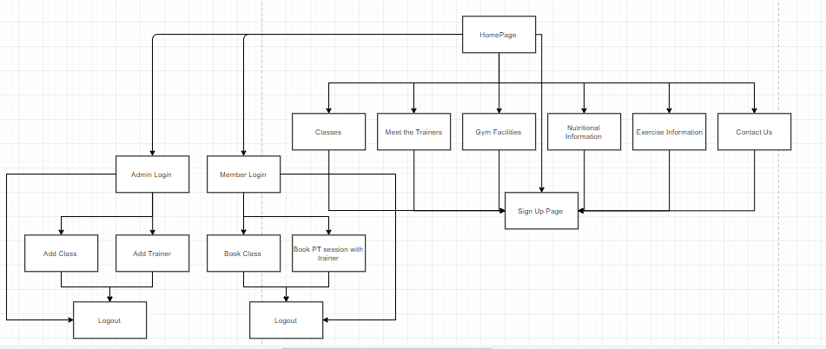

# Strengths and Weaknesses

The site has all the functionality set out in the original plan. However, there is no functionality to do with payment at all and as it currently lies there is no way to make the money outlined in the business plan. This would be the next step if we were to continue the project. On top of this there is quite a lot of performance optimization that could be done as the site is sometimes slow.

While building the site and working as a team we realized two things. Firstly our knowledge of git is lacking with regards to working on a team project this is an area we need to work on. The second is that we feel that these issues would have been alleviated somewhat by having our database in the cloud instead of storing it locally on our PCs.

We also need to create a buffer between member posts and showing those posts as to ascertain if they are relevant.

Furthermore the design could do with a number of iterations over it to refine and improve the overall aesthetics. The structural aspect could also do with improvement. Some tables could essentially be merged into others, improving the performance and flow of the application. This could have been prevented at the conceptual stage through design of the ERD.

Another task we didn't get to was the unhashing of hashed passwords. We could hash them, but when retrieving them for authenticating logins, trying to unhash them produce an exception.

# Database Design And Use

The ERD below is a representation of the SQL Server Database structure. The database was used to store the tables of all the entities in the ERD. It also contains stored procedures for insertions and other queries.

It was first developed using 2 crucial scripts: the CREATE script and the INSERT script. The create script initializes all the tables while the insert script populates those tables. These scripts made it easy to destroy and recreate are database in case there was a conflict over Git or if ever we had the wrong version (which happened more than once!).

Once we had a functional database with foreign keys matching up, we began testing using different types of queries that would be integrated into our DAO.

Our project works like this:

INPUT = View >> Controller >> Model >> DAO>> Query/Execute the Database

OUTPUT = DAO << Model << Controller << View

Each iteration through this cycle produces content for the proceeding view or inserts relevant information into our database/xml.

# ERD

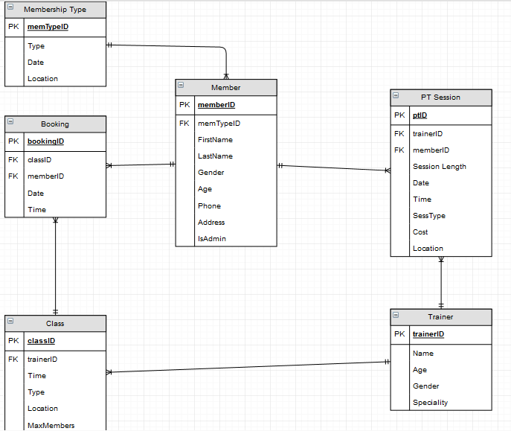

# XML

We have implemented a Nutrition Blog, a blog-like post where logged in users can make comments, offer advice or ideas on how to improve services. Their details are gathered dynamically using their logged in session.These details are then stored in and xml file. This file is then dynamically loaded into the Nutrition page seamlessly.

We also have a Contact Form which is available to users and guests. The user details and comments and the information from the Contact Form are stored in an XML file in AppData. We consider this good for performance especially with its small footprint characteristic of in-memory database systems. This is only accessible by the admin.

# CLOUD

We hosted our site up on the cloud using azures easy to use in house visual studio solution. It was easy to host are main site, but the database functionality would not publish to their service. This leaves the website without any dynamic functionality. Note that linking the database is not a straightforward procedure. We tried multiple different ways but to no avail. I uploaded both create and insert scripts to azure which worked. It created the tables and populated them. After much trial and error, I finally managed to get it to link. The problem was in the connection string and using the correct admin username and password. It should look something like this:

<connectionStrings>  
    <add name="conStringLocal" connectionString="Server=tcp:jimsgym.database.windows.net,1433;Initial Catalog=Gym_Database;Persist Security Info=False;User ID=(ADMIN NAME)@(SERVER NAME);Password=(YOUR PASSWORD);MultipleActiveResultSets=False;Encrypt=True;TrustServerCertificate=False;Connection Timeout=30;" />  
</connectionStrings>

The website can be reached at the following link:

<http://jimsgym.azurewebsites.net/>

# What Each Person Did

Martin:

All frontend development and design work.

The session id functionality, classes table from database functionality, helped with the login and register functionality, and xml read functionality.

Carl :

All of backend functionality including setting up and manipulating the database, the DAO model, xml.

Creation of the Database, dynamically populating lists on forms and dynamically entering information into the database using the logged session + foreign keys. Uploading the project to cloud and integrating cloud technology.

Felix:

The login/register functionality, some DAO, some stored procedures and xml write/read functionality.

# References

Shazia - Sample Template 8

Udemy – Course: Bootstrap 4 from Scratch

www.Pexels.com

www.unsplsh.com

www.stackoverflow.com

www.behance.com

www.coolors.com

www.getbootstrap.com

http://kenwheeler.github.io/slick/

[www.pixlr.com](http://www.pixlr.com)

# Individual Contribution Form

You are required to submit the given form signed by all the group members.

For this purpose, groups are required to maintain a “project log” for **all** stages of the assignment. This is to demonstrate the evolution of the project and the approach used. This log should contain discussions in all the meetings, any email correspondence between group members and activities regarding the assignment. The log should record the date, time, location and attendees of each meeting. The log helps to fill-up the following form (You are not required to submit the log).

Assignment Topic: ____CA Web and Cloud Development___________________

|  |  |
| --- | --- |
|  |  |

Student no : _______10364847_________ Student Name _____Martin McCarthy______________

|  |  |
| --- | --- |
| Dates | Tasks |
| 11-08-17 ----- 20-08-17 | Research, Learning Bootstrap through Udemy, Structural diagram |
| 20-8-17 ---- 11-09-17 | Implementing Front-end design, session functionality, helped with login/register functionality, nutrition blog read xml, classes page table populated from database |
| 11-09-17 ----22-09-17 | Bug fixing, polish final tweaks to the design, Report and Presentation |
|  |  |
|  |  |
|  |  |
|  |  |

Signed_____________________Martin Mccarthy___________________Date__22-09-17________

# Individual Contribution Form

You are required to submit the given form signed by all the group members.

For this purpose, groups are required to maintain a “project log” for **all** stages of the assignment. This is to demonstrate the evolution of the project and the approach used. This log should contain discussions in all the meetings, any email correspondence between group members and activities regarding the assignment. The log should record the date, time, location and attendees of each meeting. The log helps to fill-up the following form (You are not required to submit the log).

Assignment Topic: ____CA Web and Cloud Development___________________

|  |  |
| --- | --- |
|  |  |

Student no : _10369848_______ Student Name __Felix Ogiehor _ ______________

|  |  |
| --- | --- |
| Dates | Tasks |
| 13/08/2017 to 20/08/2017 | Meetings, discussions and decisions on what to include in project and possible implementation strategies. ERD. |
| 21/08/2017 to 19/09/2017 | Development and implementation of Register/Login functionality, Nutrition Blog and their associated Views. Wrote some Stored Procedures and some work on DAO. |
| 20/09/2017 to 22/09/2017 | Bug fixing and finishing touches. Report. |
|  |  |
|  |  |
|  |  |
|  |  |

Signed____Felix Ogiehor________________Date_22/09/2017__________

# Individual Contribution Form

You are required to submit the given form signed by all the group members.

For this purpose, groups are required to maintain a “project log” for **all** stages of the assignment. This is to demonstrate the evolution of the project and the approach used. This log should contain discussions in all the meetings, any email correspondence between group members and activities regarding the assignment. The log should record the date, time, location and attendees of each meeting. The log helps to fill-up the following form (You are not required to submit the log).

Assignment Topic: ____CA Web and Cloud Development___________________

|  |  |
| --- | --- |
|  |  |

Student no : _____10364204______ Student Name _____Carl Taylor______________

|  |  |
| --- | --- |
| Dates | Tasks |
| 14/08/2017 - 18/08/2017 | Meetings, discussing different ideas. Researching structures + plans. |
| 21/08/2017 - 25/08/2017 | Meetings + designing ERD |
| 28/08/2017 - 01/09/2017 | SQL Database construction + population |
| 04/09/2017 - 08/09/2017 | Backend design and dynamic interactions using the Database and Session. |
| 11/09/2017 - 15/09/2017 | Refining DAO + Controller interactions |
| 18/09/2017 - 22/09/2017 | Finishing touches to back end interactions. XML functionality, Presentation, Report, Added Cloud Implementation. |
|  |  |

Signed__________Carl Taylor______________Date______22/09/2017__