DevMundus
Jurisma - Technical Architecture & Feature Documentation

DEVMUNUDS
JURISMA

Technical Architecture & Feature Documentation
German Legal RAG Platform · Version 1.0

React 19 · Node.js · FastAPI · FAISS · MongoDB · DeepSeek AI

Confidential — Internal Use Only

Table of Contents
Table of Contents 1
1. System Overview 1
2. System Architecture 1
2.1 Three-Tier Design 1
2.2 Full Query Lifecycle 1
2.3 Project Directory Structure 1
3. Technology Stack 1
3.1 Frontend — rag-frontend/ 1
3.2 Backend — Node.js / Express 1
3.3 Python Service — PythonServices/ 1
4. LLM & AI Integration 1
4.1 Embedding Model — Always Active 1
4.2 DeepSeek Chat API — Quality Gate Fallback 1
4.3 Doctrine AI Fallback 1
4.4 What Jurisma Deliberately Does Not Use 1
5. Authority Resolution Pipeline 1
5.1 Layer 1 — AuthoritySignals 1
5.2 Layer 2 — compute_authority_state 1
5.3 Layer 3 — enforce_authority_lock 1
5.4 Clarification Flow 1
6. Retrieval, Classification & Norm Graph 1
6.1 Query Classification Types 1
6.2 Norm Graph — DOMAIN_TO_ANCHOR 1
6.3 Dual Retrieval Merge Strategy 1
7. Document Ingestion 1
7.1 Supported Legal Statutes 1
8. Core Features 1
8.1 Token Economy 1
User Tiers & Balances 1
Token Cost Per Query 1
8.2 Guest User System 1
8.3 Multilingual Interface 1
9. Security Architecture 1
10. Deployment Overview 1
10.1 Key Deployment Notes 1
11. Glossary 1

1. System Overview

Jurisma is a three-tier Retrieval-Augmented Generation (RAG) platform built for querying German legal statutes. Users submit natural language questions; the system locates the authoritative statutory paragraphs, applies legal doctrine rules, and returns structured answers with precise citations.

Domain Lock: German and EU statutory law only — BGB, StGB, HGB, GG, EU-GDPR
Core Principle: Retrieval-first by design — no LLM synthesises answers from scratch. LLMs only activate when retrieval is insufficient.
Epistemic Separation: Node.js tier owns textual truth and lexical precision. Python tier owns semantic meaning and authority resolution.

2. System Architecture

2.1 Three-Tier Design

The system is composed of three independently deployable services communicating via HTTP. Each tier has a distinct, non-overlapping responsibility:

Tier | Port | Primary Responsibility
React 19 + TypeScript | 3000 | UI, auth context, language, API calls via axios
Node.js / Express | 5000 | Orchestration, JWT auth, TF-IDF, token management, quality gate
Python / FastAPI | 8000 | FAISS semantic search, authority pipeline, doctrine induction

2.2 Full Query Lifecycle
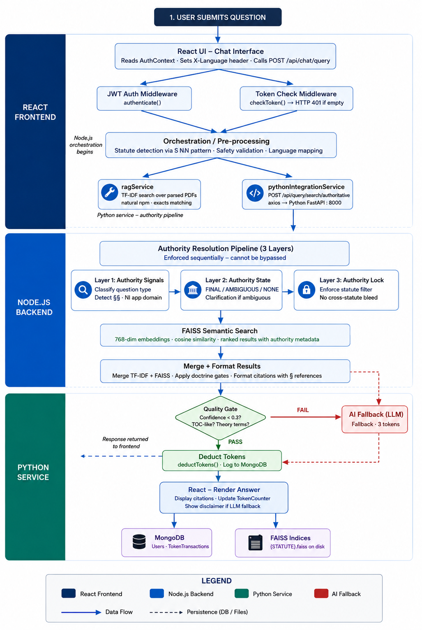
The query lifecycle traces every step from user input through all three service tiers to the final rendered answer, including the AI fallback branch and token deduction.

2.3 Project Directory Structure

The project is organized into three independently deployable service directories: rag-frontend/ (React SPA), Backend/ (Node.js/Express), and Python Services/ (FastAPI). Each service maintains its own package management, environment configuration, and Docker file.
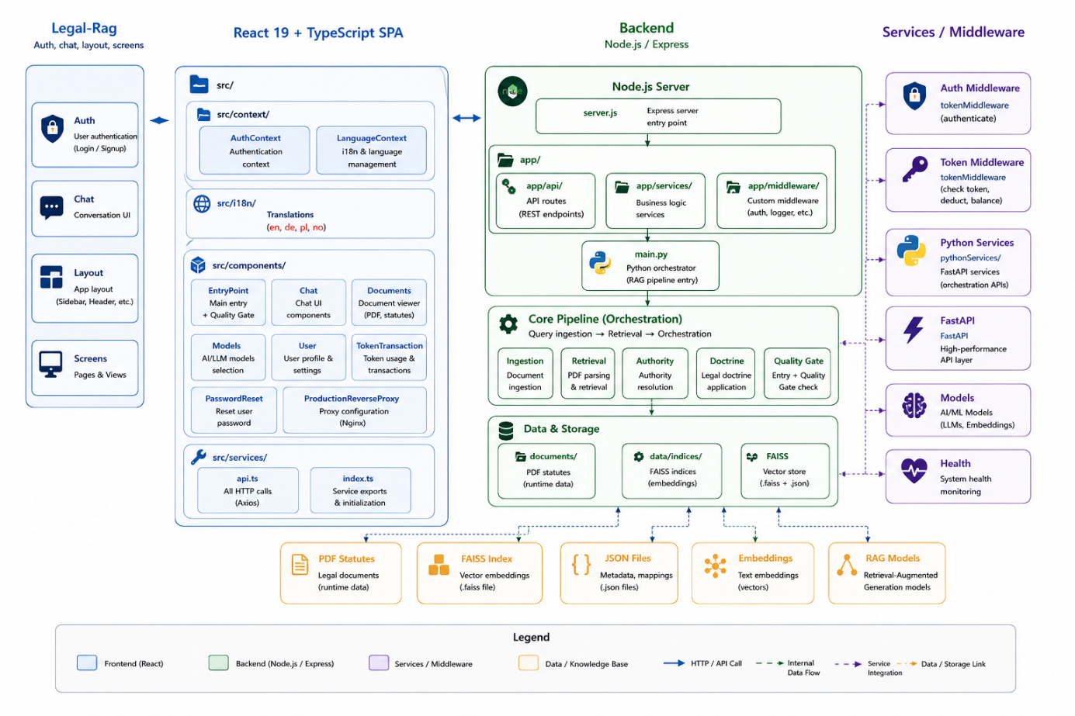

3. Technology Stack

3.1 Frontend — rag-frontend/

Single-page application built with React 19 and TypeScript. Cross-cutting concerns use React Context; server state is managed by TanStack Query.
Technology | Version | Role
React | 19 | UI framework, component-based SPA
TypeScript | 5.x | Static typing and compile-time safety
Tailwind CSS | 3.x | Utility-first responsive styling
Radix UI | latest | Accessible primitives — modals, dropdowns
TanStack Query | 5.x | Server-state management and caching
Axios | — | HTTP client for all API calls
Custom i18n | — | 4-language support — no third-party library

3.2 Backend — Node.js / Express

Orchestration hub: validates authentication, manages tokens, performs lexical PDF search, calls Python for semantic results, and runs the quality gate.

Technology | Role
Express.js | HTTP server, routing, middleware chain
Mongoose | MongoDB ODM — User, TokenTransaction models
jsonwebtoken | JWT generation and verification (7-day expiry)
bcryptjs | Password hashing (bcrypt, 8 rounds)
natural (npm) | TF-IDF lexical search over parsed PDF paragraphs
pdf-parse / pdf2json / pdfjs-dist | Multi-library PDF extraction cascade
multer | PDF upload — 50 MB limit, PDF-only MIME filter
helmet | HTTP security headers (CSP, HSTS, X-Frame-Options)
express-rate-limit | 100 req/15 min general; 500 req/15 min on auth
express-mongo-sanitize | NoSQL injection protection on all request bodies
cors | Cross-origin policy locked to FRONTEND_URL
nodemailer | Password-reset email delivery
axios | Outbound HTTP calls to Python service

3.3 Python Services

Semantic understanding tier. Embeds queries and paragraphs, searches FAISS indices, enforces the authority pipeline, and triggers AI fallback when retrieval is insufficient.

Technology | Version | Role
FastAPI | 0.128 | Async REST API framework
uvicorn | 0.40 | ASGI server
sentence-transformers | 5.2 | Multilingual embedding model (768-dim)
PyTorch | 2.9.1 CPU | Tensor computation for embeddings
faiss-cpu | 1.13.2 | Approximate nearest-neighbour vector search
scikit-learn | 1.8 | Cosine similarity utilities
LangChain / LangGraph | 1.2 / 1.0 | Doctrine induction pipeline orchestration
pypdf | 6.5 | PDF reading for Python-side ingestion
httpx | 0.28 | Async HTTP for AI fallback (DeepSeek / Gemini)
Pydantic | 2.12 | Request / response schema validation
ChromaDB, Qdrant | present | Alternative vector stores — FAISS is default

4. LLM & AI Integration

4.1 Embedding Model — Always Active

Model: sentence-transformers/paraphrase-multilingual-mpnet-base-v2 · 768 dimensions · ~420 MB · runs locally

Converts legal queries and document paragraphs into dense vectors for semantic similarity search via FAISS. Supports German, English, Polish, and Norwegian natively. The model weights are downloaded once and baked into the Docker image — no external API call is made at inference time.

4.2 DeepSeek Chat API — Quality Gate Fallback

Model: DeepSeek-chat · max 800 tokens · costs 3 tokens per query (vs 1 for standard RAG)

Triggered only when the assembled RAG answer fails the quality gate. The gate fires when any of the following conditions are met:
- The answer resembles a table of contents (many § references, no coherent sentences)
- The question contains pure legal theory terms not well-covered by the corpus (Kausalität, Tatbestandsirrtum, Garantenstellung, etc.)
- Answer confidence score is below 0.3 and the text length is under 400 characters
- The assembled answer was flagged as a clarification request

Note: DeepSeek responses are labelled: 'This answer is based on general legal knowledge, not a specific statute from our corpus.'

4.3 Doctrine AI Fallback

When a doctrinal question (e.g. 'Was ist objektive Zurechnung?') matches a settled legal doctrine but has no direct corpus entry, the Python service invokes DeepSeek as primary and Gemini as secondary fallback. Handled in PythonServices/app/services/doctrine_induction/ai_fallback.py.

4.4 What Jurisma Deliberately Does Not Use

Jurisma has no generative LLM synthesising answers from scratch. This is a deliberate architectural decision: all primary answers are assembled from retrieved statutory text, ensuring every response can be traced to a specific legal paragraph.

5. Authority Resolution Pipeline

The authority pipeline is the core of Jurisma's legal accuracy. It runs entirely in the Python service and enforces a strict 3-layer sequence that cannot be bypassed or short-circuited.
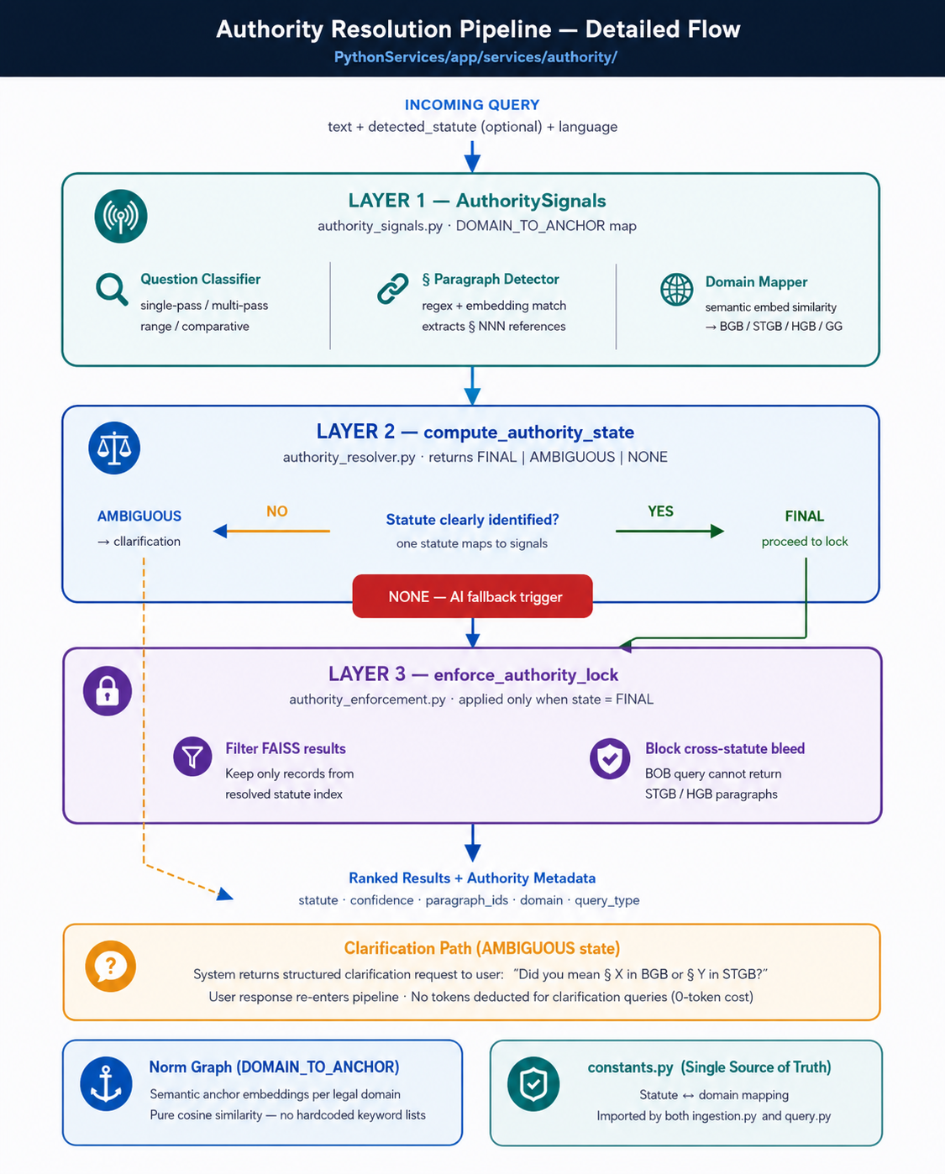

5.1 Layer 1 — Authority Signals

Classifies the question into one of four types (single-paragraph, multi-paragraph, range, comparative) and detects all referenced § paragraphs. The domain mapper uses pure cosine similarity against the DOMAIN_TO_ANCHOR embedding map — there are no hardcoded keyword lists anywhere in this stage.

5.2 Layer 2 — compute_authority_state

Determines the authority state based on the signals from Layer 1:

State | Condition | Action
FINAL | One statute maps unambiguously to all signals | Proceed to Layer 3 enforcement
AMBIGUOUS | Multiple statutes could match the query | Return structured clarification to user — 0 token cost
NONE | No corpus entry found for the doctrine | Trigger AI fallback pipeline (DeepSeek → Gemini)

5.3 Layer 3 — enforce_authority_lock

Once a statute is resolved as FINAL, all FAISS results are filtered to that statute's index only. A BGB query cannot receive StGB or HGB paragraphs regardless of semantic similarity scores. This is the primary mechanism preventing cross-statute contamination.

5.4 Clarification Flow

When the authority state is AMBIGUOUS, the system returns a structured disambiguation question to the user (e.g. 'Did you mean § 823 in BGB (tort law) or § 123 in StGB (criminal law)?'). The user's response re-enters the pipeline at Layer 1. No tokens are deducted for clarification exchanges (0-token cost).

6. Retrieval, Classification & Norm Graph

This section describes how queries are classified and matched against the legal corpus, and how the Norm Graph defines the semantic boundaries of each legal domain.
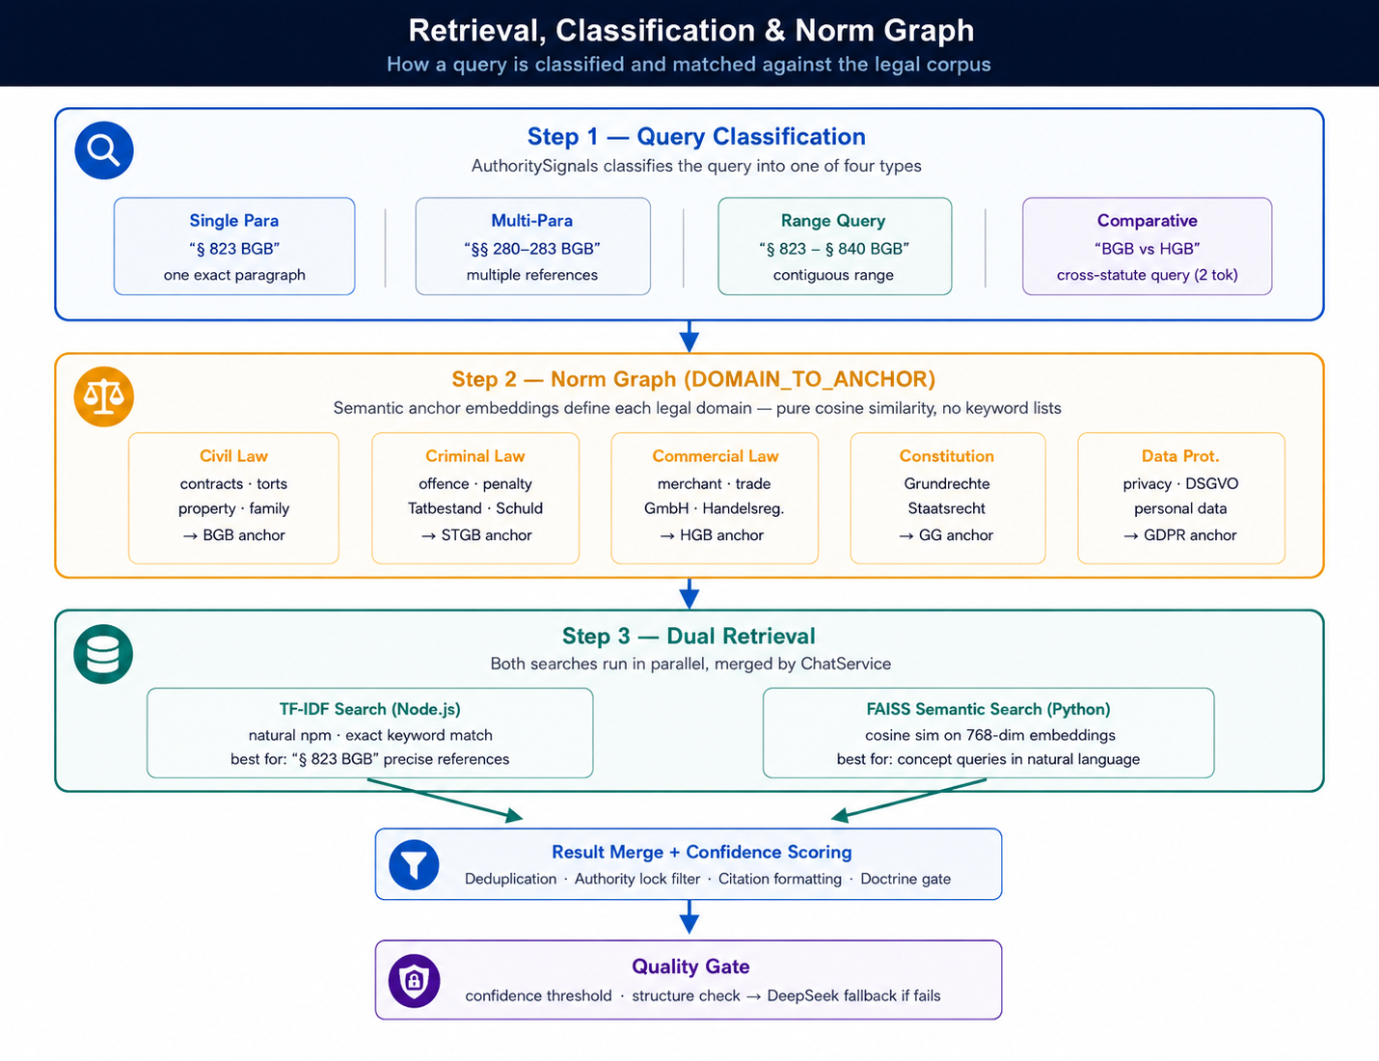

6.1 Query Classification Types

Type | Example | Token Cost
Single-Paragraph | § 823 BGB — what is it? | 1
Multi-Paragraph | What do §§ 280 and 281 BGB say? | 1
Range Query | List §§ 823-840 BGB | 1
Comparative (cross-statute) | Compare § 433 BGB with § 1 HGB | 2

6.2 Norm Graph — DOMAIN_TO_ANCHOR

The DOMAIN_TO_ANCHOR map is a dictionary of semantic anchor embeddings — one per legal domain. When a query arrives, its embedding is compared against each anchor using cosine similarity to identify the most likely governing statute. Because this uses dense vector comparison rather than keyword matching, it handles paraphrasing, synonyms, and multilingual queries correctly.

Source of Truth: constants.py in PythonServices — imported by both ingestion.py and query.py to prevent drift between the ingestion and retrieval stages

6.3 Dual Retrieval Merge Strategy

TF-IDF results and FAISS semantic results are merged in ChatService (Node.js) before returning to the user:
- TF-IDF excels at exact paragraph references (§ 823 BGB) and keyword-dense queries
- FAISS excels at concept queries, paraphrased language, and multilingual inputs
- Doctrine gates are applied after merge to reject answers that conflict with known settled doctrine rules
- The quality gate checks the final merged result before it is sent — triggering DeepSeek if confidence is low

7. Document Ingestion

Documents are ingested through two independent pipelines. Both must be populated for a statute to be fully searchable. The pipelines can run independently.
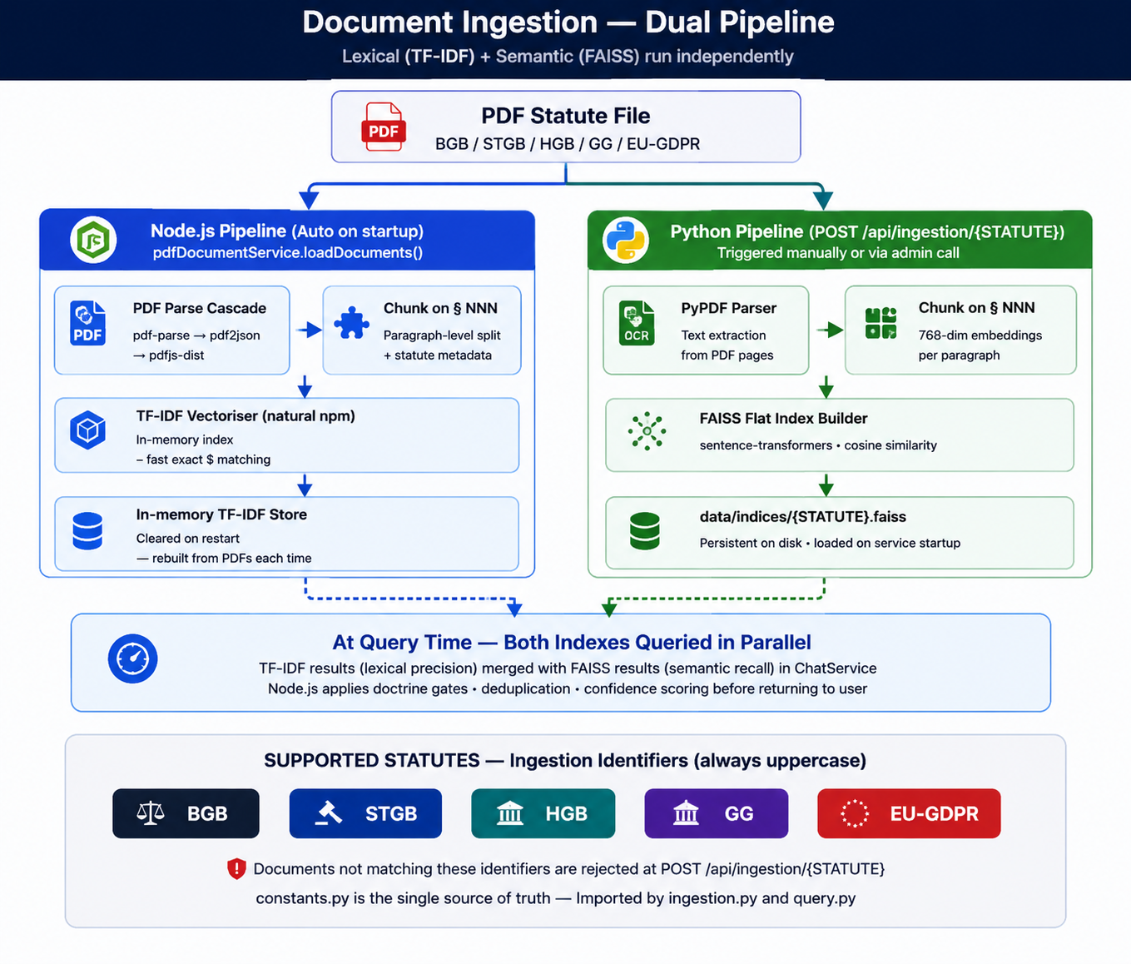

7.1 Supported Legal Statutes

Code | Full Name | Domain
BGB | Bürgerliches Gesetzbuch | Civil law — contracts, property, torts, family
StGB | Strafgesetzbuch | Criminal law — offences, penalties
HGB | Handelsgesetzbuch | Commercial law — merchants, companies, trade
GG | Grundgesetz | Constitutional law — fundamental rights
EU-GDPR | EU General Data Protection Regulation | Data protection and privacy

8. Core Features

8.1 Token Economy

Every query deducts tokens from the user's balance. The middleware chain enforces this before any computation: authenticate → checkTokens → handler → deductTokens.

User Tiers & Balances

Tier | Starting Balance | Reset Policy
Guest | 30 tokens | Session only — never resets
Pro | 300 tokens | Every 30 days
Business | 700 tokens | Every 30 days

Token Cost Per Query

Query Type | Cost | Condition
Clarification | 0 | Short question under 20 characters
Standard RAG | 1 | Default case — retrieval from corpus
Cross-statute | 2 | Query spans two statutes (e.g. BGB + HGB)
Doctrine / AI fallback | 3 | DeepSeek quality gate triggered or guest query

8.2 Guest User System

- Frontend calls POST /api/auth/guest — no registration required
- Node.js creates a User document with isGuest: true, tier: 'guest', random UUID sessionId, 30 tokens
- JWT returned and stored in localStorage as auth_token
- Offline fallback: makeOfflineGuest() creates local guest with 30 in-memory tokens if MongoDB unavailable
- GuestBanner prompts registration when balance reaches zero

8.3 Multilingual Interface

The frontend supports four languages without any third-party i18n library. Language is detected from localStorage → browser locale → 'en'.

Code | Language | Notes
de | German | Default — all legal text in German
en | English | UI and DeepSeek responses in English
pl | Polish | Full i18n translation
no | Norwegian | Full i18n translation

9. Security Architecture

Layer | Mechanism
HTTP Headers | helmet — CSP, HSTS, X-Frame-Options, X-Content-Type-Options
Rate Limiting | 100 req/15 min general; 500 req/15 min on auth endpoints (configurable)
NoSQL Injection | express-mongo-sanitize on all request bodies
Authentication | JWT 7-day expiry; bcrypt password hashing (8 rounds)
File Upload | PDF-only MIME filter, 50 MB size limit, 1 file maximum per request
Path Traversal | validateFilePath() checks against ALLOWED_DIRS allowlist
XSS | textContent used instead of innerHTML in all UI rendering
CORS | Locked to FRONTEND_URL environment variable — no wildcard *
Body Size | JSON 10 MB, URL-encoded 10 KB, 100 parameters maximum
Serialisation | All FAISS metadata in JSON; numpy arrays saved with allow_pickle=False
Python CORS | Explicit origin list — no wildcard * in FastAPI CORS config

10. Deployment Overview

Recommended: Oracle Cloud Always Free — Ampere A1 VM (4 OCPU / 24 GB RAM) — estimated monthly infrastructure cost: $0

Resource | Specification | Cost
Oracle Ampere A1 VM | 4 OCPU / 24 GB RAM / Ubuntu 22.04 | $0 (Always Free)
Block Volume | 200 GB included | $0
Outbound Bandwidth | 10 TB / month | $0
MongoDB Atlas | M0 cluster — 512 MB | $0
SSL Certificate | Let's Encrypt via certbot | $0
Domain Name | e.g. Namecheap / Porkbun | ~$10/year

10.1 Key Deployment Notes

- ARM64 compatibility: remove --extra-index-url for PyTorch; PyPI ARM64 wheels are native
- FAISS persistence: mount data/indices as a Docker volume to survive container restarts
- PDF documents: mount Backend/documents as a bind mount for file persistence
- First Docker build: ~10–15 minutes to download the 420 MB embedding model
- Two firewalls: OCI Security List AND OS iptables rules — both must be configured for ports 80 and 443

11. Glossary

Term | Definition
RAG | Retrieval-Augmented Generation — answering from retrieved documents, not model parameters
FAISS | Facebook AI Similarity Search — efficient approximate nearest-neighbour vector search
TF-IDF | Term Frequency–Inverse Document Frequency — classical lexical relevance scoring
Authority Lock | Prevents results from a different statute contaminating a query response
Doctrine Induction | Pipeline for settled legal theory questions not directly in statutory text
Norm Graph | DOMAIN_TO_ANCHOR embedding map defining semantic boundaries per legal domain
JWT | JSON Web Token — signed stateless authentication credential
§ NNN marker | German paragraph reference format (§ 823 BGB) used as a document chunking boundary
Quality Gate | Post-retrieval check in server.js that triggers DeepSeek if confidence is too low
Clarification | Authority state AMBIGUOUS — system asks user which statute they intended

End of Document — Jurisma Technical Architecture v1.0

