**About Us:**

At Madras Coaching Academy, we offer exclusive and qualitative tutoring services for a wide variety of subjects such as Mathematics, Physics, Chemistry, Biology, Business Mathematics, Accountancy, Science, Social Science, etc., cover School standards from IX to XII standards as well as for all Arts, Engineering Subjects and following the respective curriculum. Our Coaching Academy offers an extensive collection of past exams question papers which are invaluable for teaching the material and for exam preparation.

This unique problem-solving approach technique taught to the students provides the solution for all topics that the students encountering in the school/Colleges. We provide lifelong rememberable methodology for the students, in which they can better solve their own queries/problems. Our tutors are primarily concerned with answering the student’s immediate questions and concerned with providing the students with basic problem-solving skills for future applications.

**VISION AND MISSION**

**VISION**:

To provide individually focused exemplary qualitative, comprehensive and advanced technological education for our students to build a better nation based upon their unique needs and goals.

**MISSION**

1. To provide innovative, best in class coaching through interactive advanced methodology
2. To provide excellent education and mastering in their relevant subjects for every student to excel in every field of competitive exams, for achieving the highest peak.
3. To provide support for the students and identify who are in the academic distress/not meeting their own academic expectations.

Dear Students, Parents and Guardians,

Welcome to Madras Coaching Academy, the academy for knowledge building and sharing, the technological and a technology-based education center with the principles of interactive learning. Madras Coaching Academy was started based on the principle of quality and affordable education. We provide interactive learning with the students by our experienced and qualified tutors with an extra dose of knowledgeable inspiration and motivation. Our tutors may also be more compassion and friendly tutored with their intelligent and talented passionate.

Madras Coaching Academy provides a curriculum of schools/Colleges/Varsity’s with more interesting, exciting and may develop to help your child to succeed. We provide a gateway for your child to be exposed to the wonders of learning in the competitive world, struggling students who enroll with us after-Schooling/college, Enrichment Program will receive personalized tutoring at no additional cost! We also offer unlimited study hours at our center. we seek to deliver academic results using all the resources, technology and information available. Most importantly, we believe that a genuine concern for the well-being and progress of our students will help them excel. Please feel free to e-mail me if you have any questions or comments. (E Mail: [madrascoachingacademy@gmail.com](mailto:madrascoachingacademy@gmail.com))



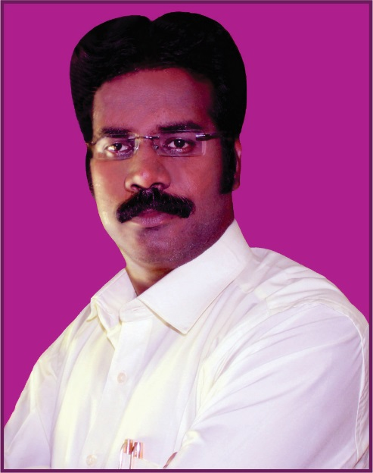

**{Choose any one photo for above profile**

**Tuition Center**

It’s a Schooling, training, tutoring and tutelage

**Tuition for why?**

This is to finish, guide, drill, improve, ground, coach and inculcate what you already know.

**Tuition center for what?**

This center is a dynamic coaching center for engineering tuition/school subjects (all subjects) of all the boards. The faculties are professionally trained and students could feel gratified after joining this institute.

**What does it provide?**

Tuition’s concept is to allow the students to practice a subject more than the given number of hours in school/college/varsity. Given the vast kaleidoscope of human interactions, it is entirely possible that a student does not “click” with his/her schoolteacher, but gets merrily along with the tuition teacher. Students from different schools /collages/varsity’s interacts which lays an important foundation in the construction of a sociable person later on.

This center would fulfill engineering, Arts, Science and school of all board thirsts.

**Contact Us:**

|  |
| --- |
| **Google Map marked Location** |

A**ddress: Contact Details**

#4/1, Round Building, Anna Nagar West Extn. Mobile: 9994744897

Chennai, Tamilnadu – 600 101 9600980606

E-Mail : [madrascoachingacademy@gmail.com](mailto:madrascoachingacademy@gmail.com)

Bus Stop: Collector Nagar Bus Stop



C:\Users\PADMANABAN V\Desktop\2.jpg9994744897 / 96009806060

<https://www.facebook.com/madrascoachingacademy>

C:\Users\PADMANABAN V\Desktop\3.jpgMadras coaching academy

<https://www.instagram.com/padmanaban__v/>

* There is ample free parking space in front of the center.
* Working hours: Monday to Friday: 5.00 AM to 7.00 AM & 5.30 PM to 10.30 PM,

Sunday: 8.00 AM to 6 PM

* All amenities are available in and around the center
* Just 1-minute walkable distance from collector nagar bus stop.

Madras Coaching Academy is located in the prestigious part of Anna Nagar West Extn. with just 1 minute walkable distance from the Collector Nagar Bus Stop. There are a variety of shops where students can have their lunch and other refreshment items during their break time.