Assignment Workbook

Winter 2018

Revision History

|  |  |  |  |  |  |
| --- | --- | --- | --- | --- | --- |
| **Date** | **Issue** | **Sub** | **Description** | **Author & Git Commit** | **Section Completion Time** |
| December 6, 2017 | 1.0 |  | Initial working document | Swerve |  |
| January 29, 2018 | 2.0 | A | patientProfile Schema & Server debugging. Google calendar created and shared | Austin Baggio  cea7e24 | 1:02 PM |
| January 29, 2018 | 2.0 | B | Patient profile & Rehabilitation route, set up the Mongo DB | Noah Chait  485b18f | 12:58PM |
| January 29, 2018 | 2.0 | C | Built the majority of the Schemas, set up the c9 environment | Quentin Madruga  05829d8 | 12:32 PM |
| January 29, 2018 | 2.0 | D | Helped generate Schemas, setup front-end/back-end environments, assisted with route creation. | Jimmy Domagala-Tang  d7e86a6 | 9:35PM |
| January 29, 2018 | 2.0 | E | Assisted with modules and routes, updating Cloud 9 environment with Git, helped with form Schema. | Connor McCauley  53fc46a | 9:08PM |
| January 29, 2018 | 2.0 | F | Fixed bugs in Routing for Patient Profiles and RehabPlan, as well as assisted in developing Schemas for some of the classes. | Husayn Kara  5361ab1 | 10:14PM |
| January 29, 2018 | 2.0 | G | Updated the SDS document to include the object model and the rationale of the design, updated revision history with commit IDs (excluding this commit). | Matthew Price  c55e843 | 10:25PM |
| February 12, 2018 | 3.0 | A | Updated toolbar and styling created the About and Services Page. Created Prototype Video | Austin Baggio  ef011ae | 10:08PM |
| February 12, 2018 | 3.0 | B | Exercises Feature | Noah Chait  f892ec7 | 8:54PM |
| February 12, 2018 | 3.0 | C | Question forms added table, routing and formatting | Quentin Madruga  a564628 | 8:49PM |
| February 12, 2018 | 3.0 | D | Rehabilitation Plan and Question Forms feature | Jimmy Domagala-Tang  18051a1 | 8:51PM |
| February 12, 2018 | 3.0 | E | Other Exercises, created modals, how it works page | Connor McCauley  Cfcf836 | 9:09PM |
| February 12, 2018 | 3.0 | F | Photo upload to exercises | Husayn Kara  b719c04 | 9:38PM |
| February 12, 2018 | 3.0 | G | Patient Profiles | Matthew Price  ee0c061 | 8:50PM |
| March 5, 2018 | 4.0 | A | Made Profile view tabs, created image cross-hairs, and worked on general styling and structure. | Austin Baggio  ef011ae | 9:47PM |
| March 5, 2018 | 4.0 | B | Implemented Scheduler including calendar and worked on Image uploader improvements. | Noah Chait  42a6349 | 10:57PM |
| March 5, 2018 | 4.0 | C | Displaying patient profiles and filtering based upon a specific filter. Admin dashboard side navigation. | Quentin Madruga  ee126e2 | 9:49PM |
| March 5,  2018 | 4.0 | D | JSON web token verification, completing initial injury form, adding authentication to routes. | Jimmy Domagala-Tang  d6d1291 | 9:52PM |
| March 5,  2018 | 4.0 | E | Fixed Git issues with synchronization and code errors, worked on Authorization for users and admin | Connor McCauley  2ee8c37 | 10:09PM |
| March 5, 2018 | 4.0 | F | Worked on exercises component, booking appointments in Scheduler and refactored login. | Husayn Kara  3a29f0a | 10:15PM |
| March 5, 2018 | 4.0 | G | Authentication through pages, routing based on authentication and Flow of account creation, login and profile. | Matthew Price  5c884e0 | 9:49PM |
| March 19, 2018 | 5.0 | A | Made demo 3 video of the prototype, Fixed errors in Profile-view and the home page. | Austin Baggio  fb2af7f | 7:45PM |
| March 19, 2018 | 5.0 | B | Finished the calendar and the image upload process. | Noah Chait  d41be1a | 9:04PM |
| March 19, 2018 | 5.0 | C | Displayed exercises on assessment tests. | Quentin Madruga  a34767b | 7:52PM |
| March 19, 2018 | 5.0 | D | Completed assessment tests and test results and allowed for its display to the user. | Jimmy Domagala-Tang  4abb57a | 9:16PM |
| March 19, 2018 | 5.0 | E | Physician authentication and user permissions. | Connor McCauley  cb9d15a | 8:27PM |
| March 19, 2018 | 5.0 | F | Populated exercises. | Husayn Kara  E84c414 | 9:25PM |
| March 19, 2018 | 5.0 | G | Edited plans, worked on basic routing and assisted with assigning rehab plans to users. | Matthew Price  ab1e571 | 8:51PM |
| April 04,  2018 | 6.0 | A | Introduced payment component and worked with parsing the receipt and storing the information to the profile. | Connor McCauley  e2cc813 | 12:13PM |
| April 04,  2018 | 6.0 | B | Created landing page, all template pages based on Marcotte’s design and recorded the prototype video. | Austin Baggio  900d02f | 11:08PM |
| April 04,  2018 | 6.0 | C | Created the notes component for the patients and created the printing components for results. | Quentin Madruga  a34767b | 11:38 pm |
| April 04,  2018 | 6.0 | D | Generated the graphing component based on progress reports and submission of health assessments. | Jimmy Domagala-Tang  947ffee | 12:07AM |
| April 04,  2018 | 6.0 | E | Created the account creation stepper, provided basic styling, created the admin Sidenav, created the messaging menu. | Noah Chait  eb9c9ba | 11:55 pm |
| April 04,  2018 | 6.0 | F | Created generation of Admin and Physician accounts, edited the access privileges of users based on account status, created change password and reset password for users and admin respectively. Edited the profile-view component, added the ability for admins to delete accounts. | Matthew Price  f63403a | 11:02PM |
| April 04,  2018 | 6.0 | G | Creating test cases and test documents. | Husayn Kara  N/A | N/A |
| April 08,  2018 | 7.0 | A | Completed Test Cases and Test Documents | Husayn Kara  e28c8c3 | 12:47AM |

Table of Contents

Potential Entity Classes 4

Classes Attributes 5

Entity Class Diagram 10

**OBJECT MODEL SELECTION 11**

**UPDATED ENTITY CLASS DIAGRAM 12**

# Potential Entity Classes

|  |  |
| --- | --- |
| **Classes** | **Brief Description** |
| Patient Account | Hold physical info on the patient, along with payment info, credentials, the physician serving them, appointments scheduled and transaction history. |
| Appointment | An instance in time linked to a physician and a patient, the multiple appointments are organized in the schedule class. A patient will have multiple appointments and a Physician will have multiple appointments. |
| Registration Form | Creates and populates patient profile with information they provide, can have new attributes added by Physician or Admin. |
| Physician Account | Contains a name and physician credentials, is able to create and assign exercises, along with assign rehab plans, change them, view reports and close patient cases. |
| Admin Account | A class to hold the admins credentials, and performs changes to user accounts. |
| Rehab Plan | Standard rehab plans that have exercises serve as base templates for custom to be built off of. Can be assigned to a patient profiles by the physician. |
| Exercise | Actions prescribed by physicians used to make up plan, includes visuals that demonstrate the exercise. |
| Assessment Test | Data that pertains to the patient and tests they undergo, assigned and customized by physicians. |
| Progress Report | Contains data that pertains to the patient's recovery, relates current assessment to previous ones to show improvement. |
| Schedule | Composed of a set of appointments booked, each physician will have their own schedule, the clinic will have a schedule of all appointments, and each patient will have their own schedule. |
| Transaction | Billing, payment method, account info, payment credentials, patientID, created by the patient or an admin. |
| Base Account | All account types {admin, physician, patient} inherit from this abstract account.  Accounts hold a name, email, username and password. |
| Template Form | The form that holds the questions that the user will fill out. May be guided by the physician. |
| Exercises in Plans | The subset of exercises that are taken into one Rehab Plan. |
| Name | Used to represent first and last name values of users. |
| Question | The Questions that are asked to the user to gauge success of treatment. Not limited to: Multiple choice, scale questions and long answer questions. |

# Classes Attributes

|  |  |  |
| --- | --- | --- |
| **Patient Account** | | |
| **Attribute Name** | **Attribute Type** | **Description** |
| username | string | The username chosen by the patient, must be unique to each account. |
| password | string | The password associated with the patient account. |
| emailAddress | string | An email address that can be used to contact the user of the account. |
| billingInfo | string | The information required to process a payment for the account. |
| accountStatus | enum {active, inactive} | Dictates whether the account is currently active or inactive. |
| openCase | enum {open, closed} | Dictates whether the case for a specific injury or treatment plan is currently active on the account. |
| assignedRehabPlanID | int | The ID of the assigned rehab plan. |
| name | Name | The first and last name of the account owner. |
| sex | char | The sex of the patient. |
| dateOfBirth | date | When the person was born. |
| address | string | Describes the patient's home address. |
| telephoneNumber | string | The phone number of a user. |
| healthCardNumber | string | The patient's health card number. |
| maritalStatus | enum {married, single, divorced, widowed, other} | Describes if the patient is married, single, widowed, etc. |
| occupation | string | Describes the patient's current job. |
|  |  |  |
| **Appointment** | | |
| **Attribute Name** | **Attribute Type** | **Description** |
| appointmentID | string | Unique identification record for the appointment. |
| physicianID | string | An id string used to uniquely identify a physician. |
| patientID | string | An id string used to uniquely identify a patient. |
| timeOfAppointment | dateTime | The timeslot of a single appointment. |
|  |  |  |
| **Template Forms** | | |
| **Attribute Name** | **Attribute Type** | **Description** |
| questionsToAsk | Questions | Holds the strings of the questions needed for the form. |
| templateID | string | The id of the template report. |
| templateName | string | The saved name of the template form. |
|  |  |  |
| **Physician Account** | | |
| username | string | The username chosen by the physician to log into a physician account. |
| password | string | A password chosen by the physician to log into their account. |
| email | string | An email address used to contact the physician. |
| name | string | The name of the physician. |
|  |  |  |
| **Admin Account** | | |
| **Attribute Name** | **Attribute Type** | **Description** |
| username | string | The username chosen by the admin to log into an admin account. |
| password | string | A password chosen by the admin to log into their account. |
| email | string | An email address used to contact the admin. |
| name | string | The name of the admin. |
|  |  |  |
| **Rehab Plan** | | |
| **Attribute Name** | **Attribute Type** | **Description** |
| rehabPlanID | string | An id number used to uniquely identify a rehab plan. |
| name | string | The name of the rehab plan. |
| description | string | A brief description that describes the rehab plan. |
| authorName | Name | The author of the rehab plan. |
| objectives | string | The objectives of the rehab plan. |
| overallRehabilitationGoal | string | The overall desired outcome of the rehab plan and what it sets out to fix. |
| listOfExercises | string[] | A list of various exercises that are part of the rehab plan, ordered properly for the plan. |
| timeframeToCompletePlan | date | Gives an estimated time frame to complete the rehab plan. |
| assessmentTest | string[] | Gives a brief assessment of the rehab plan and shows the patient's progress in the rehab plan. |
|  |  |  |
| **Exercise** | | |
| **Attribute Name** | **Attribute Type** | **Description** |
| ExerciseID | string | The unique identification code for the exercise. |
| name | Name | The name of the exercise. |
| description | string | A brief description of the exercise. |
| authorName | string | The name of the author of the exercise. |
| objective | string | Lists the benefits of the exercise. |
| actionSteps | string | The steps to perform the exercise. |
| location | string | The muscle groups that the exercise will work on. |
| multimediaURL | string | A URL that links to a video of a demonstration of the exercise. |
|  |  |  |
| **Assessment Report** | | |
| **Attribute Name** | **Attribute Type** | **Description** |
| assessmentReportID | string | Unique assessment identifier. |
| paitentUsername | string | First and last name of patient. |
| description | string | Description of the report. |
| authorName | Name | First and last name of the author. |
| assessmentTools | Questions | Possible questions to be asked on the assessment. |
|  |  |  |
| **Progress Report** | | |
| **Attribute Name** | **Attribute Type** | **Description** |
| painLevel | int | Scale of 1 to 10 with 10 being the most pain, representative by smiley images. |
| mobilityMeasurement | int | Relative to starting measurement of 0 based on the activity. |
| notes | string | Any notes on the progress of the patient. |
|  |  |  |
| **Schedule** | | |
| **Attribute Name** | **Attribute Type** | **Description** |
| patientUsername | string | The unique code for the patient, foreign key. |
| physicianUsername | string | The unique ID code for the physician, foreign key. |
| appointments | string[] | All the appointments pertaining to the schedule owner. |
| scheduleOwner | string | The owner of the report (e.g. Physician, Patient). |
|  |  |  |
| **Transaction** | | |
| **Attribute Name** | **Attribute Type** | **Description** |
| transactionID | string | Unique transaction identifier. |
| patientUsername | string | Foreign key to patient identifier. |
| amount | float | Dollar amount of treatment cost to the second decimal. |
| paymentMethod | string | The user's choice of payment. |
| plan | string | Foreign key to exercise plan. |
| dateTime | dateTime | Date and time of payment. |
|  |  |  |
| **Exercises in Plans** | | |
| **Attribute Name** | **Attribute Type** | **Description** |
| exercise | string[] | A collection of exercises that will be paired with exercise plan information and then given to a plan. |
| repNumber | int[] | The number of times an exercise should be performed in a set. |
| duration | string[] | The duration to perform the exercise. |
| frequency | string[] | the frequency of the exercise, describing how quickly the exercise should be performed. |
| targetDate | date[] | The date that the specific exercise in the plan will transition to another stage e.g. duration form  4-5 minutes, frequency from slow to fast. |
|  |  |  |
| **Name** | | |
| **Attribute Name** | **Attribute Type** | **Description** |
| firstName | string | Given name. |
| lastName | string | Surname. |
|  |  |  |
| **Questions** | | |
| **Attribute Name** | **Attribute Type** | **Description** |
| mutipleChoiceAnswer | char | Responses with possible answers a, b, c, d , etc. |
| scaleAnswer | int | Responses to questions on a relative scale |
| longQuestionsAnswer | string | Written answer |
| multipleChoiceQuestion | string | Multiple choice questions |
| scaleQuestions | string | Questions on a scale |
| longQuestions | string | Written long answer questions |
|  |  |  |
| **Base Account** | | |
| **Attribute Name** | **Attribute Type** | **Description** |
| username | string | The username for any given account. |
| password | string | A password chosen for any given account. |
| email | string | An email address used to contact the account owner. |
| name | string | The name of the account owner. |
|  |  |  |
| **Registration Form** | | |
| **Attribute Name** | **Attribute Type** | **Description** |
| questionsToAsk | Questions | Holds the strings of the questions needed for the form. |
| registrationID | string | The id of the registration form. |
| formName | string | The saved name of the registration form. |

# Entity Class Diagram

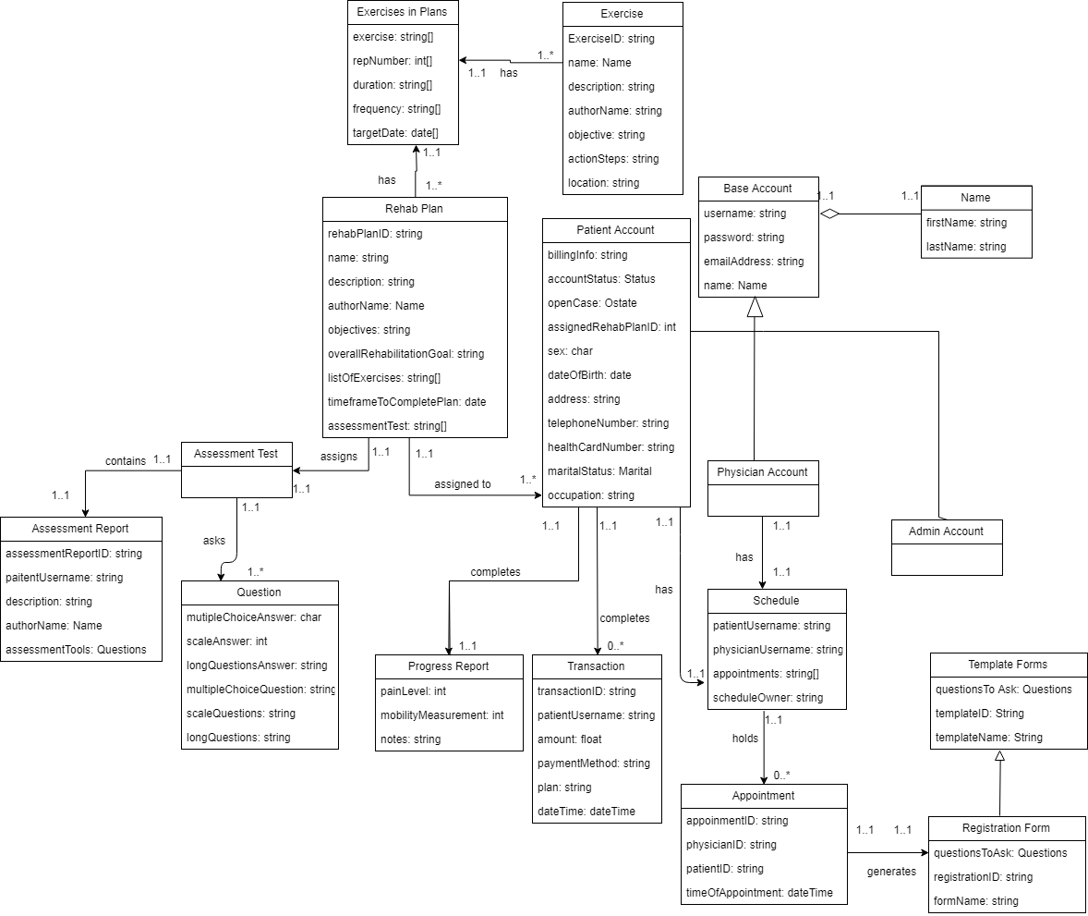

Object Model Selection:

The decision to choose the provided object model comes from the minor differences between the provided model and our created model. The provided model has a clearer separation between a user account as an entity (with username and password) and a user account as an individual (name, ID, related email address). Another factor that separates the models is the clarity of the format of included classes, such as appointments, in the provided model it is clearly shown to be a part of the patient profile while also reducing cluster by showing the presence on the relationship rather than being shown a foreign key within the class. Another main difference is in our created model, our assessment test class used an unnecessary subclass called assessment report due to a difference in the interpretation of the SRS document. By removing the subclass, the model is simplified, becomes more understandable and easier to implement. Finally, the provided model presents a simplified model of the exercise class, removing an unneeded subclass and again, simplifies the overall model. The only factor that differs between the two models that we were wary to exclude was a schedule that both the physicians and the patients could see, tentatively we will move forward solely with the provided model but we may edit that model to include a more visible schedule if we find necessary. For all these reasons, the object model provided by Dr. Ouda will be used as our basepoint moving forward.

# Updated Entity Class Diagram

Brief description: This model will represent the relations of all the separate components of our database while progressing through the project. It will be the guide to understanding how every class interacts with each other and how the data will be used and stored in the backend. This model was used to create the current schemas and assist as a guideline for route creation.