2025_2_28_Rmarkdown_HomeworkAssignment

Madeline Redd

2025-02-22

# R Markdown Formatting Options:

## Headers and Sub headers Example Code

Spaces after Pound Symbol matter to create the headers

# First-level header

## Second-level header

### Third-level header

#### Style and Emphasis

### Using Asterix Symbol to Alter Format

‘**bold**’ ‘*italic*’

**Golden Shiner** (*Notemigonus crysoleucas*)

### Using Underscores to Alter Format

‘**bold**’ ‘*italic*’

**Common Grackle** (*Quiscalus quiscula*)

### Creating Lists in Different Ways

Unordered list items start with *, -, or +, and you can nest one list within another list by indenting the sub-list.

* Other Blackbirds
  1. Red-winged Blackbird
     + *Agelaius phoeniceus*
  2. Brown-headed Cowbird
     + *Molothrus ater*
  3. Yellow-headed Blackbird
     + *Xanthocephalus xanthocephalus*

## Links

[Github Repository: ENTM 6820 Class](https://github.com/Mads-Hamrick/ENTM6820class.git)

## Images

Exclamation Point changes from link to producing image.

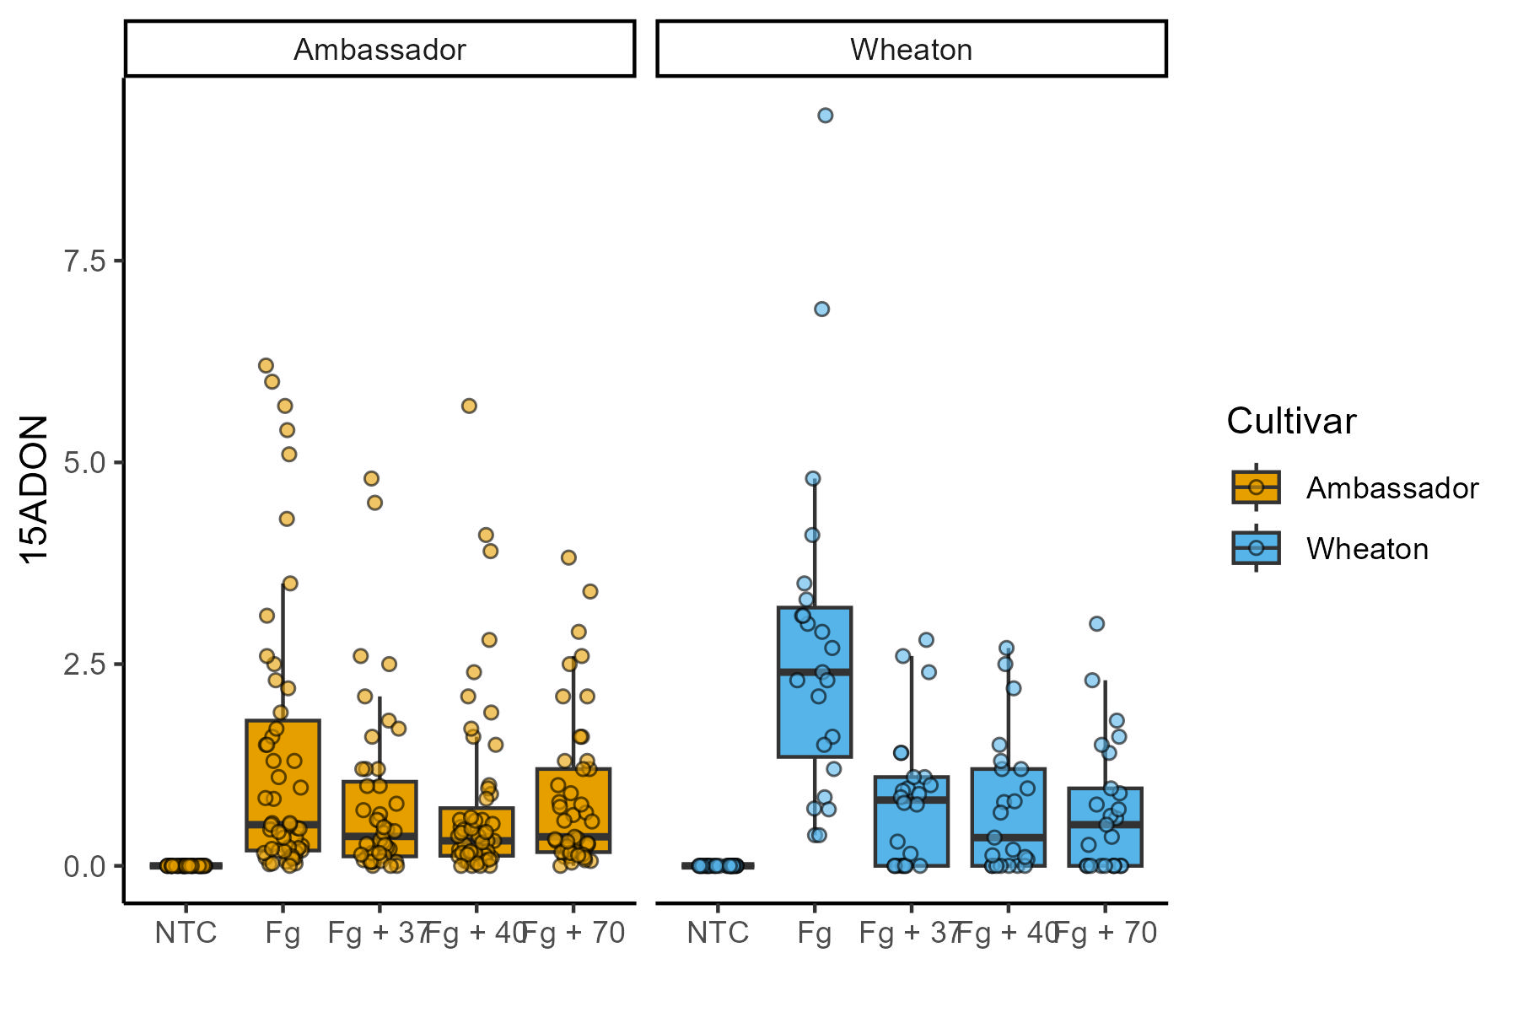

DV3_Question 3B ggplot

| Common Name | Alpha Code |
| --- | --- |
| American Crow | AMCO |
| Red-winged Blackbird | RWBL |
| Common Grackle | COGR |

kable(head(mtcars, n = 5), digits = 3, format = "markdown")

|  | mpg | cyl | disp | hp | drat | wt | qsec | vs | am | gear | carb |
| --- | --- | --- | --- | --- | --- | --- | --- | --- | --- | --- | --- |
| Mazda RX4 | 21.0 | 6 | 160 | 110 | 3.90 | 2.620 | 16.46 | 0 | 1 | 4 | 4 |
| Mazda RX4 Wag | 21.0 | 6 | 160 | 110 | 3.90 | 2.875 | 17.02 | 0 | 1 | 4 | 4 |
| Datsun 710 | 22.8 | 4 | 108 | 93 | 3.85 | 2.320 | 18.61 | 1 | 1 | 4 | 1 |
| Hornet 4 Drive | 21.4 | 6 | 258 | 110 | 3.08 | 3.215 | 19.44 | 1 | 0 | 3 | 1 |
| Hornet Sportabout | 18.7 | 8 | 360 | 175 | 3.15 | 3.440 | 17.02 | 0 | 0 | 3 | 2 |

## Quotes

Blockquotes are written after >, e.g.,

> "I thoroughly disapprove of duels. If a man should challenge me,  
 I would take him kindly and forgivingly by the hand and lead him  
 to a quiet place and kill him."  
>  
> --- Mark Twain