### Laboratory Exercises on Transmission Lines: Exercise Note

### *Purpose*

The purpose of the exercises is 1) to obtain knowledge about *transmission lines* (TLs)and *waves* guided by such lines, and 2) to support the theoretical curriculum by hands-on experience. There will be two exercises with specified tasks, and based on these, an individual report is made. All information about the exercises are included in this document.

**First exercise:** We will use simple measurements of input and output voltages under different conditions to gain understanding of the generation, propagation and reflection of voltage/current waves on a simple TL, the widely used coaxial cable. To this end, the standard laboratory equipment, such as a signal generator and an oscilloscope will be used.

**Second exercise:** We use a vector network analyzer (VNA) to investigate simple transmission line circuits. The VNA is an advanced equipment, which can directly provide the complex reflection and transmission coefficients for multiple frequencies. Both serial and parallel TL circuits will be studied and various TL tools and concepts will be applied including the *Smith Chart* and *impedance matching*.

### *Plan – What YOU must do and when to do it?*

**BEFORE the exercise:** Please read the exercise note (this document) and the specified pages in Ulaby.

**DURING the exercise:** Focus on performing all required measurements. The exercises take place in the student laboratory of Building 357. You need to use your student card (+ 4-digit code) to enter the building. An overview of the dates for the exercises is provide in the table at the bottom of this page.

**AFTER the exercise:** Complete the tasks for the exercise. Begin on the report after the first exercise.

**FINAL report:** An individual measurement report based on the tasks given in the exercise note must be submitted. The report can be of maximum 12 pages excluding the cover page. The submission consists of three part: (1) A preliminary report is submitted using “FeedbackFruits” on Learn, (2) Each student review 2 reports and give feedback, (3) Final report is submitted on Learn. See the below table for the deadlines.

|  |  |  |
| --- | --- | --- |
| **Group** | **Lab. Ex. No. (10-12 am)** | |
| **1** | **2** |
| A | 08.09 | 22.09 |
| B | 15.09 | 29.09 |
| Preliminary report deadline: 03.10 at 1 pm | | |
| Feedback deadline: 07.10 at 5 pm | | |
| Final report deadline: 10.10 at 5 pm | | |

### *Exercise 1*

**Preparation:** Read the tasks for ‘Exercise 1’ (this note) + Ulaby 2-1 – 2-4, 2-6, 2-7 (2-5 is optional).

**Attention:** For all calculations and analyses, assume the TLs to be lossless. The specification sheet for the RG58 cable is provided on page 4.

**Experimental setup:** The device under test (DUT) is a 2 m RG58 coax cable which is connected to an oscilloscope, a signal generator and a load as shown in Figure 1 below. The signal generator is configured to provide an RMS output voltage of 200 mV nomatter the load connected.* Setup the oscilloscope to measure the RMS voltage at both ports as well as the phase shift between them. Make sure that the termination of oscilloscope ports is set to 1 MΩ. Throughout the exercise, it generally recommended to measure the length of cable + connectors as the specified lengths are approximate.

*For the yellow signal generators, an attenuator is connected to the generator to provide the constant voltage output. Adjust the signal level (around 3 dBm) on the generator such that the measured RMS voltage level is 100 mV with a 50 Ω load.

Et billede, der indeholder tekst, skærmbillede, diagram, linje/række

AI-genereret indhold kan være ukorrekt.

**Figure 1. Left:** Circuit model of the setup. **Right:** Photograph of the setup

**Pre-task:** Consider the circuit in Figure 1. According to standard circuit theory, what are the expected *V*L for the following terminations: 50 Ω, 25 Ω, short-circuit and open-circuit?

**Task 1.1a:** Measure the phase shift and the RMS voltages at the input and output of a 2 m RG58 coax cable connected to a 50 Ω load as a function of frequency from 1 to 50 MHz.

* Make a spectral plot of the measured voltages (RMS + phase), together with the voltages predicted by TL theory.
* Explain what will happen if you repeated the measurements for a 1 m cable.

You can use the below table to record the measurements or make your own with even more frequency points.

|  |  |  |  |  |  |  |  |  |  |  |  |
| --- | --- | --- | --- | --- | --- | --- | --- | --- | --- | --- | --- |
| ***f* [MHz]** | **1** | **5** | **10** | **15** | **20** | **25** | **30** | **35** | **40** | **45** | **50** |
| Vi, RMS [mV] |  |  |  |  |  |  |  |  |  |  |  |
| VL, RMS [mV] |  |  |  |  |  |  |  |  |  |  |  |
| Phase shift  [˚] |  |  |  |  |  |  |  |  |  |  |  |

**Task 1.1b (no new measurements):** Using the measurements from Task 1.1a, calculate and plot the time delay (*t*) as a function of frequency (*f*).

* Estimate the phase velocity (*u*p) of the cable based on the calculated time delays. Compare it with the transmission time *T* listed in the specification sheet of the cable.

**Task 1.2a:** Measure the voltages at the input and output of a 2 m RG58 coax cable connected to three different terminations as functions of frequency from 1 to 50 MHz. The terminations should be open-circuit, short-circuit and 25 Ω.

* Make a plot of the measured Vi, RMS and the voltages predicted by the TL theory as functions of the distance to the load given in wavelengths (*λ*).* Remember to measure the full length of the DUT (cable + connectors). Compare your results with basic circuit theory. Comment on your results.  
  *Hint: Use the equivalence between frequency and electrical distance to the load.

You can use the below table to record the measurements or make your own with even more frequency points.

|  |  |  |  |  |  |  |  |  |  |  |  |  |
| --- | --- | --- | --- | --- | --- | --- | --- | --- | --- | --- | --- | --- |
| **Load** | ***f* [MHz]** | **1** | **5** | **10** | **15** | **20** | **25** | **30** | **35** | **40** | **45** | **50** |
|  | Distance to load [λ] |  |  |  |  |  |  |  |  |  |  |  |
| Open | Vi,RMS [V] |  |  |  |  |  |  |  |  |  |  |  |
|  | VL,RMS [V] |  |  |  |  |  |  |  |  |  |  |  |
| Short | Vi,RMS [V] |  |  |  |  |  |  |  |  |  |  |  |
|  | VL,RMS [V] |  |  |  |  |  |  |  |  |  |  |  |
| 25 | Vi,RMS [V] |  |  |  |  |  |  |  |  |  |  |  |
| Ω | VL,RMS [V] |  |  |  |  |  |  |  |  |  |  |  |

**Task 1.2b (no new measurements):** Based on the measurements from Task 1.2a, calculate the voltage standing wave ratio (VSWR) as well as the magnitude of the reflection coefficient at the load (|ΓL|) and compare your results with TL theory.

* What are the VSWR and |ΓL| for the 50 Ω load?

**Task 1.3:** Determination of an unknown load. Disconnect Port 2 (closest to the load). Get the load from the teacher and connect it to the 2 m cable. First, determine the VSWR by sweeping the frequency and finding the maximum and minimum Vi,RMS.* Write down the frequencies and measure the full length of the DUT (cable + connectors).

* Based on the measurements, determine the impedance of the load (also explain how you did it).

*It is recommended to avoid frequencies close to zero. Instead, find the maximum and minimum at higher frequencies.

**Task 1.4a (no measurements):** Calculate the input impedance of a 3 m RG58 coax cable connected to a load of

1. 75 Ω
2. 50 Ω
3. 0 Ω
4. (20 - *j*50) Ω

The TL is operated at a frequency of 35 MHz.

**Task 1.4b (no measurements):** At the entry of a lossless TL, one measures an input impedance of 25 Ω. The TL is composed of two parallel plates of width 10 mm and distance 2.65 mm. The insulator between the two plates has a dielectric permittivity of 4 and is non-magnetic. The TL is 3.75 mm long and the operating frequency is 10 GHz. Draw the circuit and determine the load.

*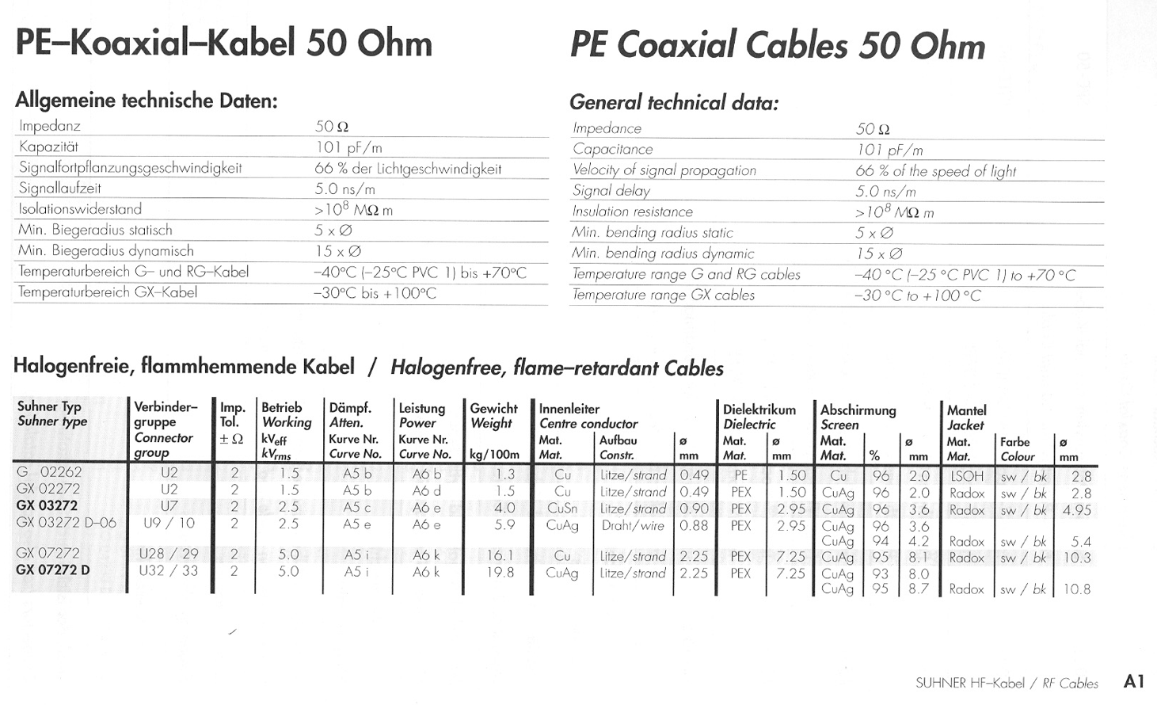****Datasheet of RG-58 coaxial cable***

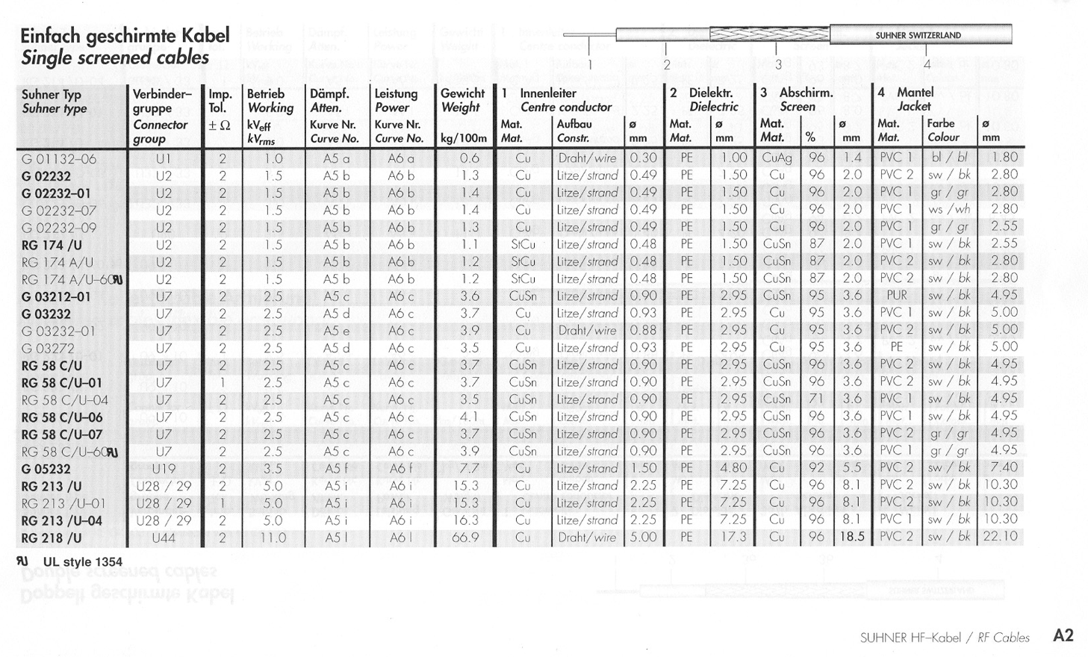

108

108

### *Exercise 2*

**Preparation:** Read ‘Exercise 2’ in this note + Ulaby 2-8, 2-10, 2-11 (2-9 is optional).

**Attention:** For all calculations and analyses, assume the TLs to be lossless. The specification sheet for the RG58 cable is provided on page 4. The VNA calibration procedure is found on page 7.

**Experimental setup:** A vector network analyzer (VNA) is used to measure the complex S-parameters of a 1- and 2-port system, see Figure 2 below. However, first, the VNA must be setup and calibrated. This is done by following the procedure found on page 8. The VNA can be calibrated for 1- or 2-port measurements, but to save time, please just perform the 2-port calibration from the beginning of the exercise. When the VNA is calibrated, it can be used to measure S11 and S21 of the TL circuits corresponding to the reflection and transmission coefficients, respectively. Remember to validate the calibration by checking the S-parameters for known loads, e.g. the ones you used for the calibration.

Set the frequency range to 100 MHz to 500 MHz.

Et billede, der indeholder elektronik, computer, kable, Elektronisk enhed

AI-genereret indhold kan være ukorrekt.

**Figure 2. Left:** Photograph of the VNA connected to a parallel TL circuit. **Right:** Sketch of a 2-port system.

**Task 2.1a:** At 200 MHz, measure the magnitude of S11 (in dB) for RG-58 coaxial cables of various lengths, terminated in different loads (open, short, matched). You can use the below table. Remember to measure the ‘true’ cable length + connector(s).

|  |  |  |  |  |
| --- | --- | --- | --- | --- |
| Cable and loads | | Measurements | | |
| RG 58 C/U | **Load** | |*S*11| [dB] | *S*11 phase [o] | VSWR |
| 0 cm | 25 ** ** |  |  |  |
| 50 ** ** |  |  |  |
| 100 ** ** |  |  |  |
| Open |  |  |  |
| Short |  |  |  |
| “25 cm” | 25 ** ** |  |  |  |
| 50 ** ** |  |  |
| 100 ** ** |  |  |
| Open |  |  |
| Short |  |  |
| “50 cm" | 25 ** ** |  |  |  |
| 50 ** ** |  |  |
| 100 ** ** |  |  |
| Open |  |  |
| Short |  |  |

1. Compare your measurements with the theoretical values from TL equations.

* Are there significant differences in magnitude or phase? If so, what could explain them? (e.g., connector losses, imperfect terminations, cable tolerances)

1. Investigate the slope of the phase as a function of frequency, for the open stub.

* How does the slope of the phase change when the cable length is increased?

**Task 2.1b (no new measurements):** Using your measured data in 2.1a:

1. Plot the results for the **0 cm** cable and the **“25 cm”** cable on the same Smith Chart.
2. From the chart, determine the input impedances in both cases.
3. Comment on the electrical length of the “25 cm” cable.

* Is it consistent with the expected value based on the velocity factor of RG-58?

**Task 2.2:** Make the setup shown in Figure 3, consisting of a T-intersection connecting the two VNA ports and a parallel TL stub, and perform the following measurements.

Et billede, der indeholder tekst, Font/skrifttype, linje/række, kvittering

AI-genereret indhold kan være ukorrekt.



Instead of sketching full traces from the VNA, use **frequency markers** to identify key points (minima, maxima) and record them in a **table**. Compare your results with theory.

a) Use an open stub with a length of 0 cm.

* Observe |S21| as a function of frequency.
* Record the maximum value of |S21| and note if any minima are present.
* Explain why no minimum appears in this case.

b) Use an open stub with a length of “25 cm”.

* Record the frequency at which |S21| has its minimum, and the value of that minimum.
* Calculate the electrical length of the stub using this frequency and velocity found in the specification sheet.
* What are the theoretical input impedances of the stub when |S21| is at a maximum and at a minimum?

c) Use a shorted stub of “25 cm”.

* Record the frequency of the first |S21| minimum.
* Compare the result with case (b).

d) Use an open stub of “100 cm”.

* Record at least two minima of |S21| and their frequencies.
* Compare the results with (b) and (c).
* Explain why more minima appear in this case.

**Task 2.3a:** Make the setup sketched in Figure 4, representing a mismatched TL circuit. Your task is to make a single-stub tuner that matches the line to the load. You need to reduce |S11| to less than –20 dB at a frequency between 200 MHz and 300 MHz. You are welcome to use either the open- or short-circuited termination for the stub.

Et billede, der indeholder tekst, diagram, linje/række, Font/skrifttype

AI-genereret indhold kan være ukorrekt.



* First, measure |S11| of the unmatched circuit and record the value and frequency.
* Add a single-stub tuner (using cables/connectors) and adjust the lengths until the mismatch is minimized (|S11| < – 20 dB).*
* Record the final TL lengths you used, the frequency where the match occurs, and the |S11| value.
* Explain how you achieved the match.

*You can also use the VNA’s Smith Chart display. Ask the instructors for help if needed.

**Task 2.3b (no new measurements):** Follow the procedure (equations or Smith Chart) to design a single-stub tuner based on the same setup as in Task 2.3a. Choose the design frequency to be the frequency where |S11| was minimum in Task 2.3a

* Calculate the required stub length and position.
* Compare your theoretical values with the ones you implemented in the lab.
* If there are differences, explain possible reasons (e.g., connector lengths, cable tolerances, measurement uncertainty).

**Task 2.4 (no measurements):** Design a quarter-wave transformer to match the 25 Ω load in Figure 4 to the main transmission line.

1. **Design**
   * Calculate the required length and characteristic impedance of the quarter-wave section.
   * Draw a clear sketch of the setup, labeling the transmission line, transformer section, and load.
   * (Optional) Use the Smith Chart to show how the impedance is transformed.
2. **Reflection**

* Compare the quarter-wave transformer with the single-stub tuner.
* Discuss the main advantages and disadvantages of each approach, considering:
  + Flexibility in matching arbitrary impedances
  + Sensitivity to frequency
  + Ease of implementation in practice (with the cables and connectors available in the lab)

***Calibration procedure***

1. Connect test port extension cables to the RF Out connector (if not already connected).
2. Turn the VNA on with the green “**ON/OFF**” button at the top right corner.
3. Two things are important before you calibrate a VNA. **The first one is to set frequency range**, since it cannot be changed after calibration without loosing error correction. To set the frequency range, please:
   * Press “**Freq/Dist**” below the display
   * Press “**Start Freq**”
   * Enter desired frequency in Hz, kHz, MHz or GHz using the keypad
   * Press “**Stop Freq**”
   * Enter desired frequency in Hz, kHz, MHz or GHz using the keypad

The second one is the output power level, which is also locked after calibration. In our case where we only deal with passive structures, the power level is not critical. This VNA only has two settings for the power level. Chose High when you make the calibration.

1. Press Shift (Blue button) and then “**Calibrate**“ i.e. the “**2**“ key.
2. Assure that the “DUT connector” in the the right menu is set to “User 2”. Also make sure that all correction coefficients is set zero in “Configure User 2”.
3. Press “**Start Cal**“.
4. Follow the calibration instructions on the screen.
5. Verify that the calibration has been performed properly by checking that the Cal Status On message is now displayed at the top of the window.
6. By pressing “**Meas**” below the display, you can choose between several measurement options.
7. During two port calibration “Thru” means: connect the two ports using a straight adapter.