**Homework 2 Report**

1. **The effect of different W.**

As we can see, the learning curve of error starts fluctuating a lot more when we increase the value of W. From the plot, the the best result is when W = 2.9, and the worst one is W = 3.5.

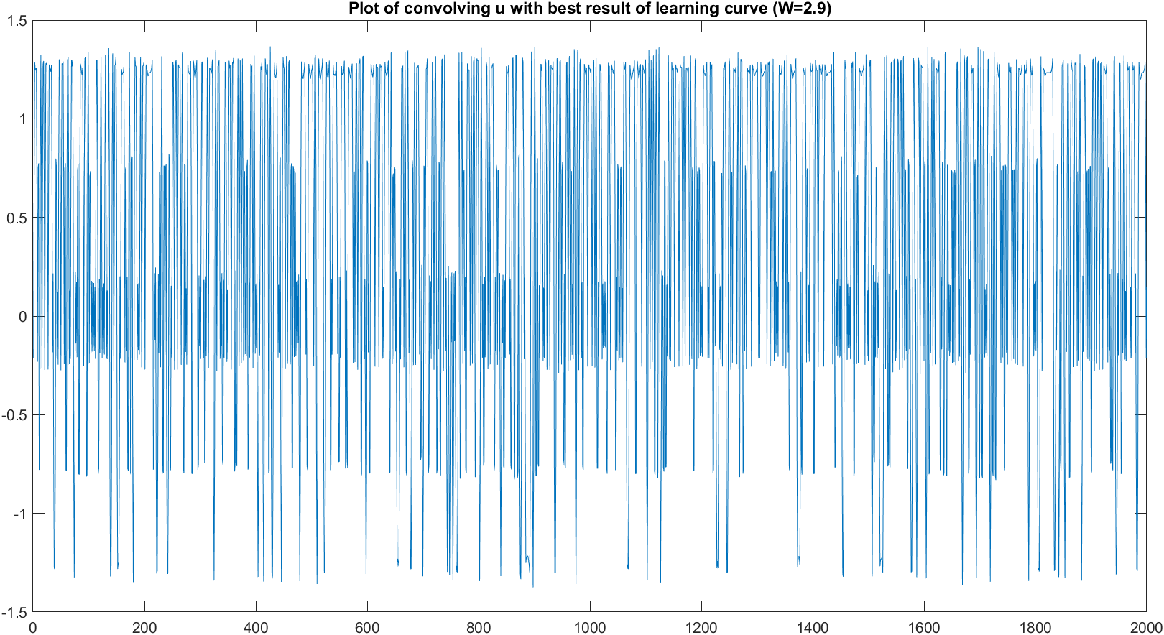

From the result of convolving u(n) with the best system when trying with different W. However, the results are not quite like what we expected.

1. **The effect of different t delay**

From the above result, we know that choosing an appropriate t_delay is also important to get the best result. In this case, t_delay = 7 will give the best result compared to other values (0,14,20). Meanwhile, the learning rate for t_delay = 0,14, 20 are fluctuating around 1 and not seems to decrease to 0.

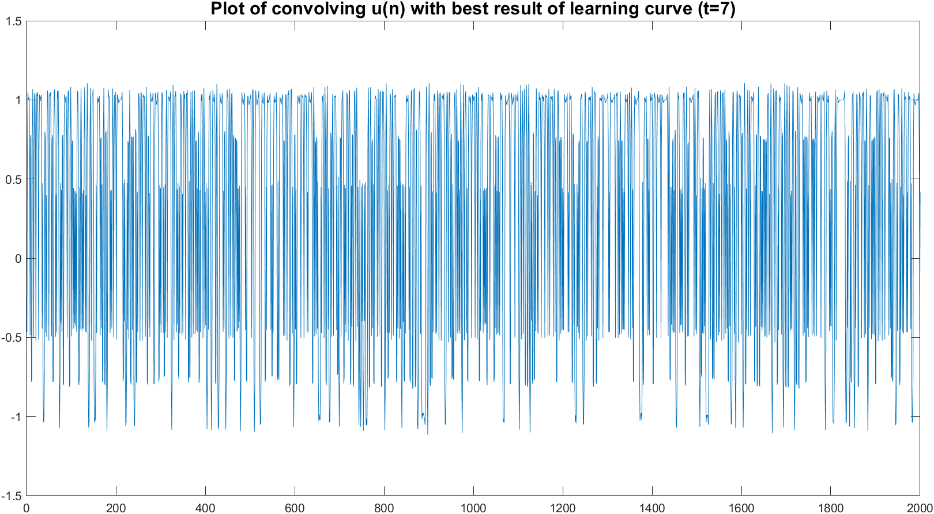

1. **The effect of different step size**

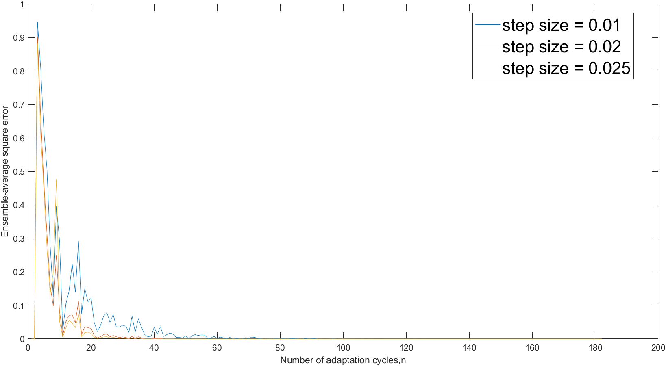

From the plot, we can see that the largest step size (0.025) leads to the biggest fluctuation before finding the minimum part of the error function. Meanwhile, step size 0.05 has the fastest decrease rate and approach to the solution sooner than the other two. From the 3 experiments, we know that each parameter has an impact on the process to approach zero of the error function. However, we can see that it is important to tune the step size to the appropriate value so that it could help to approach the solution.

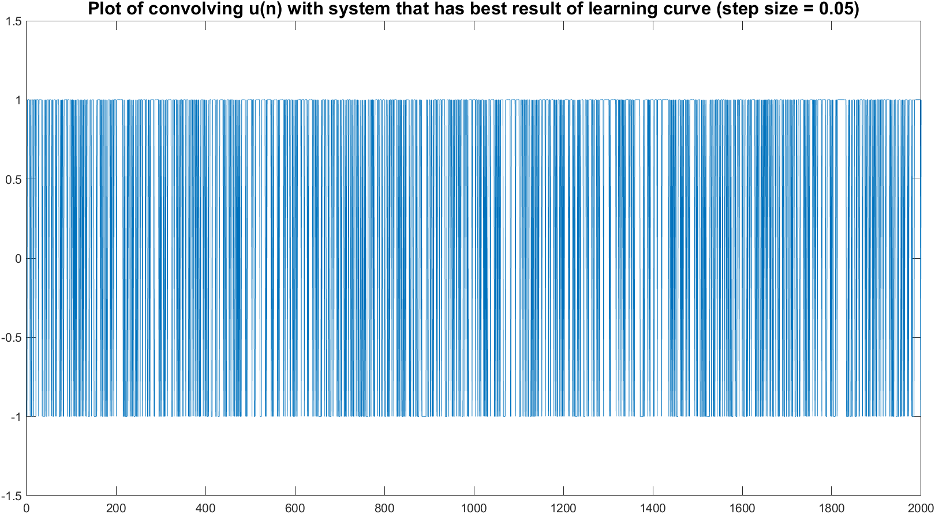

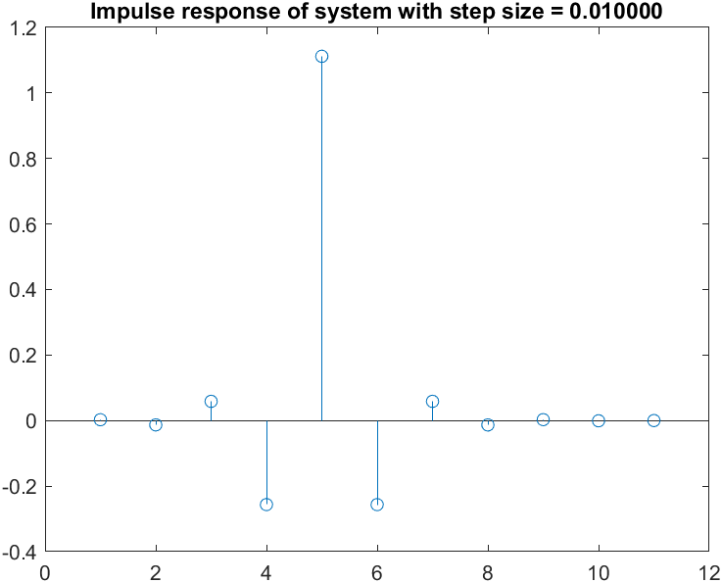

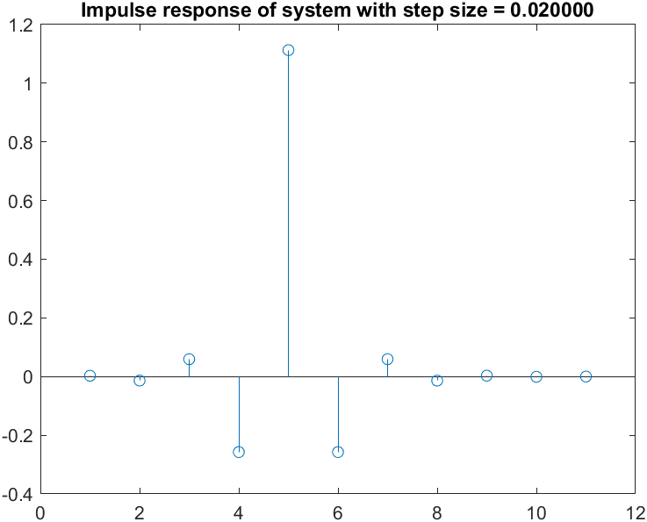

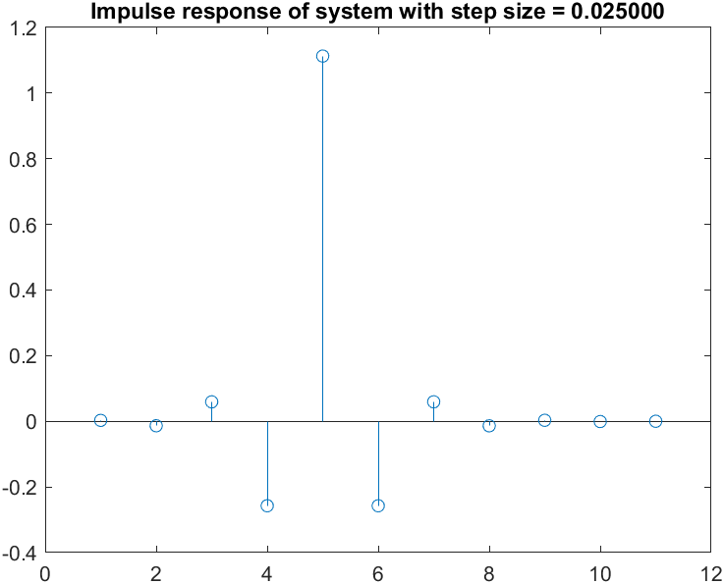

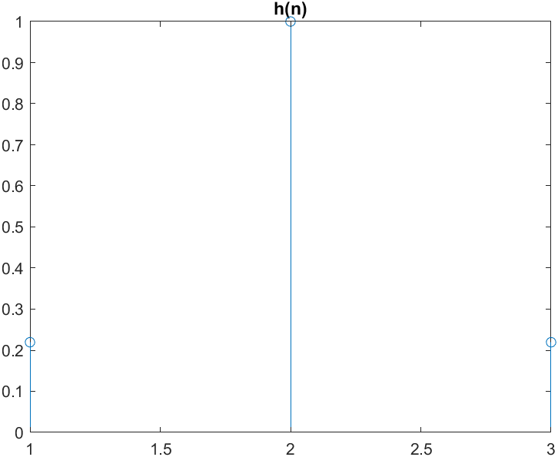

1. **The effect of adding white noise ν(n) which corrupts u(n)**

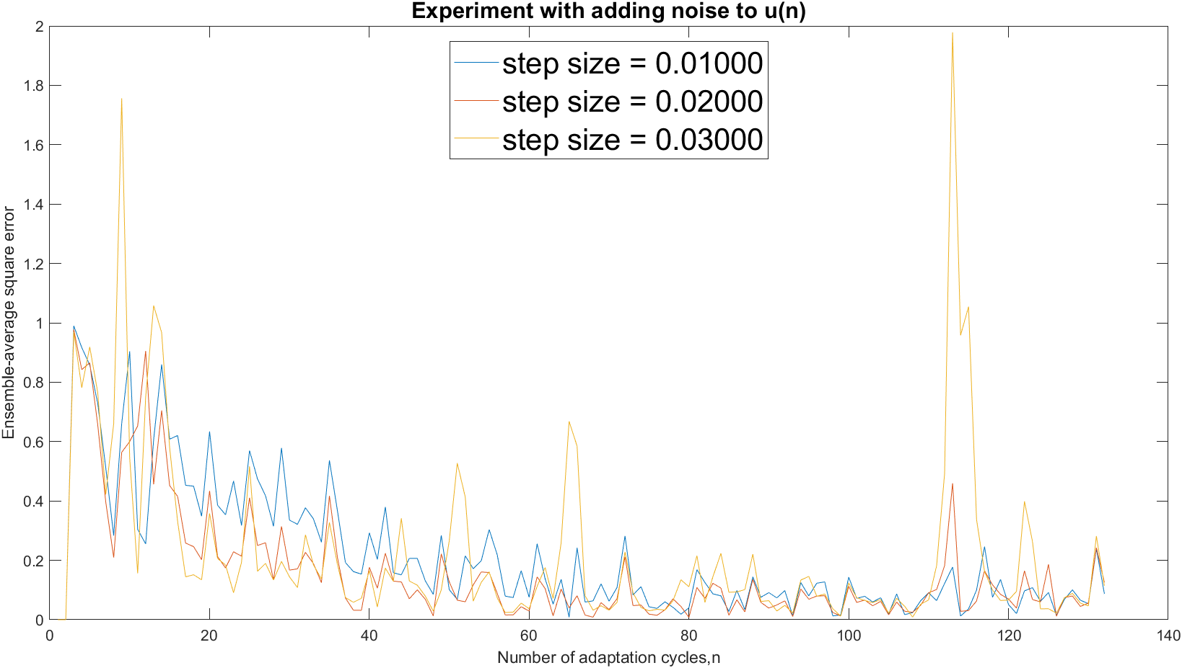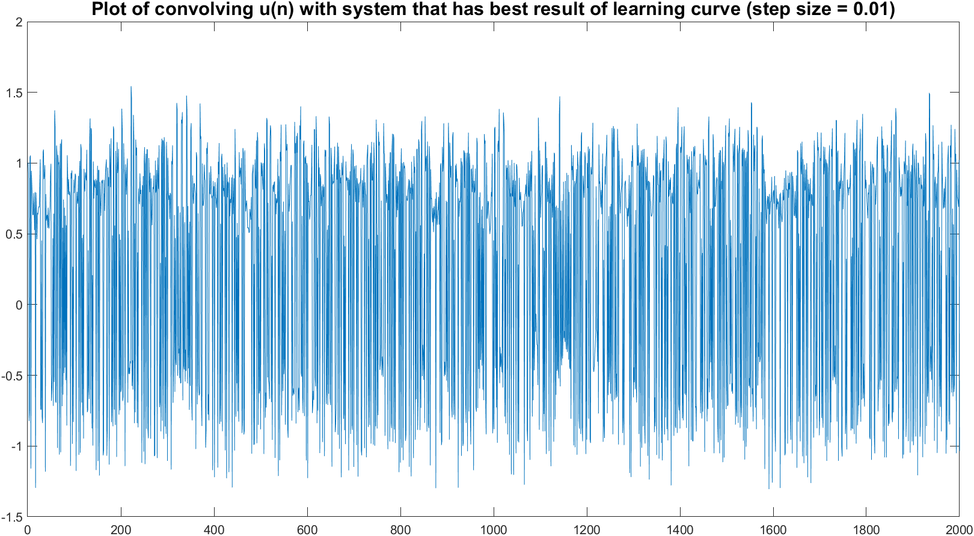

As we can see from the result, when having the impact of the noise on the signal, it’s getting harder for the system to study and find out the impulse response so that the result is similar to the original signal.