**IDENTIFICATION OF PEOPLE WHO ARE USING**

**SOLAR PANELS IN AN AREA**

A Community Service Project Report Submitted to

##### JAWAHARLAL NEHRU TECHNOLOGICAL UNIVERSITY, ANANTAPUR

**Submitted By**

M.MOHITH REDDY **(232U1A3350)** K. SREYANTH REDDY **(232U1A3344)**

M. SRI VENKATA SAI **(232U1A3362)** CH. SARATH KUMAR **(232U1A3314)**

Under the Esteemed Guidance Of

**Mr. U. SATYANARAYANA, M. Tech (PhD)**

Department of Computer Science & Engineering (AI&ML)

***Project report submitted in partial fulfilment of the requirements for the award of the degree of***

**BACHELOR OF TECHNOLOGY**

**IN**

**COMPUTER SCIENCE AND ENGINEERING(AI&ML)**



**DEPARTMENT OF COMPUTER SCIENCE & ENGINEERING(AI&ML)**

**GEETHANJALI INSTITUTE OF SCIENCE AND TECHNOLOGY**

**A Unit of USHODAYA EDUCATIONAL SOCIETY**

***Approved by AICTE, New Delhi & Permanently Affiliated to JNTUA, Anantapuramu***

**NAAC ‘A’ Grade Accredited Institution, An ISO 9001:2015 certified Institution**

**Recognized under Sec. 2(f)&12(B) of UGC Act, 1956**

3rd Mile Bombay Highway, Gangavaram (V), Kovur (M), SPSR Nellore (Dt), Andhra Pradesh, India-524137

Ph. No. 08622-212769, E-Mail: geethanjali@gist.edu.in, Website: [www.gist.edu.in](http://www.gist.edu.in/)



Website [: www.gist.edu.in](http://www.gist.edu.in/)  Ph : 08622-212781

Email: aimlhod@gist.edu.in Fax: 08622-212778

# **GEETHANJALI INSTITUTE OF SCIENCE AND TECHNOLOGY**

A Unit of USHODAYA EDUCATIONAL SOCIETY

***Approved by AICTE, New Delhi & Permanently Affiliated to JNTUA, Anantapuramu***

**NAAC ‘A’ Grade Accredited Institution, An ISO 9001:2015 certified Institution Recognized under Sec. 2(f) & 12(B) of UGC Act, 1956**

3rd Mile,Bombay Highway, Gangavaram (V),Kovur (M),SPSR Nellore (Dt), AndhraPradesh, India 524137



**BONAFIDE CERTIFICATE**

This is to certify that the project work entitled **“IDENTIFICATION OF PEOPLE WHO ARE USING SOLAR PANELS IN AN AREA”** is a bonafide record done by M.MOHITH REDDY(232U1A3350) K.SREYANTH REDDY(232U1A3344) M.VENKATA SAI(232U1A3362) CH.SARATH KUMAR(232U1A3314) in theDepartment of **Computer Science & Engineering (AI&ML), Geethanjali Institute of Science and Technology, Nellore** and is submitted to Jawaharlal Nehru Technological University, Anantapur in the partial fulfilment for the award of **B. Tech degree** in **Computer Science & Engineering(AI&ML).** This work has been carried out under my supervision.

U.Satyanarayana Dr.P.Nagendra Kumar

|  |  |
| --- | --- |
| **Project Guide** | Associate Professor and HOD |
| Department of CSE (AI&ML) | Department of CSE (AI&ML) |
| GIST, NELLORE | GIST, NELLORE |
|  |  |

Submitted for the Viva-Voce Examination held on

**Internal Examiner External Examiner**

## ACKNOWLEDGEMENTS

The satisfaction that accompanies the successful completion of the project would be incomplete without the people who made it possible. Their constant guidance and encouragement crowned the efforts with success.

We express our deepest sense of gratitude to **Mr. N. SUDHAKARREDDY, B. Tech, Secretary and Correspondent**, Geethanjali Institute of Science and Technology, Nellore and other members of Management for providing all the facilities needed for this work.

We owe our gratitude to **Dr. K. SUNDEEP KUMAR, Ph.D., PRINCIPAL**, Geethanjali Institute of Science and Technology, Nellore, for his consistent help and valuable suggestions.

Our special thanks toMr. U. SATYANARAYANA, M. Tech (Ph. D),Department of Computer Science & Engineering (AI&ML), Geethanjali Institute of Science and Technology, Nellore, who is also our guide, for his timely suggestions and help during the progress of project work in spite of his busy schedule.

During the entire course of dissertation work, we received valuable academic inputs as well as moral support from other departments, general teaching and non-teaching faculty at **GEETHANJALI INSTITUTE OF SCIENCE AND TECHNOLOGY**, Nellore. We were motivated by the uphold and moral encouragement given to us by our beloved parents. Finally, we wish to express our sincere thanks for all those who helped me directly or indirectly to complete the work.

PROJECT ASSOCIATES

M.MOHITH REDDY (232U1A3350)

K. SREYANTH REDDY (232U1A3344)

M.SRI VENKATA SAI (232U1A3362)

CH. SARATH KUMAR (232U1A3314)

**TABLE OF CONTENTS**

|  |  |  |
| --- | --- | --- |
| **S. No.** | **CONTENT** | **PAGE NUMBER** |
| 1 | ABSTRACT |  |
| 2 | SURVEY DATA |  |
| 3 | GRAPHS |  |
| 4 | CONCLUSION |  |
| 5 | SURVEY PHOTOS |  |

**ABSTRACT**

It is a survey conducted to find how many people are using solar panels on their house for generating electricity and utilizing it in their house in an area. For this survey we selected Balaji Nagar, in SPSR Nellore District. Our main theme is to know how many people are using solar panels on their house and what type of solar panels they are using in the area and also explain the advantages of using solar panels to people who are not utilising it. We collected the data from various people and found out how many people were using solar panels in that area.

**INTRODUCTION**

Solar panels are devices that capture and convert sunlight into electricity, offering a renewable and sustainable energy solution. They work by utilizing photovoltaic (PV) cells made of semiconductor materials, usually silicon, which generate electricity when exposed to sunlight. Solar panels have become a key technology in the fight against climate change, as they produce clean, green energy with minimal environmental impact.

These systems can be installed on rooftops, in large solar farms, or integrated into other structures, making them versatile for residential, commercial, and industrial use. Solar power not only helps reduce dependence on fossil fuels but also contributes to long-term savings on energy costs, making it an increasingly popular choice for individuals and organizations seeking eco-friendly and cost-effective energy solutions.

**QUESTIONAIRE**

Survey on people who are using solar panels in an area

Name: ____________________ Age: _______

Address: _________________________ Gender: _______

Do you know how solar panels generate electricity?

A. ☐ Yes B. ☐ No

Have you ever considered installing solar panels at your home?

A. ☐ Yes B. ☐ No

Do you think solar energy is a reliable source of power?

A. ☐ Yes B. ☐ No

Would you switch to solar energy if it reduced your electricity bill?

A. ☐ Yes B. ☐ No

Do you believe solar panels are environmentally friendly?

A. ☐ Yes B. ☐ No

Have you ever received a quote for solar panel installation?

A. ☐ Yes B. ☐ No

Do you think the initial cost of solar panels is too high?

A. ☐ Yes B. ☐ No

Would you support government incentives for solar energy adoption?

A. ☐ Yes B. ☐ No

Do you think solar panels increase property value?

A. ☐ Yes B. ☐ No

Have you seen solar panels installed in your neighbourhood?

A. ☐ Yes B. ☐ No

Signature: ____________________

**QUESTIONAIRE**

Survey on people who are using solar panels in an area

Name: ____________________ Age: _______

Address: _________________________ Gender: _______

Do you know how solar panels generate electricity?

A. ☐ Yes B. ☐ No

Have you ever considered installing solar panels at your home?

A. ☐ Yes B. ☐ No

Do you think solar energy is a reliable source of power?

A. ☐ Yes B. ☐ No

Would you switch to solar energy if it reduced your electricity bill?

A. ☐ Yes B. ☐ No

Do you believe solar panels are environmentally friendly?

A. ☐ Yes B. ☐ No

Have you ever received a quote for solar panel installation?

A. ☐ Yes B. ☐ No

Do you think the initial cost of solar panels is too high?

A. ☐ Yes B. ☐ No

Would you support government incentives for solar energy adoption?

A. ☐ Yes B. ☐ No

Do you think solar panels increase property value?

A. ☐ Yes B. ☐ No

Have you seen solar panels installed in your neighbourhood?

A. ☐ Yes B. ☐ No

Signature: ____________________

**QUESTIONAIRE**

Survey on people who are using solar panels in an area

Name: ____________________ Age: _______

Address: _________________________ Gender: _______

Do you know how solar panels generate electricity?

A. ☐ Yes B. ☐ No

Have you ever considered installing solar panels at your home?

A. ☐ Yes B. ☐ No

Do you think solar energy is a reliable source of power?

A. ☐ Yes B. ☐ No

Would you switch to solar energy if it reduced your electricity bill?

A. ☐ Yes B. ☐ No

Do you believe solar panels are environmentally friendly?

A. ☐ Yes B. ☐ No

Have you ever received a quote for solar panel installation?

A. ☐ Yes B. ☐ No

Do you think the initial cost of solar panels is too high?

A. ☐ Yes B. ☐ No

Would you support government incentives for solar energy adoption?

A. ☐ Yes B. ☐ No

Do you think solar panels increase property value?

A. ☐ Yes B. ☐ No

Have you seen solar panels installed in your neighbourhood?

A. ☐ Yes B. ☐ No

Signature: ____________________

**QUESTIONAIRE**

Survey on people who are using solar panels in an area

Name: ____________________ Age: _______

Address: _________________________ Gender: _______

Do you know how solar panels generate electricity?

A. ☐ Yes B. ☐ No

Have you ever considered installing solar panels at your home?

A. ☐ Yes B. ☐ No

Do you think solar energy is a reliable source of power?

A. ☐ Yes B. ☐ No

Would you switch to solar energy if it reduced your electricity bill?

A. ☐ Yes B. ☐ No

Do you believe solar panels are environmentally friendly?

A. ☐ Yes B. ☐ No

Have you ever received a quote for solar panel installation?

A. ☐ Yes B. ☐ No

Do you think the initial cost of solar panels is too high?

A. ☐ Yes B. ☐ No

Would you support government incentives for solar energy adoption?

A. ☐ Yes B. ☐ No

Do you think solar panels increase property value?

A. ☐ Yes B. ☐ No

Have you seen solar panels installed in your neighbourhood?

A. ☐ Yes B. ☐ No

Signature: ____________________

**QUESTIONAIRE**

Survey on people who are using solar panels in an area

Name: ____________________ Age: _______

Address: _________________________ Gender: _______

Do you know how solar panels generate electricity?

A. ☐ Yes B. ☐ No

Have you ever considered installing solar panels at your home?

A. ☐ Yes B. ☐ No

Do you think solar energy is a reliable source of power?

A. ☐ Yes B. ☐ No

Would you switch to solar energy if it reduced your electricity bill?

A. ☐ Yes B. ☐ No

Do you believe solar panels are environmentally friendly?

A. ☐ Yes B.

Have you ever received a quote for solar panel installation?

A. ☐ Yes B. ☐ No

Do you think the initial cost of solar panels is too high?

A. ☐ Yes B. ☐ No

Would you support government incentives for solar energy adoption?

A. ☐ Yes B. ☐ No

Do you think solar panels increase property value?

A. ☐ Yes B. ☐ No

Have you seen solar panels installed in your neighbourhood?

A. ☐ Yes B. ☐ No

Signature: ____________________

**GRAPHS**

|  |  |
| --- | --- |
| **Total number of people using solar panels** | **16** |
| **Total number of people not using solar panels** | **34** |

**The Pie chart represents the people who are using solar panels**

**and not using the solar panels**

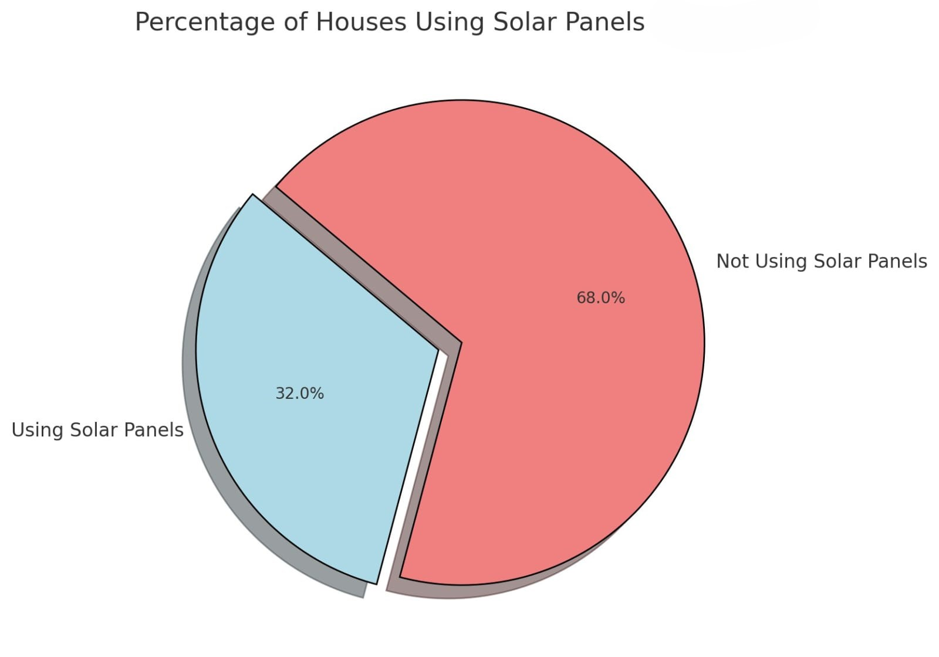

**The below graph represents the people who are using and not using the solar panels**

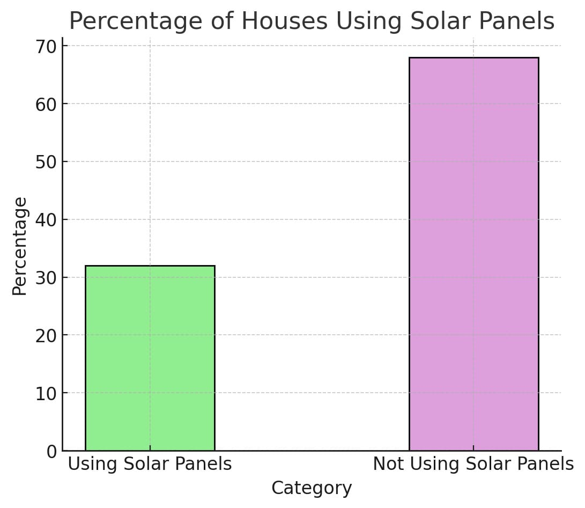

**SURVEY DATA**

|  |  |  |  |  |  |  |
| --- | --- | --- | --- | --- | --- | --- |
| **Sl.No.** | **NAME** | **AADHAR NUMBER** | **PHONE NUMBER** | **AREA NAME** | **USING SP** | **NOT USING SP** |
| 1 | Chitta Sudhamani | 205242412090 | 9440951167 | Balaji Nagar |  | NO |
| 2 | Adi Lakshmi | 223853453955 | 9491948373 | Balaji Nagar |  | NO |
| 3 | Empeti Prasanna | 256390864402 | 9949747104 | Balaji Nagar |  | NO |
| 4 | Garimella.Kan Yakumari | 256715002642 | 9440805690 | Balaji Nagar | YES |  |
| 5 | Nelaballimadhu | 274256125530 | 8801117201 | Balaji Nagar |  | NO |
| 6 | Maruboina Mangamma | 277874250012 | 9949067797 | Balaji Nagar |  | NO |
| 7 | Katepalli Lakshmiprasanna | 353242861952 | 9985183277 | Balaji Nagar | YES |  |
| 8 | Soga Mallika | 371194301443 | 9573199877 | Balaji Nagar | YES |  |
| 9 | Veeraboina Nandini | 439102742442 | 9949067797 | Balaji Nagar |  | NO |
| 10 | P Lakshmi | 441887362624 | 9052509127 | Balaji Nagar |  | NO |
| 11 | Kanamarlapudi Sireesha | 480319867398 | 8121204279 | Balaji Nagar |  | NO |
| 12 | Sirigiri Vijaya Kumari | 487987577879 | 9949704251 | Balaji Nagar |  | NO |
| 13 | Vemula Krishna Chaitanya | 551254147013 | 9182542112 | Balaji Nagar |  | NO |
| 14 | Kavitha | 552004087483 | 7799848489 | Balaji Nagar | YES |  |
| 15 | Ayyapaneni Sarojanamma | 583802085140 | 9849283132 | Balaji Nagar |  | NO |
| 16 | P.Manjula | 584719224987 | 9492081294 | Balaji Nagar |  | NO |
| 17 | Junnuti Santhi | 603876947463 | 6304424833 | Balaji Nagar | YES |  |
| 18 | Sakhapuram Venkata Ramanamma | 615876656434 | 7032008118 | Balaji Nagar | YES |  |
| 19 | Phatan Habeeb | 619717901326 | 9676298722 | Balaji Nagar | YES |  |
| 20 | Yeddala Ravanamma | 638223508346 | 7675093415 | Balaji Nagar |  | NO |
| 21 | Annam Raju Venkata Subbamma | 650544478343 | 9652913397 | Balaji Nagar | YES |  |
| 22 | Sandhu Sujana | 699818149007 | 9848148808 | Balaji Nagar |  | NO |
| 23 | Malisetty Sailakshmi | 712829818444 | 8374465544 | Balaji Nagar |  | NO |
| 24 | W.Suseela | 716865171087 | 9701355650 | Balaji Nagar |  | NO |
| 25 | Nilupu Lakshmi | 725763475491 | 9908361825 | Balaji Nagar |  | NO |
| 26 | Chalivendra Sridevi | 762774939134 | 9182683123 | Balaji Nagar |  | NO |
| 27 | Ramisetty Yamini | 780867461232 | 7093414241 | Balaji Nagar |  | NO |
| 28 | Sannapaneni Jyothi | 819062955728 | 9908272589 | Balaji Nagar | YES |  |
| 29 | Sk Naseema | 878063075675 | 7093281758 | Balaji Nagar | YES |  |
| 30 | Sridevi | 884600784926 | 9296655940 | Balaji Nagar | YES |  |
| 31 | Piduri Lakshmi | 894164877661 | 9989849755 | Balaji Nagar |  | NO |
| 32 | S Anuradha | 896241154219 | 7382277670 | Balaji Nagar |  | NO |
| 33 | Dommaraju Lalitha | 919347488279 | 8330919979 | Balaji Nagar |  | NO |
| 34 | Panchava Sudharani | 963788562658 | 9493998416 | Balaji Nagar | YES |  |
| 35 | Nanubala Kanthamma | 990366296978 | 9949534508 | Balaji Nagar |  | NO |
| 36 | Akshinthala Sakunthala | 801322939716 | 7981460500 | Balaji Nagar |  | NO |
| 37 | Bhonsle Lalitha | 607506810157 | 8885743831 | Balaji Nagar | YES |  |
| 38 | K.Ramireddy | 633273879852 | 9174853654 | Balaji Nagar | YES |  |
| 39 | M.Ramesh reddy | 837784509925 | 7981488436 | Balaji Nagar |  | NO |
| 40 | G.Gangadhar | 798393723146 | 9440538354 | Balaji Nagar |  | NO |
| 41 | A.Sravani | 877467266338 | 9490770235 | Balaji Nagar |  | NO |
| 42 | M.Reshnavi | 877018020033 | 7337245409 | Balaji Nagar |  | NO |
| 43 | P.Subbaiha | 715928715896 | 9848078937 | Balaji Nagar |  | NO |
| 44 | SK.Nayab | 633276278942 | 9542224867 | Balaji Nagar |  | NO |
| 45 | CH.Suresh | 894241158107 | 9652524711 | Balaji Nagar | YES |  |
| 46 | R.Durgarao | 930540326897 | 7416987432 | Balaji Nagar |  | NO |
| 47 | A.vishwanth | 384181044343 | 8304768912 | Balaji Nagar |  | NO |
| 48 | N.lakshmi | 640862511764 | 9409301443 | Balaji Nagar | YES |  |
| 49 | D.Rajamma | 439726155735 | 6303788708 | Balaji Nagar |  | NO |
| 50 | K.Venu | 877018020033 | 9440476174 | Balaji Nagar |  | NO |

**INFERENCE FROM SURVEY DATA**

**Total number of houses visited :50**

**Total number of houses using solar panels :16**

**Total number of houses not using solar panels: 34**

**CONCLUSION**

It has been identified from the survey that 32% of the people in that area are using solar panels and the remaining 68% of the people are not using the solar panels in Balaji Nagar, Nellore district.

|  |  |
| --- | --- |
|  |  |
|  |
|  |
|  |