Table of Contents

COS212 App: Instructional Design Document
Module: COS750 Educational Software Development Deliverable: 2b (Instructional Design document) Group: group name Members: names and student numbers Date: dd November 2026 Version: 0.3 (draft; algorithm: depth-first traversal) Companion document: COS212 App Software Engineering Document (version _)
Status of this draft. Items marked ⚠ need the group’s decisions, evidence from the pilot test, or citations to specific lecture slides or textbook pages. Each section names the COS750 lecture it draws on so that the panel can see the module being applied.

1. Purpose and context
The COS 212 lecturer has asked for an “app” that gives students a tutor-style, pre-lecture opportunity to meet a core data structure and algorithm. This document records the instructional design of our prototype, which teaches the binary tree (using a binary search tree as the running instance) and depth-first traversal in its three forms: pre-order, in-order and post-order. The software engineering design is documented separately in the SE document.
Depth-first traversal appears in CS2023 AL-Foundational, item 11(c), “O(log_b n) complexity (e.g., uninformed depth/breadth-first tree search)”, which is CS Core. Binary and search trees are item 9(a). Learning outcome 2, “for each algorithm in this unit explain step-by-step how the algorithm operates”, is exactly what the app asks the student to do (Kumar et al., 2024). The choice therefore satisfies the examination specification (University of Pretoria, 2026).
The instructional problem is specific. Students will use the app before any lecture, so it must (a) assume no prior knowledge of trees or traversal, (b) build a correct mental model that the lecture can then deepen with recursion, iterative traversal using an explicit stack, and breadth-first search, and (c) tell the student, and only the student, whether they are ready, offering extra scaffolding if they are not (examination specification, section 2.1).
Scope conventions. Trees are binary. The running example is a binary search tree with distinct integer keys so that the in-order payoff (“the output comes out sorted”) is available. “Visit” means output the node’s value. The three depth-first orders differ only in when the current node is visited relative to its subtrees. Breadth-first traversal is mentioned for contrast only. Recursion is described in words (“do the same thing for the left subtree”), never as code.

2. Instructional design approach

2.1 Overall lifecycle: ADDIE (L11, Software and Instructional Design Lifecycles)
We use ADDIE (Analyse, Design, Develop, Implement, Evaluate) as the overarching instructional design lifecycle (Branch, 2009). Three reasons: it is the reference model against which the other models in L11 are explained; its phases map cleanly onto our software engineering sprints; and its explicit Evaluate phase forces us to test with real learners rather than assume.
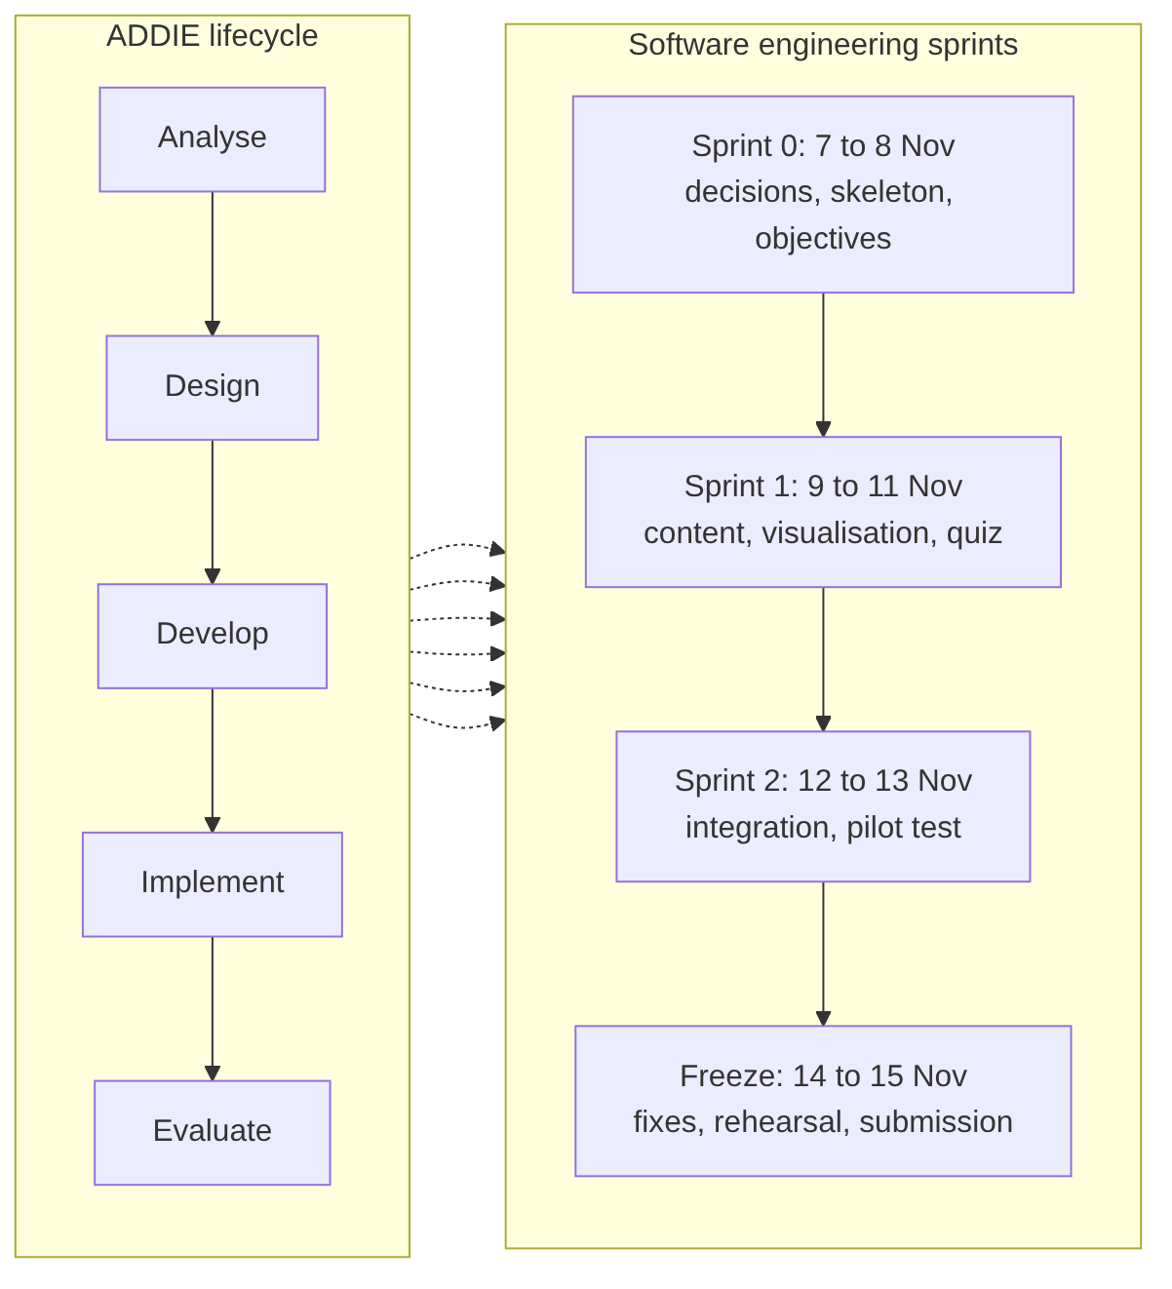
Figure 1: ADDIE phases mapped onto the project’s software engineering sprints
Table 1: ADDIE phases as applied to the prototype
ADDIE phase | What we did or will do | Where documented
Analyse | Learner analysis; task analysis of “traverse a binary tree depth-first”; gap analysis against CS2023 outcomes; likely misconceptions | Sections 3 and 7
Design | Learning objectives (Bloom’s), sequencing (Gagné), motivation design (ARCS, Malone and Lepper), assessment and scaffolding design | Sections 4 to 9
Develop | Content, visualisation (tree, breadcrumb and output strip), item bank, remedial activities; GenAI-assisted drafting | Sections 7 and 11
Implement | Delivered as a client-side web app; pilot with two or three first-year students | SE document; section 10
Evaluate | Formative: think-aloud pilot and item analysis. Summative (proposed): pre- and post-quiz in the real COS 212 cohort | Section 10

2.2 Lesson-level sequencing: Gagné’s Nine Events of Instruction (L11)
Within the app, the lesson follows Gagné’s events (Gagné, Briggs and Wager, 1992). Figure 2 shows how the events map onto the app’s screens.
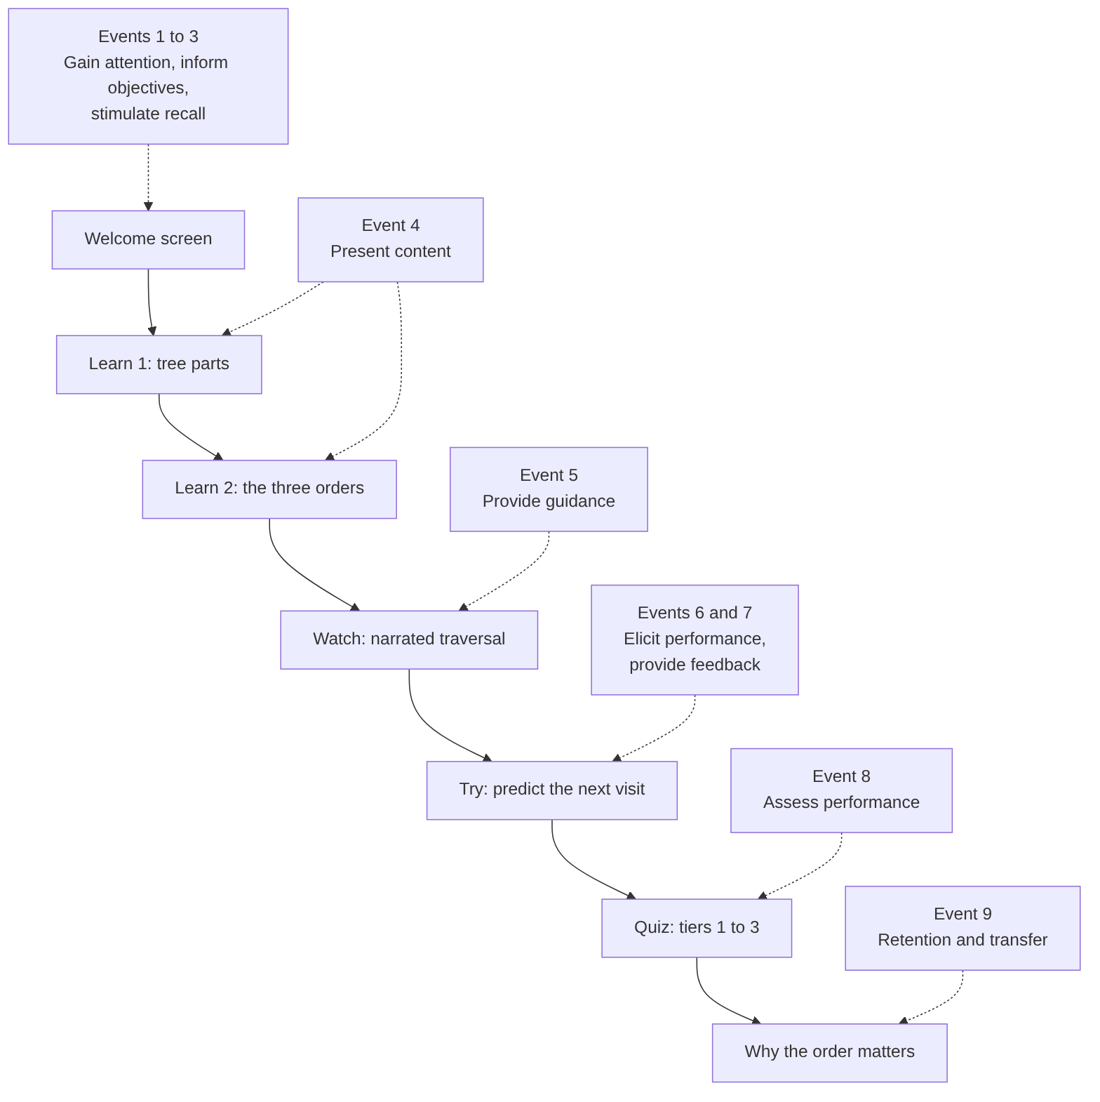
Figure 2: Gagné’s nine events of instruction mapped onto the app’s screens
Table 2: Gagné’s events and their realisation in the app
Gagné event | App realisation
1 Gain attention | Welcome screen: “A tree has no first and last, so in what order do you read it?” with a ten-second animation of a traversal lighting up nodes and building an output strip
2 Inform objectives | “In 20 minutes you will be able to…” (objectives O1 to O5 in student language)
3 Stimulate recall | One-screen recap: nodes and references (from linked lists), the idea of doing the same thing again on a smaller piece, and the BST ordering rule as context
4 Present content | Learn pages: tree parts, then what a traversal is, then the three orders as “when do you say the node’s name?”
5 Provide guidance | Watch: animated traversal showing the current node, the path taken so far (breadcrumb) and the output strip, narrated step by step (worked example)
6 Elicit performance | Try: “predict the next visit”, in which the student clicks the node they think is output next
7 Provide feedback | Immediate, specific feedback on every prediction and every quiz item
8 Assess performance | Tiered quiz (tiers 1 to 3) with mastery thresholds
9 Enhance retention and transfer | “Why the order matters”: in-order on a BST gives sorted output; pre-order copies a tree; post-order deletes one safely; a pointer to what the lecture adds (recursion, explicit stack, breadth-first search)

3. Learner analysis (L01, L04, L12)
Table 3: Learner analysis and resulting design decisions
Dimension | Finding | Design consequence
Prior knowledge | Completed first-year programming; know comparisons, loops and basic references; have not met trees or traversal; recursion is fragile | Vocabulary taught from scratch; traversal described as a procedure to repeat on each subtree, not as code; the path so far is shown explicitly so that backtracking is visible rather than implicit
Cognitive load | New vocabulary (root, leaf, subtree), the idea of traversal, and three orders that differ subtly | Three orders introduced one at a time; one node highlighted at a time; output strip builds incrementally (cognitivism, section 5)
Likely misconceptions (from task analysis) | Visiting a node as soon as it is reached regardless of order; forgetting to return to a parent after a subtree; confusing in-order with “left to right on the page” | Watch shows the return to a parent as an explicit step; Try asks for the next visit at exactly those moments; tier 2 items target them
Motivation | Mixed; pre-lecture work is often skipped | Short (20 minutes or less), visible progress, “ready for the lecture” badge (section 6)
Learning styles | Heterogeneous; see section 8 | Every concept offered visually (tree and strip), verbally (narration and text) and kinaesthetically (click the next node)
Access | Phones and laptops; intermittent data | Offline-capable, no login (SE document, NFR2)
Special needs (L12) | Some students use screen readers or have colour-vision deficiency | Keyboard operability, ARIA labels, shape and colour cues, adjustable animation speed, output strip as text

4. Learning objectives (L07, Bloom’s revised taxonomy)
After completing the app, a COS 212 student will be able to:
Table 4: Learning objectives with Bloom’s levels (Anderson and Krathwohl, 2001)
ID | Objective | Bloom’s level | Evidence and assessment
O1 | Define root, child, leaf, subtree and height, and state what “traversing” and “visiting” a node mean | Remember | Tier 1
O2 | Explain the depth-first idea (go as deep as possible down one side before backing up) and distinguish pre-, in- and post-order by when the current node is visited | Understand | Tier 1
O3 | Trace a given traversal order on a given binary tree, producing the visit sequence step by step | Apply | Try exercise; tier 2
O4 | Produce all three depth-first visit sequences for a tree of up to seven nodes, and identify which order produced a given sequence | Apply | Tier 2
O5 | Explain why in-order traversal of a binary search tree yields the keys in sorted order, and why the path so far is never longer than the tree’s height | Analyse | Tier 3
O1 to O4 target CS2023 learning outcomes 1(a), 1(b) and 2. O5 prepares the ground for the lecture’s treatment of recursion, the explicit stack and breadth-first search without pre-empting it.

5. Learning theories applied (L01, Learning Theories; Schunk)
We do not adopt a single theory. Each theory justifies specific features, as Table 5 and Figure 3 show. ⚠ Add page and slide citations.
Table 5: Learning theories, the principle used, and the feature it justifies
Theory | Principle used | Feature in the app
Behaviourism (Skinner: reinforcement, immediate feedback, shaping) | Correct responses reinforced immediately; small steps | Every “next visit” click and quiz item gives instant feedback; tiers shape from recall to apply to analyse
Cognitivism (information processing; cognitive load theory, Sweller, 1988; multimedia learning, Mayer, 2021) | Limit intrinsic and extraneous load; worked examples before problem solving; dual coding; avoid split attention | Three orders introduced one at a time; the narrated animation is a worked example and precedes Try; node, breadcrumb and output strip are co-located on one screen
Constructivism (Piaget, Bruner: learners build models through active prediction and guided discovery) | Predict-then-verify creates cognitive conflict when a prediction is wrong | Try asks which node is visited next before revealing it; the sandbox lets students build a tree and run all three orders on it
Social cognitive theory (Bandura, 1986: modelling, self-efficacy) | Observing a competent model; mastery experiences raise self-efficacy | The narrated tutor models the procedure; mastery badges per tier; failure framed as “not yet” with a route forward
Scaffolding in the zone of proximal development (Vygotsky, 1978) | Support within the ZPD, then faded | Guided predict (breadcrumb and hints shown), then unguided predict (hidden), then quiz; the remedial loop re-adds support only where needed
Figure 3: Learning theories and the prototype features they justify

5.1 Managing cognitive load (detail)
One order at a time: pre-order is taught first because “visit on arrival” is the most intuitive; in-order second because it carries the sorted-output payoff; post-order last. The animation shows exactly three things (the highlighted current node, the breadcrumb, and the output strip) and nothing else moves. The Try exercise removes the breadcrumb once the learner has completed two correct full traversals.

6. Motivation design (L05, Motivation)

6.1 Keller’s ARCS model (Keller, 1987)
Table 6: ARCS strategies and features
ARCS category | Strategy | Feature
Attention | Perceptual arousal; inquiry | “In what order do you read a tree?” hook; “beat the tutor” prediction challenge
Relevance | Goal orientation; familiarity | “This is in your next lecture and test”; real uses named (printing a folder tree, evaluating an expression, deleting a tree safely)
Confidence | Clear objectives; success opportunities; learner control | Objectives shown up front; tiers unlock progressively; the student controls speed and can replay
Satisfaction | Natural consequences; positive feedback | The output strip the student predicted appears in full; in-order on a BST comes out sorted, a visible “aha”; “Ready for the lecture” badge

6.2 Malone and Lepper’s intrinsic motivations (Malone and Lepper, 1987)
- Challenge: tiers with rising difficulty; uncertain outcome in predict-the-next-visit; a “no breadcrumb” hard mode.
- Curiosity: sensory (animation) and cognitive (“what if I run in-order on a tree that is not a BST?”; the answer is that the output is no longer sorted).
- Control: sandbox tree building; choice of order; choice of speed; choice to retry.
- Fantasy: minimal. The traversal is described as a robot that explores every corridor to the end before turning back. Kept light to avoid extraneous load.
- Interpersonal motivators (co-operation, competition, recognition): not in the prototype. A future version could show anonymised cohort progress.

7. Content design and sequencing

7.1 Task analysis of depth-first traversal
For the current node:
- Pre-order: visit the node, then traverse the left subtree, then traverse the right subtree.
- In-order: traverse the left subtree, then visit the node, then traverse the right subtree.
- Post-order: traverse the left subtree, then traverse the right subtree, then visit the node.
“Traverse a subtree” means “do these same steps starting at that child”. An empty subtree takes no steps. When a subtree is finished, return to its parent and continue with the parent’s remaining steps. Figure 4 shows the in-order procedure as the app narrates it.
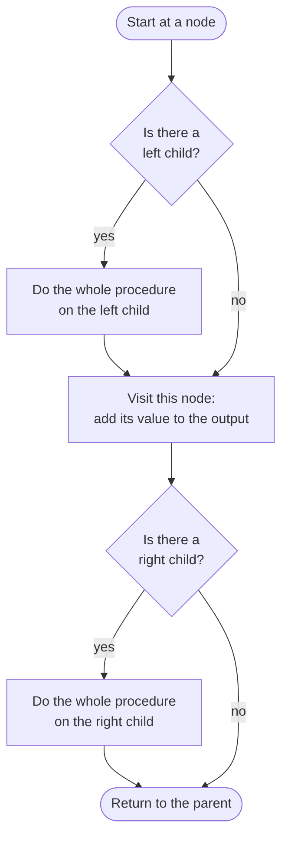
Figure 4: The in-order procedure as the app narrates it (pre-order and post-order move the “visit” box)
Each step becomes (a) a sentence in the narration, (b) a highlight or breadcrumb change in the animation, (c) a decision point in the Try exercise (“which node is visited next?”), and (d) a quiz item type. This one-to-one mapping keeps content, visualisation and assessment aligned (constructive alignment, L07).

7.2 Worked example (used in Watch and in the Learn pages)
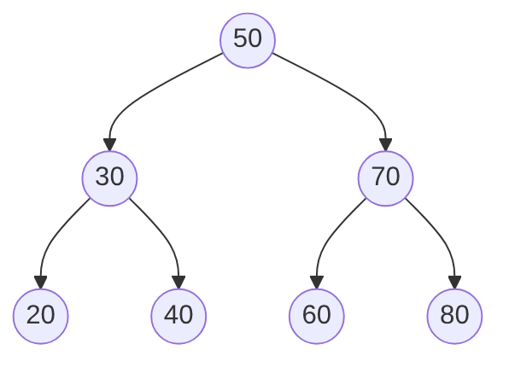
Figure 5: The worked-example tree (root 50; left subtree 30, 20, 40; right subtree 70, 60, 80)
Table 7: The three traversals of the worked-example tree
Order | Visit sequence | Narration excerpt
Pre-order | 50 30 20 40 70 60 80 | “Arrive at 50: say it. Go left to 30: say it. Go left to 20: say it. 20 has no children, so back to 30. 30’s right is 40: say it. Back to 30, back to 50. Now 50’s right…”
In-order | 20 30 40 50 60 70 80 | “Arrive at 50: do not say it yet, left first. Arrive at 30: left first. Arrive at 20: no left child, so say 20. No right child, so back to 30: now say 30. Right to 40: say 40. Back to 50: say 50…”
Post-order | 20 40 30 60 80 70 50 | “…both of 30’s children are done, so now say 30. … The root is always last.”
Reflection question after in-order: “Why did the numbers come out in increasing order?” Expected answer: in a BST everything left of a node is smaller and everything right is larger, and in-order visits left, then the node, then right, at every level.
Worked examples in Watch: three, increasing in complexity (three nodes; five nodes, unbalanced; the seven-node tree above). A fourth, optional example uses a tree that is not a BST to show that in-order is then not sorted (contrast for O5).

7.3 Content units (about 18 to 22 minutes in total)
Table 8: Content units, timing and Gagné events
Unit | Content | Minutes | Gagné events
0 | Welcome, objectives, recap | 2 | 1 to 3
1 | What is a binary tree? (shape, terms) | 3 | 4
2 | What is a traversal? Pre-, in- and post-order as “when do you say the name?” | 3 | 4
3 | Watch: three worked examples, each order selectable | 4 | 5
4 | Try: predict the next visit (guided, then unguided) | 4 | 6 and 7
5 | Quiz tiers 1 to 3, with remediation loops as needed | 5 or more | 8
6 | Why the order matters: sorted output, copy, delete; what the lecture adds | 2 | 9

7.4 Interaction design rationale (L06, User Experience: Interaction)
Interaction is step-controlled rather than continuous animation so that the learner, not the system, sets the pace (direct manipulation; visibility of system status). The current node, the breadcrumb and the output strip are always co-located to avoid split attention. In Try, the student clicks the node itself rather than choosing from a list, so the action matches the mental operation (“which one next?”).

8. Learning styles and accessibility (L04, Learning Styles; L12, Special Needs Education)
We treat learning styles as preferences for representation rather than fixed traits. The evidence for matching instruction to a diagnosed style (the “meshing hypothesis”) is weak (Pashler et al., 2008), so every learner receives every modality.
Table 9: Learning styles and the provision made for each
Style framework | Provision
Visual (VAK and VARK; Fleming) | Live tree with highlighted current node and breadcrumb; output strip; progress bars
Auditory and verbal | Step-by-step narration text written as a tutor would say it (⚠ optional speech via the Web Speech API if time allows)
Read and write | Learn pages; the three procedures written as numbered steps; downloadable one-page summary
Kinaesthetic | Click the next node; build your own tree; drag the speed slider
Honey and Mumford: Activist, Reflector, Theorist, Pragmatist | Try exercise (Activist); step and replay control (Reflector); the three procedures stated as rules and the “why is in-order sorted?” analysis (Theorist); real uses such as folder listings, expression evaluation, safe deletion and saving a tree to a file (Pragmatist)
Accessibility follows Universal Design for Learning (CAST, 2024) and L12: keyboard operability for every control, including “pick the next node” (arrow keys cycle through candidates, Enter selects); visible focus; ARIA labels naming the node and its state; the output strip and breadcrumb available as plain text; colour used only alongside shape or label; adjustable animation speed.

9. Assessment and scaffolding design (L07, Assessment and Evaluation)

9.1 Principles
- Formative, low-stakes, self-referenced. The score is for the student; nothing is transmitted.
- Aligned to objectives and Bloom’s levels (constructive alignment): each tier targets one level band and items are tagged.
- Immediate, informative feedback: every item has an explanation that re-teaches the step, not just “wrong”.
- Mastery-based progression: 80 percent threshold per tier (4 of 5). The threshold tolerates a single slip while still requiring the central skill; a stricter rule risked looping learners who had in fact grasped the procedure.

9.2 Tiers
Table 10: Quiz tiers, item types and remediation
Tier | Bloom’s level | Item types (examples) | Objectives | Remediation if below 80 percent
1 | Remember and Understand | “In in-order traversal, when is the current node visited?”; “Which of these is not a depth-first order?”; “A leaf is…” | O1, O2 | Re-show Learn page 2 with the three orders side by side on the same three-node tree; retry with fresh items
2 | Apply | “Pre-order of this tree: what is the fourth value output?”; “Which order produced 20 40 30 60 80 70 50?”; “After visiting 20 in in-order, which node is visited next?” | O3, O4 | Guided predict-the-next-visit (breadcrumb on) for two trees; retry
3 | Analyse | “Why does in-order on a BST give sorted output?”; “In-order on this tree gives 30 10 50: what does that tell you about the tree?”; “The breadcrumb is never longer than…?” | O5 | “Why the order matters” demo (BST versus non-BST in-order; tall versus short tree breadcrumb); retry
Item bank: at least ten items per tier so that a retry draws five unseen items (⚠ content developer).
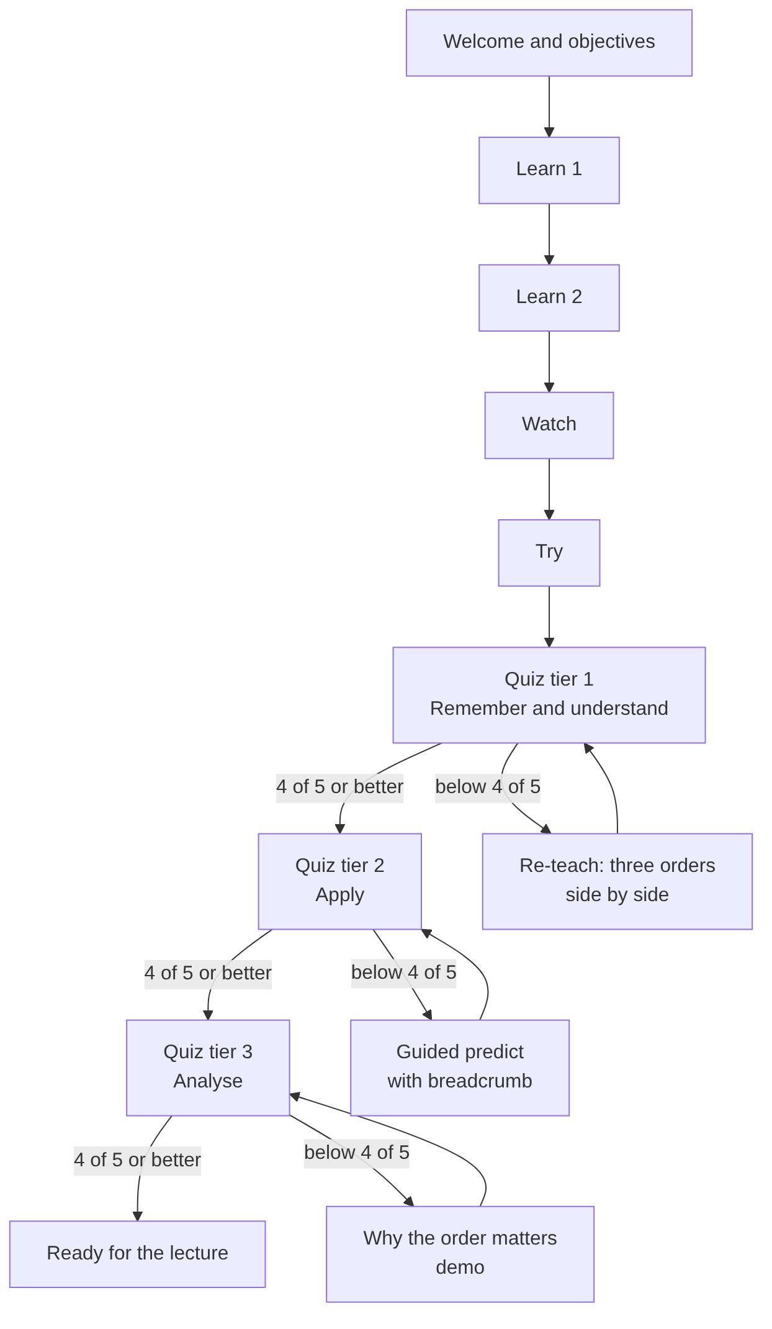
Figure 6: Lesson flow with mastery gates and remediation loops

9.3 Scaffolding mechanism
The app implements contingent scaffolding in Vygotsky’s sense: support is added only on evidence of difficulty and withdrawn on success.
- In Try, feedback is driven by the first wrong click. For example, if the learner clicks 50 first in in-order, the app asks “Does in-order visit the node before or after its left subtree?”; if the learner is still stuck, it states the rule and lets the learner make the next choice alone (Figure 7).
- Below a tier threshold, the student is told which objective they missed (“You’re not yet sure when the node itself is visited”) and routed to the remedial activity for that tier.
- Remedial activities re-present the concept in a different modality from the first exposure (text, then animation, then hands-on), consistent with section 8.
- Retry uses new items. Passing unlocks the next tier. The “Ready for the lecture” badge requires all three tiers.
- Students who pass first time see no remediation: fading by default.
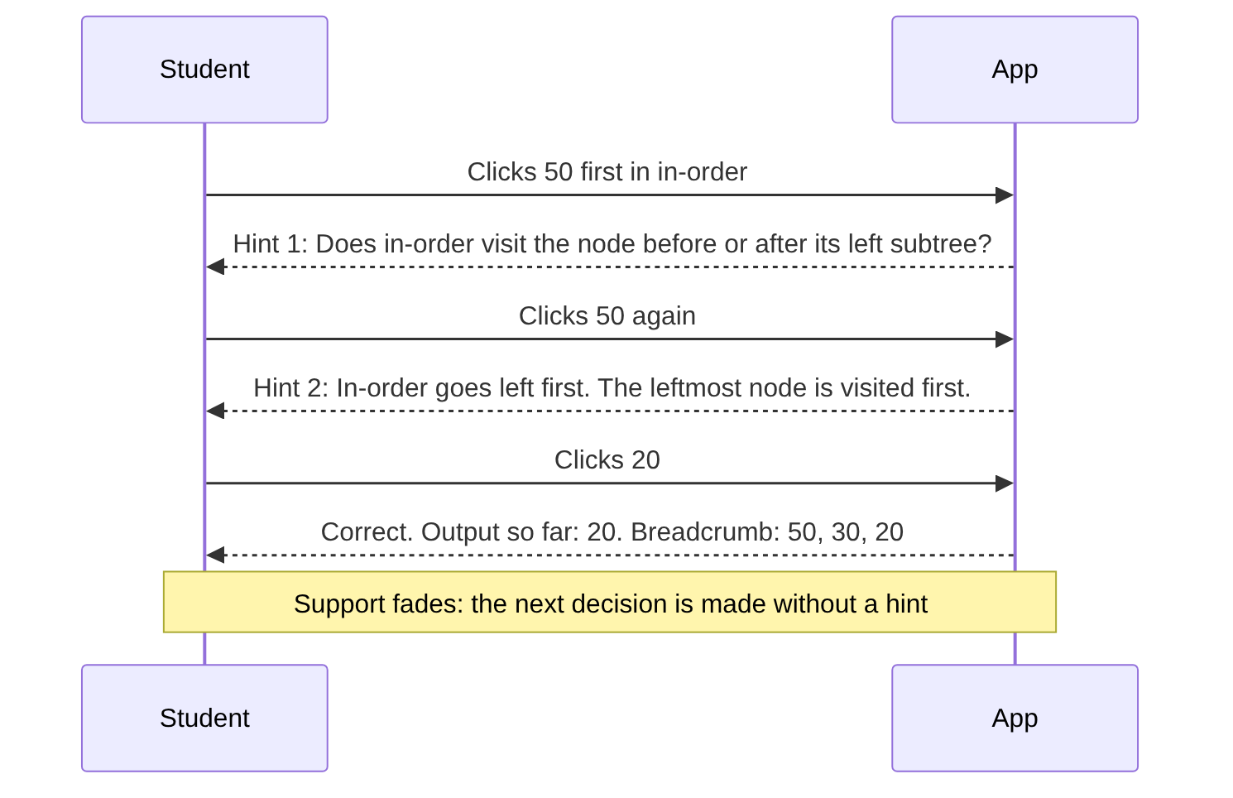
Figure 7: Contingent scaffolding in the Try exercise: hints escalate on repeated error and fade on success

10. Evaluation plan (L07; ADDIE, Evaluate)
⚠ Pilot to be conducted on Thursday 12 November with two or three first-year students who have not met tree traversal. Fill in afterwards.
Table 11: Evaluation methods
Method | Participants | Measures | Status
Think-aloud pilot | Two or three students | Confusions, time per unit, where they get stuck; each asked to explain one traversal aloud | Planned
Item analysis | Pilot quiz logs | Items with fewer than 30 percent or more than 95 percent correct flagged for rewrite | Planned
Expert review | Group members cross-check against objectives | Alignment table complete; every worked-example sequence verified by hand | Planned
Proposed summative (beyond the prototype) | Real COS 212 cohort | Pre- and post-test of five items; questions asked during the lecture | Proposal only
Table 12: Findings and changes made
Observation | Probable cause | Change
⚠

11. Generative AI acknowledgement (required by the examination specification)
Every entry lists the tool, the date, the person, the prompt (verbatim), and what was done with the output. ⚠ Add a row on the same day a tool is used.
Table 13: Generative AI use log
Date | Member | Tool | Purpose | Prompt (verbatim) | How the output was used or edited
⚠ |  | OpenAI ChatGPT | First draft of the ID document (insertion version) | ⚠ paste verbatim | Structure and worked example reused; theory sections rewritten
7 Nov 2026 | Thabo | Claude (Anthropic) | Drafting the SE document, this ID document and a first-cut prototype | “please read the spec in exam folder and summarise what is needed for this task” … “we will do the Binary Search Tree + Insertion, and do a draft of everything” | Used as a starting structure; reviewed and edited by the group
8 Nov 2026 | Thabo | Claude (Anthropic) | Revising this document for the switch to depth-first traversal; adding diagrams | “we switching from insertion algorith to depth first search tree edit the ID doc”; “include mermaid digrams also where necessary” | Objectives, task analysis, worked example, item types and remediation rewritten; figures generated from Mermaid source (Appendix A); ⚠ verified by the group
All quiz items and explanations in the final item bank were ⚠ (written by, or generated and then verified by) the content developer against the COS 212 textbook. Every traversal sequence was checked by hand. No student data is sent to any AI service by the app.

12. Reflection on instructional choices
⚠ Written last, by the ID author with input from all members. Prompts:
- Which theory did the most work in practice, and which turned out to be decorative?
- Did the 80 percent threshold behave well in the pilot? Was any student stuck in a loop?
- What did the pilot students misunderstand that we had not predicted (for example in-order versus “left to right on the page”)?
- Was switching from insertion to traversal the right call? What did it cost and what did it buy?
- What would a second iteration change (a recursion view, an explicit stack, a breadth-first contrast, speech)?
- How did the ID lifecycle interact with the SE sprints, and where did they pull against each other?

References
⚠ Convert to the department’s required style and add page numbers.
- Anderson, L. W. and Krathwohl, D. R. (2001). A Taxonomy for Learning, Teaching, and Assessing: A Revision of Bloom’s Taxonomy of Educational Objectives. New York: Longman.
- Bandura, A. (1986). Social Foundations of Thought and Action: A Social Cognitive Theory. Englewood Cliffs, NJ: Prentice-Hall.
- Branch, R. M. (2009). Instructional Design: The ADDIE Approach. New York: Springer.
- CAST (2024). Universal Design for Learning Guidelines, version 3.0.
- Fleming, N. D. (2001). Teaching and Learning Styles: VARK Strategies. Christchurch: N. D. Fleming.
- Gagné, R. M., Briggs, L. J. and Wager, W. W. (1992). Principles of Instructional Design, 4th edition. Fort Worth: Harcourt Brace Jovanovich.
- Honey, P. and Mumford, A. (1992). The Manual of Learning Styles. Maidenhead: Peter Honey.
- Keller, J. M. (1987). Development and use of the ARCS model of instructional design. Journal of Instructional Development, 10(3), 2 to 10.
- Kumar, A. N. et al. (2024). Computer Science Curricula 2023. New York: ACM. (AL-Foundational, pages 88 to 89.)
- Malone, T. W. and Lepper, M. R. (1987). Making learning fun: A taxonomy of intrinsic motivations for learning. In R. E. Snow and M. J. Farr (eds), Aptitude, Learning and Instruction, Volume 3. Hillsdale, NJ: Erlbaum.
- Mayer, R. E. (2021). Multimedia Learning, 3rd edition. Cambridge: Cambridge University Press.
- Pashler, H., McDaniel, M., Rohrer, D. and Bjork, R. (2008). Learning styles: Concepts and evidence. Psychological Science in the Public Interest, 9(3), 105 to 119.
- Schunk, D. H. (⚠ edition). Learning Theories: An Educational Perspective. Boston: Pearson.
- Sweller, J. (1988). Cognitive load during problem solving: Effects on learning. Cognitive Science, 12(2), 257 to 285.
- University of Pretoria (2026). COS750 Educational Software Development: Examination Specification, version 1, 22 October 2026. Department of Computer Science.
- Vygotsky, L. S. (1978). Mind in Society. Cambridge, MA: Harvard University Press.
- COS750 lecture notes L01, L04, L05, L06, L07, L11 and L12 (University of Pretoria, 2026).

Appendix A: Mermaid source for the figures
The figures were generated from the Mermaid definitions below (rendered with mermaid-cli). They can be re-rendered or edited at mermaid.live, or pasted into a Google Docs Mermaid add-on. The source files are in the docs/figures folder of the repository.
Figure 1 (fig1_addie_sprints.mmd)
flowchart LR
subgraph ADDIE[ADDIE lifecycle]
direction TB
A[Analyse] --> D[Design] --> Dv[Develop] --> I[Implement] --> E[Evaluate]
end
subgraph SE[Software engineering sprints]
direction TB
S0[Sprint 0: 7 to 8 Nov<br/>decisions, skeleton, objectives] --> S1[Sprint 1: 9 to 11 Nov<br/>content, visualisation, quiz] --> S2[Sprint 2: 12 to 13 Nov<br/>integration, pilot test] --> F[Freeze: 14 to 15 Nov<br/>fixes, rehearsal, submission]
end
A -.-> S0
D -.-> S0
Dv -.-> S1
I -.-> S2
E -.-> S2
E -.-> F
Figure 2 (fig2_gagne_screens.mmd)
flowchart TD
W[Welcome screen] --> L1[Learn 1: tree parts] --> L2[Learn 2: the three orders] --> WA[Watch: narrated traversal] --> T[Try: predict the next visit] --> Q[Quiz: tiers 1 to 3] --> Y[Why the order matters]
G1[Events 1 to 3<br/>Gain attention, inform objectives,<br/>stimulate recall] -.-> W
G4[Event 4<br/>Present content] -.-> L1
G4 -.-> L2
G5[Event 5<br/>Provide guidance] -.-> WA
G6[Events 6 and 7<br/>Elicit performance,<br/>provide feedback] -.-> T
G8[Event 8<br/>Assess performance] -.-> Q
G9[Event 9<br/>Retention and transfer] -.-> Y
Figure 3 (fig7_theories.mmd)
flowchart TD
B[Behaviourism<br/>Skinner] --> B1[Instant feedback on every click and item]
B --> B2[Tiers shape recall, then apply, then analyse]
C[Cognitivism<br/>Sweller, Mayer] --> C1[One traversal order at a time]
C --> C2[Worked example before practice]
C --> C3[Node, breadcrumb and output on one screen]
K[Constructivism<br/>Piaget, Bruner] --> K1[Predict the next visit before it is shown]
K --> K2[Sandbox tree building]
S[Social cognitive theory<br/>Bandura] --> S1[Narrated tutor models the procedure]
S --> S2[Mastery badges and not-yet framing]
V[Scaffolding in the ZPD<br/>Vygotsky] --> V1[Hints and breadcrumb fade with success]
V --> V2[Remediation only on a missed objective]
Figure 4 (fig4_inorder_procedure.mmd)
flowchart TD
S([Start at a node]) --> Q1{Is there a<br/>left child?}
Q1 -- yes --> L[Do the whole procedure<br/>on the left child] --> V
Q1 -- no --> V[Visit this node:<br/>add its value to the output]
V --> Q2{Is there a<br/>right child?}
Q2 -- yes --> R[Do the whole procedure<br/>on the right child] --> B
Q2 -- no --> B([Return to the parent])
Figure 5 (fig3_worked_example.mmd)
flowchart TD
n50((50)) --> n30((30))
n50 --> n70((70))
n30 --> n20((20))
n30 --> n40((40))
n70 --> n60((60))
n70 --> n80((80))
Figure 6 (fig5_lesson_flow.mmd)
flowchart TD
W[Welcome and objectives] --> L1[Learn 1] --> L2[Learn 2] --> WA[Watch] --> T[Try]
T --> Q1[Quiz tier 1<br/>Remember and understand]
Q1 -- 4 of 5 or better --> Q2[Quiz tier 2<br/>Apply]
Q1 -- below 4 of 5 --> R1[Re-teach: three orders<br/>side by side] --> Q1
Q2 -- 4 of 5 or better --> Q3[Quiz tier 3<br/>Analyse]
Q2 -- below 4 of 5 --> R2[Guided predict<br/>with breadcrumb] --> Q2
Q3 -- 4 of 5 or better --> RD[Ready for the lecture]
Q3 -- below 4 of 5 --> R3[Why the order matters<br/>demo] --> Q3
Figure 7 (fig6_scaffolding.mmd)
sequenceDiagram
participant S as Student
participant A as App
S->>A: Clicks 50 first in in-order
A-->>S: Hint 1: Does in-order visit the node before or after its left subtree?
S->>A: Clicks 50 again
A-->>S: Hint 2: In-order goes left first. The leftmost node is visited first.
S->>A: Clicks 20
A-->>S: Correct. Output so far: 20. Breadcrumb: 50, 30, 20
Note over S,A: Support fades: the next decision is made without a hint

Change log
Version | Date | Change
0.1 | 7 Nov 2026 | Initial draft: BST and insertion
0.2 | 8 Nov 2026 | Algorithm changed to depth-first traversal (pre-, in- and post-order); learner analysis table, interaction rationale and reflection prompts added
0.3 | 8 Nov 2026 | Seven figures added (Mermaid); tables numbered and captioned; punctuation style revised

