**No Boundaries**

Advancements in networking technologies are perhaps the most significant changes in the world today. They are helping to create a world in which national borders, geographic distances, and physical limitations become less relevant, presenting ever-diminishing obstacles.

The internet has changed the manner in which our social, commercial, political, and personal interactions occur. The immediate nature of communications over the internet encourages the creation of global communities. Global communities allow for social interaction that is independent of location or time zone.

The creation of online communities for the exchange of ideas and information has the potential to increase productivity opportunities across the globe.

The creation of the cloud lets us store documents and pictures and access them anywhere, anytime. So whether we are on a train, in a park, or standing on top of a mountain, we can seamlessly access our data and applications on any device.

* Network Components
* Host Roles / client

If you want to be a part of a global online community, your computer, tablet, or smart phone must first be connected to a network. That network must be connected to the internet. This topic discusses the parts of a network. See if you recognize these components in your own home or school network!

All computers that are connected to a network and participate directly in network communication are classified as hosts. Hosts can be called end devices. Some hosts are also called clients. However, the term hosts specifically refers to devices on the network that are assigned a number for communication purposes. This number identifies the host within a particular network. This number is called the Internet Protocol (IP) address. An IP address identifies the host and the network to which the host is attached.

Servers are computers with software that allow them to provide information, like email or web pages, to other end devices on the network. Each service requires separate server software. For example, a server requires web server software in order to provide web services to the network. A computer with server software can provide services simultaneously to many different clients.

As mentioned before, clients are a type of host. Clients have software for requesting and displaying the information obtained from the server, as shown in the figure.

An example of client software is a web browser, like Chrome or FireFox. A single computer can also run multiple types of client software. For example, a user can check email and view a web page while instant messaging and listening to an audio stream. The table lists three common types of server software.

| **Type** | **Description** |
| --- | --- |
| Email | The email server runs email server software. Clients use mail client software, such as Microsoft Outlook, to access email on the server. |
| Web | The web server runs web server software. Clients use browser software, such as Windows Internet Explorer, to access web pages on the server. |
| File | The file server stores corporate and user files in a central location. The client devices access these files with client software such as the Windows File Explorer. |

## **Peer-to-Peer**

Client and server software usually run on separate computers, but it is also possible for one computer to be used for both roles at the same time. In small businesses and homes, many computers function as the servers and clients on the network. This type of network is called a peer-to-peer network.

In the figure, the print sharing PC has a Universal Serial Bus (USB) connection to the printer and a network connection, using a network interface card (NIC), to the file sharing PC.

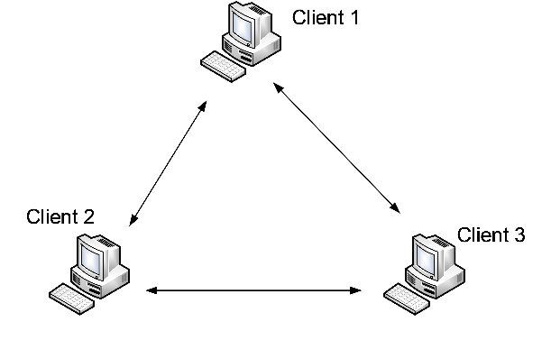

## **End Devices**

The network devices that people are most familiar with are end devices. To distinguish one end device from another, each end device on a network has an address. When an end device initiates communication, it uses the address of the destination end device to specify where to deliver the message.

An end device is either the source or destination of a message transmitted over the network.

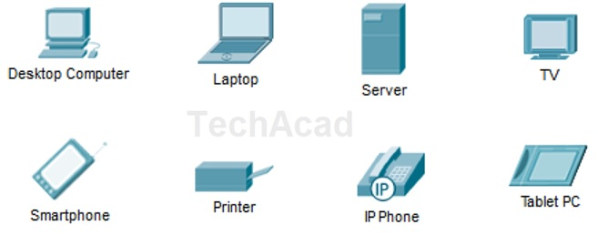

## **Intermediary Devices**

connect the individual end devices to the network. They can connect multiple individual networks to form an internetwork. These intermediary devices provide connectivity and ensure that data flows across the network.

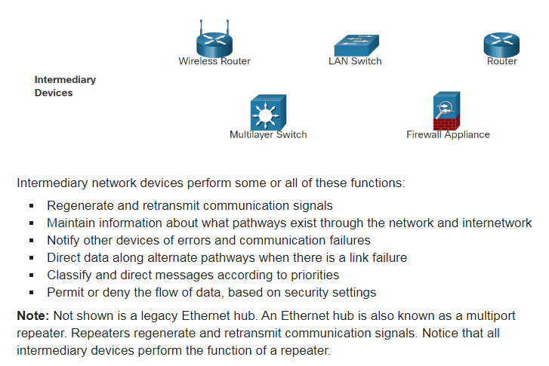Intermediary devices use the destination end device address, in conjunction with information about the network interconnections, to determine the path that messages should take through the network.

## **Network Media**

Communication transmits across a network on media. The media provides the channel over which the message travels from source to destination.

Modern networks primarily use three types of media to interconnect devices, as shown in the figure:

**Metal wires within cables** - Data is encoded into electrical impulses.

**Glass or plastic fibers within cables (fiber-optic cable)** - Data is encoded into pulses of light.

**Wireless transmission** - Data is encoded via modulation of specific frequencies of electromagnetic waves.

## **Network Representations**

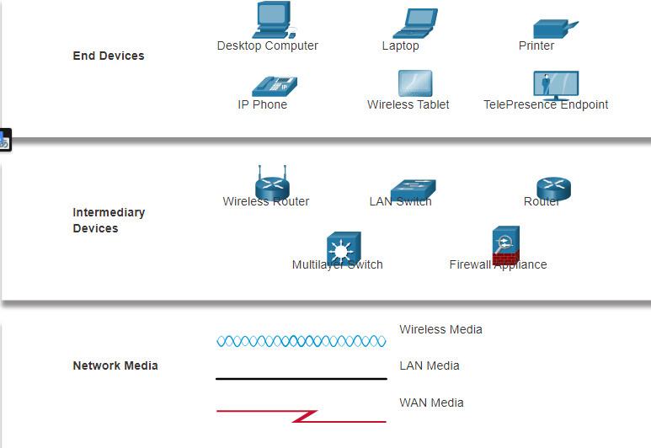

A diagram provides an easy way to understand how devices connect in a large network. This type of “picture” of a network is known as a topology diagram. The ability to recognize the logical representations of the physical networking components is critical to being able to visualize the organization and operation of a network.

In addition to these representations, specialized terminology is used to describe how each of these devices and media connect to each other:

* **Network Interface Card (NIC)** - A NIC physically connects the end device to the network.
* **Physical Port** - A connector or outlet on a networking device where the media connects to an end device or another networking device.
* **Interface** - Specialized ports on a networking device that connect to individual networks. Because routers connect networks, the ports on a router are referred to as network interfaces.

## **Topology Diagrams**

Topology diagrams are mandatory documentation for anyone working with a network. They provide a visual map of how the network is connected. There are two types of topology diagrams: **physical and logical**.

**Physical Topology Diagrams**

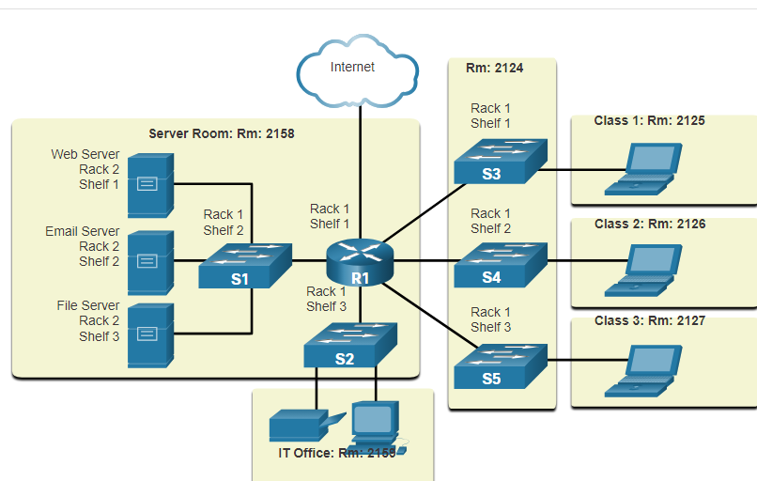Physical topology diagrams illustrate the physical location of intermediary devices and cable installation, as shown in the figure. You can see that the rooms in which these devices are located are labeled in this physical topology.

**Logical Topology Diagrams**

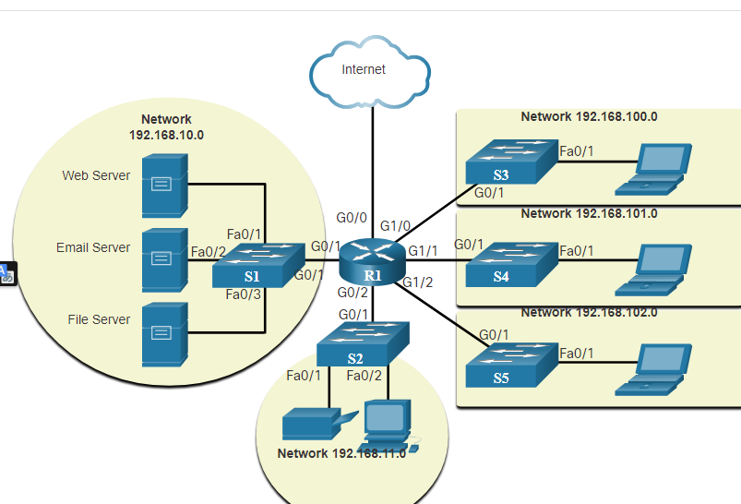Logical topology diagrams illustrate devices, ports, and the addressing scheme of the network, as shown in the figure. You can see which end devices are connected to which intermediary devices and what media is being used.

## **Networks of Many Sizes**

Now that you are familiar with the components that make up networks and their representations in physical and logical topologies, you are ready to learn about the many different types of networks.

Networks come in all sizes. They range from simple networks consisting of two computers, to networks connecting millions of devices.

Simple home networks let you share resources, such as printers, documents, pictures, and music, among a few local end devices.

Small office and home office (SOHO) networks allow people to work from home, or a remote office. Many self-employed workers use these types of networks to advertise and sell products, order supplies, and communicate with customers.

Businesses and large organizations use networks to provide consolidation, storage, and access to information on network servers. Networks provide email, instant messaging, and collaboration among employees. Many organizations use their network’s connection to the internet to provide products and services to customers.

The internet is the largest network in existence. In fact, the term internet means a “network of networks”. It is a collection of interconnected private and public networks.

In small businesses and homes, many computers function as both the servers and clients on the network. This type of network is called a peer-to-peer network.

* Small Home Networks

Small home networks connect a few computers to each other and to the internet.

* Small Office and Home Office Networks (SOHO)

The SOHO network allows computers in a home office or a remote office to connect to a corporate network, or access centralized, shared resources.

* Medium to Large Networks

Medium to large networks, such as those used by corporations and schools, can have many locations with hundreds or thousands of interconnected hosts.

* World Wide Networks

The internet is a network of networks that connects hundreds of millions of computers world-wide.

## **LANs and WANs**

Network infrastructures vary greatly in terms of:

* Size of the area covered
* Number of users connected
* Number and types of services available
* Area of responsibility

The two most common types of network infrastructures are Local Area Networks (LANs), and Wide Area Networks (WANs). A LAN is a network infrastructure that provides access to users and end devices in a small geographical area. A LAN is typically used in a department within an enterprise, a home, or a small business network. A WAN is a network infrastructure that provides access to other networks over a wide geographical area, which is typically owned and managed by a larger corporation or a telecommunications service provider. The figure shows LANs connected to a WAN.

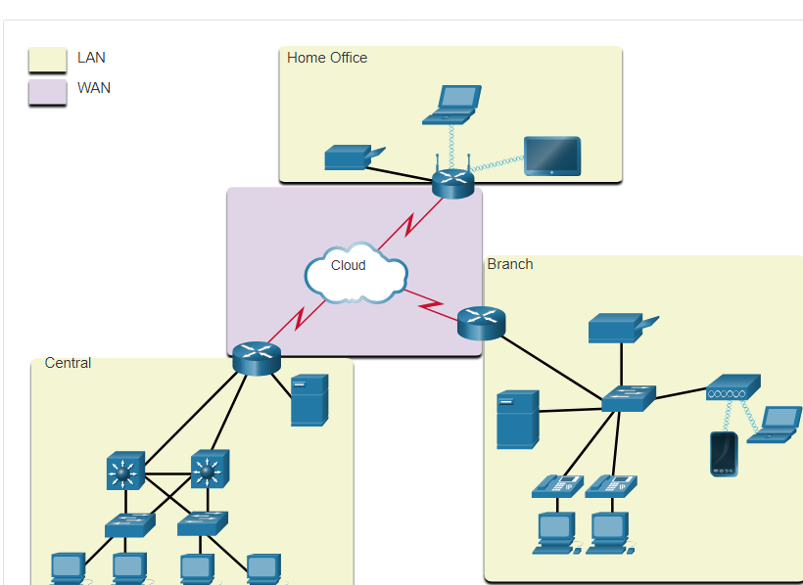

**LANs**

A LAN is a network infrastructure that spans a small geographical area. LANs have specific characteristics:

* LANs interconnect end devices in a limited area such as a home, school, office building, or campus.
* A LAN is usually administered by a single organization or individual. Administrative control is enforced at the network level and governs the security and access control policies.
* LANs provide high-speed bandwidth to internal end devices and intermediary devices, as shown in the figure.

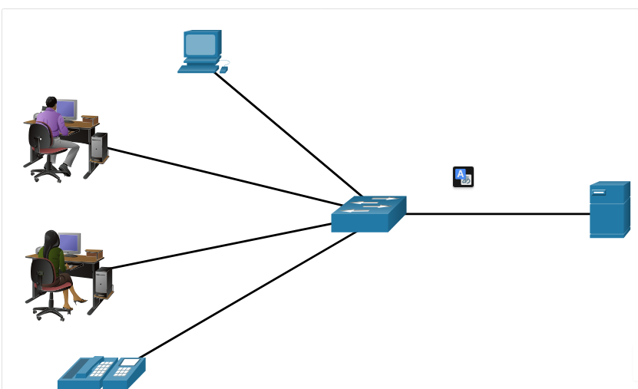

**WANs**

The figure shows a WAN which interconnects two LANs. A WAN is a network infrastructure that spans a wide geographical area. WANs are typically managed by service providers (SPs) or Internet Service Providers (ISPs).

WANs have specific characteristics:

* WANs interconnect LANs over wide geographical areas such as between cities, states, provinces, countries, or continents.
* WANs are usually administered by multiple service providers.
* WANs typically provide slower speed links between LANs.

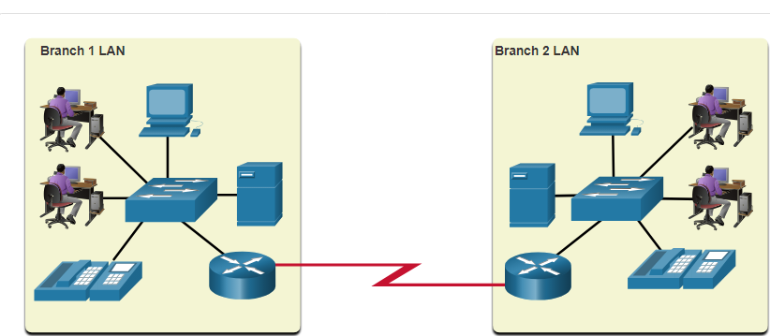

The Internet

The internet is a worldwide collection of interconnected networks (internetworks, or internet for short). The figure shows one way to view the internet as a collection of interconnected LANs and WANs

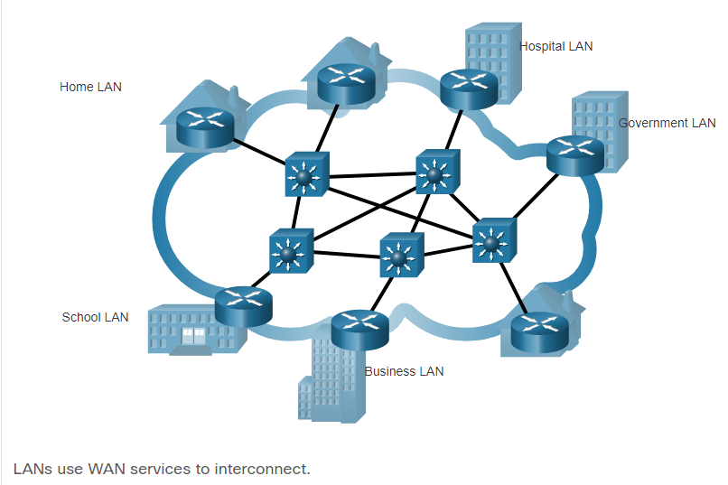

Some of the LAN examples are connected to each other through a WAN connection. WANs are then connected to each other. The red WAN connection lines represent all the varieties of ways we connect networks. WANs can connect through copper wires, fiber-optic cables, and wireless transmissions (not shown).

The internet is not owned by any individual or group. Ensuring effective communication across this diverse infrastructure requires the application of consistent and commonly recognized technologies and standards as well as the cooperation of many network administration agencies. There are organizations that were developed to help maintain the structure and standardization of internet protocols and processes. These organizations include the Internet Engineering Task Force (IETF), Internet Corporation for Assigned Names and Numbers (ICANN), and the Internet Architecture Board (IAB), plus many others.

## **Intranets and Extranets**

There are two other terms which are similar to the term internet: **intranet and extranet**.

Intranet is a term often used to refer to a private connection of LANs and WANs that belongs to an organization. An intranet is designed to be accessible only by the organization's members, employees, or others with authorization.

An organization may use an extranet to provide secure and safe access to individuals who work for a different organization but require access to the organization’s data. Here are some examples of extranets:

* A company that is providing access to outside suppliers and contractors
* A hospital that is providing a booking system to doctors so they can make appointments for their patients
* A local office of education that is providing budget and personnel information to the schools in its district

The figure illustrates the levels of access that different groups have to a company intranet, a company extranet, and the internet.

A center circle is labeled Intranet and has company only access. Surrounding that is another circle labeled Extranet and is accessible by suppliers, customers, and collaborators. Surrounding that is another circle labeled the Internet and is accessible by the world.

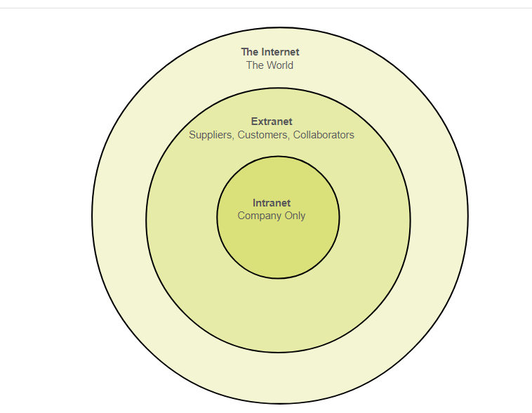

## **Internet Access Technologies**

Home users, remote workers, and small offices typically require a connection to an ISP to access the internet. Connection options vary greatly between ISPs and geographical locations. However, popular choices include broadband cable, broadband digital subscriber line (DSL), wireless WANs, and mobile services.

Organizations usually need access to other corporate sites as well as the internet. Fast connections are required to support business services including IP phones, video conferencing, and data center storage. SPs offer business-class interconnections. Popular business-class services include business DSL, leased lines, and Metro Ethernet.

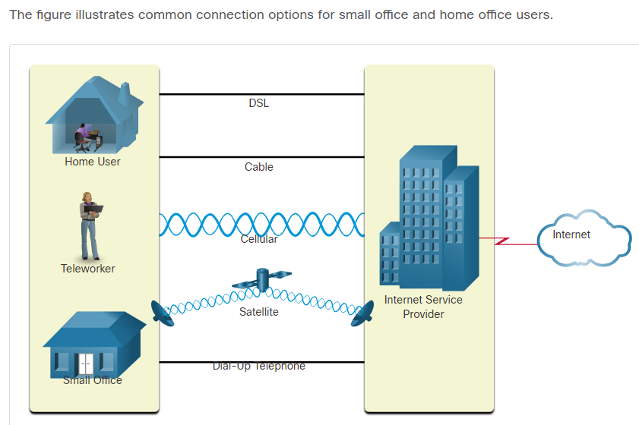

* **Cable** - Typically offered by cable television service providers, the internet data signal transmits on the same cable that delivers cable television. It provides a high bandwidth, high availability, and an always-on connection to the internet.
* **DSL** - Digital Subscriber Lines also provide high bandwidth, high availability, and an always-on connection to the internet. DSL runs over a telephone line. In general, small office and home office users connect using Asymmetrical DSL (ADSL), which means that the download speed is faster than the upload speed.
* **Cellular** - Cellular internet access uses a cell phone network to connect. Wherever you can get a cellular signal, you can get cellular internet access. Performance is limited by the capabilities of the phone and the cell tower to which it is connected.
* **Satellite** - The availability of satellite internet access is a benefit in those areas that would otherwise have no internet connectivity at all. Satellite dishes require a clear line of sight to the satellite.
* **Dial-up Telephone** - An inexpensive option that uses any phone line and a modem. The low bandwidth provided by a dial-up modem connection is not sufficient for large data transfer, although it is useful for mobile access while traveling. **The choice of connection varies depending on geographical location and service provider availability.**

Businesses Internet Connections

Corporate connection options differ from home user options. Businesses may require higher bandwidth, dedicated bandwidth, and managed services. Connection options that are available differ depending on the type of service providers located nearby.

The figure illustrates common connection options for businesses.

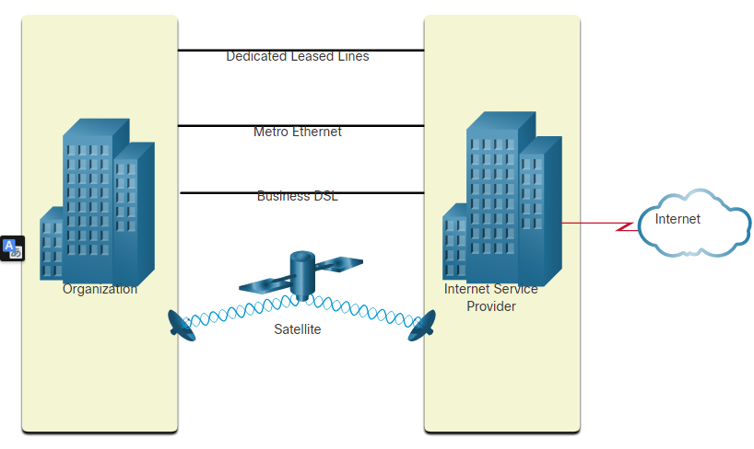

* **Dedicated Leased Line** - Leased lines are reserved circuits within the service provider’s network that connect geographically separated offices for private voice and/or data networking. The circuits are rented at a monthly or yearly rate.
* **Metro Ethernet** - This is sometimes known as Ethernet WAN. In this module, we will refer to it as Metro Ethernet. Metro ethernets extend LAN access technology into the WAN. Ethernet is a LAN technology you will learn about in a later module.
* **Business DSL** - Business DSL is available in various formats. A popular choice is Symmetric Digital Subscriber Line (SDSL) which is similar to the consumer version of DSL but provides uploads and downloads at the same high speeds.
* **Satellite** - Satellite service can provide a connection when a wired solution is not available.

The choice of connection varies depending on geographical location and service provider availability

The Converging Network

**Traditional Separate Networks**

Consider a school built thirty years ago. Back then, some classrooms were cabled for the data network, telephone network, and video network for televisions. These separate networks could not communicate with each other. Each network used different technologies to carry the communication signal. Each network had its own set of rules and standards to ensure successful communication. Multiple services ran on multiple networks.

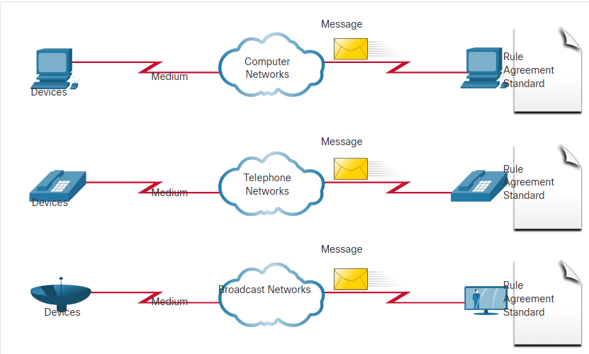

**Converged Networks**

Today, the separate data, telephone, and video networks converge. Unlike dedicated networks, converged networks are capable of delivering data, voice, and video between many different types of devices over the same network infrastructure. This network infrastructure uses the same set of rules, agreements, and implementation standards. Converged data networks carry multiple services on one network.

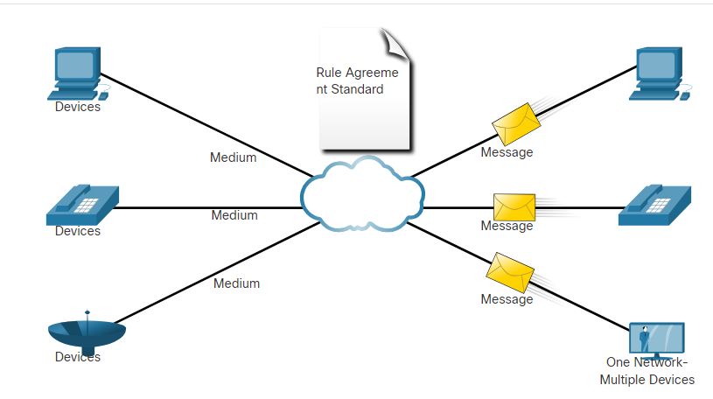

Network Architecture

Have you ever been busy working online, only to have “the internet go down”? As you know by now, the internet did not go down, you just lost your connection to it. It is very frustrating. With so many people in the world relying on network access to work and learn, it is imperative that networks are reliable. In this context, reliability means more than your connection to the internet. This topic focuses on the four aspects of network reliability.

The role of the network has changed from a data-only network to a system that enables the connections of people, devices, and information in a media-rich, converged network environment. For networks to function efficiently and grow in this type of environment, the network must be built upon a standard network architecture.

Networks also support a wide range of applications and services. They must operate over many different types of cables and devices, which make up the physical infrastructure. The term network architecture, in this context, refers to the technologies that support the infrastructure and the programmed services and rules, or protocols, that move data across the network.

As networks evolve, we have learned that there are four basic characteristics that network architects must address to meet user expectations:

* Fault Tolerance
* Scalability
* Quality of Service (QoS)
* Security

## **Fault Tolerance**

A fault tolerant network is one that limits the number of affected devices during a failure. It is built to allow quick recovery when such a failure occurs. These networks depend on multiple paths between the source and destination of a message. If one path fails, the messages are instantly sent over a different link. Having multiple paths to a destination is known as redundancy.

Implementing a packet-switched network is one way that reliable networks provide redundancy. Packet switching splits traffic into packets that are routed over a shared network. A single message, such as an email or a video stream, is broken into multiple message blocks, called packets. Each packet has the necessary addressing information of the source and destination of the message. The routers within the network switch the packets based on the condition of the network at that moment. This means that all the packets in a single message could take very different paths to the same destination. In the figure, the user is unaware and unaffected by the router that is dynamically changing the route when a link fails.

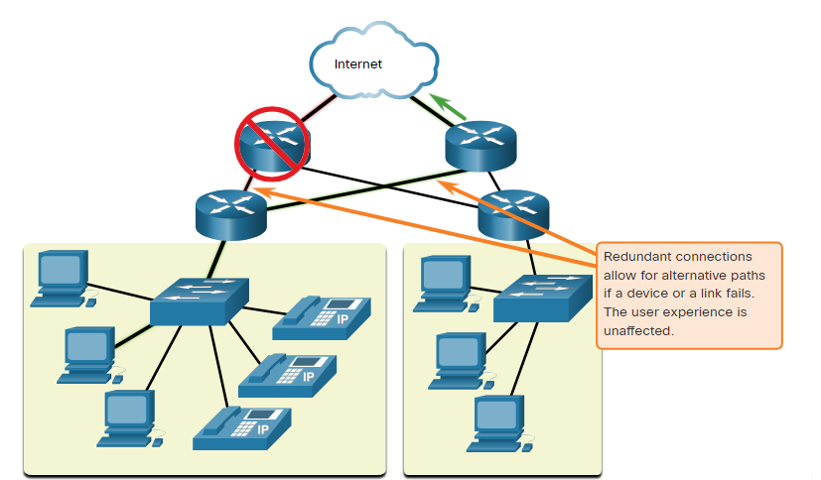

Scalability

A scalable network expands quickly to support new users and applications. It does this without degrading the performance of services that are being accessed by existing users. The figure shows how a new network is easily added to an existing network. These networks are scalable because the designers follow accepted standards and protocols. This lets software and hardware vendors focus on improving products and services without having to design a new set of rules for operating within the network.

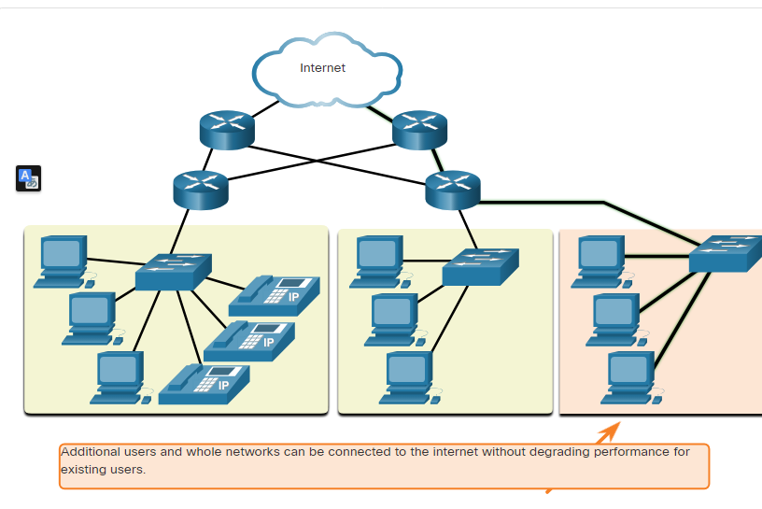

Quality of Service

Quality of Service (QoS) is an increasing requirement of networks today. New applications available to users over networks, such as voice and live video transmissions, create higher expectations for the quality of the delivered services. Have you ever tried to watch a video with constant breaks and pauses? As data, voice, and video content continue to converge onto the same network, QoS becomes a primary mechanism for managing congestion and ensuring reliable delivery of content to all users.

Congestion occurs when the demand for bandwidth exceeds the amount available. Network bandwidth is measured in the number of bits that can be transmitted in a single second, or bits per second (bps). When simultaneous communications are attempted across the network, the demand for network bandwidth can exceed its availability, creating network congestion.

When the volume of traffic is greater than what can be transported across the network, devices will hold the packets in memory until resources become available to transmit them. In the figure, one user is requesting a web page, and another is on a phone call. With a QoS policy in place, the router can manage the flow of data and voice traffic, giving priority to voice communications if the network experiences congestion.The focus of QoS is to prioritize time-sensitive traffic. The type of traffic, not the content of the traffic, is what is important.

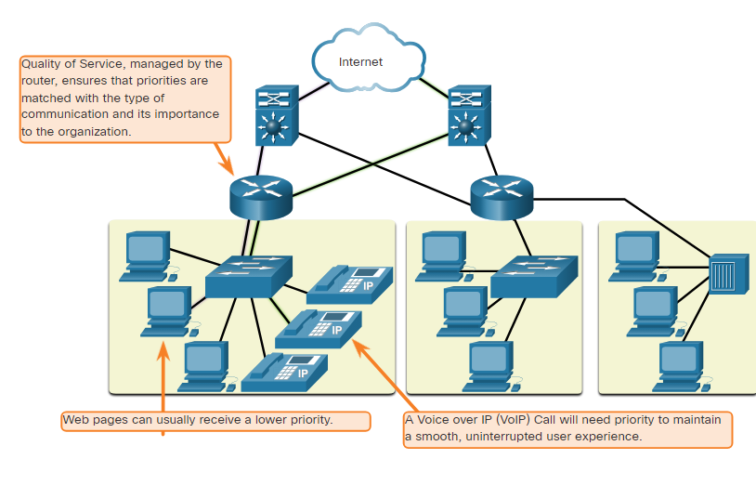

## **Network Security**

The network infrastructure, services, and the data contained on network-attached devices are crucial personal and business assets. Network administrators must address two types of network security concerns: network infrastructure security and information security.

Securing the network infrastructure includes physically securing devices that provide network connectivity and preventing unauthorized access to the management software that resides on them, as shown in the figure

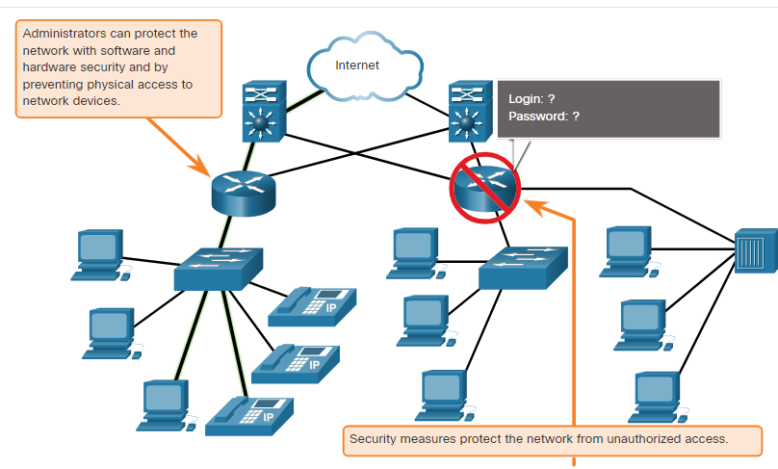

Network administrators must also protect the information contained within the packets being transmitted over the network, and the information stored on network attached devices. In order to achieve the goals of network security, there are three primary requirements.

* **Confidentiality** - Data confidentiality means that only the intended and authorized recipients can access and read data.
* **Integrity** - Data integrity assures users that the information has not been altered in transmission, from origin to destination.
* **Availability** - Data availability assures users of timely and reliable access to data services for authorized users.

# Network Trends

Recent Trends

You know a lot about networks now, what they are made of, how they connect us, and what is needed to keep them reliable. But networks, like everything else, continue to change. There are a few trends in networking that you, as a NetAcad student, should know about.

As new technologies and end-user devices come to market, businesses and consumers must continue to adjust to this ever-changing environment. There are several networking trends that affect organizations and consumers:

* Bring Your Own Device (BYOD)
* Online collaboration
* Video communications
* Cloud Computing