LAB Logbook

SID: - 2517680
Student Name: - Madushan Bhashana Dissanayake

Lab 1
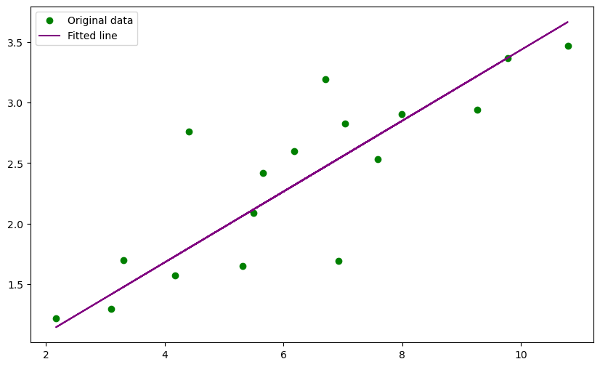

Lab 2

Lab 3

Test accuracy: 88.47%

Model Development Summary

This neural network was developed using the Sequential API

The input images (28×28) were flattened into a 784-dimensional vector using a Flatten layer.

A fully connected Dense layer with 128 neurons and ReLU activation was added to learn image features.

The output layer consists of 10 neurons corresponding to the 10 Fashion-MNIST classes.

The model was compiled using the Adam optimizer and Sparse Categorical Crossentropy loss function.
The model was trained for 30 epochs.
Model: "sequential_3"
┏━━━━━━━━━━━━━━━━━━━━━━━━━━━━━━━━━┳━━━━━━━━━━━━━━━━━━━━━━━━┳━━━━━━━━━━━━━━━┓
┃ Layer (type) ┃ Output Shape ┃ Param # ┃
┡━━━━━━━━━━━━━━━━━━━━━━━━━━━━━━━━━╇━━━━━━━━━━━━━━━━━━━━━━━━╇━━━━━━━━━━━━━━━┩
│ flatten_3 (Flatten) │ (None, 784) │ 0 │
├─────────────────────────────────┼────────────────────────┼───────────────┤
│ dense_6 (Dense) │ (None, 128) │ 100,480 │
├─────────────────────────────────┼────────────────────────┼───────────────┤
│ dense_7 (Dense) │ (None, 10) │ 1,290 │
└─────────────────────────────────┴────────────────────────┴───────────────┘
Total params: 305,312 (1.16 MB)
Trainable params: 101,770 (397.54 KB)
Non-trainable params: 0 (0.00 B)
Optimizer params: 203,542 (795.09 KB)
Lab 4
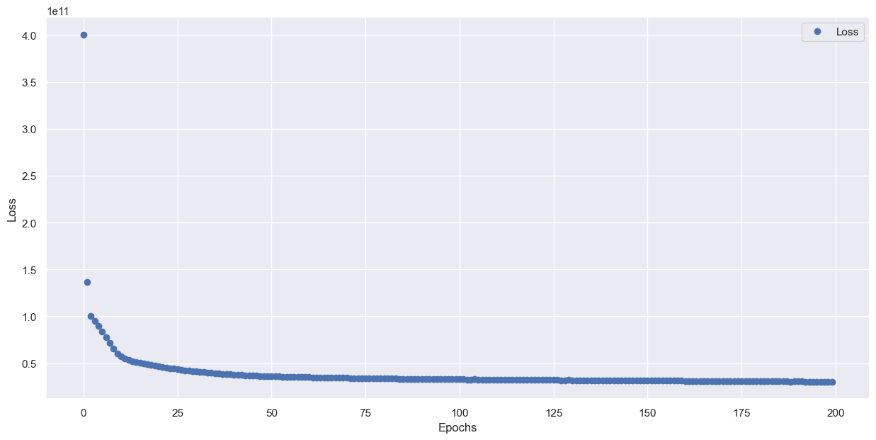
Model: "sequential_2"
┏━━━━━━━━━━━━━━━━━━━━━━━━━━━━━━━━━┳━━━━━━━━━━━━━━━━━━━━━━━━┳━━━━━━━━━━━━━━━┓
┃ Layer (type) ┃ Output Shape ┃ Param # ┃
┡━━━━━━━━━━━━━━━━━━━━━━━━━━━━━━━━━╇━━━━━━━━━━━━━━━━━━━━━━━━╇━━━━━━━━━━━━━━━┩
│ dense (Dense) │ (None, 128) │ 2,560 │
├─────────────────────────────────┼────────────────────────┼───────────────┤
│ dense_1 (Dense) │ (None, 64) │ 8,256 │
├─────────────────────────────────┼────────────────────────┼───────────────┤
│ dense_2 (Dense) │ (None, 32) │ 2,080 │
├─────────────────────────────────┼────────────────────────┼───────────────┤
│ dense_3 (Dense) │ (None, 1) │ 33 │
└─────────────────────────────────┴────────────────────────┴───────────────┘
Total params: 38,789 (151.52 KB)
Trainable params: 12,929 (50.50 KB)
Non-trainable params: 0 (0.00 B)
Optimizer params: 25,860 (101.02 KB)

Lab 5
- 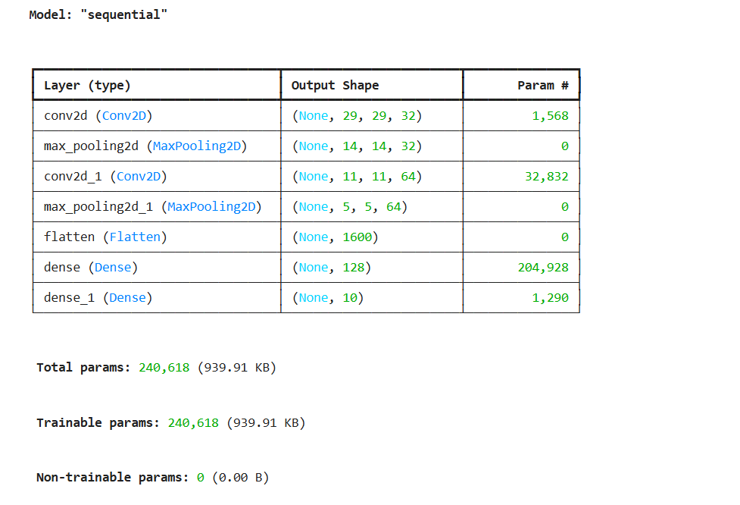
- 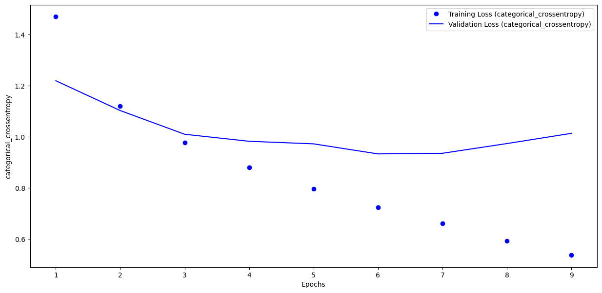
- 7 epochs , because after that validation loss is not going down and it’s going to be increased while the training loss is going down.

Lab 6

Lab 7

VGG16
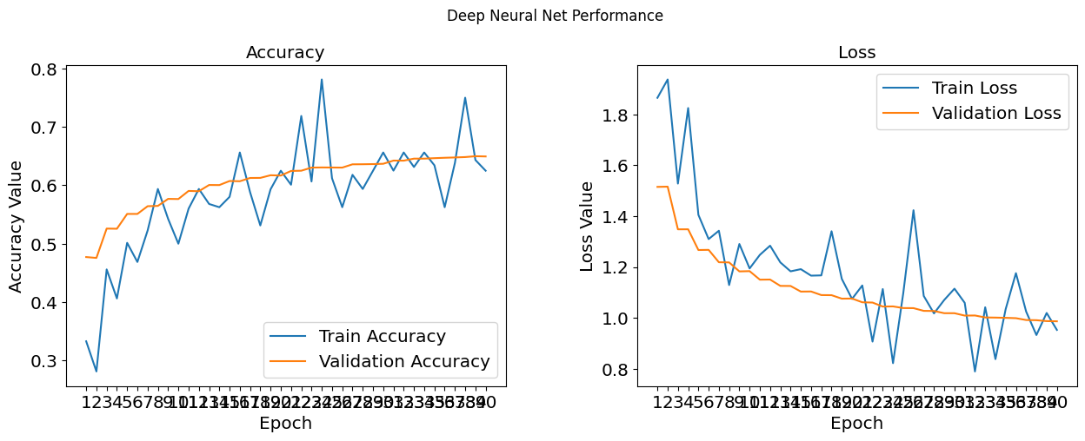
VGG19
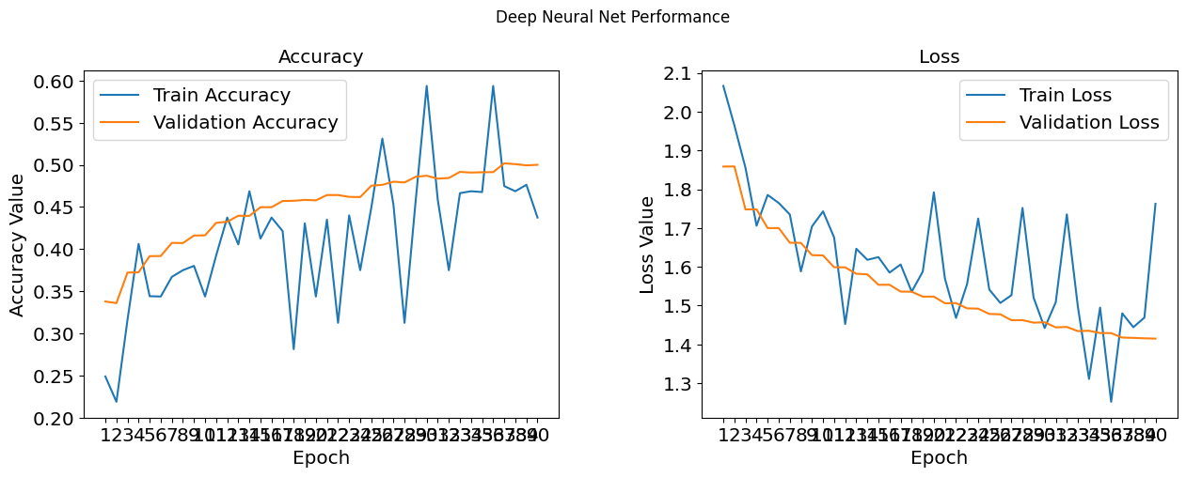

Optimum number of epochs for training VGG16 model :- 38 epochs

 | Accuracy | Precision | Recall | F1_Score
VGG-16 | 0.6548 | 0.654669 | 0.6548 | 0.653463
VGG_19 | 0.4992 | 0.494318 | 0.4992 | 0.494875

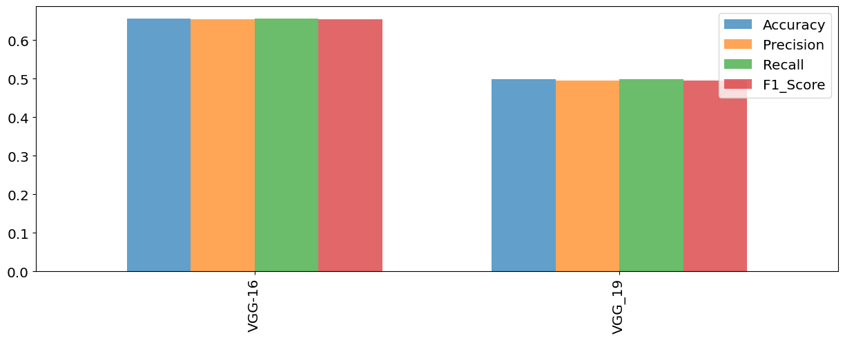

Lab 8

Lab 9

My SID :- 2517680 , Therefore Z = 0
Therefore :- epochs = 30 , Batch size = 10

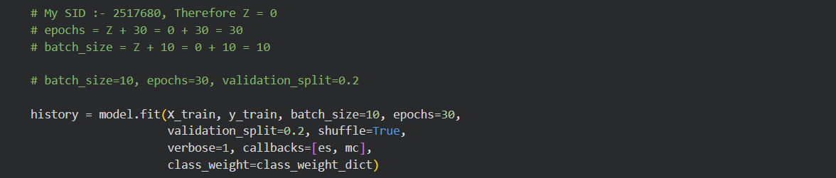

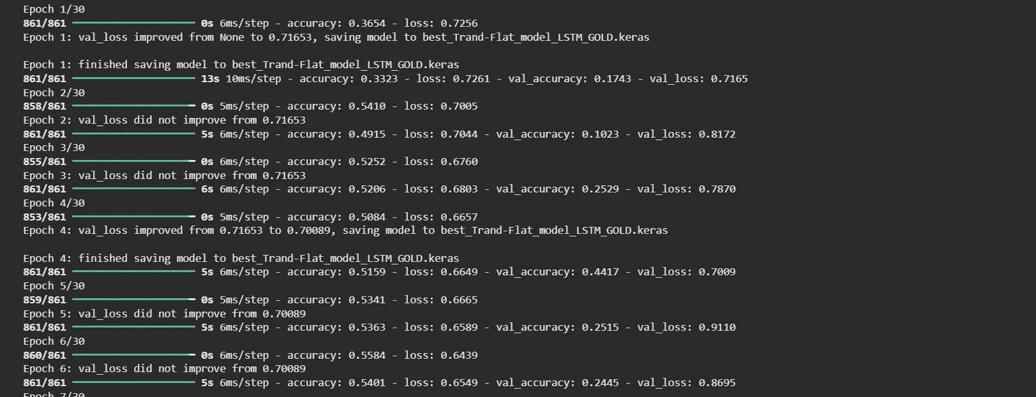
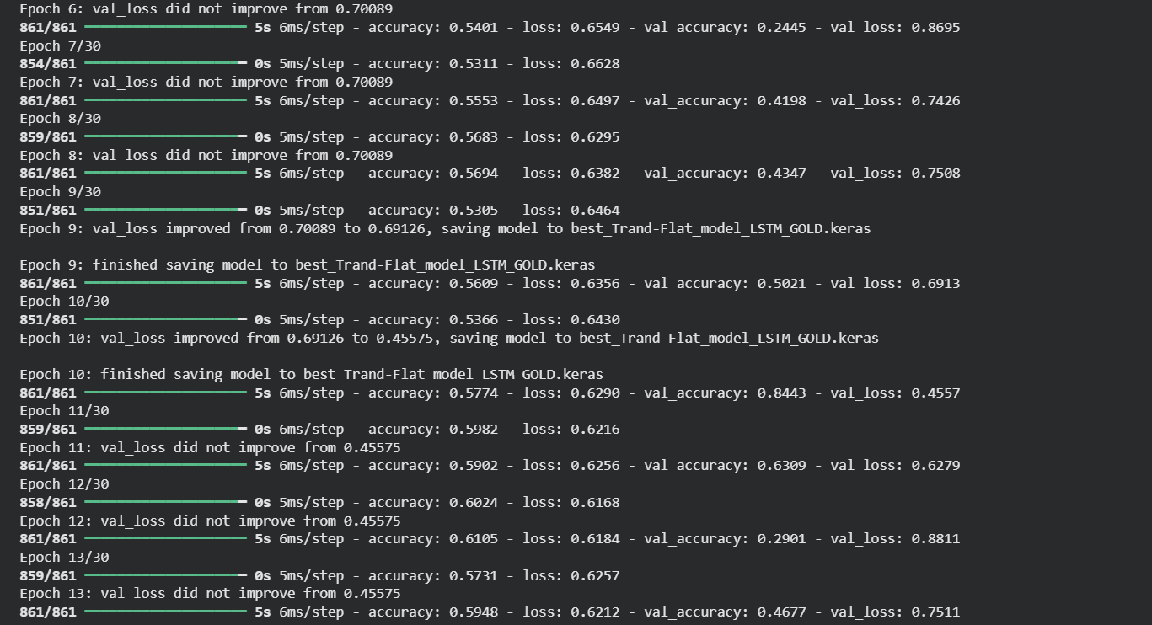

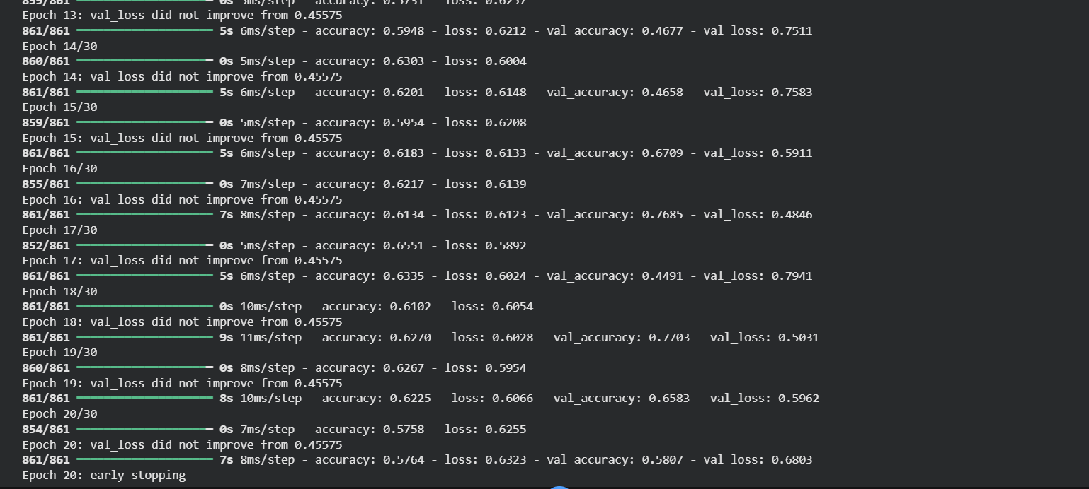

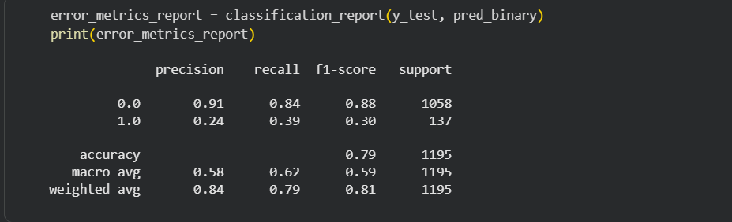

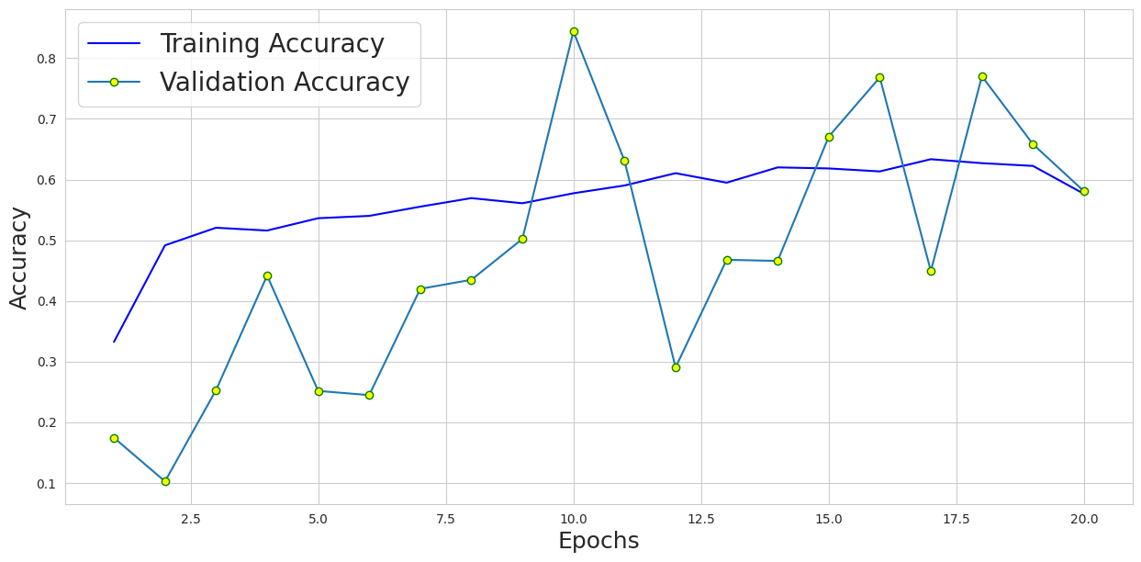

Lab 10

Notebook 1: - Week-10__Simple_Autoendoder_std_2025

- encoder summary

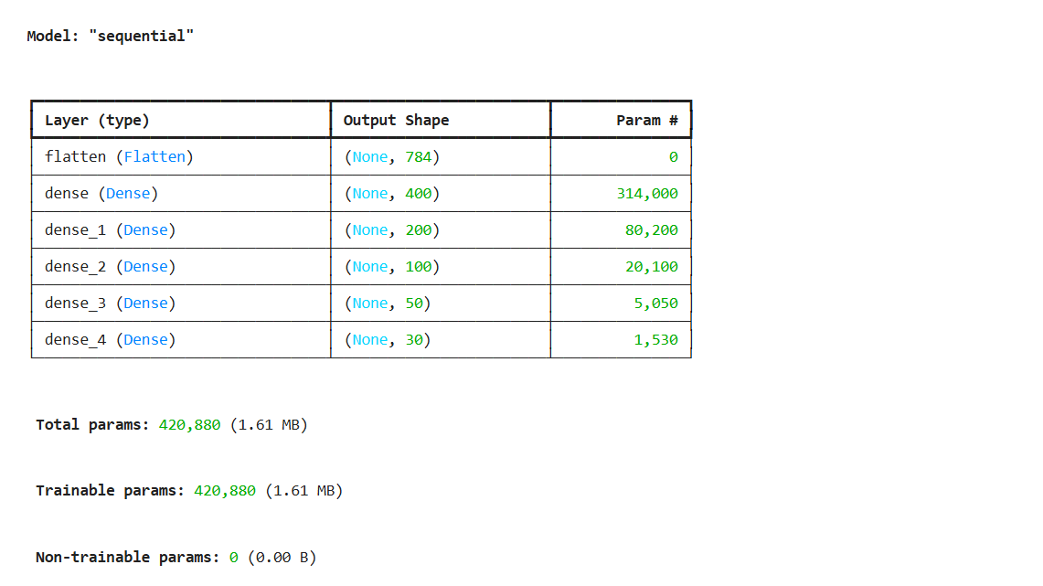

- Decoder summary

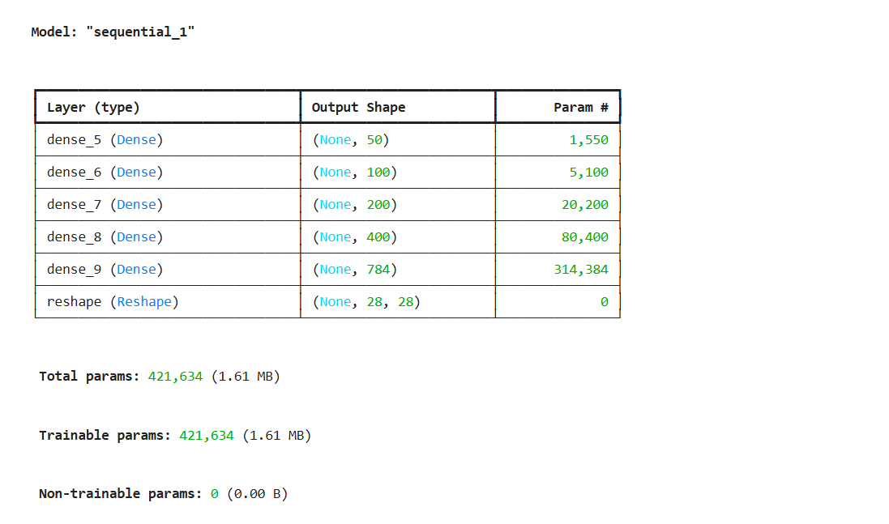

- Autoencoder summary

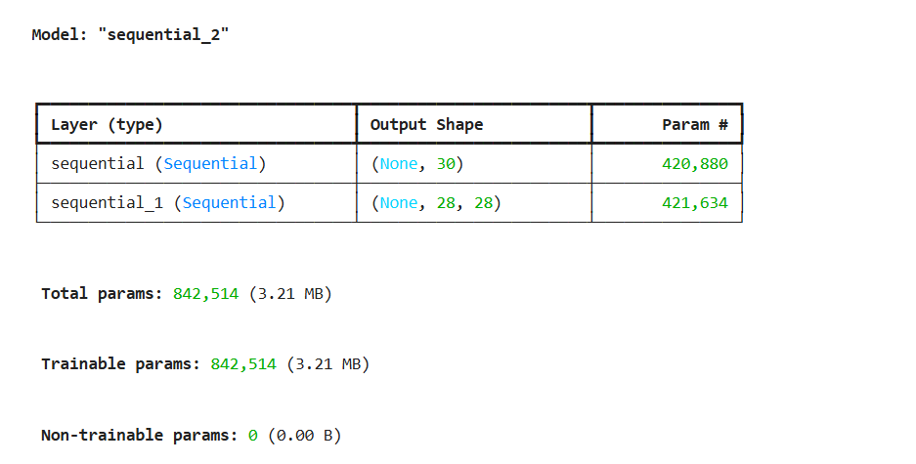

Notebook 2: - Week-10_CNN_autoencoder_std_2025

- Autoencoder summary

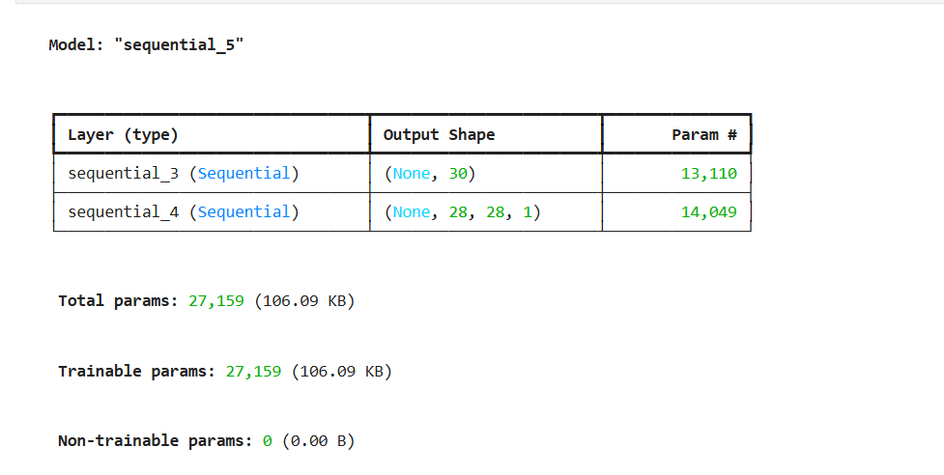

- autoencoder. Fit() code

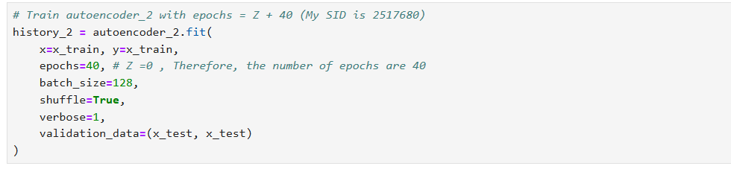

- The accuracy detailed graph

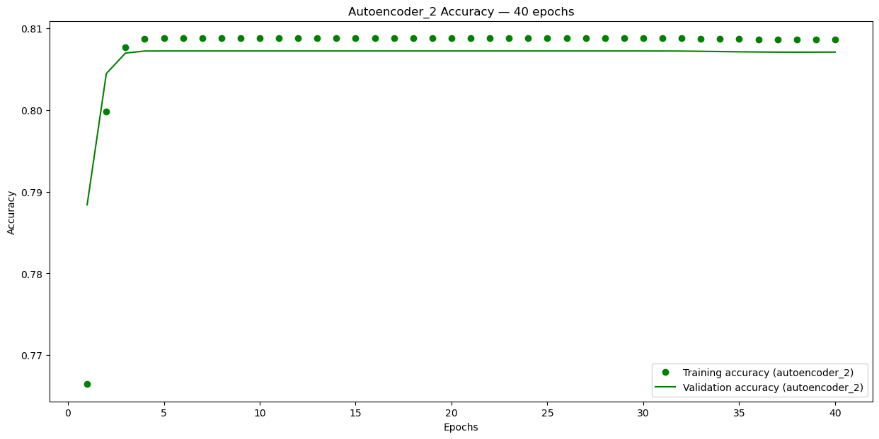

- The customized decoded images

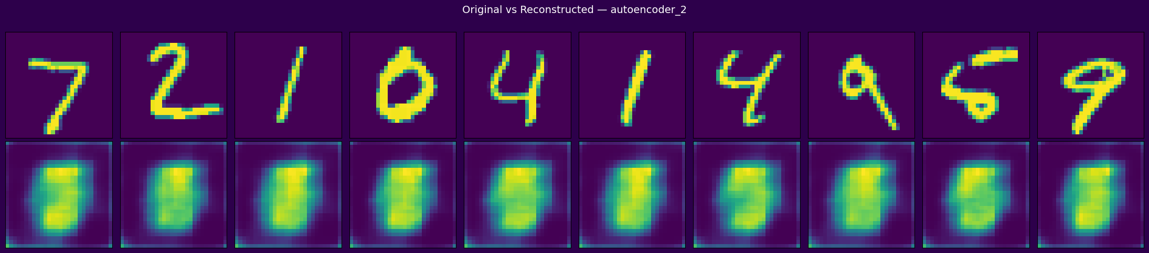

Lab 11

My SID:- 2517680
Last two digits :- 80
80>50
Therefore no of epochs :- 80/2 = 40

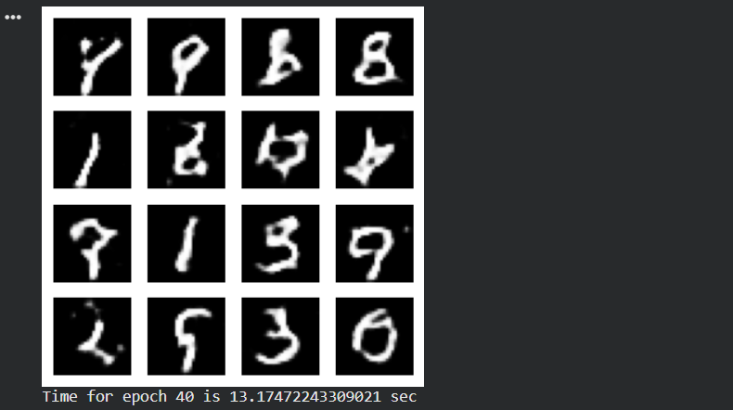

Lab 12

