IV. Results

A. Pest Classification — MobileNetV2

1) Training Progression:
The MobileNetV2 classifier was trained in two phases. Table I summarises the accuracy achieved at the end of each phase. During the feature extraction phase (15 epochs, frozen backbone), training accuracy reached 85.1% and validation accuracy reached 87.5%. Following fine-tuning (20 epochs, last 30 backbone layers unfrozen, lr = 1×10⁻⁵), training accuracy improved to 97.0% and validation accuracy to 95.8%, confirming that domain-specific fine-tuning substantially benefited the model.

TABLE I
MobileNetV2 Training Progression
Phase | Epochs | Final Train Acc. | Final Val. Acc.
Feature Extraction | 15 | 85.1% | 87.5%
Fine-Tuning | 20 | 97.0% | 95.8%

2) Classification Performance:
After fine-tuning, the model was evaluated on the 72-image test set. Table II reports per-class precision, recall, and F1-score. The fine-tuned MobileNetV2 achieved an overall test accuracy of 94.4% (68/72 correct predictions) with a macro-averaged F1-score of 0.94. Ladybug and Mealybug were classified with perfect precision and recall (F1 = 1.00 for both classes). Thrips showed a minor recall drop to 0.78, yielding an F1 of 0.88, while Vineborer demonstrated perfect recall (1.00) at a precision of 0.82, yielding an F1 of 0.90.

TABLE II
MobileNetV2 Per-Class Classification Report on Test Set (72 Images)
Class | Precision | Recall | F1-Score | Support
Ladybug | 1.00 | 1.00 | 1.00 | 18
Mealybug | 1.00 | 1.00 | 1.00 | 18
Thrips | 1.00 | 0.78 | 0.88 | 18
Vineborer | 0.82 | 1.00 | 0.90 | 18
Macro Avg | 0.95 | 0.94 | 0.94 | 72
Overall Acc. | — | — | 0.94 | 72

3) Confusion Matrix Analysis:
Fig. 1 presents the confusion matrix for the MobileNetV2 classifier on the test set. The matrix confirms that Ladybug and Mealybug were classified without a single error (18/18 correct each). The only source of misclassification was Thrips: four of the 18 Thrips samples were incorrectly predicted as Vineborer. This confusion is attributable to the visual similarity between the elongated body morphology of both species, which becomes ambiguous under varying image orientations and magnification levels. Vineborer was classified perfectly (18/18), with no instances confused with any other class.

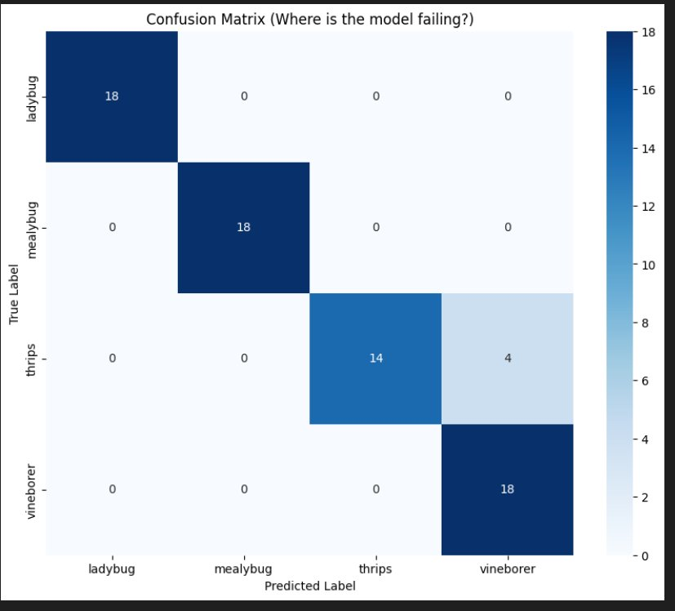
Fig. 1. Confusion matrix of the fine-tuned MobileNetV2 classifier on the 72-image test set.

B. Object Detection and Pest Counting — YOLOv8s

1) Detection Performance:
The best checkpoint (selected by highest validation mAP@50 across 50 training epochs) was evaluated on the held-out 50-image test set containing 99 annotated pest instances. Table III reports per-class and overall detection metrics. The model achieved an overall mAP@50 of 0.789 and an mAP@50–95 of 0.530, with a mean precision of 0.918 and mean recall of 0.691 across all four classes.

TABLE III
YOLOv8s Per-Class Detection Results on Test Set (50 Images, 99 Instances)
Class | Precision | Recall | mAP@50 | mAP@50-95
Ladybug | 0.908 | 0.583 | 0.704 | 0.412
Mealybug | 0.833 | 0.441 | 0.631 | 0.398
Thrips | 0.997 | 0.875 | 0.886 | 0.591
Vineborer | 0.935 | 0.867 | 0.935 | 0.718
All (mean) | 0.918 | 0.691 | 0.789 | 0.530
Thrips and Vineborer achieved the strongest detection performance, with mAP@50 scores of 0.886 and 0.935 respectively. Vineborer attained the highest mAP@50–95 of 0.718, indicating robust localisation accuracy even at tighter IoU thresholds. Ladybug yielded a mAP@50 of 0.704. Mealybug was the most challenging class, achieving the lowest mAP@50 of 0.631 and the lowest recall of 0.441, which is attributed to the clustered, overlapping nature of mealybug colonies that generates high inter-box overlap and is difficult for the detector to resolve into individual instances.

2) Confusion Matrix Analysis:
Fig. 2 presents the YOLOv8s confusion matrix on the validation set. The matrix includes a background row, representing instances predicted as background (i.e., missed detections or false negatives). The diagonal shows: Ladybug 35 correct detections, Mealybug 52, Thrips 36, and Vineborer 22. The most prominent off-diagonal entries are: 17 Mealybug ground-truth instances predicted as background, and 24 Mealybug instances missed (background row, mealybug column). This pattern is consistent with the low recall of 0.441 reported for Mealybug — the model detects the presence of mealybug colonies but systematically under-counts individual instances in dense clusters. Thrips also generated 8 false-negative background predictions. Vineborer showed 1 instance confused with background. These results confirm that Mealybug remains the principal source of detection error, justifying the supplementary density heatmap estimation described in Section III-E.

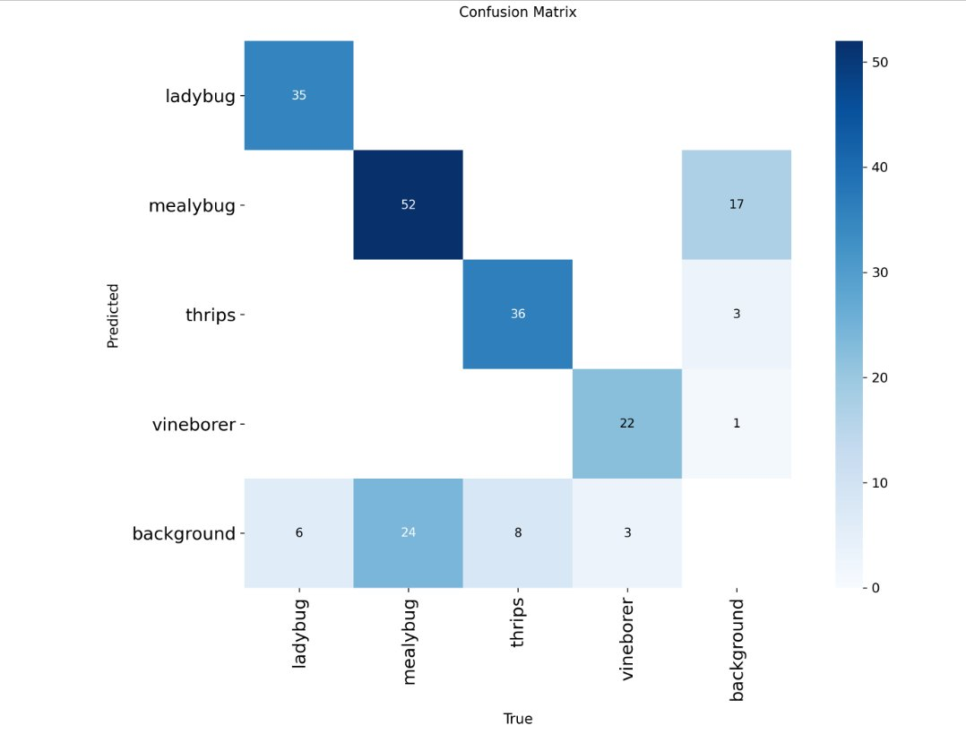
Fig. 2. Confusion matrix of the YOLOv8s detector on the validation set (includes background class for missed detections).

3) Mealybug Density Heatmap and Severity Estimation:
Given the low recall for Mealybug demonstrated in both the per-class metrics and the confusion matrix, the density heatmap severity estimator provides a complementary population assessment. Rather than relying solely on discrete bounding-box counts, the system derives two continuous metrics from the Gaussian-smoothed density map: coverage percentage (fraction of image area with density exceeding 5% of peak activation) and mean density (average normalised activation across the full image). These are mapped to an ordered severity label — None, Low, Moderate, High, or Severe — using rule-based thresholds. This approach correctly distinguishes a dense but spatially compact cluster (high mean density, low coverage) from a sparse but widespread infestation (low mean density, high coverage), both of which would yield identical bounding-box counts.

C. Integrated Pest Identification Module
The two models operate as complementary components within the pest identification pipeline. YOLOv8s performs real-time spatial localisation and per-frame instance counting for Ladybug, Thrips, and Vineborer. For Mealybug, the density heatmap pipeline augments discrete bounding-box counts with a colony-level severity estimate. MobileNetV2 provides a high-confidence species label for each detected region-of-interest. This dual-model architecture separates the spatially demanding localisation task from fine-grained visual classification, mitigating the accuracy trade-offs that arise when a single model must solve both problems jointly on a limited dataset. The combined module reports, per image: (i) the species identity of each detected pest, (ii) the instance count for non-colonial species, and (iii) the infestation severity category for Mealybug infestations.

D. Summary of Key Results
Table IV consolidates the principal performance metrics of both models. The YOLOv8s detector achieved a mAP@50 of 78.9% and the MobileNetV2 classifier achieved a test accuracy of 94.4% following fine-tuning, demonstrating that the proposed two-stage pipeline delivers reliable pest identification across all four target species found in black pepper cultivation environments.

TABLE IV
Summary of Model Performance Metrics
Metric | YOLOv8s (Detection) | MobileNetV2 (Classification)
Test Set Size | 50 images (99 instances) | 72 images
Overall Acc. / mAP@50 | 78.9% (mAP@50) | 94.4%
mAP@50-95 | 53.0% | N/A
Mean Precision | 91.8% | 95.5% (macro)
Mean Recall | 69.1% | 94.4% (macro)
Macro F1-Score | N/A | 0.94
Best Per-Class | Vineborer (mAP@50: 0.935) | Ladybug & Mealybug (F1: 1.00)
Most Challenging Class | Mealybug (mAP@50: 0.631) | Thrips (F1: 0.88)

