The French adaptation of the Cambridge Depersonalization Scale (CDS): psychometric characteristics in a non-clinical population

Christophe Lopez¹ ✉️, Maélis Gobinet¹, and Maya Elzière^{1,2}

¹ Aix Marseille Univ, CNRS, Centre de Recherche en Psychologie et Neurosciences (CRPN), Marseille, France
² Centre des Vertiges, European Hospital, Marseille, France

AUTHORS’ ORCID:
Christophe Lopez = orcid.org/0000-0001-9298-2969

https://www.journals.elsevier.com/journal-of-affective-disorders
The Impact Factor of this journal is 4.839, ranking it 53 out of 208 in Clinical Neurology
PlosOne?

✉️ Address for correspondence:

Dr Christophe Lopez
Centre de Recherche en Psychologie et Neurosciences (CRPN) – UMR 7077
Aix Marseille Univ & Centre National de la Recherche Scientifique (CNRS)
Centre Saint-Charles, Fédération de Recherche 3C – Case B
3, Place Victor Hugo. 13331 Marseille Cedex 03, France
Tel: +33 4 13 55 08 41 Fax: + 33 4 13 55 08 44

email: christophe.lopez@univ-amu.fr

Abstract
Depersonalization-derealization (DD) disorders are a clinical phenomenon characterized by a profound feeling of detachment. Several scales have been developed to measure DD, including the Cambridge Depersonalization Scale (CDS) developed by Sierra and Berrios in 2000. The CDS allows to draw a comprehensive overview of the clinical symptoms pertaining to DD disorders and to measure the frequency and duration of these symptoms. The CDS has already been translated and culturally adapted to several languages. However, there is no French version of the CDS available, which may concern over 200 million locutors using French language daily. The primary aim of this study was to translate and adapt the CDS into French and to evaluate its characteristics in a sample of general population free of known neurological and otoneurological disorders. The secondary aim was to analyze the influence of age, sex, anxiety and depression on DD experience.
In total, xxx volunteers from the South of France participated in the study completing the CDS in French, the Hospital Anxiety and Depression Scale and sociodemographic data were collected.
We found that DD over the cut-off value was observed in x% of the sample. Factors influencing DD symptoms were age, sex, anxiety and depression…
A factorial analysis …. Cronbach’s a coefficients were 0.75 (UG) and 0.81 (UL).
Introduction
Mental health is increasingly recognized as a major societal challenge, and several cohort studies have been initiated to investigate the predisposing factors and environmental influences shaping mental health across the lifespan (e.g., Bartrés-Faz et al. 2025; Hill et al. 2025; Myran et al. 2025). Among the various manifestations of mental health disorders, disturbances in the sense of self appear to be relatively rare and transient in the general population (Michal et al. 2009) but are frequently observed across a range of neurological and psychiatric conditions (Dieguez and Lopez 2017; Hunter et al. 2004; Ronchi et al. 2018).
Disturbances in the sense of self may involve altered perception of reality, leading to sensations of dissolution, fragmentation, duplication of the self, or detachment from the self. These experiences may also include a reduced sense of agency over one’s thoughts and actions. Such phenomena are core features of depersonalization-derealization (DD) disorders (Simeon et al. 2003; Simeon and Abugel 2006) and are also encountered in psychotic disorders (e.g., schizophrenia; Raballo et al., 2021), neurodegenerative diseases (e.g., Alzheimer’s disease, Lewy body dementia; 1 reference), as well as in motor or sensory dysfunctions (Bernasconi et al. 2021; Sang et al. 2006). Transient disruptions in the sense of self have also been reported in association with depression, migraine episodes (Beh et al. 2018), fatigue (Tibubos et al. 2018), substance use (Medford et al. 2003), and when falling asleep or waking up (Simeon and Abugel 2006; Simeon and Stein 2025).
According to the DSM-5-TR, DD is characterized by “the presence of persistent or recurrent experiences of depersonalization” (i.e., “experiences of unreality, detachment, or being an outside observer with respect to one’s thoughts, feelings, sensations, body, or actions”) or/and of derealization (i.e., “experiences of unreality or detachment with respect to surroundings”), during which reality testing remains intact (American Psychiatric Association 2022). Transient symptoms of DD are rather common in the general population, with an estimated lifetime prevalence rate ranging from 26% to 74% (reviewed in Hunter et al. 2004). By contrast, clinically significant DD assessed using diagnostic interviews is estimated to affect approximately 1–2% of individuals (Hunter et al. 2004; Michal et al. 2009), but it has been argued that DD is likely underdiagnosed in the general population (Michal et al. 2010). All of this highlights the need for improved awareness about DD symptoms among healthcare professionals and adapted screening tools.
Reliable tools for assessing mental health symptoms, including those related to DD, are essential for cross-sectional and longitudinal research. Several instruments have been developed to assess DD, including the Cox & Swinson questionnaire (Cox and Swinson 2002), the Dixon’s Scale (Dixon 1963), the Jacobs & Bovasso’s Depersonalization Scale (Jacobs and Bovasso 1992), and the Bernstein & Putnam’s Dissociative Experience Scale (Bernstein and Putnam 1986) (scales reviewed in Migliorini et al. 2012; Sierra and Berrios 2000). The Cambridge Depersonalization Scale (CDS), developed by Sierra and Berrios (Sierra and Berrios 2000), offers a comprehensive evaluation of both frequency and duration of DD symptoms and has demonstrated strong psychometric properties, including high internal consistency and good reliability.
The CDS has been subjected to exploratory factor analyses in psychiatric populations (Sierra et al. 2005; Simeon et al. 2008) and trauma-exposed college students (Blevins et al. 2013), supporting its structural validity. It has also been translated and culturally adapted into several languages, including Spanish (Spain: Molina Castillo et al. 2006; Puerto Rico: Aponte-Soto et al. 2014), Italian (Migliorini et al. 2012), German (Michal et al. 2004), Greek (Kontoangelos et al. 2016), Japanese (Sugiura et al. 2009), and Brazilian Portuguese (Salgado et al. 2016). However, no validated French version of the CDS is currently available, despite the fact that French is spoken daily by over 200 million people worldwide.
A 2-item version of the CDS has proven useful in assessing DD symptoms in the general population in Germany, with an estimated prevalence of clinically relevant DD of 3.4% (Michal et al. 2011). Additionally, the CDS has been used in the general population to examine how the sense of self relates to self and body experiences in dream states (Gwyther et al. 2024), as well as to more objective assessments of self-perception. For instance, studies suggest that individuals with higher CDS scores exhibit stronger susceptibility to illusory self-identification with a rubber hand (Braithwaite et al. 2017).

Review of the literature indicates inconsistent findings regarding the association between DD and other sociodemographic and clinical variables. While DD is negatively correlated with age (Michal et al., 2009; 2016), with a higher prevalence in adolescent and young adults (Baker et al., 2003; Yang et al., 2023), it was inconsistently associated with sex (Aderibigbe et al., 2001, Michal et al., 2016a; Simeon et al., 2013). DD was also related to anxiety and depression (Hunter et al., 2004; 2014; Lee et al., 2012; Medford et al. 2005; 2016; Michal et al., 2009; 2011; 2016; Schlax et al., 2020; Simeon et al., 2003; Yang et al., 2023), which are increasingly prevalent in the general population (Bandelow and Michaelis, 2015; Moreno-Agostino et al., 2021). Even though they are distinct disorders (Sierra et al., 2012; Stein et al., 2024), DD, anxiety, and depression have mutual influences that require further investigations in the general population.
This prospective, observational, cross-sectional study had two main objectives:
- The first objective was to translate and culturally adapt the CDS into French, and to validate its psychometric properties in a general population sample without known psychiatric, neurological or otoneurological disorders.
- The second objective was to assess the prevalence of DD experiences in a non-clinical French-speaking population, to examine the phenomenological content of DD in a large non-clinical sample, and to examine the influence of age, sex, anxiety, and depression on the intensity of these experiences.

Materials and methods

This prospective, observational, cross-sectional study follows the Strengthening the Reporting of Observational Studies in Epidemiology (STROBE) guidelines¹⁸.

French translation and cross-cultural adaptation
The rights to translate the questionnaire (Appendix A from Sierra & Berrios (2000)) into French and to reproduce it were granted by Elsevier, the publisher. The steps for the French translation and cross-cultural adaptation were as follows:
- Forward translation. A bilingual French translator, with French as the mother tongue and familiar with the neuroscience and neuropsychology of the self and body representations, translated the instructions and questionnaire items to French.
- Back translation. The forward-translated questionnaire was translated back to English by a bilingual English translator, with English as the mother tongue, who was naive to the CDS and the study purpose.
- Back translation review. The French and English translated questionnaires were compared with the original version of the CDS (Sierra and Berrios 2000) to check for congruency. The questionnaire was corrected accordingly to obtain the final questionnaire reproduced in Supplementary Table 1.
Comparison of the original items in English and the French translation is provided in Supplementary Table 2, together with intermediate steps of translation.

Participants
Data were collected from three prospective, observational, cross-sectional studies: the ImVesPerSE study (conducted from October 2016 to December 2018), the PERSOCOR study (conducted from March 2022 to October 2024), and the VESTICOR study (conducted from xx to xx), which aimed to compare the sense of self in a population devoid of known otoneurological and psychiatric disorders and in a population with vertigo and dizziness. Subsample of these cohorts have been described elsewhere (Lopez and Elzière 2018; Gobinet et al. 2026). Participants were included in the cohorts if they met the following criteria: (1) age over 18; (2) able to read and understand the questionnaires; (3) no severe neurological, otoneurological or psychiatric disorders (self-reported); (4) willing and able to give informed consent to participate to the study. We included x participants of which only x were further included in the analysis after data were cleaned for multiple missing values and incorrect answers (see Table 1 for detailed sociodemographic data). Participants were recruited in the area of Marseille, South of France. They were partners, family members and acquaintances that accompanied patients and hospital staff at the European Hospital, Marseille, or participants recruited from advertisement posted at Aix-Marseille University.

Ethical approval and patient’s consent
Ethical approval was granted by our Institutional Ethics Committee (ImVesPerSE study: Hôpital Européen, CEDP-HE16.03) and National Ethics Review Board (PERSOCOR: CPP Île de France 2, n° 2021-A03111-40; VESTICOR: CPP Ouest IV, n° 2022-A00098-35) and procedures were in accordance with the Declaration of Helsinki. Participants gave their consent to participate in the study for PERSOCOR and VESTICOR, but a formal consent form was waived by the institution for the ImVesPerSE study. Participants received no payment or compensation.

Procedures
Participants answered all questionnaires on paper. The CDS translated in French included a first section about basic sociodemographic data, including age, sex, education level, marital status, employment status, smoking and drinking habits, and history of migraine.
In the second section of the questionnaire, participants were asked whether they have had these 29 experiences during the last six months. As in the original CDS, the questionnaire was introduced as follows: This questionnaire describes strange and ‘funny’ experiences that normal people may have in their daily life. We are interested in their: (a) frequency, i.e. how often have you had these experiences over the last six months and (b) their approximate duration. For each item, participants indicated the frequency of the experience on a scale ranging from 0 (“never”) to 4 (“all the time”), and the duration of the experience on a scale ranging from 1 (“few seconds”) to 6 (“more than a week”). The introductory paragraph indicated: If you are not sure, give your best guess. For each item, the global score (sum of the frequency and duration) ranged from 0 to 10. The total score for the CDS ranges from 0 to 290. A cut-off score of 70 is used to indicate probable DD disorder (Sierra and Berrios 2000).
Participants also filled-out the Hospital Anxiety and Depression Scale (HADS) (Zigmond and Snaith 1983). The HADS is a 14-item self-reported scale with 7 items tapping into anxiety (e.g., Worrying thoughts go through my mind) and 7 items tapping into depression (e.g., I feel as if I am slowed down). Answers to each item are rated from 0 to 3, contributing to an anxiety subscale (HADS-A) and a depression subscale (HADS-D). Each subscale has scores ranging from 0 to 21. A cut-off score of 11 is used to indicate probable anxiety disorder or probable depression. The HADS shows high sensitivity and reliability in assessing the symptom severity of anxiety disorders and depression in various clinical populations, as well as in the general population (Bjelland et al. 2002). The validated French version of the HADS (Bocéréan and Dupret 2014) has good internal consistency, similar to other countries. Normative values in the have been provided by Hinz and Brähler (Hinz and Brähler 2011) in 4 410 adults from the general German population.

Data analysis
Statistical analyses were carried out in IBM SPSS (version 25), GraphPad Prism (version 10.1.0) and JASP (version 0.16.1). We used two-tailed tests for all analyses and p-values were considered statistically significant when < 0.05, unless otherwise specified.

Exploratory factor analysis. Given that our sample was from the general population, we conducted an exploratory factor analysis to identify dimensions of DD beyond the psychiatric domain. The factor analysis was conducted on the patients scores (sum of frequency and duration) for the 29 questionnaire items (SPSS Statistics, IBM, Version 25). As components of DD have been described to be correlated (Sierra et al. 2005; Simeon et al. 2008), we used an oblique rotation (direct oblimin, delta = 0) to estimate the factors. Factors with eigenvalues larger than 1 (respecting Kayser’s criterion) and that survived parallel analysis were considered. Only questionnaire items with loadings larger than 0.4 were retained within a factor.

Reliability analysis. The reliability of the CDS and its subscales were measured using Cronbach’s alpha (α). Reliability is considered good for a Cronbach’s α of 0.70−0.95, and poor for a Cronbach’s α below 0.70 (Terwee et al. 2007).

Data availability
Requests to access the deidentified dataset can be submitted by qualified researchers to the authors.

Results

Sample characteristics
For the study, 719 patients with at least one chronic condition were approached at T1 (Fig 1). Most refusals to participate (n = 164) were due to lack of time before the medical appointment. Among the 232 patients who completed the questionnaire, 46 were incomplete (less than half of the questionnaire was completed), 8 were not valid (two answers to the same question or completed by another person) and 10 questionnaires pre- sented 16 missing data (PIH section), particularly for the item one. These questionnaires (n = 64) were excluded from the analysis. Finally, 168 participants (23.4%) completed the questionnaire at T1. At T2, 47 participants completed the questionnaire after 82 of the 168 partici- pants of T1 were contacted (Table 1). Those samples were used for the analysis. Participants were diagnosed with a mean average of four chronic conditions. Almost half of participants were retired (48.2%), had an annual income of $50,000 CAD (47.2%) and were married or lived with a partner (54.5%).

Parameters of the CDS
Figure 1A shows the distribution of the CDS score in our sample. Total CDS scores ranged from 0 to 249. The mean total score ± SD was: 16.3 ± y and the median was z. We found that x participants had a score above the cut-off point of 70 (Sierra et al. 2005; Sierra and Berrios 2000), which represented x% of the study sample. The orange area in Figure 1A represents the mean ± SD of the total CDS scores in a sample of psychiatric patients with documented DD, showing an average CDS score about 7 times higher than what was found in our population free of known neurological and otoneurological disorders.
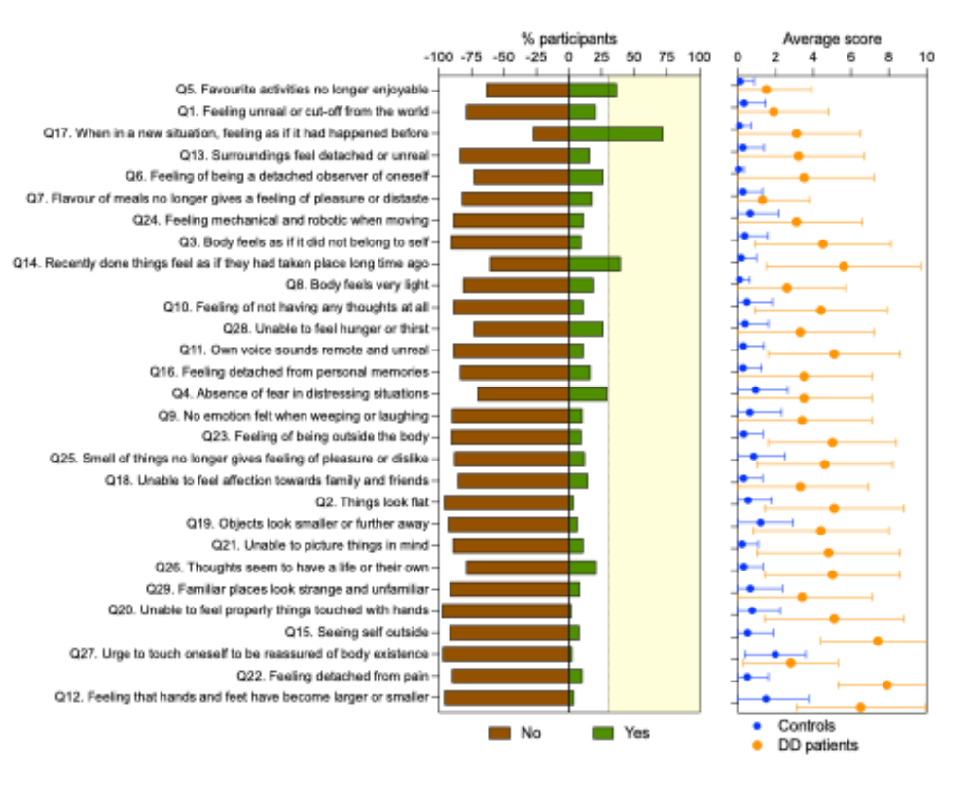

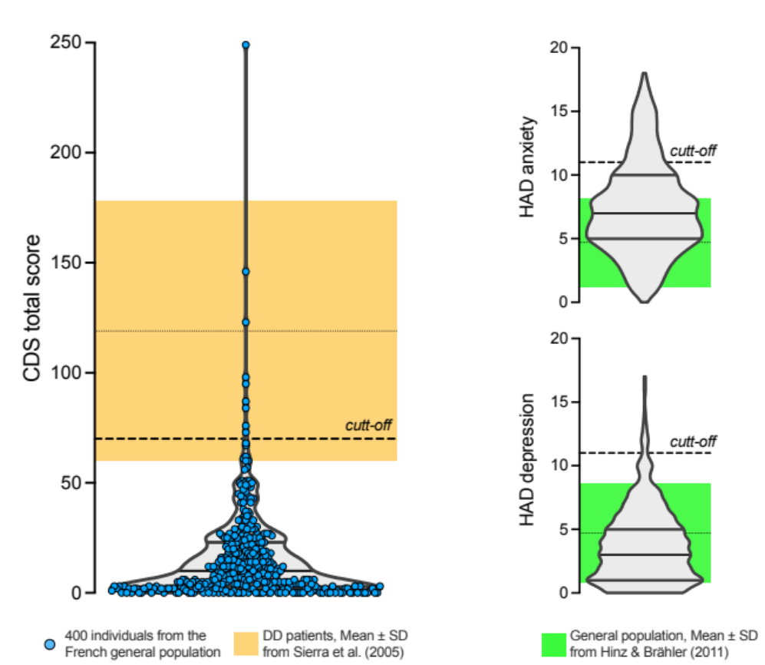

Exploratory factor analysis
The Kaiser–Meyer–Olkin measure confirmed that the sample size was excellent for our exploratory factor analysis (KMO = 0.94). Five factors had eigenvalues above the Kaiser’s criterion of 1 (Table e–2). Altogether, these factors explained 51.4% of the total variance in the data. Extracted communalities ranged from 0.18 to 0.71. The analysis of the residuals, comparing observed and predicted correlations, indicated that 90% of the residuals were below 0.05, suggesting that the model with 5 factors described correctly the data.
Factor 1, which explained 40.16% of the variance, contained items about distorted subjective recall [20] (e.g., feeling detached from personal memories) and temporal disintegration (Simeon et al. 2008) (e.g., recently done things feel as if they had taken place long time ago). Factor 2, which explained 6.89% of the variance, described distortions in the experience of the body (e.g., feeling of being outside of the body) and in the experience of the self (e.g., feeling unreal or cut–off from the world). Factor 3 explained 5.12% of the variance and was labelled numbing as it incorporates 3 items related to attenuations of pleasure and body sensations (e.g., unable to feel hunger or thirst). Factor 4 explained 3.84% of the variance and incorporated three items describing perceptual alterations regarding the body (e.g., feeling that hands and feet have become larger or smaller). As only one item (Q15) had loading > 0.4 for Factor 5, it was not considered further in the analysis. Seven questionnaire items (Q9, Q5, Q19, Q18, Q22, Q17 and Q4) had loadings ≤ 0.4 and were not included in the factors. Table e–3 shows the pattern matrix with the factor loadings after rotation. Correlations between the five factors are summarized in Table e–4.
In conclusion, it was considered that the structure of the CDS in patients with dizziness encompassed four subscales labelled: ‘Distorted subjective recall and temporal disintegration’, ‘Distorted body and self experience’, ‘Numbing’ and ‘Perceptual alterations’.
The reliability analysis indicates that the first two factors, ‘Distorted subjective recall and temporal disintegration’ and ‘Distorted body and self experience’, had high reliability (all Cronbach’s α > 0.8) and the last two factors ‘Numbing’ and ‘Perceptual alterations’ had good reliability (all Cronbach’s α > 0.7) (Table e–2).

Cited from another study: “Cronbach’s alpha was 0.85 (95% CI: 0,81–0,88). The intraclass correlation coefficient between T1 and T2 was 0.77 (CI at 95%: 0.58–0.87). Spearman’s correlation was 0.61 with the PAM, and 0.68 with the SEM-CD.”

Relation between CDS scores and the participants’ sex and age
A regression analysis with age and sex as independent variables revealed a significant effect of age and sex on the total CDS score (Table 2). Figure 2 compares the CDS, anxiety and depression scores in female and male participants.
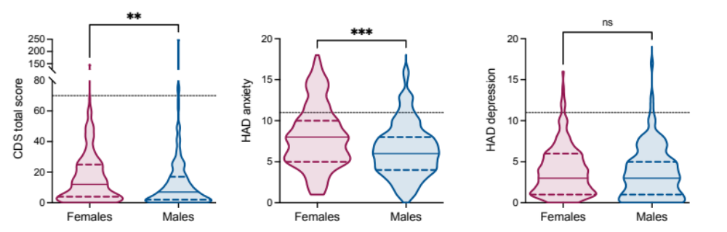

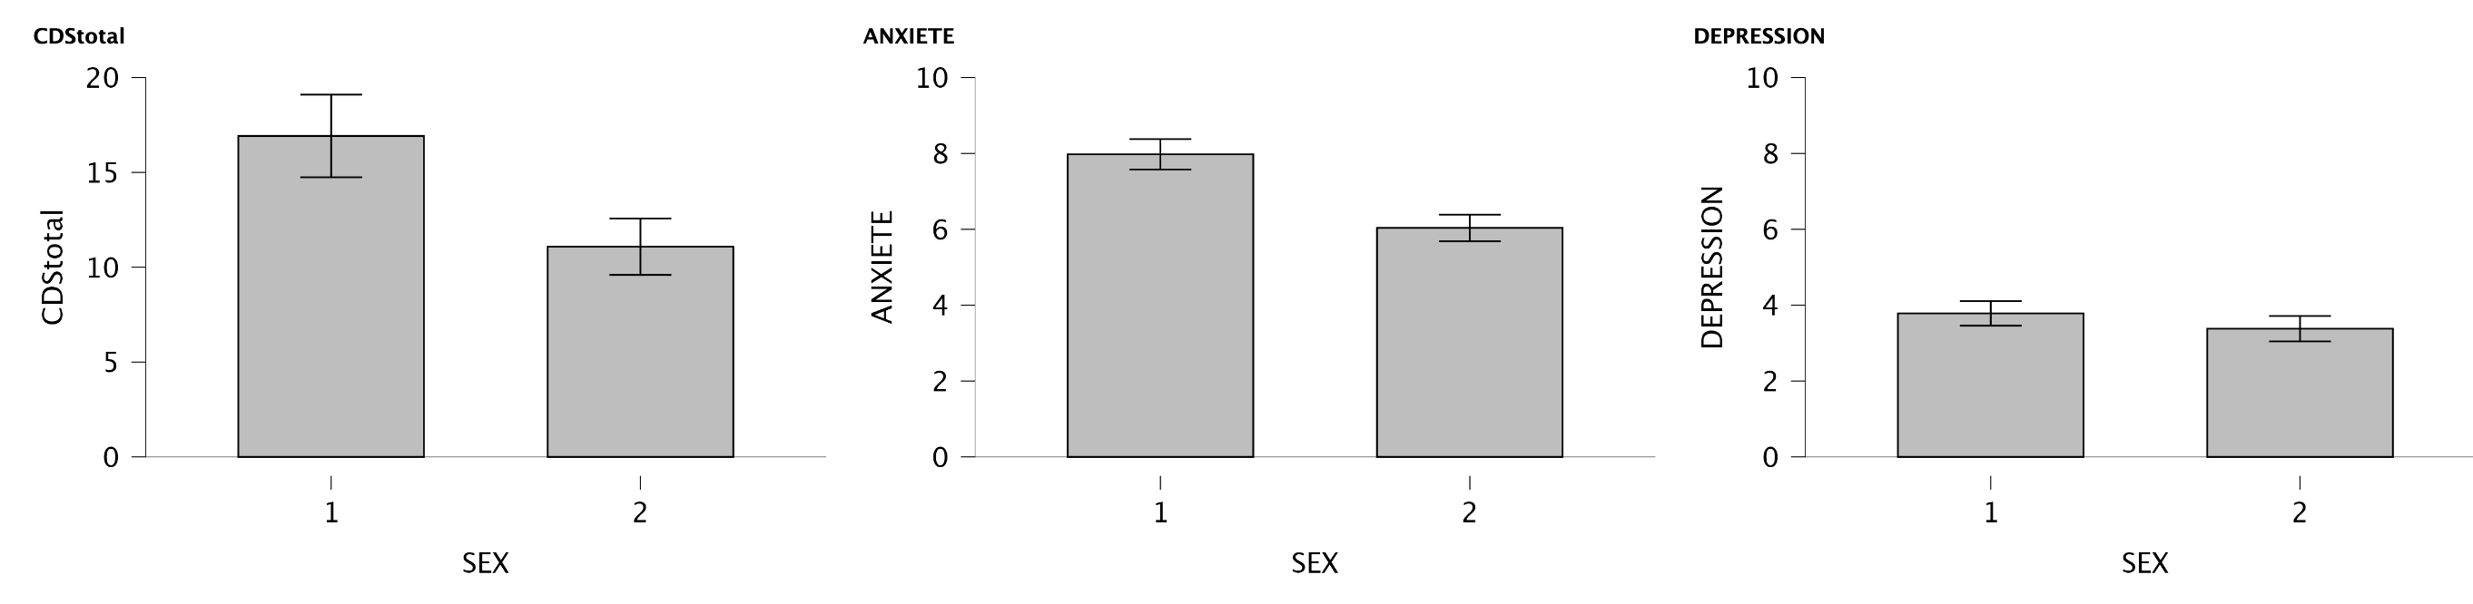
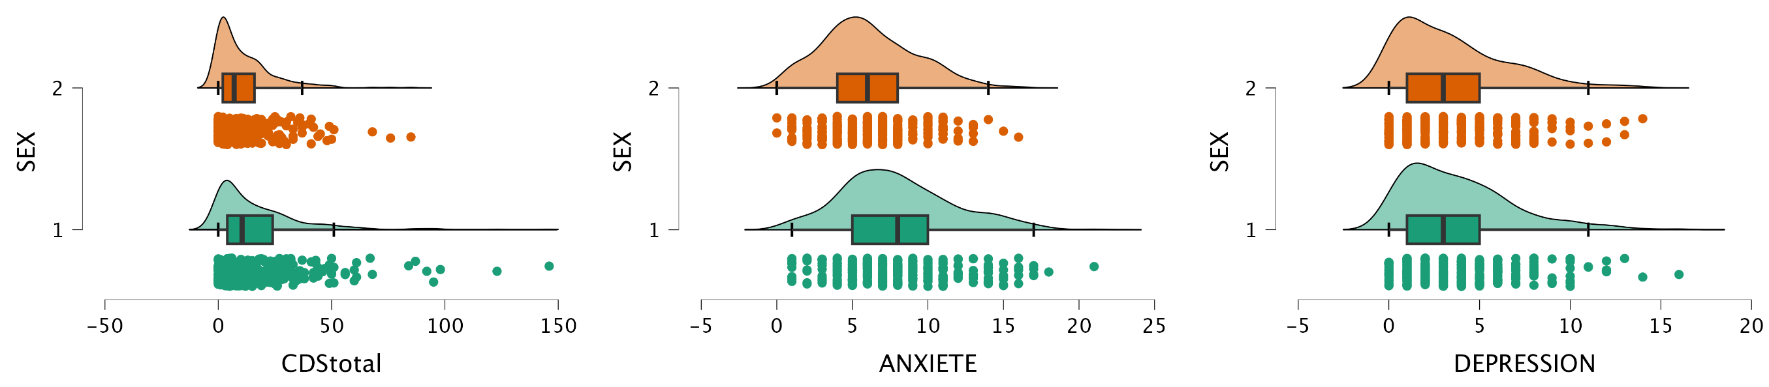

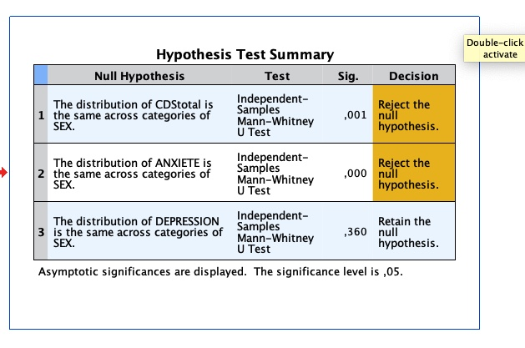

Table 2. Results from linear regression analyses with age and sex as independent variables.
 | CDS total score |  |  |  | HADS-anxiety |  |  |  | HADS-depression
 | B | Beta | p | Adj. R² | B | Beta | p | Adj. R² | B | Beta | p | Adj. R²
Constant
Age
Sex
Migraine?
Other variables?

CDS:
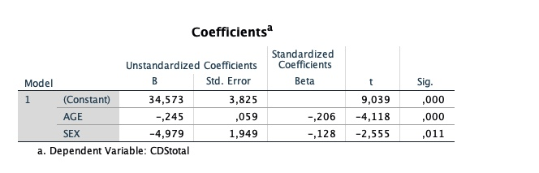
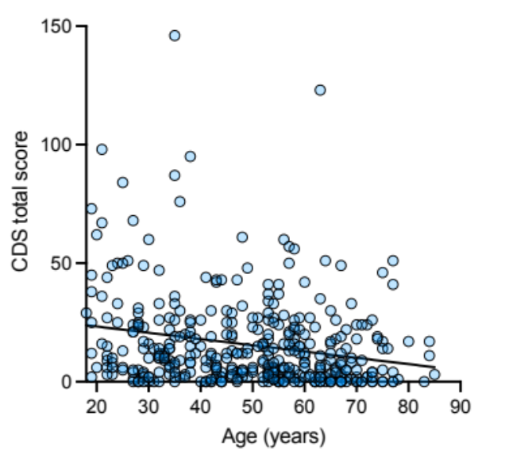

Relation between CDS scores and HADS scores
Figure 1B shows the distribution of the HADS scores in our sample and the green area represents the mean ± SD of the HADS-anxiety and HADS-depression scores in a larger sample of the general population in Germany [34]. We found that the CDS total score was significantly correlated with HADS-anxiety (stats) and HADS-depression (stats). Participants were stratified into low-anxiety/low-depression and high-anxiety/high-depression, defined as HADS-anxiety or HADS-depression scores (equals and?) below 8 and above 8, respectively (for similar procedures, see Ref. [19]). Figure 3 shows that individuals with probable anxiety and depression had significantly higher CDS scores than individuals with probable low anxiety (stats) and individuals with low depression (stats).
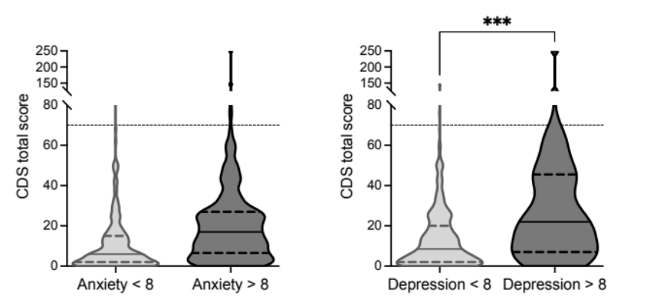

From Michal 2001: 3.4. Overlap and distinctiveness with anxiety and depression
With respect to HADS case de!nition, 24.4% (N=603) of the participants scored in the range of clinically signi!cant depression (HADS-D >= 8), 22.1% (N=548) were in the range of clinically signi!cant anxiety (HADS-A 8), 14.7% (N = 362) ful!lled both criteria, and 31.7% (N=779) met at least one criterion (i.e. HADS-A or HADS-D case level). In the total sample the mean scores for HADS-D were 4.64 ± 3.99 and for HADS-A 4.66±3.67. Both conditions were positively corre- lated with age (HADS-A r = 0.07, p = 0.001; HADS-D r = 0.24, p b 0.001). With respect to sex distribution for depression no signi!cant difference was found (OR 0.85, 95%CI 0.71–1.02, p = 0.091), however anxiety was more often in females (OR 1.23, 95%CI 1.02–1.50, p = 0.032). Depersonalization severity according to the CDS-2 scores correlated strongly with the HADS-depression subscale (r=0.51, pb0.001) as well as with the anxiety subscale (r = 0.52, p b 0.001), but the correlation between the two HADS subscales was higher (r = 0.69, p b 0.001). To examine differential associa- tions of anxiety and depression with depersonalization severity we performed a stepwise linear regression with the CDS-2 score as the dependent variable and HADS-A and HADS-D as the independent variables. Both variables explained 32.1% of the variance of depersonalization severity (F(df = 2, 2452) = 580.299, p b 0.001), HADS-A 27.3% (à=0.320, pb0.001) and HADS-D additionally 4.8% (à = 0.299, p b 0.001).
Persons with clinically signi!cant DP reached case level of depression in 90.1% and case level of anxiety in 76.8%. Only N = 3 persons with clinically signi!cant DP reached neither case level of anxiety nor depression. These persons were two men (age 65 and 32 years) and one woman (age 17 years), with a mean score for HADS-A of 5.0 ± 3.5 and for HADS-D of 6.3 ± 1.2. This strong co-occurrence of DP with anxiety and depression is further illustrated in Fig. 1, showing that with increasing depersonalization severity, subjects also score increasingly in the range of clinically signi!cant depression, anxiety or both conditions (depression and anxiety). In order to consider covariates, we calculated a logistic regression analysis with CDS 3 as the dependent variable, and anxiety (HADS-A 8), depression (HADS-D 8) as the predictors adjusted for age (in years) and sex. A strong association of clinically signi!cant DP was found with depression OR 17.72

Discussion
Vestibular loss decreases the odds of using navigation strategies
The results of this study demonstrated good psychometric properties of the PIH-Fv, which are comparable to the original version and to other cross-cultural adaptations (Dutch and Chi- nese). To our knowledge, this is the first study of the translation and adaptation of the PIH into French. We used Hawkins and Osborne’s method. The authors of the cross-cultural adap- tation of the Chinese and Dutch versions used the Brislin (1970) [39] and the Guillemin (1993) [40] methods [12, 13] respectively. These two translation methods require an evaluation ommittee for the translation. However, they did not mention if patients or authors of the original questionnaires participated [39, 40].
This study is also the first evaluation of the psychometric properties of the PIH-Fv. The average score for T1 (82.17) tended towards good self-management, similarly to the Dutch adaptation (ẋ = 78.1) [12]. Internal consistency of previous initial English versions [5, 6] and the Dutch adaptation [12] of the PIH yielded Cronbach’s alphas varying from 0.82 to 0.86. The internal consistency in this study remained similar after the translation process (α = 0.85). Test-retest reliability was also documented in the Chinese adaptation [13] with an ICC of 0.82, but the confidence interval was not mentioned. The coefficient (ICC = 0.77) in our study is slightly lower than the Chinese adaptation. In our, study the ICC could have been affected by a medical visit between T1 and T2 [38] which might have provided some self-management sup- port explaining an increase in total score (81.1 at T1 versus 84.7 at T2). This result may also be linked to the change in the administration procedure of the PIH-Fv at T1 (in person) and T2 (by telephone) [41].
This is the first study to measure the concurrent validity of the PIH with the SEM-CD and the PAM. The concurrent validity of the PIH-Fv measuring self-management showed a moderate correlation with the concept of activation as measured by the PAM and with the concept of self-efficacy as measured by SEM-CD. This is explained by the fact that these con- cepts are related [9].
Strengths and limitations
Strengths. The study was conducted in two different regions of Quebec, which covers a rural population (n = 49) as well as an urban one (n = 119), making the sample more represen- tative of the population.
The study was performed rigorously, using Hawkins and Osborne’s method, which allowed us to conduct the cross-cultural French adaptation of the questionnaire while preserving the original meaning of the questions by consulting the authors of the PIH. Finally, all information collected and entered into the database was validated by a second person, independently, ensuring accuracy.
Limitations. Participants had to complete the questionnaire while sitting in the clinics’ waiting rooms. If the patient’s appointment with the clinician was ahead of time and the par- ticipants did not have enough time to complete the questionnaire, it was rarely completed after that appointment. This may explain the high number of incomplete questionnaires (n = 45).
To further appraise PIH-Fv psychometric properties, a next study should recruit a larger sample to evaluate PIH-Fv structural validity. In addition, it may be appropriate to conduct a sensitivity to change analysis in a clinical intervention study to assess the capacity of the PIH-Fv to capture clinical improvement of self-management level [7]. Finally, missing data were particularly associated with item one of the PIH-Fv. This could be explained by the con- figuration of the questionnaire; the first question was presented directly below examples of answer options. To reduce the number of missing data, it would be preferable to separate examples of answers options more clearly at the beginning to the PIH-FV. Finally, we suggest conducting a pre-test to evaluate cultural differences before using the French version with other French populations.

Conclusions
The PIH-Fv demonstrated good internal consistency, good test-retest reliability and moderate concurrent validity with the PAM and the SEM-CD. The PIH-Fv can be used to measure level of self-management among French-speaking adults with chronic conditions.

Link with COVID-19= https://pubmed.ncbi.nlm.nih.gov/33319496/
https://pubmed.ncbi.nlm.nih.gov/32766539/ Hu D, Kong Y, Li W, Han Q, Zhang X, Zhu LX, et al. Frontline nurses’ burnout, anxiety, depression, and fear statuses and their associated factors during the COVID-19 outbreak in Wuhan, China: A large-scale cross-sectional study. EClinicalMedicine. 2020;24:100424. Epub 2020/08/09. pmid:32766539

- Research article

Symptoms of depersonalization/derealization are independent risk factors for the development or persistence of psychological distress in the general population: Results from the Gutenberg health study
Journal of Affective Disorders1 August 2020
  - Jasmin Schlax
  - Jörg Wiltink
  - Matthias Michal

Acknowledgements
We are very thankful to Pauline Grellet for her help with the questionnaire translation. We thank Dr Maeva Montero, staff from the Centre des Vertiges at the European Hospital-Marseille, Estelle Lesieux, and the Clinical Research Department of European Hospital-Marseille, clinical study sponsor, for helping with patients’ inclusion and testing. We are thankful to Nathalie Baril for helping with software programming.

Funding

This work was supported by the ANR VESTISELF project, grant ANR-19-CE37-0027 of the French Agence Nationale de la Recherche.
+ Wakam For Good and Fondation CNRS.

References
American Psychiatric Association. Diagnostic and Statistical Manual of Mental Disorders: DSM-5. American Psychiatric Publishing, Inc., 2013.
Aponte-Soto MR, Vélez-Pastrana M, Martínez-Taboas A, González RA. Psychometric properties of the Cambridge depersonalization scale in Puerto Rico. J Trauma Dissociation 15: 348–363, 2014.
Bartrés-Faz D, Demnitz-King H, Cabello-Toscano M, Vaqué-Alcázar L, Saunders R, Touron E, Cattaneo G, Gonneaud J, Klimecki O, Bargalló N, Sánchez-Solana J, Tormos JM, Chételat G, Pascual-Leone Á, Marchant NL. Psychological profiles associated with mental, cognitive and brain health in middle-aged and older adults. Nat Mental Health 3: 92–103, 2025.
Beh SC, Masrour S, Smith SV, Friedman DI. Clinical characteristics of Alice in Wonderland syndrome in a cohort with vestibular migraine. Neurol Clin Pract 8: 389–396, 2018.
Bernasconi F, Blondiaux E, Potheegadoo J, Stripeikyte G, Pagonabarraga J, Bejr-Kasem H, Bassolino M, Akselrod M, Martinez-Horta S, Sampedro F, Hara M, Horvath J, Franza M, Konik S, Bereau M, Ghika J-A, Burkhard PR, Van De Ville D, Faivre N, Rognini G, Krack P, Kulisevsky J, Blanke O. Robot-induced hallucinations in Parkinson’s disease depend on altered sensorimotor processing in fronto-temporal network. Sci Transl Med 13: eabc8362, 2021.
Bernstein EM, Putnam FW. Development, reliability, and validity of a dissociation scale. J Nerv Ment Dis 174: 727–735, 1986.
Bjelland I, Dahl AA, Haug TT, Neckelmann D. The validity of the Hospital Anxiety and Depression Scale. Journal of Psychosomatic Research 52: 69–77, 2002.
Blevins CA, Witte TK, Weathers FW. Factor structure of the Cambridge Depersonalization Scale in trauma-exposed college students. J Trauma Dissociation 14: 288–301, 2013.
Bocéréan C, Dupret E. A validation study of the Hospital Anxiety and Depression Scale (HADS) in a large sample of French employees. BMC Psychiatry 14: 354, 2014.
Braithwaite JJ, Watson DG, Dewe H. Predisposition to out-of-body experience (OBE) is associated with aberrations in multisensory integration: Psychophysiological support from a “rubber hand illusion” study. J Exp Psychol Hum Percept Perform 43: 1125–1143, 2017.
Cox BJ, Swinson RP. Instrument to assess depersonalization-derealization in panic disorder. Depress Anxiety 15: 172–5, 2002.
Dieguez S, Lopez C. The bodily self: Insights from clinical and experimental research. Ann Phys Rehabil Med 60: 198–207, 2017.
Dixon JC. Depersonalization phenomena in a sample population of college students. Br J Psychiatry 109: 371–375, 1963.
Gwyther MPD, Lenggenhager B, Windt JM, Aspell JE, Ciaunica A. Examining the association between depersonalisation traits and the bodily self in waking and dreaming. Sci Rep 14: 6107, 2024.
Hill ED, Kashyap P, Raffanello E, Wang Y, Moffitt TE, Caspi A, Engelhard M, Posner J. Prediction of mental health risk in adolescents. Nat Med , 2025. doi:10.1038/s41591-025-03560-7.
Hinz A, Brähler E. Normative values for the hospital anxiety and depression scale (HADS) in the general German population. J Psychosom Res 71: 74–78, 2011.
Hunter ECM, Sierra M, David AS. The epidemiology of depersonalisation and derealisation. A systematic review. Soc Psychiatry Psychiatr Epidemiol 39: 9–18, 2004.
Jacobs JR, Bovasso GB. Toward the clarification of the construct of depersonalization and its association with affective and cognitive dysfunctions. J Pers Assess 59: 352–365, 1992.
Kontoangelos K, Tsiori S, Poulakou G, Protopapas, Katsarolis I, Sakka V, Kavatha D, Papadopoulos A, Antoniadou A, Papageorgiou CC. Reliability, validity, and psychometric properties of the greek translation of the Cambridge Depersonalization Scale (CDS). Mater Sociomed 28: 387–391, 2016.
Lopez C, Elzière M. Out-of-body experience in vestibular disorders - A prospective study of 210 patients with dizziness. Cortex 104: 193–206, 2018.
Medford N, Baker D, Hunter E, Sierra M, Lawrence E, Phillips ML, David AS. Chronic depersonalization following illicit drug use: a controlled analysis of 40 cases. Addiction 98: 1731–1736, 2003.
Michal M, Beutel ME, Grobe TG. [How often is the Depersonalization-Derealization Disorder (ICD-10: F48.1) diagnosed in the outpatient health-care service?]. Z Psychosom Med Psychother 56: 74–83, 2010.
Michal M, Glaesmer H, Zwerenz R, Knebel A, Wiltink J, Brähler E, Beutel ME. Base rates for depersonalization according to the 2-item version of the Cambridge Depersonalization Scale (CDS-2) and its associations with depression/anxiety in the general population. J Affect Disord 128: 106–111, 2011.
Michal M, Sann U, Niebecker M, Lazanowsky C, Kernhof K, Aurich S, Overbeck G, Sierra M, Berríos G. Die Erfassung des Depersonalisations-Derealisations-Syndroms mit der deutschen Version der Cambridge Depersonalisation Scale (CDS). Psychother Psychosom Med Psychol 54: 367–374, 2004.
Michal M, Wiltink J, Subic-Wrana C, Zwerenz R, Tuin I, Lichy M, Brähler E, Beutel ME. Prevalence, correlates, and predictors of depersonalization experiences in the German general population. J Nerv Ment Dis 197: 499–506, 2009.
Migliorini V, Dell’erba A, Fagioli F, Sierra M, Mosticoni S, Telesforo L, Patanè M, Consolazione M, Fiori-Nastro P. Italian (cross cultural) adaptation and validation of the Cambridge Depersonalization Scale (CDS). Epidemiol Psychiatr Sci 21: 221–226, 2012.
Molina Castillo JJ, Martínez de la Iglesia J, Albert Colomer C, Berrios G, Sierra M, Luque Luque R. [Cross-cultural adaptation and validation of the Cambridge Depersonalisation Scale]. Actas Esp Psiquiatr 34: 185–192, 2006.
Myran DT, Pugliese M, Harrison LD, Solmi M, Anderson KK, Fiedorowicz JG, Finkelstein Y, Manuel D, Taljaard M, Webber C, Tanuseputro P. Changes in Incident Schizophrenia Diagnoses Associated With Cannabis Use Disorder After Cannabis Legalization. JAMA Netw Open 8: e2457868, 2025.
Ronchi R, Park H-D, Blanke O. Chapter 15 - Bodily self-consciousness and its disorders. In: Handbook of Clinical Neurology, edited by Vallar G, Coslett HB. Elsevier, p. 313–330.
Salgado ACS, de Souza LC, Salgado JV, Sierra M, Teixeira AL. Tradução e adaptação cultural para o português brasileiro da Cambridge Depersonalisation Scale (Escala de Despersonalização de Cambridge). [Translation and cultural adaptation to Brazilian Portuguese of the Cambridge Depersonalisation Scale.]. Jornal Brasileiro de Psiquiatria 65: 330–333, 2016.
Sang FYP, Jáuregui‐Renaud K, Green DA, Bronstein AM, Gresty MA. Depersonalisation/derealisation symptoms in vestibular disease. J Neurol Neurosurg Psychiatry 77: 760–766, 2006.
Sierra M, Baker D, Medford N, David AS. Unpacking the depersonalization syndrome: an exploratory factor analysis on the Cambridge Depersonalization Scale. Psychological Medicine null: 1523–1532, 2005.
Sierra M, Berrios GE. The Cambridge Depersonalization Scale: a new instrument for the measurement of depersonalization. Psychiatry Res 93: 153–64, 2000.
Simeon D, Abugel J. Feeling unreal. Depersonalization disorder and the loss of the self. New York: Oxford University Press, 2006.
Simeon D, Knutelska M, Nelson D, Guralnik O. Feeling unreal: a depersonalization disorder update of 117 cases. J Clin Psychiatry 64: 990–7, 2003.
Simeon D, Kozin DS, Segal K, Lerch B, Dujour R, Giesbrecht T. De-constructing depersonalization: further evidence for symptom clusters. Psychiatry Res 157: 303–306, 2008.
Simeon D, Stein DJ. Depersonalization/derealization and its relationship to mood and anxiety disorders in the National Comorbidity Survey-Replication (NCS-R). Soc Psychiatry Psychiatr Epidemiol , 2025. doi:10.1007/s00127-025-02915-2.
Sugiura M, Hirosawa M, Tanaka S, Nishi Y, Yamada Y, Mizuno M. Reliability and validity of a Japanese version of the Cambridge depersonalization scale as a screening instrument for depersonalization disorder. Psychiatry Clin Neurosci 63: 314–321, 2009.
Terwee CB, Bot SDM, De Boer MR, Van Der Windt DAWM, Knol DL, Dekker J, Bouter LM, De Vet HCW. Quality criteria were proposed for measurement properties of health status questionnaires. Journal of Clinical Epidemiology 60: 34–42, 2007.
Tibubos AN, Grammes J, Beutel ME, Michal M, Schmutzer G, Brähler E. Emotion regulation strategies moderate the relationship of fatigue with depersonalization and derealization symptoms. J Affect Disord 227: 571–579, 2018.
Zigmond AS, Snaith RP. The Hospital Anxiety and Depression Scale. Acta Psychiatrica Scandinavica 67: 361–370, 1983.

