The French adaptation of the Cambridge Depersonalization Scale (CDS): psychometric characteristics in a non-clinical population

Maélis Gobinet¹, Maya Elzière^{1,2}, and Christophe Lopez¹ ✉️

¹ Aix Marseille Univ, CNRS, Centre de Recherche en Psychologie et Neurosciences (CRPN), Marseille, France
² Centre des Vertiges, European Hospital, Marseille, France

Version 17/10/2026

AUTHORS’ ORCID:
Christophe Lopez = orcid.org/0000-0001-9298-2969

https://www.journals.elsevier.com/journal-of-affective-disorders
The Impact Factor of this journal is 4.839, ranking it 53 out of 208 in Clinical Neurology
—> payant?

BMC Psychiatry? Mais payant et cher à éviter...

✉️ Address for correspondence:

Dr Christophe Lopez
Centre de Recherche en Psychologie et Neurosciences (CRPN) – UMR 7077
Aix Marseille Univ & Centre National de la Recherche Scientifique (CNRS)
Centre Saint-Charles, Fédération de Recherche 3C – Case B
3, Place Victor Hugo. 13331 Marseille Cedex 03, France
Tel: +33 4 13 55 08 41 Fax: + 33 4 13 55 08 44

email: christophe.lopez@univ-amu.fr
Abstract
Depersonalization-derealization (DD) disorders are a clinical phenomenon characterized by a profound feeling of detachment. Several scales have been developed to measure DD, including the Cambridge Depersonalization Scale (CDS) developed by Sierra and Berrios in 2000. The CDS allows to draw a comprehensive overview of the clinical symptoms pertaining to DD disorders and to measure the frequency and duration of these symptoms. The CDS has already been translated and culturally adapted to several languages. However, there is no French version of the CDS available, which may concern over 200 million locutors using French language daily. The primary aim of this study was to translate and adapt the CDS into French and to evaluate its characteristics in a sample of general population free of known neurological and otoneurological disorders. The secondary aim was to analyze the influence of age, sex, anxiety and depression on DD experience.
In total, xxx volunteers from the South of France participated in the study completing the CDS in French, the Hospital Anxiety and Depression Scale and sociodemographic data were collected.
We found that DD over the cut-off value was observed in x% of the sample. Factors influencing DD symptoms were age, sex, anxiety and depression…
A factorial analysis …. Cronbach’s a coefficients were 0.75 (UG) and 0.81 (UL).
Introduction
Mental health is increasingly recognized as a major societal challenge, and several cohort studies have been initiated to investigate the predisposing factors and environmental influences shaping mental health across the lifespan (e.g., Bartrés-Faz et al. 2025; Hill et al. 2025; Myran et al. 2025). Among the various manifestations of mental health disorders, disturbances in the sense of self appear to be relatively rare and transient in the general population (Michal et al., 2009) but they are frequently observed across a range of neurological and psychiatric conditions (Dieguez and Lopez, 2017; Hunter et al., 2004; Ronchi et al., 2018).
Disturbances in the sense of self may involve altered perception of reality, leading to sensations of dissolution, fragmentation, duplication of the self, or detachment from the self. These experiences may also include a reduced sense of agency over one’s thoughts and actions. Such phenomena are core features of depersonalization-derealization (DD) disorders (Simeon et al., 2003; Simeon and Abugel, 2006). They are also encountered in psychotic disorders (Giersch et al., 2025), as well as in motor or sensory dysfunctions (Bernasconi et al., 2021; Yen Pik Sang et al., 2006). Transient disruptions in the sense of self have also been reported in association with depression, migraine (Beh et al., 2018), fatigue (Tibubos et al., 2018), substance use (Medford et al., 2003), and when falling asleep or waking up (Simeon and Abugel, 2006; Simeon and Stein, 2025).
According to the DSM-5, DD disorder is characterized by “the presence of persistent or recurrent experiences of depersonalization” (i.e., “experiences of unreality, detachment, or being an outside observer with respect to one’s thoughts, feelings, sensations, body, or actions”) or/and of derealization (i.e., “experiences of unreality or detachment with respect to surroundings”), during which reality testing remains intact (American Psychiatric Association, 2013). Transient symptoms of DD are rather common in the general population, with an estimated lifetime prevalence rate ranging from 26% to 74% (reviewed in Hunter et al., 2004). By contrast, clinically significant DD assessed using diagnostic interviews is estimated to affect approximately 1–2% of individuals (Hunter et al., 2004; Michal et al., 2009). Yet, it has been argued that DD is likely underdiagnosed in the general population (Michal et al., 2010). All of this highlights the need for improved awareness about DD symptoms among healthcare professionals and adapted screening tools.
Reliable tools for assessing mental health symptoms, including those related to DD, are essential for cross-sectional and longitudinal research. Several instruments have been developed to assess DD, including the Cox & Swinson questionnaire (Cox and Swinson, 2002), the Dixon’s Scale (Dixon, 1963), the Jacobs & Bovasso’s Depersonalization Scale (Jacobs and Bovasso, 1992), and the Bernstein & Putnam’s Dissociative Experience Scale (Bernstein and Putnam, 1986) (scales reviewed in Sierra and Berrios, 2000; Migliorini et al., 2012). The Cambridge Depersonalization Scale (CDS), developed by Sierra and Berrios (2000), offers a comprehensive evaluation of both frequency and duration of DD symptoms and has demonstrated strong psychometric properties, including high internal consistency and good reliability.
The CDS has been subjected to exploratory factor analyses in psychiatric populations (Sierra et al., 2005; Simeon et al., 2008) and trauma-exposed college students (Blevins et al., 2013), supporting its structural validity. It has also been translated and culturally adapted into several languages, including Spanish (Spain: (Molina Castillo et al., 2006); Puerto Rico: (Aponte-Soto et al., 2014), Italian (Migliorini et al., 2012), German (Michal et al., 2004), Greek (Kontoangelos et al., 2016), Japanese (Sugiura et al., 2009), and Brazilian Portuguese (Salgado et al., 2016). However, no validated French version of the CDS is currently available, despite the fact that French is spoken daily by over 200 million people worldwide.
A 2-item version of the CDS has proven useful in assessing DD symptoms in the general population in Germany, with an estimated prevalence of clinically relevant DD of 3.4% (Michal et al., 2011). Additionally, the CDS has been used in the general population to examine how the sense of self relates to self and body experiences in dream states (Gwyther et al., 2024), as well as to more objective assessments of self-perception. For instance, studies suggest that individuals with higher CDS scores exhibit stronger susceptibility to illusory self-identification with a rubber hand (Braithwaite et al., 2017) and are more prone to experience to disembodied self-location (Lopez and Elzière, 2018).

Review of the literature indicates inconsistent findings regarding the association between DD and sociodemographic and clinical variables. While DD is negatively correlated with age (Michal et al., 2016, 2009), with a higher prevalence in adolescent and young adults (Baker et al., 2003; Yang et al., 2023), it was inconsistently associated with sex (Aderibigbe et al., 2001; Michal et al., 2016) (Aderibigbe et al., 2001, Michal et al., 2016a; Simeon et al., 2013). DD was also related to anxiety and depression (Hunter et al., 2004; 2014; Lee et al., 2012; Medford et al. 2005; 2016; Michal et al., 2009; 2011; 2016; Schlax et al., 2020; Simeon et al., 2003; Yang et al., 2023), which are increasingly prevalent in the general population (Bandelow and Michaelis, 2015; Moreno-Agostino et al., 2021). Even though they are distinct disorders (Sierra et al., 2012; Stein et al., 2024), DD, anxiety, and depression have mutual influences that require further investigations in the general population.
This prospective, observational, cross-sectional study had two main objectives: (1)
The first objective was to translate and culturally adapt the CDS into French, and to validate its psychometric properties in a general population sample without known psychiatric, neurological or otoneurological disorders. (2)
The second objective was to assess the prevalence of DD experiences in a non-clinical French-speaking population, to examine the phenomenological content of DD in a large non-clinical sample, and to examine the influence of sex, age, anxiety, and depression on the intensity of these experiences.

Materials and methods

This prospective, observational, cross-sectional study follows the Strengthening the Reporting of Observational Studies in Epidemiology (STROBE) guidelines (von Elm et al., 2007).

French translation and cross-cultural adaptation
The rights to translate the questionnaire (Appendix A from Sierra & Berrios (2000)) into French and to reproduce it were granted by Elsevier, the publisher. The steps for the French translation and cross-cultural adaptation were as follows:
- Forward translation. A bilingual French translator, with French as the mother tongue and familiar with the neuroscience and neuropsychology of the self and body representations, translated the instructions and questionnaire items to French.
- Back translation. The forward-translated questionnaire was translated back to English by a bilingual English translator, with English as the mother tongue, who was naive to the CDS and the study purpose.
- Back translation review. The French and English translated questionnaires were compared with the original version of the CDS (Sierra and Berrios, 2000) to check for congruency. The questionnaire was corrected accordingly to obtain the final questionnaire reproduced in Supplementary Table 1.
Comparison of the original items in English and the French translation is provided in Supplementary Table 2, together with intermediate steps of translation.

Participants
To investigate the association between vertigo/dizziness and the sense of self, we used data collected from two prospective, observational, cross-sectional studies: the ImVesPerSE study (conducted from October 2016 to December 2018) and the PERSOCOR study (conducted from March 2022 to October 2024) which aimed to compare the sense of self in a population devoid of known otoneurological and psychiatric disorders and in a population with vertigo and dizziness. Clinical subsamples of these cohorts have been described elsewhere (Gobinet et al., 2026; Lopez and Elzière, 2018). Participants were included in the cohorts if they met the following criteria: (1) age over 18; (2) able to read and understand the questionnaires; (3) no severe neurological, otoneurological or psychiatric disorders (self-reported); (4) willing and able to give informed consent to participate to the study. We included 665 participants of which only 574 were further included in the analysis after data were cleaned for multiple missing values and incorrect answers (Figure 1A). Participants were recruited in the area of Marseille, South of France. They were partners, family members and acquaintances that accompanied patients and hospital staff at the European Hospital, Marseille, or participants recruited from advertisement posted at Aix-Marseille University.

Ethical approval and consent
Ethical approval was granted by our Institutional Ethics Committee (ImVesPerSE study: Hôpital Européen, CEDP-HE16.03) and National Ethics Review Board (PERSOCOR: CPP Île de France 2, n° 2021-A03111-40) and procedures were in accordance with the Declaration of Helsinki. Participants gave their consent to participate in the study for PERSOCOR, but a formal consent form was waived by the institution for the ImVesPerSE study. Participants received no payment or compensation.

Procedures
Participants answered all questionnaires on papers. The CDS translated in French included a first section about basic sociodemographic data, including age, sex, education level, marital status, employment status, smoking and drinking habits, and history of migraine.
In the second section of the questionnaire, participants were asked whether they have had these 29 experiences during the last six months. As in the original CDS, the questionnaire was introduced as follows: This questionnaire describes strange and ‘funny’ experiences that normal people may have in their daily life. We are interested in their: (a) frequency, i.e. how often have you had these experiences over the last six months and (b) their approximate duration. For each item, participants indicated the frequency of the experience on a scale ranging from 0 (“never”) to 4 (“all the time”), and the duration of the experience on a scale ranging from 1 (“few seconds”) to 6 (“more than a week”). The introductory paragraph indicated: If you are not sure, give your best guess. For each item, the global score (sum of the frequency and duration) ranged from 0 to 10. The total score for the CDS ranges from 0 to 290. A cut-off score of 70 is used to indicate probable DD disorder (Sierra and Berrios, 2000).
Participants also filled-out the French version of the Hospital Anxiety and Depression Scale (HADS) (Zigmond and Snaith, 1983). The HADS is a 14-item self-reported scale with 7 items tapping into anxiety (e.g., Worrying thoughts go through my mind) and 7 items tapping into depression (e.g., I feel as if I am slowed down). Answers to each item are rated from 0 to 3, contributing to an anxiety subscale (HADS-A) and a depression subscale (HADS-D). Each subscale has scores ranging from 0 to 21. A cut-off score of 11 is used to indicate probable anxiety disorder or probable depression. The HADS shows high sensitivity and reliability in assessing the symptom severity of anxiety disorders and depression in various clinical populations, as well as in the general population (Bjelland et al., 2002). The validated French version of the HADS (Bocéréan and Dupret, 2014) has good internal consistency, similar to other countries. Normative values have been provided in 4 410 adults from the general German population (Hinz and Brähler, 2011).

Data analysis
Statistical analyses were carried out in R (version 4.4.2) and GraphPad Prism (version 10.1.0). We used two-tailed tests for all analyses and p-values were considered statistically significant when < 0.05, unless otherwise specified. All analyses were conducted on complete data.

Exploratory factor analysis. An exploratory factor analysis (EFA) was carried out to identify dimensions of DD in the general population. We verified the absence of multicolinearity between items (inter-items correlation range: -0.01−0.44). Assumptions for EFA were met, as Bartlett’s test of sphericity was significant (χ²₍₄₀₆₎ = 3703.44, p < 0.001) and the Kaiser-Meyer-Olkin (KMO) index was adequate (KMO = 0.90). EFA was conducted on all 29 items of the CDS (sum of frequency and duration scores) using the psych package in R with the minres extraction method. As the items were not normally distributed, the EFA was based on a Spearman correlation matrix. An oblique promax rotation was used given the expected intercorrelations between DD components (Sierra et al., 2005; Simeon et al., 2008). Only items with factor loadings >0.4 were retained, and no item showed cross-loadings above this threshold. Several criteria were used to determine the number of factors [Kaiser criterion, empirical Kaiser criterion, comparison data, Hull method with ULS estimator, Minimum Average Partial (MAP) TR2 and TR4, parallel analysis, and scree plot] using EFAtools in R. Although their results differed, we retained the MAP criterion, considered among the most reliable, which suggested a two-factor structure. Comparison of several solutions (1 to 3 factors) confirmed that the two-factor structure was the most stable and theoretically meaningful. Item loadings, communalities, eigenvalues, variance and inter-factor correlations were extracted. Factor scores were computed as the sum of the items loading on each factor.

Reliability analysis. We assessed internal consistency and split-half reliability for the total CDS score and its identified factors using the psych package in R. We estimated Cronbach’s α (with 95% confidence interval), total ω, mean inter-item correlation, and split-half reliability indices (average, minimum (β), and maximum (λ4)).

Hurdle models (generalized linear models). CDS scores were strongly right-skewed, zero-inflated, over-dispersed and integer-valued, and therefore did not meet the assumptions for classical multiple linear regression. We thus fitted hurdle models using the glmmTMB package in R, to assess the association of sociodemographic and psychological factors with CDS scores. Hurdle models separately estimate (a) the probability of a zero score using a logistic regression (zero-inflation component), and (b) the magnitude of the score among participants with a non-zero score (count component) (reference to be added here please). For the count component, a zero-truncated negative binomial distribution was used, as it accounts for the over-dispersion of the non-zero scores and showed a good fit to our data. Six competing models were compared, with predictors entered progressively [age, sex (woman vs. man), anxiety (HADS-A), depression (HADS-D), migraine (yes vs. no)]. The same procedure was applied to the CDS total score and to both CDS factors identified by the EFA. Model residuals were assessed using the DHARMa package and were satisfactory for all models. Model selection was based on fit indices [Nagelkerke pseudo-R², Akaike Information Criterion (AIC)], likelihood ratio tests for nested models and parsimony. Age was mean-centered (mean = 47.7 years) so that the intercept reflects a participant of average age.

Mediation models and structural equation modeling.
Mediation analysis based on CDS total score, and structural equation modeling (SEM; lavaan package) based on CDS factors, were computed to test whether anxiety and depression mediated the association between sex and DD symptoms.
In both models, sex (woman vs. man) was the exogenous variable whereas depression and anxiety were entered as mediators and allowed to covary. Age was included as a covariate for the CDS total score and factors, given its established association with D(rep ref 1–5).
The endogenous variable for the mediation analysis was the CDS total score. In the SEM, outcomes were the CDS factors identified by the EFA, modeled as latent variables measured by their respective items. They were considered to be inter-correlated. The residuals of items 7, 25 and 28 were allowed to covary, based on their shared content and modification indices.
Indirect effects were computed as products of the corresponding path coefficients, with 95% confidence intervals obtained from 5,000 bootstrap resamples (ML estimator). SEM fit was evaluated with the MLR estimator to account for multivariate non-normality, using robust fit indices (CFI, TLI, RMSEA, SRMR). Standardized coefficients for latent variables are reported.

Data availability
Requests to access the deidentified dataset can be submitted by qualified researchers to the authors.

Results

Sample characteristics
Out of the initial cohorts, 665 healthy participants were enrolled. A total of 91 participants were excluded for the following reasons : under 18 years of age (n=1), incomplete CDS (at least one subitem missing) (n=80), missing demographic data (n=5), technical recording failure (n=2), suspected otoneurological disorder (n=3), and ongoing antidepressant treatment (n=1).
For the hurdle models and mediation/SEM analyses, an additional 31 participants were excluded due to missing data in HADS or migraine data (see Flowchart of inclusion).

The cohort (n=574) had a mean age of 47.71 ± 15.94, comprising 50.2% men and 49.8% women. Regarding laterality, 89.2% of the sample was right-handed, 9.7% left-handed and 1.1% ambidextrous. The majority were employed (69%) and/or in a relationship (76.4%). Concerning lifestyle, 51.1% reported weekly alcohol consumption, 22.2% were smokers and 17.4% reported migraines.

Characteristic | Total (N = 574)¹
Age (years) | 47.71 ± 15.94
Sex
Men | 288 / 574 (50.2%)
Women | 286 / 574 (49.8%)
Laterality
Right-handed | 505 / 566 (89.2%)
Left-handed | 55 / 566 (9.7%)
Ambidextrous | 6 / 566 (1.1%)
Missing values | 8
Employment
Employed | 372 / 539 (69.0%)
Retired | 104 / 539 (19.3%)
Student | 31 / 539 (5.8%)
Unemployed | 32 / 539 (5.9%)
Missing values | 35
Family status
Divorced/Widowed | 46 / 567 (8.1%)
Married/Couple | 433 / 567 (76.4%)
Single | 88 / 567 (15.5%)
Missing values | 7
Smoking habits | 126 / 567 (22.2%)
Missing values | 7
Alcohol consumption
None | 281 / 563 (49.9%)
1 to 5 units/week | 232 / 563 (41.2%)
6 to 10 units/week | 45 / 563 (8.0%)
>10 units/week | 5 / 563 (0.9%)
Missing values | 11
Migraine | 96 / 552 (17.4%)
Missing values | 22
Visual disorder | 384 / 534 (71.9%)
Missing values | 40
¹Mean (± SD); n / N (%)

Distribution of the CDS total scores
Figure 2A shows the distribution of the CDS scores in our sample. Total CDS scores ranged from 0 to 146. The mean total score ± SD was: 14.5 ± 16.8 and the median was 9 (IQR à rapporter?). We found that 8 participants had a score above the cut-off point of 70 (Sierra et al., 2005; Sierra and Berrios, 2000), which represents 1.39% of the study sample. The orange area in Figure 1A represents the mean ± SD of the total CDS scores in a sample of psychiatric patients with documented DD, showing an average CDS score about 7 times higher than what was found in our non-clinical sample.

Most frequently reported DD symptoms in the general population
Ajouter ici une description des items les plus fréquemment rapportés dan la population générale (% participants graphique ci-dessous que je mettrai à jour).
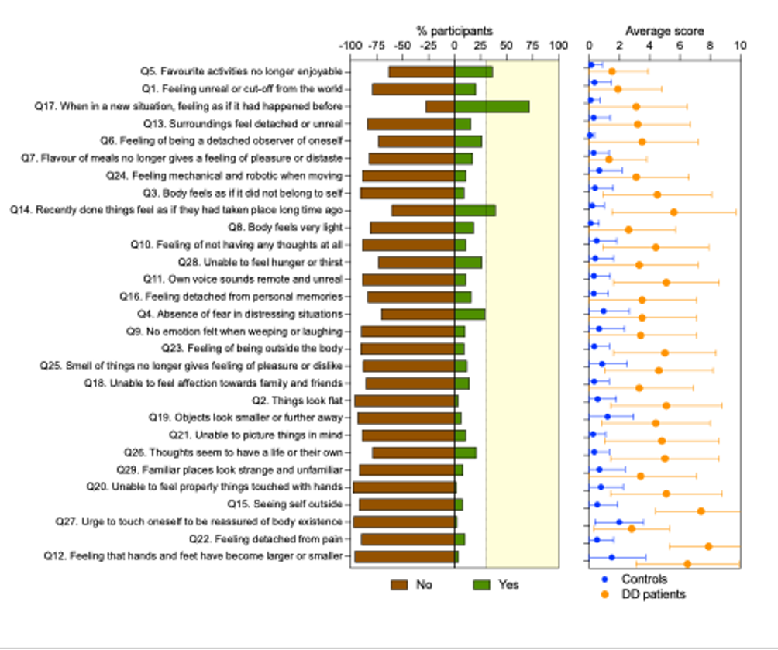

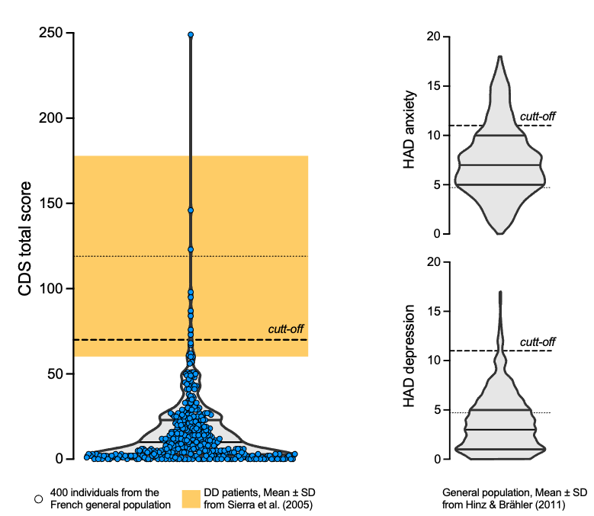

Exploratory factor analysis
The EFA revealed a two-factor structure of DD symptoms in our sample. This solution showed an acceptable fit to the data (χ²₍₃₄₉₎ = 473.8, p < 0.001; RMSEA = 0.046, 90% CI [0.042, 0.051]; RMSR = 0.045; TLI = 0.849). Residuals analysis supported the accuracy of this solution (24.1% of residuals > |0.05|, 2.7% > |0.10|) and factor score determinacy was acceptable (0.83 for Factor 1; 0.80 for Factor 2). Together, the two factors explained 24.6% of the total variance and extracted communalities ranged from 0.09 to 0.41. Twelve questionnaire items (Q4, Q11, Q12, Q14, Q16, Q17, Q18, Q19, Q20, Q21, Q22, Q27) had loadings ≤ 0.4 and were not included in the factors.

Factor 1, which explained 14.7% of the variance, grouped 11 items encompassing altered experiences of the body and self, such as body ownership, self-location, agency and first-person perspective, together with feelings of unreality and detachment from the world and from one’s thoughts. We labeled it Self and Body Detachment (Fig. x, Table x).
Factor 2, which explained 9.99% of the variance, comprised 6 items reflecting a blunting of emotional and sensory experience, namely reduced emotional responses, pleasure and familiarity, and attenuated sensations of taste, smell, hunger and thirst. Therefore, we labeled it Emotional and Sensory Numbing (Fig. x, Table x).

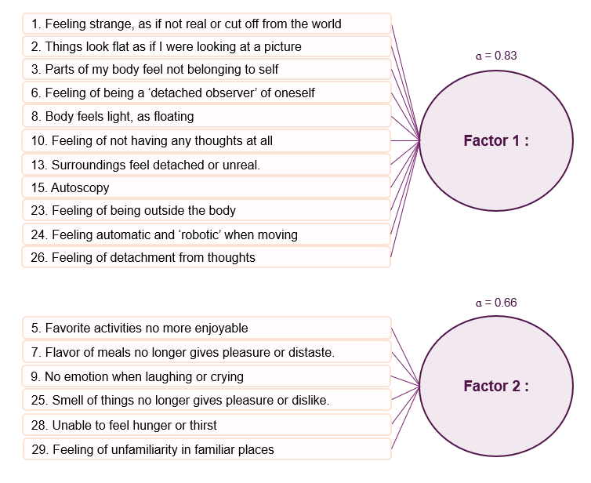

Reliability of the CDS and its factors
The reliability analysis indicates that internal consistency was good for the CDS total score (Cronbach’s ɑ = 0.88, 95% CI [0.87, 0.89]; McDonald’s Ω = 0.89; mean split-half reliability = 0.89) and Factor Self and Body Detachment (Cronbach’s ɑ = 0.83, 95% CI [0.82, 0.85]; McDonald’s Ω = 0.84; mean split-half reliability = 0.83). It was lower for Factor Emotional and Sensory Numbing (Cronbach’s ɑ = 0.66, 95% CI [0.62, 0.70]; McDonald’s Ω = 0.69; mean split-half reliability = 0.69), which is explained by a lower number of items and strongly skewed item distributions. However, its mean inter-correlation is adequate (r = 0.27), supporting correct consistency. No item deletion improved reliability for any of the scores.

Relation between CDS total score, sociodemographic and psychological factors

Among the six hurdle models tested, Model 4, which includes age, sex, anxiety and depression as predictors of the CDS total score showed the best fit (AIC = 3806.38, pseudo-R² = 0.992; Supplementary Table x). Adding migraine as a predictor did not improve model fit (∆AIC = 2.02, p = 0.372).
Zero-inflation component. Each additional year of age was associated with 3% higher odds of a zero score (OR = 1.03, 95% CI [1.01–1.05], p < 0.001), whereas each additional point of depression was associated with 29% lower odds of a zero score (OR = 0.71, 95% CI [0.61–0.83], p < 0.001). Anxiety showed a non-significant trend (p = 0.066), and sex was not significantly associated with the probability of a zero score (p = 0.412).
Count component (among participants with a non-zero score). Age was associated with a 1% lower expected CDS score for each additional year (IRR = 0.99, 95% CI [0.99–1.00], p < 0.001). Higher anxiety and depression scores were associated with higher expected CDS scores, by 8% (IRR = 1.08, 95% CI [1.05–1.11], p < 0.001) and 9% (IRR = 1.09, 95% CI [1.05–1.12], p < 0.001) per point, respectively. Sex was not significantly associated with CDS scores (p = 0.101).

Relation between Self and Body Detachment, sociodemographic and psychological factors

As for the CDS total score, the best model included age, sex, anxiety and depression (AIC = 2299.95, pseudo-R² = 0.925). The model was not improved by adding migraine as a predictor (Supplementary Tables xx-xx).

Zero-inflation component. The odds of a zero score were increased by 2% for each additional year of age (OR = 1.02, 95% CI [1.01–1.04], p < 0.001), whereas they were lowered by 14% for each anxiety point (OR = 0.86, 95% CI [0.80–0.92], p < 0.001) and lowered by 9% for each depression point (OR = 0.91, 95% CI [0.85–0.98], p < 0.05).

Count component. Each additional year of age was associated with a 1% lower expected CDS score (IRR = 0.99, 95% CI [0.99–1.00], p < 0.001), while each point of anxiety and depression was associated with higher expected CDS scores, by 6% (IRR = 1.06, 95% CI [1.03–1.10], p < 0.001) and 5% (IRR = 1.05, 95% CI [1.01–1.09], p < 0.01), respectively.
Sex was neither associated with the probability of a zero score (p = 0.244) nor the expected CDS score (p = 0.181).

Relation between Emotional and Sensory Numbing, sociodemographic and psychological factors
The best model included age, sex, anxiety and depression (AIC = 2148.05, pseudo-R² = 0.878), without improvement by adding migraine in the model (Supplementary Tables xx-xx).

Zero-inflation component. In contrast with Factor 1, only anxiety and depression were associated with the probability of a zero score, with respectively 9% (OR = 0.91, 95% CI [0.85–0.97], p < 0.01) and 21% (OR = 0.79, 95% CI [0.72–0.85], p < 0.001) lower odds per point. There was no association between the probability of a zero score and sex (p = 0.638), while age showed a non-significant trend (p = 0.052).

Count component. Higher expected CDS scores were predicted by sex and depression: women had a 22% higher expected CDS score than men (IRR = 1.22, 95% CI [1.01–1.47], p < 0.05) and the expected CDS score was 9% higher (IRR = 1.09, 95% CI [1.06–1.13], p < 0.001) for each point of depression.
Neither age (p = 0.136) nor anxiety (p = 0.998) was associated with the expected CDS score.

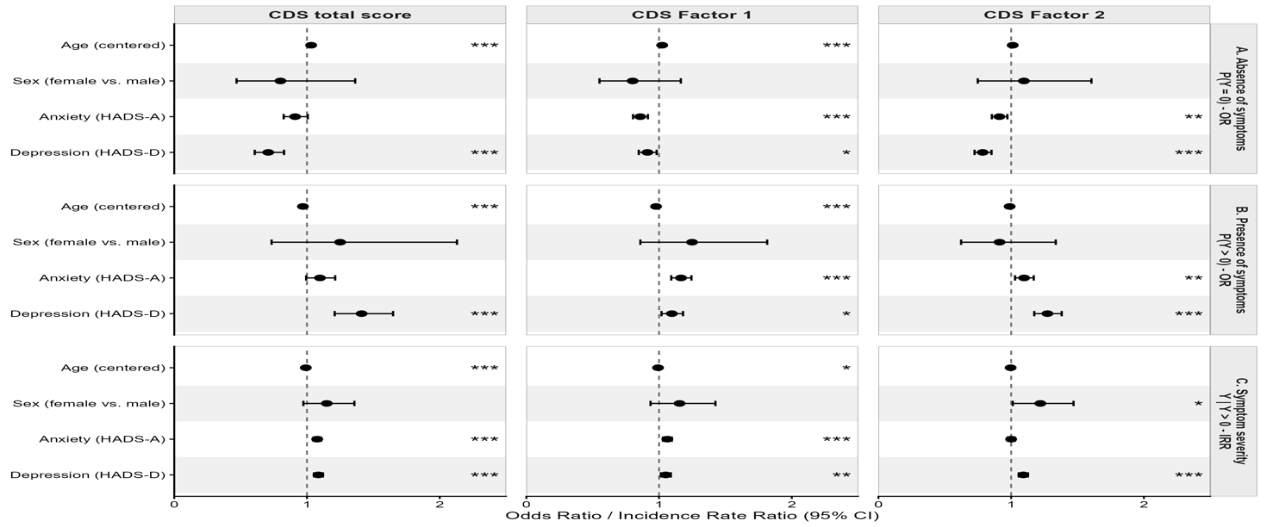

Effect of sex on DD symptoms and mediation by anxiety and depression
Commencer par les statistiques descriptives corrsepondant à la stratification dans la figure ci-dessous en fonction du sexe des participants?
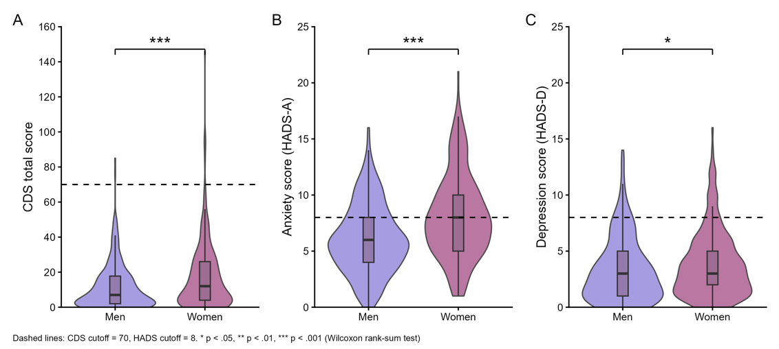

In the mediation model, sex (women vs. men) exhibited a moderate total effect on the CDS total score (β(total) = 5.69, 95% CI [3.01, 8.40], p < 0.001). Importantly, this association persisted after controlling for depression, anxiety and age, with a significant direct effect (β(direct) = 2.75, 95% CI [0.33, 5.19], p < 0.05). Anxiety partially mediated this relationship (β(indirect) = 2.19, 95% CI [0.95, 3.79], p < 0.01), accounting for 38% of the total effect. In contrast, depression did not mediate the relationship between sex and the CDS total score (p = 0.081). Age was negatively associated with the CDS total score (β = –0.17, 95% CI [–0.25, –0.10], p < 0.001).

Structural equation modelling
The structural equation model showed acceptable to good fit to the data (χ²₍₁₇₇₎ = 273.3, p < 0.001; CFI = 0.941, TLI = 0.931; RMSE = 0.039, 95%CI [0.028-0.05]; SRMR = 0.046).

For the factor Self and Body Detachment, the SEM revealed
a significant total effect of sex (β(total) = 0.33, 95% CI [0.17, 0.48], p < 0.001). A direct effect of sex persisted when depression, anxiety and age were controlled, but was marginally significant (β(direct) = 0.15, 95% CI [0.00, 0.34], p = 0.049). Anxiety mediated 45% of this effect (β(indirect) = 0.14, 95% CI [0.04, 0.25], p < 0.01), whereas depression did not (p = 0.188). Age had a small negative effect (β = –0.01, 95% CI [–0.01, –0.00], p < 0.001).

For the factor Emotional and Sensory Numbing, there was also a significant total effect of sex (β(total) = 0.25, 95% CI [0.02, 0.45], p < 0.05) but no direct effect remained after controlling for anxiety, depression and age (p = 0.194). Neither anxiety (p = 0.547) nor depression (p = 0.062) significantly mediated this effect, although depression showed a non-significant trend. Age was not significantly associated with this factor (p = 0.191).

Discussion
Vestibular loss decreases the odds of using navigation strategies
The results of this study demonstrated good psychometric properties of the PIH-Fv, which are comparable to the original version and to other cross-cultural adaptations (Dutch and Chi- nese). To our knowledge, this is the first study of the translation and adaptation of the PIH into French. We used Hawkins and Osborne’s method. The authors of the cross-cultural adap- tation of the Chinese and Dutch versions used the Brislin (1970) [39] and the Guillemin (1993) [40] methods [12, 13] respectively. These two translation methods require an evaluation ommittee for the translation. However, they did not mention if patients or authors of the original questionnaires participated [39, 40].
This study is also the first evaluation of the psychometric properties of the PIH-Fv. The average score for T1 (82.17) tended towards good self-management, similarly to the Dutch adaptation (ẋ = 78.1) [12]. Internal consistency of previous initial English versions [5, 6] and the Dutch adaptation [12] of the PIH yielded Cronbach’s alphas varying from 0.82 to 0.86. The internal consistency in this study remained similar after the translation process (α = 0.85). Test-retest reliability was also documented in the Chinese adaptation [13] with an ICC of 0.82, but the confidence interval was not mentioned. The coefficient (ICC = 0.77) in our study is slightly lower than the Chinese adaptation. In our, study the ICC could have been affected by a medical visit between T1 and T2 [38] which might have provided some self-management sup- port explaining an increase in total score (81.1 at T1 versus 84.7 at T2). This result may also be linked to the change in the administration procedure of the PIH-Fv at T1 (in person) and T2 (by telephone) [41].
This is the first study to measure the concurrent validity of the PIH with the SEM-CD and the PAM. The concurrent validity of the PIH-Fv measuring self-management showed a moderate correlation with the concept of activation as measured by the PAM and with the concept of self-efficacy as measured by SEM-CD. This is explained by the fact that these con- cepts are related [9].
Strengths and limitations
Strengths. The study was conducted in two different regions of Quebec, which covers a rural population (n = 49) as well as an urban one (n = 119), making the sample more represen- tative of the population.
The study was performed rigorously, using Hawkins and Osborne’s method, which allowed us to conduct the cross-cultural French adaptation of the questionnaire while preserving the original meaning of the questions by consulting the authors of the PIH. Finally, all information collected and entered into the database was validated by a second person, independently, ensuring accuracy.
Limitations. Participants had to complete the questionnaire while sitting in the clinics’ waiting rooms. If the patient’s appointment with the clinician was ahead of time and the par- ticipants did not have enough time to complete the questionnaire, it was rarely completed after that appointment. This may explain the high number of incomplete questionnaires (n = 45).
To further appraise PIH-Fv psychometric properties, a next study should recruit a larger sample to evaluate PIH-Fv structural validity. In addition, it may be appropriate to conduct a sensitivity to change analysis in a clinical intervention study to assess the capacity of the PIH-Fv to capture clinical improvement of self-management level [7]. Finally, missing data were particularly associated with item one of the PIH-Fv. This could be explained by the con- figuration of the questionnaire; the first question was presented directly below examples of answer options. To reduce the number of missing data, it would be preferable to separate examples of answers options more clearly at the beginning to the PIH-FV. Finally, we suggest conducting a pre-test to evaluate cultural differences before using the French version with other French populations.

Conclusions
The PIH-Fv demonstrated good internal consistency, good test-retest reliability and moderate concurrent validity with the PAM and the SEM-CD. The PIH-Fv can be used to measure level of self-management among French-speaking adults with chronic conditions.

Link with COVID-19= https://pubmed.ncbi.nlm.nih.gov/33319496/
https://pubmed.ncbi.nlm.nih.gov/32766539/ Hu D, Kong Y, Li W, Han Q, Zhang X, Zhu LX, et al. Frontline nurses’ burnout, anxiety, depression, and fear statuses and their associated factors during the COVID-19 outbreak in Wuhan, China: A large-scale cross-sectional study. EClinicalMedicine. 2020;24:100424. Epub 2020/08/09. pmid:32766539

- Research article

Symptoms of depersonalization/derealization are independent risk factors for the development or persistence of psychological distress in the general population: Results from the Gutenberg health study
Journal of Affective Disorders1 August 2020
  - Jasmin Schlax
  - Jörg Wiltink
  - Matthias Michal

Acknowledgements
We are very thankful to Pauline Grellet for her help with the questionnaire translation. We thank Dr Maeva Montero, staff from the Centre des Vertiges at the European Hospital-Marseille, Jacques Léonard, and the Clinical Research Department of European Hospital-Marseille, clinical study sponsor, for helping with participants’ inclusion and testing.

Funding

This work was supported by the ANR VESTISELF project (grant ANR-19-CE37-0027) from the French Agence Nationale de la Recherche to C. Lopez and M. Elzière, and received financial support from the Fondation Wakam for Good and the Fondation CNRS to C. Lopez and M. Gobinet.

References
Aderibigbe, Y.A., Bloch, R.M., Walker, W.R., 2001. Prevalence of depersonalization and derealization experiences in a rural population. Soc Psychiatry Psychiatr Epidemiol 36, 63–69. https://doi.org/10.1007/s001270050291
American Psychiatric Association, 2013. Diagnostic and Statistical Manual of Mental Disorders: DSM-5. American Psychiatric Publishing, Inc.
Aponte-Soto, M.R., Vélez-Pastrana, M., Martínez-Taboas, A., González, R.A., 2014. Psychometric properties of the Cambridge depersonalization scale in Puerto Rico. J Trauma Dissociation 15, 348–363. https://doi.org/10.1080/15299732.2013.856370
Baker, D., Hunter, E., Lawrence, E., Medford, N., Patel, M., Senior, C., Sierra, M., Lambert, M.V., Phillips, M.L., David, A.S., 2003. Depersonalisation disorder: clinical features of 204 cases. Br J Psychiatry 182, 428–433.
Bartrés-Faz, D., Demnitz-King, H., Cabello-Toscano, M., Vaqué-Alcázar, L., Saunders, R., Touron, E., Cattaneo, G., Gonneaud, J., Klimecki, O., Bargalló, N., Sánchez-Solana, J., Tormos, J.M., Chételat, G., Pascual-Leone, Á., Marchant, N.L., 2025. Psychological profiles associated with mental, cognitive and brain health in middle-aged and older adults. Nat. Mental Health 3, 92–103. https://doi.org/10.1038/s44220-024-00361-8
Beh, S.C., Masrour, S., Smith, S.V., Friedman, D.I., 2018. Clinical characteristics of Alice in Wonderland syndrome in a cohort with vestibular migraine. Neurol Clin Pract 8, 389–396. https://doi.org/10.1212/CPJ.0000000000000518
Bernasconi, F., Blondiaux, E., Potheegadoo, J., Stripeikyte, G., Pagonabarraga, J., Bejr-Kasem, H., Bassolino, M., Akselrod, M., Martinez-Horta, S., Sampedro, F., Hara, M., Horvath, J., Franza, M., Konik, S., Bereau, M., Ghika, J.-A., Burkhard, P.R., Van De Ville, D., Faivre, N., Rognini, G., Krack, P., Kulisevsky, J., Blanke, O., 2021. Robot-induced hallucinations in Parkinson’s disease depend on altered sensorimotor processing in fronto-temporal network. Sci Transl Med 13, eabc8362. https://doi.org/10.1126/scitranslmed.abc8362
Bernstein, E.M., Putnam, F.W., 1986. Development, reliability, and validity of a dissociation scale. J Nerv Ment Dis 174, 727–735. https://doi.org/10.1097/00005053-198612000-00004
Bjelland, I., Dahl, A.A., Haug, T.T., Neckelmann, D., 2002. The validity of the Hospital Anxiety and Depression Scale. Journal of Psychosomatic Research 52, 69–77. https://doi.org/10.1016/S0022-3999(01)00296-3
Blevins, C.A., Witte, T.K., Weathers, F.W., 2013. Factor structure of the Cambridge Depersonalization Scale in trauma-exposed college students. J Trauma Dissociation 14, 288–301. https://doi.org/10.1080/15299732.2012.729555
Bocéréan, C., Dupret, E., 2014. A validation study of the Hospital Anxiety and Depression Scale (HADS) in a large sample of French employees. BMC Psychiatry 14, 354. https://doi.org/10.1186/s12888-014-0354-0
Braithwaite, J.J., Watson, D.G., Dewe, H., 2017. Predisposition to out-of-body experience (OBE) is associated with aberrations in multisensory integration: Psychophysiological support from a “rubber hand illusion” study. J Exp Psychol Hum Percept Perform 43, 1125–1143. https://doi.org/10.1037/xhp0000406
Cox, B.J., Swinson, R.P., 2002. Instrument to assess depersonalization-derealization in panic disorder. Depress Anxiety 15, 172–5.
Dieguez, S., Lopez, C., 2017. The bodily self: Insights from clinical and experimental research. Ann Phys Rehabil Med 60, 198–207. https://doi.org/10.1016/j.rehab.2016.04.007
Dixon, J.C., 1963. Depersonalization phenomena in a sample population of college students. Br J Psychiatry 109, 371–375. https://doi.org/10.1192/bjp.109.460.371
Giersch, A., Ferri, F., Park, S., Thompson, J.L., Humpston, C.S., 2025. Bodily Self-Disturbances and Hallucinations in Schizophrenia. Schizophr Bull 51, S241–S252. https://doi.org/10.1093/schbul/sbaf063
Gobinet, M., Elzière, M., Léonard, J., Lopez, C., 2026. Bodily self disturbances: a new clinical marker of persistent postural-perceptual dizziness. medRxiv 2026.01.30.26345201. https://doi.org/10.64898/2026.01.30.26345201
Gwyther, M.P.D., Lenggenhager, B., Windt, J.M., Aspell, J.E., Ciaunica, A., 2024. Examining the association between depersonalisation traits and the bodily self in waking and dreaming. Sci Rep 14, 6107. https://doi.org/10.1038/s41598-024-56119-w
Hill, E.D., Kashyap, P., Raffanello, E., Wang, Y., Moffitt, T.E., Caspi, A., Engelhard, M., Posner, J., 2025. Prediction of mental health risk in adolescents. Nat Med. https://doi.org/10.1038/s41591-025-03560-7
Hinz, A., Brähler, E., 2011. Normative values for the hospital anxiety and depression scale (HADS) in the general German population. J Psychosom Res 71, 74–78. https://doi.org/10.1016/j.jpsychores.2011.01.005
Hunter, E.C.M., Sierra, M., David, A.S., 2004. The epidemiology of depersonalisation and derealisation. A systematic review. Soc Psychiatry Psychiatr Epidemiol 39, 9–18. https://doi.org/10.1007/s00127-004-0701-4
Jacobs, J.R., Bovasso, G.B., 1992. Toward the clarification of the construct of depersonalization and its association with affective and cognitive dysfunctions. J Pers Assess 59, 352–365. https://doi.org/10.1207/s15327752jpa5902_11
Kontoangelos, K., Tsiori, S., Poulakou, G., Protopapas, Katsarolis, I., Sakka, V., Kavatha, D., Papadopoulos, A., Antoniadou, A., Papageorgiou, C.C., 2016. Reliability, validity, and psychometric properties of the greek translation of the Cambridge Depersonalization Scale (CDS). Mater Sociomed 28, 387–391. https://doi.org/10.5455/msm.2016.28.387-391
Lopez, C., Elzière, M., 2018. Out-of-body experience in vestibular disorders - A prospective study of 210 patients with dizziness. Cortex 104, 193–206. https://doi.org/10.1016/j.cortex.2017.05.026
Medford, N., Baker, D., Hunter, E., Sierra, M., Lawrence, E., Phillips, M.L., David, A.S., 2003. Chronic depersonalization following illicit drug use: a controlled analysis of 40 cases. Addiction 98, 1731–1736. https://doi.org/10.1111/j.1360-0443.2003.00548.x
Michal, M., Adler, J., Wiltink, J., Reiner, I., Tschan, R., Wölfling, K., Weimert, S., Tuin, I., Subic-Wrana, C., Beutel, M.E., Zwerenz, R., 2016. A case series of 223 patients with depersonalization-derealization syndrome. BMC Psychiatry 16, 203. https://doi.org/10.1186/s12888-016-0908-4
Michal, M., Beutel, M.E., Grobe, T.G., 2010. [How often is the Depersonalization-Derealization Disorder (ICD-10: F48.1) diagnosed in the outpatient health-care service?]. Z Psychosom Med Psychother 56, 74–83. https://doi.org/10.13109/zptm.2010.56.1.74
Michal, M., Glaesmer, H., Zwerenz, R., Knebel, A., Wiltink, J., Brähler, E., Beutel, M.E., 2011. Base rates for depersonalization according to the 2-item version of the Cambridge Depersonalization Scale (CDS-2) and its associations with depression/anxiety in the general population. J Affect Disord 128, 106–111. https://doi.org/10.1016/j.jad.2010.06.033
Michal, M., Sann, U., Niebecker, M., Lazanowsky, C., Kernhof, K., Aurich, S., Overbeck, G., Sierra, M., Berríos, G., 2004. Die Erfassung des Depersonalisations-Derealisations-Syndroms mit der deutschen Version der Cambridge Depersonalisation Scale (CDS). Psychother Psychosom Med Psychol 54, 367–374. https://doi.org/10.1055/S-2004-828296
Michal, M., Wiltink, J., Subic-Wrana, C., Zwerenz, R., Tuin, I., Lichy, M., Brähler, E., Beutel, M.E., 2009. Prevalence, correlates, and predictors of depersonalization experiences in the German general population. J. Nerv. Ment. Dis. 197, 499–506. https://doi.org/10.1097/NMD.0b013e3181aacd94
Migliorini, V., Dell’erba, A., Fagioli, F., Sierra, M., Mosticoni, S., Telesforo, L., Patanè, M., Consolazione, M., Fiori-Nastro, P., 2012. Italian (cross cultural) adaptation and validation of the Cambridge Depersonalization Scale (CDS). Epidemiol Psychiatr Sci 21, 221–226. https://doi.org/10.1017/S2045796011000850
Molina Castillo, J.J., Martínez de la Iglesia, J., Albert Colomer, C., Berrios, G., Sierra, M., Luque Luque, R., 2006. [Cross-cultural adaptation and validation of the Cambridge Depersonalisation Scale]. Actas Esp Psiquiatr 34, 185–192.
Myran, D.T., Pugliese, M., Harrison, L.D., Solmi, M., Anderson, K.K., Fiedorowicz, J.G., Finkelstein, Y., Manuel, D., Taljaard, M., Webber, C., Tanuseputro, P., 2025. Changes in Incident Schizophrenia Diagnoses Associated With Cannabis Use Disorder After Cannabis Legalization. JAMA Netw Open 8, e2457868. https://doi.org/10.1001/jamanetworkopen.2024.57868
Ronchi, R., Park, H.-D., Blanke, O., 2018. Chapter 15 - Bodily self-consciousness and its disorders, in: Vallar, G., Coslett, H.B. (Eds.), Handbook of Clinical Neurology, The Parietal Lobe. Elsevier, pp. 313–330. https://doi.org/10.1016/B978-0-444-63622-5.00015-2
Salgado, A.C.S., de Souza, L.C., Salgado, J.V., Sierra, M., Teixeira, A.L., 2016. Tradução e adaptação cultural para o português brasileiro da Cambridge Depersonalisation Scale (Escala de Despersonalização de Cambridge). [Translation and cultural adaptation to Brazilian Portuguese of the Cambridge Depersonalisation Scale.]. Jornal Brasileiro de Psiquiatria 65, 330–333. https://doi.org/10.1590/0047-2085000000141
Sierra, M., Baker, D., Medford, N., David, A.S., 2005. Unpacking the depersonalization syndrome: an exploratory factor analysis on the Cambridge Depersonalization Scale. Psychological Medicine null, 1523–1532. https://doi.org/10.1017/S0033291705005325
Sierra, M., Berrios, G.E., 2000. The Cambridge Depersonalization Scale: a new instrument for the measurement of depersonalization. Psychiatry Res 93, 153–64.
Simeon, D., Abugel, J., 2006. Feeling unreal. Depersonalization disorder and the loss of the self. Oxford University Press, New York.
Simeon, D., Knutelska, M., Nelson, D., Guralnik, O., 2003. Feeling unreal: a depersonalization disorder update of 117 cases. J Clin Psychiatry 64, 990–7.
Simeon, D., Kozin, D.S., Segal, K., Lerch, B., Dujour, R., Giesbrecht, T., 2008. De-constructing depersonalization: further evidence for symptom clusters. Psychiatry Res 157, 303–306. https://doi.org/10.1016/j.psychres.2007.07.007
Simeon, D., Stein, D.J., 2025. Depersonalization/derealization and its relationship to mood and anxiety disorders in the National Comorbidity Survey-Replication (NCS-R). Soc Psychiatry Psychiatr Epidemiol. https://doi.org/10.1007/s00127-025-02915-2
Sugiura, M., Hirosawa, M., Tanaka, S., Nishi, Y., Yamada, Y., Mizuno, M., 2009. Reliability and validity of a Japanese version of the Cambridge depersonalization scale as a screening instrument for depersonalization disorder. Psychiatry Clin Neurosci 63, 314–321. https://doi.org/10.1111/j.1440-1819.2009.01939.x
Tibubos, A.N., Grammes, J., Beutel, M.E., Michal, M., Schmutzer, G., Brähler, E., 2018. Emotion regulation strategies moderate the relationship of fatigue with depersonalization and derealization symptoms. J Affect Disord 227, 571–579. https://doi.org/10.1016/j.jad.2017.11.079
von Elm, E., Altman, D.G., Egger, M., Pocock, S.J., Gøtzsche, P.C., Vandenbroucke, J.P., STROBE Initiative, 2007. The Strengthening the Reporting of Observational Studies in Epidemiology (STROBE) statement: guidelines for reporting observational studies. Lancet 370, 1453–1457. https://doi.org/10.1016/S0140-6736(07)61602-X
Yang, J., Millman, L.S.M., David, A.S., Hunter, E.C.M., 2023. The Prevalence of Depersonalization-Derealization Disorder: A Systematic Review. J Trauma Dissociation 24, 8–41. https://doi.org/10.1080/15299732.2022.2079796
Yen Pik Sang, F., Jáuregui‐Renaud, K., Green, D.A., Bronstein, A.M., Gresty, M.A., 2006. Depersonalisation/derealisation symptoms in vestibular disease. J Neurol Neurosurg Psychiatry 77, 760–766. https://doi.org/10.1136/jnnp.2005.075473
Zigmond, A.S., Snaith, R.P., 1983. The Hospital Anxiety and Depression Scale. Acta Psychiatrica Scandinavica 67, 361–370. https://doi.org/10.1111/j.1600-0447.1983.tb09716.x

