
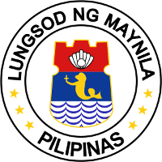
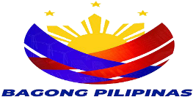
REPUBLIC OF THE PHILIPPINES
CITY OF MANILA
OFFICE OF THE BARANGAY CHAIRMAN
Barangay 181 Zone 16 District II
one 81tdo2@gmail.com

TRANSMITTAL

DATE: SEPTEMBER , 2024

Respectfully transmitted to your office the enclosed:


BADAC MONTHLY ACCOMPLISHMENT REPORT FOR THE MONTH OF
SEPTEMBER 2024

I / We hereby certify that the information enclosed has been verified and

Confidentially deliberated upon the Barangay Anti-Drug Abuse Council ( BADAC ) of

Barangay 181 Zone 16 District II to accurate and true.

Prepared by :

ANA MANILA A. SALVADOR
Attested by : BRGY SECRETARY

ROBERT M. ATAD
BRGY CHAIRMAN

