**eXtreme Design**

**Task 1. Get into the project context**

The project aims to address bias in machine learning models and develop techniques to mitigate its impact. Bias in AI models can lead to unfair and discriminatory outcomes, affecting various aspects of society, such as hiring decisions, loan approvals, and criminal justice systems. The project focuses on identifying, understanding, and rectifying bias to build more equitable and ethical AI systems.

**Task 2. Collect requirement stories**

**Story1:**

"Sarah, a politically active individual, had a strong confirmation bias towards a particular political party. She avidly followed news sources and social media accounts that shared views aligned with her party's ideology. One day, Sarah came across an article that presented a different perspective on a key issue. Despite the article being well-researched and providing evidence to support its claims, Sarah immediately dismissed it as biased and inaccurate, due to her confirmation bias. She shared the article with her friends, highlighting the parts that confirmed her pre-existing beliefs, reinforcing their shared biases.”

**Story2:**

“John, a young professional, attends a networking event. As he enters the room, he notices a woman named Sarah standing by herself. Based on her elegant attire and confident posture, John immediately assumes that Sarah is unapproachable and disinterested in talking to him. He decides to focus his attention on other attendees who seem more approachable based on his preconceived notions. Little does John know that Sarah is actually a friendly and welcoming person who would have loved to engage in a conversation. Due to John's bias of discarding specifics to form generalities, he missed out on an opportunity to connect with someone who could have been a valuable professional contact or even a potential friend.”

**Task 3. Select a story that has not been treated yet**

1. **Story1**
2. **Story2**

**Task 4. Transform the story into CQs**

1. **Name of the observer is Story 1?**
2. **Which bias does Sarah exhibits?**
3. **Which information confirms her bias?**
4. **She holds belief about?**
5. **Which information she encountered?**
6. **Name of the characters in Story 2?**
7. **List all the generalities in Story 2?**
8. **Name of the bias does John exhibits in story 2?**
9. **What is the observation in story 2?**
10. **What are some specifics in Story 2?**

**Task 5. Select a CQ that has not been treated yet**

* **CQ2**

**Task 6. Match the CQ to GUCs**

**There was no match of CQ on** <http://ontologydesignpatterns.org/>

**Task 7. Select the CPs to reuse**

**We decided to go with Exhibiting of bias in story1.**

**Task 8. Reuse and integrate selected CPs**

**Task 8.1. Select a CP that has not been integrated yet**

1. **Which bias does Sarah exhibits?**

**Task 8.2. Specialization**

**Class**

**We will first create a subclass of owl:Thing which will be Bias1. Then we will Create child two child classes of the create Bias1 class which will be**

1. **Observer class**
2. **Bias Class.**

**Individual**

* 1. **Observer Class has an Individual Sarah**
  2. **Bias class has individual Confirmation_Bias**

**Properties**

1. **exhibitsBias**
   1. **Domain: Observer Class**
   2. **Range: Bias Class**

**After all the above creating of class, Properties and individual we will assert Object Property Assertion of Sarah that she exhibitsBias Confirmation_Bias**

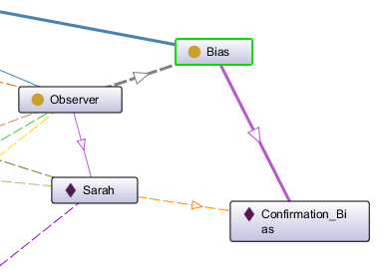

**Task 9. Test and fix.**

**SPARQL Query**

**PREFIX rdf: <http://www.w3.org/1999/02/22-rdf-syntax-ns#>**

**PREFIX owl: <http://www.w3.org/2002/07/owl#>**

**PREFIX rdfs: <http://www.w3.org/2000/01/rdf-schema#>**

**PREFIX xsd: <http://www.w3.org/2001/XMLSchema#>**

**PREFIX bias: <http://www.semanticweb.org/bias#>**

**SELECT ?subject**

**WHERE { bias:Sarah bias:exhibitsBias ?subject }**

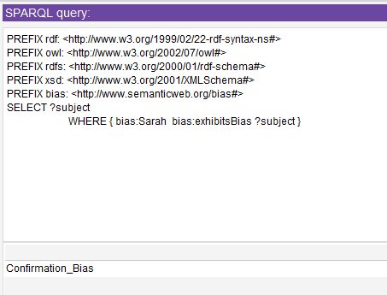

**Task 10. Release module.**

**Task 11. Integrate, test and fix**

