**Lab 1 Creating tables for Human Resource**

**Evaluate an ER diagram of the given HR schema**

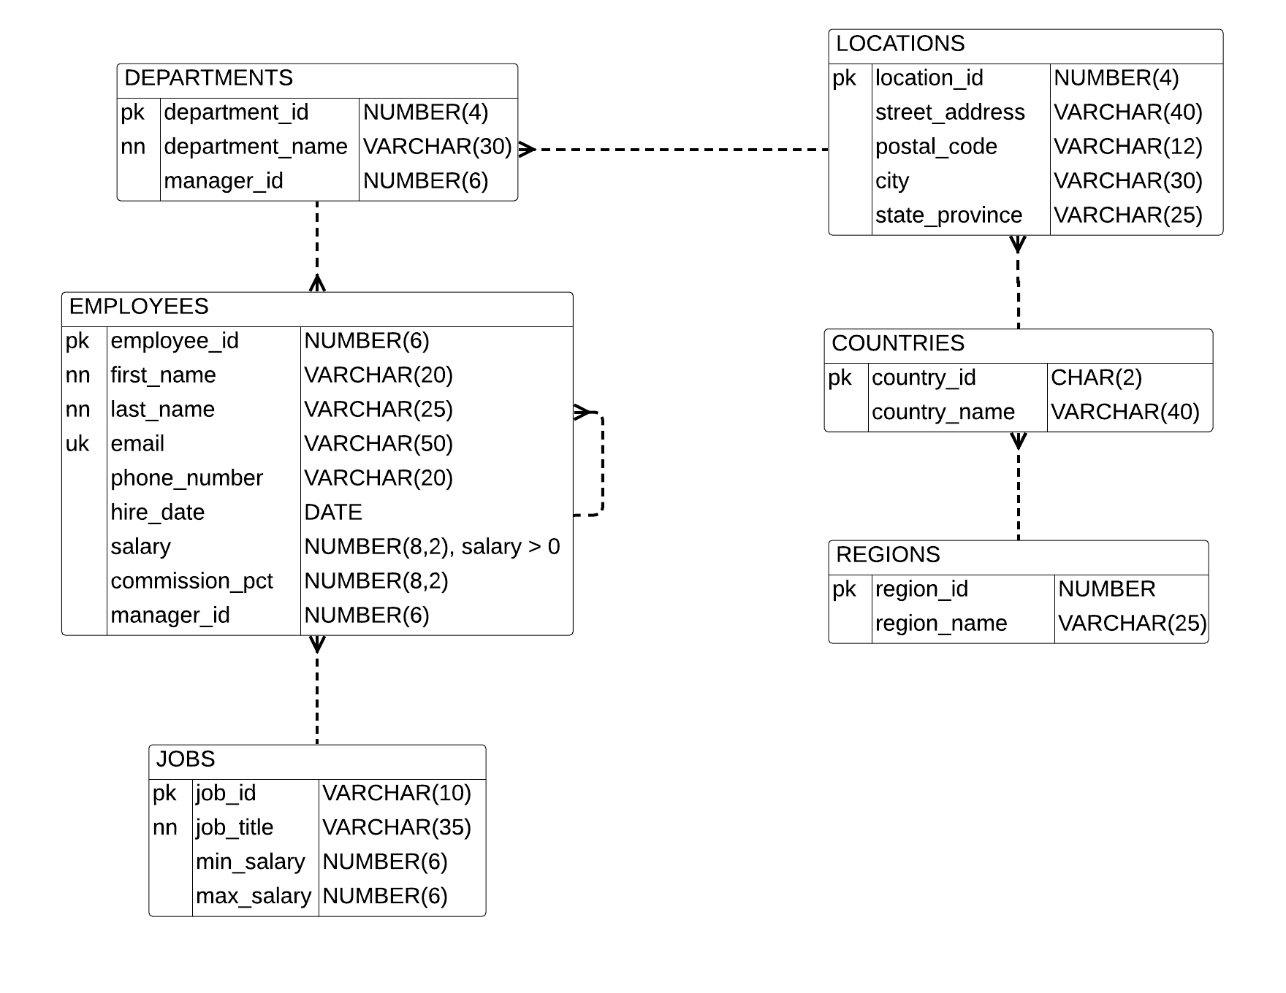

* Write SQL statements for creating the tables. The sequence of creating tables should correspond to the need for referencing tables. The statements should include constraints, including primary-key, foreign-key, unique, not null and check constraints.

**Syntax:**

--Column Level--

**CREATE TABLE tablename1**

**(**

**column1 datatype [CONSTRAINT tablename1_column1_pk] PRIMARY KEY,**

**column2 datatype [CONSTRAINT tablename1_column2_nn] NOT NULL,**

**column3 datatype [CONSTRAINT tablename1_cloumn3_uk] UNIQUE,**

**column4 datatype [CONSTRAINT tablename1_column4_ck]**

**CHECK (condition(s)),**

**column5 datatype [CONSTRAINT tablename1_column5_fk]**

**REFERENCES tablename2 (pk_column), …**

**) ;**

--Table Level--

**CREATE TABLE tablename2**

**(**

**Column6 datatype ,**

**Column7 datatype,**

**Column8 datatype NOT NULL,**

**Column9 datatype,**

**CONSTRAINT tablename2_column67_pk PRIMARY KEY (column6[,column7]),**

**CONSTRAINT tablename2_column8_fk FOREIGN KEY**

**(column8 [,columnX]) REFERENCES tablename1,**

**CONSTRAINT tablename2_cloumn9_uk UNIQUE (column9),**

**CONSTRAINT tablename2_column9_ck CHECK (condition)**

**) ;**