**Lab 3:** **Creating Secondary Indexes (Cont.)**

## CREATE INDEX Syntax:

**CREATE [UNIQUE][BITMAP] INDEX *index_name***

**ON *table_name* (column [, column]);**

## DROP INDEX Syntax:

**DROP INDEX *index_name*;**

**Example:**

* You want to improve the speed of query access to LAST_NAME column in the EMPLOYEES table:

**CREATE INDEX** emp_last_name_idx  **ON** employees ( last_name) ;

**Order Index columns for Performance**

* The order of columns in the CREATE INDEX statement can affect query performance. In general, specify the most frequently used columns first.
* If you create a single index across columns to speed up queries that access
  + For example, col1, col2, and col3;
  + Then queries that access just col1, or that access just col1 and col2, are also speeded up.
  + But a query that accessed just col2, just col3, or just col2 and col3 does not use the index.

**Index Matching**

* + For index matching, you can use one or more operators such as >,>=,<,<=, LIKE, IN, IS NULL, BETWEEN…..AND in WHERE clause.
  + Generally, search arguments in the WHERE clause such as "IS NOT NULL", "<>", "!=", "!>", "!<", "NOT", "NOT EXISTS", "NOT IN", "NOT LIKE", and "LIKE '%500'" prevents Oracle from using an index to perform the search (*however, not always*).

***Practices***

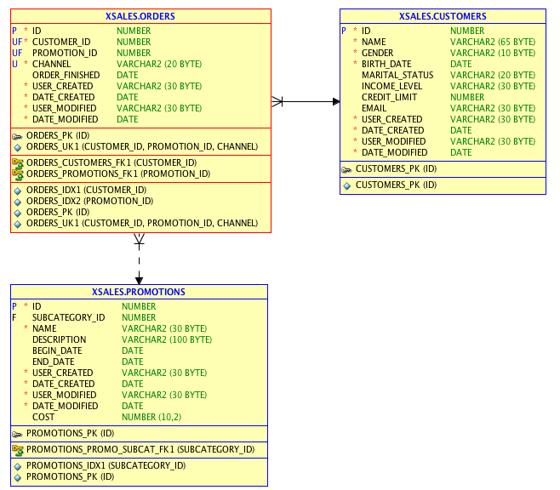

## View the existing indexes of the XSALES.CUSTOMERS, XSALES.ORDERS and XSALES.PROMOTIONS tables.

|  |  |  |  |
| --- | --- | --- | --- |
| **Table Name** | **Index Name (s)** | **Index Type (s)**  **[B-tree vs Bitmap]** | **Column Name (s)** |
| XSALES.CUSTOMERS |  |  |  |
|  |  |  |  |
|  |  |  |  |
| XSALES.ORDERS |  |  |  |
|  |  |  |  |
|  |  |  |  |
|  |  |  |  |
|  |  |  |  |
| XSALES.PROMOTIONS |  |  |  |
|  |  |  |  |
|  |  |  |  |

1. Write SQL statements to query information in the following, Please find out the use of the existing indexes found in Question 1 in each query.
2. List customer name, marital status, income level and birth date of customer named 'Antony Chinn'.
3. List order id, promotion id and channel of the customer number 14053.
4. List order id, promotion id and channel of all customers whose customer number is between 10000 and 15000 and has orders with promotion id 999 and ordered from the Internet channel.
5. List customer name, marital status and order finished date of all customers whose marital statuses are 'single' and credit limits are 15000.
6. Find promotion name and the number of orders in each promotion.
7. Create your own questions and answer those by writing SQL queries that has the use of the index(s) found in Question 1. Do 5 questions with different usage of the indexes.