This is a test document
Its purpose is for integration tests; To verify that this text is correctly extracted.

This is a false title
Ideally it should be picked up by the extractor, even if it is made only using bold and font-size

H1 title
A wee paragraph

H2 title
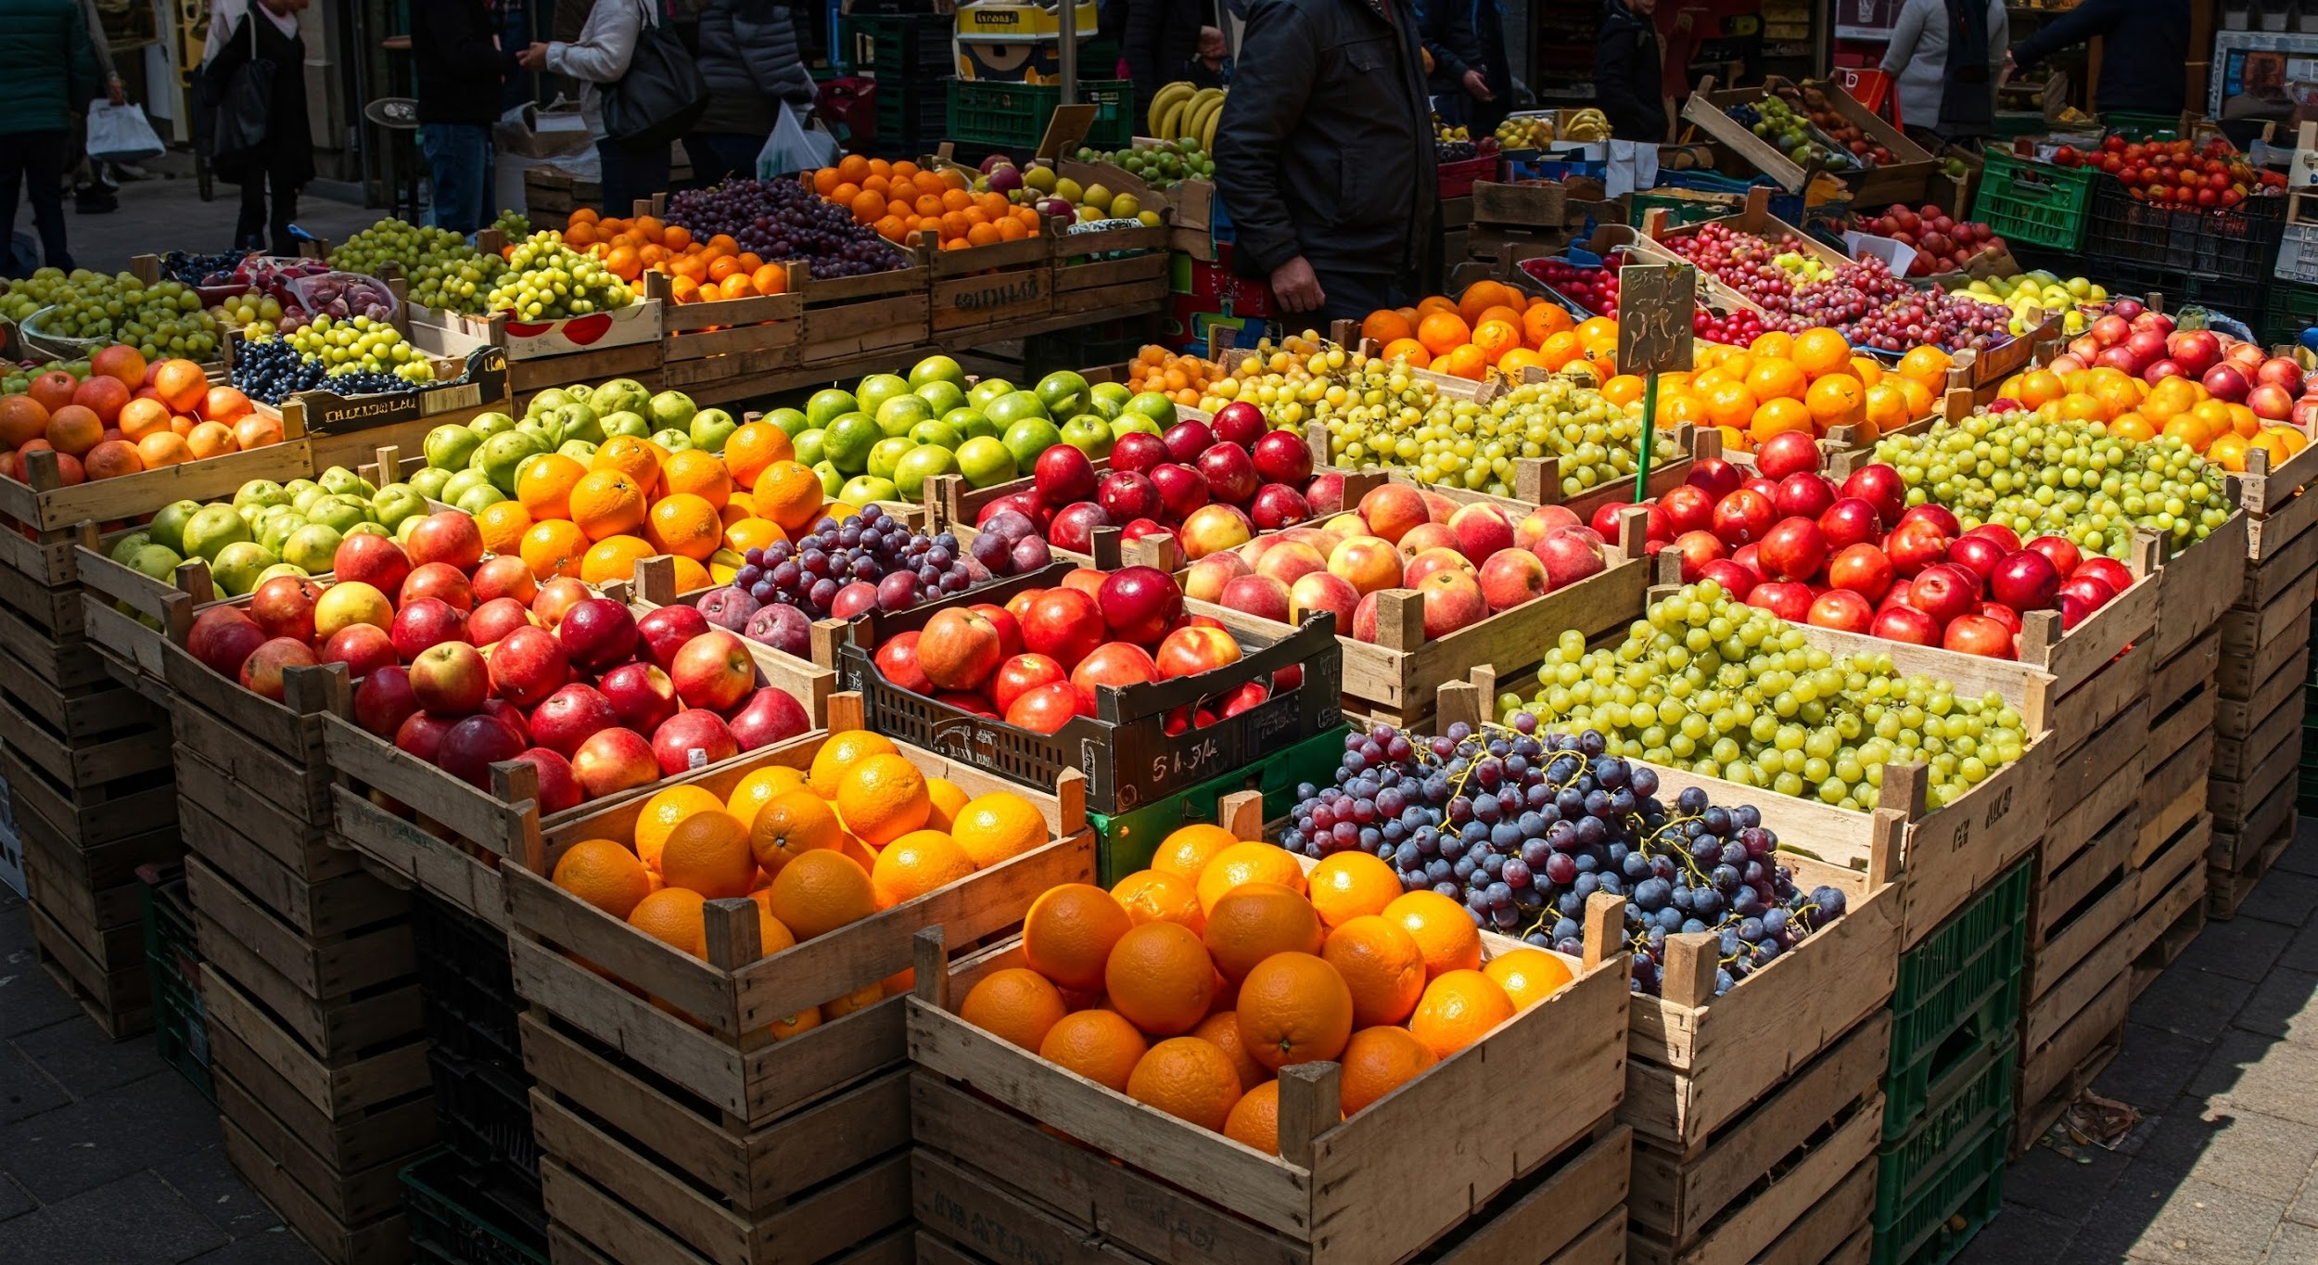
- Some items
- More items

- An unrelated list
- With other items
- Another item
- This is to force
- A page break
- Without using the actual
- Page
- break
- Xml
- Element
- One more
- yay!

This is the second page

OR gate table | true | false
true | true | true
false | true | false

A nice diagram
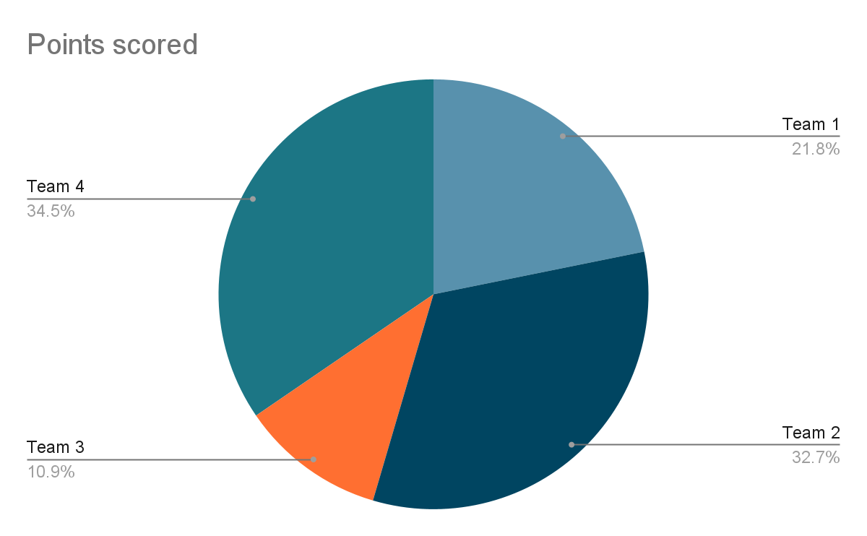
Circle area is

A forced page break:

And my table of contents

H1 1
H2 1
A nice diagram 2

