This is a test document
Its purpose is for integration tests; To verify that this text is correctly extracted.

H1
Sub title

H2
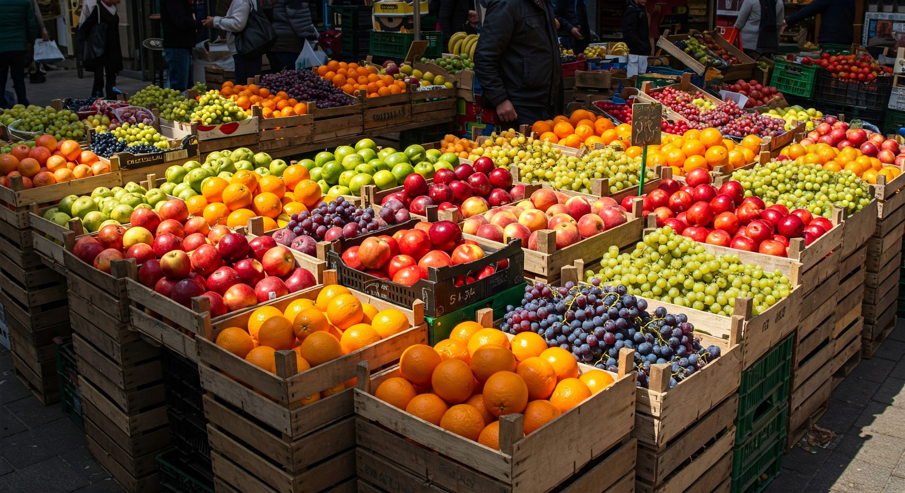
- Some items
- More items

- An unrelated list
- With other items

This is the second page

OR gate table | true | false
true | true | true
false | true | false

A nice diagram
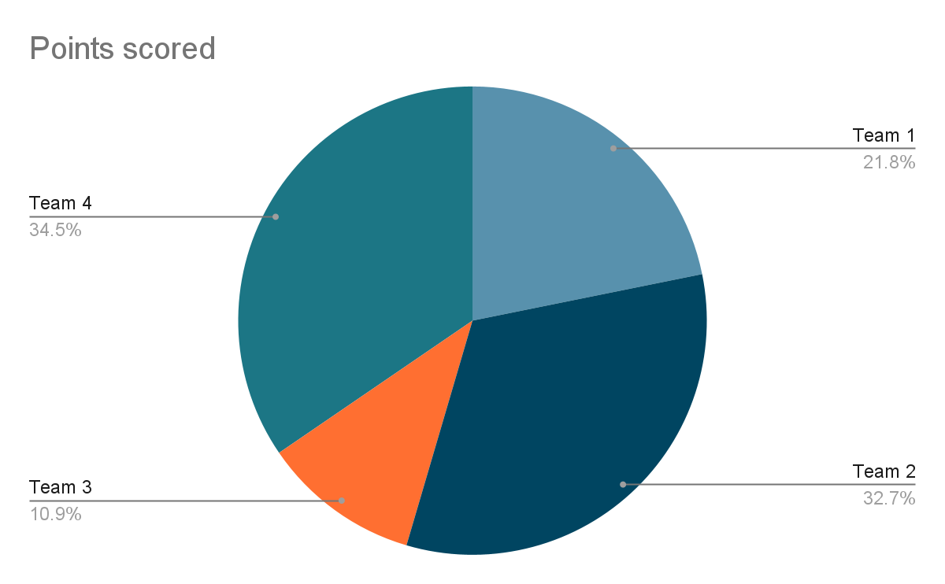
Circle area is

And my table of contents

H1 1
H2 1
A nice diagram 2

