This is a test document

Its *purpose is for* ***integration tests;*** To verify that this text is correctly extracted.

**This is a false title**

Ideally it should be picked up by the extractor, even if it is made only using bold and font-size

# H1 title

A wee paragraph

## H2 title

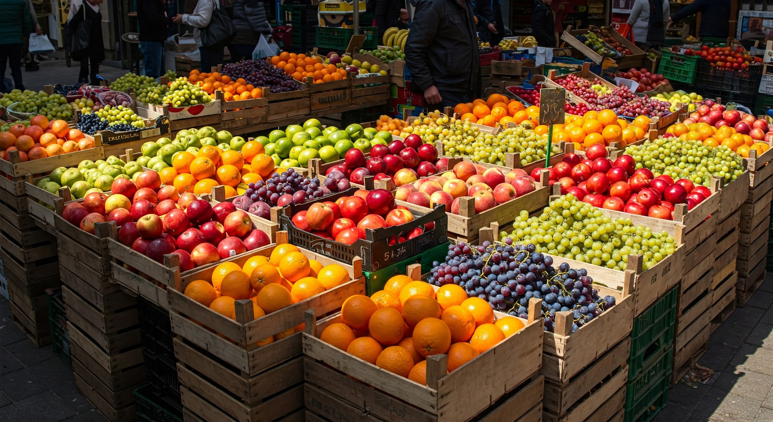

* Some items
* More items
* An unrelated list
* With other items
* Another item
* This is to force
* A page break
* Without using the actual
* Page
* break
* Xml
* Element
* One more
* yay!

This is the second page

| OR gate table | true | false |
| --- | --- | --- |
| true | true | true |
| false | true | false |

### A nice diagram

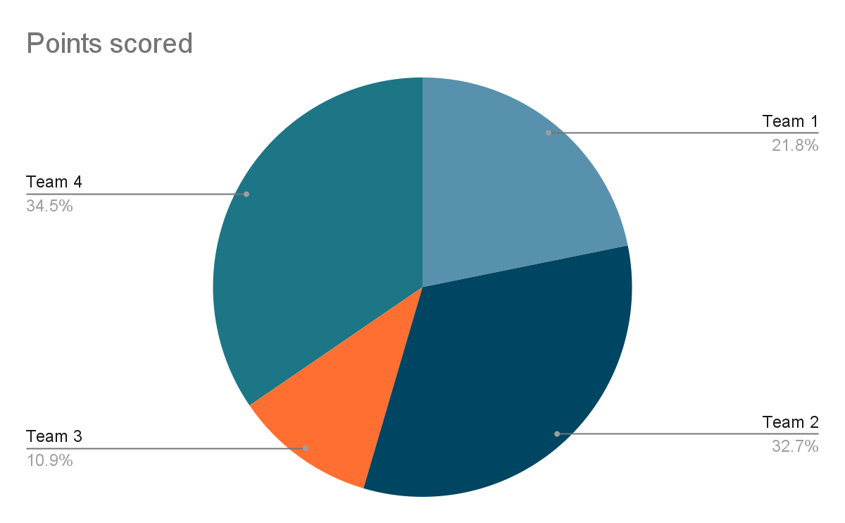

Circle area is $πR²$

A forced page break:

And my table of contents

**H1 1**

H2 1

A nice diagram 2