

Universidad de las Fuerzas Armadas ESPE

DEPARTMENT OF COMPUTER SCIENCE

Object-Oriented Programming

Edison Lascano PhD

NRC:36863

MEMBERS: Dylan Cumbajin, Anthony Arevalo, Juan Alvarez

AssignmentTest
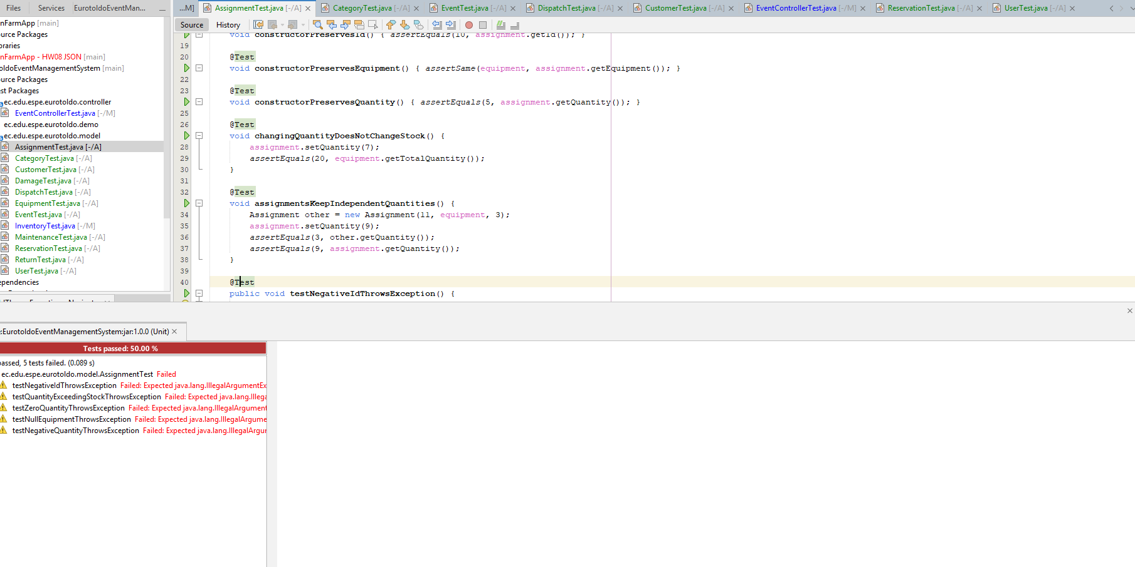
CategoryTest
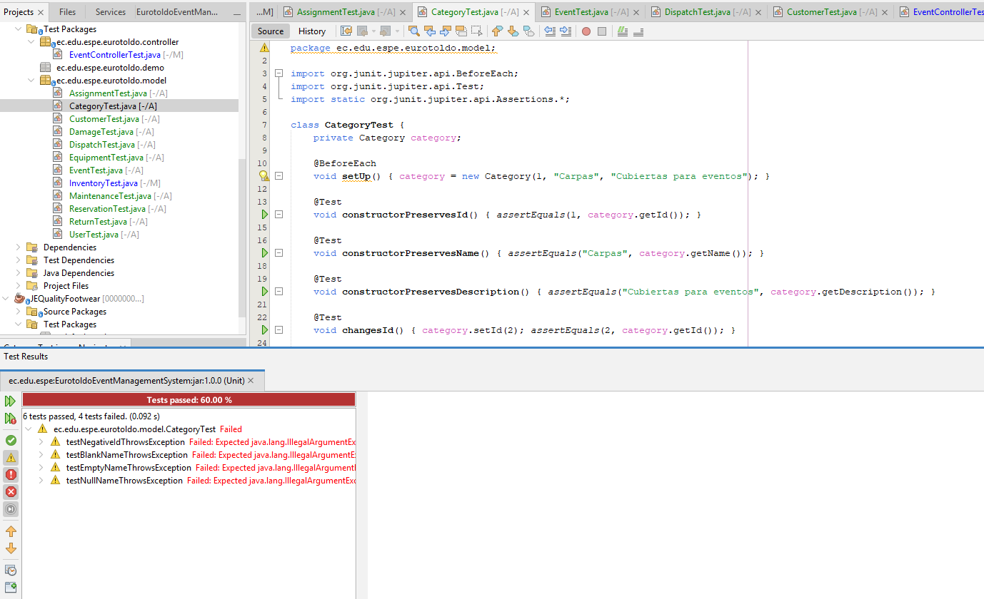
CustomerTest
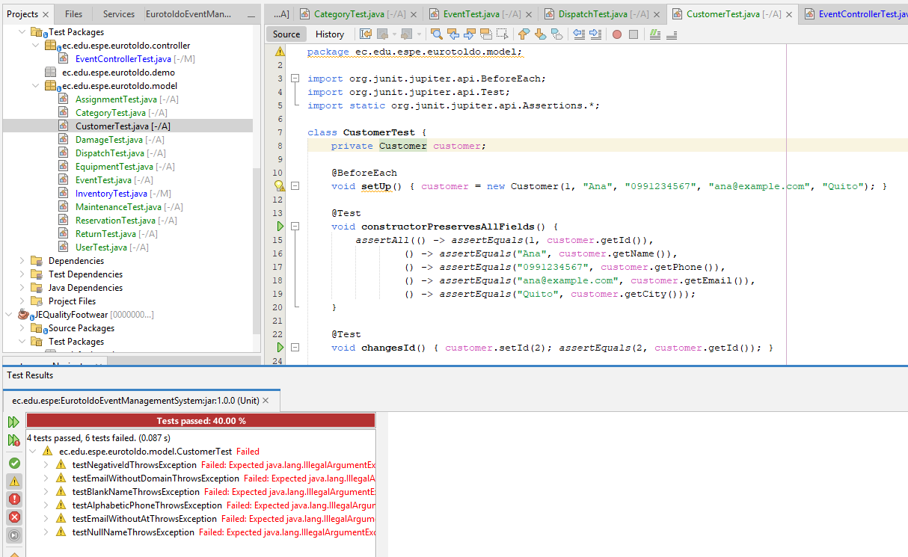

DamageTest
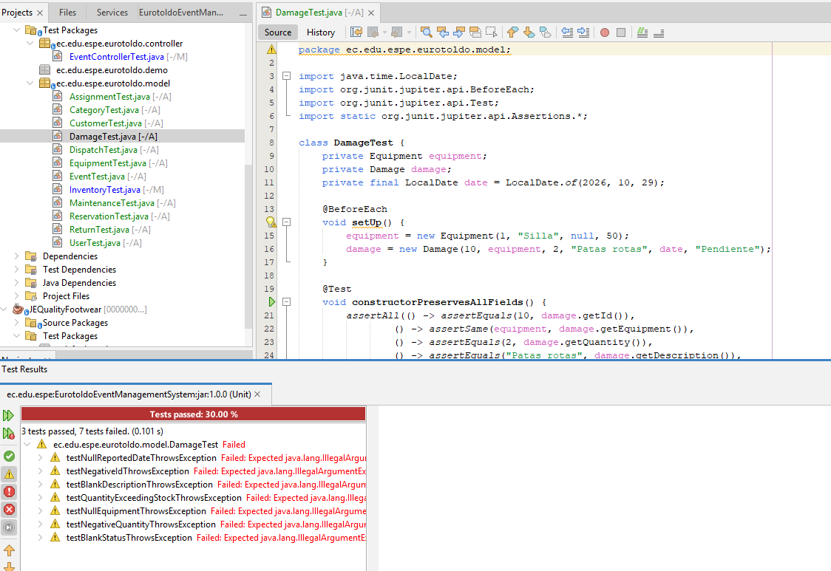
DispatchTest
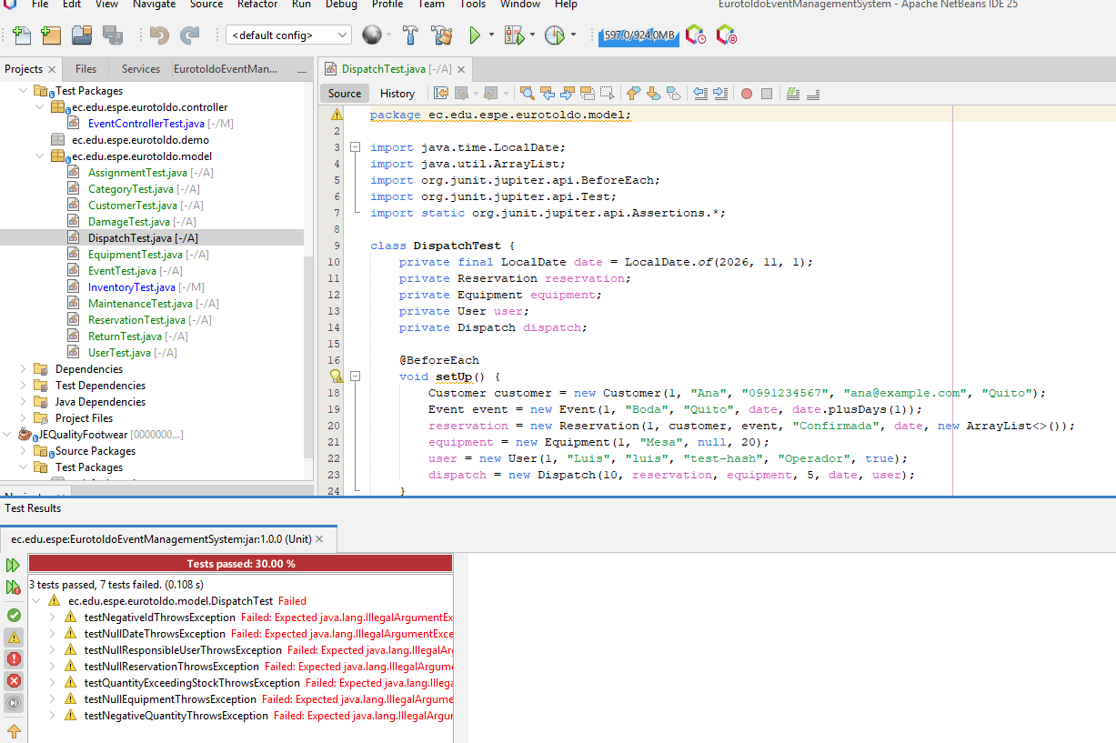
EquipmentTest
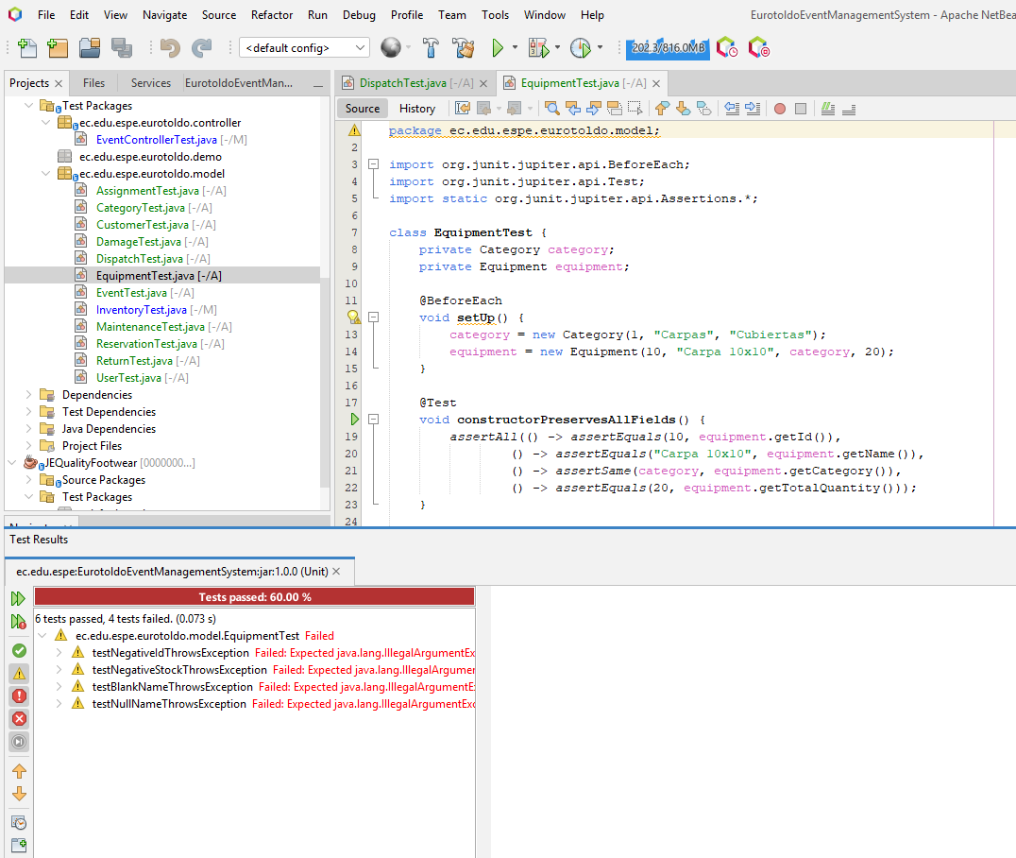
EventTest
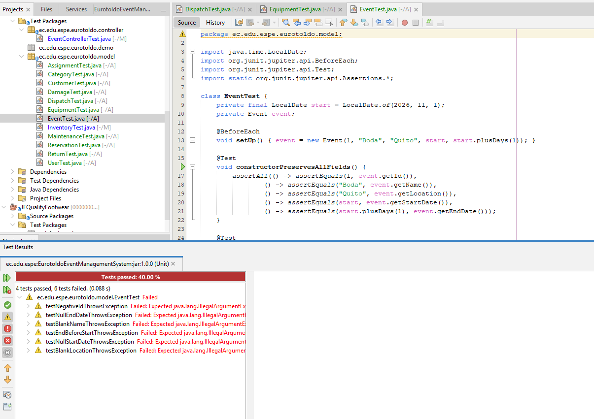
InventoryTest
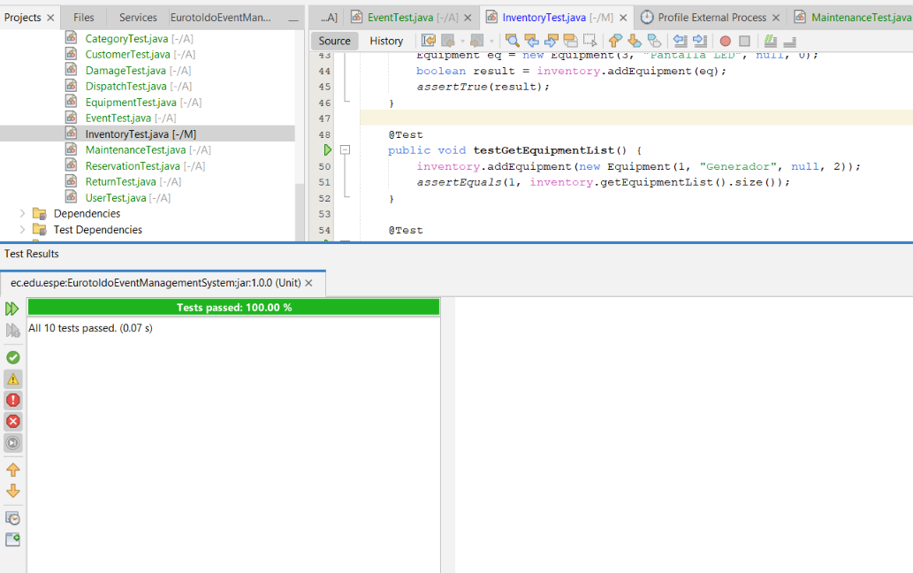

MaintenanceTest
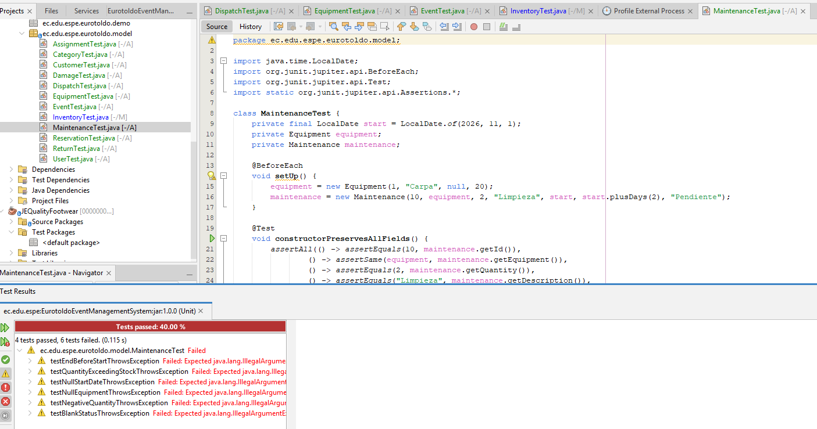
ReservationTest
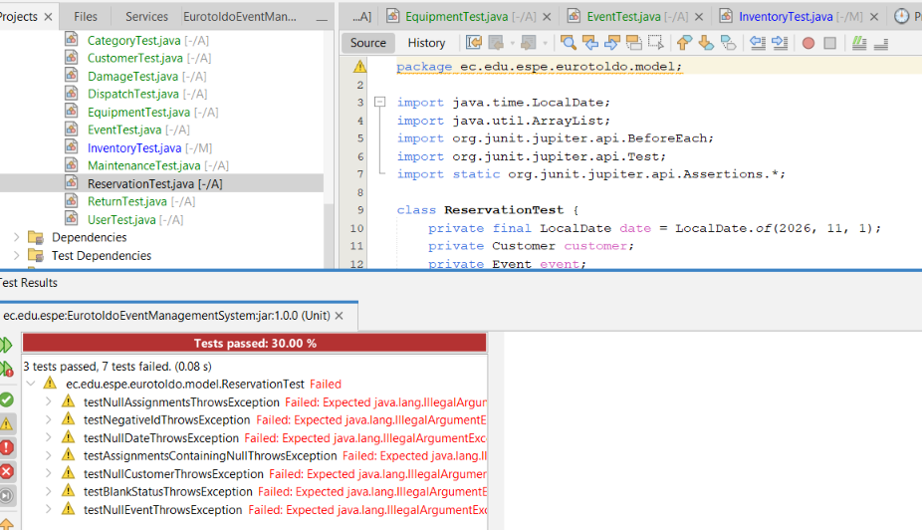
ReturnTest
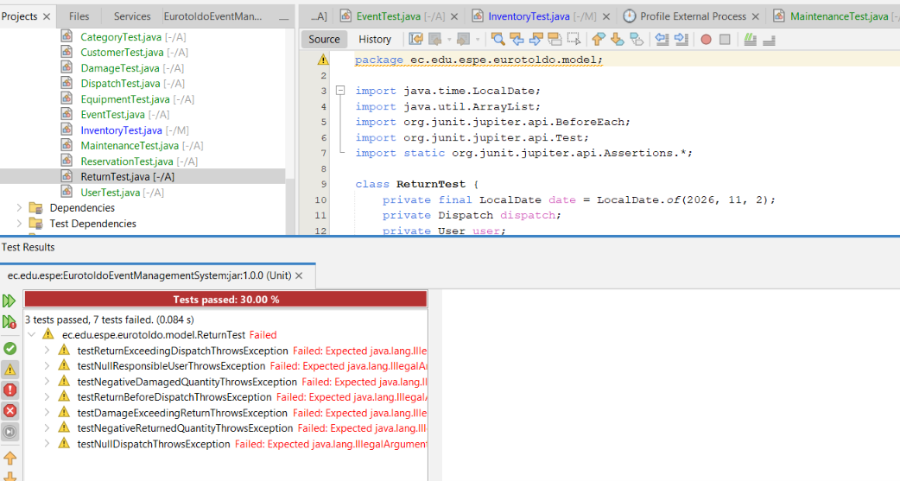

UserTest
