**NAME: DOS SANTOS Bruno**

**CHALON Maël**

**Installation and User Instructions**

**File Server**

**Raspberry PI 3**



October 2021  
**SAE 1.03**

**Approvals**

This document requires following approvals:

|  |  |
| --- | --- |
| Name | Title |
| FARRUGIA Jean Philippe | Head of the computer science department |
| DAUMAS Anne | English teacher |
| POZET Lionel | Network Administrator |
|  |  |

# Distribution

This document has been distributed to:

|  |  |
| --- | --- |
| Name | Title |
| FARRUGIA Jean Philippe | Head of the computer science department |
| DAUMAS Anne | English teacher |
| POZET Lionel | Network Administrator |
|  |  |

# Table of Contents

1 PREFACE 4

1.1 Description of the User 4

1.2 Conventions Used in This Manual 4

2 DESCRIPTION OF THE PRODUCT 5

2.1 Purpose of the Product 5

2.2 Key features of the product 5

2.3 Accessories 5

2.4 Product elements 5

2.5 Understanding the user interface 5

2.6 Operating Panels 5

3 SAFETY INSTRUCTIONS 6

3.1 How to Use the Product Safely 6

4 INSTALLATION / PACKAGES 7

4.1 STEP 1 7

4.1.1 Procedures for step 1 7

4.2 STEP 2 7

4.2.1 Procedures for step 2 7

5 OPERATION/USE 8

5.1 How to Use the Product 8

5.1.1 Operational environment 8

5.1.2 Manual operating techniques 8

5.1.3 Stopping the product’s operation 8

5.2 What to Do in Emergency and Exceptional Situations 8

6 TROUBLESHOOTING AND REPAIR 9

6.1 How to Identify and Solve Problems 9

7 GLOSSARY 10

8 RELATED DOCUMENTATION 11

# PREFACE

## Description of the User

Our file server is intended to everyone, it’s simple to use when it’s setup. For example, a company that wants to allow its employees to access at a local wireless file server everywhere in the building where they can share their documents with the other users.

The users can be created or removed at anytime by the owner to satisfy his needs.

With our manual we don’t need any certification or expertise to use the server and it’s available on Windows, Linux or Android.

## Conventions Used in This Manual

The following style conventions are used in this document:

**Bold**Names of product elements, commands, options, programs, processes, services, and utilities Names of interface elements (such windows, dialog boxes, buttons, fields, and menus)  
Interface elements the user selects, clicks, presses, or types

*Italic*Publication titles referenced in text  
Emphasis (for example a new term)  
Variables

Courier  
System output, such as an error message or script  
URLs, complete paths, filenames, prompts, and syntax

User input variables  
< > Angle brackets surround user-supplied values  
[ ] Square brackets surround optional items  
| Vertical bar indicates alternate selections - the bar means “or”

# DESCRIPTION OF THE PRODUCT

## Purpose of the Product

The goal of our product is to access easily to a wireless file server. With this device you could reach your file from any computer in your building.

## Key features of the product

The key features of the product are the Raspberry PI and the SD card with the Operating System in It. If you unplug the storage devices you will not be able to access your files.

## Accessories

You can connect the raspberry PI to a monitor with the HDMI port, there is an Operating System to access your files and to solve your problems with the computer terminal. There are four USB port, a HDMI output, an Ethernet port. You must connect the SD card with the Operating System to be able to use the raspberry PI.

## Product elements

1. Raspberry PI 3
2. USB ports (connect hard drive/mice/keyboard/…)
3. Ethernet port
4. Power supply
5. HDMI port (to connect a display)
6. SD card (with the OS)

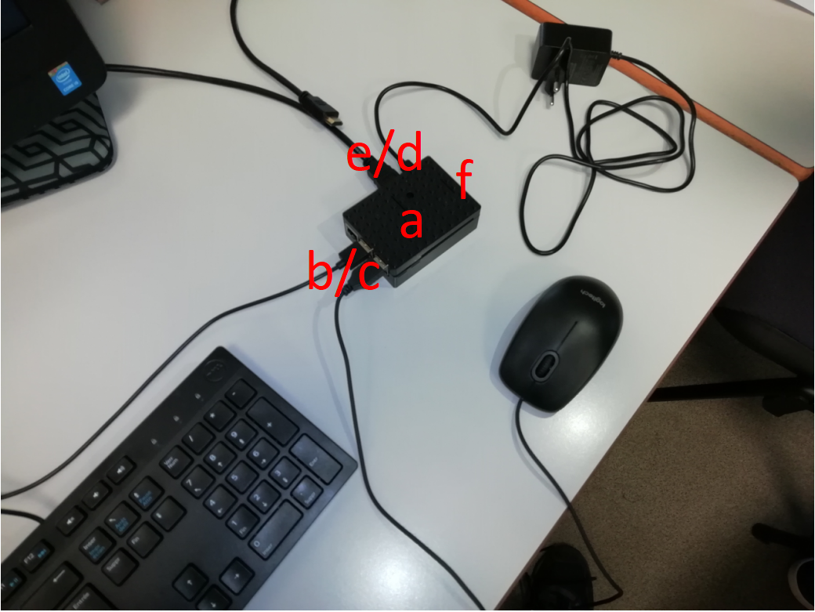

## Understanding the user interface

Connect the raspberry pi to the same network as your device.

For windows OS:

- open the file explorer

- on the left right click on “this PC” and select “map network drive”

- in “file” enter “\\raspberrypi\{username}” (this selects the directory in the file server)

## Operating Panels

In the raspberry computer terminal:

-to create a new Linux user:

- “su –“

- enter the root password

- “adduser {username}”

- enter his password

- press enter five times (to set it by default)

- type “o” and press enter

(the Linux user is created)

-to create the samba user:

- “sudo smbpasswd -a {same username as Linux}”

- type his password

# SAFETY INSTRUCTIONS

**WARNING!**

## How to Use the Product Safely

Do not give access at the raspberry to everyone.

Do not unplug the power supply when the file server is on.

Use only secured passwords for all the users (Linux and Samba)

If there is any doubt on the security change all passwords :

- for samba “sudo smbpasswd -a {same username as Linux}”

- for Linux : - “su –“

- enter the root password

- passwd {username}

- enter the new password

# INSTALLATION / PACKAGES

## Install the OS.

### Procedures to install the OS

**To install OS:**

1. Flash the SD card.
2. Initialize the OS at the first login.

## Install Samba.

Open the computer terminal.

### Procedures to install Samba

**To install Samba:**

1. In the raspberry computer terminal type : “sudo apt install samba samba-common-bin”
2. We modified the possibility to users to be able to see the directory “public”

# OPERATION/USE

## How to Use the Product

### Operational environment

The wireless file server is under Linux. You can access to the files with Windows, Linux or Android.

### Manual operating techniques

1. You have to turn on the raspberry Pi.
2. You must be connected at the same network as the raspberry pi. The server will automatically be available.

### Stopping the product’s operation

To stop the product’s operation you have to shutdown the raspberry Pi.

1. When you are on the desktop click on the Raspberry Pi icon
2. Then Disconnect
3. Click on «shutdown»

## What to Do in Emergency and Exceptional Situations

**In case of an emergency:**

- If there is any doubt on the security change all passwords :

- for samba “sudo smbpasswd -a {same username as Linux}”

- for Linux : - “su –“

- enter the root password

- passwd {username}

- enter the new password

- If the server is not working properly, reboot the raspberry Pi.

# TROUBLESHOOTING AND REPAIR

## How to Identify and Solve Problems

**WARNING:**

|  |  |  |
| --- | --- | --- |
| Error | Cause | Solution |
| If you can’t find the server on the network. | Sometimes it is not working. | Try to replace in “\\raspberrypi\{username}”  «raspberry» by the IP address of the raspberry Pi.  (In the raspberry computer terminal type : «ifconfig» to get the IP address). |
| User error | If you are already connected with a user you cannot change user. | You have to open an another «map network drive». |
| To remove an user | Process in use | Reboot the raspberry |

# GLOSSARY

|  |  |
| --- | --- |
| Term | Meaning |
| Samba | Samba enables Linux / Unix machines to communicate with Windows machines in a network. Samba is open source software. Originally, Samba was developed in 1991 for fast and secure file and print share for all clients using the SMB protocol. Since then it has evolved and added more capabilities. |
| root | It’s the name of the superuser under Linux. It is a special user account used for system administration. |
| IP address | Stands for Internet Protocol address, it is a numerical label such as 192.168.35.20 that is connected to a computer network that uses the Internet Protocol for communication. An IP address serves two main functions : network interface identification and location addressing. |

# RELATED DOCUMENTATION

|  |  |  |  |  |
| --- | --- | --- | --- | --- |
| # | Document Title | Version # | Location | Author |
| 1 | Créer un NAS avec votre raspberry Pi et Samba |  | <https://raspberry-pi.fr/raspberry-pi-nas-samba/> | Raspberry Pi FR |
| 2 | Superuser |  | <https://en.wikipedia.org/wiki/Superuser> | Wikipédia |
| 3 | IP address |  | <https://en.wikipedia.org/wiki/IP_address> | Wikipédia |
| 4 | Créer un NAS avec samba sur Raspberry |  | <http://emery.claude.free.fr/nas-samba.html> | Claude EMERY |