Finally.. We Have Reached the Creation of the First Perpetual Motion Machine

Notes:
- This is a real scientific research, and we have created the machine in simulation phase, and everyone can view it and its code to verify. However, it must be noted that work is underway to create the first real physical version of it, because materials may differ in reality from simulation. And in order for us to be able to implement it in the real world, we challenge anyone capable of implementing it to do so and prove what we have reached wrong, provided that the reason is not the poor quality of the raw materials used or loading the machine with a load greater than its capacity.
- We urge everyone not to use this research or idea or any of the product of our effort in any non-peaceful purposes or any work that may harm or ultimately lead to corruption, because the primary purpose of this research is to serve humanity and provide permanent clean energy.
- It is permitted to use this idea or research or develop it freely for public or private benefit, provided that the above conditions are adhered to, and commercial exploitation of it or any development branching from it or from the research applications is prohibited except with explicit permission from the inventor personally or his heirs after him. -The Inventor: Mustafa Sayed Mohamed Abdullah Sharif, the inventor's email maelshspro@gmail.com, the DOI of the idea <https://doi.org/10.5281/zenodo.19899456>, the inventor is one of the founders of Maelsh Pro company, the repository of the idea on github <https://github.com/Maelsh/AHPW> -, link to one of the simulation applications we created <https://ai.studio/apps/d9997683-1a46-4b42-9bac-8bebbe76f659>

Clarification: -To Prevent Confusion-
If the research mentions the term pendulum with opposing pistons or with opposing containers, or even abbreviated as the pendulum, this means that what is intended is two opposing hydraulic pistons, each one is called a container, and a tube connects them to transfer the liquid between them, and the tube is in the shape of the letter S -and therefore the shape of the whole pendulum will look like the letter S and the pendulum as a whole can be called the S-pendulum-,
And if we mention the word container, what is meant is a hydraulic piston with a piston arm that has been replaced by a weight, and with a piston chamber -we call it the liquid vessel or the vessel for short-. -All containers in the system are identical in everything (except what occurs to them of change due to filling or emptying or reversing their position due to the rotation of the wheel)-
As for if we use the term piston arm, we mean by it the weight that we placed instead of the piston arm in one of the containers,
Also, when we mention the Main Wheel, it is a wheel suspended in the air from its center on an axis in front of the wheel and another behind the wheel -when we mention front and back we mean the third dimension (z) and not the two dimensions (x and y) which are represented in the two-dimensional drawing- (and each of the two axes rotates inside a ball bearing, and each ball bearing of them is raised from the ground by a support that raises it from the ground by a distance that prevents the Main Wheel from touching the ground),
As for if we mention the pendulum wheel, it is the frame that holds the containers of the pendulum and its tube,
And when we calculate the angles for the Main Wheel on the x and y axes, the angle 0 and 360 is the beginning -and the container that is at it is at the top point of the wheel-. And the angle 180 -the container that is at it is at the bottom point (closest point to the ground) and the container at 90 is at the far right of the wheel and the container at 270 is at the far left of the wheel-
Likewise, since each pendulum has two opposing containers, each one a piston, then each pendulum will have a position on the Main Wheel that we call by two angles together -for example we say the pendulum at 45 and 225-,
(It must be noted that the Main Wheel brings together a set of pendulum wheels and confines them between a wheel in front of them connected to the front axis and a wheel behind them connected to the rear axis, and all the wheels are connected from their frames such that no wheel intersects the axes except the front and rear wheels)

Introduction:
For centuries, humans have been searching for a machine that continues to rotate to produce free energy. But after many attempts that ended in failure, scientists inferred that this can never happen, and they said that this is because of the laws of conservation of energy (the first law) -which states that energy is neither destroyed nor created from nothing, but is transformed from one form to another- and thermodynamics (the second law) -which states that in any energy conversion process, a portion of it is always lost as wasted heat, meaning that the machine will eventually stop-. And the result after this despair was that any invention of a perpetual motion machine is immediately rejected, and whoever made it is considered a fraud. And what contributed to entrenching this principle in people's minds was that many fraudsters made such attempts that were quickly exposed as fake, which created a general frustration. And it became known to investigators that whoever invents something like this does not reveal the true nature of how it works because he knows in his heart that it is not real. And if it were real, he would reveal it clearly in a way that allows people to experiment with it and apply it themselves. At the same time, the path remained open and there are still many inventors trying to harness magnetism and gravity for this purpose, and that is because gravity and magnetism contain a real ability to move things. But all of these things ended in failure for reasons, the first of which is that the friction of things is not accounted for, in which some energy is converted into heat, resulting in energy loss, and therefore any perpetual motion machine must expend energy to rotate itself, then energy equal to the friction energy, then what it produces of energy to the outside, and this means that this is impossible, and therefore the machine needs an external energy source. The second of these reasons is that permanent magnets have potential energy -when used to move something, they do work and discharge a portion of their potential energy, and in order to reuse them again, external energy must be expended to move them away, meaning that the expended energy equals or exceeds the produced energy -for example, pulling a magnet to something and it settles at it, to make it pull it again we must pull the thing away from the magnet and return it to the pulling position once more, and the same if two magnets repel and move away, they will need the same force to return them to the repelling position again-. The third of the reasons is gravity, which is said to be a conservative force or conservative field, and that is because when it reverses the motion of a body, it needs the same energy to return it to its original position -for example, if we throw a kilogram weight upwards one meter, gravity will pull it back down the same one meter, meaning that gravity has done work that equals exactly the work we did to throw it upwards, and in order to make the kilogram weight rise one meter again, we must expend the same work once more-.
Therefore, after all this, anyone claiming to make a perpetual motion machine must be aware that he is not dealing with a purely physical or mathematical problem only, but must be aware that he is trying to break an impression that has become entrenched among scientists before the general public about the impossibility of that, and that he must clarify the idea with convincing clarity, clarity with no ambiguity in it, clarity sufficient to the degree that makes the scientists themselves able to explain it to the public and not just convince themselves, clarity that can take the idea from the theoretical framework to the practical framework that makes it possible to apply the idea practically and prove its validity.
For this reason, and because we understand our current situation and the skepticism we will face, we have done this research to highlight the idea in a way that proves to everyone that a perpetual motion machine can be made in the real world.
But first we must clarify well what is the meaning of a perpetual motion machine and whether what we have made can be called a perpetual motion machine or not.

Meaning of a Perpetual Motion Machine:
We have previously clarified that a perpetual motion machine is, in the common understanding among people, a machine that moves continuously and can be utilized to produce energy. But does this mean that people believe it is a machine that never stops or a machine that does not need maintenance or whose parts never wear out? The truth is that this is not correct. Rather, it is sufficient that the machine rotates producing energy more than it consumes of energy in its rotation. Also, it must continue in that for a relatively long period, such that the output from its benefit is economically more than its costs -meaning that it is not funded with products that economically cost a great deal, then the machine stops producing before it achieves this cost and exceeds it-. Also, this machine must have a closed system, meaning that it produces energy without an external energy source, because any machine that has an energy production source in an open system is one of two things: the first is that its motion is derived from a non-renewable energy source -petroleum materials and others as an example, or nuclear energy-, or a renewable source -dam water, wind, and sun-. As for the first, the rotation of the machine is a result of that energy and not a producer of it, and therefore the rotation of the machine is a depleter of energy and not a producer of it. And as for the second, it is like the first but differs from it in that the energy that causes the rotation if it stops, the machine will stop for a period of time and not permanently, and also that it is often energy linked to a specific location and cannot be used anywhere -for example solar power plants are fixed in a place and not moved elsewhere, and likewise dams and nuclear power plants-. And the disadvantages of these systems, besides not being movable, is that they stop at times or under conditions, and thus the productivity is not constant, and also the production costs are high.
And now, after we have clarified this, we can say that a perpetual motion machine is a machine that works by itself in a closed system and produces energy more than it consumes -covers its rotation energy and overflows to cover its economic expenses and yields surplus benefit- and does not have a renewable energy source or a spring because this makes its system open and not closed.
And for this reason, the idea of the perpetual motion machine has been classified by us into two categories:-
• First: A machine that produces energy from nothing or from something metaphysical that cannot be scientifically verified, and this type is either pure myth or beyond human capability no matter how advanced his knowledge, because energy in our universe and matter are two sides of the same coin and they have one origin which is the Creator of the Universe (God) the One God who created everything, glory be to Him, the Almighty. So no one has the ability to create something from nothing except Him.
• Second: A machine that produces energy from an internal source that can be moved with the machine wherever it is, or in any place where the conditions are natural, whether in the East or the West. And because the meaning of a machine rotating by an internal energy source is understood to mean that it depletes potential energy in the machine or depletes its material, scientists rejected the idea that this machine would remain in a state of perpetual rotation or even produce energy that covers the expenses we talked about before.
Note: It should be noted that perpetual motion machines outside our classification are classified into two or three types as follows:-
- Perpetual motion machines of the first type: produce energy without any energy input to them, or produce energy more than they consume.
- Perpetual motion machines of the second type: automatically and completely convert thermal energy into kinetic energy without any waste, using only one thermal reservoir.
- Perpetual motion machines of the third type: completely eliminate all forms of dissipation (such as friction, air resistance, and electrical resistance).
And within this framework, it becomes clear why any machine that might produce perpetual motion from magnetism or gravity falls under the framework of perpetual motion machines, and for this reason also modern physicists stopped and considered all of these types impossible, and they considered (wrongly, and this is what we will prove) that gravity and magnetism are from the category of conservative fields, and thus any claim of obtaining energy from them violates the second or even the first law of energy.

The Idea:
How did the idea come to us? At first, contemplating the universe indicated to us that everything is either balanced or in the process of reaching balance. If something is unbalanced, you find it expending energy (and from its forms are motion and heat) to reach balance. If it reaches balance, you find it stopping producing energy and settling even if temporarily. -That is why you find that if we want to obtain nuclear energy, we enrich uranium until it is in an unstable position, and in chemical reactions as soon as bonds are broken, energy is obtained-. Therefore, the first part of the idea was that we create a machine that cannot balance, and if we reach a state of imbalance, we must obtain energy -this was our initial analysis-.
And the basic rule that we inferred and formulated: "Break the balance, you get energy."
After this, we considered that to make a system in which there is permanent imbalance with no external energy source, this means that we will necessarily arrive at the only two sources that those before us have reached, which are (gravity and the permanent magnet) because despite both containing the ability to move things, their potential energy does not deplete, at least for a very long period relative to human lifespan. But there is a challenge here, which is that it is known that any source of them, as soon as you benefit from it once, you cannot obtain energy from it except by expending energy equal to the energy gained from it. Therefore, the second part of the idea was that we use gravity -and we left the permanent magnet to reduce cost- to be our energy source in our closed system.
After this, the biggest challenge was combining the first two parts of the idea, which is to make a closed system that works by gravity and yet does not balance, despite gravity being a conservative field. And here, contemplation took us to what preceded us to everyone who thought about a perpetual motion machine. Therefore, the third part of the idea was (the Wheel).
And why the wheel? Because the wheel is one of the most important human inventions, from which he benefited and from its applications in many fields. It benefited him in dividing effort and benefiting from the laws of the lever and reducing friction and other things that would not have happened if humans had not invented the wheel. But even the wheel, if we push it with energy or apply torque to it, a time will come and it will stop due to consumption of the initial torque energy in rotation or friction. So how will we get energy from it? And here we will reach the point that those before us also reached, which is the fourth part of the idea, which is permanent asymmetry, meaning making one side or part of the wheel heavier than the other part.
But here we will collide with the pendulum motion of the wheel -which is that the wheel rotates until the heavier part settles at the bottom "the closest point in the wheel to the ground" and after this settling the wheel will stop-. So for the wheel to return to rotating again, the weight must return to its first position, and this seems at first glance impossible without expending effort or energy equal to the same energy that gravity exerted to pull the weight down. Therefore, the fifth part of the idea -and here is the genius of the idea that God blessed us with- was to use a pendulum with two hydraulic pistons -but it is not an ordinary pendulum and we will explain it shortly- to return the weight to its position.
And here we must ask everyone who has reached this point in the research to be a little patient until we complete explaining the idea, because some may rush and think that the pendulum pistons will require pressure on them and friction to perform the motion, which requires energy, and therefore we will reach consuming more energy than what might be produced, so the idea would be corrupt. But we promise the follower of the research that he will be able to verify for himself that the idea will succeed, just follow -please- until the full idea is explained, then judge after that.
Why will we use the hydraulic twin-piston pendulum? It is known that the hydraulic piston is a natural transmitter of motion or force or pressure, and that is because the liquid trapped between its two ends does not easily accept compression. For this reason, we decided to use it to return the weight to its position.
But how will this be done? And what is the weight that will be transferred? And here we can say that we have reached the sixth part of the idea, which is the nature of the weight that will be transferred, and we say that we have decided that the weight will be a liquid, and that is for ease of dividing and transferring it compared to solid materials. And we have decided to use water in particular over the rest of the liquids due to ease of obtaining it.
And of course, the follower will understand with us that transferring the liquid will be by the piston, but this of course will not solve the problem, because the pressure required to be applied on the piston to raise the liquid upwards will require energy that may exceed the energy we will get from raising the liquid. But let us pause a little and follow the idea, because the energy we will expend is not energy we will apply ourselves, but rather will be applied automatically. How? And here we have reached the seventh part of the idea, which is how will the pressure be applied on the piston to transfer the liquid from bottom to top? The answer is in the weights that we will place in the position of the piston arm, which we will call each one of them the piston arm.
But in order to understand the mechanism of liquid transfer, we must pause a little to know what the pendulum with opposing pistons looks like and what the opposing containers in it look like which are the pistons, and what the piston arm looks like and the shape of the tube and the pendulum wheel and the Main Wheel.
And let us begin explaining the Main Wheel.

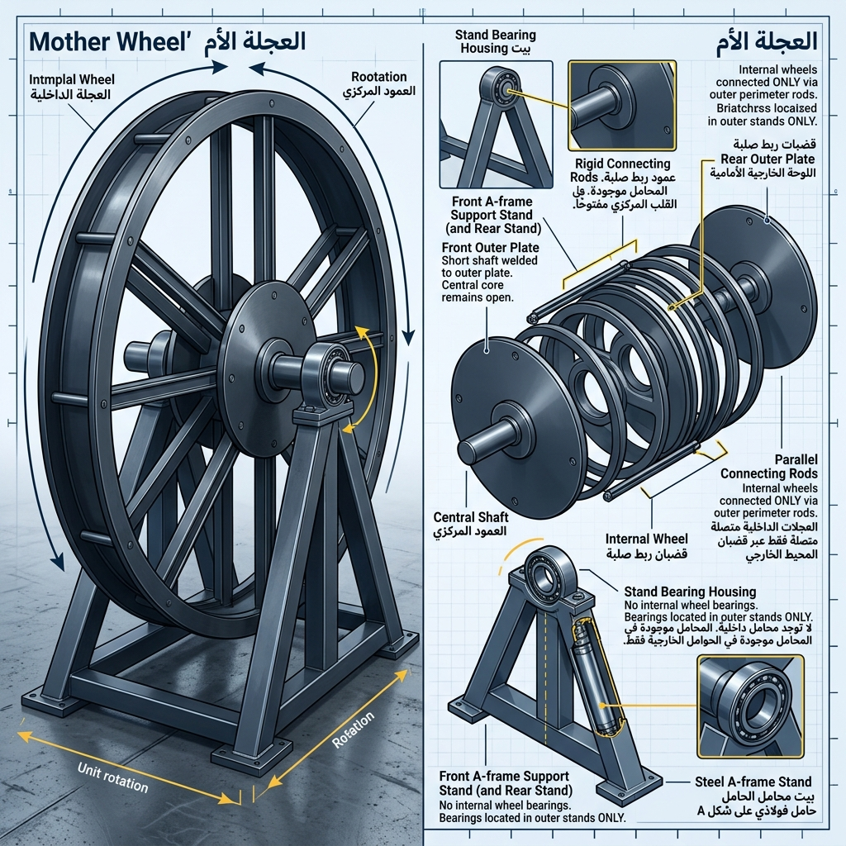
Explanation of the Main Wheel

The Main Wheel is considered the machine itself, and this wheel, like every physical object, has six directions, four of which can be represented on the x and y axes -in the two-dimensional drawing- and they are top and bottom, right and left. As for the other two directions, they are front and back, which are hidden in the two-dimensional drawing. As for what matters in the drawing and the two-dimensional or three-dimensional simulation, is that the inside of the wheel be highlighted even if the three-dimensional is simplified to two-dimensional in the drawing. But no effect of any of them is neglected in the calculations, whether in simulation or reality.
And let us begin explaining the farthest front and farthest back, then enter little by little to the inside. As for the farthest front and farthest back outside the wheel, we will find a support -in front of the wheel one and behind the wheel one like it- that holds the wheel such that it raises it from the ground so that it never touches the ground. The connection of each support of them to the wheel axis will be through a ball bearing fixed in the support, inside which the wheel axis rotates -the front wheel axis rotates inside the ball bearing fixed in the front side support, and likewise the rear axis rotates in the ball bearing of the rear side support-.
As for the axis, it is a cylindrical rod capable of carrying the wheel -note that it divides the entire load of the wheel on the front and rear rods, so they must be of a thickness that allows them to carry the weight of the wheel-. And these two axes connect to the front and rear wheels -the front axis connects to the front wheel from its center, and the rear axis connects to the rear wheel from its center-.
And the front wheel or the rear wheel is a solid wheel but not completely solid. It is sufficient that its durability be such that it does not shatter under the weights it carries. -As if the front and rear wheels with the inner wheels form a sandwich or a book, and the two wheels in it are like the covers that surround what is inside them, and the inner wheel (the wheel of each pendulum) is the core of the sandwich or the book-.
And all the wheels are connected together from the outer circumference of each wheel -either we connect between every wheel with a connected cylindrical circumference, so the shape of the Main Wheel becomes like a cylinder whose two bases are the front wheel and the rear wheel, or to reduce weight we suffice with rods whose length is sufficient to connect from the front wheel to the rear wheel, and in this way it connects with every wheel to make them all as one unit, and the remaining rods are distributed equally on the outer frame of the Main Wheel such that each rod also connects between every wheel in the same way as the first-.
And thus we have finished explaining the Main Wheel, except that it remains to note that the number of inner wheels (the wheel of each pendulum) cannot be less than 2, and it is preferred not to exceed 36.
And the diameter of the Main Wheel or any inner wheel must be the same diameter, and this unified diameter is important because the height of the container cylinder (the piston) is derived from it, because the circumference of the wheel is divided by the number of containers such that the containers do not overlap each other if we mount them on one circumference.
-It is preferred not to calculate a space for occupancy and that a point from each base of the container meets the previous container and the next container (for example, the meeting of the top point from the right base of the container with the top point from the right base of the container, and the top point from the left base of the container with the top point from the left base of the container)-

Explanation of the Shape of the Pendulum with Opposing Pistons (S)
The pendulum will be an outer frame and two containers and a tube. As for the outer frame, it holds two opposing containers on the circumference of this frame, and we will call the frame the pendulum wheel.
And the two containers are parallel and identical in shape, but one of them is in a position that is the inverse of the other, vertically or horizontally -depending on the position of the pendulum wheel in the Main Wheel (for example, if the pendulum wheel is at phase 0 of the Main Wheel, we will find the two containers inversely horizontal, and if the wheel is at phase 90, the two containers will be inversely vertical).
And since all containers are identical, after the wheel rotates half a turn (180 degrees), each container will have inverted to become like the one opposite to it when it was in the same position-.
And between the two containers is a tube in the shape of the letter (S) such that the tube and the two containers together represent the shape (S).
Let us see the following Figure 1.1 and Figure 1.2
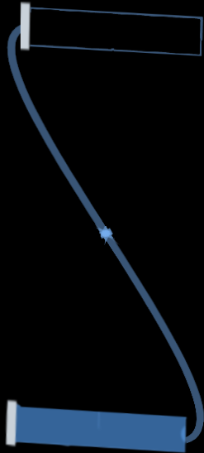

Figure 1.1

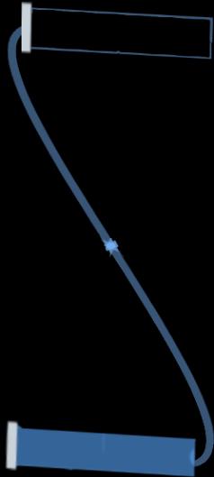

Figure 1.2
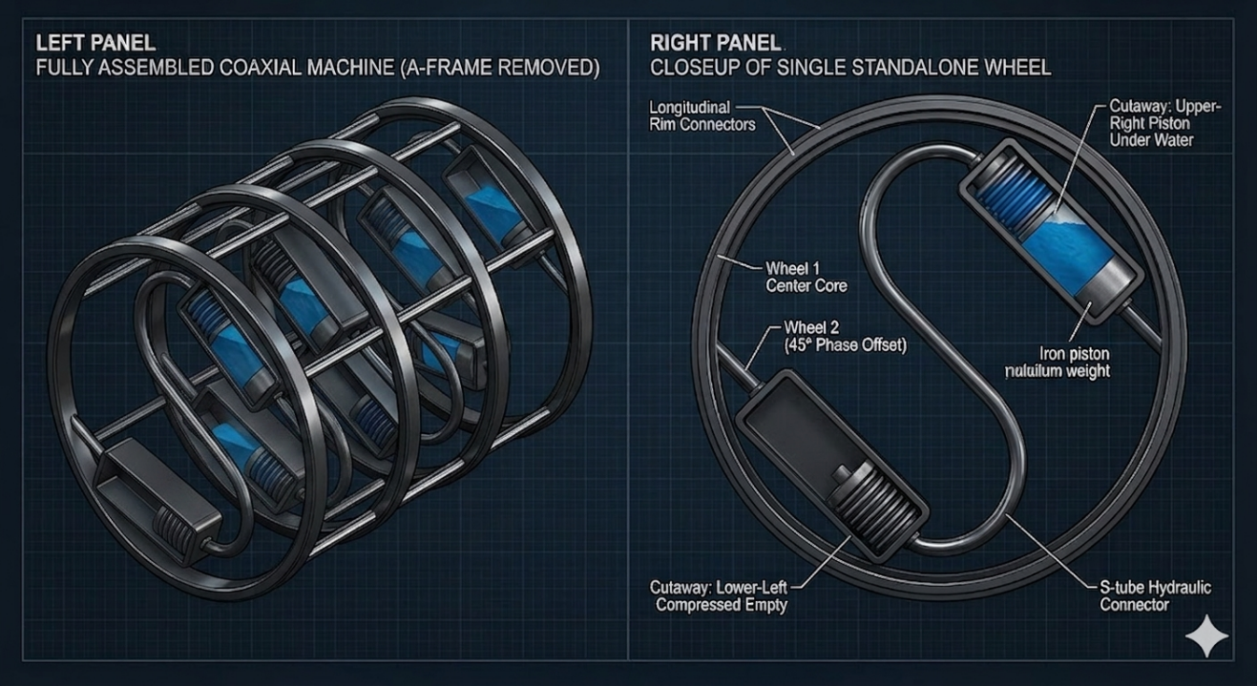
These figures show the shape of the pendulum with the two containers, and always one of the two containers in the pendulum is full of liquid and the other is empty. But with the change of position after the wheel rotates 180 degrees, the full container becomes empty and the empty container becomes full.

And we will call the container that is at the beginning of the Main Wheel movement empty the negative-start container, and the container that is full at the beginning of the Main Wheel movement we will call the positive-start container.
And let us begin with the shape of each container -and we will imagine the initial position of the container in the case of it being tangential- if it is at angle 0 and completely perpendicular to the radius of the wheel -note the shape of the container never changes, but its position changes according to the rotation of the wheel and according to that its internal parts move to empty or fill - we will find that the container is a cylindrical shape in its three-dimensional form, and in its two-dimensional form we will represent it as a rectangle.
Therefore, this container has two bases, we will call one of them the arm base (and it is the base that does not connect to the tube) and the other we will call the tube base (and it is the one that connects to the tube that transfers water to it or transfers it from it).
And let us begin with the side (tube base) the side connected to the tube exiting the container (water transfer tube also connected to the opposite container in the pendulum), we will find the first thing in this side inside the container, is the opening of the liquid vessel connected to the tube and fused to the base, then the body of the vessel -we chose that the vessel has an accordion shape so it folds and expands easily-.
Then the base of the vessel, which we will find connected to the piston arm -which is the weight that represents the piston arm in the container-.
This description is sufficient, but to clarify the picture a little more clearly, the liquid vessel is surrounded by a cylindrical body of pillars (rods) -thin cylindrical pillars -prevent the vessel from going out of its radial path-.
These pillars are considered the outer structure of the container except the two bases of the container -these pillars also work as rods on which the piston arm runs-.
And we will also find that the piston arm has openings that allow the pillars (called rods) to pass through it, and that is for the piston arm to run on the pillars (called rods) -.
And for more distinction and to help with imagination and drawing, we will call the side close to the circumference of the wheel from the container structure the circumference side, and the side close to the center of the wheel the center side-.
And finally, we will find that the two bases of the container are two circles, for each side a circle connecting between all the pillars -for example, if the left side of the container, the circle will be the connection between the left ends of the pillars (rods)-.
And thus the four directions of the container can be represented in the two-dimensional drawing as follows (if we imagine that we represent the container on the x and y coordinates and point (0,0) is the center of the container, then the top of the container is the circumference side and the bottom of the container is the center side, and the right of the container is the arm base, then the left of the container is the tube base).
-We must not forget that with the rotation of the wheel, the container will rotate around its center, and therefore everything will flip according to its rotation around its axis.
Also, we must not forget that this description is the description of the container if the center side and the circumference side of the container are completely perpendicular to the radius of the wheel.
But if the container is in our preferred position (which is tilting the container around its center 45 degrees in the clockwise direction and fixing the containers in this position on the circumference of the wheel), the follower can now imagine what its shape will be after this rotation-.
The following figures are pictures of the container.

Figure 1.3

Figure 1.4

Describing the Dimensions and Weights of the Container and Everything in It
And let us begin now with describing the dimensions and weights of the container and everything in it, and let us begin with the dimensions of the container as a whole. And because the container has a cylindrical shape, we will talk about the diameter and the height because they alone determine the external dimensions of the container -the height of the container is the distance between two points, each on one of the two bases of the container from the outside without tilt-. And the height of the container, as we indicated before, is determined from the diameter of the Main Wheel. And as for the diameter of the container, the maximum diameter that can be allowed is that the diameter of the container equals its height, and the minimum diameter will be according to our estimate not less than 1/10 of the height of the container. And experimentation can be done in the simulation to reach the most suitable ratio.
And the first thing that must be talked about is the rods, which represent the outer structure of the container, and their thickness relative to the diameter of the container as a whole should not be 2 percent -meaning if the diameter of the container is 50 cm, the two rods on the two ends of the circumference cut 1 cm, and the diameter of each rod should not exceed half a cm-.
And the second thing we talk about is the thickness of the two bases, and their thickness together should be 1 percent of the height of the container. As for the arm base, a rubber circle should be attached to its inner side that works as a lining for the base to cushion the impact of the piston arm if it falls on it. And in the opposite, in the tube base we will find the vessel, which is compressed, and it will do the same work. And the circle should be of a thickness that is the same as the height of the vessel if it is compressed, and the two together form 4 percent of the height of the vessel.
And now we talk about the vessel, and because it is an accordion cylindrical body, we have estimated its diameter to be 99 percent of the diameter of the vessel, and as for its height when compressed, as we indicated, it will only be 2 percent according to our estimate. And when expanded, its height will be approximately 87 percent of the height of the container. And because it is very necessary to calculate the mass of water that will fill it when full, we confirm that the mass of water will approximately be the product of multiplying the density of the liquid by the area of the vessel diameter by 85 percent of the height of the container.
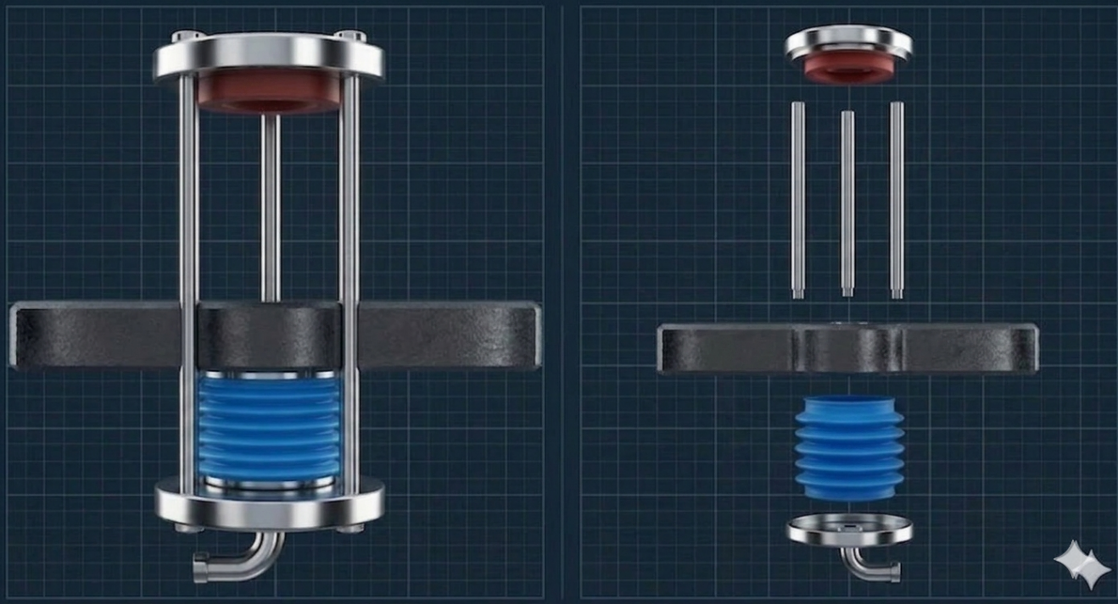
It remains for us the piston arm, which is the weight that presses on the vessel and is connected to its base and runs on the container rods that pass through the openings of the arm when it moves. And this arm, like any three-dimensional body, has a height (which is its thickness), and it is what we cut from the height of the container, because its radial movement in it is what presses or pulls the vessel.

And as for the width of this arm, it must be equal to the diameter of the vessel. But its length is estimated from its weight, and that is because there is a required weight for the arm such that it can press or pull the vessel. So we get the length from dividing the required weight of the arm by its density, then its thickness and width, and the length comes out for us. But because it has openings slightly wider than the rods that pass through it, we will compensate the volume of the openings in the length (for example, if we need a weight of 50 kilos and the density of the material is 7800 and the width is 49 cm and the thickness is 5 cm, then the length will be approximately 26.16 cm. And if the volume of the openings is 8 -representing 8 rods- each opening thickness is 5 cm and its diameter is 0.5 cm squared times 3.14, then the result that will be added to the length will be 0.00314 cm -and of course it is very negligible-).
And we say that the thickness of the piston arm and its width are what can be represented in the three-dimensional drawing, such that the thickness appears as part of the length of the container moving in it radially. And as for its width, it is what is attached to the base of the vessel and appears as if it and the base of the vessel are one thing.

How to Calculate the Required Weight of the Piston Arm
And now, how do we calculate the required weight of the piston arm? To do that, we must know what is required of this piston arm? And the truth is that what is required of this piston arm is to form a permanent imbalance for the machine, and that is by making the liquid always in one of the two sides of the wheel.
But how will this happen, and it is just a solid, inert mass? And the answer is that the engineering design of the pendulum is what provides this. Because the two containers (the two pistons) opposing each other, each one an inverse image of the other, either vertically or horizontally, makes it impossible for the liquid -note the liquid in the whole pendulum is sufficient for the connecting tube between the two containers + filling one container vessel- to be in more than one container.
And that is because if the pendulum is at phase 0 relative to the Main Wheel, the piston arm, whether in the upper or lower container, will be in a horizontal position and has no ability to affect the liquid, and therefore the liquid will be in the lower container completely and the upper one will be empty, and that is by the effect of gravity.
-In our example, we will assume that the upper container in the completely horizontal position has its right base as the arm base and its left base as the tube base. And the lower container is also horizontal but its right base is the pendulum base and its left base is the arm base-.
And let us begin by displacing the pendulum 45 degrees in the clockwise direction. If the weight of the piston arm in the upper container and the lower container allows them to fall in the direction of gravity, they will fall and transfer the liquid from the positive-start container to the negative-start container -and this is what we want in this position, so we will calculate the weights that allow that-.
So if liquid transfer happens at this phase of displacement, we will have succeeded in the correct engineering design, because this is the point at which we want to transfer the liquid from bottom to top. And what prevents this is the weight of the water column, if we overcome it at this point, then all the points that follow are easier. Because either the water column is opposing us but its height has decreased, or the water column has become aligned with our design, and this is what we want (for example, at displacement 90 degrees, the water column height is only 15 percent of the container height. And at displacement 135 or 180, the water column is settled at the bottom by the effect of gravity on the side we wanted from the wheel).
Therefore, the water column must be calculated at this point so that we can calculate the required weight of the piston arm. And the water column at displacement 45 can be calculated as follows: The height between the liquid surface and the place it is to be raised to, multiplied by the density of the liquid, multiplied by gravity, multiplied by the piston surface area -which for us is the area of the base of the liquid vessel-.
As for the height between the liquid surface and the place we want to transfer it to -the highest point in the tube connected to the vessel opening in the negative-start container- it can be calculated by the following equation: Square root of (((the diameter of the Main Wheel) squared) divided by 2), then we subtract from it the height of the liquid in the lower container (the positive-start container) -if the containers are mounted on the wheel completely tangential at zero angle, then the height of the liquid will be the height of the liquid vessel divided by 2. And if the containers are mounted at a 45 degree angle (and this means that at displacement 45 from the wheel they are completely perpendicular to the ground, and this is the position we prefer), then the height of the liquid is the entire height of the vessel -.
And the piston surface will be ((the radius of the liquid vessel) squared) multiplied by 3.14.
(Example: if the wheel diameter is 2 meters and the liquid is water with a density of 1000 and gravity is 9.8, and the containers are mounted at a 45 degree angle, and the diameter of the liquid vessel is 15 cm and its height is 35 cm, then the water column will be as follows: (Square root((2) * (2)/2)) - (0.35)) * (1000) * (9.8) * (0.15) * (0.15) * (3.14) = 736.8)
And now we calculate the required weight for one piston arm -we must not forget that we have a piston arm that presses on the liquid to raise it, while at the highest point that we want to raise to, there is a piston arm that also pulls the liquid. And therefore the required effort will be divided between them-.
And to calculate this, we must look at the opposing forces, which are first the water column, second the viscosity of the liquid, third the friction between the piston arm and the rods that it runs on, and fourth the resistance of the accordion vessel to bending.
And since we have calculated the water column, which is the most important, and since the viscosity of the liquid, friction, and accordion resistance can be overcome simply or even calculate estimated ratios for them, attention must be paid to the most important point, which is that if the containers were not mounted on the wheel at a 45 degree tilt from being tangential, then the weight of the piston arm when the pendulum wheel is at displacement phase 45 will not be completely perpendicular to the ground, and this requires that the mass of the piston arm not be calculated in full against the water column and the other forces, but on the contrary, the ratio of its weight's effect will decrease proportionally to its tilt angle.
-For example, if the containers are completely tangential, then the piston arm at phase 45 of the Main Wheel will be tilted 45 degrees, and therefore its effect is half the effect and not a full effect-.
And therefore, the calculation of the required weight of the piston arm is calculated from the following equation: ((weight of water column + viscosity effect + friction effect) / 2 / (9.8) * (-ratio of piston arm tilt to full tilt- 45/90)).
(Example: if the weight of the water column is 736.8 and the viscosity and friction effect is 3.2 and the tilt of the piston arm is full 90 degree tilt (that is, at displacement 45 of the pendulum wheel from the Main Wheel), then the required weight of the piston arm equals ((736.8 + 3.2) / (2) / (9.8) = 37.755)).
And now we must not forget that the tube in the shape of the letter (S) that connects between the two containers, its diameter must be suitable for transferring the liquid immediately upon pumping and with the least friction caused by viscosity. And it makes the pendulum system a closed system into which and from which no liquid enters or exits except what is in it. And what happens is only the transfer of liquid from the lower container to the upper one if the natural conditions for that are available, or the opposite also if the conditions are available for transferring the liquid from the upper container to the lower one, the liquid is transferred.

So How Does Our Pendulum Work?
Our pendulum with its wheel rotates with the Main Wheel and is affected by our rotation and affects it, so our pendulum works -if its two containers are perpendicular or even close to being perpendicular to the ground such that the two bases of each container become approximately parallel to the ground- when gravity is able to pull the piston arms towards the ground.
In this position, the pendulum works on transferring the liquid from one of its two containers to the other, and that is because one of the two containers has the piston arm above the liquid vessel -and it is the container that has entered the weak torque side of the Main Wheel-, and because the piston arm is above the vessel, it presses on it. At the same time, in the other container -which is the vertical inverse of the first container and it is the one inside the strong torque side of the Main Wheel- the piston arm falls pulling the vessel with it.
And therefore the two containers together transfer the liquid from one container to the other (in a clearer sense, from the lower container to the upper container) -provided that the weight of the two piston arms together is heavier than the height of the liquid column between them at the moment of transfer-.
So what will happen if we rotate the piston as a whole 180 degrees after the transfer is completed? -And let us always talk about the clockwise direction to unify the idea in the follower's mind-. The answer is that we will find that the liquid has started to transfer again from the full container to the empty one.
See the following image Figure 1.5
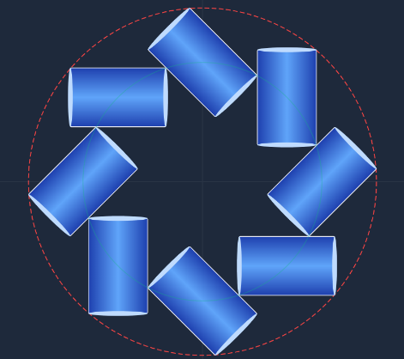
Figure 1.5

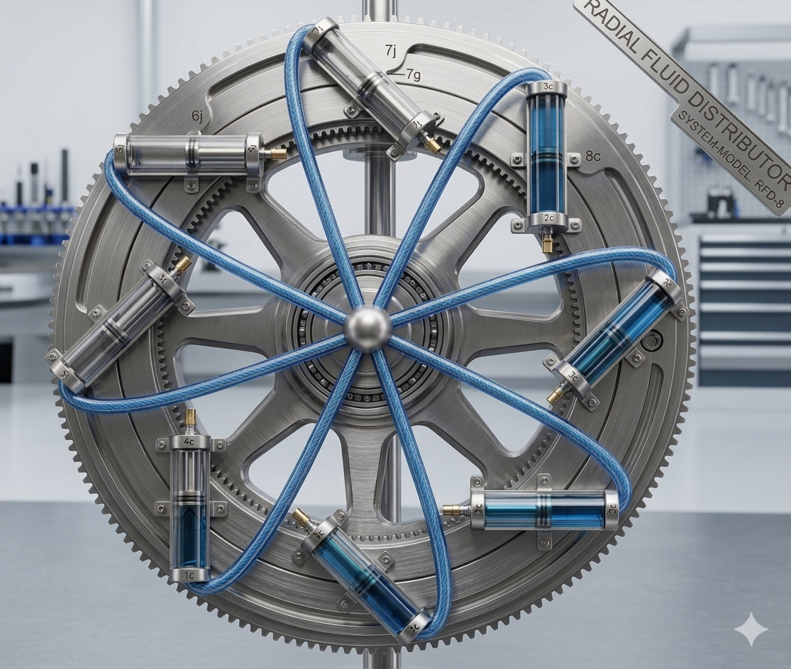

Now Let Us Resume Explaining the Whole Situation
And now let us resume explaining the whole situation after we have detailed the shape of the pendulum, the wheel, and the containers. And specifically, we will begin explaining the movement of the single pendulum with the two pistons in the Main Wheel. -And let us begin with the pendulum at phase 0 relative to the Main Wheel-. At first, the pendulum will be stationary and balanced -and its two containers, one at angle 0, which is the (negative-start) container, and the other at 180, which is the (positive-start) container-. We will find that the upper container is completely empty and the lower one is completely full of liquid.
And we will assume that we will apply torque to the pendulum wheel that makes the right side of it overcome the left side of it, such that the wheel rotates until it begins the transfer process -in our example, until the wheel is displaced 45 degrees-.
And now, as expected, since we have calculated the required weight for the two piston arms, the transfer of liquid from bottom to top -that is, from the (positive-start) container that is full to the (negative-start) container that is empty- is completed. And therefore the weight of the liquid becomes in the upper right container at angle 45 -which is the (negative-start) container that was previously empty-. So it becomes full, and the lower one at angle 225 -which is the (positive-start) container that was full- becomes empty.
And here is what will happen: the pendulum with the two pistons with its two containers will rotate like any pendulum and will rotate with the wheel until it completes half a turn around itself -135 degrees additional displacement from the Main Wheel. And therefore the pendulum will have made half a full turn-. And here it will stop.
And we will stop with it to see the situation. Now the container that was at the top -the (negative-start) container- has become at the bottom, and likewise the container that was at the bottom -the (positive-start) container- has become at the top. And therefore the (negative-start) container that started empty from the liquid has become full of liquid. And the opposite, the (positive-start) container- has become empty of the liquid after it was full.
Therefore, looking at the pendulum with the two pistons as a whole with its two containers, nothing has changed except that the upper and lower containers have exchanged their positions.
But regarding the effort or energy expended and the effort or energy that we obtained, what happened?
We applied torque that rotated the pendulum wheel 45 degrees, so it rotated with greater torque 135 degrees.
-We say greater because the torque exerted by the pendulum with the two pistons to move from displacement phase 135 to displacement phase 180 from the Main Wheel, is exactly equal to the torque we exerted to move it from displacement phase 0 to displacement phase 45 from the Main Wheel. And we still have the torque exerted by the pendulum in its transition from phase 45 to 90, which is torque greater than the first that we exerted, and from displacement phase 90 to 135 (and this is the greatest torque for those who know physics)-.
And now let us assume that we have applied the same torque that we exerted in the beginning again, then we stop and see what happened.
First, we will see that the pendulum rotated with its wheel half a turn once more, and it has returned in this time to the starting position of the cycle exactly -the same container positions and the same liquid position before the beginning of the cycle exactly-. And if we look at what we obtained from effort or energy, we will find that we obtained the same as what we obtained in the previous half cycle.
Therefore, we have indeed achieved net effort or work and additional energy of at least three times what we actually expended -because we rotated the wheel one-eighth of a turn then one-eighth of a turn = quarter of a turn, so it made a full turn. Meaning we got three times the energy but with greater torque and greater acceleration-.
The following table represents what happens from the pendulum movement at each movement of the full cycle of the containers.
Pendulum at Phase | Negative-Start Container at | Status of Negative-Start Container | Positive-Start Container at | Status of Positive-Start Container | Torque +/- | Rotation
0 | Angle 0 | Empty | Angle 180 | Full | Negative | 1/8 turn
45 | Angle 45 | Filling | Angle 225 | Emptying | Positive | 1/8 turn
90 | Angle 90 | Full | Angle 270 | Empty | Strong Positive | 1/8 turn
135 | Angle 135 | Full | Angle 315 | Empty | Positive | 1/8 turn
180 | Angle 180 | Full | Angle 0 | Empty | Negative | 1/8 turn
225 | Angle 225 | Emptying | Angle 45 | Filling | Positive | 1/8 turn
270 | Angle 270 | Empty | Angle 90 | Full | Strong Positive | 1/8 turn
315 | Angle 315 | Empty | Angle 135 | Full | Positive | 1/8 turn
And now, after we have verified that we have indeed obtained net energy, one problem remained, which is that we have indeed applied effort to obtain this effort. But the follower with us will discover that this is no longer a problem, because the net of what we obtained covers and exceeds what we expended. And therefore, and as will appear in the follower's mind from the sequence, the last point of the idea will come, which is:
The eighth part of the idea, which is adding three additional pendulums similar to our first pendulum to the Main Wheel -it is sufficient to have two additional pendulums-. With equal displacements between each wheel and the other, such that if our first pendulum is at the beginning in a position with no displacement for it from the Main Wheel, then the three other pendulums will be distributed on the Main Wheel axis as follows: (Pendulum 2 at displacement phase 45, Pendulum 3 at displacement phase 90, and Pendulum 4 at displacement phase 135).
Here the follower will discover that we will always have several things that repeat every 1/8 of a turn:
- There is a pendulum in a state of rest.
- A pendulum in a state of transferring liquid from a full lower container to an empty lower container.
- A pendulum in a state of giving maximum positive torque to the Main Wheel.
- A pendulum that produces torque equal to the negative torque of the pendulum that is in the liquid transfer phase.
- The side with the full containers -the right side in our example- of the wheel is heavier in weight and its torque is greater than the lighter side -the left side in our example- of it.
- We obtain net energy due to the torque on the heavier side -the right side in our example-.
This table shows the position of the pendulums in every cycle.
Pendulum | Pendulum Position at Phase | Negative-Start Container at | Status of Negative-Start Container | Positive-Start Container at | Status of Positive-Start Container | Moving to Phase | Moving with Torque
First | 0 | 0 | Empty | 180 | Full | 45 | Negative
Second | 45 | 45 | Filling | 225 | Emptying | 90 | Positive
Third | 90 | 90 | Full | 270 | Empty | 135 | Strong Positive
Fourth | 135 | 135 | Full | 315 | Empty | 0 | Positive
First | 180 | 180 | Full | 0 | Empty | 225 | Negative
Second | 225 | 225 | Emptying | 45 | Filling | 270 | Positive
Third | 270 | 270 | Empty | 90 | Full | 315 | Strong Positive
Fourth | 315 | 315 | Empty | 135 | Full | 0 | Positive

Calculating the Affecting Forces and Energy:
Now what remains for us is to know the forces affecting the Main Wheel (the machine) and calculate the energy. And that is because many who imagine the machine incorrectly -especially AI models- calculate that it will stop or that the produced energy must be zero, because the system in their imagination -as we explained before- is a closed system, and because gravity is a conservative field. And to remove the confusion initially, we must know what are the forces affecting the rotation of the Main Wheel. And the forces can be divided into external forces and internal forces.

1 - External Forces:
These are the forces that resist the rotation of the Main Wheel from the outside or help it from the outside. And these forces are limited to:
• External Friction: And it is the friction of the Main Wheel axis with the ball bearing that rotates inside it. And this friction is affected by the weight of the Main Wheel as a whole in addition to the loads that are loaded on it such as energy converters.
• Air Friction: And that is if the Main Wheel reaches high speeds where air friction with it can become significant.
• Inertia: And it is the acceleration that occurs as a result of the wheel rotating in one direction.
• Gravity: And it is the most important factor, without which the Main Wheel would stop completely, because it derives its ability to rotate from it externally, where gravity pulls the heavier side of the wheel towards the earth, forming a torque that rotates the wheel.

2 - Internal Forces:
These are the forces that do not affect the rotation of the Main Wheel from the outside, but if they do not affect from the inside, the engineering design of the Main Wheel cannot work, and therefore it will balance and stop completely.
• Weight of the Liquid: And it represents the weight of the liquid as an assisting factor when it is in the containers of the heavier side always of the Main Wheel, where gravity pulls this side downwards by virtue of it, forming a torque that rotates the wheel. But it also represents a resisting factor when the weights of the piston arms try to return it to the top again.
• Weight of the Piston Arms: And despite the weights of the piston arms being equal in all containers, forming a balance in all containers -except what increased from the weight of the liquid-. But had it not been for gravity pulling those weights downwards, the liquid would never have been raised again in an upper container.
• Viscosity of the Liquid: May impede rapid transfer of the liquid.
• Gravity: As it is an external factor, it is also an internal factor, where it pulls the piston arms and pulls the liquid downwards.
And in view of what we have presented, it is completely wrong for anyone to think that raising the liquid may affect the torque of the wheel, because the wheel does not bring it from the outside, but it is inside a closed system.
Or for anyone to think that the falling of the piston arms may oppose or increase the torque of the Main Wheel, and this is incorrect, because every two opposing containers in a pendulum have their two piston arms falling together and in one direction -towards gravity-. And since they are on two sides of the pendulum wheel, every effect of one of them in one side will be completely canceled by the effect of the other in the other side.
Likewise, some may think that we need to return the piston arms that fell to their place again to begin raising the liquid again, and this may be considered correct if we return the arms in the way they imagine. But in reality, in our design, the piston arms that fell towards the base of their container remain fallen in their place and are never raised. Rather, the Main Wheel rotates with all the containers, then after a full half turn, we find that every piston arm has had its container flipped upside down, and the arm flipped with it, so what was below it became above it, and what was above it became below it, and gravity pulls it then to what it was pulling it from before the half turn.
So how do we calculate the energy that our Main Wheel will generate correctly?
- We will start from inside the wheel and look at whether the conditions conducive to wheel rotation are correct or not. And the conditions are two conditions:
• That the containers of one side of the Main Wheel be full.
• That the weights of the piston arms be capable of transferring the liquid from bottom to top if the pendulum of those arms is in the transfer phase -at displacement phase 45 from the Main Wheel-.
- As long as the above conditions are available, the initial torque exists. And also the renewal of torque will happen after the complete transfer of the liquid -and that is because the torque decreases as gravity pulls the heavier side of the Main Wheel downwards, then the liquid is transferred to the top of the heavier side again (by the falling of the piston arms in the pendulum that is in the liquid raising phase), causing the transfer of the liquid to renew the torque-.
- It is never correct to confuse what happens from the internal energy calculation, in which the interaction between the piston arms and the weight of the liquid and its viscosity, with what happens outside the Main Wheel.
- Outside the Main Wheel, the negative forces will be calculated, which are friction and air viscosity -if the speed increases greatly- and the weight of the empty side of the Main Wheel -as negative torque (and we must not forget that at the time of liquid transfer, the lower container that has moved from the heavier side of the wheel and is full of liquid forms a negative torque, while the empty container that has moved from the lighter side to the heavier side forms a positive torque)-. And the result of this torque is calculated as negative energy after looking at the radius of the Main Wheel and its effect on the torque -we do not forget that every container and every piston arm and every liquid weight must have its torque calculated according to its angle relative to the axis of the Main Wheel-.
- Also outside the wheel, the positive torque forces are calculated, which are the weight of the containers full of liquid - and even those that were empty in the lighter side of the Main Wheel and moved to the heavier side-. Then we calculate the acceleration from inertia with the acceleration of the wheel, and the result of this torque is calculated as positive energy after looking at the radius of the Main Wheel and its effect on the torque -we do not forget that every container and every piston arm and every liquid weight must have its torque calculated according to its angle relative to the axis of the Main Wheel-.
- The resultant between the output of the two energies is what will show whether our estimates about the continued rotation of this wheel are correct.
- For any simulation to be sound, the laws of energy must not be applied to it as a foregone conclusion and stopping it despite itself, because many may start the calculation from the result and that we know the result must be zero, so we start with zero then calculate where we exhausted the initial energy. But rather what must be done is to let the machine work in the light of Newton's laws and monitor the energy produced, even if we monitor the states and potential energies and torques in every cycle before its beginning, as if the machine is stationary. That will be better than stopping the machine with a predetermined result.
- And in conclusion, if what we calculate is correct, the laws of energy will not change, but rather gravity will be considered a non-conservative field that can be manipulated through engineering to obtain energy from it.

Objections and Rebuttals:
• Some may object -especially AI models because they have not been trained on such a design- to our separation of internal energy calculations from external ones, and think that this may create a loophole in the calculation. And the answer is that if the calculation of any internal change will affect the external torque of the machine, here we are calculating the external torque every time. And if the internal change is not affecting the external torque, how can we be asked to calculate it in the effects? And likewise for the external torque, if it will affect the internal distribution, here we are monitoring the internal distribution, and if it has no effect, how can we be asked to add it to the internal effects?
• Some may imagine that this machine can stop by itself without applying a load on it that balances its continuous positive torque. And we answer them with simple logic, and let us imagine the following logic:
- The machine begins with positive torque due to the full containers in its heavier side -in our example the right side- and negative torque in the lighter side -the left side in our example-. If this torque is capable of pushing one of the pendulums to reach the liquid transfer point, it will reach.
- If the pendulum reaches the liquid transfer point, it has consumed torque from the machine equal to moving it from the rest point to the liquid transfer point. If the conditions are conducive to transferring the liquid between the two containers of the pendulum -from the lower container to the upper container- it will transfer.
- If the liquid transfers, the transfer of the liquid has consumed energy from the falling of the piston arms inside their containers -but both arms are in two opposing containers on two sides of the wheel, so their torques cancel each other completely, and their rebounds cancel each other, and the pushing of one acts as a brake for the other, and the resultant of their interaction is zero-. And the liquid has gained a new potential energy from them that it added to the heavier side of the Main Wheel. And the positive torque has increased again. If this torque is capable of pushing one of the pendulums to reach the liquid transfer point, it will reach.
- If the pendulum reaches the liquid transfer point, it has consumed torque from the machine equal to moving it from the rest point to the liquid transfer point. If the conditions are conducive to transferring the liquid between the two containers of the pendulum -from the lower container to the upper container- it will transfer.
- And so every time, the same steps.
• Some may question that the torque obtained from our previous logic will be less each time than its predecessor, so it will not be able to move a pendulum to the liquid transfer point. And we answer them to go back to the table in which we monitored the pendulum behavior, and you will find that the torque we will obtain is logically greater.
• Some may question that the logical cycle we made in our point before last may break and not complete. And we answer them that for that circle to break, it would be for one of two reasons:
- That the torque of the machine is not capable of pushing it to bring a stationary pendulum to the liquid transfer point. And this we have proven that if the liquid is transferred in the pendulum that preceded the currently stationary pendulum, the result of its torque that was added to the machine will be greater, and therefore it will be able to push the stationary pendulum to the liquid transfer point.
- That the liquid is not transferred at the transfer point. And the answer is simply: do we have the ability to prepare the suitable conditions for that or not? If we do -and indeed we do, and that is by providing the necessary weights for the piston arms- then the liquid will be transferred. And if we do not, then the liquid will not be transferred. And since we do and we will provide it, the cycle will continue.
• The following objection -which is usually raised by AI models because they do not understand the design- is what will return the arms that fell to their place to transfer the liquid again, and what will raise the liquid again after the machine rotates it with its torque and reaches the lowest point in the wheel? And the answer is simple: as for the liquid, the falling of the piston arms to their place raises it again. And as for the arms that fell in their containers, do not imagine them returning again, but rather imagine two weights in the bases of their two containers, and their containers on two sides of the wheel, and the base of each container is the ground relative to the weight, and each container of them has a ceiling. If the wheel is able to rotate with them half a turn (180 degrees), will not the ceiling become the ground and the ground become the ceiling relative to the weight? Will that not push it to fall to the new ground? If the wheel rotates another half turn, will not the position change again and every weight fall to its new ground? And since this will inevitably happen, the rotation of the wheel is responsible. And therefore we return once again to the torque point: if the torque is capable, it will rotate, and if not, then it will not.

The Neutral Test:
Therefore, we propose this neutral test: that we measure the torque difference between the two sides of the wheel every time before any rotation that can move a pendulum from the rest point to the liquid transfer point. If the torque is capable, we will let the wheel rotate and measure the torque after that before the liquid transfer, and we know the torque that was consumed. Then we measure whether the conditions allow the arms to transfer the liquid or not. If they can, we will let the liquid transfer. Then we begin measuring the torque again before the rotation that can move a pendulum from the rest point to the liquid transfer point. If the torque is capable, we will let the wheel rotate and measure the torque after that before the liquid transfer, and we know the torque that was consumed. Then we measure whether the conditions allow the arms to transfer the liquid or not. If they can, we will let the liquid transfer... And so on and so forth.

The Result:
If the cycle breaks and stops completely, then gravity is indeed a conservative field for energy. And if the cycle does not stop -as we calculate and expect-, then gravity may not be a conservative field, but rather a field that produces energy, provided that the necessary geometry is created to bring that about. And the laws of energy will remain valid after that, provided that the possibility of extracting energy from gravity is taken into account.

Conclusion:
The follower will discover that by the rotation of the cycle by itself, it has achieved a rotational torque in every 1/8 of a turn at least, a strong positive torque. And by the rotation of the wheel in one direction -the clockwise direction in our example- we have obtained an ever-increasing acceleration until it reaches the point where it stops due to increasing friction factors and remains constant. And this is an image from the simulation of the wheel in Figure 1.6

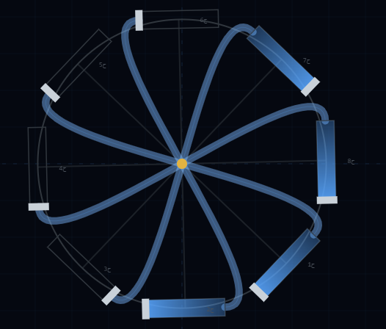

Summary:
Dear follower, here we have concluded our research journey in which we have proven with logical evidence that we have produced the first perpetual motion machine in the common understanding among people. And we expect that as soon as the first model of it is applied in the real world, the psychological barrier that has become entrenched in humans in general and scientists in particular will be broken. And it will open new horizons for the production of very economical clean energy, easy to manufacture and circulate, and within reach of all people. And in the end, we conclude with the words of God Almighty, who blessed us with this idea:
"Whatever Allah opens to mankind of mercy, none can withhold it; and whatever He withholds, none can release it after Him. And He is the Exalted in Might, the Wise." Surah Fatir (2)
God Almighty has spoken the truth.

