

**SOFTWARE DESIGN AND ARCHITECTURE**

**CSC 3505**

**Sem II 2018/2019**

Software Requirements Specification

MHD Khaled Maen 1523591

**iHearU**

1. **System Overview**

iHearU is a machine learning model which helps the hearing-impaired community to communicate with hearing ones by capture an image of a sing and identify its meaning then interpret it into voice.

1. **Project Mission Statement**

Communication difficulties arising from damage to hearing directly have an effect on the standard of life. Difficulties in communication could end in deviations within the emotional and social development which will have a major impact on the standard of lifetime of every one. It is well recognized that hearing is crucial to speech and language development, communication, and learning. Folks with listening difficulties due to hearing loss or auditory processing problems continue to be an under-identified and under-served population. The earlier the matter is known and intervention began, the less serious the ultimate impact.

The communication between hearing-impaired and other individuals is a colossal gab need to be filled up. In order to overcome this challenge many researches and products have been developed to solve this problem, but there is a lot to be enhanced

* 1. **Product Vision**

Make the communication more reliable with hearing-impaired people.

* Give the hearing-impaired people the power to communicate with more people.
* Build a strong connected community.
* Can be used by anyone anywhere.
* Have integrated Application Programming Interface (API).
  1. **Project Scope**

The Project will be mainly used by the camera and speaker for the smart devices.

* 1. **Target Markets**

All people with hearing-impaired problem and their loved ones.

* 1. **Stakeholders**
* Developers: One-person team based Computer Science student.
* Users: All hearing-impaired people.
* Purchasers: Government agencies such as schools and hospitals, families and individuals.
  1. **Business Requirement**
* iHearU must establish base for upcoming product in the same filed.
* iHearU must save money for companies that use it instead of hiring a human translator.
* The first version of iHearU must be brought to the market within 6 months of the development.

1. **Stakeholder-Goals List**

|  |  |
| --- | --- |
| **Stakeholder Category** | **Goals** |
| Installers | Have a product that is easy to install |
| Operators | Hand gesture can be detected once user raise his/her hand.  Camera window and sound volume can be adjusted |
| Maintainers | It is quick and easy to:   * Track down problem. * Fix a problem. * Recover from routine failures. |
| Purchasers | Have a good customer service |

1. **System Needs List**
   1. **Functional Needs**

Operands need iHearU to allow set window screen size and sound volume

* 1. **Non-Functional Needs**

iHearU should detect and identify the sign language guesture in Real Time period.

* 1. **Data Needs**

Maintainers need iHearU to record the sign that being mistakenly identified.

* 1. **Interface Needs**

iHearU interface should be simple that show the sign with the interpreted text.

**5.** **System User-Level Requirements**

**5.1.** **Functional Requirements**

Sing detection and identification must occur in real-time.

**5.2.** **Non-Functional Requirements**

iHearU must have checkpoint to be able to operate after any kind of failure.

**5.3.** **Data Requirements**

iHearU must read and analysis the frames that come from the device camera.

**6.** **Use Case Model**

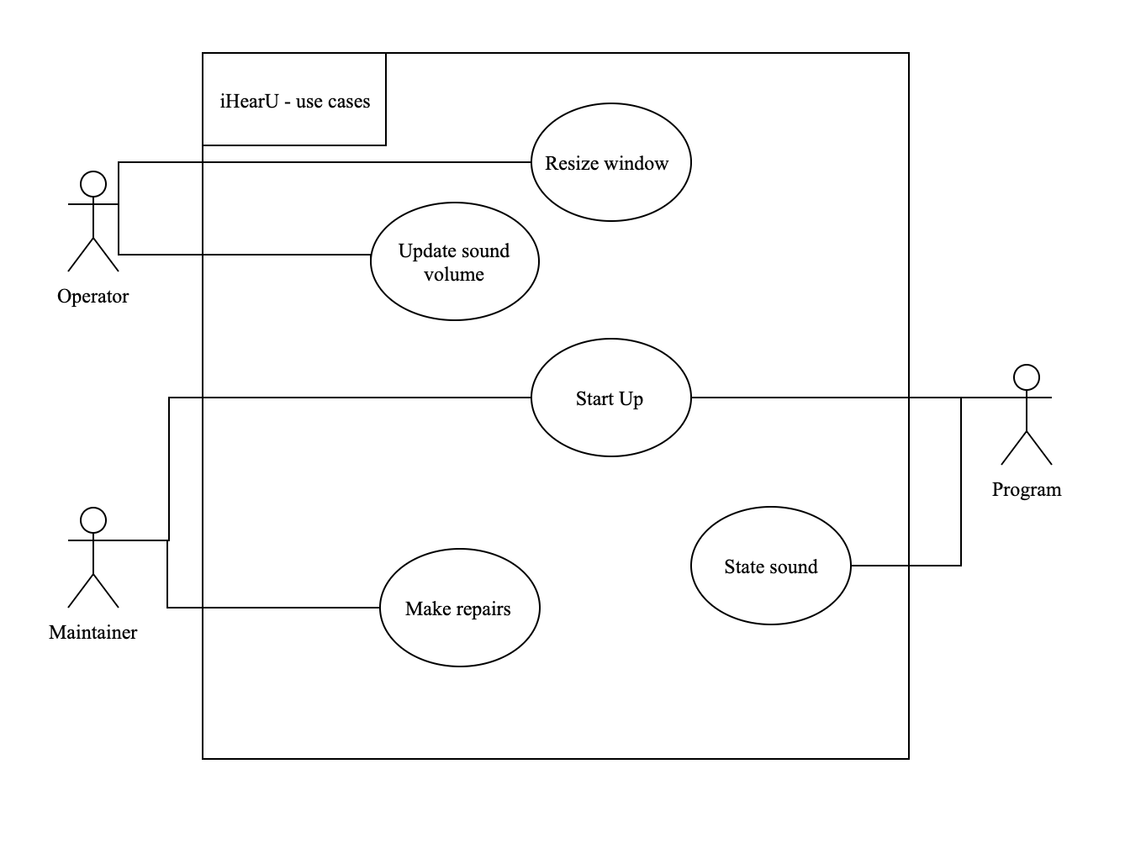

Figure 1 iHearU use Case

**7.** **Use Case Description**

|  |
| --- |
| **Use Case:** Resize window.  **Actors:** Operator, Maintainer, **Stakeholders and Needs:**   * Operator, Maintainer: To change the window camera size.   **Preconditions:** iHearU is in ready state.  **Postconditions:** All failures are recorded and reported.  **Tigger:** Open device camera.  **Basic Flow:**   1. Operator open iHearU. 2. Camera window pop up automatically.   **Extensions:**   1. Program fail to open the camera. |

Figure 1 Resize window.

|  |
| --- |
| **Use Case:** Update sound volume.  **Actors:** Operator, Maintainer, **Stakeholders and Needs:**   * Operator, Maintainer: To change the sound volume.   **Preconditions:** iHearU is in ready state.  **Postconditions:** All failures are recorded and reported.  **Tigger:** Open device camera.  **Basic Flow:**  1. Operator open iHearU.  **Extensions:**  1. Program fail to open the control the speaker sound. |

Figure 2 Update sound volume.

|  |
| --- |
| **Use Case:** Start up.  **Actors:** Maintainer, Program **Stakeholders and Needs:**   * Maintainer, Program: restart iHearU when it’s in failure state.   **Preconditions:** iHearU is in failure state.  **Postconditions:** All failures are recorded and reported, back to ready state  **Tigger:** Failure occur.  **Basic Flow:**  1. Maintainer, Program restart iHearU.  **Extensions:**  1. Program fail to restart. |

Figure 3 Start up the system.

|  |
| --- |
| **Use Case:** State sound.  **Actors:** Operator, Maintainer, Program. **Stakeholders and Needs:**   * Operator: To make the hand gesture. * Maintainer: To detect the failure and fix it. * Program: To identify the sign and state it.   **Preconditions:** iHearU is in ready state.  **Postconditions:** All failures are recorded and reported.  **Tigger:** Operator make a sign language hand gesture.  **Basic Flow:**   1. Operator make a sign language gesture. 2. iHearU identify the sign and state the match sound.   **Extensions:**   1. Program fail to detect the sign: iHearU alert the Operator. |

Figure 4 State sound.

|  |
| --- |
| **Use Case:** Make repairs.  **Actors:** Operator, Maintainer, Program. **Stakeholders and Needs:**   * Operator: Causes a failure. * Maintainer: To detect the failure and fix it. * Program: Halts.   **Preconditions:** iHearU is in Failure state.  **Postconditions:** All failures are recorded and reported, Back to ready state  **Tigger:** Operator make a sign language hand gesture.  **Basic Flow:**  1. Operator make a sign language gesture.   1. iHearU identify the sign and state the match sound.   **Extensions:**  1. Program fail to detect the sign: iHearU alert the Operator. |

Figure 5 Make repairs.