Facial Expression and Emotion detection

Abdirahman Abdullahi
Kulliyyah of information communication and technology ,international Islamic university Malaysia,
abdomursal@gmail.com

MHD Khaled Maen
Kulliyyah of information communication and technology ,international Islamic university Malaysia,
mk.maen93@gmail.com

Abstract—Facial expression and Emotion detection are playing important role in today technology. Facial expression and emotion detection can be used in many application such as in online learning can be useful for the academic purpose, In this paper we aimed to experiment on dataset which is image based, we have downloaded a dataset from Kaggle library, and then we used CNN (conventional neural network) as our algorithm. This paper provides a basic knowledge on facial expression and emotion detection using Deep learning.

- Introduction
Facial expression and emotion detection are essential aspects in human communication that help people to understand each other, not only human but also the machine must understand our emotions in terms to help us to discover certain emotion that is difficult from human to recognise it. However, people infer the emotional states of other people, such as joy, sadness, and anger, using facial expressions and emotion detection. it is obvious the study of facial expression has become the centre of attention over the past decades in affective computing and computer animations.

- Related Work
- Deep Learning
Deep learning is a machine learning subfield that deals with algorithms based on the structure and function of the brain called artificial neural networks. In other words, it mirrors the brain's functioning. Deep learning algorithms are similar to the structure of the nervous system in which each neuron connects and passes information. Deep learning models work in the layers and three layers of a typical model at least. Each layer accepts and passes the information from the previous layer to the next layer.

- Convolutional Neural Network
Convolutional Neural Networks are very similar to ordinary Neural Networks, they are made up of neurons that have learnable weights and biases .The architectures of ConvNet make the explicit assumption that the inputs are images which will be encoded to certain properties in the architecture. This makes the forward function more efficient to implement and reduces the number of parameters in the network considerably.
Convolutional Neural networks allow computers to see, meaning that Convnets is used to recognize images by transforming the original image into a class scoring through layers. CNN was inspired by the visual cortex. Every time we see something, a series of layers of neurons gets activated, and each layer will detect a set of features such as lines, edges. The high level of layers will detect more complex features in order to recognize what we saw.

- Previous Work
Following the same path many previous attempts has been conducted to find a solution for this problem, marvelous work has been done.

- Methodology
In order to get a model with satisfying results, we setup an environment with a powerful computational resources and large datasets.
  - Environment
Google Cloud Platform (GCP) is a cloud computing service provided by Google which provides a lot of products including cloud computing.
Google Compute Engine (GCE) is the Infrastructure as a Service (IaaS) enables users to setup Virtual Machines (VMs) can be accessed via the developer console, command line interface (CLI) and RESTful API [5].
The VM instance of choice run on an Ubuntu operating system version 16.04. Alongside, the VM instance is powered by 8 Graphics Processing Units (GPUs) of type NVIDIA Tesla K80 which engineered to boost throughput in real-world applications by 5-10x times, compared to Central Processing Unit (CPU).

  - Dataset
The data consists of 48x48 pixel grayscale images of faces. The faces have been automatically registered so that the face is more or less centred and occupies about the same amount of space in each image. The task is to categorize each face based on the emotion shown in the facial expression in to one of seven categories (0=Angry, 1=Disgust, 2=Fear, 3=Happy, 4=Sad, 5=Surprise, 6=Neutral) as shown in Fig. 1.

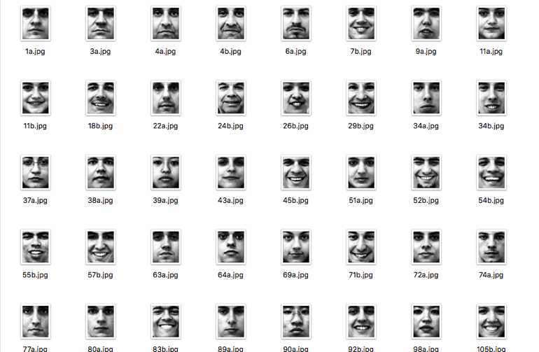
Fig. 1 A sample images of dataset
  - Algorithm
The algorithm used in this experiment is

