1. Given the plaintext to AES {0405060708090A0B000102030C0D0E0F}

Do the following:

1. Show the original contents of state, displayed as 4x4 matrix.
2. Show the value of state after ShiftRows.
3. Show the value of state after MixColumn, Using the following matrix:

02 03 01 01

01 02 03 01

01 01 02 03

03 01 01 02

Solutions:

a.

|  |  |  |  |
| --- | --- | --- | --- |
| 04 | 08 | 00 | 0C |
| 05 | 09 | 01 | 0D |
| 06 | 0A | 02 | 0E |
| 07 | 0B | 03 | 0F |

b.

|  |  |  |  |
| --- | --- | --- | --- |
| 04 | 08 | 00 | 0C |
| 09 | 01 | 0D | 05 |
| 02 | 0E | 06 | 0A |
| 0F | 07 | 0B | 03 |

c.

|  |  |  |  |
| --- | --- | --- | --- |
| 02 | 03 | 01 | 01 |
| 01 | 02 | 03 | 01 |
| 01 | 01 | 02 | 03 |
| 03 | 01 | 01 | 02 |

|  |  |  |  |
| --- | --- | --- | --- |
| 04 | 08 | 00 | 0C |
| 05 | 09 | 01 | 0D |
| 06 | 0A | 02 | 0E |
| 07 | 0B | 03 | 0F |

First row

1. 02 * 04 ⊕ 03 * 05 ⊕ 01 * 06 ⊕ 01 * 07
2. 02 * 08 ⊕ 03 * 09 ⊕ 01 * 0A⊕ 01 * 0B
3. 02 * 00 ⊕ 03 * 01 ⊕ 01 * 02 ⊕ 01 * 03
4. 02 * 0C ⊕ 03 * 0D ⊕ 01 * 0E ⊕ 01 * 0F

Convert to binary form

1. 0000 0100 * 10 ⊕ (0000 0101 * 10 ⊕ 0000 0101 * 01)⊕ 0000 0110 * 01 ⊕ 0000 0111 * 01
2. 0000 1000 * 10 ⊕ (0000 1001 * 10 ⊕ 0000 1001 * 01)⊕ 0000 1010 * 01 ⊕ 0000 1011 * 01
3. 0000 0000 * 10 ⊕ (0000 0001 * 10 ⊕ 0000 0001 * 01) ⊕ 0000 0010 * 01 ⊕ 0000 0011 * 01
4. 0000 1100 * 10 ⊕ (0000 1101 * 10 ⊕ 0000 1101 * 01) ⊕ 0000 1110 * 01 ⊕ 0000 1111 * 01

Shift and XOR

1. 0000 1000 ⊕ 0000 1111 ⊕ 0000 0110 ⊕ 0000 0111 = 0000 0110 = 06 =6
2. 0001 0000 ⊕ 0001 1011 ⊕ 0000 1010 ⊕ 0000 1011 = 0000 1010 = 0A =10
3. 0000 0000 ⊕ 0000 0011 ⊕ 0000 0010 ⊕ 0000 0011 = 0000 0010 = 02 = 2
4. 0001 1000 ⊕ 0001 0111 ⊕ 0000 1110 ⊕ 0000 1111 = 0000 1110 = 0E =14

Second row

1. 01 * 04 ⊕ 02 * 05 ⊕ 03 * 06 ⊕ 01 * 07
2. 01 * 08 ⊕ 02 * 09 ⊕ 03 * 0A⊕ 01 * 0B
3. 01 * 00 ⊕ 02 * 01 ⊕ 03 * 02 ⊕ 01 * 03
4. 01 * 0C ⊕ 02 * 0D ⊕ 03 * 0E ⊕ 01 * 0F

Convert to binary form

1. 0000 0100 * 01 ⊕ 0000 0101 * 10 ⊕ (0000 0110 * 10 ⊕ 0000 0110 * 01) ⊕ 0000 0111 * 01
2. 0000 1000 * 01 ⊕ 0000 1001 * 10 ⊕ (0000 0110 * 10 ⊕ 0000 1010 * 01) ⊕ 0000 1011 * 01
3. 0000 0000 * 01 ⊕ 0000 0001 * 10 ⊕ (0000 0010 * 10 ⊕ 0000 0010 * 01) ⊕ 0000 0011 * 01
4. 0000 1100 * 01 ⊕ 0000 1101 * 10 ⊕ (0000 1110 * 10 ⊕ 0000 1110 * 01) ⊕ 0000 1111 * 01

Shift and XOR

1. 0000 0100 ⊕ 0000 1010 ⊕ 0001 1010 ⊕ 0000 0111 = 0001 0011 = 13 = 38
2. 0000 1000 ⊕ 0001 0010 ⊕ 0000 0110 ⊕ 0000 1011 = 0001 0111 = 17 = 46
3. 0000 0000 ⊕ 0000 0010 ⊕ 0000 0110 ⊕ 0000 0011 = 0000 0111 = 07 = 7
4. 0000 1100 ⊕ 0001 1010 ⊕ 0001 0010 ⊕ 0000 1111 = 0000 1011 = 0B = 11

Third row

1. 01 * 04 ⊕ 01 * 05 ⊕ 02 * 06 ⊕ 03 * 07
2. 01 * 08 ⊕ 01 * 09 ⊕ 02 * 0A⊕ 03 * 0B
3. 01 * 00 ⊕ 01 * 01 ⊕ 02 * 02 ⊕ 03 * 03
4. 01 * 0C ⊕ 01 * 0D ⊕ 02 * 0E ⊕ 03 * 0F

Convert to binary form

1. 0000 0100 * 01 ⊕ 0000 0101 * 01 ⊕ 0000 0110 * 10 ⊕ (0000 0111 * 10 ⊕ 0000 0111 * 01)
2. 0000 1000 * 01 ⊕ 0000 1001 * 01 ⊕ 0000 1010 * 10 ⊕ (0000 1011 * 10 ⊕ 0000 1011 * 01)
3. 0000 0000 * 01 ⊕ 0000 0001 * 01 ⊕ 0000 0010 * 10 ⊕ (0000 0011 * 10 ⊕ 0000 0011 * 01)
4. 0000 1100 * 01 ⊕ 0000 1101 * 01 ⊕ 0000 1110 * 10 ⊕ (0000 1111 * 10 ⊕ 0000 1111 * 01)

Shift and XOR

1. 0000 0100 ⊕ 0000 0101 ⊕ 0000 1100 ⊕ 0000 1001 = 0000 0110 = 06 = 6
2. 0000 1000 ⊕ 0000 1001 ⊕ 0001 0100 ⊕ 0001 1101 = 0000 1000 = 08 = 8
3. 0000 0000 ⊕ 0000 0001 ⊕ 0000 0100 ⊕ 0000 0101 = 0000 0000 = 00 = 0
4. 0000 1100 ⊕ 0000 1101 ⊕ 0000 1110 ⊕ 0001 0001 = 0001 1110 = 1E = 60

Fourth row

1. 03 * 04 ⊕ 01 * 05 ⊕ 01 * 06 ⊕ 02 * 07
2. 03 * 08 ⊕ 01 * 09 ⊕ 01 * 0A⊕ 02 * 0B
3. 03 * 00 ⊕ 01 * 01 ⊕ 01 * 02 ⊕ 02 * 03
4. 03 * 0C ⊕ 01 * 0D ⊕ 01 * 0E ⊕ 02 * 0F

Convert to binary

1. (0000 0100 * 10 ⊕ 0000 0100* 01) ⊕ 0000 0101 * 01 ⊕ 0000 0110 * 01 ⊕ 0000 0111 * 10
2. (0000 1000 * 10 ⊕ 0000 1000 * 01) ⊕ 0000 1001 * 01 ⊕ 0000 1010 * 01 ⊕ 0000 1011 * 10
3. (0000 0000 * 10 ⊕ 0000 0000 * 01) ⊕ 0000 0001 * 01 ⊕ 0000 0010 * 01 ⊕ 0000 0011 * 10
4. (0000 1100 * 10 ⊕ 0000 1100 * 01) ⊕ 0000 1101 * 01 ⊕ 0000 1110 * 01 ⊕ 0000 1111 * 10

Shift and XOR

1. 0000 1100 ⊕ 0000 0101 ⊕ 0000 0110 ⊕ 0000 1110 = 0000 0001 = 01 = 1
2. 0001 1000 ⊕ 0000 1001 ⊕ 0000 1010 ⊕ 0001 0110 = 0000 1101 = 0D = 13
3. 0000 0000 ⊕ 0000 0001 ⊕ 0000 0010 ⊕ 0000 1100 = 0000 1111 = 0F = 15
4. 0001 0100 ⊕ 0000 1101 ⊕ 0000 1110 ⊕ 0001 1110 = 0000 1001 = 09 = 9

The result:

|  |  |  |  |
| --- | --- | --- | --- |
| 6 | 10 | 2 | 14 |
| 38 | 46 | 7 | 11 |
| 6 | 8 | 0 | 60 |
| 1 | 13 | 15 | 9 |

2.

1. How many bytes in **State** are affected by ShiftRows operation?
2. Explain the three security properties of Hash Functions (with diagrams).

Solutions:

1. 6-bytes.
2. pre-image resistance, second pre-image resistance, and collision resistance.

* pre-image resistance: given an output z it’s impossible to find any input x such that h(x) = z , h(x) is one way function.
* second pre-image resistance: given x, h(x) it’s computationally infeasible to find y such that h(x) = h(y).
* collision resistance: It is computationally infeasible to ﬁnd any pairs x != y such that h(x) = h(y).

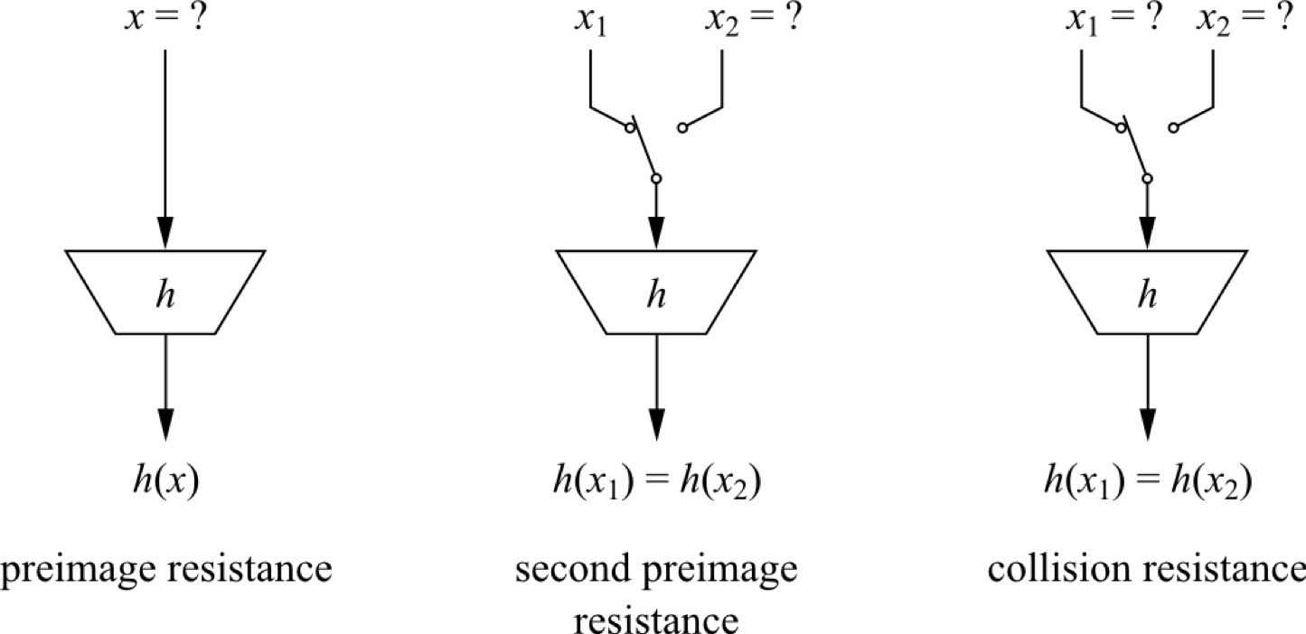

1. Decrypt the cipher C= 87 using RSA with the following parameters:

e = 1127, n = 41 X 37.

Solution:

P = 41 , q = 37, n = 1517

F(n) = 40 * 36 = 1440

e * d mod f(n) = 1 => d = 23

PU{1120, 1517}

PR{23, 1517}

Plain text = 87^23 mod 1517 = 1028

1. Apply an attack to send a valid signature to Alice pretending you are Bob, provided, you know that Bob and Alice are using RSA digital signature, Public Key of Bob is 11, and the public Modula n=221.

Show that your attack is successful.

1. Convert the superincreasing knapsack (1, 4, 9, 17, 38, 79) to a general one. Then encrypt the message (101011010100011).

N = 79 * 2 = 158

M = 37; relatively prime with N

1 * 37 mod 158 = 37

4 * 37 mod 158 = 148

9 * 37 mod 158 = 17

17 * 37 mod 158 = 155

38 * 37 mod 158 = 142

79 * 37 mod 158 = 79

GK: (37, 148, 17, 155, 142, 79)

Finding the inverse of M

|  |  |  |  |  |  |  |
| --- | --- | --- | --- | --- | --- | --- |
| Q | A1 | A2 | A3 | B1 | B2 | B3 |
| - | 1 | 0 | 158 | 0 | 1 | 37 |
| 4 | 0 | 1 | 37 | 1 | -4 | 10 |
| 3 | 1 | -4 | 10 | -3 | 13 | 7 |
| 1 | -3 | 13 | 7 | 4 | -17 | 3 |
| 2 | 4 | -17 | 3 | -11 | 47 | 1 |

Inverse of M = 47

(1 0 1 0 1 1 0 1 0 1 0 0 0 1 1 )

37+0+17+0+142+79+0+148 +0+155+0+0+0+148 + 17 = 615