

Princess Sumaya University for Technology

King Abdullah II Faculty of Engineering

Computer Engineering Department

Microprocessors and Embedded Systems

**Project Report**

*Greenhouse*

|  |  |  |  |
| --- | --- | --- | --- |
| Student | Student ID | Major | Email |
| Mais Allahham | 20200250 | NIS Engineering | mai20200250@std.psut.edu.jo |
| Dina Shweikh | 20200565 | NIS Engineering | din20200565@std.psut.edu.jo |
| Maen Amer | 20200457 | NIS Engineering | Mae20200457@std.psut.edu.jo |

Fall 2023/2024

Introduction

In the realm of indoor gardening, the fusion of technology and cultivation has become essential. Traditional greenhouse methods often lack precision, requiring continuous manual oversight for optimal plant growth.

This project endeavors to redefine indoor plant care through an intelligent embedded system. By integrating sensors, actuators, and smart controls, it automates vital care aspects and offers easy monitoring for enthusiasts.

Existing solutions fall short in tailoring care to individual plant needs. This smart greenhouse system aims to automate irrigation based on soil moisture, regulate temperature using responsive controls, and optimize light exposure for different plants.

The vision is to create an intuitive, adaptable system empowering enthusiasts to nurture indoor plants with ease, fostering healthy growth and vibrant greenery.

Features

1-Buzzer for alert: a buzzer will generate a sound to alert the user that the water level in the pump in considerably low.

2. Small water pump: used to imitate an actual water pump that irrigates the plant based on certain times.

3- LED bulb: provides required light to the indoor plant.

4-Temperature sensor: maintains continuous monitoring of the temperature to inform the user if the environment’s temperature is suitable for the plant or not. Readings will be displayed on an LCD screen.

5-Water level sensor: observes water level in chamber to assure the user the water is not low.

6-LEDs: Three LEDs will be used to display an accurate observation of current temperature:

RED LED: will be turned on if temperature is considerably higher than accepted temperature that the plant can withstand.

GREEN LED: will be turned on if temperature is stable.

BLUE LED: will be turned on if temperature is considered low.

7-LCD screen: Displays readings of humidity of air and soil. As well as, current temperature, water level and light readings.

8-Humidity Sensor: observes the humidity in soil and air.

Mechanism

The embedded greenhouse system focuses on automating and controlling vital aspects of indoor plant care. At its core is an irrigation setup consisting of a small water tank housing a motorized pump and pipes. This system operates on a predefined schedule, activating the pump to irrigate the plants. The soil humidity sensor acts as a crucial trigger, detecting soil moisture levels. When the sensor identifies a drop below the set threshold, it initiates the watering process. Once the desired moisture level is achieved, the system automatically halts the irrigation.

The system also incorporates a water level sensor that continually monitors the tank's water levels. Should the water level fall critically low, a buzzer alerts users to refill the tank, ensuring uninterrupted irrigation. Temperature regulation is facilitated by a temperature sensor and three LEDs - red, green, and blue. The temperature sensor monitors the ambient temperature, triggering the appropriate LED to indicate the conditions. The red LED signifies high temperatures, prompting the activation of a fan to cool the environment. Meanwhile, the green LED indicates moderate temperatures, and the blue LED signals low temperatures.

Additionally, a controlled light system manages the duration and timing of light exposure crucial for plant growth. This system turns on and off based on a predetermined schedule. Any deviation from this schedule triggers an alarm, notifying users of irregular light usage. To facilitate monitoring and interaction, an LCD display showcases real-time data on soil moisture, temperature, water levels, and overall system status. This interface allows users to adjust settings and monitor the greenhouse environment effectively.

Block Diagram

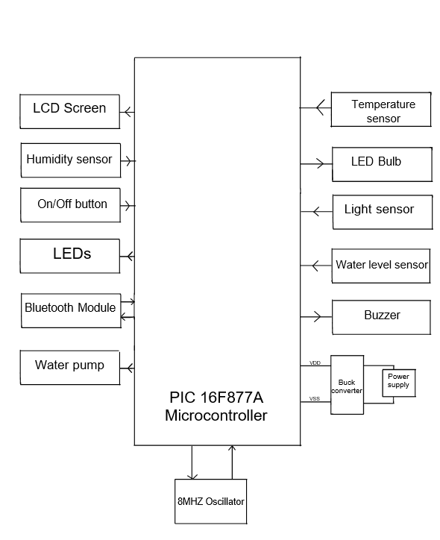

Components

**LM35**LM35 is a temperature sensor that outputs an analog signal which is proportional to the instantaneous temperature. The output voltage can easily be interpreted to obtain a temperature reading in Celsius. In our project, we used it to measure ambient temperature of the plant.

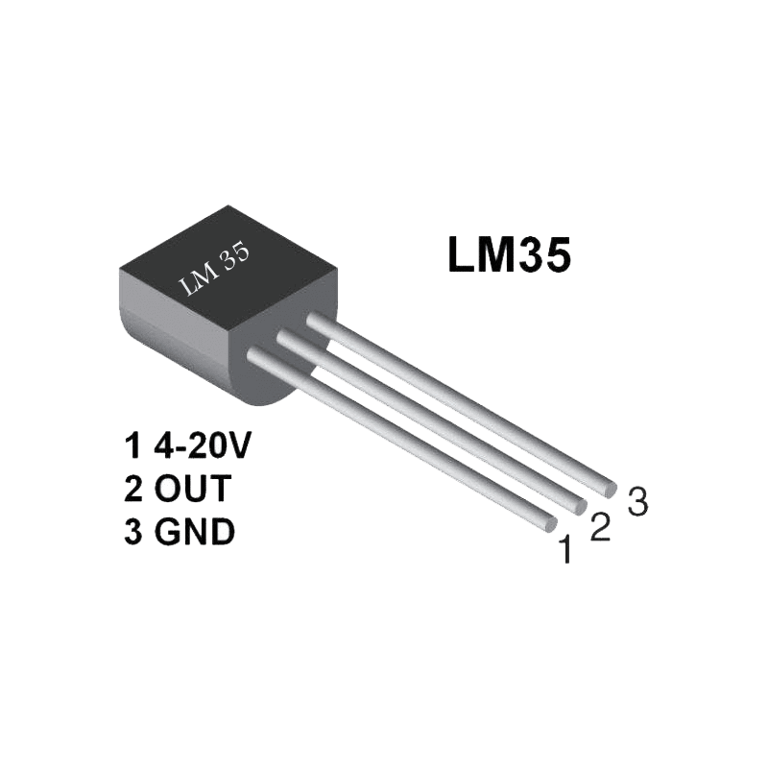

F

**16x2 LCD Screen**LCD screens are used for displaying information in various electronic devices. For our project, we used it to display the temperature.

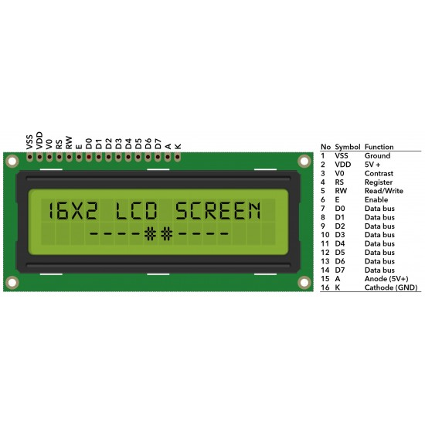

**Water level**  
A digital water level sensor is a device designed to measure the water level in a given location and provide a digital output based on the detected water level

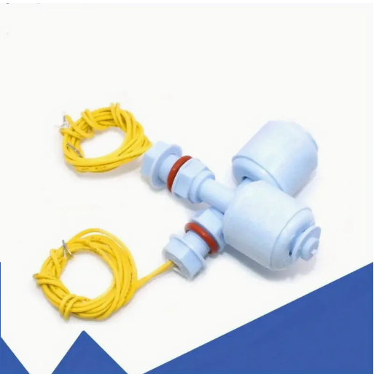

**DC Water Pump Motor**

The DC water pump motor is a compact and efficient electric motor designed for the purpose of moving water. It typically consists of a motor unit and an attached impeller or pumping mechanism. The motor is engineered to convert electrical energy from a DC power source into mechanical energy, driving the impeller to create water flow. We are using it in our project to irrigate the plant

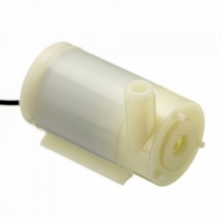

**DC Water Pump Motor**

The DC fan motor is a specialized electric motor designed for the purpose of driving fan systems. Comprising a motor unit and a fan blade assembly, the motor's primary function is to transform electrical energy from a DC power source into mechanical energy. We use it in our project to turn on the fan for the plant based on the temperature.

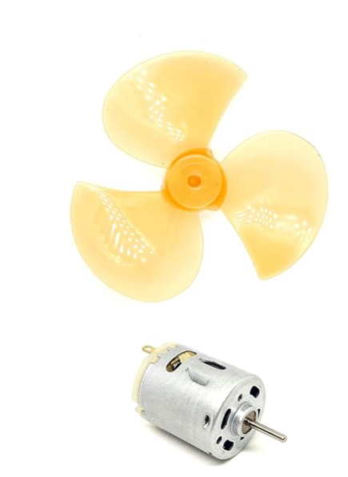

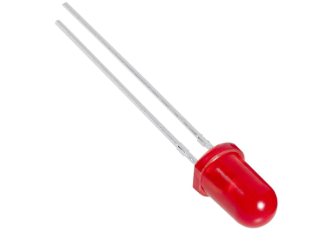

An LED, or Light Emitting Diode, is a small semiconductor device that emits light when an electric current passes through it

Mechanical Design

Method 1:

Gravity-Fed Watering System:

Mechanism:Relies on a straightforward gravity-driven mechanism, we can place a water container above the plant and add a water valve actuator to it

Letting the water drip on the top of the plant.

Pros of this method:

* Low Cost: Requires minimal components, leading to lower initial costs.

* Energy-Efficient: Operates without the need for a pump, reducing energy consumption.

* Reliability: Less prone to technical malfunctions due to its simple design.

* Cons of this method:

* Limited Range: Gravity-fed systems are most effective in setups where the water source is elevated above the plants.

* Less Precision: Might not provide as precise control over water delivery compared to more complex systems since water runoffs might occur too.

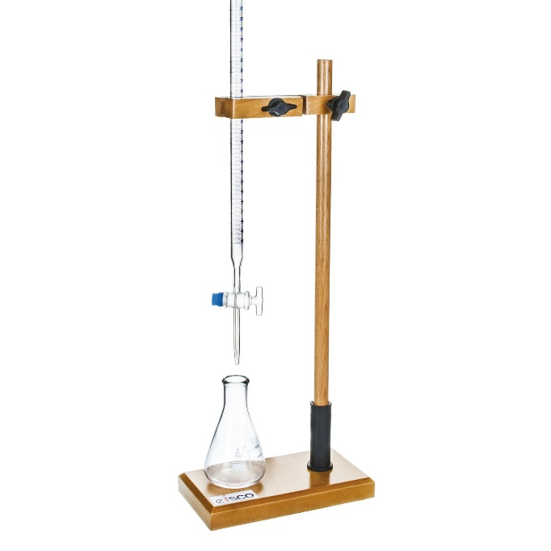

Method 2

Drip Irrigation System:

Mechanism: Employ a small water pump connected to a water reservoir. Use a network of tubes with strategically placed drip emitters to deliver water directly to the base of each plant.

Peripheral: Water pump,tubes

* precision: Delivers water directly to the base of each plant, ensuring targeted hydration.

* Efficiency: Minimizes water wastage by avoiding unnecessary runoff.

Scalability: Can be scaled for various garden sizes, from small plant pots to larger greenhouse setups.

Cons of this project:

* Complexity: Setting up the tubing and emitters may require more initial effort and maintenance.

* Cost: Initial setup costs might be higher due to the need for a water pump(which also needs more voltage and power) and additional components.

• Our decision: In our case we chose this method since it’s pros are way more than the cons and it’s more suitable for our project that needs precision and aims for water reservation

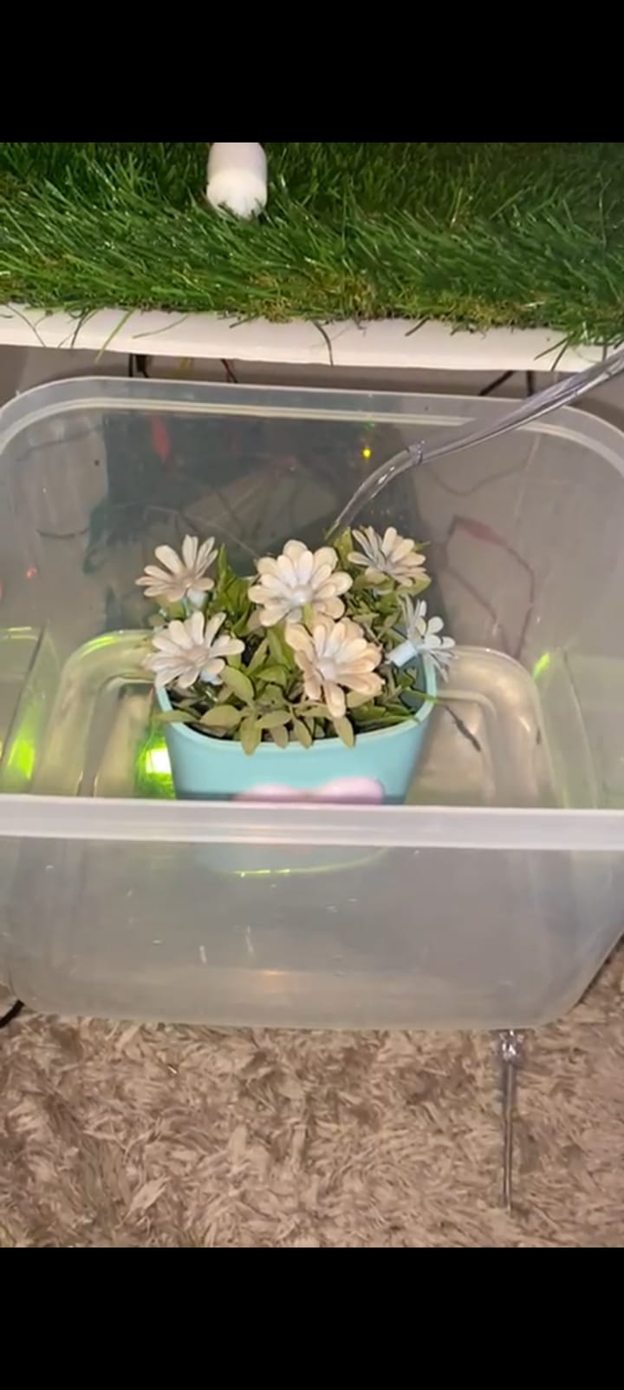

Electrical Design

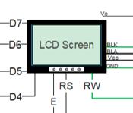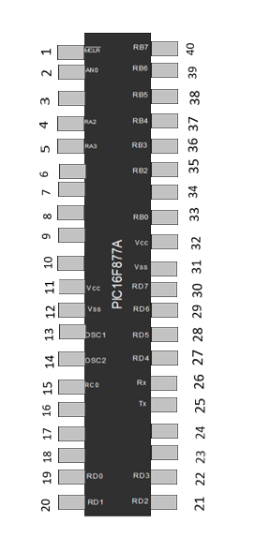

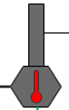









Software Design

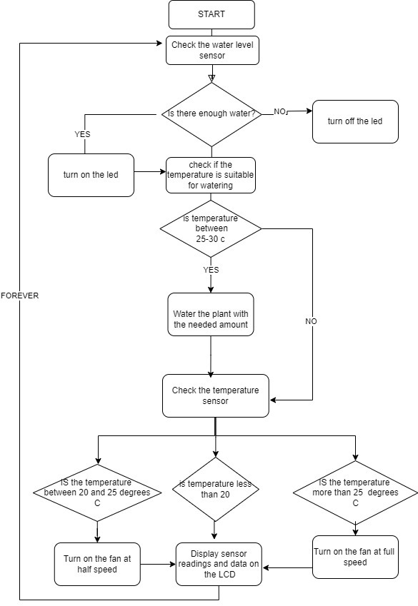

Final Design

# Problems and Recommendations

While working on this project, our team faced many complications, some that we managed to solve, and some that we unfortunately were unable to overcome. Some of these problems are:

we've encountered a few challenges in both the software and electrical aspects of the project. While progressing through the development stages, we paid too much attention to our code adding many sensors and ideas but didn’t debug our code and test the sensors after every step until we were done with it. All our code even the parts that didn’t work at the end will be provided .

•Software issues:

*We had a full serial communication code to inform the user that the water container is empty , yet we couldn’t use it since the hyper terminal program wasn’t installing for us

*Another issue we had is our timer 0 interrupt ( that was responsible for watering the plant on time)wasn’t working although the code and logic was 100% correct we tried and experimented many variations yet it still didn’t work.

•Electrical issues:

*We wanted to add more than one ATD sensor however our lcd would crash so we couldn’t do that although we bought all the components and the code was fully working since when we used every sensor individually there was no problems