# C:\Users\dell\Desktop\app image.pngCERTIFICATE MANAGEMENT APP

**Prepared For:-**

**SFDC INTERN Program**

**Capgemini Services**

**Submitted By:-**

**Name :- Abhilash Kar**

**Emp. Id :- 46022584**

**Abstract**:-

The Certificate Management app is a salesforce app which is used to handle the certification request made by the employee for the voucher. This app is made by using a CRM tool i.e. salesforce. Here the employees can send their details and the choice of certification they want the voucher for to the app user who generates a request for the voucher to the app admin filling out the details for the approval. Here the app admin can only create, delete and edit the certification and voucher. The vouchers will get automatically assigned to the request once it gets approved by the app admin. After the employee appears the certification exams for whom the voucher was assigned for will have to give the details about the results to the app user so that app user can update the status to pass or fail. This will help to know about the certified employees in the company and can keep a track about the people who appear for those certification exams.

**Scopes:**

Inscope:-

Following is the functionality provided by the system:

There are two categories of people who would access the system: app user and app admin. Each of these would have some exclusive privileges.

1. The App User can:

a. Login into the application.

b. Create an employee record.

c. View Certification.

d. View Voucher.

e. Make a certification request.

f. View the certification request made.

g. Cancel or modify a certification request.

2. The App Admin can:

a. Login into the application.

b. Add, delete and edit certification.

c. Add, delete and edit certification.

d. Check for available flights.

e. View the certification request details.

f. View the employee details.

g. Approve/Reject the request.

Outscope:-

The following functionalities have not been covered under the application:

1. The application does not allow employee to add their own details or send a certification request.
2. One voucher cannot be used again by different employees.

**Class Diagram:-**

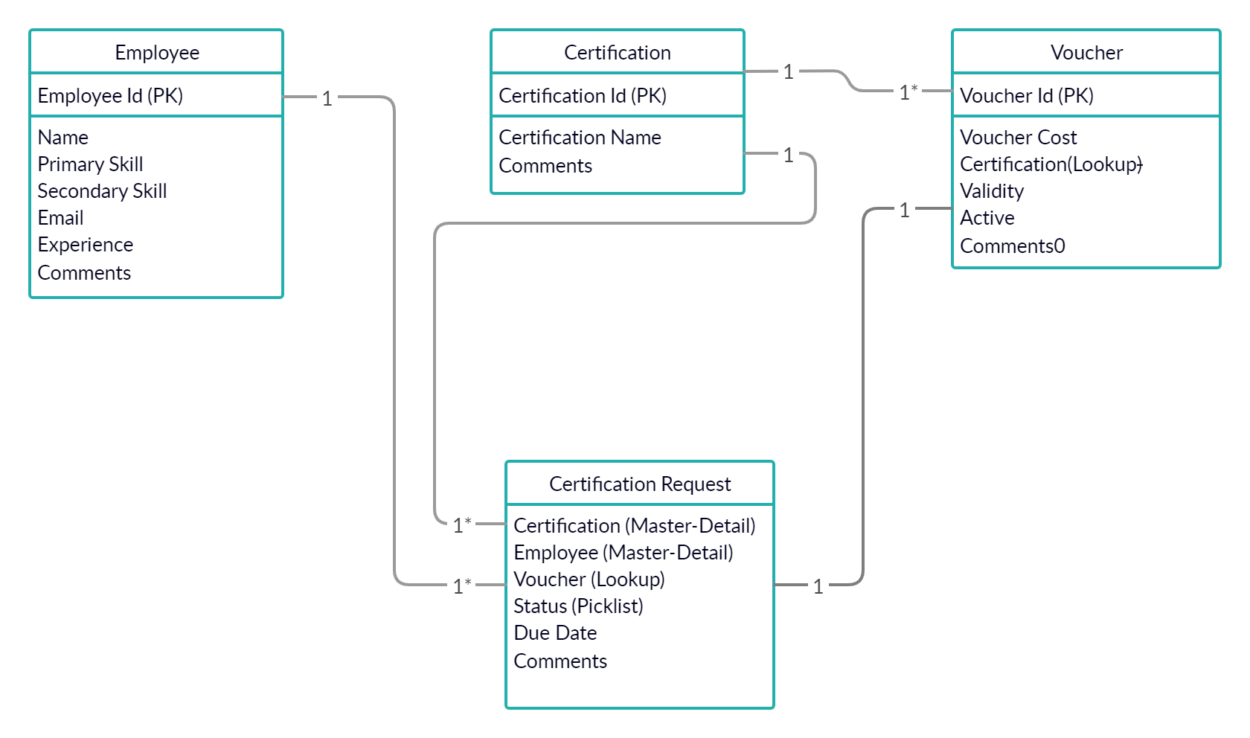

**SEQUENCE DIAGRAM FOR APP USER:-**

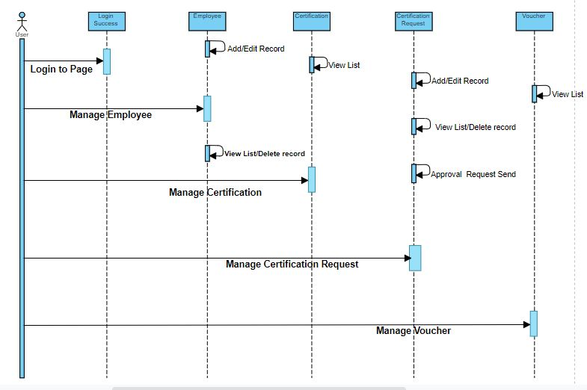

**SEQUENCE DIAGRAM FOR APP ADMIN:-**

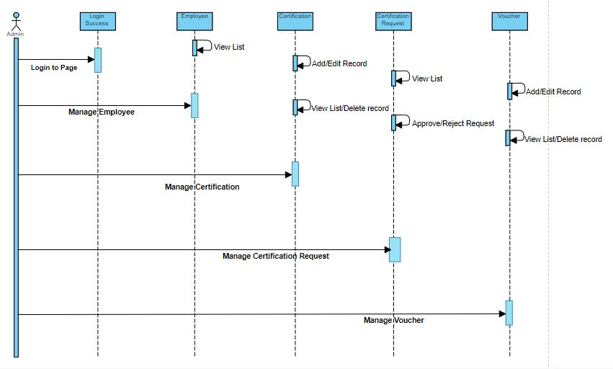

**Activity Diagram for Admin:-**

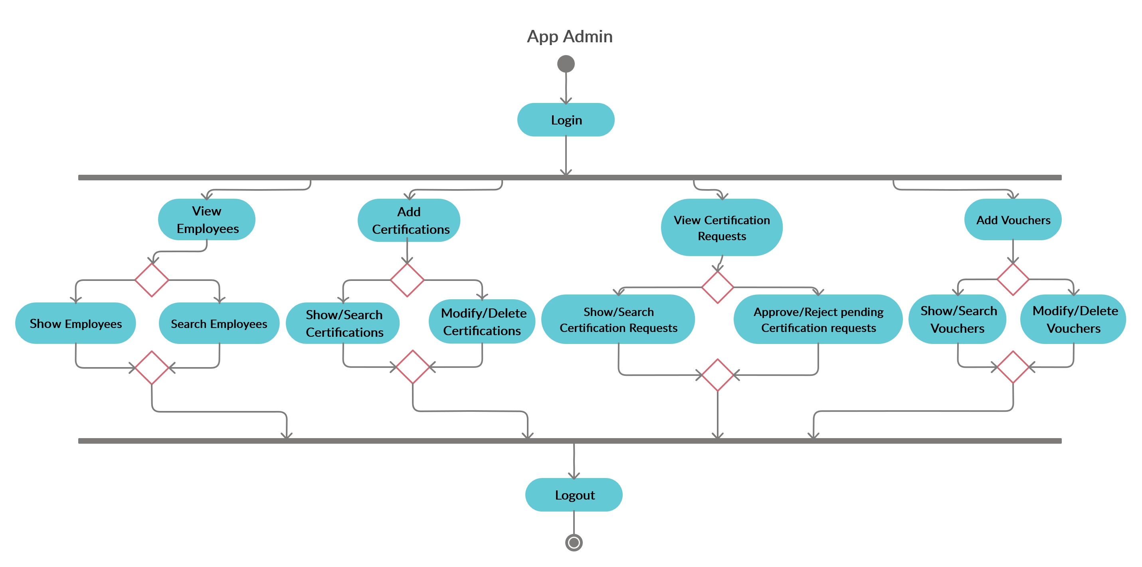

**Activity Diagram for User:-**

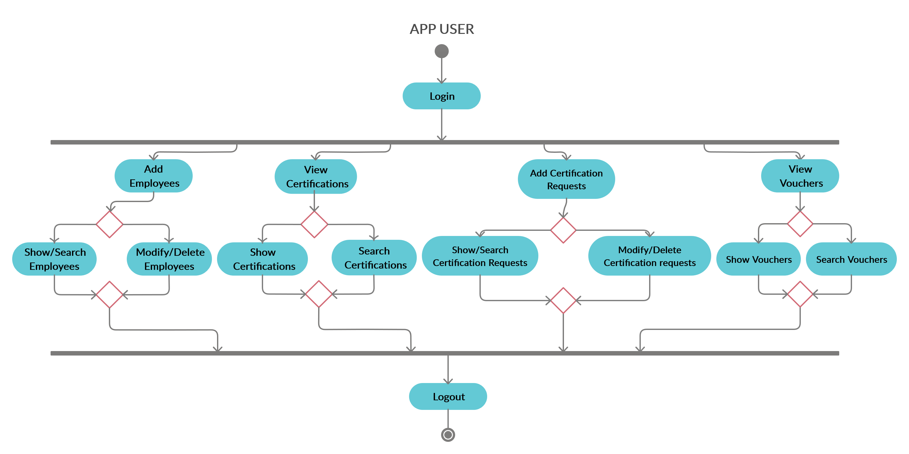

**Flowchart:-**

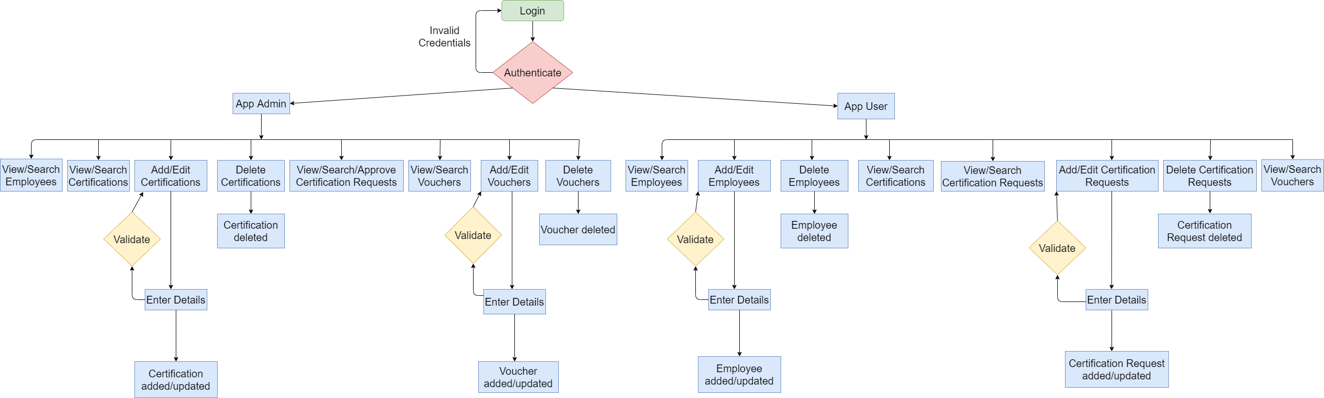

**Use Case Diagram:-**

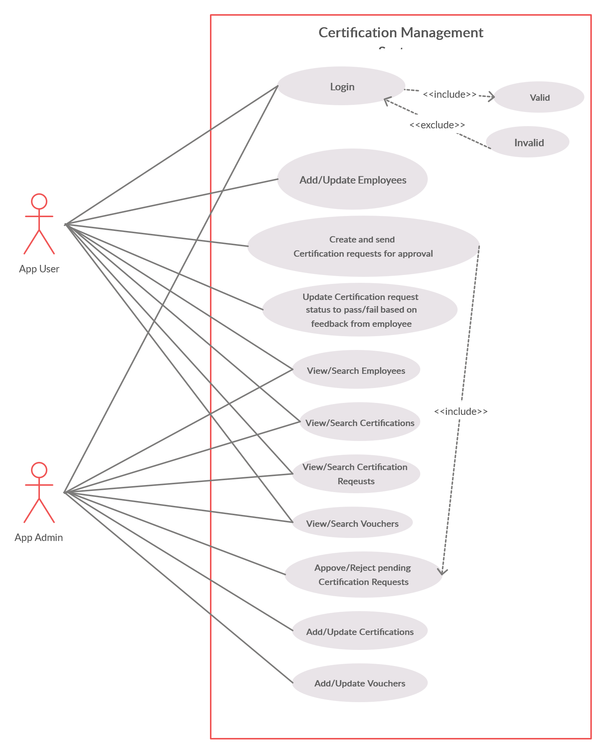

**Wireframes:-**

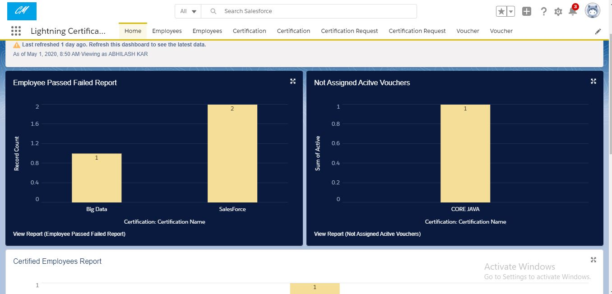

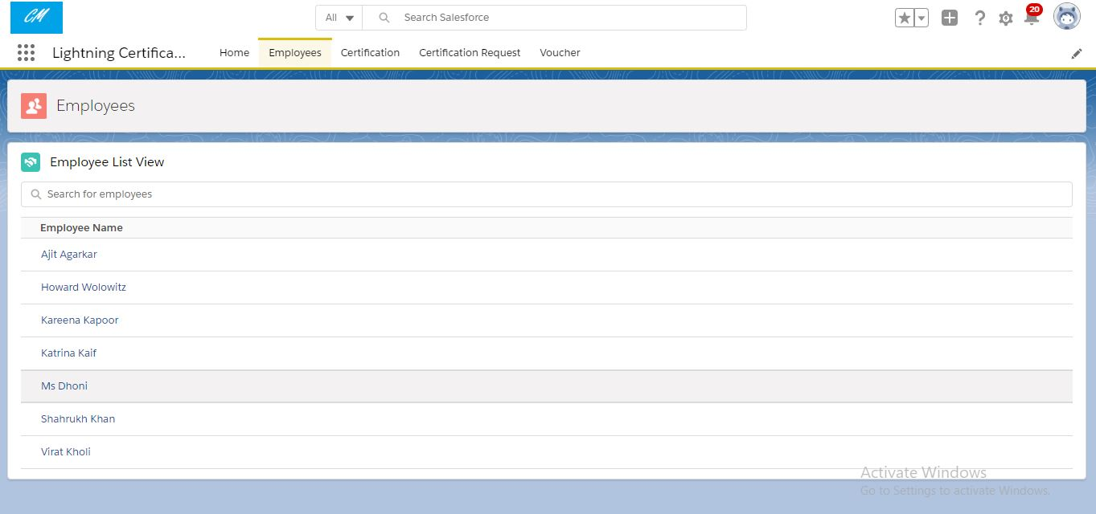

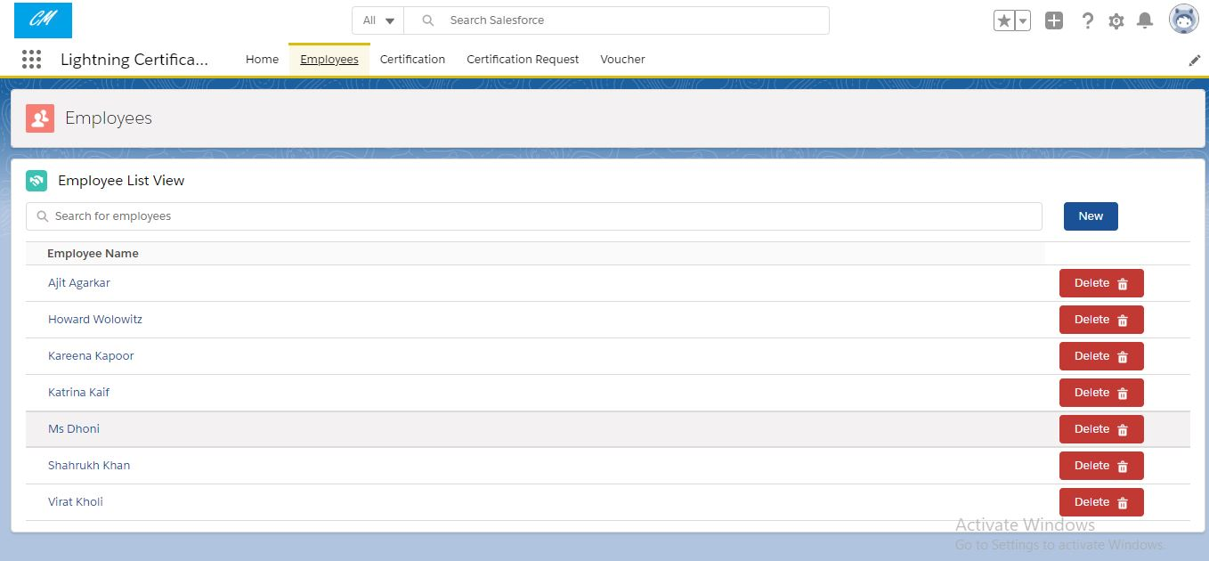

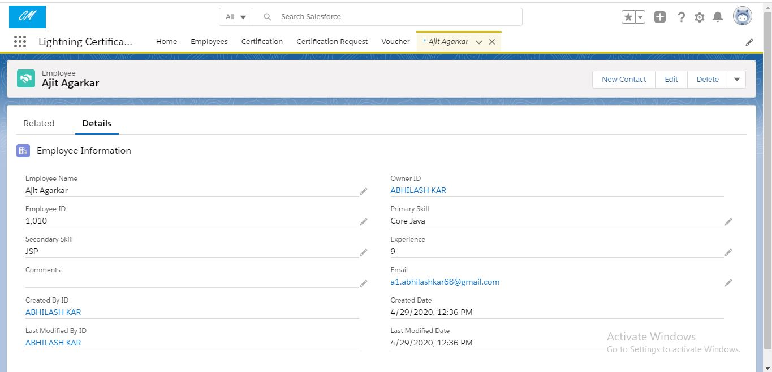

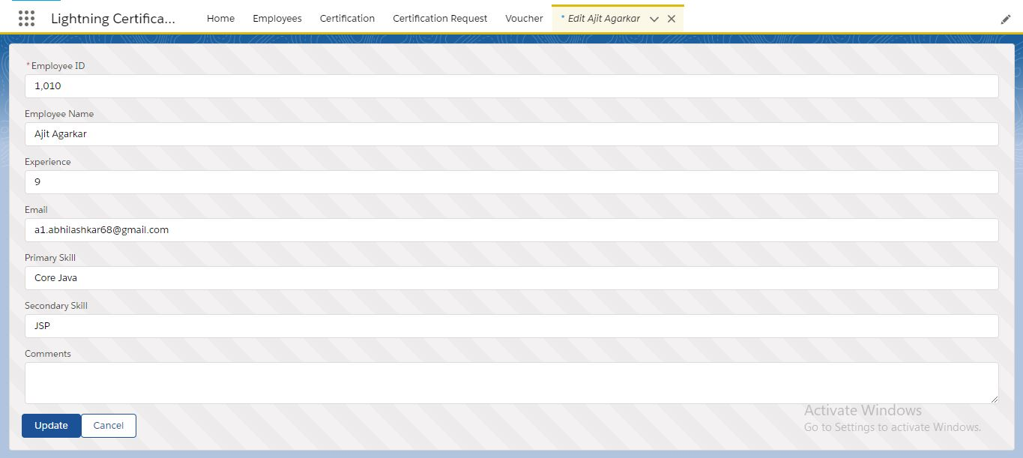

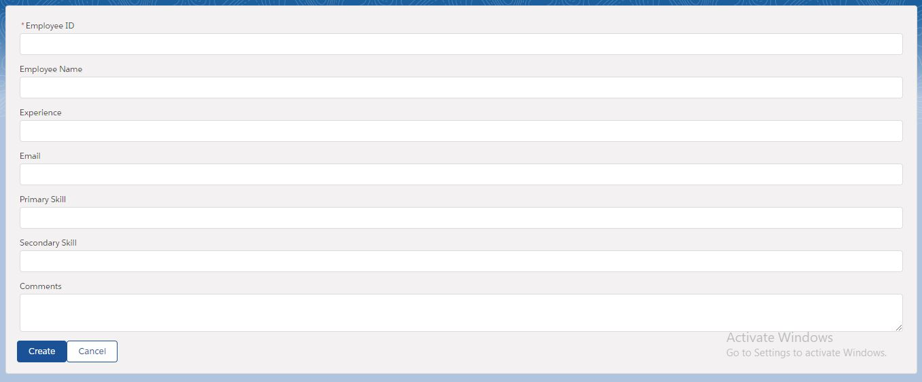

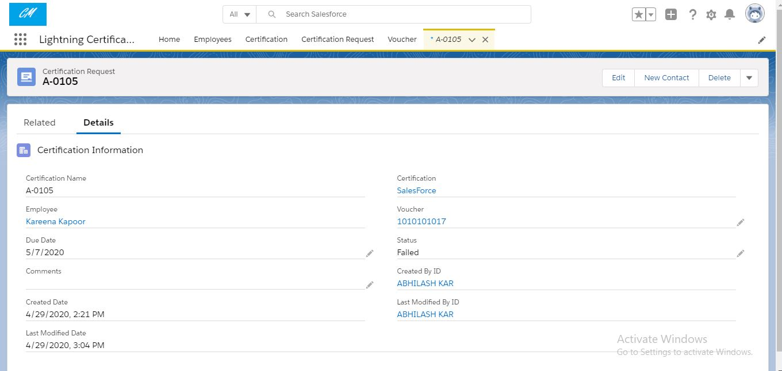

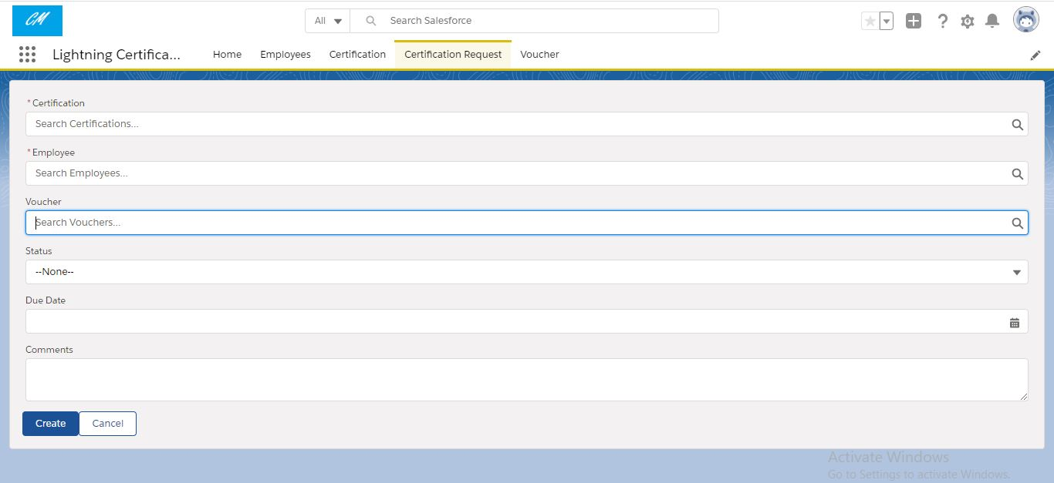

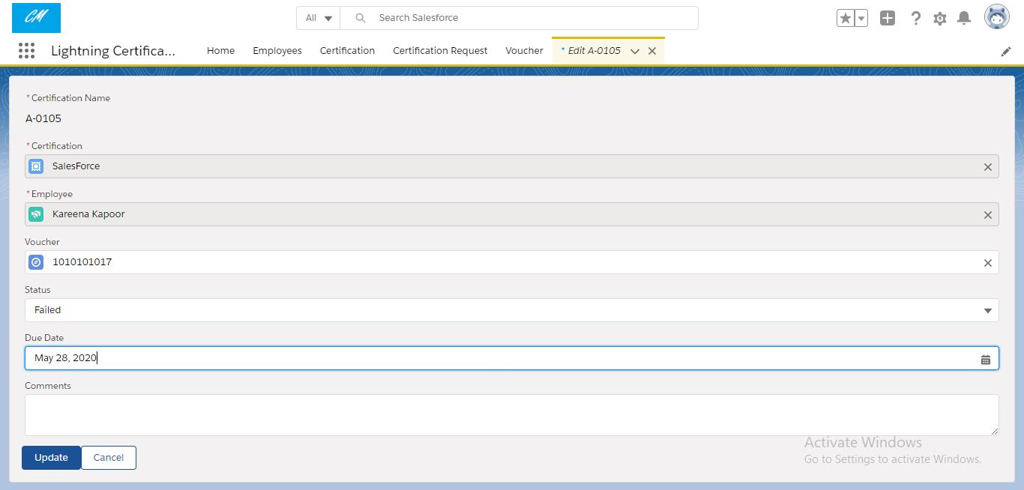

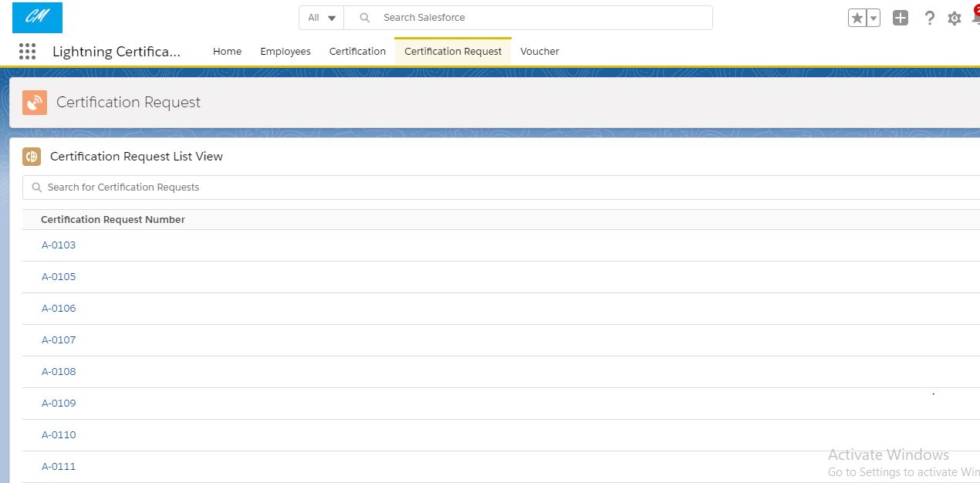

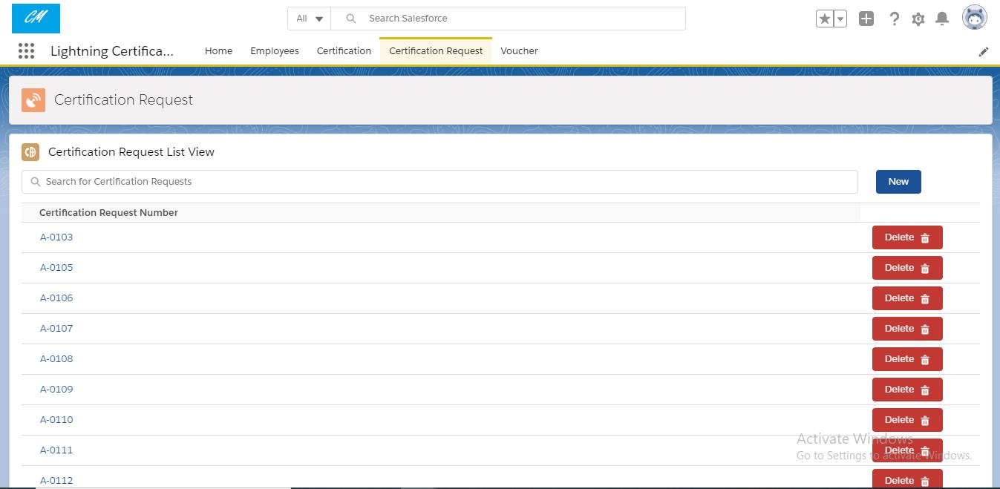

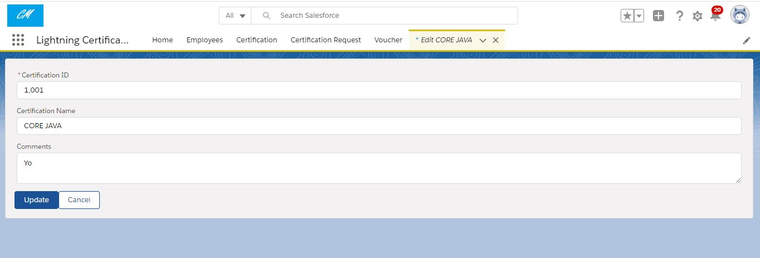

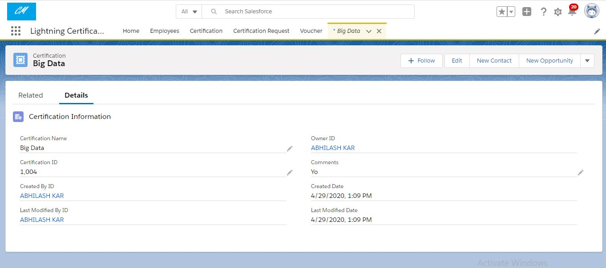

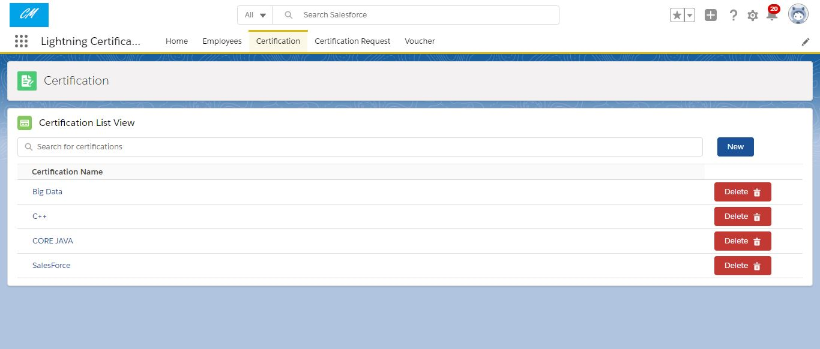

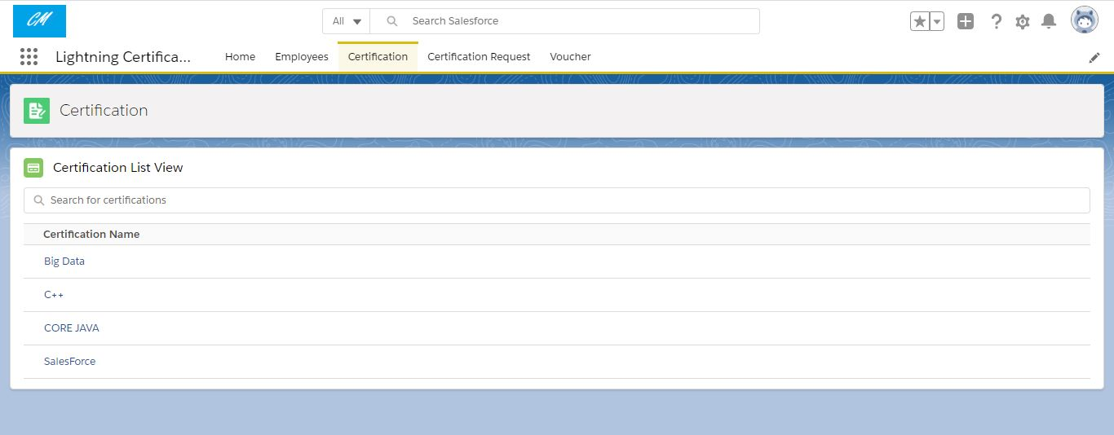

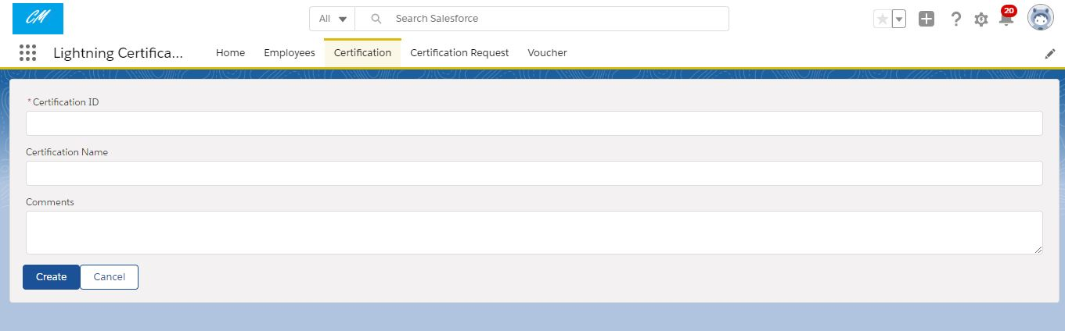

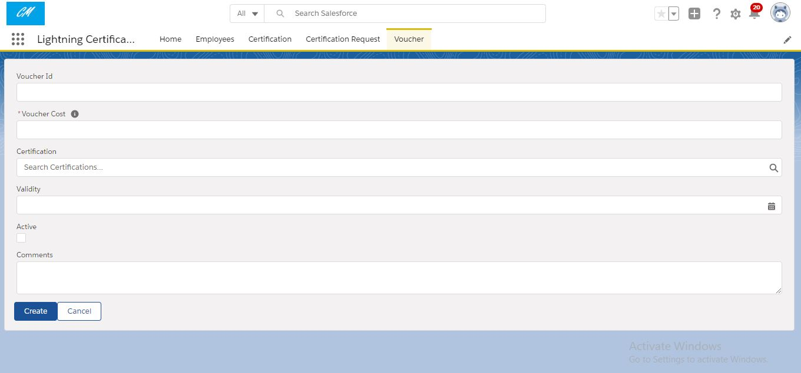

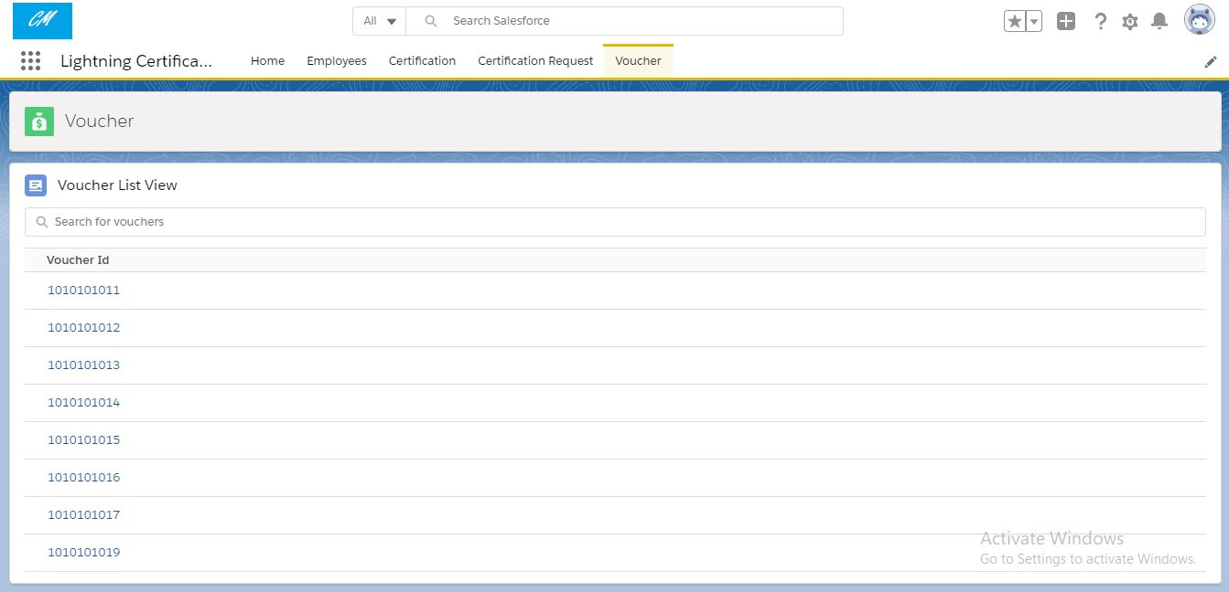

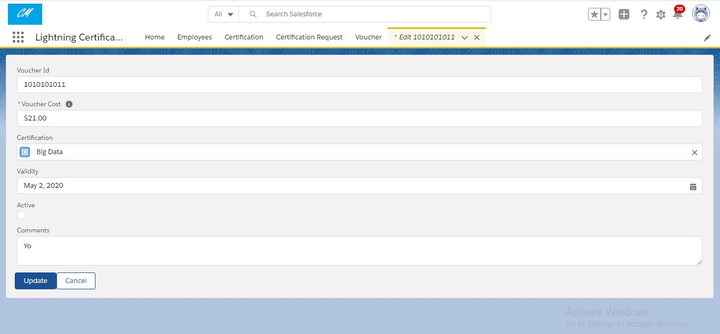

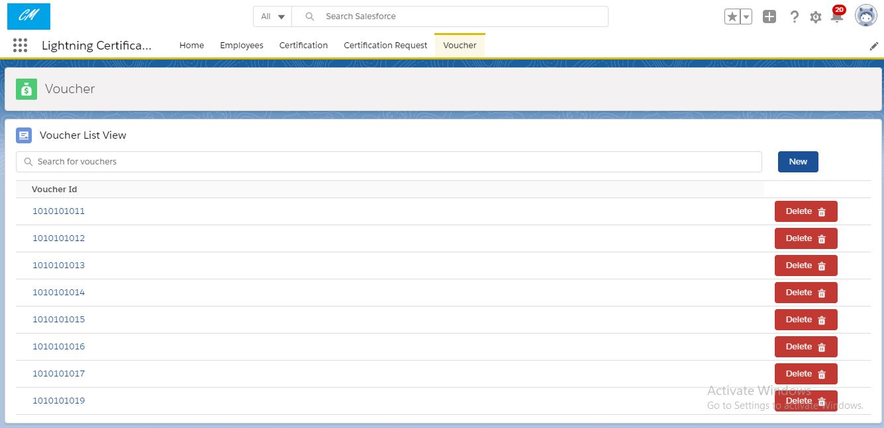

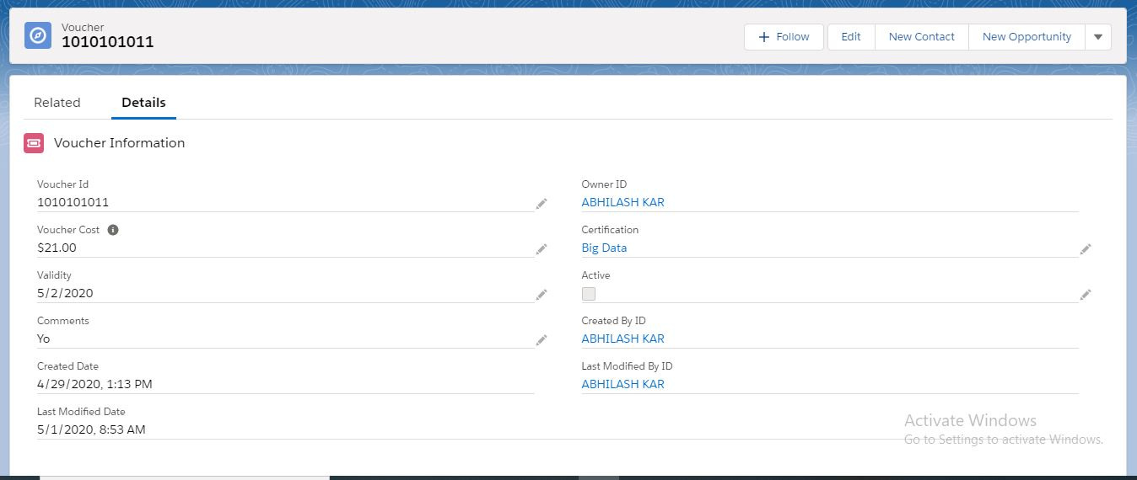

**Profiles**:-

App Admin:-

Custom Objects permission:-

Employee - Read

Certification - Read, Create, Edit and Delete

Certification Request - Read and Approving/Rejecting the Certification Request send by the app user

Voucher - Read, Create, Edit and Delete

App Pages Turned on:-

1. Employee1

2. Certification

3. Certification_Request1

4. Voucher

Apps Allowed:-

Lightning Certification Management

App User:-

Custom Objects permission:-

Employee - Read, Create, Edit and Delete

Certification - Read

Certification Request - Read , Create, Edit ,Delete and submits the certification request to the app admin.

Voucher - Read

App Pages Turned on:-

1. Employee

2. Certification1

3. Certification_Request

4. Voucher1

Apps Allowed:-

Lightning Certification Management

**Custom Objects and its Fields**:-

1. Employee:-

1. Employee ID : Number

2. Employee Name : Text

3. Primary Skill : Text

4. Secondary Skill : Text

5. Experience : Number

6. Email : Email

7. Comments : Textarea

2. Certification:-

1. Certification Id : Number

2. Certification Name : Text

3. Comments : Textarea

3. Certification Request:-

1. Certification Request Id : Auto-Number

2. Certification : Master-Detail

3. Employee : Master-Detail

4. Voucher : lookup

5. Due Date : Date

6. Status : Picklist

7. Comments : Textarea

4. Voucher:-

1. Voucher Id : Text

2. Voucher Cost : Currency

3. Certification : Lookup

4. Active : Checkbox

5. Validity : Date

6. Comments : Textarea

**Components and its function:-**

createOverride:-

It basically overrides the new standard button of the employee object with our custom new button made by using record-edit-form and lwc integrated in aura.

editOverride:-

It basically overrides the edit standard button of the employee object with our custom edit button made by using record-edit-form and lwc integrated in aura.

searchEmployee:-

It shows the list of Employee object records with a search bar, new button which will help to create new record and delete button which will delete the records.

employeeSearch:-

It shows the list of employee record with a search bar.

employeeRecordForm:-

It shows the details of employee within a lightning card.

certificationNew:-

It basically overrides the new standard button of the certification object with our custom new button made by using record-edit-form and lwc integrated in aura.

certificationEdit:-

It basically overrides the edit standard button of the certification object with our custom edit button made by using record-edit-form and lwc integrated in aura.

searchCertification:-

It shows the list of certification object records with a search bar, new button which will help to create new record and delete button which will delete the records.

certificationSearch:-

It shows the list of certification record with a search bar.

certificationRecordForm:-

It shows the details of certification within a lightning card.

certificationRequestNew:-

It basically overrides the new standard button of the certification_request object with our custom new button made by using record-edit-form and lwc integrated in aura.

certificationRequestEdit:-

It basically overrides the edit standard button of the certification_request object with our custom edit button made by using record-edit-form and lwc integrated in aura.

searchCertificationRequest:-

It shows the list of certification_request object records with a search bar, new button which will help to create new record and delete button which will delete the records.

certificationRequestSearch:-

It shows the list of certification_request record with a search bar.

certificationRequestRecordForm:-

It shows the details of certification_request within a lightning card.

voucherNew:-

It basically overrides the new standard button of the voucher object with our custom new button made by using record-edit-form and lwc integrated in aura.

voucherEdit:-

It basically overrides the edit standard button of the voucher object with our custom edit button made by using record-edit-form and lwc integrated in aura.

searchVoucher:-

It shows the list of voucher object records with an search bar, new button which will help to create new record and delete button which will delete the records.

voucherSearch:-

It shows the list of voucher record with a search bar.

voucherRecordForm:-

It shows the details of voucher within a lightning card.

**Apex Classes**:-

1.Employees:-

Returns the Name and Id of records of the Employee object.

2.Certification:-

Returns the Name and Id of records of the Certification object.

3.CertificationRequest:-

Returns the Name and Id of records of the Certification_Request object.

4.Voucher:-

Returns the Name and Id of records of the Voucher object.

**Validations**:-

App User should not be able to add new certification voucher request in system if there is any pending request exist for that employee.

App User should not be able to raise same certification voucher request again if one already exist in the system.

Only Unused voucher should be assigned to the certification request. App Admin should not able to assign voucher manually without approval.

Only One Voucher can be assigned to 1 Certification request.

Voucher should be exact 10 characters long and unique.

If an employee gets passed/failed in any certification then system should not allow to App User to raise same certification request for that employee again.

**Assumptions**:-

The employee will send it’s details to the app user over his email id which would be entered by the app user manually.

When a voucher gets assigned to an employee it gets deactivated and can be used on only one certification and one employee.