Name: ASHMIN KARKI

Student ID: 104081193

Checklist of Tasks Completion ***(please tick each one as appropriate)***

|  |  |
| --- | --- |
| **Assessment item** | **Completed** |
| Comment and readme file | YES  NO ☐ PARTIALLY ☐ |
| **Task 1:** | YES  NO ☐ PARTIALLY ☐ |
| **Task 2.1** | YES  NO ☐ PARTIALLY ☐ |
| **Task 2.2** | YES  NO ☐ PARTIALLY ☐ |
| **Task 3.1** | YES  NO ☐ PARTIALLY ☐ |
| **Task 3.2** | YES  NO ☐ PARTIALLY ☐ |
| **Task 3.3** | YES  NO ☐ PARTIALLY ☐ |
| **Task 3.4** | YES ☐ NO ☐ PARTIALLY |
| **Task 4.1** | YES  NO ☐ PARTIALLY ☐ |
| **Task 4.2** | YES  NO ☐ PARTIALLY ☐ |
| **Task 3.3** | YES  NO ☐ PARTIALLY ☐ |

**Comment on Task 3.4 Partial Task Completion**

Email not being sent to the receiver with an error message bounced to my student email as follows:

(I have used my personal gmail and student email to test this)

To my student email

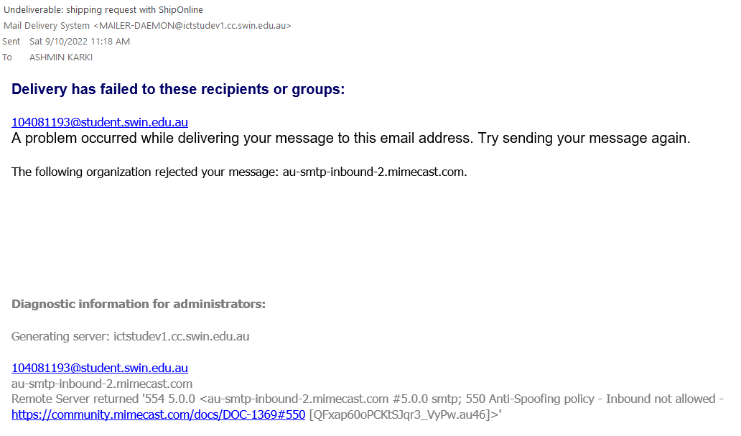

**To my personal gmail**

