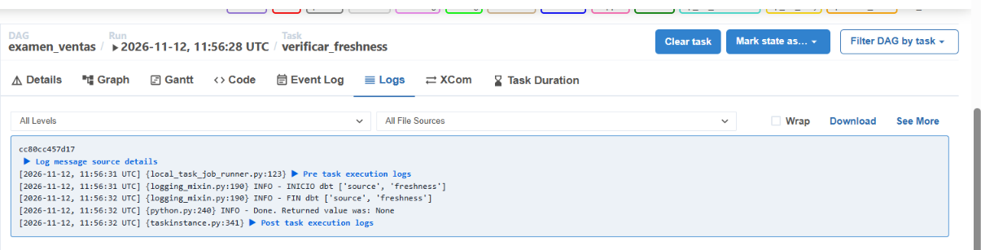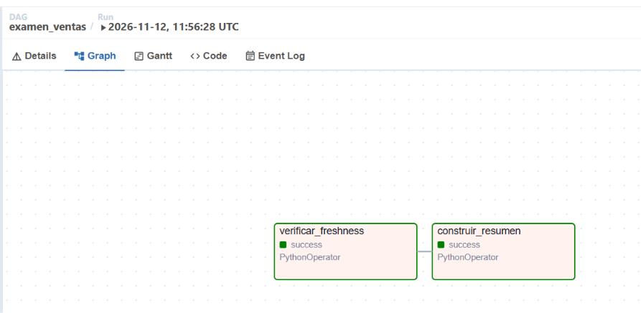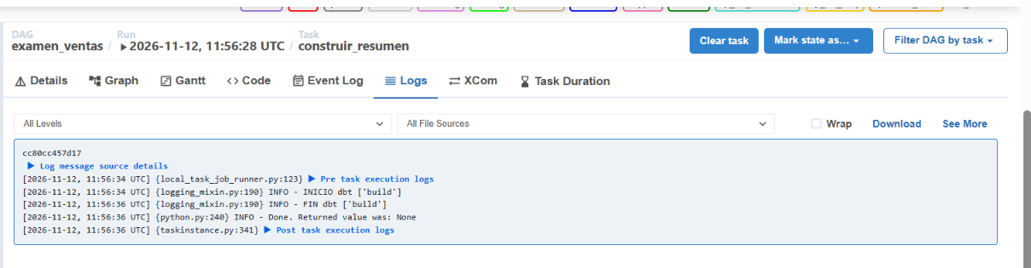
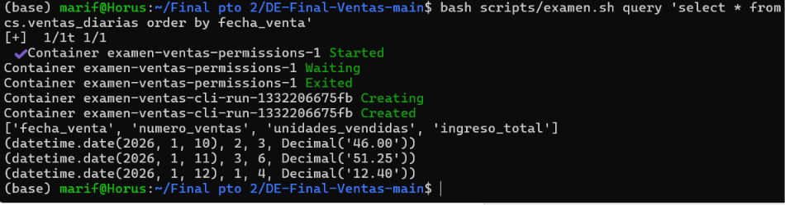

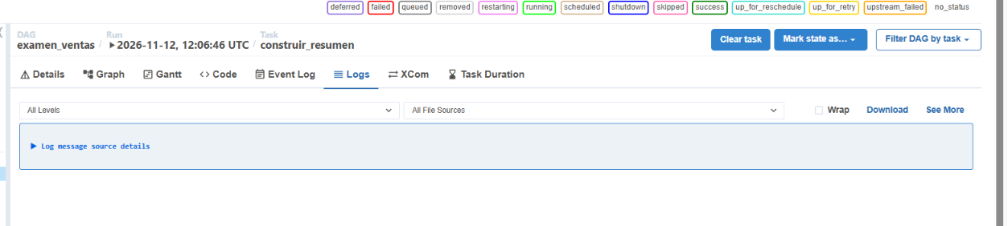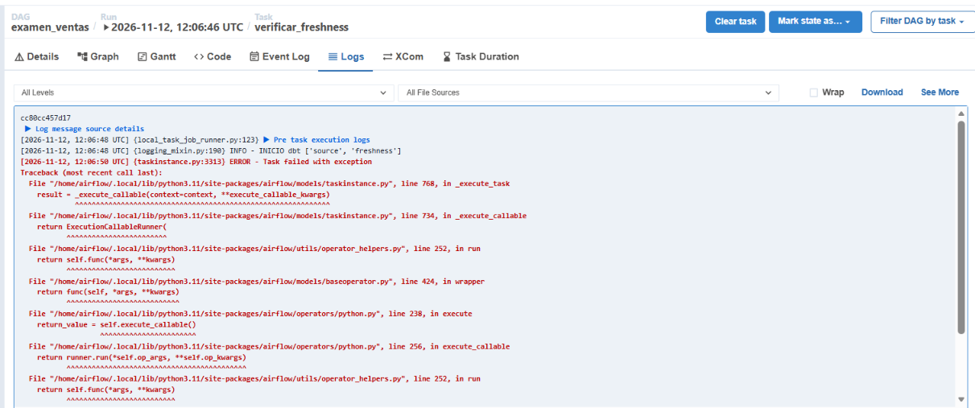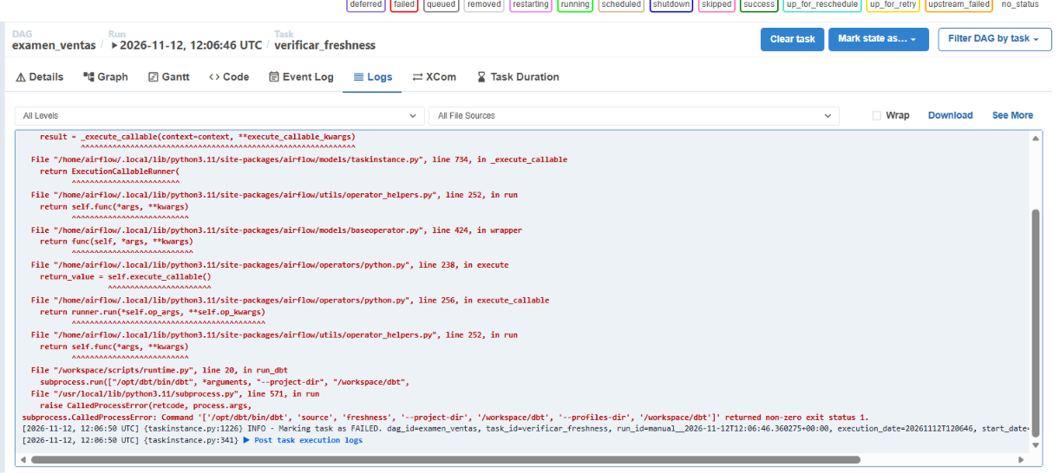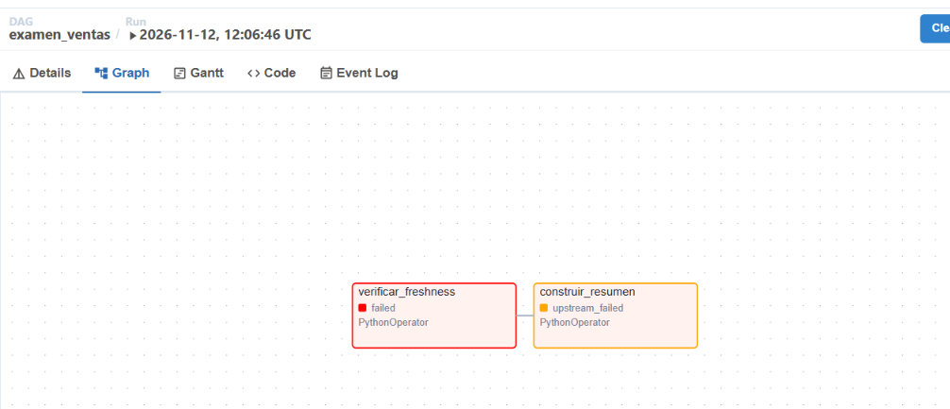
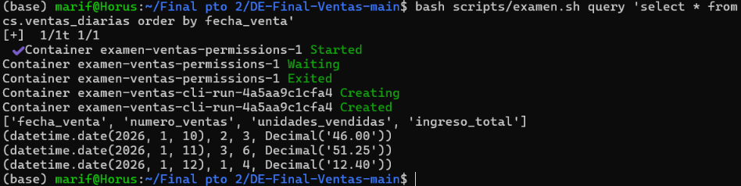
(base) marif@Horus:~/Final pto 2/DE-Final-Ventas-main$ bash scripts/examen.sh artifacts
[+] 1/1t 1/1
✔ Container examen-ventas-permissions-1 Started 0.2s
Container examen-ventas-permissions-1 Waiting
Container examen-ventas-permissions-1 Exited
Container examen-ventas-cli-run-a8a8df304b31 Creating
Container examen-ventas-cli-run-a8a8df304b31 Created
sources.json
{"metadata": {"dbt_schema_version": "https://schemas.getdbt.com/dbt/sources/v3.json", "dbt_version": "1.9.4", "generated_at": "2026-11-12T12:06:49.983956Z", "invocation_id": "ac0280e3-c35e-4ff3-81e4-a82a50751936", "env": {}}, "results": [{"unique_id": "source.examen_ventas.ventas_raw.ventas", "max_loaded_at": "2026-11-11T06:06:27.933582+00:00", "snapshotted_at": "2026-11-12T12:06:49.976000+00:00", "max_loaded_at_time_ago_in_s": 108022.042418, "status": "error", "criteria": {"warn_after": {"count": 12, "period": "hour"}, "error_after": {"count": 24, "period": "hour"}, "filter": null}, "adapter_response": {"_message": "OK"}, "timing": [{"name": "compile", "started_at": "2026-11-12T12:06:49.968397Z", "completed_at": "2026-11-12T12:06:49.968400Z"}, {"name": "execute", "started_at": "2026-11-12T12:06:49.968579Z", "completed_at": "2026-11-12T12:06:49.978505Z"}], "thread_id": "Thread-1 (worker)", "execution_time": 0.010627031326293945}], "elapsed_time": 0.0599980354309082}
run_results.json
{"metadata": {"dbt_schema_version": "https://schemas.getdbt.com/dbt/run-results/v6.json", "dbt_version": "1.9.4", "generated_at": "2026-11-12T12:01:06.833553Z", "invocation_id": "09e9135f-40af-4fb1-9ace-27df188b7817", "env": {}}, "results": [{"status": "pass", "timing": [{"name": "compile", "started_at": "2026-11-12T12:01:06.559770Z", "completed_at": "2026-11-12T12:01:06.570568Z"}, {"name": "execute", "started_at": "2026-11-12T12:01:06.570894Z", "completed_at": "2026-11-12T12:01:06.587512Z"}], "thread_id": "Thread-1 (worker)", "execution_time": 0.029102802276611328, "adapter_response": {"_message": "OK"}, "message": null, "failures": 0, "unique_id": "test.examen_ventas.source_not_null_ventas_raw_ventas_id_venta.b061a16ac7", "compiled": true, "compiled_code": "\n \n \n\n\n\nselect id_venta\nfrom \"ventas\".\"raw\".\"ventas\"\nwhere id_venta is null\n\n\n", "relation_name": null, "batch_results": null}, {"status": "pass", "timing": [{"name": "compile", "started_at": "2026-11-12T12:01:06.590204Z", "completed_at": "2026-11-12T12:01:06.594529Z"}, {"name": "execute", "started_at": "2026-11-12T12:01:06.594749Z", "completed_at": "2026-11-12T12:01:06.600871Z"}], "thread_id": "Thread-1 (worker)", "execution_time": 0.012118816375732422, "adapter_response": {"_message": "OK"}, "message": null, "failures": 0, "unique_id": "test.examen_ventas.source_unique_ventas_raw_ventas_id_venta.11db42d5b5", "compiled": true, "compiled_code": "\n \n \n\nselect\n id_venta as unique_field,\n count(*) as n_records\n\nfrom \"ventas\".\"raw\".\"ventas\"\nwhere id_venta is not null\ngroup by id_venta\nhaving count(*) > 1\n\n\n", "relation_name": null, "batch_results": null}, {"status": "success", "timing": [{"name": "compile", "started_at": "2026-11-12T12:01:06.603867Z", "completed_at": "2026-11-12T12:01:06.606134Z"}, {"name": "execute", "started_at": "2026-11-12T12:01:06.606350Z", "completed_at": "2026-11-12T12:01:06.657059Z"}], "thread_id": "Thread-1 (worker)", "execution_time": 0.054088592529296875, "adapter_response": {"_message": "OK"}, "message": "OK", "failures": null, "unique_id": "model.examen_ventas.stg_ventas", "compiled": true, "compiled_code": "select\n id_venta,\n fecha_venta,\n cantidad,\n precio_unitario,\n _loaded_at\nfrom \"ventas\".\"raw\".\"ventas\"", "relation_name": "\"ventas\".\"analytics\".\"stg_ventas\"", "batch_results": null}, {"status": "pass", "timing": [{"name": "compile", "started_at": "2026-11-12T12:01:06.660408Z", "completed_at": "2026-11-12T12:01:06.662812Z"}, {"name": "execute", "started_at": "2026-11-12T12:01:06.663041Z", "completed_at": "2026-11-12T12:01:06.667804Z"}], "thread_id": "Thread-1 (worker)", "execution_time": 0.008742809295654297, "adapter_response": {"_message": "OK"}, "message": null, "failures": 0, "unique_id": "test.examen_ventas.not_null_stg_ventas_cantidad.07c9fe8b19", "compiled": true, "compiled_code": "\n \n \n\n\n\nselect cantidad\nfrom \"ventas\".\"analytics\".\"stg_ventas\"\nwhere cantidad is null\n\n\n", "relation_name": null, "batch_results": null}, {"status": "pass", "timing": [{"name": "compile", "started_at": "2026-11-12T12:01:06.670565Z", "completed_at": "2026-11-12T12:01:06.673888Z"}, {"name": "execute", "started_at": "2026-11-12T12:01:06.674095Z", "completed_at": "2026-11-12T12:01:06.709172Z"}], "thread_id": "Thread-1 (worker)", "execution_time": 0.04036760330200195, "adapter_response": {"_message": "OK"}, "message": null, "failures": 0, "unique_id": "test.examen_ventas.not_null_stg_ventas_fecha_venta.45981ae998", "compiled": true, "compiled_code": "\n \n \n\n\n\nselect fecha_venta\nfrom \"ventas\".\"analytics\".\"stg_ventas\"\nwhere fecha_venta is null\n\n\n", "relation_name": null, "batch_results": null}, {"status": "pass", "timing": [{"name": "compile", "started_at": "2026-11-12T12:01:06.711976Z", "completed_at": "2026-11-12T12:01:06.714868Z"}, {"name": "execute", "started_at": "2026-11-12T12:01:06.715107Z", "completed_at": "2026-11-12T12:01:06.719803Z"}], "thread_id": "Thread-1 (worker)", "execution_time": 0.009173154830932617, "adapter_response": {"_message": "OK"}, "message": null, "failures": 0, "unique_id": "test.examen_ventas.not_null_stg_ventas_id_venta.13dc2a03be", "compiled": true, "compiled_code": "\n \n \n\n\n\nselect id_venta\nfrom \"ventas\".\"analytics\".\"stg_ventas\"\nwhere id_venta is null\n\n\n", "relation_name": null, "batch_results": null}, {"status": "pass", "timing": [{"name": "compile", "started_at": "2026-11-12T12:01:06.722283Z", "completed_at": "2026-11-12T12:01:06.724585Z"}, {"name": "execute", "started_at": "2026-11-12T12:01:06.724937Z", "completed_at": "2026-11-12T12:01:06.729257Z"}], "thread_id": "Thread-1 (worker)", "execution_time": 0.008266210556030273, "adapter_response": {"_message": "OK"}, "message": null, "failures": 0, "unique_id": "test.examen_ventas.not_null_stg_ventas_precio_unitario.a4ffbcf3e1", "compiled": true, "compiled_code": "\n \n \n\n\n\nselect precio_unitario\nfrom \"ventas\".\"analytics\".\"stg_ventas\"\nwhere precio_unitario is null\n\n\n", "relation_name": null, "batch_results": null}, {"status": "pass", "timing": [{"name": "compile", "started_at": "2026-11-12T12:01:06.731820Z", "completed_at": "2026-11-12T12:01:06.734246Z"}, {"name": "execute", "started_at": "2026-11-12T12:01:06.734504Z", "completed_at": "2026-11-12T12:01:06.739185Z"}], "thread_id": "Thread-1 (worker)", "execution_time": 0.008660078048706055, "adapter_response": {"_message": "OK"}, "message": null, "failures": 0, "unique_id": "test.examen_ventas.unique_stg_ventas_id_venta.80234f8744", "compiled": true, "compiled_code": "\n \n \n\nselect\n id_venta as unique_field,\n count(*) as n_records\n\nfrom \"ventas\".\"analytics\".\"stg_ventas\"\nwhere id_venta is not null\ngroup by id_venta\nhaving count(*) > 1\n\n\n", "relation_name": null, "batch_results": null}, {"status": "pass", "timing": [{"name": "compile", "started_at": "2026-11-12T12:01:06.741837Z", "completed_at": "2026-11-12T12:01:06.743337Z"}, {"name": "execute", "started_at": "2026-11-12T12:01:06.743561Z", "completed_at": "2026-11-12T12:01:06.748883Z"}], "thread_id": "Thread-1 (worker)", "execution_time": 0.008495092391967773, "adapter_response": {"_message": "OK"}, "message": null, "failures": 0, "unique_id": "test.examen_ventas.valores_ventas", "compiled": true, "compiled_code": "select id_venta from \"ventas\".\"analytics\".\"stg_ventas\"\nwhere cantidad <= 0 or precio_unitario < 0", "relation_name": null, "batch_results": null}, {"status": "success", "timing": [{"name": "compile", "started_at": "2026-11-12T12:01:06.751776Z", "completed_at": "2026-11-12T12:01:06.753935Z"}, {"name": "execute", "started_at": "2026-11-12T12:01:06.754162Z", "completed_at": "2026-11-12T12:01:06.774882Z"}], "thread_id": "Thread-1 (worker)", "execution_time": 0.024096012115478516, "adapter_response": {"_message": "OK"}, "message": "OK", "failures": null, "unique_id": "model.examen_ventas.ventas_diarias", "compiled": true, "compiled_code": "select\n fecha_venta,\n count(*) as numero_ventas,\n sum(cantidad) as unidades_vendidas,\n sum(cantidad * precio_unitario) as ingreso_total\nfrom \"ventas\".\"analytics\".\"stg_ventas\"\ngroup by fecha_venta", "relation_name": "\"ventas\".\"analytics\".\"ventas_diarias\"", "batch_results": null}, {"status": "pass", "timing": [{"name": "compile", "started_at": "2026-11-12T12:01:06.777618Z", "completed_at": "2026-11-12T12:01:06.780027Z"}, {"name": "execute", "started_at": "2026-11-12T12:01:06.780279Z", "completed_at": "2026-11-12T12:01:06.785505Z"}], "thread_id": "Thread-1 (worker)", "execution_time": 0.00934290885925293, "adapter_response": {"_message": "OK"}, "message": null, "failures": 0, "unique_id": "test.examen_ventas.not_null_ventas_diarias_fecha_venta.5dc16b0a8b", "compiled": true, "compiled_code": "\n \n \n\n\n\nselect fecha_venta\nfrom \"ventas\".\"analytics\".\"ventas_diarias\"\nwhere fecha_venta is null\n\n\n", "relation_name": null, "batch_results": null}, {"status": "pass", "timing": [{"name": "compile", "started_at": "2026-11-12T12:01:06.788708Z", "completed_at": "2026-11-12T12:01:06.790953Z"}, {"name": "execute", "started_at": "2026-11-12T12:01:06.791170Z", "completed_at": "2026-11-12T12:01:06.795457Z"}], "thread_id": "Thread-1 (worker)", "execution_time": 0.008419990539550781, "adapter_response": {"_message": "OK"}, "message": null, "failures": 0, "unique_id": "test.examen_ventas.not_null_ventas_diarias_ingreso_total.3c8cfeeead", "compiled": true, "compiled_code": "\n \n \n\n\n\nselect ingreso_total\nfrom \"ventas\".\"analytics\".\"ventas_diarias\"\nwhere ingreso_total is null\n\n\n", "relation_name": null, "batch_results": null}, {"status": "pass", "timing": [{"name": "compile", "started_at": "2026-11-12T12:01:06.798292Z", "completed_at": "2026-11-12T12:01:06.800654Z"}, {"name": "execute", "started_at": "2026-11-12T12:01:06.800900Z", "completed_at": "2026-11-12T12:01:06.805945Z"}], "thread_id": "Thread-1 (worker)", "execution_time": 0.009032726287841797, "adapter_response": {"_message": "OK"}, "message": null, "failures": 0, "unique_id": "test.examen_ventas.not_null_ventas_diarias_numero_ventas.8b0573872d", "compiled": true, "compiled_code": "\n \n \n\n\n\nselect numero_ventas\nfrom \"ventas\".\"analytics\".\"ventas_diarias\"\nwhere numero_ventas is null\n\n\n", "relation_name": null, "batch_results": null}, {"status": "pass", "timing": [{"name": "compile", "started_at": "2026-11-12T12:01:06.809144Z", "completed_at": "2026-11-12T12:01:06.811471Z"}, {"name": "execute", "started_at": "2026-11-12T12:01:06.811699Z", "completed_at": "2026-11-12T12:01:06.816106Z"}], "thread_id": "Thread-1 (worker)", "execution_time": 0.008919715881347656, "adapter_response": {"_message": "OK"}, "message": null, "failures": 0, "unique_id": "test.examen_ventas.not_null_ventas_diarias_unidades_vendidas.3216324b92", "compiled": true, "compiled_code": "\n \n \n\n\n\nselect unidades_vendidas\nfrom \"ventas\".\"analytics\".\"ventas_diarias\"\nwhere unidades_vendidas is null\n\n\n", "relation_name": null, "batch_results": null}, {"status": "pass", "timing": [{"name": "compile", "started_at": "2026-11-12T12:01:06.818840Z", "completed_at": "2026-11-12T12:01:06.821239Z"}, {"name": "execute", "started_at": "2026-11-12T12:01:06.821467Z", "completed_at": "2026-11-12T12:01:06.827761Z"}], "thread_id": "Thread-1 (worker)", "execution_time": 0.010334014892578125, "adapter_response": {"_message": "OK"}, "message": null, "failures": 0, "unique_id": "test.examen_ventas.unique_ventas_diarias_fecha_venta.2ea53a6459", "compiled": true, "compiled_code": "\n \n \n\nselect\n fecha_venta as unique_field,\n count(*) as n_records\n\nfrom \"ventas\".\"analytics\".\"ventas_diarias\"\nwhere fecha_venta is not null\ngroup by fecha_venta\nhaving count(*) > 1\n\n\n", "relation_name": null, "batch_results": null}], "elapsed_time": 0.34201836585998535, "args": {"quiet": false, "project_dir": "/workspace/dbt", "send_anonymous_usage_stats": false, "resource_types": [], "log_file_max_bytes": 10485760, "defer": false, "log_path": "/state/dbt/logs", "indirect_selection": "eager", "log_level_file": "debug", "printer_width": 80, "log_format_file": "debug", "strict_mode": false, "version_check": true, "target_path": "/state/dbt/target", "vars": {}, "require_resource_names_without_spaces": false, "skip_nodes_if_on_run_start_fails": false, "favor_state": false, "use_colors": true, "show": false, "include_saved_query": false, "require_batched_execution_for_custom_microbatch_strategy": false, "partial_parse": true, "state_modified_compare_more_unrendered_values": false, "which": "build", "write_json": true, "source_freshness_run_project_hooks": false, "profiles_dir": "/workspace/dbt", "empty": false, "require_yaml_configuration_for_mf_time_spines": false, "log_level": "info", "state_modified_compare_vars": false, "print": true, "static_parser": true, "require_explicit_package_overrides_for_builtin_materializations": true, "macro_debugging": false, "exclude_resource_types": [], "select": [], "introspect": true, "partial_parse_file_diff": true, "log_format": "default", "require_nested_cumulative_type_params": false, "populate_cache": true, "show_resource_report": false, "use_colors_file": true, "cache_selected_only": false, "exclude": [], "warn_error_options": {"include": [], "exclude": []}, "export_saved_queries": false, "invocation_command": "dbt build --project-dir /workspace/dbt --profiles-dir /workspace/dbt"}}
(base) marif@Horus:~/Final pto 2/DE-Final-Ventas-main$

Preguntas
- ¿Por qué usar _loaded_at y no fecha_venta para este control?
R/= Debito a que fecha_venta solo avisa cuando ocurrió el evento, no exactamente cuando llego como lo hace _loaded_at
- ¿Por qué las pruebas de integridad no garantizan actualidad?
R/= Ya que solo se enfocan en revisar la forma y la calidad, no en el momento de llegada al sistema.

