**Script access**

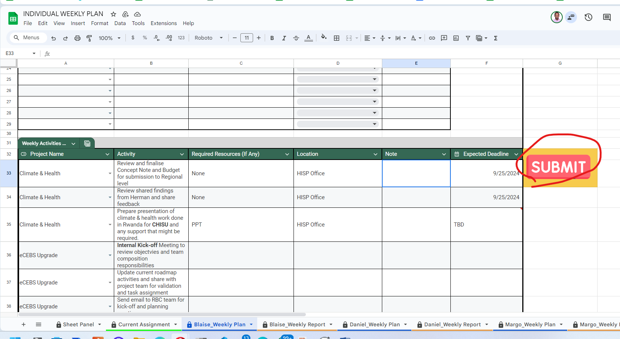

1. On first submission you will be required to approve authorization (One time activation, can be rebuked later)

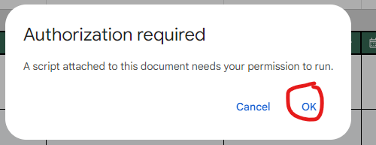

1. Press **OK** to proceed to select your gmail account

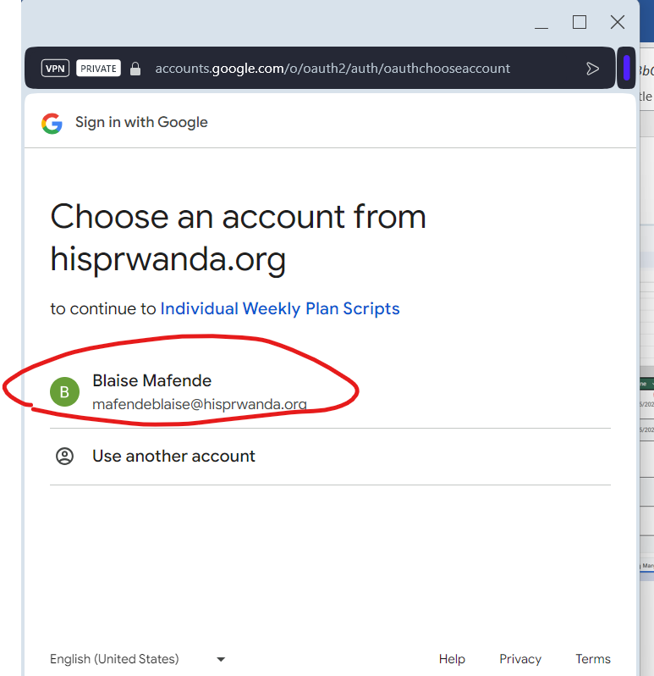

1. Select your gmail account that is shared

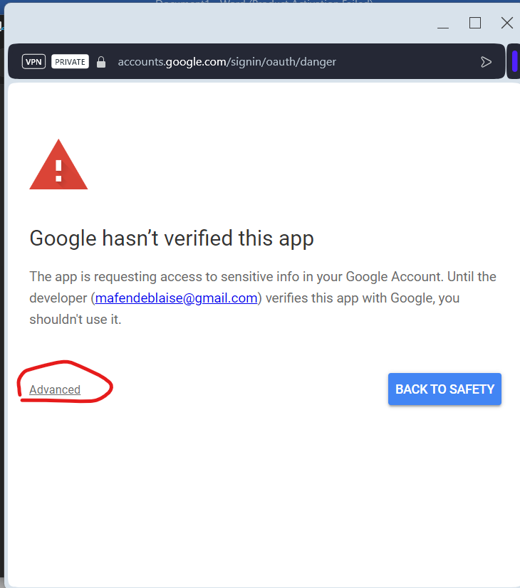

1. Go to advanced setting to give the google appscript access to your google sheet.

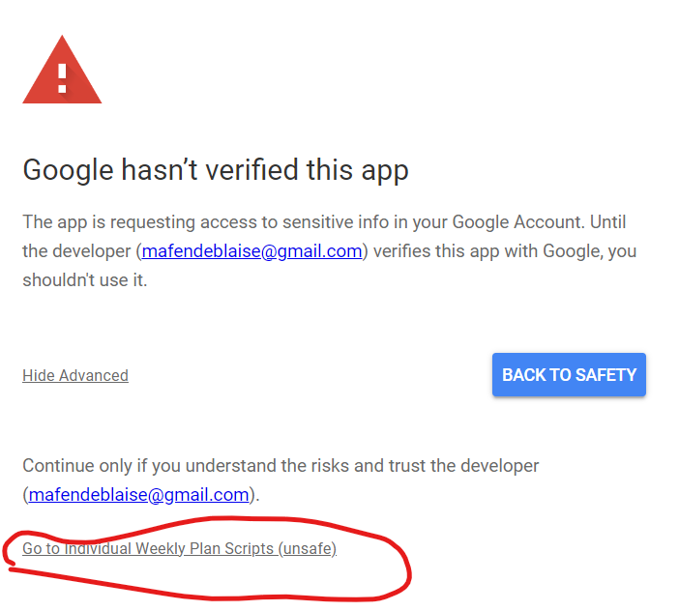

1. Select Go to the **Individual Weekly Plan Scripts**
   1. You can access the script in my git repository to review the code if you wish ([Click Here](https://github.com/Mafende-III/PlanningandReporting.git))

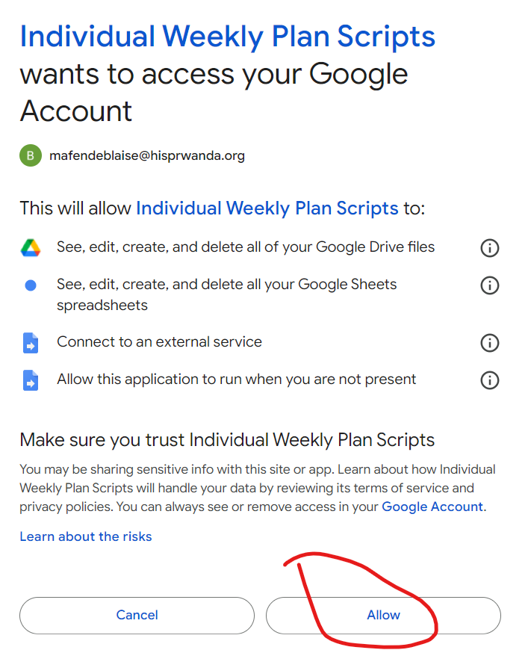

1. Allow access
2. Go back and click submit to submit your plan

**Errors­**

