**Muhammad Habibullah**

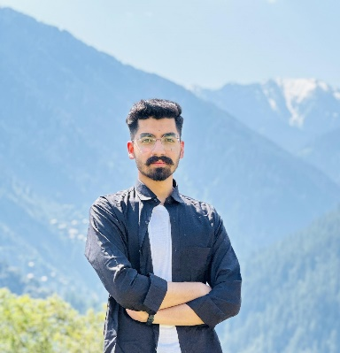**Python Programmer & Multimedia Specialist**

**Phone :** 03319991014

**Email :** mrbones03339@gmail.com

**LinkedIn :**linkedin.com/m-habibullah

**GitHub** **:** github.com/MuhammadHabib72

**Languages :** English, Urdu , Pushto

**Professional Summary**

Dedicated Python Programmer and Multimedia Specialist with expertise in AI-based projects, cryptographic programming, and application development. Proficient in building AI systems, computer vision applications, and multimedia content for social media. Passionate about using programming and design to innovate and solve real-world problems, with strong skills in Python, Flutter, Videography, Photography.

**Education**

**Bachelor of Science in Computer Science**

University Of Peshawar | September 2024

Grade: 3.7 GPA

**16 years of education in computer science, focusing on AI, and software development**.

**Professional Experience**

**Python Programmer**

Final Year Project – Developed a research based final year project which uses finetuned voice recognition ai model (in Python) integrated to mobile app ( in Flutter ) which performs Mistake detection in Quran recitation

**Online Quran Tutor**

Tarteel Kuran company online academy – Tutor for Quran recitation to adults and kids

**Technical Projects**

**AI-Based Quran Recitation Recognition**

- Developed a research-backed project using Python for voice recognition of Quranic recitations, incorporating AI and machine learning algorithms.

**Computer Vision Projects**

- **Face Detection & Gesture Control**: Implemented face detection using OpenCV’s Haar cascades.

- **Object Detection**: Used YOLO for real-time crowd detection from CCTV, integrating DMSS and OBS Studio.

- **Workshops Presented**: Conducted workshops on CNN, GNN, and OpenCV fundamentals, including crowd and object detection techniques.

**Data Analysis**

- Conducted cryptographic performance analysis, comparing encryption and decryption methods through data visualization with Matplotlib, Numpy, and Pandas.

**Flutter Projects**

**Quran Recitation & Memorization App**

* Developed an offline Quran app using Flutter, incorporating real-time voice recognition and transcription for Quran recitation.
* Integrated TFLite for on-device processing, allowing students in madrasas to practice recitation without internet access.
* Implemented unique modes like 'Hifz' mode, which hides text and reveals recited verses, aiding memorization.

**Islamic Calendar & Masnoon Duas App**

* Created an Islamic utility app that provides a Hijri calendar with custom colour themes and a collection of Masnoon duas.
* Integrated UI components to ensure ease of navigation and accessibility, enhancing the user experience.

**Notes Taking App**

* Designed a straightforward notes-taking app with functionality for organizing and categorizing notes.
* Employed a clean UI for efficient note management, allowing users to quickly add, edit, and delete entries.

**Calculator App**

* Built a user-friendly calculator app with essential arithmetic operations and a visually appealing layout.
* Focused on responsive design to ensure compatibility across different screen sizes.

**Technical Skills**

**Programming**: Python, Flutter, Dart, C++, Kotlin

**Python Libraries & Frameworks**:

**AI and Machine Learning** : OpenCV, TensorFlow, YOLO, PyTorch, Whisper, Hugging Face, Librosa, Transformers, ONNX, Google Cloud Text-to-speech, **Database in** SQL Alchemy, **Automation in** Pyautogui , **User Interface** in Tkinter, **Data Science** in Numpy, Pandas, Matplotlib,

- **Web Development**: HTML, CSS, JavaScript, Bootstrap **Python** : Flask, DJANGO

-**Chatbot development :** Dialogueflow