# Muhammad Haaris 21F-9060 Section: 6E

# Web Assignment: 01

Task 1

Code:  
<!DOCTYPE html>

<html>

<head>

<title>Simple Calculator</title>

<style>

.calculator {

max-width: 300px;

margin: 50px auto;

padding: 20px;

background-color: #fff;

border: 1px solid #ccc;

border-radius: 8px;

box-shadow: 0px 0px 10px rgba(0, 0, 0, 0.1);

}

.display {

padding: 10px;

margin-bottom: 10px;

border: 1px solid #ccc;

border-radius: 4px;

background-color: #f9f9f9;

text-align: right;

font-size: 24px;

font-weight: bold;

}

.buttons {

display: grid;

grid-template-columns: repeat(4, 1fr);

gap: 10px;

}

.button {

padding: 15px;

font-size: 18px;

border: 1px solid #ccc;

background-color: #e6e6e6;

border-radius: 5px;

cursor: pointer;

transition: background-color 0.3s;

}

.button.operator {

background-color: #76D7C4;

color: #fff;

}

</style>

</head>

<body>

<div class="calculator">

<div class="display" id="result">0</div>

<div class="buttons">

<div><button class="button">7</button></div>

<div><button class="button">8</button></div>

<div><button class="button">9</button></div>

<div><button class="button operator">/</button></div>

<div><button class="button">4</button></div>

<div><button class="button">5</button></div>

<div><button class="button">6</button></div>

<div><button class="button operator">*</button></div>

<div><button class="button">1</button></div>

<div><button class="button">2</button></div>

<div><button class="button">3</button></div>

<div><button class="button operator">-</button></div>

<div><button class="button">0</button></div>

<div><button class="button">.</button></div>

<div><button class="button operator">=</button></div>

<div><button class="button operator">+</button></div>

</div>

</div>

</body>

</html>

Output:  
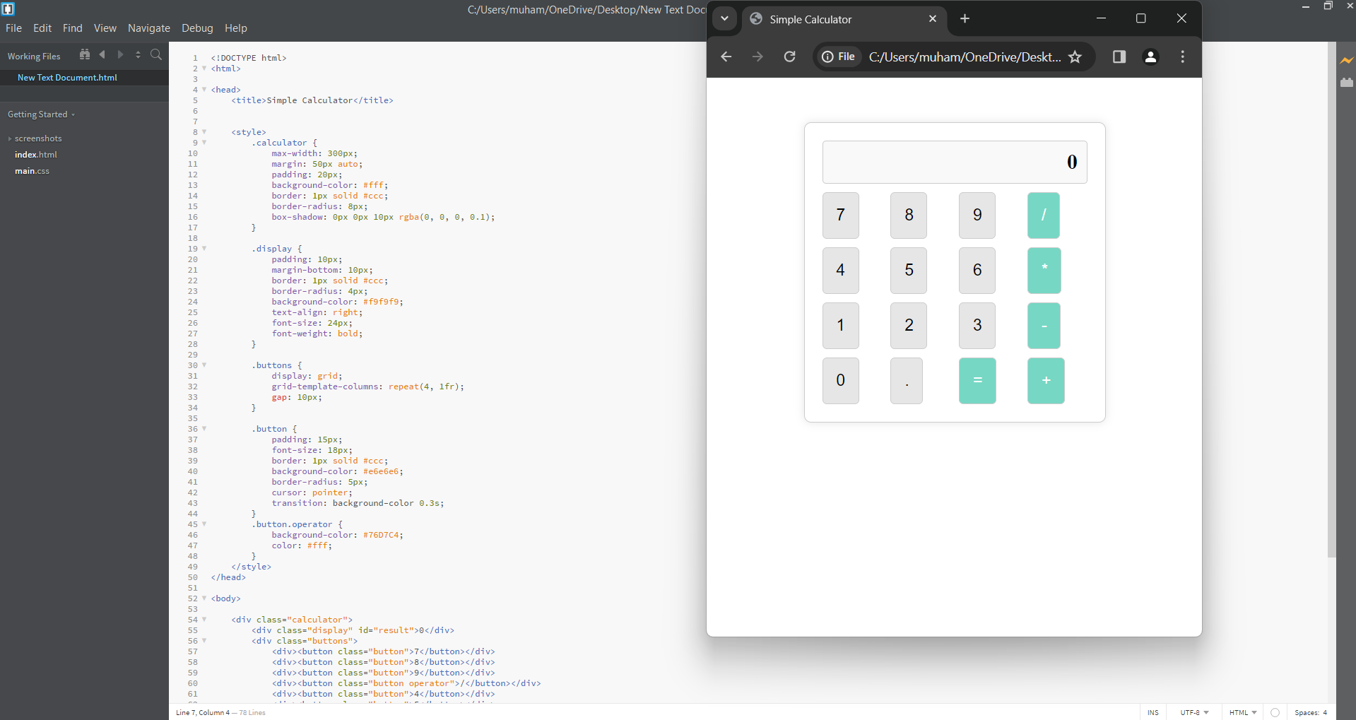

Task 2

Code:  
<!DOCTYPE html>

<html lang="en">

<head>

<meta charset="UTF-8">

<meta name="viewport" content="width=device-width, initial-scale=1.0">

<title>Time Table</title>

<style>

table {

border-collapse: collapse;

width: 100%;

}

th,

td {

border: 1px solid black;

padding: 20px; /* Increased padding to make cells bigger */

text-align: center;

font-size: 18px;

}

th {

background-color: #f2f2f2;

}

h2 {

text-align: center;

}

h1 {

text-align: center;

}

</style>

</head>

<body>

<h2>Department of Computer Science</h2>

<h1>BSCS 6-E</h1>

<table>

<tr>

<th>Day/Time</th>

<th>8:45 - 9:15</th>

<th>9:15 - 9:45</th>

<th>9:45 - 10:15</th>

<th>10:15 - 10:45</th>

<th>10:45 - 11:15</th>

<th>11:15 - 11:45</th>

<th>11:45 - 12:15</th>

<th>12:15 - 12:45</th>

<th>12:45 - 1:15</th>

<th>1:15 - 1:45</th>

<th>1:45 - 2:15</th>

<th>2:15 - 2:45</th>

<th>2:45 - 3:15</th>

<th>3:15 - 3:45</th>

<th>3:45 - 4:15</th>

<th>4:15 - 4:45</th>

</tr>

<tr>

<td>Monday</td>

<td></td>

<td></td>

<td></td>

<td colspan="3">WEB PROGRAMMING</td>

<td colspan="3">Parallel Distributed Computing</td>

<td></td>

<td colspan="3">Artificial Intelligence</td>

<td></td>

<td></td>

<td></td>

</tr>

<tr>

<td>Tuesday</td>

<td colspan="3">Computer networks</td>

<td colspan="3">Artificial Intelligence</td>

<td></td>

<td></td>

<td></td>

<td></td>

<td colspan="6">Artificial Intelligence-Lab</td>

</tr>

<tr>

<td>Wednesday</td>

<td></td>

<td></td>

<td></td>

<td></td>

<td></td>

<td></td>

<td></td>

<td></td>

<td></td>

<td></td>

<td colspan="6">Computer Networks-Lab</td>

</tr>

<tr>

<td>Thursday</td>

<td></td>

<td></td>

<td></td>

<td colspan="3">Computer Networks</td>

<td colspan="3">Software Design & Analysis</td>

<td></td>

<td colspan="3">Web Programming</td>

<td colspan="3">Parallel & Distributed Computing</td>

</tr>

<tr>

<td>Friday</td>

<td></td>

<td></td>

<td></td>

<td colspan="3">Software Design & Analysis</td>

<td></td>

<td></td>

<td></td>

<td></td>

<td></td>

<td></td>

<td></td>

<td></td>

<td></td>

<td></td>

</tr>

</table>

</body>

</html>

Output:  
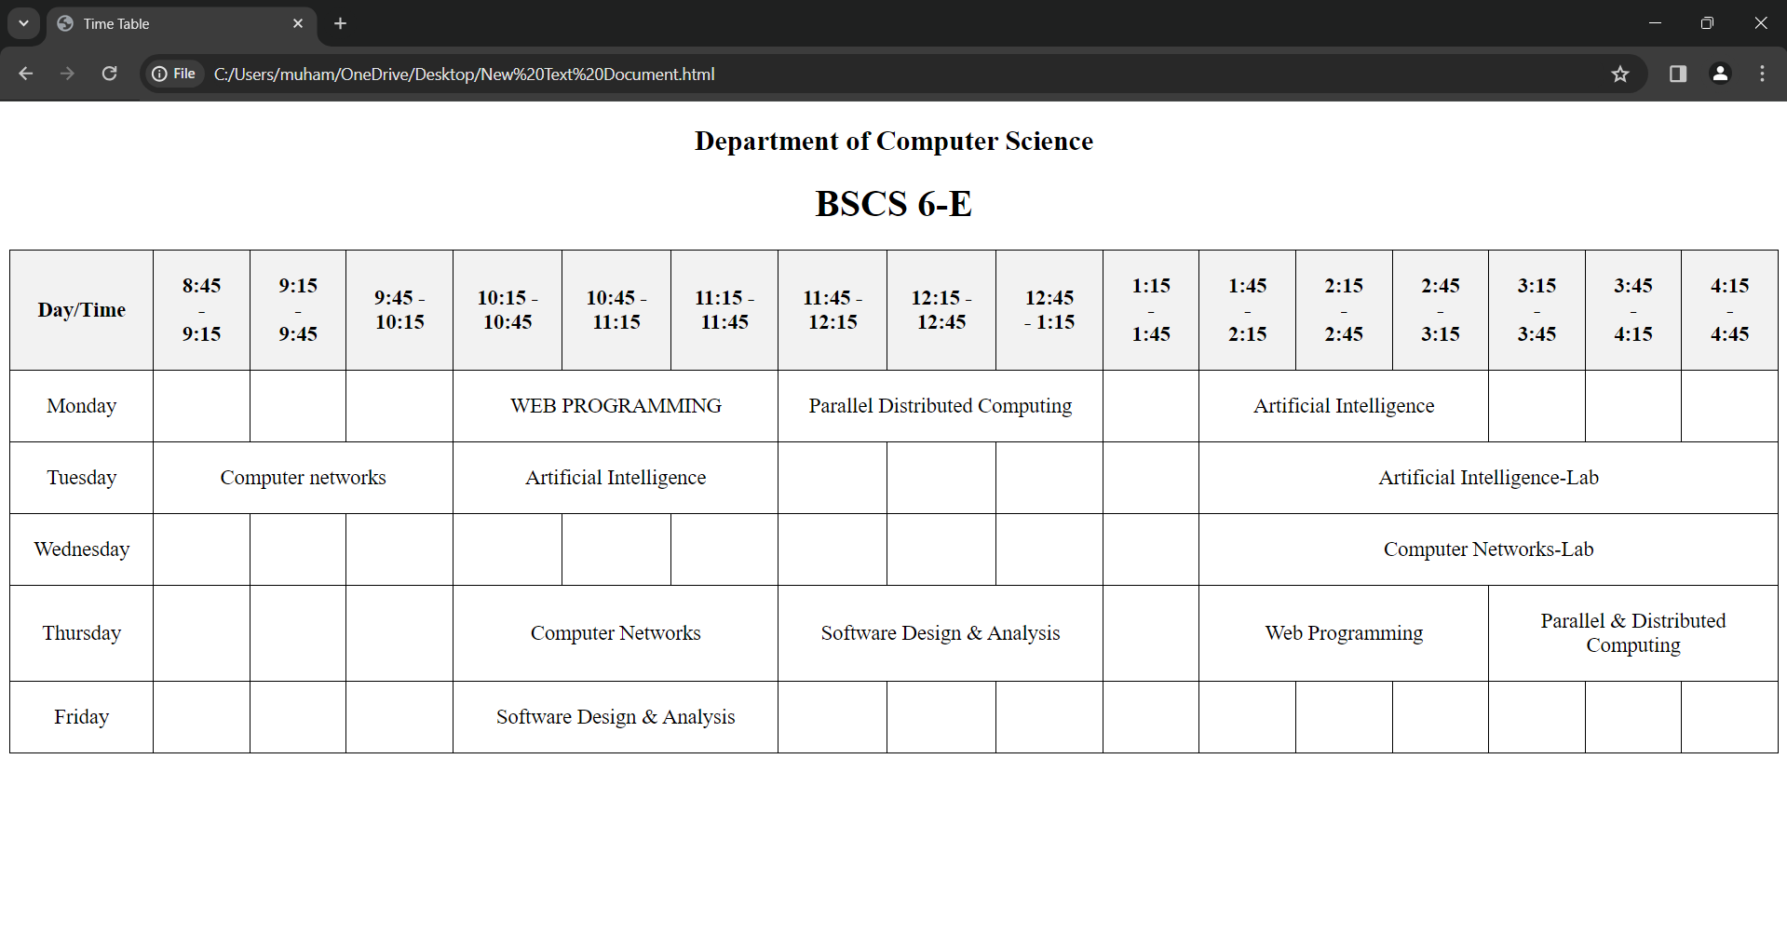

Task 3

Code:  
<!DOCTYPE html>

<html lang="en">

<head>

<meta charset="UTF-8">

<meta name="viewport" content="width=device-width, initial-scale=1.0">

<title>My CV</title>

<style>

body {

font-family: Arial, sans-serif;

margin: 0;

padding: 0;

background-color: #f4f4f4;

}

.container {

max-width: 800px;

margin: 50px auto;

background-color: #fff;

padding: 20px;

border-radius: 8px;

box-shadow: 0px 0px 10px rgba(0, 0, 0, 0.1);

}

.left {

float: left;

width: 30%;

}

.right {

float: right;

width: 65%;

}

h2 {

margin-top: 0;

}

h3 {

margin-bottom: 5px;

}

p {

margin: 5px 0;

}

.contact, .skills, .language, .hobbies {

margin-bottom: 20px;

}

</style>

</head>

<body>

<div class="container">

<div class="left">

<div class="contact">

<h2>Contact</h2>

<p>Contact Number: 03049444702</p>

<p>Email: muhammad.haaris2000@gmail.com</p>

<p>Address: Allam Iqbal Town, Lahore</p>

</div>

<div class="skills">

<h2>Skills</h2>

<h4>Trading</h4>

<p>Candles,Chart Patterns,S/R Levels,SMC,RR</p>

</div>

<div class="language">

<h2>Language</h2>

<p>English (Fluent)</p>

<p>Urdu</p>

<p>Punjabi</p>

</div>

<div class="hobbies">

<h2>Hobbies</h2>

<p>Gaming</p>

</div>

</div>

<div class="right">

<h1>Name</h1><p>Muhammad Haaris</p>

<h3>Job Title</h3>

<p>Scalp Trader</p>

<p>Summary: Trading involves meticulous analysis, quick decision-making, and disciplined execution to capitalize on market opportunities. </p>

<h3>Experience</h3>

<p>Binance - Scalper - 2023-Present</p>

<h3>Education</h3>

<p>TKS - Matric - 2019</p>

<p>PGC - FSC - 2021</p>

<p>FAST - BSCS - 2025</p>

</div>

</div>

</body>

</html>

Output:

