# Muhammad Haaris

# 21F-9060

# Section: 6E

Task 1

Create Git hub repo and upload folders  
  
Here are the screenshots

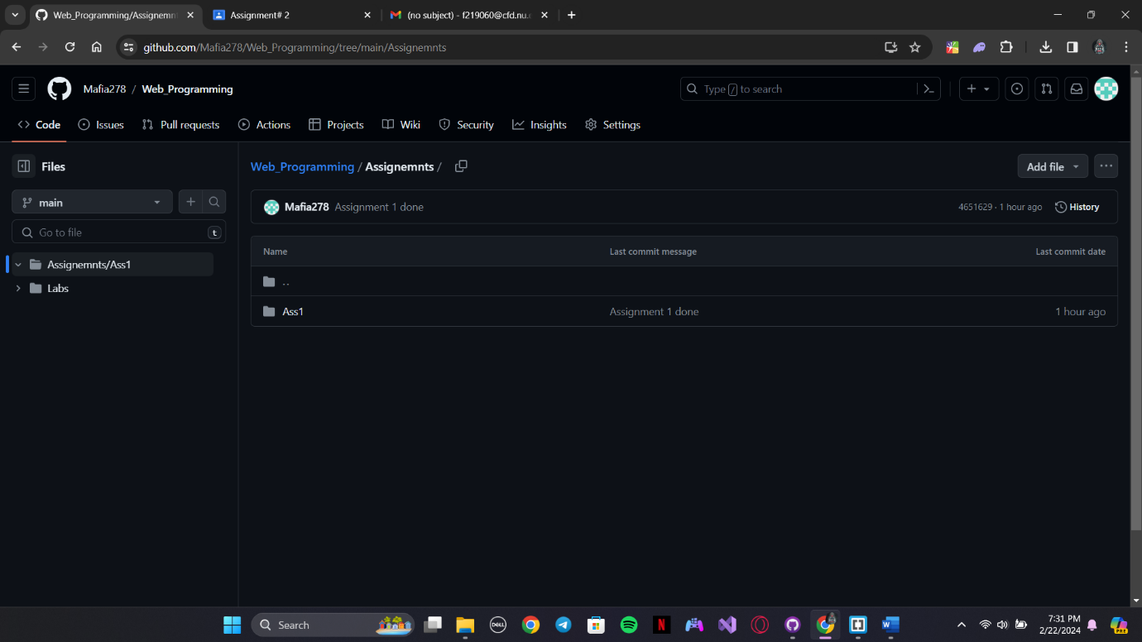

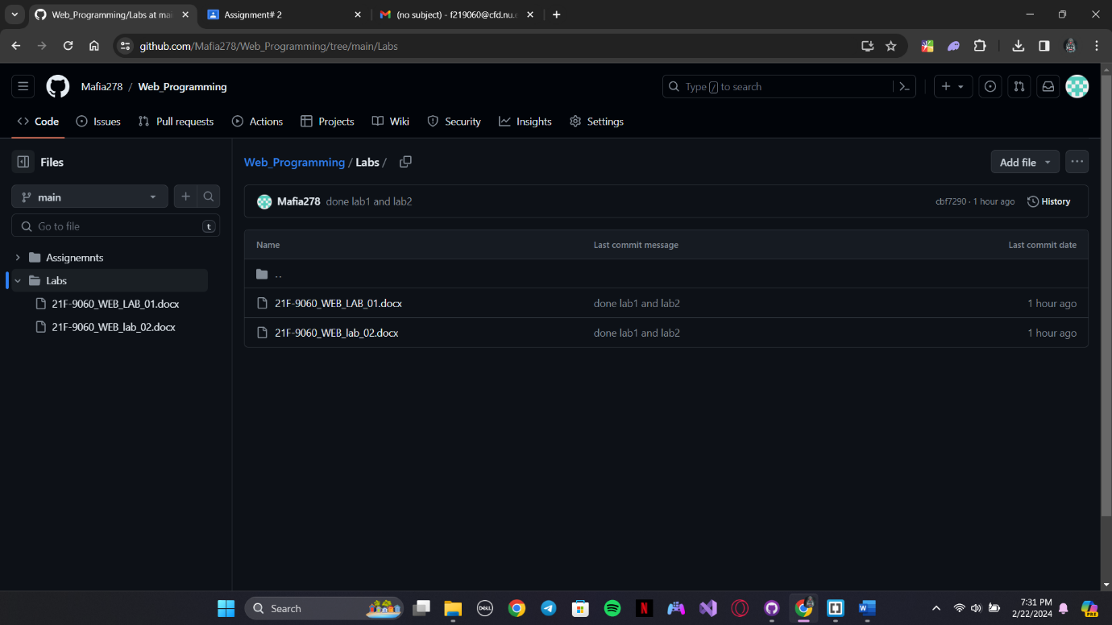

Task 2

Sign IN

Output:

Task 3  
Output:  
