# Muhammad Haaris 21F-9060 Section: 6E

Task 1

Output:  


Task 2

Output:  
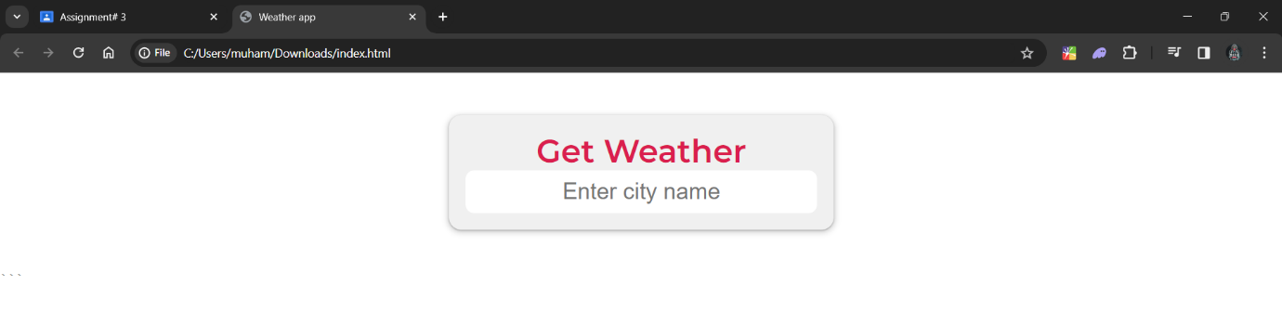

Task 3

Output:

Task 4

Output:  
